
A TECHNICAL REPORT ON
STUDENT INDUSTRIAL WORK EXPERIENCE SCHEME (SIWES)

HELD AT
WORKS MAINTENANCE DEPARTMENT. KWARA POLY, ILORIN

PRESENTED BY:
OLUGBEMI EMMANUEL OMOTAYO
ND/23/BLD/FT/0005

SUBMITTED TO:
DEPARTMENT OF BUILDING TECHNOLOGY,
INSTITUTE OF ENVIRONMENT STUDIES
KWARA STATE POLYTECGNIC, ILORIN
IN PARTIAL FUFILLMENT OF THE REQUIREMENT OF AWARD OF THE NATIONAL DIPLOMA (ND) IN BUILDING TECHNOLOGY.

AUGUST TO NOVEMBER, 2024.
i
DEDICATION
This report is dedicated to God almighty for his abundant grace, immeasurable love and consistent mercy for sparing my life throughout the duration of my SIWES program.
I would also like to dedicate this report to my parent, MR. and Mrs. OLUGBEMI, for their consistent support and unwavering assistance throughout the entire phase of the program, as well as my beloved friend, siblings and supervisor for their motivation and support.

ii
PREFACE
The student industrial work experience scheme (SIWES) program helps in exposing student to the practical application of their course and to get used to equipment and machine that are utilize in the factory. The SIWES was established to promote student ability and skill in industrial practice and pre-exposed them to working experience in industrial setting.
The SIWES program covered a period of 4 month from August to November 2024 and it is a partial fulfillment of a two years academic program to obtain an ND certificate in Building technology. The report explains the skilled acquired.

iii
ACKNOWLEDGEMENT
I wish to acknowledge my gratitude and appreciation to almighty God for the guidance and grace throughout the duration of the program.
My special thanks go to my industrial based supervisor for their numerous contribution and effort to make the program successful. I pray for success in your endeavors.
I extend my thanks to my head of department and all my amazing lecturers that contributed positively to success of the program. I pray Almighty God will reward you all.

iv
TABLE OF CONTENT
Title page
Dedication
Preface
Acknowledgement
Table of content
CHAPTER ONE: Introduction
  - Historical Background of SIWES
  - Aims and objectives of SIWES
CHAPTER TWO: Description of the establishment of attachment
2.1 Location and brief history of establishment
2.2 Objectives of the establishment
2.3 Organization structure
CHAPTER THREE: Reporting on work actually carried out
3.1 Introduction to materials, equipment and machineries on site
3.2 Brief explanation of some part of a building
3.3 Report on a particular work carried out on site
CHAPTER FOUR: Image showing practical work carried out
CHAPTER FIVE: Summary, Conclusion and recommendation
5.1 Summary of the attachment activities
5.2 Problem encountered during the program
5.3 Suggestions for the improvement of the scheme
CHAPTER ONE INTRODUCTION
  - Historical Background of SIWES
The Students Industrial Work Experience Scheme (SIWES), is a skills Development program initiated by the Industrial Training Fund (ITF), in 1973 to bridge the gap between theory and practice among students of Engineering and technology in Institutions of Higher Learning in Nigeria. It provides for on-the-job practical experience for students as they are exposed to work methods and techniques in handling equipment and machinery that may not be available in their Institutions.
SIWES was established by ITF in 1973 to solve the problem of lack of adequate practical skills preparatory for employment in industries by Nigerian graduates of tertiary institutions.
The Scheme exposes students to industry-based skills necessary for a smooth transition from the classroom to the world of work. It gives student of tertiary institutions the opportunity of being familiarized and exposed to the needed experience in handling machinery and equipment which are usually not available in the educational institutions.
Participation in SIWES has become a necessary pre-condition for the award of Diploma and Degree certificates in specific disciplines in most institutions of higher learning in the country, in accordance with the education policy of government.
Duration – Four months for the Polytechnics, college of education and six months for university
  - Aims and Objectives of SIWES
Aim of the Study
The aim of the study was to evaluate the impact of SIWES on Technical Skills Development in the Nigerian economy. This is to enable Institutions of Higher Learning and other Stakeholders assess the performance of their roles in the Scheme.

1
Objectives of SIWES
1. To Provide Practical Experience – SIWES helps students gain hands-on experience in their field of study, complementing their academic knowledge with real-world application.
2. To Develop Technical Skills – The program equips students with technical and professional skills relevant to their discipline.
3. To Enhance Employability – By acquiring industry-relevant skills, students improve their chances of securing jobs after graduation.
4. To Familiarize Students with Workplace Ethics – SIWES helps students understand organizational structure, teamwork, and professional ethics.
5. To Bridge the Gap Between Theory and Practice – It ensures that students apply classroom theories in real-life work situations.
6. To Promote Self-Reliance and Entrepreneurship – By gaining hands-on knowledge, students can develop skills that make them self-employed or start their own businesses.
7. To Foster Collaboration Between Institutions and Industries – SIWES strengthens the relationship between higher institutions and industries, ensuring students get relevant training.
8. To Improve Research and Development – Exposure to industry challenges may inspire students to conduct research that contributes to national development.

2
CHAPTER TWO
Description of the establishment of attachment
2.1 Location and brief history of establishment.
Works maintenance department is located in the west side of Kwara state polytechnic, Ilorin.
Works maintenance department was established in 1973. same year as the
institution. It was established to handle the maintenance and development of the
physical infrastructure of the institution.
2.2 Objectives of establishment.
Work department has these objectives to carry-on in the institution.
- Maintenance of all structures, furniture’s, building and facilities.
- Overseeing construction and renovation of infrastructure in the institution.
- Managing essential services like water and electricity.

2.3 Organization structure
Director of works

Building unit
Mechanical unit
Electrical unit
Physical planning unit
Civic engineering unit
Plant unit

3.
CHAPTER THREE
Reporting on work actually carried out
3.1 Introduction to site materials, equipment and machineries.
In the process of my work experience program i was introduce to various materials, equipment and machineries use in construction and development of a building.
Materials
Example of material used in building construction is as follows;
Cement: This is a powdered substance that develops strong adhesive properties when mixed with water. It is used in Block work, Plastering, Rendering, Concreting.
Reinforcement: Reinforcement is provided in concrete structure to enhance its tensile strength. It is provided in the region of the element that will be subjected to tension. Standard reinforcement bar diameters – 6,8,10,12,14,16,20,25,32 and 40 mm.
Aggregates: This consist of sand, ground crushed stone, pebbles and granite.
Water Bar: This is a construction element used to prevent the passage of water through joints or gaps in concrete structures. It is commonly used in foundation, retaining wall, basement, tunnel and other structures where water infiltration could cause damage.
Bituminous felt: This is a waterproofing membrane consisting of a thin fibrous mat of polyester or glass fibers saturated with bitumen or a bitumen-polymer.

Equipment’s
The following are example of various tools used in construction.
Trowel: This is a flat metal blade fixed to a short handle use for application, joining, smoothing and shaping of mortal in masonry. It is also use in the trimming of block/bricks. Trowel sizes range from 225-350mm measuring from the blade.
4.
Spirit level: This is a hand-tool used for indicating true horizontal and vertical of a surface by means of an air bubble sealed in a marked, liquid-filled glass tube mounted in a frame. Spirit level are of various length ranging from about 225mm to 1.2m.
Iron square: This is a hand-tools of angle 90 which measure 600mm by 450mm long. It is used for setting out walls at right angle to check for square nature of a section of work.
Hammer: A hammer is a tool consisting of a weighted head fixed to a long handle that is swung to deliver an impact to a small area of an object.
Head pan: This is a round container, like a bowl used in construction work. It is used to transport mortal, concrete, fine or coarse aggregates.
Shovel: A shovel is a tool resembling a spade with broad blade and typically upturned sides, used for moving earth or other materials. It is used for digging, lifting and moving bulk materials such as sand, soil and gravel.
Straight Edge: The kind of straight edge that is used in construction site is an aluminum frame of about 2m in length. The straight edge is used to check the fairness of the newly laid piece of a wall and to ensure that all the block is laid to same level of each course.
MACHINERIES
The machineries that were used on site were brought into consideration so as to promote high standards required particularly in the context of structural engineering works. Machineries are used on site to eliminate heavy manual work thus reducing fatigue and as a consequence increasing productivity. Such machineries that were used include;

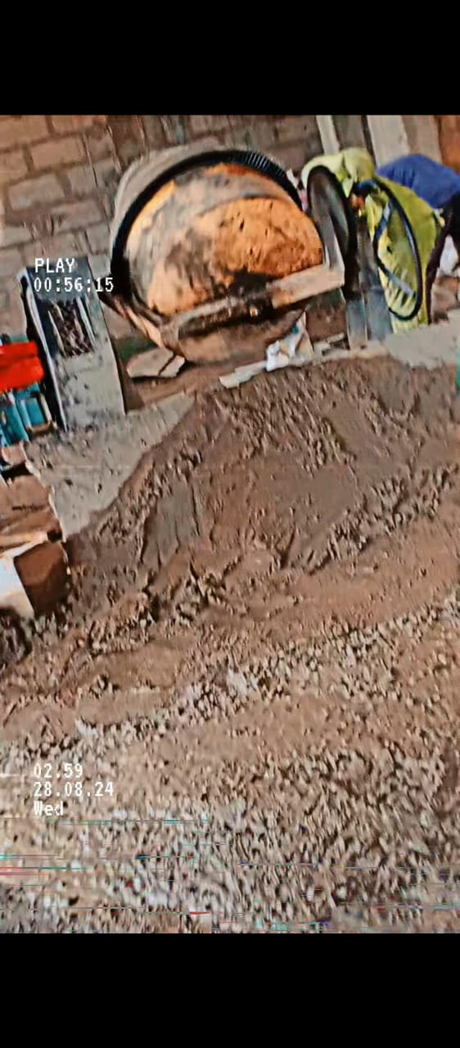
Tilting drum concrete mixer: This is a type of concrete mixer with a rotating hinged drum in which the constituent materials are mixed thoroughly and can be tilted to enable emptying.

5
3.2 Brief explanation of some part of building
Foundation: This is the lowest part of a building or structure that transfer the load of the building (including its own weight, occupants, furniture’s, and environmental forces like wind or snow) to the ground.
Column: This is a vertical structural element that primarily support compressive load. It is design to transfer the load from above (such as beams, slabs, or roofs) to the foundation then to the ground.
Beam: A beam is a horizontal or sloping structural element that primarily resist bending force. It transfers loads to vertical supports like columns or walls.
Lintel: This is a horizontal structural element that span an opening, such as door, window and archway, to support the load above it.
Fool sab: This is a flat horizontal structural element that form the base of a fool in building. It provides a sturdy and level surface for occupant, furniture, and equipment, while also transferring loads (such as live loads and dead loads) to the supporting structural element like beams, columns, and walls.
Stairs case: This is a structural element design to provide a means of vertical movement between different levels or floors of a building.
Roof: This is the uppermost part of a building or structure that provides protection from weather element such as rain, snow, sunlight, wind, and extreme temperatures.

3.3 Report on a particular work carried out on site
Getting to the site for my SIWES program, project on site was a two-story building (ICT) Complex.
The project construction is at the roofing beam level, After the introduction to the site materials, equipment, and machineries. Preparation for roofing beam and parapets begins.
6
The construction process of a roofing beam and parapets involves several steps to ensure structural integrity, safety, and functionality. From design, material selection and construction and so on.
Roofing beam is defined as a critical structural element that support the roof and transfer loads to the walls and columns.
Parapet is a low wall or railing built at the edge of a roof, balcony, or terrace. It provides safety, prevent water ingress, and enhances aesthetics.

Detailed explanation of the construction process
Here’s how there are constructed:
Design and planning

Structural analysis: Engineer calculate the loads, (dead, live, wind, snow etc.) and design the beam and parapet dimensions, reinforcement, and material specification.
Material selection: The type of beam and parapet constructed is a reinforced concrete one. Material include: cement, aggregate, and reinforcement.
Drawing: Detailed structural drawings showing beam and parapet placement, dimension, reinforcement size, and connection.
Height and Thickness: The height and thickness of the parapet was determined based on the Building codes and design requirements.
Material and construction process for concrete roofing beam and parapet
Formwork: Formwork are temporary molds, to shape and support freshly poured concrete until it is hardening and gain enough strength to support itself. Formwork material include different sizes of planks 1by12, 1by9, and woods 2by3, 1by3, 1by4, and 2by2.

7
It is cut and join to form the molds for the beam and parapet. All internal walls that requires beam has joined planks nailed on both side of the wall and (baton) a small Sized wood is nailed to the horizontal part of the wall in between the formwork. As shown in the image below.
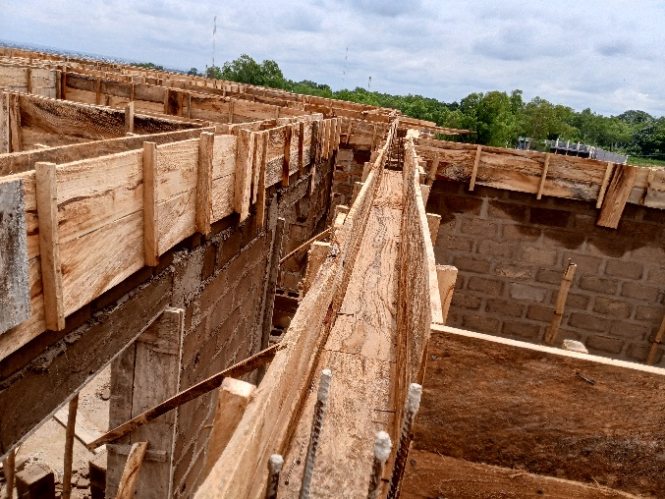
External walls have joined planks nailed at one side, but at the internal side of the wall. The outer side is carefully constructed by professional for the parapet. 1by3, 1by4, 2by3, 1by9 are cut and joined properly using nail and hammer to form ziggzard sharp for the parapet.
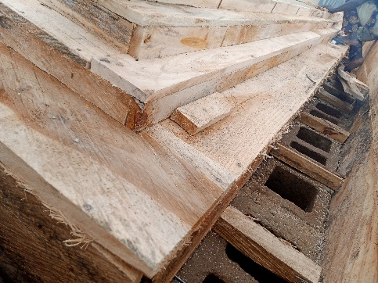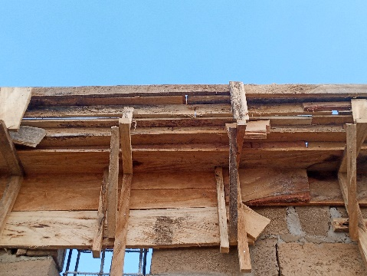
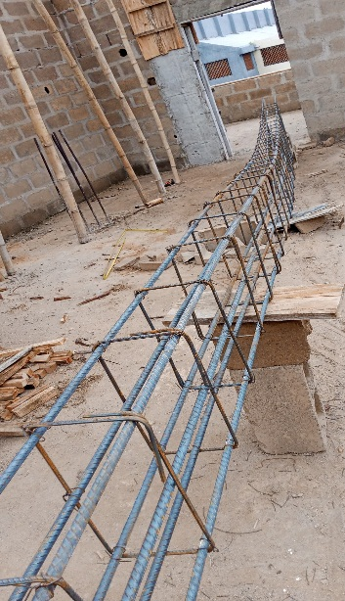
Reinforcement: Reinforcement size to be is determine by the load that will be subjected to the beam and parapet. Reinforcement bar is cut to the length size of the beam and parapet, and 12mm is bend to form links for the beam and zigzard for the parapet sharp. It is tied together with wire to create a reinforced boxed cast beam and parapet. Then it is position or placed in the formwork ensuring it is centered and secured. As shown in image below.

8
Concrete: Cement and aggregate are mixed in ratio 1:3:6 with concrete mixer. Shovel, wheelbarrow and head pan are used for transportation of the concrete and it is poured in the formwork. Compacting is done properly to avoid air pocket and air bubbles, levelling and smoothing the top surface of the beam and parapet with trowel. Then wait for it to harden.
Spacers: This is use to maintain the required concrete cover around the reinforcement.
Water curing: Regularly sprinkle of water on the beams for 7 days minimum to ensure proper hydration and strength development.
Stripping Time: Remover of the formwork after the concrete has gain sufficient strength.
Inspection: This is to check for defects likes cracks or honey combing and repair it if necessary.

9
CHAPTER FOUR
4.1 Image showing practical work carried out on site
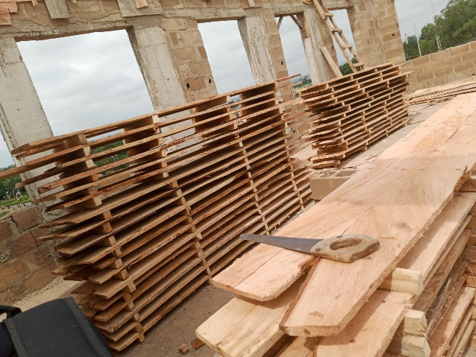

image 1: 1 by 12 planks joined with 2 by 3 wood at both end and center nailed together for formwork.
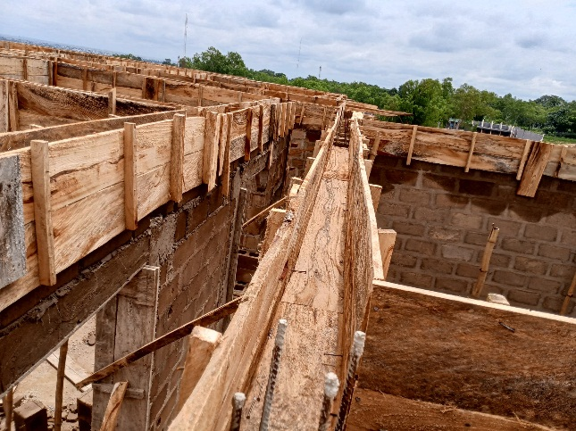

Image 2: formwork for beam without walls. i.e. The formwork is at three side of
The beam, both sides and the bottom.

10
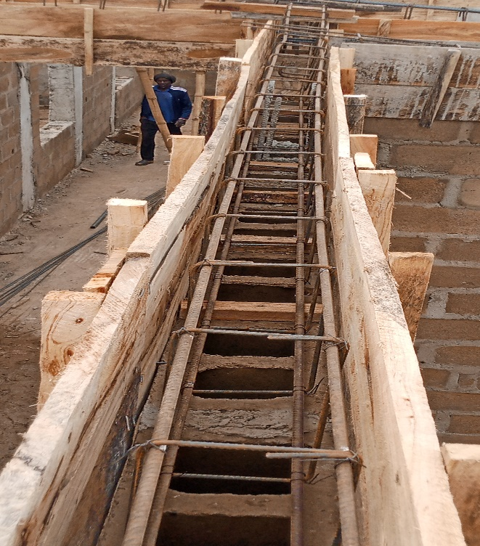
Image 3: Reinforcement placed in formwork for internal walls, centered and well positioned.
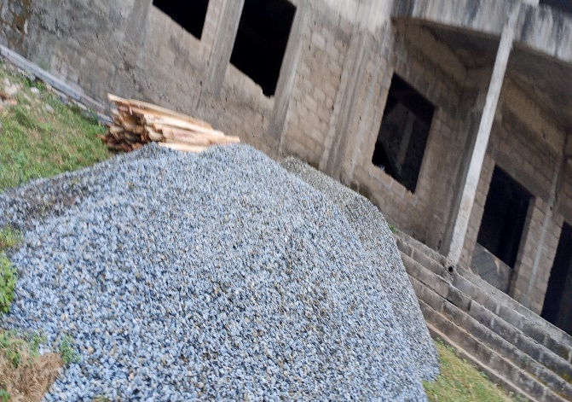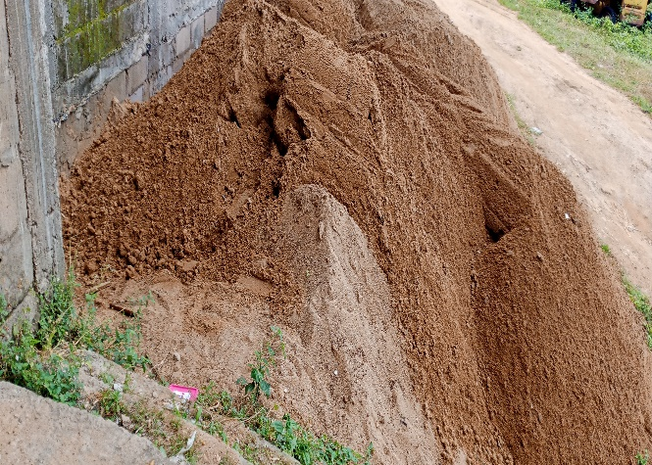
Image 4: Aggregate for concrete work.

11
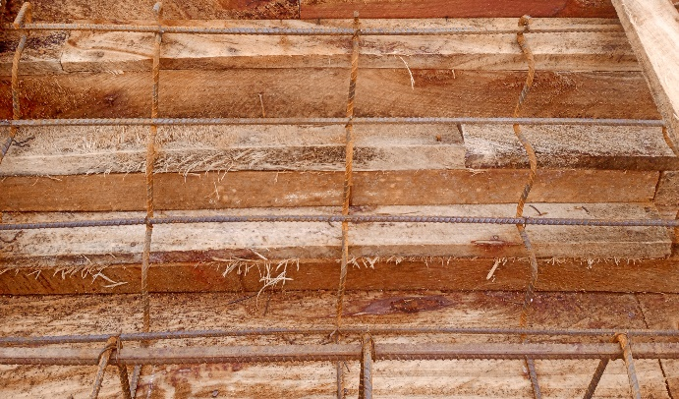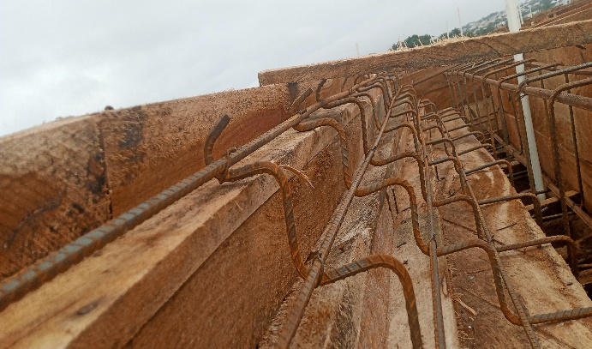
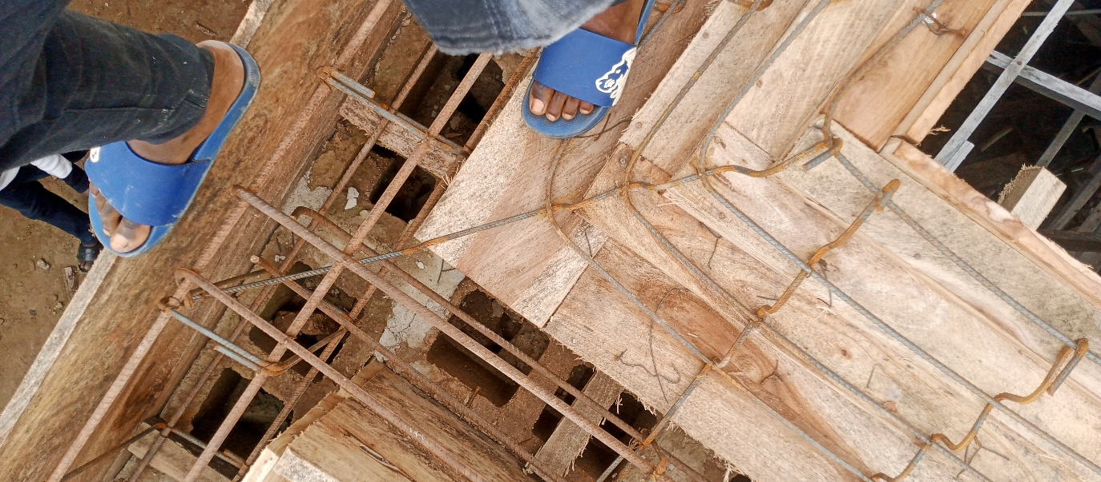
Image 5: Roofing beam and parapet formwork with reinforcement centered and properly position ready for casting.
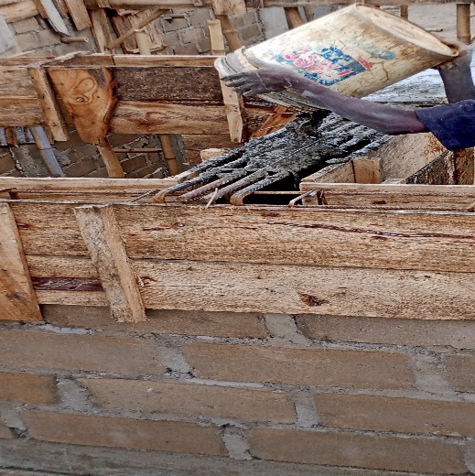Image 6: Concrete been poured inside formwork with reinforcement.
12

CHAPTER FIVE
Summary, Conclusion and recommendation
5.1 Summary of the attachment activities
During my SIWES program at a two-story building construction site, I was introduced to materials (cement, reinforcement bars, aggregates, waterproofing elements), equipment (trowels, spirit levels, shovels), and machinery (concrete mixer). Key structural components included foundations, columns, beams, slabs, and roofs. The project focused on constructing reinforced concrete roofing beams and parapets. The process involved formwork assembly (using planks and battens), reinforcement placement (12mm bars bent into links/zigzags), and concrete mixing (1:3:6 ratio) poured into molds. Compacting, curing (7-day water sprinkling), and formwork removal followed. Parapets were designed per building codes for safety and waterproofing. Inspections ensured defect-free results, emphasizing structural integrity. This hands-on experience highlighted efficient material use, machinery roles in productivity, and adherence to engineering standards for load-bearing and safety compliance.
5.2 conclusion
This program has brought improvement to my field of study. The experience gained through program is majorly based on roofing beam and parapet construction on a two-story complex. This program has inspired me to have technical knowledge and practical aspect of what I have learnt in school.
5.3 Recommendation
- The Federal Government school provide industries and organizations with incentives to encourage and solicit for their cooperation and construction to the program.
- The Industrial Training Fund should provide a network in which Establishments and student could communicate better so promote easier means of finding placements.
- Government on their part should make reasonable payment to students on completion of this program. This will help to reduce the financial burden on parents of these students. It will also help to encourage them to fully
13
participate in it.
- The students should prepare to face the realities of work life. There should be adequate orientation to educate them on the need for them to embrace the program and possible challenges the may encounter.
- The institution and Industrial Training Fund should help the student to get the place of attachment, so that the program will commence as planned.

14

