CONTENTS PAGE
Section………………………………………………………………Page Number
Certification………………………………………………………………..……ii
Dedication……………………………………………………………………….iii
Acknowledgements……………………………………………………………...iv
Abstract………………………………………………………………………….v
Contents Page……………………………………………………………………vi
CHAPTER ONE
1.1 Introduction…………………………………………..………………....……1
1.2 About Industrial Training Fund (ITF)……………………………….…….....1
1.3 Brief History SIWES………………………………………………………....2
1.4 Objectives of SIWES…………………………………………………………2
CHAPTER TWO
2.1 Overview of State Civil Service Commission..………………………….…...3
2.2 Structural Organisation of the Civil Service Commission…………………...3
2.3 Functions of Civil Service ………………….………………………….…….4
CHAPTER THREE
3.1 Gombe Civil Service Commission…..…….……………………….…..……5
3.2 Vision……………………………………………………………………..…5
3.3 Mission………………………………………………………………………5
3.4 Structure……………………………………………………………………..5
3.5 Organogram of the Orangisation……………………………………………6
3.6 Responsibilities of kwara Civil Service Commission……………………..6
3.7 Policies/Programmes………………………………………………………..6
3.8 Civil Service Departments…………………………………………………..7
3.9 Membership of the Commission…………………………………………….7
CHAPTER FOUR
4.1 Department of Service…………………………..………………….………8
4.2 Duty Section.………………….………………………………..…………..8
4.3 Functions of the CSC Secret Registry………………………………………9
4.4 Knowledge Acquired………………………………………………………..9
4.5 Problems Encountered ……………………………………………………..10
4.6 Proposed Solutions to Problem…………………………………………….10
CHAPTER FIVE
5.1 Recommendation..…………………………………………………………11
5.2 Conclusion………………………………………………………….……...11

CHAPTER ONE
- . INTRODUCTION
This report was written in respect to the Industrial Training (IT) program undergone. It examines the activities carried out during the program as regard to the duties and responsibilities undertaken by my department.
This program was incorporated and funded by the Industrial Training Fund (ITF) jointly coordinated by Student Industrial Work Experience Scheme (SIWES), for the acquisition of skills and added values to students of various institutions.
In the course of the program, I was meant to understand the verse responsibilities and duties of the civil service commission with the flow of command which is majorly bureaucratic (a procedure of performing a task in consideration of the laid down rules and regulation). It also induce in me the knowledge of chain of command is important and to have someone under-checking your performance and coaching you on a more positive aspect of carrying out all paper works.
  - ABOUT INDUSTRIAL TRAINING FUND (ITF)
In October 1971, the Federal Government established the Industrial Training Fund (I.T.F). In its policy statement No.1 published in 1973, a clause was inserted dealing with the issue of practical skills among the locally trained professionals in the tertiary institutions especially the universities of technology, polytechnics, colleges of education and technical colleges.
Hence, Section 15 of the policy statement states clearly that “Great emphasis will be placed on assisting certain products of the post-secondary school system to adapt or orientate easily to their possible post-graduation job environments”, subsequently leading to the launch of a scheme known as Student’s Industrial Work Experience Scheme (SIWES).

  - BRIEF HISTORY OF S.I.W.E.S
SIWES (Student industrial work experience scheme) was established by ITF in 1973 to solve the problem of lack of adequate skills by graduating student in the industrial world. The scheme exposes students to industry based skills necessary for an easy transition from the classroom to the industrial world.
Participation in SIWES has become a necessary pre-condition for the award of diploma and degree certificates in specific disciplines in most institutions of the higher leaning in the country, in accordance with the education policy of government.
Operators of SIWES include: the ITF, the coordinating agencies; NUC, NCCE, NBTE, employers of labour and the various institutions. The SIWES program is funded by the Federal Government of Nigeria.

  - OBJECTIVES OF SIWES
- SIWES provides the avenue for students in institutions of higher learning to acquire industrial skills and experiences in their course of study.
- Prepare the students for the industrial work situation they’re likely to meet after graduation.
- Expose students to work method and techniques in handling equipment and machinery that may not be available in their institutions.
- Make the transition from school to the world of work easier and enhance students contact for later job placement.
- SIWES provides students with an opportunity to apply their knowledge in real work situations thereby bridging the gap between theory and practice.

CHAPTER TWO
- . OVERVIEW OF STATE CIVIL SERVICE COMMISSION (CSC)
The Civil Service Commission consists of employees in Nigerian government agencies other than the military and police. Most employees are career civil servants in the Nigerian ministries, progressing based on qualifications and seniority. The Civil Service oversees hiring and promotions, and promote the values of the public service. Its role is roughly analogous to that of the human resources department in corporations. Civil service commissions are often independent from elected politicians.
The Civil Service can also be considered to be machinery through which the government implements its policies, designed to meet political aims and provide social services. This however, does not preclude the legislative and the judicial arms of government in the attainment of the objectives of the Civil Service.
2.2. STRUCTURAL ORGANISATION OF THE CIVIL SERVICE COMMISSION (CSC)
- Administrative class: This cadre of civil service formulates and initiates policies and programmes which the executive class would generally implement. (Dedicated and hardworking employees from the executive class may be periodically promoted into the administrative cadre.)
- Executive class: Supervises and controls the activities of the clerical class, and stores information which the administrative class utilizes in the process of policy planning and implementation.
- Professional class: They offer useful advice on the technical policies to be formulated and implemented by the administrative and executive classes in the civil service.
- Clerical class: They comprise the clerks, typist and secretaries. They undertake the clerical work of their departments such as record keeping, movement of files, preparation of vouchers, accounts examination and payment of claims to all categories of staff.
- Auxiliary class: This cadre comprises the drivers, messengers, gardeners, porters security men, painters, cleaners etc. they provide various services such as driving of top civil servants, protecting them from criminal attacks, building and painting of government offices and general cleaning.
2.3. FUNCTIONS OF CIVIL SERVICE COMMISSION (CSC)
- It recruits highly qualified personnel into the civil service, based upon good educational qualifications and performance in competitive, written examinations and interviews.
- The civil service commission promotes competent and productive senior civil servants from one grade to another,
- It can transfer civil servants from one department to the other
- The commission has disciplinary powers like suspension or dismissal of erring civil servants
- It is vested with the power of retiring civil servants and advising in the payment of their pension entitlements and allowance
- It offers advice to the government on the appointment of suitable individuals to fill some sensitive positions in public corporations and parastatals.

CHAPTER THREE
- GOMBE CIVIL SERVICE COMMISSION
Gombe State Civil Service Commission is a Constitutional body vested with power to appoint Civil Persons to the office in the State Civil Service and thereafter monitor the progress and conduct of such persons up to the point of exit from the Service. It exercises disciplinary control over persons holding such offices.
Civil service has divisions responsible for unique services. These divisions are known as ministries. A ministry is headed by a permanent secretary. Permanent secretaries report directly to ministers of the ministry and the Ministers report directly to the Governor of the state.
Hence, the civil is charged with the sole responsibility of formulating establishments and training policies for the entire State Public Service and determination of establishment matters, including staff complements, pension administration, grading and conditions of appointment, in conjunction with the office of the Head of Service.
3.2. VISION
To sustain a reformed civil service, proficient in professionalism, effective and transparent service delivery.
3.3. MISSION
To create quality and objective Civil Service through adherence to rules and regulations.
3.4. STRUCTURE
The Gombe State Civil Service is made up of Ministries and Extra-Ministerial Departments, each responsible for a particular area of service of Government.

3.5. ORGANOGRAM OF THE ORGANISATION
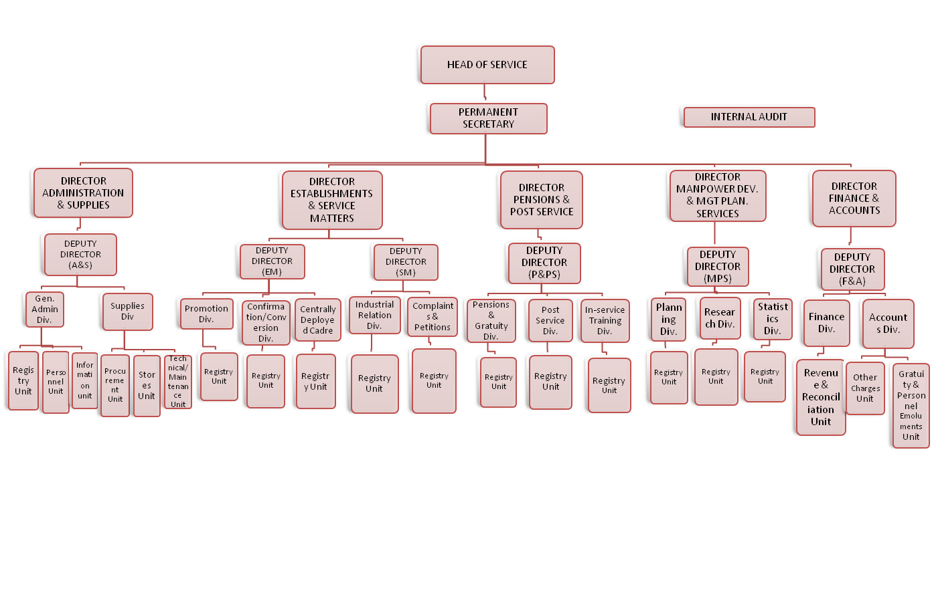

3.6. RESPONSIBILITIES OF GOMBE STATE CIVIL SERVICE COMMISSION
- The Ministry has the sole responsibility of formulating establishments and training policies for the entire State Public Service.
- Determination of establishment matters, including staff complements, grading and conditions of appointment, in conjunction with the office of the Head of Service.
- Attendance at the meetings of the National Council on establishments in conjunction with the office of the Head of Service.
- Reviewing of the condition of Service in conjunction with the Head of Service;
- Issuance of establishment circulars, giving guidelines and interpretation on the use of Public Service Rules and Schemes of Service
- Management of industrial relations with the accredited Trade Unions in conjunction with the Office of the Head of Service; and
- Pensions and gratuity Administration, reimbursements and welfare
- Maintenance of comprehensive and updated personnel records of the civil service
3.7. POLICIES/PROGRAMMES
- Monthly payment of pension and gratuities
- Biometric verification of pensioners
- Distribution of welfare packages to pensioners (every quarter of the year)
- Visitation
3.8. CIVIL SERVICE DEPARTMENTS
The Commission has the following departments:-
- Administration Department: This Department is responsible for the General Administration of the Commission. It takes charge of staff Welfare and Maintenance of Vehicles.
- Finance Department: This department deals with all matters of Finance and Budget Estimates.
- Planning, Research and Statistics: This Department is charged with the responsibility of collating, collecting and keeping records of Civil Servants. The data collected are used for the preparation of the Commission's Annual Reports, Achievements and Quarterly Reports. The Department is also responsible for providing information/data for Gazette publications of promotions, transfers, secondment, new appointments, withdrawals, resignations and retirements from service on request.
- Recruitment, Promotion and Discipline Department: The Department is responsible for processing employment of staff from GL.06 and above for Ministries and Departments. It is also responsible for scouting and securing employment opportunities for the State' indigenes into the Federal Civil Service and does this by liaising with the Federal Civil Service Commission. It also deals with cases of promotion and discipline within the Civil Service. It liaises with Ministries/departments for Personnel Management Board meetings. It also guides and gives general advice on the application of the Civil Service Reforms. Furthermore, it is charged with the responsibility of arranging the Commission's meetings.

3.9. MEMBERSHIP OF THE COMMISSION
The Commission has a Chairman and four members. The Permanent Secretary serves as the administrative head of the Commission. The Office of the Head of Service posts all supporting staff to the Commission except those on Grade Levels 01-05. The membership of the Commission is as follows:
- The Chairman
- Commissioner I
- Commissioner II
- Commissioner III
- Commissioner IV
CHAPTER FOUR
- . DEPARTMENT OF SERVICE

The Registry
Registry is a place where written records are kept or a place where register of events are kept. However, a registry in the context of public service rule refers to a room where written records, documents are kept.

The Two Types of Registry:
Open Registry
This may refer to a room in every ministry or organization where all files and records relating to staff are kept or it is a place where all clerical work is performed.
Secret Registry
It is a place where confidential file/ records are kept intact. Secret registry is the same thing with open registry but, when we talk of a secret matter we are referring to a secret room or registry. Secret file deals with Grade C file i.e. confidential file

  - DUTY SECTION
Secret Registry
The Secret Registry is the custodian of staff secret files and the registry secret documents as well as policy documents. Secret registry is charge with the responsibilities of opening new files for newly recruited staff, record of in-coming and out-going mails etc.
Gombe civil service secret registry is incorporated to oversee other state owned ministries, staff transfer from one ministry to another, in-service level, upgrade of staff grade level and retirement of staff. All civil servant data are highly documented by this section of the administration, hence filing and referencing of staff file is been carried out by this department. However the secret registry is set on confidentiality grounds which is no civil servant in the department is allow to whisper the affairs in the department to anyone outside, moreover officers in these department are bound by oath.
The secret registry is headed and supervised by the Chief Executive Officer (CEO) Mrs. Hassan Tabitha Lander. Therefore the secret registry is only entered by authorized members of the organization and restriction is highly recommended cause of the complexity of individual document. It is the duty of the staff in the secret registry to trace any civil servant file and recognize any dispatch delivered to other ministries.

A good registry provides control of records and presents several benefits:
- Efficiency: Records are better organised and located, therefore making them quickly retrievable, thereby facilitating ease of reference, eradicating staff frustrations and increasing productivity.
- Consistency: the existence of documented policies means that staff members execute actions relative to records in a consistent manner.
- Continuity – good records facilitate continuity on occasions when staff members leave the employment of the organisation. In the absence of records, staff members take their knowledge with them when they leave.
- Good decision making: staff members have ready access to all necessary records; they are able to make decisions with reference to precedent, context and eventualities.

  - FUNCTIONS OF THE CSC SECRET REGISTRY
The essential functions of a registry are to:
- Receiving and record of in-coming and out-going mails
- Preparation and delivery of dispatch
- Morning listing supervision
- Building and referencing of GM files
- Typing of promotion memo
- Opening of GM file for newly appointed officers
- Transfer of service
- Review and dispose of all inactive files or other records in accordance with the Archives Regulations.
- Sorting and arranging of officers promotion file

  - KNOWLEDGE ACQUIRED DURING SERVICE
The major knowledge acquired is that in Civil Service Commission is that hierarchy is duly recognized and there are strict rules and regulation in carrying out a function i.e it should be in accordance with the laid down rules of Public Service Rules (PSR)
Secondly, manual filing system is still appreciated in our society despite the technological advancement
Lastly cordial communication of ideas improves the working and learning speed of each staffs.

  - PROBLEMS ENCOUNTERED
As this department play some essential to the organization, some of the problem adhere to it are as follows:
- The department was over staffed which cause some of the officers to be idle
- The department now sees the commission as a place concerned with their own personal business neglecting the affairs of the government
- Late coming of some staffs of the department
- Lack of stationery to carried out the organization duties
- Sleeping on duty
- Absence from duty without leave
- Filing system which an essential part in the department was carelessly handed
- Misplacement of officers file

  - PROPOSED SOLUTION TO ENCOUNTERED PROBLEMS
- All officers should be treated equally and duly discipline should be given in accordance of the Public Services Rules
- The organization should employed competent and ready minded staff
- Provision of stationeries when required
- Office cabinet should be made available and damaged ones should be replaced

CHAPTER FIVE
  - RECOMMENDATIONS
The experience I had in Gombe Civil Service Commission (CSC) has posed me to recommend the following should to implemented
- SIWES student should be given access to the organization history
- Proper orientation should be given to any SIWES student
- Supervision of the student in accordance of is been done and what he/she learn for that day
- SIWES student should be posted to the department base on their field of study

  - CONCLUSION
A registry is the life wire of every organization just as the head perform crucial function in the body. It houses all the information and documents which are valuable for effective decision-making and references.

Besides senior officer should cooperate with all registry staff in discharging of their duties by avoiding unnecessary delay of files and removal of documents in interest of good service, document preservation, storage and retrieval.

