
TECHNICAL REPORT
ON
STUDENTS INDUSTRIAL WORKS EXPERIENCE SCHEMES
(SIWES)
HELD AT
ILLAL-AMAM ENGINEERING CONSTRUCTION COMPANY, ARAROMI PHASE 2, OKOLOWO ILORIN, KWARA STATE
BY:
USMAN TOHEEB OLAREWAJU
ND/23/WEC/FT/0011
SUBMITTED TO:
DEPARTMENT OF WEDING AND FABRICATION ENGINEERING, INSTITUTE OF TECHNOLOGY (IOT), KWARA STATE POLYTECHNIC, KWARA STATE.

IN PARTIAL FULFILMENT OF THE REQUIREMENTS FOR THE AWARD OF NATIONAL DIPLOMA (ND) IN WEDING AND FABRICATION ENGINEERING, KWARA STATE POLYTECHNIC ILORIN, NIGERIA.
AUGUST — DECEMBER, 2024.

DEDICATION
DEDICATION
I dedicate this project to God Almighty my creator, my strong pillar, my source of inspiration,
wisdom, knowledge and understanding. He has been the source of my strength throughout this
program and on His wings only have I soared.
I also dedicate this to my parents and my loving sister who encouraged me all the way and whose
encouragement have made sure that I give it all it takes to finish that which I have started. May
the blessing of God be with them now and always “AmenDEDICATION
I dedicate this project to God Almighty my creator, my strong pillar, my source of inspiration, wisdom, knowledge and understanding. God has been the source of my strength throughout this program and on His wings only have I soared. I also dedicate this work to my parents who has encouraged me all the way and whose encouragement has made sure that I give it all it takes to finish that which I have started.

ACKNOWLEDGEMENT
This SIWES work has been a great journey for me and has helped me to understand an area of work that is vast and wonderful. It has been completed with months of hard work and dedication and would not have been possible if not for the blessing and guidance I have received from a number of people. For this I am particularly indebted to all staffs of Welding and Fabrication Engineering Department of Kwara Poly who had earlier thought me all the basics involved with workshop practice. Also, I appreciate the rigorous training and teaching from the company.

TABLE OF CONTENTS
TITLE PAGE I
DEDICATION II
ACKNOWLEDGMENT III
TABLE OF CONTENT IV
CHAPTER ONE
1.0 INTRODUCTION 1
1.1 DEFINITION OF SIWES 1
1.2 FUNCTION OF SIWES UNIT 1
1.3 AIMS AND OBJECTIVES OF SIWES 2
CHAPTER TWO
2.0 HISTORICAL BACKGROUND OF THE ORGANIZATION ATTACHMENT 3
2.1 ORGANIZATION CHART OF THE ORGANIZATION…………….…………………..3
2.2 MATERIAL, TOOLS AND EQUIPMENT USED IN THE WORKSHOP……………...4
CHAPTER THREE
3.0 INTRODUCTION TO WELDING TECHNOLOGY ………………………….………..12
3.1 STEPS TO FOLLOW IN WELDING AND FABRICATION…………………………...15
CHAPTER FOUR
4.0 WORK DONE/ EXPERIENCE GAINED …………………….………………………….16
4.1 FABRICATION OF A BURGLARY …………………………………………………….16
4.2 CONSTRUCTING OF METAL GATE …………………………………….……………17
4.3 CONSTRUCTING OF METAL DOOR ………………………………………………....17
CHAPTER FIVE
- RECOMMENDATION AND CONCLUSION………………………………………….20
5.1 CHALLENGES ENCOUNTER………………….………………………………………20
5.2 RECOMMENDATION……………………………………………….……………………..20
5.3 CONCLUSION …………………………………………………………..……………...20

CHAPTER ONE
- INTRODUCTION
The student industrial works experience scheme (SIWES) was established by the industrial training fund (I.T.F) in 1973 and control by the national board for technical education (NBTE). The aims and objectives is to develop student skill and to expose students in the school of engineering, technology, environment, science and agriculture and medical science to the working experience in which they will found themselves in future.
It is integral part of degree and National Diploma programme institute of higher learning in Nigeria. This privilege programme would definitely broaden student chance of learning and would empower his/her academic efficiency.
During my four months Industrial Working Experience Scheme (SIWES) at Federal Ministry of Agricultural and Rural Development, the usefulness of maintenance in Tractor was proved and lot of experience was gained.
1.1 DEFINITION OF SIWES
Student industrial Working Experience (SIWES) is a skill acquisition training programme set up by the Federal and State government across the Nation in collaboration with the body known as Industrial Training Fund (I.T.F) for student to have a working experience and a feel of what it takes to be genius in one discipline before challenges ahead.

1.2 FUNCTION OF SIWES UNIT
By the directive of National Universities Commission (NUC) and IndustrialTraining Fund (ITF), the Unit is mandated to carry out the following functions.
i. Supervision of the students placed in the industries located within our ITFzone.
ii. Processing of students’ logbooks, ITF forms and industrial
attachment reports upon which is based on the Federal Government funding of supervision and
students’ allowances.
iii. Fostering of close links between the university and industries participating inSIWES programme.
iv.Provision of advisory guidance to participating students on careeremployment opportunities.
v. Monitoring of compliance with the requirements of SIWES on the part ofstudents in eligible disciplines as a condition for graduation.
1.3 AIMS AND OBJECTIVES OF SIWES
1. It exposes the prepare students of higher institution for the industrial working situation they can likely to meet in the future.
2. It enables student to apply what they have learn theoretically in class into practice in the real world.
3. It makes student to understand the technical implication of their profession.
4. It helps student to express their initiatives, competence and standard in task they have chosen.
5. It enable student to be technically and morally oriented
6. It helps to make transition from school to the working environment easier and to enhance students contact for later job placement.

CHAPTER TWO
- HISTORICAL BACKGROUND OF THE ORGANIZATION ATTACHMENT
Illal-Amam Engineering Construction Company is located at Araromi Phase 2, Okolowo Ilorin, Kwara State. The company was established in the year 2000 and registered with CAC in the year 2005.
The company engages in the following activities which includes:
- The machining work
- The fabrication work
2.1 ORGANIZATION CHART OF THE ORGANIZATION
Manager
Engineers
Apprentice
Surface Finishing & Dressing
Fabrication Section
MachiningSection

2.3 MATERIAL STOOLS AND EQUIPMENT USED IN THE WELDIND AND FABRICATION WORKSHOP
1. Pipe
2. Welding Machine
3. Electrode
4. Chipping Hammer
5. Hack Saw
6 Measuring Tape
7 Try Square
8 Plier
9 Venier caliper
10 Steel chalk and marker

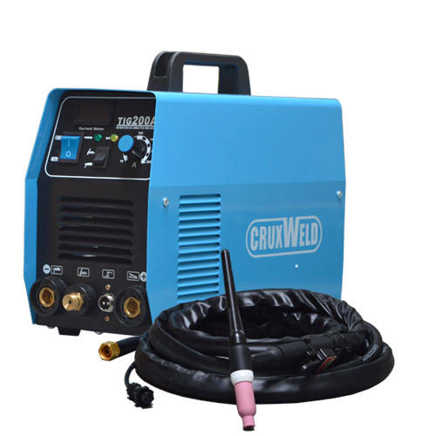
- Welding Machine: This machine is coupled with the electrode holder and the return current cable known as earth by non engineers. It is made up of primary coil and the secondary coil, with the two hands of the primary coil connected to the electric source bringing current into the welding machine and the two hands of the secondary coil connected to the electrode holder and the return current cable.

Welding Machine
- Pipe: For the frame of the burglary bar, cut twelve pieces of pipe horizontal, and two pieces of pipe vertical. Make sure the pipe arc cut properly. Make the end of the pipe straight and bend appropriately.
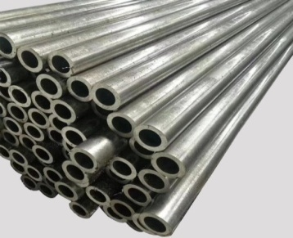

Pipe
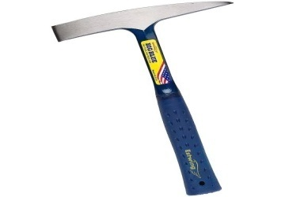
- Chipping Hammer: The Chipping hammer is used to remove some dark portion called slag or carbon that covers the welded portion and also using this hammer makes the welded portion to look like real metal. The chipping hammer was not available, locally improvised chipping hammer was made by welding two metals together to look like the chipping hammer.

Chipping Hammer
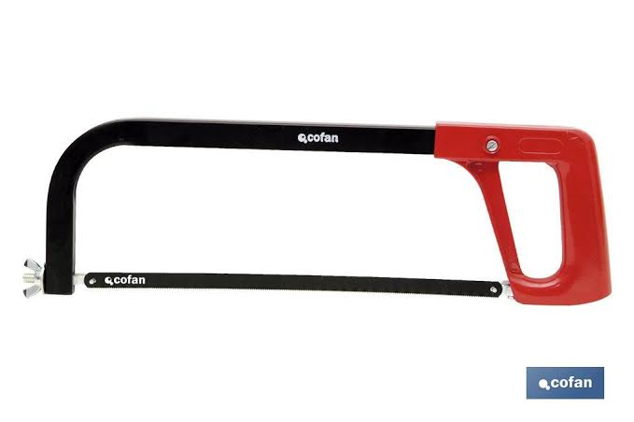
4. Hack saw: The arc saw blade was fixed to its frame and was used in cutting the mild steel iron. Arc saw is of different teeth/ blade i.e. the 18 or 24 teeth. Selection is based on type of work.

Arc Saw
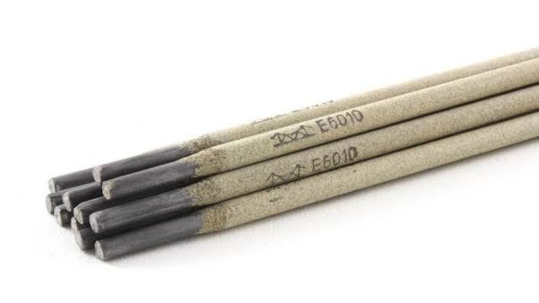
5 Electrode: In arc welding an electrode is used to conduct current through a work piece to fuse two pieces together. Electrodes are of different gauges but for the assembly process, gauge 12 was used and it’s of 2.5 mm thickness. If the electrode is positively charged, the base metal will be hotter, increasing weld penetration and welding speed. Alternatively, a negatively charged electrode results in more shallow welds

Electrode
6. Paint for beautification: The burglary was then painted so as to beautify it and at the same time, to prevent corrosion.

7 Measuring tape
A tape measure, also called measuring tape, is a type of flexible ruler. Tape measures are made from a variety of materials, including fiber glass, plastic and cloth. They are among the most common measuring tools used today.
Generally speaking, the term “tape measure” refers to a roll-up, self-retracting style tape measure that’s designed for carpentry. The actual tape potion of the measure, called the ‘ribbon,’ is usually constructed from a stiff metallic material that can stiffen when needed but can also roll up for simple use and storage. However, the term covers all types of tape measures – even tailor’s tape.

Metre Rule

8 Try square
A try square is special purpose square in wood- and metalworking used to mark or measure material. The name ‘try square’ comes from the concepts of ‘trying a surface’ (to check a surface’s straightness or correspondence to an adjacent surface) and ‘square’ (a 90°, or right, angle).Try squares generally consist of two parts. The ‘blade’ is the longer portion, usually made of metal. The ‘handle’ (or ‘stock’) is usually made of wood, plastic or metal. Try Squares from Johnson Level feature blades with hash marks for measuring shortdistances.

How to Use a Try Square
- Place the try square blade across the material you want to test or mark. The thicker part of the handle should extend over the edge of the surface, allowing the blade to lie flat across the surface.
- Hold the handle against the edge of the material. The blade is now positioned at a 90° angle compared to the edge.
- Find where you want to mark the material by adjusting the blade. Using the blade’s edge, draw a line across the material. To check the board’s square, align the blade with the end of the material. Make sure the corner of the material lines up with the corner of the try square. If there’s a gap between the try square and the material, the material isn’t square.
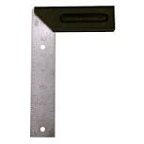
Try square

9 Plier
This is a hand-operated tool for holding and gripping small articles or for bending and cutting wire. Slip-joint pliers have grooved jaws, and the pivot hole in one member is elongated so that the member can pivot in either of two positions in order to grasp objects of different size in the most effective way. On some pliers the jaws have a portion that can cut soft wire and nails.
For bending wire and thin metal, round-nose pliers with tapering, conical jaws are used. Diagonal cutting pliers are used for cutting wire and small pins in areas that cannot be reached by larger cutting tools. Because the cutting edges are diagonally offset about 15 degrees, these can cut objects flush with a surface.

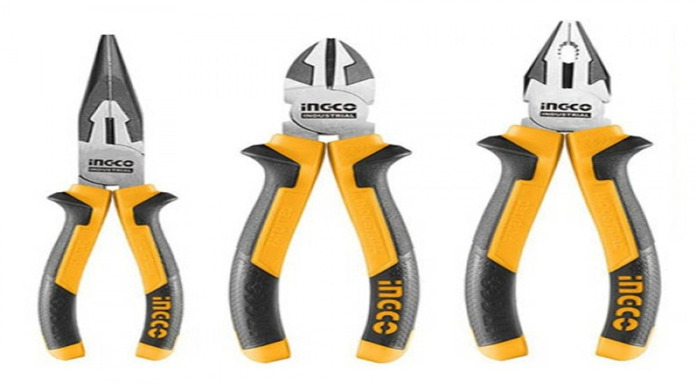
Plier

10 Venier Caliper
This is an instrument for making very accurate linear measurements introduced in 1631 by Pierre Vernier of France. It uses two graduated scales: a main scale similar to that on a ruler and an especially graduated auxiliary scale, the vernier, that slides parallel to the main scale and enables readings to be made to a fraction of a division on the main scale. Vernier calipers are widely used in scientific laboratories and in manufacturing for quality control measurements.
In the figure, the vernier scale has 25 divisions, whereas the main scale has 24 divisions in the same length. This means that the divisions on the vernier scale are shorter than those on the main scale by ¹/₂₅ of a division on the main scale. In the figure, line 8 on the vernier coincides with line x on the main scale. To align lines 7 and y, the vernier would have to be moved to the left by ¹/₂₅ of a main-scale division; to align lines 6 and 40, the movement would be ²/₂₅, and so on. By similar reasoning, the 0 line on the vernier would have to be moved a distance equal to ⁸/₂₅ of a main-scale division to align it with the 8.50 line (before the 40 line, therefore this is the 38.50 line) on the main scale.
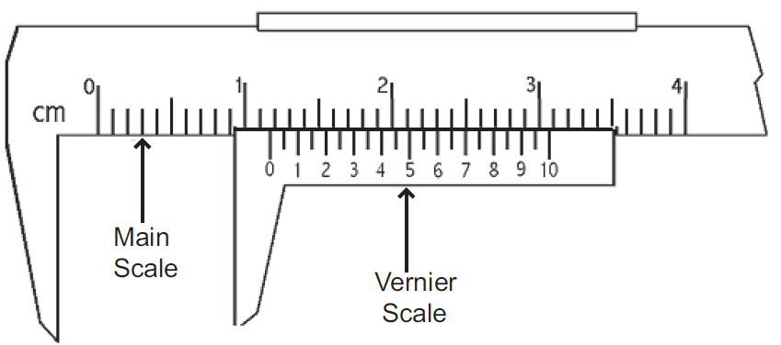
Venier Caliper

11 Steel chalk and Marker
This is mainly used for marking Metal & Steel with a clear, wax-like mark.
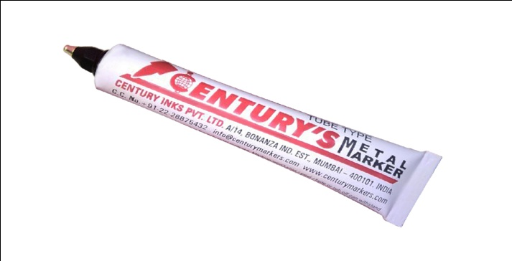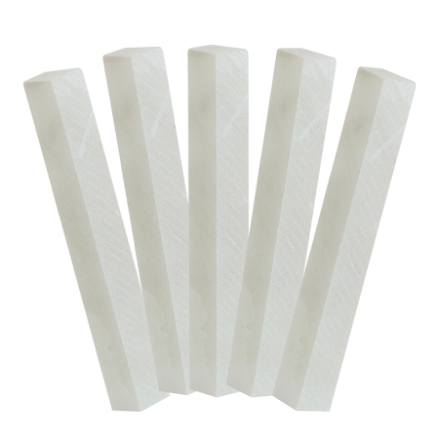
Steel chalk and Marker

12 Wrench
A wrench or spanner is a tool used to provide grip and mechanical advantage in applying torque to turn objects—usually rotary fasteners, such as nuts and bolts—or keep them from turning.

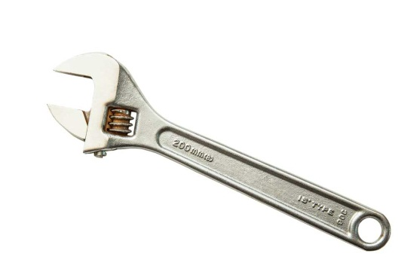
Wrench

13 Wire brush
Wire brushes are an excellent choice for the removal of rust and oxidations, paint, slag, weld splatter and other unwanted surface contaminants with angle grinders, bench grinders or drills.
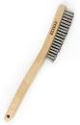
Wire brush

CHAPTER THREE
3.0 INTRODUCTION TO WELDING TECHNOLOGY
Welding is a fabrication process used to join materials, usually metals or thermoplastics, together. using welding, the pieces to be joined (the work pieces) are melted at the joining interface and usually a filler material is added to form a pool of molten material (the weld pool) that solidifies to become a strong joint.
In contrast, Soldering and Brazing do not involve melting the work piece but rather a lower-melting-point material is melted between the work pieces to bond them together.

Types of Welding
There are many different types of welding processes and in general they can be categorized as:
Arc Welding: A welding power supply is used to create and maintain an electric arc between an electrode and the base material to melt metals at the welding point. In such welding processes the power supply could be AC or DC, the electrode could be consumable or non-consumable and a filler material may or may not be added.
The most common types of arc welding are:
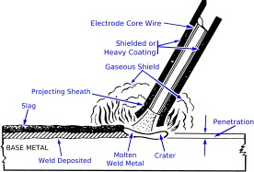
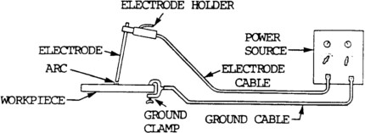
Shielded Metal Arc Welding (SMAW):A process that uses a coated consumable electrode to lay the weld. As the electrode melts, the (flux) coating disintegrates, giving off shielding gases that protect the weld area from atmospheric gases and provides molten slag which covers the filler metal as it travels from the electrode to the weld pool. Once part of the weld pool, the slag floats to the surface and protects the weld from contamination as it solidifies. Once hardened, the slag must be chipped away to reveal the finished weld.

Gas Metal Arc Welding (GMAW):A process in which a continuous and consumable wire electrode and a shielding gas (usually an argon and carbon dioxide mixture) are fed.

Gas Tungsten Arc Welding (GTAW): A process that uses a non consumable tungsten electrode to produce the weld. The weld area is protected from atmospheric contamination by a shielding gas, and a filler metal that is fed manually is usually used.
Gas Welding: In this method a focused high temperature flame generated by gas combustion is used to melt the work pieces (and filler) together. The most common type of gas welding is Oxy-fuel welding where acetylene is combusted in oxygen.
Resistance Welding: Resistance welding involves the generation of heat by passing a high current (1000–100,000 A) through the resistance caused by the contact between two or more metal surfaces where that causes pools of molten metal to be formed at the weld area. The most common types of resistance welding are Spot-welding (using pointed electrodes) and Seam-welding (using wheel-shaped electrodes).
Energy Beam Welding: In this method a focused high-energy beam (Laser beam or electron beam) is used to melt the workpieces and thus join them together.
Solid-State Welding: In contrast to other welding methods, solid-state welding processes do not involve the melting of the materials being joined. Common types of solid-state welding include; ultrasonic welding, explosion welding, electromagnetic pulse welding, roll welding, friction welding (including friction-stir- welding), etc.

Welding Terminology
There is some special technical vocabulary (or language) that is used in welding. The basic terms of the welding language include:
Filler Material: When welding two pieces of metal together, we often have to leave a space between the joint. The material that is added to fill this space during the welding process is known as the filler material (or filler metal).
Welding Rod: The term welding rod refers to a form of filler metal that does not conduct an electric current during the welding process. The only purpose of a welding rod is to supply filler metal to the joint. This type of filler metal is often used for gas welding.
Electrode: In electric-arc welding, the term electrode refers to the component that conducts the current from the electrode holder to the metal being welded. Electrodes are classified into two groups: consumable and non-consumable.
- Consumable electrodes not only provide a path for the current but they also supply filler metal to the joint. An example is the electrode used in shielded metal-arc welding.
- Non-consumable electrodes are only used as a conductor for the electrical current, such as in gas tungsten arc welding. The filler metal for gas tungsten arc welding is a hand fed consumable welding rod.
Flux: Before performing any welding process, the base metal must be cleaned form impurities such as oxides (rust). Unless these oxides are removed by using a proper flux, a faulty weld may result. The term flux refers to a material used to dissolve oxides and release trapped gases and slag (impurities) from the base metal such that the filler metal and the base metal can be fused together. Fluxes come in the form of a paste, powder, or liquid. Different types of fluxes are available and the selection of appropriate flux is usually based on the type of welding and the type of the base metal.

Types of Welded Joints
The weld joint is where two or more metal parts are joined by welding. The five basic types of weld joints are the butt, corner, tee, lap, and edge.
Butt Joint: it is used to join two members aligned in the same plane. This joint is frequently used in plate, sheet metal, and pipe work.
Corner and Tee Joints: these joints are used to join two members located at right angles to each other. In cross section, the corner joint forms an L-shape, and the tee joint has the shape of the letter T.

Lap Joint: this joint is made by lapping one piece of metal over another.
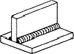
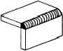
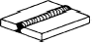

3.1 STEPS TO FOLLOW IN WELDING AND FABRICATION
1. Properly setting up the frame before welding is critical for ensuring the finished frame is square.
2. Lay the head and the two jambs down on a level work surface with the non-door side down.
3. Assemble the door frame and bend the tabs on the jamb to lock the jambs to the head.
4. Clamp the frame to the table for stability. Confirm the frame is square and adjust as needed.
5. Tack weld a shipping bar into the door side of the frame to guarantee the opening width of the welded frame. For example, if the door opening is 3 feet, then the spreader bar should be exactly 3 feet.
6. Now the frame is ready for welding. Using the minimum amount of weld necessary, apply the face weld, back weld, or full profile weld as specified.
- File the edges smooth.
- Grind until the weld is level with the face of the frame.
- The frame is ready to be painted after it is painted, a proper weld will give the frame a seamless appearance.

CHAPTER FOUR
4.0 WORK DONE/ EXPERIENCE GAINED
4.1 FABRICATION OF A BURGLARY
The following operations are carried out during the fabrication processes of burglaries, namely:
Design of burglary: This involves detail calculation and drawing of the burglary to be fabricated.
Measuring of Mild Steel: This involves the measurement of the 16 MM mild steel iron to prescribed lengths as shown in the detailed diagram. It is done with the aid of a measuring tape.
Cutting of Mild Steel: Mild steel were cut in accordance with the prescribed measurement and designed values using hand saw.
Welding: Arc welding it is welding process whereby coalescence is produced by heating the work piece with an electric arc set up between a flux coated electrode and the work piece.
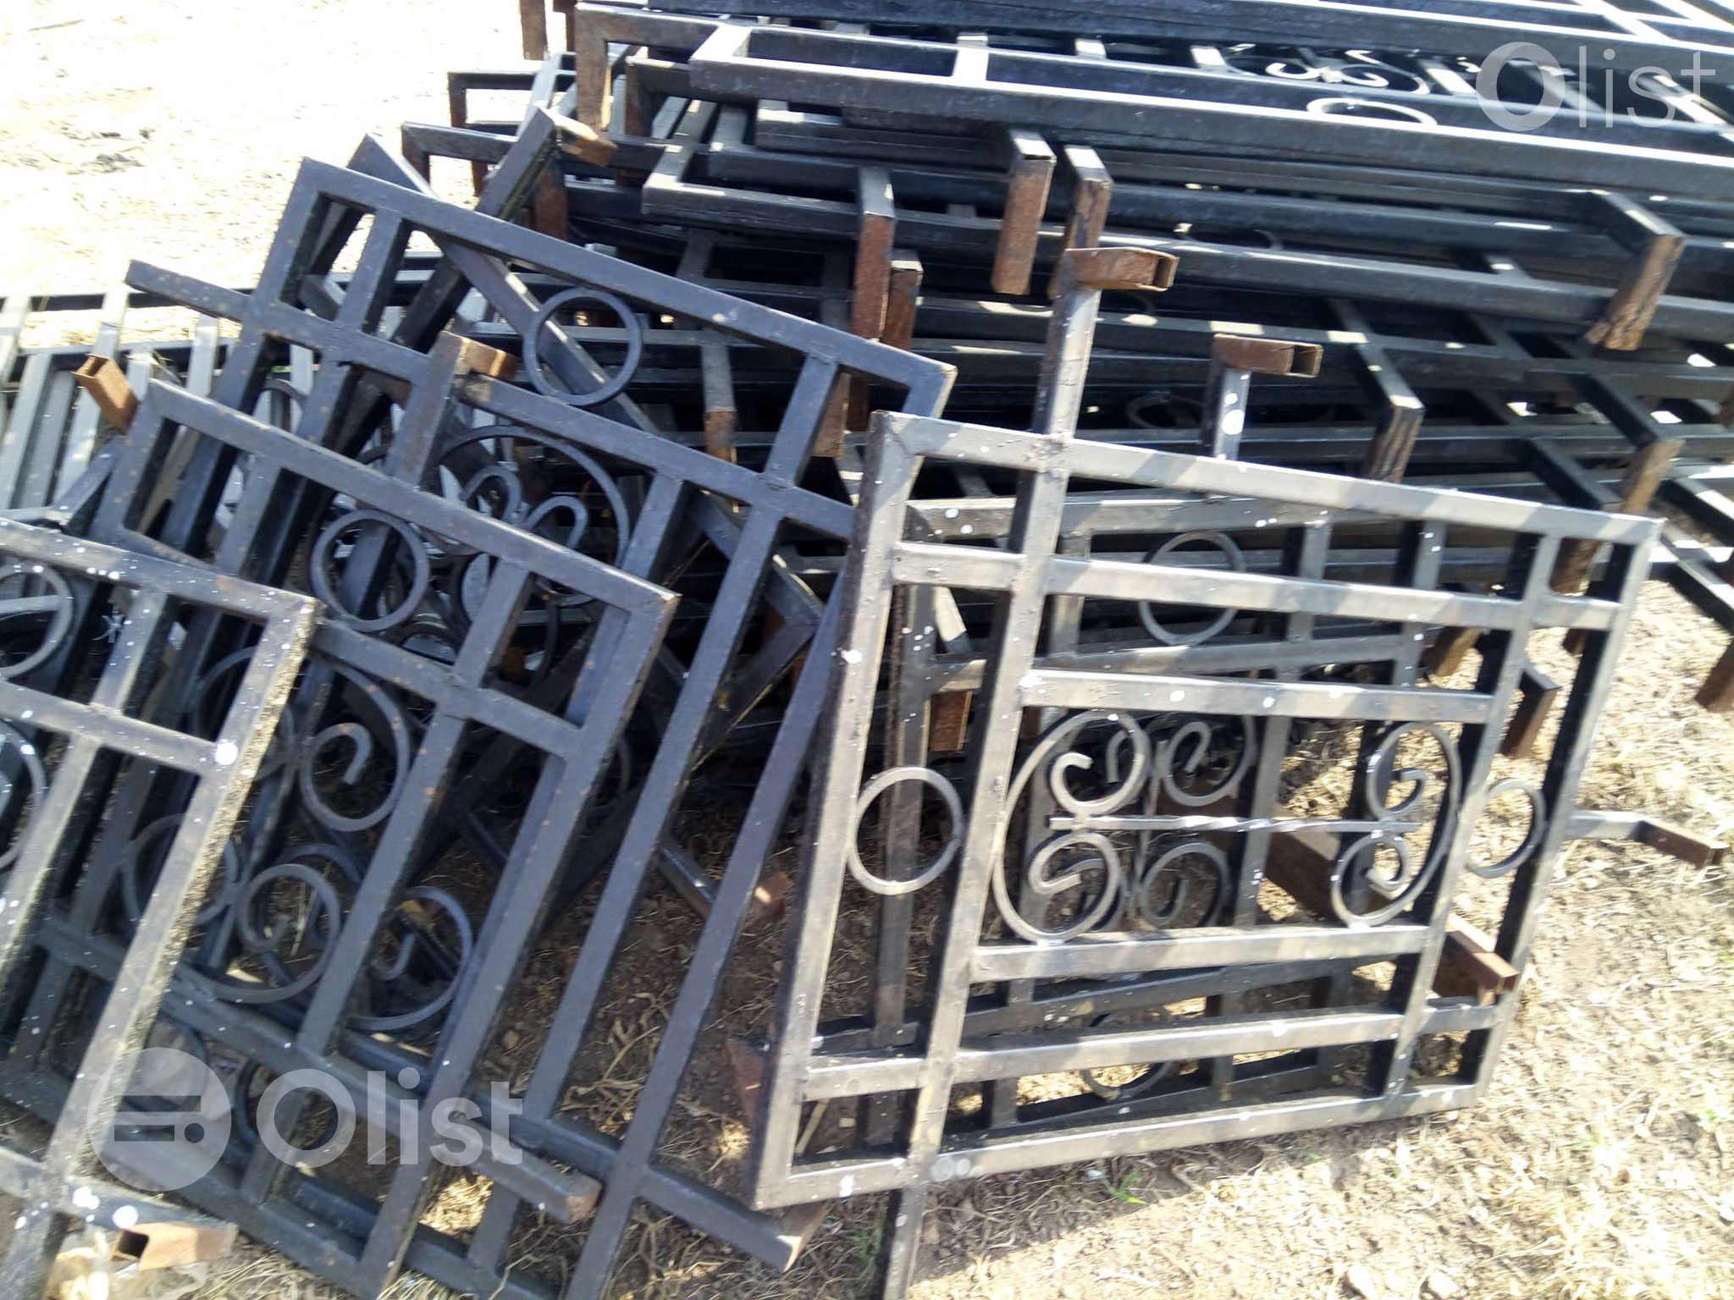

BURGLARY
4.2 CONSTRUCTING OF METAL GATE
To fabricate a metal gate, some basic operations must be carried out using the vice, hacksaw, hand grinding machine, and the drilling machine.
The Following are the steps to be followed when constructing a metal gate:
- MARKING OUT:
Before every constructing operation is carried out, marking out is the first operation to be carried out so as to construct the exact size. The marking operation was done on a 3x3 angle iron using a meter rule and the scriber.

- CUTTING OPERATION:
After the marking out, the next sequence is the cutting operation; the cutting operation is carried out by the use of the hand grinding machine.
- WELDING OPERATION:
Before welding is to be carried out, tacking was done for temporary fastening, to have a correct figure. And then full welding was carried out on the four angle iron members using an electric arc welding to form a rectangular shape.

- GRINDING OPERATION:
Grinding operation is to be carried out using the hand grinding machine to smoothen the welded part in other to look fine and have a smooth surface.
- DRILLING OPERATION:
Drilling operation is to be carried out using the vertical drilling machine so as to have a spot in order to fix a chain link when a copper wire is use to tie it to the angle iron and a fence is constructed.
With the following procedure a metal fence is successfully construct. The metal gate is fixed in between pillars behind the workshop in the Ministry of public works and infrastructure.

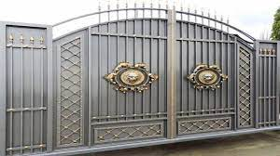
METAL GATE
4.3 CONSTRUCTING OF METAL DOOR
Preparing to weld
1. Properly setting up the frame before welding is critical for ensuring the finished frame is square.
2. Lay the head and the two jambs down on a level work surface with the non-door side down.
3. Assemble the frame and bend the tabs on the jamb to lock the jambs to the head. Follow the manufacturer’s instructions to determine which direction to bend the tabs. This is critical to ensure the proper door opening width.
4. Clamp the frame to the table for stability. Confirm the frame is square and adjust as needed.
5. Tack weld a shipping bar into the door side of the frame to guarantee the opening width of the welded frame. For example, if the door opening is 3 feet, then the spreader bar should be exactly 3 feet. 6. Now the frame is ready for welding. Using the minimum amount of weld necessary, apply the face weld, back weld, or full profile weld as specified.
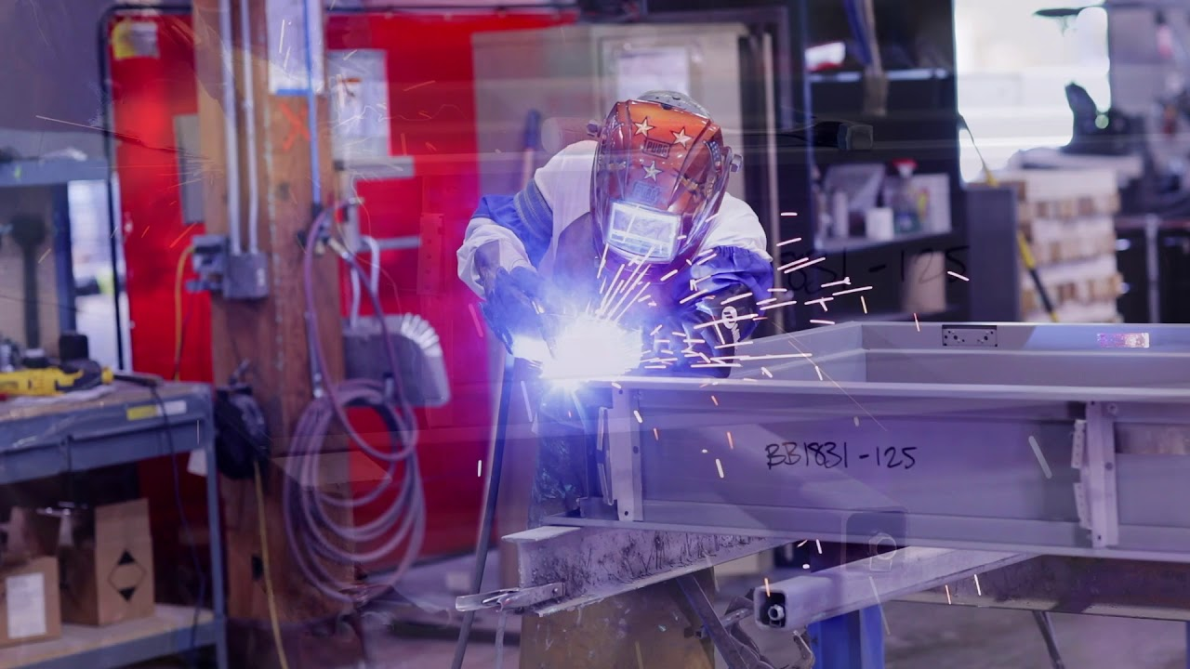

Finishing the weld
1. Grind until the weld is level with the face of the frame.
2. File the edges smooth.
3. Finish with a DA sander.
4. The finishing process is complete, and the frame is ready to be painted. After it is painted, a proper weld will give the frame a seamless appearance.
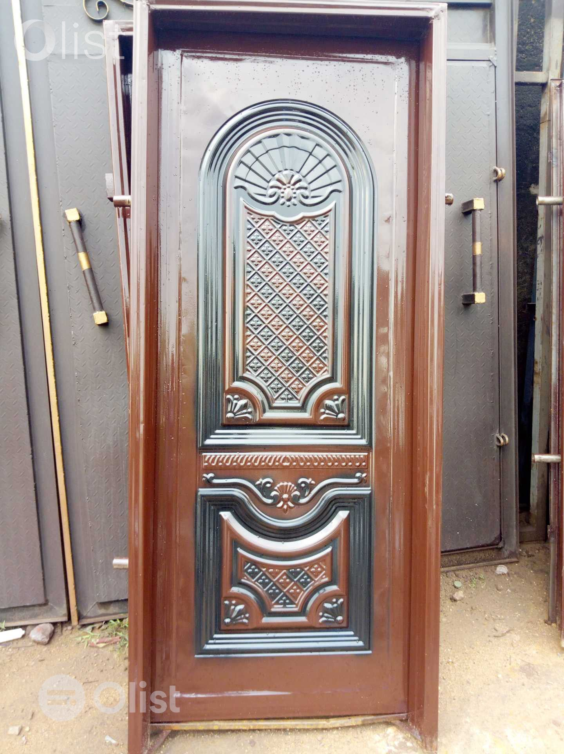

CHAPTER FIVE
  - RECOMMENDATION AND CONCLUSION
  - CHALLENGES ENCOUNTER
Despite the knowledge, experience and exposures acquires during this period. The following are some of the challenges encountered.
- Difficulty in findings a place for industrial training is a big problem for students on SIWES program.
- Another challenge is transport fare issues. After eventually getting a company for the SIWES program, to finance my transport fare to my place of work is a very difficult experience.
- The combination of the Industrial training together with the course work was so challenging and stressful.
5.2 RECOMMENDATION
I would recommend that the organization should appeal to the federal government to make provision for necessary equipment for the effectiveness of the programme.
I would recommend that the organization should provide transport facilities for SIWES students so as to ease their mobility.
5.3 CONCLUSION
The SIWES programe is an efficient an effective program which has bring much improvement to my field of study. I have gained a lot of experience from the various works done on field such as construction of sliding gate, solar street light and production of different set of burglary. It is a programe that bridges the gap between theory and practical aspect, so therefore it has made me to have technical knowledge about what I have learnt theoretically in class.
My four months SIWES program has equipped me the knowledge of fabrication and production of a project. I hereby appreciate the effort to the Federal Government and Industrial Training Fund (I.T.F) for improving the technological development of this country.

REFERENCE
www.google.com
www.wikipedia.com
My training log book
Machines and laboratory manuals

