

KWARA STATE POLYTECHNIC, ILORIN
INSTITUTE OF ENVIRONMENTAL STUDIES
DEPARTMENT OF SURVEY AND GEO-INFORMATICS

A TECHNICAL REPORT OF THE STUDENTS INDUSTRIAL WORK EXPERIENCE SCHEME (SIWES)

AREO JOSHUA OLUWASEUN
ND/23/SGI/FT/0031

UNDERTAKEN AT:
KWARA STATE GEOGRAPHIC INFORMATION SERVICE
COMMISSIONER’S LODGE WAY, ILORIN KWARA STATE

PERIOD OF ATTACHMENT:
AUGUST 2024 – NOVEMBER 2024
CERTIFICATION
This is to certify that this report is compiled by the author, AREO JOSHUA OLUWASEUN with Matric No ND/23/SGI/FT/0031 of the Department of Survey and Geo-Informatics, Institute of Environmental Studies, Kwara State Polytechnic Ilorin upon completion of Student Industrial Work Experience Scheme (SIWES).

SIWES SUPERVISOR _________________________
Sign/Date

HEAD OF DEPARTMENT _________________________
Sign/Date

DEDICATION
I dedicated this report to God Almighty for grace given, also wisdom, strength, and good health throughout this experience.
ACKNOWLEDGEMENT
I would like to express my sincere gratitude to Almighty God for granting me the strength, wisdom, and perseverance to successfully complete my Student Industrial Work Experience Scheme (SIWES).
My heartfelt appreciation goes to my parents and family for their constant support, encouragement, and prayers throughout this journey.
I extend my profound gratitude to my institution, my lecturers, and the SIWES coordinator for their guidance and for providing me with the opportunity to gain practical experience in my field of study.
A special thanks to my industry supervisor and the entire staff of KW-GIS for their mentorship, patience, and invaluable knowledge shared during my internship. Their support and willingness to teach me have significantly contributed to my professional growth.
Finally, I appreciate my friends and colleagues for their encouragement, collaboration, and shared experiences, which made this journey more enriching and enjoyable.
Thank you all for your unwavering support.

TABLE OF CONTENT
Title page i
Certification ii
Dedication iii
Acknowledgement iv
Table of contents v
CHAPTER 1: INTRODUCTION
SIWES Background 1
1.1 Objectives of SIWES 2
1.2 Bodies involved in the management of SIWES 3
1.3 Background of Establishment. 4

CHAPTER 2:
2.0 Work experience during attachment 6
Administrative Orientation 6
Survey And Surveying Instruments 7
Surveying Instruments 7
Site Inspection Analysis 8
Practical Experience Of Site Inspection At The KWGIS 9
Drawing Sketch Plan Of Inspected Sites 11
Layout Design 12
Features Of A Good Layout 12
Assessment Of Township Road 13
Process Of Obtaining Statutory 17
List Of Instruments Used In The KWGIS 19
Introduction to AutoCAD 21
CHAPTER 3
3.0 Problems encountered during period of attachment 24
CHAPTER 4
4.0 Conclusion 25
4.1 Recommendation 26

CHAPTER ONE

INTRODUCTION

STUDENT INDUSTRIAL WORK EXPERIENCE SCHEME (SIWES) BACKGROUND
In the earlier stage of science and technology education in Nigeria, students were graduating from their respective institutions without any technical knowledge or working experience. It was in this view that students undergoing science and technology related courses were mandated for students in different institution in view of widening their horizons so as to enable them have technical knowledge or working experience before graduating from their various institutions.
The Student Industrial Work Experience Scheme (SIWES) was established by the Industrial Training Fund (ITF) in 1973 to enable students of tertiary institution have technical knowledge of industrial work base on their course of study before the completion of their program in their respective institutions. The scheme was designed to expose students to industrial environment and enable them develop occupational competencies so that they can readily contribute their quota to national economic and technological development after graduation. The major background behind the embarkment of students in SIWES was to expose them to the industrial environment and enable them develop occupational competencies so that they can readily contribute their quota to national economic and technological development after graduation. The major benefit accruing to students who participate conscientiously in Students Industrial Work Experience Scheme (SIWES) are the skills and competencies they acquire. The relevant production skills remain a part of the recipients of industrial training as life-long assets which cannot be taken away from them. This is because the knowledge and skills acquired through training are internalized and become relevant when required to perform jobs or functions.

1.1 OBJECTIVES
The Industrial Training Funds policy Document No. 1 of 1973 which established SIWES outlined the objectives of the scheme. The objectives are to:
- Provide an avenue for students in higher institutions of learning to acquire industrial skills and experiences during their course of study.
- Prepare students for industrial work situations that they are likely to meet after graduation.
- Expose students to work methods and techniques in handling equipment and machinery that may not be available in their institutions.
- Make the transition from school to the world of work easier and enhance students’ contacts for later job placements.
- Provide students with the opportunities to apply their educational knowledge in real work situations, thereby bridging the gap between theory and practice.
- Enlist and strengthen employers’ involvement in the entire educational process and prepare students for employment in Industry and Commerce (Information and Guideline for SIWES, 2002).
1.2 BODIES INVOLVED IN THE MANAGEMENT OF SIWES
The bodies involved are:
- The Federal Government.
- Industrial Training Fund (ITF).
Other supervising agents are:
- National University Commission (NUC)
- National Board for Technical Education (NBTE)
- National Council for Colleges of Education (NCE)
The functions of these Agencies above include;
- Establish SIWES and accredit SIWES unit in the approved institutions.
- Formulate policies and guideline for participating bodies and institutions as well as appointing SIWES coordinators and supporting staff.
- Supervise students at their places of attachment and sign their lob-book and IT forms.
- Ensure payment of allowances for the students and supervisors.
- Ensure adequate funding of the scheme.
1.3 BACKGROUND OF ESTABLISHMENT
The Kwara State Geographic Information Service (KW-GIS) bill was passed into Law by the State House of Assembly and assented to by His Excellency, Mallam AbdulRahman AbdulRazaq in the year 2020, which by this Law, the Kwara State Urban and Regional Planning and Development Law No 13 of 2017 was repealed, making KW-GIS a Parastatal, which shall directly report to the Office of the Executive Governor of the State. Located at Commissioner’s Lodge Way, G.R.A Ilorin, Kwara State.
In 2021, the State Government established the Kwara State Geographic Information Service (KW-GIS) as an Agency to provide modern and efficient land administration in Kwara State, improve land Administration, provision of modern equipment and other processes related to land with the use of technology and digital platforms. This development would also lead to the collocation and harmonization of all the four Departments in the built environment in the State namely: Bureau of Lands, Office of Surveyor General, Town Planning Development Authority and Urban and Regional Planning that deal with land administration, with the purpose to minimize bottlenecks, enhance efficiency, curtail the activities of land grabbers, digitize and serialize title documents.
The Agency as a system consists of four major Directorates which are: Directorate of Lands; Directorate of Urban & Regional Planning; Directorate of Physical Planning and Development Control and the Office of the Surveyor General.

MISSION AND VISION
The new arrangement is to ensure proper Administration and Management of Land and Building matters in the State as well as all issues relating to Titles, Registration, Searches, Physical Planning and Urban Development and other responsibilities as may be determined by the Executive Governor of the State.
The Agency ensures that all developmental activities in the State are in line with the State Master Plan and are not altered by the citizens/and activities of citizens in order to promote growth and rapid development so as to have a viable, peaceful and serene environment for all and sundry in the State.
The digitalized record keeping as part of land reforms initiated by the present administration in the State under His Excellency, the Executive Governor, Mallam AbdulRahman AbdulRazaq (CON) through the establishment of KWGIS in 2021, is to protect titles in lands by bringing documentation of land transactions in Kwara State into the 21st century and giving up-to-date information on land acquisitions and dealings.

RESPONSIBILITIES
a) Development and maintenance of a database of all Land within the State, particularly with respect to title history, location, size, use and other related data.
b) Introduction, implementation and sustainability of best practices for Land ownership and title certification in the State.
c) Access to existing data on Land for the purpose of conducting title searches for members of the public at a fee to be prescribed from time to time by the service in consonances with other related Laws.
d) Undertaking such other activities as may be required for the efficiency management and administration of Land matters and other related data in the State.
e) Development and maintenance of a geospatial information system or such approach system and structures for overall development, research and land management and the service may subject to the approval of the Government by an order published in the Gazette, make regulations for the effective operation of the Law and the due administration thereof.
CHAPTER TWO
2.0 WORK EXPERIENCED DURING ATTACHMENT
I carried out my four (4) month SIWES at the Kwara State Geographic Information Service (KWGIS). During my training,I was able to acquire the following experience;
  - Administrative Orientation
  - Little briefing about Survey and some Survey Instruments.
  - Site inspection analysis
  - Drawing of sketch plan of inspected sites.
  - Layout design
  - Solving land disputes
  - Record keeping
  - Assessment of township road.
  - Process of obtaining statutory.

ADMINISTRATIVE ORIENTATION
This involves how the different sections of the ministry perform their duties. Among the orientation given to me, I was told that the section under which I have done my training provide field data to the other sections for further analysis. I was told that respect to their staffs and to the rest of the students should be adhered. According to the field director, the students should be available at the office as early as possible (if possible 8:00am) because of the field activities and can leave the office at 2:00pm.

SURVEY AND SURVEYING INSTRUMENTS
What is Survey?
Survey is a technique, profession and science of accurately determining the terrestrial or three dimensional position of points and the distance and angles between them commonly practiced by surveyors and members of various engineering profession.
SURVEYING INSTRUMENTS
Ranging Pole: It is a 5m straight piece of wood or steel colored red and white used for alignment during survey.
Compass: Is used for measuring bearings from 0º to 360º in clockwise direction.
Theodolite: Is used for measuring both horizontal and vertical angles.
Leveling Instrument: Is used for measuring the difference in height between points on the surface of the earth they are of different types: automatic level, dumpy level, digital level etc.
Total Station: Used in determining the coordinate of positions, angles and bearing can also be determined.
Tripod Stand: Is equipment used in mounting survey instrument such as theodolite, level, total station etc.
Leveling Staff: Also called leveling rod used with a leveling instrument to determine the difference in height between points above a datum surface.
Gunter Chain: A formal measuring instrument of 66 ft (20.1m) long, subdivided into 100 links, each of which is a short section of wire connected to the next link by a loop.
Measuring Tape: A flexible ruler that is used to measure distance. It consists of a ribbon of cloth, plastic, fibre glass, or metals strip with linear measurement markings.
G.P.S (Global Positioning System): A framework for gathering, managing, and analyzing data. Rooted in the science of geography, it analyzes spatial location and organizes layers of information into visualizations using maps and 3D scenes.
Field Notebook: A roundup note that entails all necessary information jotted from the field.
SITE INSPECTION ANALYSIS.
Site: - is the position or location of a town, building, plot, etc especially as to its environment. Or is an area or exact plot of ground on which anything is, has been, or is to be located. It can be described in terms of physical characteristics of the site.
Site inspection and analysis: - is the act or process of looking at something closely in order to learn more about it, to find problems, and give details account of the site in terms of physical features. Planners usually make a sketch of the inspected site in order to represent it on paper. And it mostly had been done with the presence of the site owner or representative, for witness and proper referencing.
PROCESSES INVOLVED IN SITE INSPECTION ANALYSIS.
Location of site: the planner locates the site which is to be inspected using topographical map of the area.
Identification: the planner identifies the plot boundary.
Measurement: the length and breadth of the plot is measured using either tape or chain and the measurements are being recorded.
Sketch: - draw the rough sketch of the area.
Calculation: - the dimension of the plot is calculated and recorded.
Drawing: - the planner draws the site inspection plan in the studio.
Report: - write down the report of the site inspection analysis.
Documentation: - the site inspection plan and report is documented in technical file.
Forwarding: - the technical file is forwarded to the Director Town Planning for further analysis.
THINGS TO BE NOTED WHEN REPORTING AFTER SITE INSPECTION
- Report on the specific address of the property
- Report on the boundaries of the property
- Report on the purpose of the property
- Report on the total area of the property
PRACTICAL EXPERIENCE OF SITE INSPECTION AT THE KW-GIS
I learned about sites inspection of various places within the Ilorin metropolis and its environs.
Some of the various places/areas we went for site inspections are listed below:-
- A site inspection situated at Akerebiata, Ilorin.
- In-depth inspection was carried out in company of the applicant representative and the student on I.T
- The inspection reveals that the site is situated at Akerebiata.
- The site is for residential purpose, covering a total land area of about 390.6m². It was developed as of the time of inspection.
- The site is bounded by a stream to the north, access road to the south and west and by a build-up plot to the east respectively.
- Therefore, the application is in order and within physical planning requirement.
- A site inspection of at Tanke
- A site inspection at Malete.
Also some site are allocated for several purposes like,
-Industrial purpose.
-Agricultural purposes.
-Educational purposes.
- Health sectors/hospitals.
- Recreational purposes.
- Sports and etc.
In a nutshell all kinds of land uses we can think of, the planning section do their best to design areas suitable for all such activities be it for government, private ownership, organizational bodies and religious societies, so long it will be of great benefit and growth of the state at large.
DRAWING SKETCH PLAN OF INSPECTED SITES
In drawing the sketch plan of inspected sites, suitable scale has to be chosen. The chosen scale depends on the type of paper the sketch is to be done, for example larger scale (1:1000) will be suitable for A4 paper type, because the larger the scale the smaller the sketch appears on the paper and the smaller the scale the larger the sketch appears on the paper. Some instruments such as; pencil, eraser, set square, scale rule, black and red pen are used in the process of drawing a sketch plan of inspected sites.
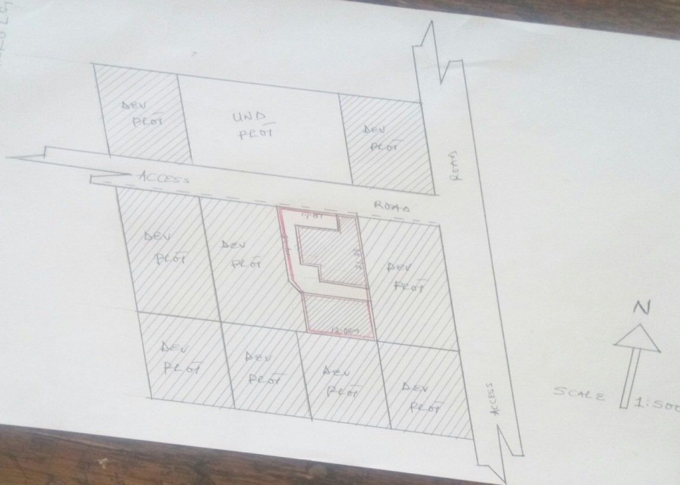
Below is one of the sketches of inspected sites carried out in the KWGIS;

NOTE: The red lines on the sketch shows the boundaries of the main area of observation and the hatched areas signifies build-up plots as of the time of the inspection.
LAYOUT DESIGN
Layout: A structured arrangement of items within certain limits or a map or a drawing of a construction site showing the position of roads, buildings, or other construction.
Layout Design: This can be said as the process of designing a suitable plan containing so many plots for several functions, such as; residential, commercial, educational etc.
FEATURES OF A GOOD LAYOUT
- Good road network
- Accessibility to market
- Accessibility to religious center
- Provision of health care sector
- Security offices
- Availability of job opportunities
- Adequate electricity
- Good spacing
- Accessibility to educational sectors

ASSESSMENT OF TOWNSHIP ROAD
What is assessment? There is various definition of the word assessment, in education it is simply the ways which a teacher will follow to check, mark, reward, and placed confidence on his or her students knowing the exact capacity, ability, and well-being of the performance of the students, that calls for the student award of certificate at the end of the program attained.
Now concerning the nature and work of lands and survey ministry, assessment can be defined as the process of gratings of lands either developed or undeveloped, houses, or any order constructed erection that will be need to know the cost of construction of such valuable property, to enable the government do the necessary, by making adequate consideration in terms of rendering compensation to the property owners concerned.
PROCESSES OF MAKING ASSESSMENTS
There are different processes that are involved in making an assessment exercise, and they are listed below:-
- Reaching the property owners.
- Making of appropriate survey by the surveyor using its instrument.
- Marking the affected areas i.e. signs of corridors.
- Placement of road construction sings e.g. pegs, number marks, benchmarks, (km, m, cm) etc.
MATERIALS USED IN THE ASSESSMENT EXERCISE.
- Measuring tapes (10m, 30m, 50m, 100m, 150m, 200m, 300m,) and etc.
- Pegs wooden arrows,(alignment).
- Markings e.g.BM, Marks, Arrows.
- Record books.
- Cameras if necessary.
- Pens (biros, pencils, plain sheets, rulers).etc.
PROCESSION OF ASSESSMENT MAKING:-
The assessment work is done with a cover letters from the ministry to the areas affected through their heads of which the letters are written in the letter heads of the ministry.
Also the security services will be needed in some areas where necessary to maintain the law, peace, and order. To enable the assessment team to do their work without any form of threat from the public nuisance and un-educative/illiterate property owners. So after that the letter of notification has reached the right authorities concerned, then the team will fallout for their work.
FACTORS /REASONS FOR ASSESSMENT
- Provision of dual roads within the town to alleviate the general public to meet up with their goods and services around the metropolitan city.
- To help control the erosion effect in some areas this is already eating up the lives and property of the public.
- Ensuring the placement of the original plans of some areas already design by the ministry.
- For proper evaluation and compensation.
- To provide avenue for town planning and maintenance.
STEPS INVOLVE IN THE ASSESSMENT WORK.
- Reaching the owner of the property to be assessed.
- Explain the purpose of the work you are to do there.
- Expressing the organization involve in the work, and the authority empowering the work.
- Taking the measurement and the description of the affected property.
- Stating the nature of the property.
- Measuring the size of the property by the length, breath, or even taking of the gross measurement of the property. (In some cases is allowed).
- Recording of the data collected.
VALID PROPERTIES TO BE ASSESSED:-
  - Houses made up of cement/blocks, and mud houses.
  - Structures owned by government and private owners, religious societies, and company owns.
  - Boreholes, wells, reservoirs, (both underground and surface ones).
  - Block and cement overhead tank/iron constructed overhead tank.
  - Soakaways (waste bins).
  - Temporary structures e.g. with CIS cover.
  - Economic trees (plantations).
  - Lands (layout, plots, and farms).
  - Pavement with tiles, interlocks, D.P.C, Cement floor, concrete casted floor.
  - Veranda, car porch, walls.
  - Incinerators.
  - Transformer standout.
INVALID PROPERTIES NOT TO BE ASSESSED
- Open temporary with arched roof.
- Un-economical trees.
- Containers which are movable, and cariole.
- Government properties and structures.
- Constructed community/government aided drainages.
- Thatched house
During my training, I was part of the assessment team for the construction of road. The aim of this assessment in general is to note the properties affected by the road design corridors, and compensation was being made to owner’s in which property are being affected as a result of the road construction processes.
The compensation is being issued to the owner of the property by showing evidence of ownership.
PROCESS OF OBTAINING STATUTORY
- Certificate of Occupancy (C/O)
In other obtain the statutory certificate of occupancy, the following processes is to be undertaken:
- Filling of application form in triplicate.
- Statutory form for different purpose
- Conversion form (customary to statutory)
- Evidence of tax payment
- Local government C/O and it’s confirmation
- Passport
- Valid means of ID
- Declaration of age
- Valid receipt of all payment
- Movement of file on process of C/O
Step 1
File is been open at the office, where it will be given a number known as metro number (M/1234).

STEP 2
After a file is been opened at the area office, it is being forwarded to the office of the surveyor general for charting on topo-sheet. At this step, a number is given to the file known as GM number (GM/16001).
STEP 3
From the office of the surveyor general, the file is then being forwarded to the directorate of planning for planning recommendation. Planning recommendation is given to the file if there is no any encumbrance on the property. If the file is for conversion, then a town planning officer is assigned to go for inspection, which after the inspection recommendation is granted or otherwise. If it is on government layout, a preliminary charting is done on the layout design to show that the particular plot is on processed.
STEP 4
From planning, the file is then sent back to the office of the surveyor general for design of Tittle Deed Plan (TDP).

STEP 5
After the design if the TDP, the file is forwarded to the lands directorate, where grant would be awarded to the applicant.

STEP 6
After the grant is awarded, the file is then forwarded to the office of His Excellency the governor of the state, where approval of C/O is given pending upon all the requirement as needed.
STEP 7
After the approval from His Excellency, the file is being sent back to the lands directorate where C/O is awarded to the applicant.
FORMS TO BE FILLED IN THE PROCESS OF OBTAINING STATUTORY
LIST OF INSTRUMENTS USED IN THE KWGIS
- Paper ( A0, A3 & A4 )
- Set squares
- Scale rule
- Adjustable set square
- T-square
- Eraser
- Drawing board ( standing )
- Rotary pen/ink
- Clutch pencil
- Pen ( red/black )
- Measuring tape
- Paper: this is a thin, flat material used for writing, drawing and painting. It is mostly used for the purpose of making the sketch of the inspected site and writing of report about the site inspected in the ministry.
- Set squares: These are triangular instruments mostly used in technical drawing and engineering. They are used to provide a straightedge at a right angle or other particular planar angle to a baseline.
- Scale rule: this is a three sided ruler with different scales (1:100, 1:200, 1:250 etc.), used to measure linear distance and create proportional linear measurements and also to draw straight lines.
- Adjustable set square: this is also a triangular instrument that provides a straightedge at a right angle, but it’s adjustable not like the ordinary set-squares.
- T-square: this is a technical drawing instrument used primarily as a guide for drawing horizontal lines on a drafting table, and it is also used to guide set squares to draw vertical or diagonal lines.
- Eraser: this is an instrument used for removing writing from paper or for erasing mistakes in the process of making a sketch.
- Drawing board (standing):this is a multipurpose desk which can be used for any kind of drawing or writing. The instrument can be adjust to any suitable height.
- Rotary pen: this is an instrument inform of a pen mostly used in layout designs having a thick black ink with different openings (0.5, 1.5, 2.0….).
- Clutch pencil: this is an instrument with a replaceable and mechanically extendable solid pigment core called a “lead”. It is an instrument used in drawing and writing as well.
- Pen (red/black): this instrument is used to trace the original sketch done with a pencil in order to make it more presentable.
- Measuring Tape: A flexible ruler that is used to measure distance. It consists of a ribbon of cloth, plastic, fibre glass, or metals strip with linear measurement markings.
INTRODUCTION TO AUTOCAD
CAD: Computer-Aided Design(CAD) or Computer-Aided Design and Drafting (CADD) can be defined as using computer systems to assist in the creation, modification, analysis, or optimization of a design. (Narayan, 2008) CAD software is used to increase the productivity of the designer, improve the quality of design, improve communications through documentation, and create a database for manufacturing. (Narayan, 2008)
AutoCAD : is an industry-leading commercial CAD software. AutoCAD is used by AEC(Architecture, Engineer, and Construction) to generate and optimize 2D and 3D designs. AutoCAD is a widely used software program that can help you draft construction documentation, explore design ideas, visualize concepts through photorealistic renderings, and simulate how a design performs in the real world.

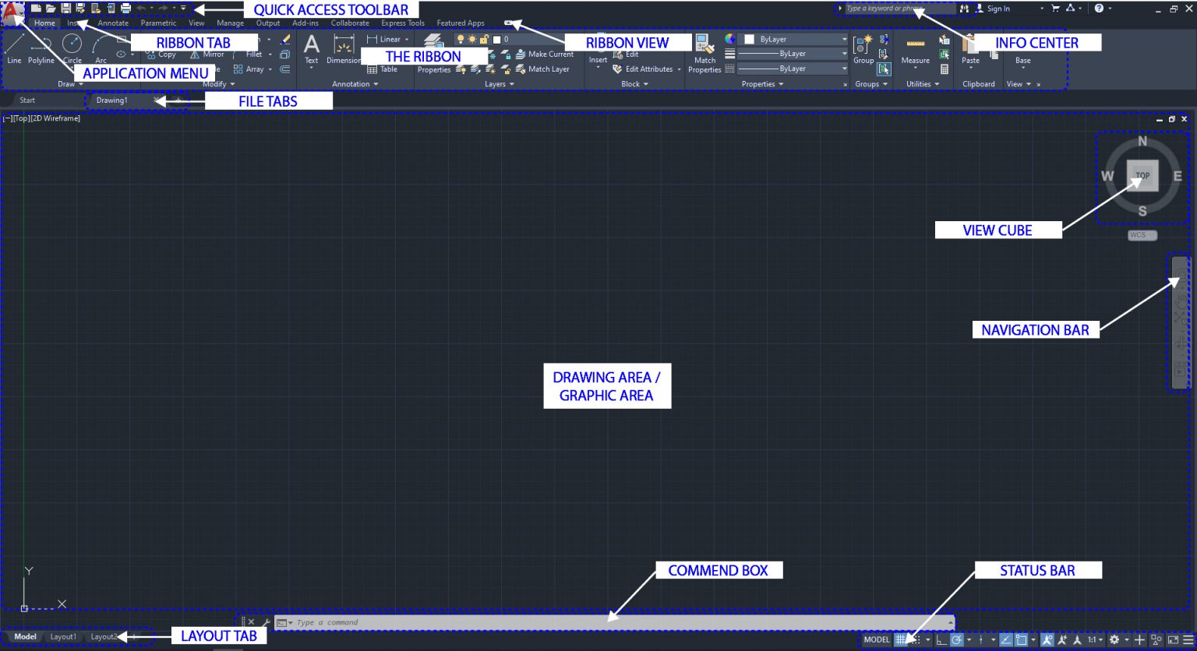
AutoCAD Interface

- Application menu: New, open, save, import, export, print
- Quick access toolbar: User can save tools that they often use
- Info Center: Ask a question, find out answers from Autodesk community
- Ribbon: Main menus – Home, Insert, Annotate, View, Manage
- Ribbon tab
- Ribbon view: User can minimize and maximize the ribbon
- File tab: Navigate files and create and open files
- Drawing area/graphic area: Main drawing space
- View cube: User can change the view, top, front, 3D, or more
- Navigation bar: Zoom in and out, pan, zoon to all, and more
- Command box: Can type commands and see the previous commands
- Layout tab: Can see model space and print spaces
- Status bar: Can set grid, snaps, scales, and more
Common Shortcuts in AutoCAD
- [l] – line
- [pl] – polyline
- [mt] – multiline text
- [m] – move
- [co] – copy
- [ro] – rotate
- [z] – zoom and [a] – all
- [b] – block
- [s] – stretch
- [x] – explode
- [ex] – extend
- [c] – circle
- [re] – regen (refresh)
- [h] – hatch
- [o] – offset
- F3 – osnap
- F8 – ortho

CHAPTER THREE
3.0 PROBLEMS ENCOUNTERED DURING ATTACHMENT
I encountered some problems which include;
- Insufficient site vehicles.
- Insufficient staffs within the department.
- Inadequate design materials/instruments.

CHAPTER FOUR
4.0 CONCLUSION
This report is the summarizing of the experienced of works and activities carried out During my SIWES in the KWGIS, I have acquired a lot of knowledge and skills concerning the activities of the ministry which include: allocation of lands to members of the public, layout design, assessment of township road, settlement of dispute among two parties, site inspection and analysis, drawing of sketch plans of inspected sites, process of obtaining statutory.
In respect to the higher ranking of the establishment, the ministry is headed by the commissioner and assisted by the permanent secretary and surveyor general of the state. While director’s takes charge of the various departments of the ministry and staff officer (SO) take charge of the affairs of all administration works in the ministry.
In planning departments, I learned about developmental plan, how to design a plan, processes in applying for conversion of plots of land from customary to stationary plots of land, processes in acquisition of certificate of ownership (C of O), the importance of layout designs, importance of site inspection and many others functions of the departments.
In conclusion, the Industrial training program was a wonderful experience that provided me with the opportunity to know what it feels like to be in the working environment and how to meet and cope with office works and challenges and how to tackle matters arising from place of work, it also advance my thought about planning and survey profession in general and the type of challenge encounter when I was in such field as officer.
4.1 RECOMMENDATION
The following Recommendation are required and thus goes to Place where I took my SIWES, My Institution, Industrial Training Fund and the Government; in order to improve and enhance the expected results of SIWES:
- The Federal Government should establish and promote the allocations of works to the organization concerned with construction and also provide industries and organizations with incentives to encourage and solicit for their cooperation and contribution to the programme.
- The Federal Government should provide free transportation for the SIWES and IT Student for proper learning on daily basis.
- The Management of Kwara State Housing Cooperation should provide adequate social amenities for their SIWES and IT Student and enhance their welfare.
- The Kwara State Polytechnic SIWES Unit should give their student means of identification during attachment like Jacket indicating School Name or Logo or any forms to present during attachment to be on a safer side.
- The Industrial Training Fund should provide a network in which Establishments and Students could communicate better so promotes easier means of finding placements.

