

A TECHNICAL REPORT ON
STUDENT INDUSTRIAL WORK EXPERIENCE SCHEME
(SIWES)

HELD AT
NUTRI CONSTRUCTION COMPANY
Portharcort Nigeria

WRITTEN BY

MUSA MARIAM OYINDAMOLA
(ND/23/BLD/FT/0020)

SUBMITTED TO
DEPARTMENT OF BUI LDING TECHNOLOGY, INSTITUTE OF
ENVIRONMENTAL STUDIES, KWARA STATE POLYTECHNIC,
ILORIN

IN PARTIAL FULFILLMENT OF THE REQUIREMENTS FOR THE
AWARD OF NATIONAL DIPLOMA (ND) IN BUILDING TECHNOLOGY

AUGUST - NOVEMBER, 2024

PREFACE
This report contains all experience gained during the time of my student industrial work experience scheme (SIWES).Thus, it vividly gives a comprehensive summary report of the engaged and experience gained at Nutri Construction Company.

DEDICATION
I dedicate this report to Almighty Allah, the source of my strength and ability. To my parents Mr. &. Mrs. Musa God Bless.
ACKNOWLEDGEMENT
My sincere thanks and praises are to Almighty Allah; the uncreated creator who within His mercy I’m able to begin and end this programme successfully. He is forever worthy of my appreciation “ALHAMDULILLAH ROBILL ALAMEEN”. My gratitude also goes to my parents Mr and Mrs Musa for their care and passion into my future. May Allah keep you both to reap the good fruit of your labour, Amen.
I have learnt a lot both in academic and life as a whole. May Allah keep protecting you and your families with lot of goodness. Sirs, thank you so much.
My thanks goes to my father in the company in the person of Engr. Eric Ugbebor, May Almighty Allah be with you, stay with you and fulfill our dreams, Insha Allah.
To everyone who has in one way contributed to the success of this programme, you are acknowledged. “JAZAKUMULLAHU KAIRAL JAZZA” ii

ABSTRACT
This technical report is based on four months compressive industrial training exercise.
The report comprises of five chapters, chapter one: focuses on general introduction to work, chapter two; gives the description of establishment, chapter three and four explain the experience gain and gathered during the programme, chapter five gives the summary conclusion of the report and recommendation needed to the organization and to the polytechnic and development of students industrial work experience scheme (SIWES).
TABLE OF CONTENT
Title page i
Certification ii
Dedication iii
Acknowledgement iv
Table of content v
CHAPTER ONE
1.0 Introduction 7
1.1 Background of SIWES 7
1.2 Aim and objective of SIWES 8
1.3 Benefit of SIWES 8
1.4 The Bodies involved in the management of SIWES 8
2.0 CHAPTER TWO
2.1 Location and brief history of the organization 10
2.2 Objective of the Study 11
3.0 CHAPTER THREE
3.1 The Quantity surveying profession 11
3.Office Experience 17
4.0 CHAPTER FOUR
4.1 Site Experience 12
4.1.1 Calculation of measurement taken from road 14
5.0 CHAPTER FIVE
5.1 Conclusion 19
5.2 Recommendations 19

CHAPTER ONE
INTRODUCTION
I had my four (4) months Student Industrial Work Experience Scheme at Reynolds Construction Company Limited, a Road construction company and I partake on Lagos-Ibadan Express way construction, the company is located at No. 5, Holy Ghost Street, Badagry Express way.
The period of my attachment was from August to November, 2024.
This report is a comprehensive summary of my four months training which was completed at the above mentioned organization and also contains information about the organization.
I officially started my SIWES training on 12th of August, 2024, and worked on both construction sites and in the office. The task carried out on site include, supervision of Road Repair, taking measurement of work done to know the quantity of material used, checking the component made off site.
The office task and responsibilities include taking off, preparation of bill of quantities, estimation for the material used on site/Road, preparation of daily production report e.t.c. The task carried out, works observed and experiences gained are fully explained in the later chapters of this report.
I also took part in some Laboratory work which include Slump test, Aterberg limit test, and Concrete cube test.
1.1 Background of Students’ Industrial Work Experience Scheme (Siwes)
The Students Industrial Work Experience Scheme (SIEWS) is a Skills Training Programme designed to expose and prepare Students of Universities, Polytechnics, and Colleges of Education for the Industrial Work situation they are likely to meet after graduation.
The Industrial Training Fund (ITF) solely funded the scheme during its formative years. However, due to financial constraints, the Fund withdrew from the scheme in 1978. The Federal Government, noting the significance of the skills training, handed the management of the Scheme to both National Board for Technical Education (NBTE) and National Universities Commission (NUC) in 1979.
1.2 Aim and Objectives of SIWES Programme
The aim is to provide an enabling environment for the practical application of theoretical knowledge in actual real work situation and also to enable practical establishment of theoretical facts that had been learnt is school.
Specifically, the objectives of the Students of the Industrial Work Experience Scheme (SIWES) are to:
a) Provide an avenue for Students in Institutions of higher learning to acquire industrial skills and experience in their course of study.
b) Prepare students for the industrial work situation they are to meet after graduation.
c) Expose students to work methods and techniques in handling equipment and machinery that may not be available in their institutions.
d) Make the transition from school to the world of work easier, and enhance students contact for later job placement.
1.3 Benefits of SIWES Programme
There are many benefits derived from SIWES, some of which are:
a) The opportunity for the students to boost the theoretical knowledge gained in the classroom with practical knowledge in the Industry.
b) The opportunity for the students to be in direct contact with Junior, intermediate and senior professional staff in the industry.
c) It provides opportunities for students to handle equipment and machine that they may not have access to in their academic institutes.
d) It serves as an avenue for students to understand the technicalities and realities used in the business world that relate to their various field of study thus exposing them to practical levels and advanced level of learning.
1.4 THE BODIES INVOLVED IN THE MANAGEMENT OF SIWES
In Nigeria, there are five bodies that are involved in the smooth operation of SIWES. They are:
i. Educational Institutions
ii. Employers
iii. Students
iv. National University Commissions (NUC)
v. Industrial Training Fund (ITF)
Employers
The employers are to work out relevant industrial attachment programmes with institutions; ensuring that attachment programme exposes students to real life working situations; and inspect and countersign students logbooks on weekly basis and make comments where necessary. They are to pay students allowances and when due for every month completed and submit to the ITF monthly returns of actual amounts disbursed, and complete the end of the programme evaluation form (ITF FORM 8) in respect of all students who served in the organization.
Students
Students on Industrial training are expected to keep logbooks (obtained from their respective schools) in which daily activities and other assignments are recorded. They must equally be present regularly at the respective organizations to which they have been attached.
Industrial Training Fund
The ITF was established upon promulgation of the ITF decree of 1971. It publishes the rules and guidelines for the Student Industrial Work Experience Scheme (SIWES), identifies and prepares list of suitable industries for placement and assist institutions of learning in facilitating placements for their students.
CHAPTER TWO
2.1 LOCATION AND BRIEF HISTROY OF THE ORGANIZATION
China Civil Engineering Construction Company was established since 1969 as a construction company with the headquarter at No. 5, Holy Ghost Street, Badagry Express way. The location of the branch where my SIWES was held is Badagry Express way, Lagos State.
China Civil Engineering Construction Company (CCECC) Limited is a subsidiary of SBI International Holdings AG (SBI), whose headquarters is in Switzerland. SBI is a transnational construction and development group, with subsidiaries in several countries of the world.
The Group's projects span the globe with concentration of activities in Africa, Central America and Europe.

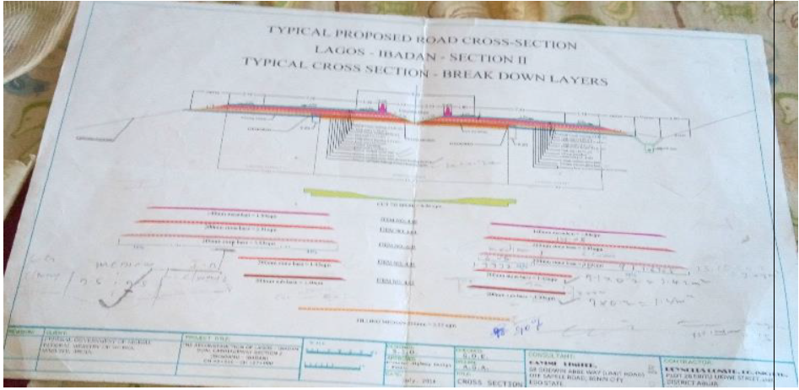
THE DESIGN FOR THE PROJECT

2.2 OBJECTIVES OF THE STUDY
My supervising make me farming company is environment introduction me to the department and staff. Review of company policies and safety protocols. Observations of ongoing projects and process. I meeting with supervised for to discuss learning objectives and expectations. We went to trade for alignment of the drainage constructed and make used of dumpy. Level for the leveling of the surface. Stakeout at you Oba using total station to carryout point each inform of boundary lines ok 244960. We were at Mazamaza for stakeout of the construction of pion for the bridge at chamage L 13-1270 we went to staout at Mazamaza to reconfirm our position of yes today and we established new paints such as 7,11,17 etc. because the new pier to be layed is in hexagen shape. We went at Igboju for coordination to make sure our work are did was carried out perfectly according to the design of the company, and we measured the sub-grade and sub base level for cutting and filling we work at Mazamaza to stakeout new point per construction and we confirmed the old stakeout. We did the orientation of the machine (GP) first at trade fair to BL7 we were at trade fair for alignment of the drainage been construded there and we went to Alaba rago for recording of points to the grade of the road we were at Alaba rago for the leveling of the road and establishing same change work or Mazamaza to stakeout point and the leveling of the road for the stone base level we went to make the road for selection of the stone base level and the sharp level for the railway construction at Lusuroad and we did the same at be saction area. Were at Agbaju for directing and coortingting the labourers all day to implementing the work According to the site.
CHAPTER THREE
3.0 OFFICE EXPERIENCE
3.1 Calculation of measurement taken on road
As a Quantity surveyor whose responsibility is to provide value for the client’s money, there should be a way in which you can know the amount of work done and the amount of materials used to know the amount of money spent. As an IT student in Reynolds Construction Company, I was introduced to method of valuing the amount of work done on a project on daily basis by daily measurement of work done.
Strength testing of the concrete cubs was carries out on fresh concrete the remove of the form use of the foundation bases from axs 6-10 was two we did foundation beam from axis 1-5 and section A and B we made use of the concrete pump machine which help to distribute the average result 97mm. The concrete from the mixer bucher to the foundation beam where its being casted we came out the slump test for the concrete used and the first test = 80mm, 95mm and third 45mm which after would be taking to the testing. Also, the removed of the work of the foundation bearn from as i.e was done we did sound filling of the foundation base from ascis i.e in order to establish a stable base
- Stone pitching
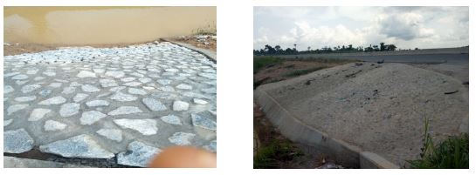
This is done to prevent the seepage of water to the carriage way. It is done by laying stones and joining them with motar.

- Sub base filling on carriage way
These are laterite materials that are borrowed from nearby pit for filling to formation level on road, they can be laterite materials (for suitable ground) and hard core material (for unsuitable ground). It is laid in 200mm thickness.
The measurement for this is calculated and billed in cubic meter (m3), Length width and depth.
- Stone base filling on carriage way
These are the materials are used after laterite filling on road, they are materials extract from crushed rock. They are laid in 3 layers and each layer been in thickness of 200mm.
This is also billed in cubic meter (m3) 17
- Approach slab
It is a concrete slab that is construct on a bridge beams.
This is billed in number (Nr) because they are prefabricated element.
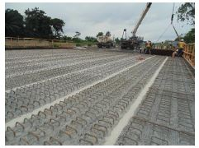

- Abutment wall
They are the two sided reinforced wall that serve two functions for a bridge (1) it retain the earth after and before the bridge and (2) to serve as a support for the girders or beams of the bridge.
- Girders
They are the reinforced concrete beam that span from one abutment wall to another to serve as a support for easy movement of motors on the bridge.
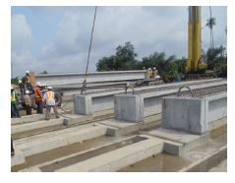
This is billed in number (Nr) because they are prefabricated element. 20
`

3.2 ESTIMATION
During my SIWES program I improved on my estimation skills, whereby I was asked to estimate for a 25m pipe culvert of 900mm diameter.
Calculation
The length=25m
Width=1.20m
Depth= 1.20m
1. EXCAVATION
L X B X D
3.20 X 27 X 1.20 (adding 2m to the length as the working allowance) = 38.8m3
2. CONCRETE WORK
Volume of concrete to use
25 x 1.20 x 1.20=36m3
Using the formula for the volume of a cylinder to remove the pipe opening there
22/7*0.45*0.45*25=15.91m3
Total volume of concrete = 36 - 15.91m3
= 20.09m3
1:2:4 cement sand and granite using grade 20 cement which has a density of 259kg
Cement (50kg/bag)
259kg/50kg= 5.18bag/m3
5.18 x 20.09m3= 104.066 bags of cement required
Cost per bag is N 2,600, 104.066bags will cost N 273000
Add cost of haulage N 50,000
N 323000
SAND (density of sand =1.6)
According to RCC the volume of box (head pan) they are using is 0.027m3
0.027m3*2=0.054m3
104. 620m3066m3*0.054m3=5.
5.620m3*1.60=8.99 tons
Cost per tons N2300 N 20700
Add haulage cost N 15000
N 35700
CHAPTER FOUR
4.1 SITE EXPERIENCE
The reconstruction of Lagos- Ibadan dual carriage way section Two
Project Description
The existing (old) Lagos- Ibadan express way being a Federal Road was too small to accommodate easy movement of vehicles on the road, so the federal government needs to expand the road to accommodate vehicles and others.
The project commence by June 2013, under the administration of President Ebele Jonathan.
It involves removing the existing road and reconstructing it again with new materials but in accordance with the previous design.
According to design the full width of the road should be 33m including the shoulders, i.e Each carriage way will be 7.30m,
The external shoulder will be 2.75m
The internal shoulder will be 1.80m and
The median barrier will take a length of 0.60m
The process of Road Reconstruction
For carriage way for an Existing Road
The leveling which was already on the plan such as the elevation of 4.02 to be transferred all through and allowing an error we were at Lasu to determine the level of excavation and the height for filling of the concrete and the sand surface there was not any work because it is rained all day. We worked at Alakija to establish the boundary marks using nails and painted link for alignment we also worked at Mazamaza to record both sand and stone base level we work at both Mazamaza and Alakija that day which were establish the point.
The right 3.4 and the center for the barriers 5.55 and 6.15 interval of 60cm and for the lost side we affect for 7.65 or 7.35 so we just did the orientation of the machine (GPS) only work at Mazamaza to establish points such as pie 1 and 2 respectively we also worked at Alakija to check and re-correct for those offsets been established before such as 7.35 for the left 3.45 worked out voks there we staked out points such as drain point 10,9,8 etc we gave the engineers the level for the excavation of the surface level of the station we also worked at trade fair for the offsetting of the rails such as for the left 10.883.7.857.75 etc we worked at Iyanaoba for transferring of off sets and the level such as 5.4 for the level and offset of 2000. He drainage and our previous work there we were at Alakeija to transfer the offset for the retaining wall, such as the center for the barriers 5.55 and 6.15 interval of 60cm and for the left side we offset for 7.65 or 7.35 there was no work for that day so we just did the orientation of the machine (gps) only worked at Mazamaza to establish points such as pierz and 2 respectively we also worked at Alakija to check and recorrect for these offsets been established before such as 7.35 for the left 345. For the right worked at works there we started out points such as drain point 10.98 etc. we gave the engineers the level for the excavation of the surface level of the station we also worked at trade fair for the offsetting offsets of the rails such as for the left 10.883.785.7.95 etc. we worked at Iyana Oba for transferring of offsets of 2000.
- Scarification: This is the removal of existing Asphalt on the road with the use of
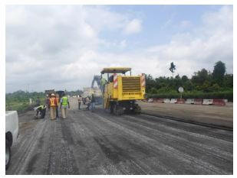

MILLING MACHINE

We have 3 types of slump test, which are:
- True slump: In a true slump, concrete just subsides shortly and more or less maintain the mould shape.
- Shear slump: In a shear slump, one-half of the concrete slide down in an inclined plane. This indicates lack of cohesion in the concrete mix.
- Collapse slump: In a collapse slump, fresh concrete collapse completely.



HAND TROWEL

WHEEL BARROW

TYPES OF SLUMP TEST
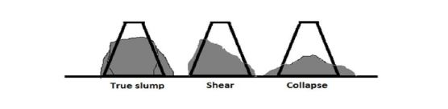
CUBE RUBBER MALLET
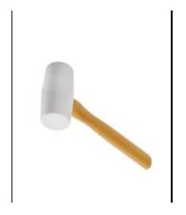
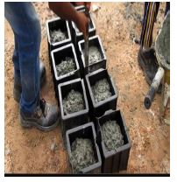

HAND TROWEL



CHAPTER FIVE
5.0 CONCLUSION AND RECOMMENDATION
CONCLUSION
The importance of industrial training cannot be overemphasized because it boosts the student’s practical experience and exposure which in turn lays foundation for student’s development and nation building.
I hereby submit that the industrial training initiative has been most productive as I can now to a great extent relate the things I have heard and read to a physical process which solidify my knowledge on construction activities.
5.1 RECOMMENDATIONS
The knowledge gained was most valuable and therefore; the following recommendations are made to further aid a more rewarding Industrial training experience.
- The Industrial Training Fund (ITF) should encourage the Government as well as companies to accept and train students from tertiary institutions as a contribution to nation building.
- Prospective Industrial Trainees must learn to comport themselves learn and comply with the ethics of work in the establishments they eventually get trained.
- Companies and Establishments should upgrade the working conditions of Trainees to internationally accepted standards in order to boost the nation’s chances in competitive rivalry of expertise in the field.
- Tertiary Institutions should get more involved in guidance rendered for the placement of Students for industrial training in Establishments.
- The Industrial Trainee must constantly strive to acquire knowledge and expertise in their field.
- There should be proper monitoring of the trainees by the industrial trust fund and the institutions.
- Only lecturers from trainees departments should be allowed to visit them at their workplaces for good appraisal.

