

STUDENTS’ INDUSTRIAL WORK EXPERIENCE SCHEME (SIWES)

HELD AT

AL-HIKMA UNIVERSITY, ILORIN
P.M.B 1601, ADEWOLE, OFF ADETA ROUNDABOUT, ILORIN

BY
SHITTU AWAWU OYINDAMOLA
ND/23/COM/PT/0052

SUBMITTED TO THE DEPARTMENT OF COMPUTER SCIENCE,
INSTITUTE OF INFORMATION TECHNOLOGY,
KWARA STATE POLYTECHNIC, ILORIN

2024/2025 Academic Session

Dedication
This SIWES report is dedicated to Almighty God for its successful completion

Acknowledgements
Foremost, my appreciation goes to Almighty God for the successful completion of this SIWES report.
My sincere appreciation goes to Industrial Training and Management of Kwara State polytechnic for the opportunities given in having practical idea of what’s learnt in the four wall of a class room.
Lastly, my appreciation goes to all those who were supportive in one way or the other in the success of this work.
Thanks to you all.

TABLE OF CONTENTS
Title Page i
Dedication ii
Acknowledgements iii
Table of Contents iv
CHAPTER ONE: INTRODUCTION
1.1 Background to SIWES 1
1.2 Objectives of SIWES 3
CHAPTER TWO: DESCRIPTION OF THE ORGANIZATION
2.1 Description of the Organization 4
2.2 Organogram 5
CHAPTER THREE
3.1 SIWES Activities 6
3.2 CHALLENGES I FACED DURING THE PROGRAM
3.3 Solutions to the Challenges faced During the Program 8
CHAPTER FOUR: CONCLUSION AND RECOMMENDATIONS
4.1 Conclusion 11
4.2 Recommendations 11

CHAPTER ONE
INTRODUCTION
1.1 Background to SIWES
The Student Industrial Work Experience Scheme (SIWES) is an essential training program introduced to bridge the gap between theoretical knowledge and practical application for students in tertiary institutions across Nigeria. The scheme provides hands-on experience in real-world industries, allowing students to gain valuable skills relevant to their field of study. As a Computer Science student, my SIWES training at Al-Hikmah University, Ilorin, offered me the opportunity to apply my academic knowledge to practical problem-solving in an actual IT environment.
SIWES was established in 1973 by the Federal Government of Nigeria under the administration of General Yakubu Gowon. The program was initially designed and managed by the Industrial Training Fund (ITF) to cater to students in engineering, technology, and science-related disciplines. Over the years, it has expanded to accommodate students from business, environmental, and other professional fields. The main objective of SIWES is to ensure that students gain the necessary industrial exposure before graduation, making them more competent and employable in their respective careers.
The need for SIWES arose due to the lack of practical exposure among graduates, which made it difficult for them to transition smoothly into the workforce. Many Nigerian graduates struggled to meet the expectations of employers because they lacked industry experience. To address this issue, the ITF introduced the scheme, making it compulsory for students in accredited higher institutions offering technical and applied courses. Today, SIWES is a mandatory requirement for students in universities, polytechnics, and colleges of education, ensuring that they develop job-ready skills before graduation.
At Al-Hikmah University, the SIWES program is structured to equip students with practical knowledge in various fields, including computer programming, network administration, database management, and cybersecurity. During my training, I had the opportunity to work with the university's ICT Unit, where I gained firsthand experience in troubleshooting computer systems, managing software installations, and supporting the institution’s digital infrastructure. The experience not only enhanced my technical skills but also improved my problem-solving abilities and teamwork.
Beyond technical skills, SIWES also helps students develop essential workplace ethics, communication skills, and time management abilities. Working in a structured environment teaches students how to interact with colleagues, follow organizational procedures, and meet deadlines. These soft skills are just as crucial as technical expertise, as they prepare students for professional careers in competitive job markets. My time at Al-Hikmah University’s ICT Unit exposed me to the realities of workplace responsibilities and the expectations of IT professionals in a modern organization.
In conclusion, SIWES remains a vital component of higher education in Nigeria, contributing significantly to the quality and employability of graduates. By merging academic learning with real-world application, the scheme continues to play a crucial role in preparing students for the workforce. My experience during SIWES was both enlightening and transformative, giving me a deeper understanding of Computer Science beyond the classroom. With continuous improvements and better industry partnerships, SIWES can further strengthen the bridge between education and industry, ensuring that Nigerian graduates remain competitive in the global economy.
1.2 Objectives of SIWES
To Bridge the Gap Between Theory and Practice: SIWES provides students with practical, real-world experience that complements their academic knowledge, ensuring they can apply theoretical concepts effectively in their field of study.
- To Expose Students to Industrial Equipment and Technology: The program allows students to familiarize themselves with modern tools, equipment, and processes used in industries, helping them adapt easily to workplace demands after graduation.
- To Develop Professional and Workplace Skills: SIWES helps students cultivate essential skills such as teamwork, communication, time management, and problem-solving, making them better prepared for the workforce.
- To Enhance Employability and Career Readiness: By gaining hands-on experience, students become more attractive to potential employers, increasing their chances of securing jobs after graduation.
- To Strengthen Industry-Academia Collaboration: The scheme fosters a strong relationship between educational institutions and industries, ensuring that the curriculum remains relevant to industry needs and trends.

CHAPTER TWO
DESCRIPTION OF THE ORGANIZATION
2.1 Description of the Organization
Al-Hikmah University, Ilorin, is a private higher institution established in 2006 under the leadership of Alhaji Oladimeji Igbaja. The university was founded with the vision of providing quality education that blends academic excellence with moral discipline. Since its inception, Al-Hikmah University has remained committed to producing well-rounded graduates who are not only knowledgeable in their respective fields but also possess strong ethical values that prepare them for leadership roles in society.
The university provides institutional services to the host community by offering a wide range of academic programs. Some of the courses available include Accounting, Statistics, English, Computer Science, Business Administration, and Mass Communication, among others. These programs are designed to meet national and international academic standards, ensuring that students receive a well-structured and comprehensive education. The institution has also integrated technology into its teaching and learning process, equipping students with digital skills relevant to today’s evolving job market.
Al-Hikmah University is known for its strong academic structure, comprising various faculties and departments that cater to different fields of study. The university offers undergraduate and postgraduate programs, ensuring that students have access to advanced education opportunities. With a dedicated team of lecturers and administrative staff, the institution prioritizes student development, research, and community service. This commitment to excellence has positioned the university as one of the reputable private institutions in Nigeria.
Beyond academics, Al-Hikmah University also contributes to the social and economic development of its host community. The institution provides employment opportunities for residents, partners with local businesses, and supports various community development initiatives. Through seminars, workshops, and public lectures, the university engages with the local community, fostering knowledge sharing and intellectual growth. These initiatives help strengthen the bond between the institution and its surrounding environment.
Al-Hikmah University, Ilorin, is a reputable institution that has continued to grow in both academic excellence and community impact since its establishment in 2006. Founded under the leadership of Alhaji Oladimeji Igbaja, the university remains committed to providing quality education, fostering research, and contributing positively to society. Through its diverse range of academic programs, dedicated faculty, and community engagement efforts, the institution plays a crucial role in shaping the future of its students and the development of the host community.
2.2 Organogram
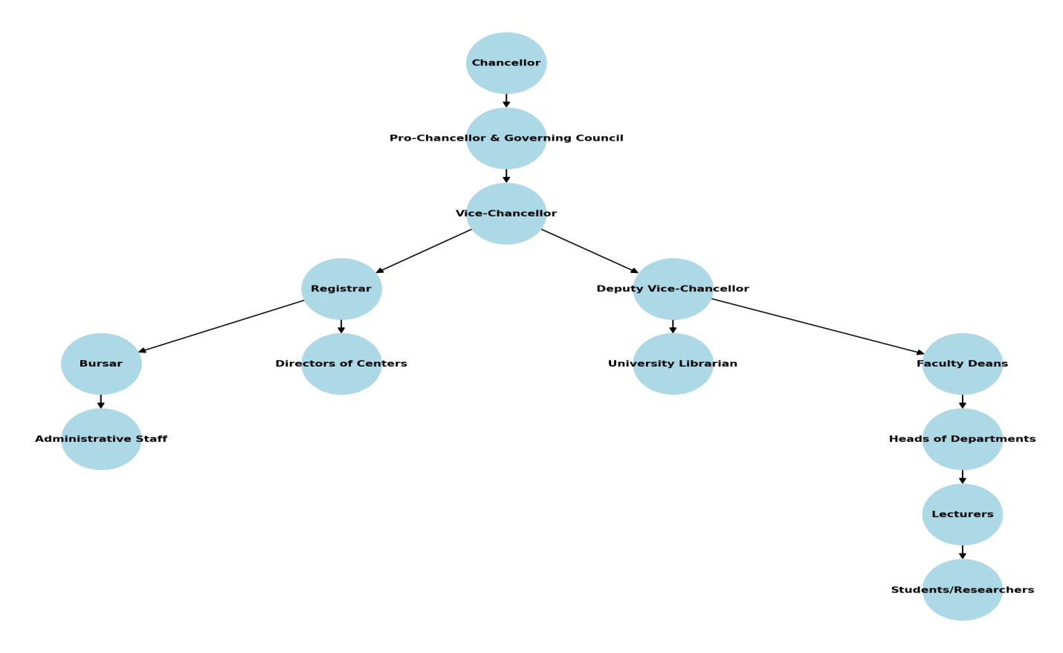

CHAPTER THREE
3.1 SIWES Activities
During my SIWES program at Al-Hikmah University, Ilorin, I had the opportunity to engage in various practical activities that enhanced my technical and professional skills. One of the most exciting aspects of my training was learning how to use CorelDRAW for graphic design. Before my SIWES experience, I had little knowledge of the software, but with continuous practice and guidance from my supervisors, I became proficient in designing flyers, logos, and other visual materials. This skill has significantly improved my creativity and ability to handle design-related tasks efficiently.
In addition to CorelDRAW, I received hands-on training in Microsoft Excel, a crucial tool for data analysis and management. I was taught how to create and format spreadsheets, use formulas for calculations, and generate reports. I also learned how to visualize data using charts and graphs. These skills were particularly useful in managing records and organizing information systematically, which are essential in any administrative or business setting.
Another important aspect of my SIWES training was working with Microsoft PowerPoint to create professional presentations. I was trained on how to design slides, add animations, and structure content effectively to communicate ideas clearly. This experience helped me improve my ability to present information in a well-organized and visually appealing manner, which is a vital skill for both academic and professional settings.
I also engaged in record management, which involved organizing, storing, and retrieving important documents. I learned how to maintain both physical and digital records efficiently, ensuring easy access when needed. This experience exposed me to the importance of proper documentation in an organization, as well as how to handle confidential files responsibly.
Throughout my training, I had the opportunity to work closely with experienced professionals who guided me on workplace ethics and time management. I learned the importance of meeting deadlines, maintaining professionalism, and working effectively in a team. These soft skills are just as important as technical skills, as they help in building a strong work ethic and improving productivity in any organization.
Additionally, I was introduced to basic troubleshooting techniques for computers and software applications. I learned how to resolve minor hardware and software issues, install necessary applications, and update system software. This knowledge helped me develop problem-solving skills and increased my confidence in handling IT-related challenges.
My experience during SIWES also gave me insight into customer service and communication skills. I interacted with staff and students who needed technical support, which allowed me to practice effective communication and problem-solving. I realized how important it is to listen attentively, understand users' needs, and provide clear and helpful responses.
In conclusion, my SIWES program at Al-Hikmah University was an eye-opening experience that provided me with practical knowledge and valuable skills. From learning CorelDRAW and Microsoft Office tools to record management and troubleshooting, I gained hands-on experience that will be useful in my future career. The training helped me build confidence in my abilities, and I now feel more prepared to apply my skills in real-world situations.

Tools I worked with
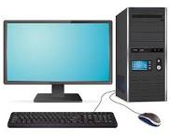

3.2 Challenges I Faced During the Program
During my SIWES program, I encountered several challenges that tested my patience, adaptability, and problem-solving skills. One of the major difficulties I faced was limited experience with some of the software tools. At the beginning of the program, I struggled with using CorelDRAW and Microsoft Excel because I had little prior knowledge of these applications. It took me some time to understand the various tools and functions, and I had to put in extra effort to practice and seek guidance from my supervisors.
Another challenge was slow computer systems and occasional technical issues. Some of the computers I worked with were outdated and slow, which made tasks like designing in CorelDRAW or processing data in Excel frustrating. At times, the system would freeze or crash while I was working, causing delays and loss of unsaved work. I had to learn how to troubleshoot minor issues and ensure I saved my work frequently to avoid losing progress.
I also faced difficulty in adapting to workplace demands and time management. Unlike school, where tasks are more flexible, the work environment required me to complete assignments within specific deadlines. At first, I found it challenging to balance multiple tasks, but with time, I improved my ability to prioritize work, manage time effectively, and meet expectations.
Communication was another area where I faced some challenges. Interacting with colleagues, supervisors, and clients required a level of professionalism that I was still developing. Sometimes, I struggled with understanding instructions or expressing my ideas clearly, especially when working on assignments that required teamwork. However, as the program progressed, I gained confidence in my communication skills and learned the importance of active listening and asking for clarification when needed.
Lastly, adapting to workplace ethics and professional conduct was initially challenging. I had to learn how to maintain discipline, dress appropriately, and follow office protocols. Adjusting to these expectations took some time, but I gradually became more comfortable with the work culture and professional etiquette.
Despite these challenges, my SIWES experience was highly rewarding. Each difficulty I faced helped me grow, develop resilience, and acquire skills that will be valuable in my future car
3.3 Solutions to the Challenges faced During the Program
To overcome the lack of experience with some software tools, I dedicated extra time to self-learning and practice. I watched online tutorials, read user guides, and sought help from my supervisors and colleagues. By continuously working with CorelDRAW, Microsoft Excel, and PowerPoint, I gradually became more comfortable and proficient in using these applications.
To address the slow computer systems and technical issues, I learned basic troubleshooting techniques, such as clearing temporary files, optimizing system performance, and saving my work frequently to prevent data loss. Whenever I encountered a problem beyond my control, I promptly reported it to the IT department or my supervisors to ensure a quick resolution.
For workplace time management and adapting to deadlines, I started using task prioritization techniques to organize my daily activities effectively. I created to-do lists and set realistic deadlines for myself, which helped me stay on track and complete assignments efficiently. Over time, I became more disciplined in managing multiple tasks without feeling overwhelmed.
To improve my communication skills, I made a conscious effort to engage more with my colleagues and supervisors. I practiced active listening, asked for clarifications when needed, and participated in discussions to enhance my confidence in expressing my ideas. By observing how professionals interacted, I also learned the importance of clear and respectful communication in a workplace setting.
Lastly, to adapt to workplace ethics and professional conduct, I carefully observed and followed company policies, dress codes, and work etiquette. I sought feedback from my supervisors to ensure I was meeting expectations and gradually adjusted to the professional work culture. Over time, I became more comfortable with the responsibilities and expectations of a professional environment.
By implementing these solutions, I was able to overcome most of the challenges I faced during my SIWES program, making the experience both valuable and rewarding.

CHAPTER FOUR
CONCLUSION AND RECOMMENDATIONS
4.1 Conclusion
In conclusion, my SIWES program at Al-Hikmah University, Ilorin, was a highly rewarding experience that provided me with practical knowledge, technical skills, and workplace exposure. Through hands-on training in CorelDRAW, Microsoft Excel, PowerPoint, and record management, I developed valuable competencies that will be beneficial in my future career. Despite the challenges I faced, such as technical difficulties, time management issues, and adapting to workplace ethics, I was able to overcome them through continuous learning, self-discipline, and the support of my supervisors. The program not only enhanced my professional skills but also helped me build confidence, teamwork abilities, and a strong work ethic. Overall, SIWES has significantly prepared me for real-world job environments, and I am grateful for the experience.
4.2 Recommendations
At the end of the program, the following recommendations are made:
- Institutions should provide updated computers and efficient software tools.
- Students should undergo pre-SIWES training on essential computer skills.
- Supervisors should offer more hands-on guidance and mentorship.
- Time management skills should be emphasized during the program.
- Organizations should ensure a conducive learning environment for students.

