

KWARA STATE POLYTECHNIC, ILORIN
INSTITUTE OF INFORMATION AND COMMUNICATION TECHNOLOGY (IICT)
DEPARTMENT OF MASS COMMUNICATION

A TECHNICAL REPORT OF THE STUDENTS INDUSTRIAL WORK EXPERIENCE SCHEME (SIWES)

OYINWOLA OYINKANSOLA RHODA
ND/23/MAC/PT/0743

UNDERTAKEN AT:
KWARA STATE BROADCASTING CORPORATION
2, POLICE ROAD G.R.A ILORIN, KWARA STATE

PERIOD OF ATTACHMENT:
AUGUST 2024 – NOVEMBER 2024
CERTIFICATION
This is to certify that this report is compiled by the author, OYUNWOLA OYINKANSOLA RHODA with Matric No ND/23/MAC/PT/0743 of the Department of Mass Communication, Institute of Information and Communication Technology, Ilorin upon completion of Student Industrial Work Experience Scheme (SIWES).

SIWES SUPERVISOR _________________________
Sign/Date

HEAD OF DEPARTMENT _________________________
Sign/Date

DEDICATION
I dedicate this SIWES report to Almighty God for granting me wisdom, strength, and good health throughout this learning experience.
ACKNOWLEDGEMENT
I would like to express my sincere gratitude to the Management and Staff of Kwara State Broadcasting Corporation for granting me the opportunity to undergo my Student Industrial Work Experience Scheme (SIWES) with them. Their unwavering support, guidance, and encouragement throughout my training have been invaluable to my learning experience.
My heartfelt appreciation goes to my supervisor, Mrs. Aminat Adediji-Soladiye, whose mentorship, patience, and willingness to share knowledge significantly contributed to my professional growth. I am also grateful to my colleagues and other members of the team for their cooperation and for making my time at the organization both insightful and enjoyable.
I extend my appreciation to my institution and SIWES coordinator, whose efforts in facilitating this industrial attachment made this experience possible. Special thanks also go to my family and friends for their constant encouragement and support throughout this period.
Above all, I am grateful to God Almighty for granting me the strength, wisdom, and good health to successfully complete this training.

TABLE OF CONTENT
Title page i
Certification ii
Dedication iii
Acknowledgement iv
Table of contents v
CHAPTER 1: INTRODUCTION
SIWES Background 1
1.1 Objectives of SIWES 2
1.2 Bodies involved in the management of SIWES 3
1.3 Background of Establishment. 4

CHAPTER 2:
2.0 Work experience during attachment 7
News Gathering 7
Observation 8
Telephone Conversation 8
Research 9
Granting of Interview 9
Writing of News 9
Covering Events 10
2.1 Equipment’s Used at KBSC 14
2.2 Live Program 17
2.3 Structural Representation of Studio Signs 17
CHAPTER 3
3.0 Problems encountered during period of attachment 18
CHAPTER 4
4.0 Conclusion 19
4.1 Recommendation 20

CHAPTER ONE

INTRODUCTION

STUDENT INDUSTRIAL WORK EXPERIENCE SCHEME (SIWES) BACKGROUND
In the earlier stage of science and technology education in Nigeria, students were graduating from their respective institutions without any technical knowledge or working experience. It was in this view that students undergoing science and technology related courses were mandated for students in different institution in view of widening their horizons so as to enable them have technical knowledge or working experience before graduating from their various institutions.
The Student Industrial Work Experience Scheme (SIWES) was established by the Industrial Training Fund (ITF) in 1973 to enable students of tertiary institution have technical knowledge of industrial work base on their course of study before the completion of their program in their respective institutions. The scheme was designed to expose students to industrial environment and enable them develop occupational competencies so that they can readily contribute their quota to national economic and technological development after graduation. The major background behind the embarkment of students in SIWES was to expose them to the industrial environment and enable them develop occupational competencies so that they can readily contribute their quota to national economic and technological development after graduation. The major benefit accruing to students who participate conscientiously in Students Industrial Work Experience Scheme (SIWES) are the skills and competencies they acquire. The relevant production skills remain a part of the recipients of industrial training as life-long assets which cannot be taken away from them. This is because the knowledge and skills acquired through training are internalized and become relevant when required to perform jobs or functions.

1.1 OBJECTIVES
The Industrial Training Funds policy Document No. 1 of 1973 which established SIWES outlined the objectives of the scheme. The objectives are to:
- Provide an avenue for students in higher institutions of learning to acquire industrial skills and experiences during their course of study.
- Prepare students for industrial work situations that they are likely to meet after graduation.
- Expose students to work methods and techniques in handling equipment and machinery that may not be available in their institutions.
- Make the transition from school to the world of work easier and enhance students’ contacts for later job placements.
- Provide students with the opportunities to apply their educational knowledge in real work situations, thereby bridging the gap between theory and practice.
- Enlist and strengthen employers’ involvement in the entire educational process and prepare students for employment in Industry and Commerce (Information and Guideline for SIWES, 2002).
1.2 BODIES INVOLVED IN THE MANAGEMENT OF SIWES
The bodies involved are:
- The Federal Government.
- Industrial Training Fund (ITF).
Other supervising agents are:
- National University Commission (NUC)
- National Board for Technical Education (NBTE)
- National Council for Colleges of Education (NCE)
The functions of these Agencies above include;
- Establish SIWES and accredit SIWES unit in the approved institutions.
- Formulate policies and guideline for participating bodies and institutions as well as appointing SIWES coordinators and supporting staff.
- Supervise students at their places of attachment and sign their lob-book and IT forms.
- Ensure payment of allowances for the students and supervisors.
- Ensure adequate funding of the scheme.
1.3 BACKGROUND OF ESTABLISHMENT
Radio Kwara, also known as the Kwara State Broadcasting Corporation, is a Nigerian radio station that started broadcasting in Ilorin in 1956 as a relay station and is known as "The People's Station" with the slogan "My Radio... My State. It aims to be a vital communication tool that informs, educates, and entertains its audience while also playing a crucial role in the development of its community.
Kwara State broadcasting corporation has multiple stations, and therefore multiple transmitters, across the state of Kwara. Radio Kwara is located in Kwara State, Nigeria. The main broadcasting hub and some of its stations are based in Ilorin, the capital city of Kwara State the main hub is located at 2 Police Road, GRA, P.M.B 1345 Ilorin, Kwara State, Nigeria. Also, each of the stations has their own broadcast locations. Nootia FM broadcasts from Baruten, Kwara State.
Stations and Frequencies
    - Midland FM (99.1 FM): Previously known as Radio Kwara 2.
    - Nootia FM (90.7 FM)
    - Kakakin FM (91.7 FM)
Content
  - The programming includes news bulletins, talk shows, and a variety of entertainment programs.
  - It broadcasts in both English and Yoruba languages.
Online Presence
  - Radio Kwara has an online presence, allowing listeners to stream live broadcasts and access news content.
  - Their website provides current news, and information about the radio stations.
Role in the Community
  - Radio Kwara plays a vital role in keeping the community informed and connected.
  - It is an important tool for disseminating information from the Kwara state government.
Mission
  - To build a broadcast giant that promotes societal values and human development through performance-driven innovative and quality services.
Objectives
  - To provide reliable and accurate news and information to the people of Kwara State.
  - To offer diverse and engaging entertainment programs.
  - To serve as a platform for public discourse and community engagement.
  - To facilitate the dissemination of government information and policies.
  - To contribute to the social, cultural, and economic development of Kwara State.
  - To be a preferred source of world class broadcasting.
  - To be responsive to the dynamic environment.
Radio Kwara, a state-owned radio station in Kwara State, Nigeria, typically has various departments that handle different aspects of broadcasting and station management. While specific department names may vary, here are some common departments found in most radio stations, including Radio Kwara:
Departments/Units
- News & Current Affairs: Responsible for gathering, editing, and broadcasting news and current events.
- Programmes & Production: Oversees the planning, development, and execution of radio programs, talk shows, and entertainment segments.
- Engineering & Technical: Handles the station’s transmission, equipment maintenance, and technical operations.
- Marketing & Advertising: Focuses on generating revenue through advertisements, sponsorships, and promotions.
- Administration & Human Resources: Manages staff, recruitment, and overall administrative duties.
- Accounts & Finance: Oversees budgeting, financial planning, and revenue management.
- ICT & Digital Media: Handles online presence, social media, and digital broadcasting efforts.
- Library & Archives: Maintains records of past broadcasts, music collections, and research materials.

CHAPTER TWO
2.0 WORK EXPERIENCED DURING ATTACHMENT
During my SIWES training in Mass Communcation at KWARA STATE BROADCASTING CORPORATION (KBSC) I was posted to the News and Current Affairs Department and introduced to my Industrial-Based Supervisor (Mrs. Aminat Adediji-Soladoye) and I was given an orientation on the in-house style of the station and other rudiments of news writing.
I gained valuable hands-on experience in news gathering, reporting, and media production. I learned the essential methods of gathering news, including observation, research, telephone interviews, and face-to-face interviews, which helped me develop the ability to identify newsworthy events and collect relevant facts efficiently. Additionally, I improved my news writing and reporting skills, mastering the inverted pyramid structure and learning how to craft compelling leads while ensuring accuracy and clarity in every story.
My experience also involved covering live events such as meetings, press conferences, and speeches, where I learned to identify key takeaways, adapt to unexpected developments, and effectively use direct quotes to enhance the depth and credibility of my reports. I also gained insight into photojournalism, where I developed the skill of writing concise and informative captions, ensuring accurate identification of individuals and providing necessary context to make images more meaningful to readers.
- NEWS GATHERING
Recognize the most commonly used methods of gathering news. The four most commonly used methods in news gathering used by journalists are observation, telephone conversations, research, and interviews.

- OBSERVATION
Observation consists of actually seeing an event take place and then reporting what you have seen in the form of a news story. The difference between a good story and a poor one is often in the skill of the observer. Skilled observers use their eyes, ears, mind, notebooks, and tape recorders. They make sure they get concrete facts, specific figures, and accurate information. They look for the colorful, the dramatic, or the unusual in any situation.
- TELEPHONE CONVERSATIONS
Telephone conversations may range from full-scale interviews to brief queries to verify or amplify information. But regardless of how often you use this method of news gathering, you should keep the following points in mind:
- Know what information you want before you dial. Keep your pencil and paper handy. Do not call someone and then ask that person to wait while you look for writing materials.
- Speak politely in distinct, well-modulated tones.
- Be cheerful and businesslike.
- Make sure you get your facts straight. Ask the other person to repeat figures or spell out names.
- Avoid three-way conversations among yourself, the person on the telephone, and somebody else in your office.
- Recheck your information by reading it back to the person who has given it to you.
- Do not discuss classified information.
Although a telephone is a very useful instrument, remember it is not the only, and not necessarily the best, method of gathering news. It should supplement, but not replace, all other methods. Whenever it is proper and convenient, use the telephone, but do not be afraid to engage in a little legwork.

- RESEARCH
Research is nothing more than digging out information from files and reference works. It is used to verify or amplify facts in news stories and to give depth to feature stories and magazine articles.
- GRANTING OF INTERVIEWS
About 90 percent of everything in a news story is based on some form of interviewing—either in person, by telephone, or occasionally by correspondence.
- WRITING OF NEWS
The following are procedures on how to write and craft a good news story:
1) Choose A Recent, Newsworthy Event Or Topic: There are a few points that we need to discuss when it comes to this step. The first, of course, is knowing when something is newsworthy and when it is not.
A newsworthy story is anything happening in your community that might interest readers. It should be unique, active, and impactful. For example, covering a business (if it isn’t new or offering any particular changes) isn’t particularly newsworthy, especially if it has always been there. However, covering a new business in the area is absolutely newsworthy and will bring the company to the attention of your readers.
2) Conduct Timely, In-Person Interviews With Witnesses: The hardest part about writing a news story is getting interviews with the right people. If there was a robbery at a local grocery store, you would need to talk to the store manager and, if possible, the cashier or employee involved. You should not ask a family that shops at the store frequently (unless they were witnesses) or a random community member. These interviews are cop-outs; gimmicks that keep you from asking hard questions of key witnesses.
3) Establish The “Four Main Ws”: Within your first paragraph, you need to establish the who, what, when, and where of your piece. The why and how can wait until the following paragraphs.
Remember, a journalism piece should look like a pyramid—the most important information goes at the top, while the rest is spread throughout the remaining column space.
4) Construct Your Piece: Now that you have the materials you need, start putting your piece together. Begin with the necessary information, and let the rest trickle down. As you continue to write journalistically, you’ll develop a better sense of this process.
5) Insert Quotations: Some writers choose to add quotations as they write, while others decide to insert them at specific points after the story has already been developed. Either way, ensure that your quotes are well-placed and that key people in the story are identified by their full name, occupation, and age.
6) Research Additional Facts And Figures: When your story is nearly complete, utilize Google and other credible sources to find additional interesting facts and figures that will make your piece stand out.
Remember, you will almost always be competing with another news source, and both of you will be trying to feed information to the same audience. Add that extra touch—it will make a difference.
7) Read Your Article Out Loud Before Publication: I always suggest that writers read their articles out loud before submitting them to their professor or editor. This helps with sentence structure, phrasing, and the overall flow of the story.
- COVERING EVENTS
Writing about live events such as meetings, press conferences, and speeches can be tricky, even for seasoned reporters. Such events are often unstructured and chaotic, and the reporter—working on a deadline—must make sense of what happened and present it in a story that has structure, order, and meaning. This is not always easy. Below are some basic do's and don'ts for good reporting of live events:

- FIND YOUR LEAD
The lead of a live event story should focus on the most newsworthy and interesting aspect of the event. Sometimes, this is obvious: If a congressional leader announces a vote to raise income taxes, that’s your lead. But if it’s unclear what’s most important, or even what just happened, interview knowledgeable people after the event to gain insight and perspective. It may be something you didn’t fully understand at the time or a combination of multiple elements. Don't be afraid to ask questions.
- AVOID LEADS THAT SAY NOTHING
Regardless of how dull the story may seem, find a way to write an interesting lead.
Bad lead examples:
"The Centerville City Council met last night to discuss the budget."
"A visiting expert on dinosaurs gave a talk last night at Centerville College."
These lack impact and fail to engage readers.
Better lead examples:
- "Members of the Centerville Town Council argued bitterly last night over whether to cut services or raise taxes."
- "A giant meteorite was probably responsible for the extinction of dinosaurs 65 million years ago, an expert said last night at Centerville College."
A good lead should provide specific, interesting, or surprising details.
- WATCH FOR THE UNEXPECTED
No matter how an event is advertised, what you expect to be the most important story may turn out to be dull or a non-event. Sometimes, a side story—a protest, an unexpected statement from a notable figure, or a controversy—becomes the real headline.
Keep your ears and eyes open, stay flexible, and be willing to shift your focus, start over, and reorganize your approach if necessary.
- DON'T COVER EVENTS CHRONOLOGICALLY
New reporters often feel the urge to cover an event from start to finish, fearing they might leave out something important. This is a classic mistake.
Instead of listing everything in order—starting with roll call and the approval of minutes—focus on the most compelling, newsworthy elements of the event.
- INCLUDE PLENTY OF DIRECT QUOTES
Good direct quotes add depth and authenticity to a story. They transport readers to the scene, provide insight into key figures, and add flavor, energy, and credibility. Strong quotes can even define a public official’s career, making them a crucial element of a news story.
- ADD COLOR AND LEAVE OUT THE BORING STUFF
Remember, you’re a reporter, not a stenographer. You don’t have to include every detail of the event. If school board members casually discuss the weather, it’s probably not worth mentioning (unless that’s the only thing they discuss, which could be a story in itself).
However, you are the eyes and ears of your readers. Adding vivid descriptions and background details can elevate your story from ordinary to memorable. Report with your senses—describe sights, sounds, and emotions to bring the scene to life.
- PHOTO NEWS AND CAPTIONS
Photo captions are often the first elements of a publication that readers notice. Writing effective captions is an essential part of a news photographer’s job. A photo caption should provide the reader with basic information to understand the image and its relevance to the news.
- WRITING CAPTIONS
Most photo captions follow a consistent and concise format to allow for quick publication. A basic caption should:
- Identify people and locations – Clearly name individuals and places featured in the photo. Include professional titles and the formal name of the location. Always spell names correctly (verify spellings with the article if needed).
- For group photos, list names from left to right unless instructed otherwise. For large groups, only notable figures may need to be identified. In some cases, no identifications are required. Publications should establish a standard for captioning.
- Include the date and day – This is essential for a news publication. The more current a photo is, the better.
- If using an archive photo or an image taken before the event, clearly label it as a “file photo.”
- Provide context or background – Help readers understand the significance of the image in one or two sentences.
- Write in complete sentences and in the present tense – The present tense gives captions a sense of immediacy. If necessary, the first sentence can be in the present tense, while the following sentences may use past tense for additional details.
- Be brief – Most captions are one or two short, declarative sentences. A third sentence may be added if necessary to provide essential context.

2.1 EQUIPMENT’S USED AT KBSC
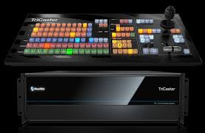
- Tricaster: Is also used to broadcast live program while the playout system is used for recorded programs. When there is no live show going on recorded program are being played through it.

- Video Camera: Is a camera used for electronic motion picture acquisition, initially developed for the television industry but now common in other applications as well. There are types of shots using the Zoom, the Close up Shot, Medium Close up (MC) and the Medium long shot (MLS).
Experiences using the camera
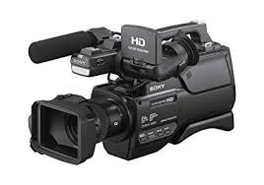
Colour adjustment, Cropping, framing and composition of picture including the layout, PAN, the movement of camera from right to left. Tilt movement which include the up and down tilt movement. Light and create visual image, there are different types of light which is the fill light, the back light, the hard light, and the spot light.

- Teleprompter: Is a display device that prompts the person speaking with an electronic visual text of a speech or script using a teleprompter is similar to using cue cards. I heard experiences on how weather forecast script to the teleprompter by highlighting all first then copy the document and clicking the teleprompter software, then add script and paste, then connect the teleprompter. A laptop was used to operate it to make it move fast and slow.
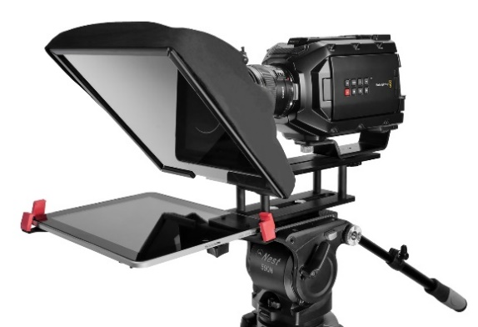

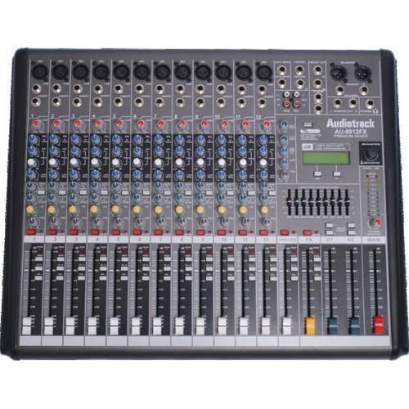
- Audio mixer: A mixer is an electronic device which is often used for changing the quality and the levels of audio signals. It is also known as a mixing console, an audio mixer, or a soundboard. Using a mixer is the most convenient way to route or combine various audio signals and even change the timbre and dynamics of the sound.

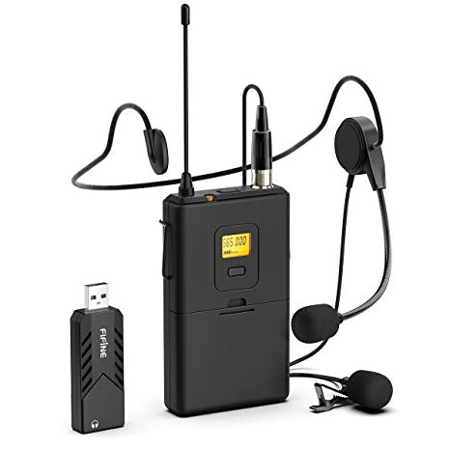
- Lapel microphone: Is a small microphone used for television, theatre, and public speaking, in order to allow for hands-free operation.

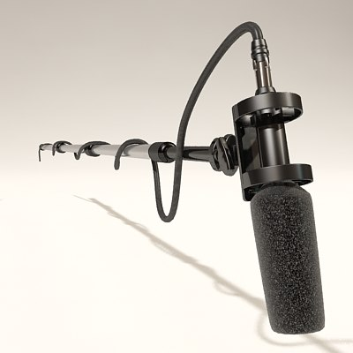
- Boom mic: is used to pick up sounds of the presenter and the guests, from ascending to decending order in all angels of the studio.

- Lights: Is mainly used in the studio to clear shadows of an object, to also have a clear image of the subject or talent
Type of light
1. Fill Light is placed by the side of the subject to cast out shadow or to fill out shadows
2. Back lights are placed at the back of the subject to light him/her from behind.
3. Hard Light close to the natural light, source from the sun
4. Spot light is controlled narrowly focused beam of light
- Standing light is mainly used to have a clear picture or visual of the object behind the scene while a program or interview is being conducted
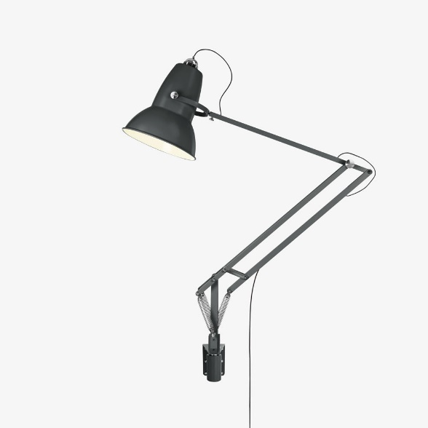

2.2 LIVE PROGRAM
The live program I monitored was the Yoruba edition of the platform tagged “Gbagede Oro” and extract news from the program. Anchored by Ibrahim Solihu. The program is Yoruba interactive program where prominent figures and the public discuss current issues, particularly concerning the State of Harmony (Kwara State).
2.3 STRUCTURAL REPRESENTATION OF STUDIO SIGNS
Studio signs also refer to as using studio stickers with written words of instruction using to conduct the activities of a reporter in the studio. It is also used in order to avoid distortion while reporting news.
ADVERT
BREAK
ROUND-UP
STOP
SLOW DOWN
STAND-BY
SPEED-UP
OK
STRETCH
OR
SLOW DOWN
COME
CLOSER
ON
TIME
CUT
30
SECONDS
15
SECONDS
KEEP
TALKING
GO
BACK
A
MINUTES
COUNT
DOWN
STOP
DON’T
MOVE

CHAPTER THREE
3.0 PROBLEMS ENCOUNTERED DURING ATTACHMENT
    - The bureaucratic system is rigid and before things are done its takes so much time. This affected the conducive working environment for the members of staff in that whenever machines are bad and need repairs it takes so much time before it gets attended to. This system made work so tedious and cumbersome.
    - The issue of expensive transportation was the problem of transportation because my place of attachment was a little bit far.

CHAPTER FOUR
4.0 CONCLUSION
This report is the summarizing of the experienced of works and activities carried out during my SIWES I gained valuable hands-on experience in news gathering, reporting, and media production. I learned the essential methods of gathering news, including observation, research, telephone interviews, and face-to-face interviews, which helped me develop the ability to identify newsworthy events and collect relevant facts efficiently. Additionally, I improved my news writing and reporting skills, mastering the inverted pyramid structure and learning how to craft compelling leads while ensuring accuracy and clarity in every story.
My experience also involved covering live events such as meetings, press conferences, and speeches, where I learned to identify key takeaways, adapt to unexpected developments, and effectively use direct quotes to enhance the depth and credibility of my reports. I also gained insight into photojournalism, where I developed the skill of writing concise and informative captions, ensuring accurate identification of individuals and providing necessary context to make images more meaningful to readers.
Beyond technical skills, the program helped me develop professional communication and ethical awareness. I improved my ability to interact professionally with journalists, media professionals, and interviewees while upholding the core values of journalism, including accuracy, fairness, and confidentiality. Working under tight deadlines also enhanced my ability to stay focused and maintain a professional attitude in a fast-paced environment.
Overall, my SIWES experience has significantly strengthened my journalistic skills, research ability, and professional competence. The knowledge and practical exposure I gained have prepared me for future challenges in the media industry, equipping me with the necessary skills to excel in journalism and news reporting.

4.1 RECOMMENDATION
The recommendations arising from the foregoing appraisal of the effectiveness of SIWES in the formation of competent and productive technical manpower for the economy are summarized as follows:
- The establishment of a National Commission for Student Industrial Training or a National Board for Cooperative Education was proposed to oversee the implementation of SIWES at the national level.
- Funds earmarked for SIWES should be appropriated directly by the National Assembly in the same way for the National Youth Service Corps Scheme in order to remove the bottlenecks associated with release of fund for the operation of the scheme.
- The Federal Government should make adequate provisions in the annual budget for proper funding for SIWES in view of the potentials of the scheme to contribute to enhancing the quality of pool of technical skills available to the economy.
- The stipulation that employers should accept students for SIWES should be strengthened with stiffer penalties put in place for defaulters.
- A review of the policies that guide and regulate SIWES is necessary to ensure that the scheme complies fully with the tenants of cooperative education or work-integrated learning.

