

A TECHNICAL REPORT OF WORK DONE
STUDENT INDUSTRIAL WORKING EXPERIENCE SHCEME
HELD AT
KWARA POLY WORKS DEPARTMENT
PRESENTED BY:
OHERE ABDULRASHEED ABIODUN
ND/23/BLD/FT/0033

IN PARTIAL FULFILLMENT OF THE NATIONAL DIPLOMA OF KWARA STATE POLYTECHNIC.

SUBMITTED TO:
THE DEPARTMENT OF BUILDING TECHNOLOGY.
INSITUTE OF ENVIRONMENTAL STUDIES, KWARA STATE
POLYTECHNIC ILORIN

DECEMBER 2024

DEDICATION
This piece of work is dedicated first to Almighty Allah for giving me the opportunity and resources to complete this work and my parent for their love, support and parental care throughout the program.

PREFACE
This report is aimed at giving introduction to what was achieved during the siwes program which will be useful to building technology student. The technical written to improve the standard of learning and create for continuing education in tertiary institution.
This report is written in chapter and each chapter has individual sub headings which indicate the direction of the focus.

ACKNOWLEGEMENT
Thanks and glory is to Almighty Allah for life, provision and protection during the course of writing this work.
To my Virtuous parents Mr. and Mrs. OHERE
. Thanks for your support and understanding.
My sincere thanks also goes to my able lecturers and supervisor, to management and staff of my department.
I will also like to say a big thank you to my friends and colleagues, those who assisted financially and those who assisted me morally and spiritually, May god bless you all.

TABLE OF CONTENTS
Title page
Dedication
Acknowledgement
Preface
CHAPTER ONE
  - General Introduction
  - Definition of SIWES
  - Aims and objectives
CHAPTER TWO
2.1 Organization chart
2.2 Major activities of organization
2.3 Role of Quality Surveyor.
2.4 Role of a Builder
CHAPTER THREE
3.1 Building Instrument
3.2 Introduction to measurement
3.3 Foundation
3.4 Health and Safety in Construction
CAPTER FOUR
4.1 Waffle Slab
4.2 Wall Making
4.3 Job Site preparation
CHAPTER FIVE
5.1 Conclusion
5.2 Personal impression about the organization
5.3 Recommendation
CHAPTER ONE
1.1 INTRODUCTION
This programme is introduced by the Federal Government of Nigeria to all the student of higher institutions throughout the country in order to gives them the opportunity to obtain industrial working experience in their respective disciplines. And it has been introduced in 1973.
I was attached to computer and information technology centre, kwara state college of education, which is divided into different units for the four months of my SIWES (Student Industrial Work Experience Schemes) programme.
Furthermore, the student industrial work experience scheme (SIWES) provides an atmosphere for continuity of learning that can update student’s understanding on the course of study. SIWES also prepare students for future purposes and also supply the needed experience which will assist the student to maintain their stand in the labor market. SIWES will also assist the students to be more exposed and prepare them for challenge ahead.
1.2 DEFINITION OF SIWES
The student industrial work experience scheme (SIWES) can be referred to as the industrial training or the involvement for science and technology education in order to gain more theories an practical works being offered in the place of attachment, it is the programme designed for student for students in higher institution to acquire practical skills in their respective field of study. The student industrial work experience scheme (SIWES) enable student to improve on the practical skills and as well as to improve students on the overall development.
1.3 AIMS AND OBJECTIVES
The aims and objective of this programme is to expose student to computer operating system, professional work methods, hardware device and ways of carryout operation in industries and others organizations.
The objectives set out for this report is that, the ideal of student industrial work experience scheme (SIWES) has set a goal for student who really has the focus to achieve in his/her respective field of specialization. Many higher institutions could not afford adequate number of computer and others things for the practical work, as a result of economic predicament in the country, so the programme give students opportunity to have a full knowledge of practical and application of various devices.

CHAPTER TWO
2.1 ORGANIZATIONAL CHART
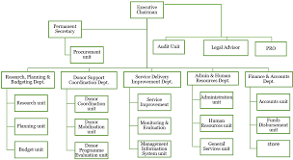

2.2 MAJOR ACTIVITIES OF ORGANIZATION
S.O OLADEJI & SON NIGERIA LIMITED, (SOOSNL) it’s typically engages in a variety of activities aimed at addressing the challenges and needs of housing development. While specific activities can vary from country to country, some common major activities of such ministries include:
- Housing Policy Development: SOOSNL often formulates and implements housing policies aimed at ensuring adequate, affordable, and sustainable housing for all segments of society. This may involve conducting research, analyzing housing markets, and creating strategies to address housing shortages and affordability issues.
- Building Planning and Development: The ministry is often responsible for structure planning and development, which includes land use planning, zoning regulations, infrastructure development, and environmental sustainability initiatives in a specific area.
- Public Housing Programs: SOOSNL may administer public housing programs aimed at providing affordable housing to low-income individuals and families. This can include the construction, maintenance, and management of public housing projects.
- Housing Finance and Subsidies: The ministry may oversee housing finance programs and subsidies designed to assist low and moderate-income households in accessing housing finance, including mortgage assistance programs and rental subsidies.
- Building Renewal and Redevelopment: SOOSNL often initiates building renewal and redevelopment projects aimed at revitalizing blighted particular areas, improving infrastructure, and promoting economic development and investment in neighborhoods.
2.3 ROLE OF QUALITY SURVEYOR
A Quantity Surveyor (QS) plays a crucial role in the construction industry, particularly in managing the financial aspects of construction projects. Here are the key roles and responsibilities of a Quantity Surveyor:
- Cost Estimation: Quantity Surveyors are responsible for accurately estimating the costs associated with construction projects. This involves analyzing project plans and specifications to quantify the materials, labor, and other resources required for construction.
- Budget Management: QS professionals develop and manage project budgets, ensuring that costs are kept within the approved budget constraints. They monitor expenses throughout the project lifecycle and advice on cost-saving measures when necessary.
- Procurement Management: Quantity Surveyors are involved in procurement processes, including obtaining quotes, negotiating contracts with suppliers and subcontractors, and ensuring that materials and services are procured in a cost-effective manner.
- Tendering Process: Quantity Surveyors prepare tender documents and analyze bids from contractors and suppliers. They assess the financial viability of bids, evaluate proposed costs against project requirements, and recommend suitable contractors for awarding contracts.
- Cost Control: QS professionals monitor and control project costs throughout the construction phase. They track expenditures, identify cost variances, and implement corrective actions to keep costs in line with the budget.

2.4 ROLE OF A BUILDER
The role of a builder in the construction industry is multifaceted and crucial for the successful completion of construction projects. Here are the key roles and responsibilities of a builder:
- Project Planning and Management: Builders are responsible for planning and managing construction projects from inception to completion. This involves coordinating various aspects of the project, including scheduling, resource allocation, and procurement of materials and equipment.
- Site Preparation and Management: Builders oversee site preparation activities, including clearing, grading, and excavation, to ensure that the site is ready for construction. They manage site logistics, safety protocols, and environmental compliance throughout the construction process.
- Construction Execution: Builders are responsible for executing construction activities according to project specifications, drawings, and quality standards. This includes coordinating subcontractors, supervising construction crews, and ensuring that work is completed on time and within budget.
- Quality Control and Assurance: Builders ensure that construction work meets quality standards and adheres to regulatory requirements. They conduct quality inspections, review workmanship, and address any deficiencies or non-compliance issues to maintain the integrity of the construction project.
- Health and Safety Management: Builders prioritize health and safety on construction sites by implementing safety protocols, providing training to workers, and maintaining a safe working environment. They identify and mitigate potential hazards, conduct safety inspections, and ensure compliance with occupational health and safety regulations.

CHAPTER THREE

EXPERIENCE GAINED DURING SIWES
3.1 BUILDING INSTRUMENT
A building instrument typically refers to a tool or device used in the construction industry for various purposes related to building, renovating, or maintaining structures. These instruments can range from simple handheld tools to complex machinery, each serving specific functions in the construction process. Here are some common types of building instruments:
- Measuring Tools: Measuring instruments such as tape measures, rulers, levels, and laser distance meters are used to accurately measure distances, dimensions, angles, and elevations during the construction process.
- Cutting Tools: Cutting instruments like saws, knives, shears, and cutting pliers are essential for cutting and shaping materials such as wood, metal, plastic, and drywall to the required dimensions for construction projects.
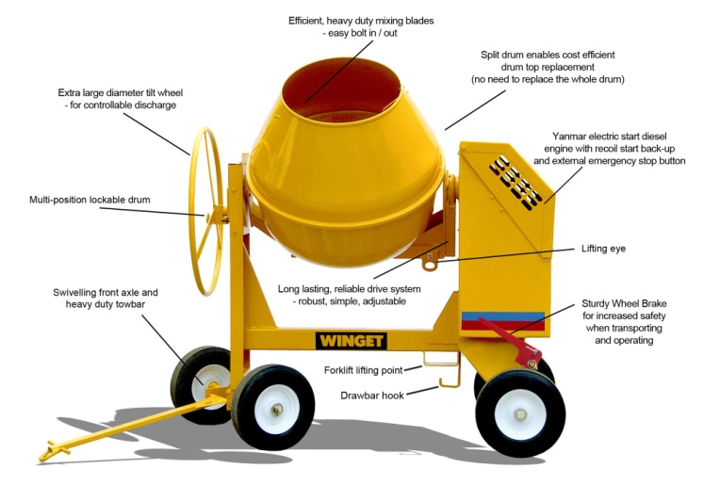
- Fastening Tools: Fastening instruments such as hammers, screwdrivers, nail guns, staple guns, and drills are used to fasten and secure materials together, including nails, screws, bolts, and adhesives.
- Excavation and Earthmoving Equipment: Excavation and earthmoving machinery such as excavators, bulldozers, backhoes, loaders, and trenchers are used to dig, move, and reshape soil and earth during site preparation and excavation work.
- Concrete Tools: Concrete instruments such as concrete mixers, trowels, screeds, floats, and vibrators are used to mix, pour, spread, level, and finish concrete for foundations, slabs, walls, and other structural components.
3.2 INTRODUCTION TO MEASUREMENT
Measurement is the act of measuring base on design, the act of measurement from a certain unit. Everything in the world can be measured; there is nothing that cannot be measured. The known quantity which is used in measurement is called a UNIT, for example; when you say that your height is 150cm then the measurement of your height is being expressed in a number, i.e. 150 and a unit, i.e. centimeter. Example of measurement in our daily life:
- Time
- Size

- Distance Water Bar
- Speed
- Direction
- Weight
- Volume
- Temperature
- Pressure
- Force
- Sound
- Light
- Energy
Basic Measurement
Type U.S Unit Merit Unit
Length Inches, Feet, Yards, Miles Millimeters, Centimeters, Weight Ounces, Pounds Grams. Kilograms
Time Sounds, Minutes, Hours Seconds. etc
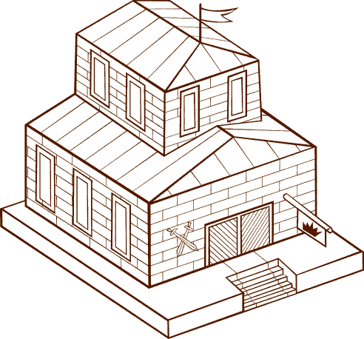
The measurement of quantities for construction works involves the transform plans and quantities.
Major types of Measurement
- Direct
- Indirect
- Fundamental
- Substitution
- Compassion
Maintenance of Building:
Building maintenance refers to activities performed to retain and restore the functionality of residential and commercial properties.
3.3 FOUNDATION
Foundations are crucial structural elements of buildings that distribute the weight of the structure and its loads to the ground, providing stability and preventing settlement or movement. Different types of foundations are used based on factors such as soil conditions, building size, and structural requirements.
Types of Foundations:
- Shallow Foundations:
  - Strip Footing: A continuous strip of concrete that supports the load of a masonry wall or a line of closely spaced columns.
  - Spread Footing: A wider base under individual columns or walls to distribute the load over a larger area.
  - Mat or Raft Foundation: A large concrete slab that supports the entire structure, distributing the load evenly over a wide area. It's suitable for weak or expansive soils.
- Deep Foundations:
  - Pile Foundations: Long, slender columns driven into the ground to transfer loads through weak or compressible soils to deeper, more competent layers.
    - Driven Piles: Installed by driving prefabricated piles into the ground using impact hammers.
    - Bored Piles: Constructed by drilling holes into the ground and then filling them with reinforced concrete.
  - Caisson Foundations: Large-diameter, watertight cylindrical structures sunk into the ground and filled with concrete. They can be open or closed at the bottom.
    - Open Caisson (Cofferdam): Used for constructing bridge piers and other structures in water.
    - Closed Caisson (Pneumatic Caisson): Pressurized to keep water and soil out during construction.
- Special Foundations:
  - Floating Foundations: Used in areas with soft soils or high water tables. The structure "floats" on the ground or water with minimal or no excavation.
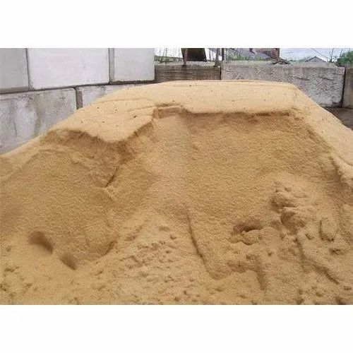
  - Screw Piles: Helical steel piles screwed into the ground. They're quick to install and suitable for temporary structures or areas with restricted access.
  - Grillage Foundations: Consist of steel beams or grillage mats supported by piles. Used for heavy structures on soft soils.
- Combination Foundations:
  - Underpinning: Strengthening or stabilizing existing foundations by extending them deeper into the ground or adding new piles or footings.
  - Raft and Pile Foundations: A combination of mat or raft foundation with piles to provide additional support in areas with poor soil conditions.
3.4 HEALTH AND SAFETY IN CONSTRUCTION
Health and safety in construction are paramount due to the inherently hazardous nature of construction work. Construction sites involve various risks, including falls from height, exposure to hazardous substances, heavy machinery operation, and structural collapses. Proper health and safety measures are essential to protect workers, prevent accidents, and ensure compliance with regulations. Here are key aspects of health and safety in construction:

- Risk Assessment and Management: Conducting thorough risk assessments to identify potential hazards and implementing measures to control or eliminate risks. This includes regular inspections of the site, equipment, and work practices.
- Training and Education: Providing comprehensive health and safety training to all workers, including orientation for new employees and specific training for tasks involving hazardous activities or equipment operation.
- Personal Protective Equipment (PPE): Ensuring the provision and proper use of PPE, such as hard hats, safety goggles, gloves, high-visibility clothing, and fall protection gear, to mitigate the risk of injury.
- Fall Protection: Implementing fall protection measures, such as guardrails, safety nets, and personal fall arrest systems, to prevent falls from heights, which are one of the leading causes of construction-related injuries and fatalities.
- Scaffolding Safety: Ensuring the proper erection, inspection, and maintenance of scaffolding to provide a safe working platform for workers at elevated heights.
- Electrical Safety: Adhering to electrical safety standards and regulations to prevent electric shocks, fires, and other electrical hazards. This includes proper installation, maintenance, and use of electrical equipment and wiring.
- Machinery and Equipment Safety: Providing adequate training for the safe operation of machinery and equipment, conducting regular inspections and maintenance, and implementing lockout/tag out procedures to control hazardous energy sources.
- Hazardous Substances Management: Identifying and controlling exposure to hazardous substances such as asbestos, lead, silica dust, and toxic chemicals through proper handling, storage, and use of controls such as ventilation, respiratory protection, and decontamination procedures.
- Emergency Preparedness: Developing and implementing emergency response plans, including procedures for evacuation, first aid, and reporting accidents and incidents.
- Worker Involvement and Communication: Encouraging worker involvement in health and safety matters, providing avenues for reporting concerns or hazards, and fostering a culture of safety through effective communication and consultation.
- Compliance with Regulations: Ensuring compliance with local, state, and federal health and safety regulations, as well as industry standards and best practices.
- Continuous Improvement: Regularly reviewing and evaluating health and safety performance, seeking feedback from workers, and implementing measures to improve safety practices and prevent accidents.

CAPTER FOUR
4.1 WAFFLE SLAB
A waffle slab is a type of reinforced concrete slab with a grid-like pattern of ribs or deep beams underneath the slab. This grid of ribs resembles a waffle, hence the name. Waffle slabs are commonly used in construction for both residential and commercial buildings due to their structural efficiency and versatility. Here are some key features and advantages of waffle slabs:
- Structural Efficiency: The grid pattern of ribs provides significant strength and stiffness to the slab, allowing it to span longer distances without the need for additional support columns or beams.
- Reduced Concrete Usage: Waffle slabs typically use less concrete compared to solid slabs of similar span and load-bearing capacity, resulting in cost savings and environmental benefits.
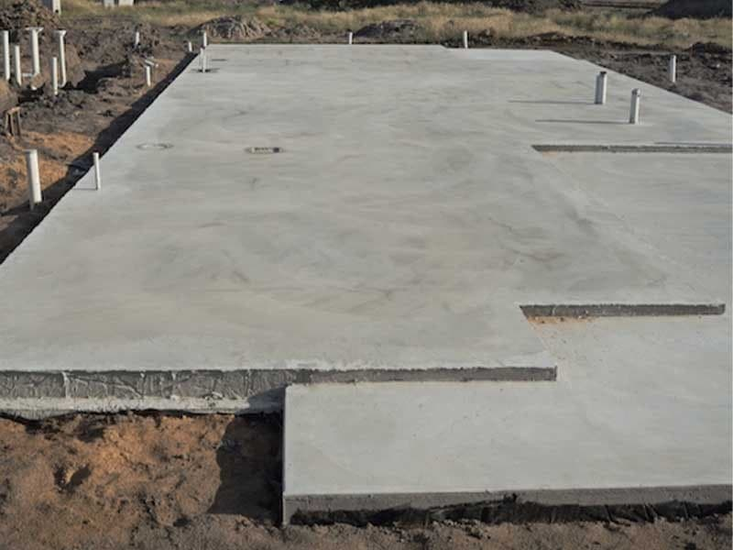
- Lightweight Construction: Despite their structural strength, waffle slabs are relatively lightweight, making them easier to handle and transport during construction.
- Improved Thermal and Sound Insulation: The voids created by the ribbed pattern in waffle slabs can be filled with insulating materials, enhancing thermal and sound insulation properties of the building.
- Flexibility in Design: Waffle slabs offer flexibility in design, allowing for various configurations of rib spacing, depth, and layout to accommodate different architectural and structural requirements.
- Aesthetic Appeal: The grid pattern of waffle slabs can create visually interesting ceilings and architectural features, adding aesthetic appeal to interior spaces.
- Long-Span Capabilities: Waffle slabs can span longer distances compared to traditional solid slabs, making them suitable for large open floor plans and areas where column-free space is desired.
- Ease of Installation: Waffle slabs are typically prefabricated off-site or constructed using reusable formwork systems, reducing on-site construction time and labor costs.
Despite their advantages, waffle slabs also have some limitations and considerations:
- Increased Floor Height: The deep beams or ribs of waffle slabs can result in increased floor height, which may be a consideration in building design and construction.
- Complex Formwork: The construction of waffle slabs requires careful planning and complex formwork systems to create the ribbed pattern, which can increase initial construction costs.
- Maintenance Challenges: Cleaning and maintaining the voids in waffle slabs can be challenging, particularly if they are used as exposed ceilings.
4.2 WALL MAKING
Wall is made from many materials the most common among them are as follows:
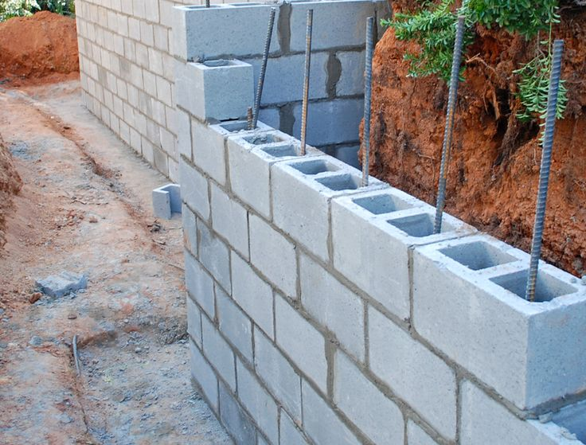
- Sand
- Blocks
- Concrete blocks
- Bricks Block wall
- Stones
- Timbers
- Reinforced concrete etc.
The method of constructing a wall with sand etc blocks is the same with that used of blocks, reasoning first the outer or end of the wall are contracted with few course of blocks, or its applied to the bottom of blocks. A mortar is applied to the bottom on the horizontal members. Straight walls are constructed using the corner or end blocks to make a reference line.
Before making walls, it is advisable to ensure that the blocks are well cured and dry. Block of successive joint are staged and joint shroud.
4.3 JOB SITE PREPARATION
Job site preparation is a critical initial phase in any construction project. It involves various tasks and activities aimed at readying the construction site for building activities. Here are the key aspects of job site preparation:
- Site Clearing: The first step is to clear the construction site of any existing structures, vegetation, debris, and obstacles. This includes demolishing old buildings, removing trees, bushes, rocks, and other obstructions that may interfere with construction activities.
- Grading and Excavation: After clearing the site, grading and excavation are conducted to level the ground and prepare it for construction. This involves cutting, filling, and reshaping the land to achieve the desired elevation and slope according to the building plans.
- Utility Identification and Marking: Before excavation begins, utility lines such as water pipes, sewer lines, electrical conduits, and gas lines must be identified and marked to prevent accidental damage during excavation. This is typically done by contacting local utility companies or using specialized services for utility locating.
- Temporary Facilities Setup: Temporary facilities such as construction trailers, storage containers, portable toilets, and fencing may need to be installed on the site to accommodate construction crews, equipment, and materials throughout the project duration.
- Access and Egress: Access points for construction vehicles and personnel must be established to ensure safe and efficient entry and exit to the site. This may involve creating driveways, access roads, and pedestrian walkways that comply with local regulations and safety standards.

- Erosion Control Measures: Measures to prevent soil erosion and sediment runoff must be implemented to protect the surrounding environment and comply with environmental regulations. This may include installing erosion control barriers, silt fences, and sediment basins to manage storm water runoff.

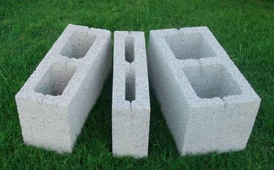
Peg

3inches and 9inches

CHAPTER FIVE
5.1 CONCLUSION
In Conclusion It’s Good To Understand At This Contemporary Stage In Life That “Success As We All Understand Is Not Measured By The Height At Which One Find Himself, But It Can Be Measured By What You Can Achieved With Your Initiative”.
The organization has been able to import knowledge like now what are in jet age where knowledge is mostly needed in the running of daily life. My coming out of the organization has increased my knowledge of the computer practically and theatrically which is an eye opener.
5.2 PERSONAL IMPRESSIONS ABOUT THE ORGANIZATION
The introduction of the students industrial worked experience scheme (SIWES) is highly appreciated has applied to the part of fundamental learning of students.
As discussed thoroughly, the idea of students industrial worked experience scheme is a great opportunity to student who is ready to achieve and to gain more in the area of specialization course of study.
5.3 RECOMMENDATION
With the opportunity of the students industrial worked experience scheme (SIWES) effective facilities are here by demanded to equip trainee for effective performance and standard.
The implementation of the students industrial worked experience scheme (SIWES) should be made a stronger exercise so as to improve the level of exercise.

[

