

TECHNICAL REPORT ON
STUDENTS INDUSTRIAL WORKS EXPERIENCE SCHEMES (SIWES)

HELD AT

sTAndard broadcasting station (sbs fm 96.9)
Ikwah Community Federal Low Cost Oloje Estate Ilorin Kwara State

PRESENTED BY:

ADEDOYIN IRADAT TUNRAYO
ND/23/MAC/PT/1124

SUBMITTED TO:

THE DEPARTMENT OF MASS COMMUNICATION, INSTITUTE OF INFORMATION AND COMMUNICATION TECHNOLOGY, KWARA STATE POLYTECHNIC, ILORIN.
IN PARTIAL FULFILMENT OF THE REQUIREMENT FOR THE
AWARD OF NATIONAL DIPLOMA (ND) IN MASS COMMUNICATION.

AUGUST - NOVERMBER 2024

DEDICATION
I am delight to dedicate this report to Almighty God who gave me the grace and opportunity to complete this programme.

ACKNOWLEDGEMENT
I thank God Almighty for his mercy and grace that kept me all through my SIWES period.
I am greatly indebted to my parents, Mr. & Mrs. Adedoyin for their morally, spiritually and financially, word of encouragement and prayer given to me, who make my SIWES programme successful and also my relatives and siblings.
I also want to thank my friend and everyone that contributed to the success of my SIWES program my Industrial supervisors, my colleagues and co-workers for the tremendous moral assistance throughout the period of my attachment.

REPORT OVERVIEW
The report comprises the background of SIWES, the description of the organization, its aims and objectives, the experiences gained as an industrial training student and the summary, conclusions and recommendations.
It has a total of 5 chapters with sub-chapters. It also has the preliminary pages, such as the title page, report overview and table of contents and recommendations on the improvement of scheme.

TABLE OF CONTENT
Title Page i
Dedication ii
Acknowledgement iii
Report Overview iv
Table of Contents v

CHAPTER ONE
1.0 Introduction 1
1.1 Definition of SIWES 1
1.2 Aim and Objectives 1

CHAPTER TWO
2.0 Brief history of the organization 3
2.1 Organization chart 4

CHAPTER THREE
3.0 Workdone 5
3.1 The elements of journalism 5
3.2 Taking picture with caption 5
3.3 Tips for writing effective captions 5
3.4 What is print media 7
3.5 How do you structure a radio program 7
3.6 What is news casting 7
3.7 What is news writing 7
3.8 How to write news 7
3.9 What are the rules of press reporters 8
3.10 Broadcasting 10
3.11 Types of broadcasting 11
3.12 Studio broadcasting equipment 11

CHAPTER FOUR
4.0 Experience gain 13

CHAPTER FIVE
5.0 Conclusion 14
5.1 Suggestion and Recommendation to the organization and polytechnic concerning the siwes program 14

CHAPTER ONE
- INTRODUCTION
SIWES program was established in year 1973 by the federal Government of Nigeria through the industrial Training Fund (ITF) under the National Board of Technical Education (N.B.T.E) and it has its head quarters in Jos, plateau state.
There are other reasons behind the establishment of SIWES program, but the major reason is to learn the practical aspect of their field of study while still in course of study, which will help to face the future challenges in their respective field of study.
1.1 DEFINITION OF SIWES
Student Industrial Work Experience Scheme (SIWES) can simply be defined as a course by which student are exposed to practical training in their respective field of study. Its aim is to expose students to work practically in their respective disciplines. However, the scheme therefore was introduce to enable students match theoretical classroom knowledge with related practical knowledge in the industrial environment.
1.2 AIM AND OBJECTIVES OF SIWES
- SIWES helps the student to have experience and develop during industrial training.
- To improve students in the practical aspect of their field.
- It helps to improve quality of student in the level of their technology.
- It makes student to find their interests in the various fields of study.
- To prepare student for the future.

CHAPTER TWO
2.0 BRIEF HISTORY OF THE ORGANIZATION
Standard Broadcasting Station (SBS FM 96.9) was established on May 10, 1976, with the primary function of gathering, processing and distributing news about Nigeria to local and foreign news media. The Agency’s mandate is to present a complete, objective and impartial information, news or news material or features on any matter of public or national interest within and outside the federation. NAN is determined to maintain its position as the leading News Agency in Africa through increased capacity for quick and efficient delivery of accurate, reliable, comprehensive and balanced information for our varied clientele on a commercial basis.
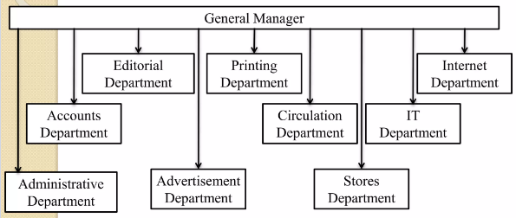
2.1 ORGANIZATION CHART

CHAPTER THREE
3.0 WORKDONE
3.1 THE ELEMENTS OF JOURNALISM
- Journalism's first obligation is to the truth
- Its first loyalty is to citizens
- Its essence is a discipline of verification
- Its practitioners must maintain an independence from those they cover
- It must serve as an independent monitor of power.
3.2 TAKING PICTURE WITH CAPTION
Even if a picture is worth a thousand words, it still needs a caption to draw readers, provide context and tell the story.
3.3 TIPS FOR WRITING EFFECTIVE CAPTIONS.
- Check the facts. Be accurate with credit lines, details and anything else that might catch a reader’s eye.
- Captions should add new information. Don’t merely repeat the story headline or summary, and avoid stating the obvious elements that are captured in the image. The caption should add context to the image, not just duplicate what the reader already sees.
- Always identify the main people in the photograph.
- A photograph captures a moment in time. Whenever possible, use present tense. This creates a sense of immediacy and impact.
- Conversational language works best. Write the caption as though you are talking to a family member or friend.
- The tone of the caption should match the tone of the image. Don’t try to be humorous when the photo is not.

EQUIPMENT FOR JOURNALIST
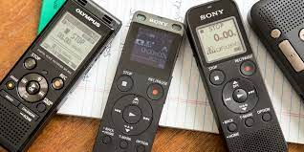



HEADPHONES MICROPHONES VOICE RECORDER
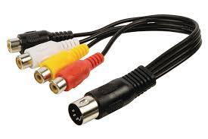

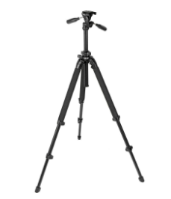


PRO-TRIPOD AUDIO ADAPTER CABLE NOTE BOOK
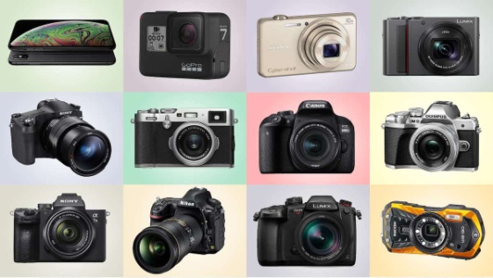


DITTO FOR MEMORY CARDS CAMERAS PEN & PENCIL



LAPTOP COMPUTER SMART PHONE
3.4 WHAT IS PRINT MEDIA
Print media refers to any form of communication or information distributed in printed format, typically on paper. It encompasses various publications, such as newspapers, magazines, brochures, pamphlets, newsletters, books, and posters.
3.5 HOW DO YOU STRUCTURE A RADIO PROGRAM?
Start with an Intro, End with an outro. It's not a bad idea to start with some kind of open or intro that explains what people are about to hear and who they are listening to. Intros make a great slot for thanking program sponsors, too. Likewise, end the show with a close or an outro.
3.6 WHAT IS NEWS CASTING?
A newscast is a news programme that is broadcast on the radio or on television.
3.7 WHAT IS NEWS WRITING?
Journalism or news writing is a prose style used for reporting in newspapers, radio, and television. When writing journalistically, one has to take into account not only one's audience, but also the tone in which the piece is delivered, as well as the ABCs of news writing: Accuracy, Brevity, and Clarity.
3.8 HOW TO WRITE NEWS
A news report should include the following,
- Headline: It tells what the story is about.
- Byline: It tells about the writer of the story.
- Lead: Covers the most important facts.
- Body: Includes a detailed account of the event/occurrence.
- Ending: Talks about the solution or something to think about.
RULES GUIDING NEWS WRITING
- Organization (the Inverted Pyramid) People have a tendency to tell stories chronologically
- Lead. The start of a news story should present the most compelling information.
- Fact (Not Opinion) and Attribution
- Identification
- Short Paragraphs
- Person
- Headlines
3.9 WHAT ARE THE RULES OF PRESS REPORTERS?
- Accuracy is the first rule of reporting.
- Be fair. It is not sufficient for an article to be libel-proof. Try to get the other side of the story and tell it.
- Observe the laws of good taste, something which is impossible of exact definition, but which most civilized and educated people know by instinct.
- Rarely is there such a thing as too much of a good story.
- Important stories need not be long.
- Sentences and paragraphs should be short.
- The lead should always be clear, provocative and simple. It should promise things to come, and the promise should be fulfilled.
- News accounts are improved by quotes. Speech should be quoted exactly as spoken.
- Select adjectives as you would lovers. Too many are dangerous.
- Do not be overly impressed when you get an important assignment. If you do, it will show in your copy.
- Go directly to the source on every story. Use your legs. Most so-called Big Shots are ever bit as approachable as a peasant and much more inclined to articulate their views.
- Leave no reasonable questions unanswered.
- Do not assume that the reader knows the background of the story.
- Get everything, including the last small details. If the speaker wears button shoes, that’s news. So is a wig. When you start the writing process you may kick yourself if you’re missing a detail you could have gotten when you were out doing the reporting.
- Be polite, but do not be servile.
- Don’t avoid writing facts on the assumption that "everybody knows that."
- Most stories are improved by a time element. That doesn’t mean you should say an accident occurred at 2:18.5 p.m., but it is laziness to say it occurred "yesterday."
- Never despise the homely, the familiar, the sweaty. The average reader should be able to identify with the story, and sometimes say, "This could have happened to me."
- Never insult or stereotype a race. You can mention race when it is necessary to the story, but otherwise be colorblind.
- Don’t abuse the weapons of your trade.
3.10 BROADCASTING
Broadcasting is the distribution of content, either audio or video, to a large dispersed audience by means of any medium of electronic mass communications. Typically, the mass communications medium is one that uses the electromagnetic spectrum, i.e. radio waves, in a one-to-many model.
3.11 TYPES OF BROADCASTING
- Radio broadcasting
- Television broadcasting
- Satellite broadcasting
- Cable broadcasting:
3.12 STUDIO BROADCASTING EQUIPMENT
- HEADPHONES
- MICROPHONES
- MIXER
- ON AIR LIGHT
- SPEAKERS
- AUDIO
- MIC ARM
- MONITOR
- MICROPHONE PROCESSOR
- RDS ENCODER
- VIDEO TRANSMITTER
- BROADCAST DESK
- CABLE
- CAMERAS
- CD PLAYER
- GSM INTERFACE
- RADIO AUTOMATED SOFTWARE
- TALENT PANEL
- TELEPHONE
- AMPLIFIERS
- ANTENNA
- AUDIO SWITCHER
- BROADCASTING SOFTWARE
- COMPUTER

CHAPTER FOUR
4.0 EXPERIENCE GAIN
In summary, this program has exposed me to some practical aspect in relation to my course of study (Mass communication) and I benefitted greatly from the program. What I learnt at various department involves the following.
- How to make an interview
- How to write good news
- How to write an headline and where to put a byline
- How to take a picture in news writing
- Identification of necessary equipment for journalist.
- How to do investigating journalism
- How to curb for fake news as a professional
- How to conduct and collate survey.

CHAPTER FIVE
5.0 CONCLUSION
The student industrial work experience scheme (SIWES) in an interesting and programmed that adds more value to students view and objectives of their field of studies.
More so, it adds advancement to the student experience on the theoretical aspect of their course, since they are exposed to the real practical aspect during the programmed.
Furthermore, it widens the horizon of students, because it makes them understand the rules and regulations governing their field of studies. This would guide them when they establish on their own.
5.1 SUGGESTION AND RECOMMENDATION TO THE ORGANIZATION AND POLYTECHNIC CONCERNING THE SIWES PROGRAM
SIWES coordinator and the polytechnic authority should try to stop the habit of rejecting students for SIWES program by the industry. The institution supervisor should make it a priority to visit their designated students in the various organizations to update the student’s log book.
Finally, they should resist the habit of staying in school and wait for their wards to finish the SIWES program only for them to sign their training log book and award them grade of the choices without checking the performance of the student in the field.

