

TECHNICAL REPORT ON STUDENTS INDUSTRIAL WORK EXPERIENCE SCHEME (SIWES)
HELD AT

SBS [96.9fm]
BY
IGE DORCAS OLUWATOSIN
ND/23/MAC/PT/0896

SUBMITTED TO:
THE DEPARTMENT OF MASS COMMUNICATION, KWARA STATE POLYTECHNIC
INSTITUTE OF INFORMATION AND COMMUNICATION TECHNOLOGY (IICT)
P.M.B. 1375 ILORIN, KWARA STATE.

IN PARTIAL FULFILMENT FOR THE AWARD OF NATIONAL DIPLOMA (ND) IN
MASS COMMUNICATION,
KWARA STATE.

AUGUST- NOVEMBER, 2024

DEDICATION
I dedicate this to God for seeing me through; also to my lovely parent Mr& Mr IGE for their support both morally and financially, May God reward you abundantly with long life and good health.

ACKNOWLEDGEMENT
Special appreciation goes to my parent Mr& Mrs IGE for their love and care, applaud them for making me fall in love with education.
My gratitude is incomplete without acknowledging my maternal family for their support and contribution to my onward progress in life.
I also commend my supervisor, Mr. Yahya G.M for his intellectual contribution and support during my SIWES
A big thanks to my colleagues from different intuitions that formed the group members during my training.

TABLE OF CONTENTS
TITLE PAGE…………………………………………………………………………..i
Dedication……………….………………………………………………………………ii
Acknowledgement………………………………………………………………………iii
Table of Contents………………...…………………………………………………iv-v
CHAPTER ONE
- Introduction………………………………………………………………………….1
  - Background of the SIWES……………………………………………………...…1-2
  - Aims and Objectives of SIWES…………………………………………………......2
CHAPTER TWO
2.0 Location and Brief history of SBS ……………………………………………….3
2.1 Objectives of SBS …………………………….………………………………….3
2.2 Organization of SBS….……..…………………………………………………....4
2.3 SBS organization Chart…………………………………………………………..5
CHAPTER THREE
3.0 Items in the Studio with their functions…………………………………………….6
3.1 Departments in SBS and their functions.…………………….………..……………10
CHAPTER FOUR
- Experience Gained………………………………………………………………12
4.1 Interpersonal Relationship with the organization……………………………........12
4.2 Suggestion for improvement of the program……………………………………..12
CHAPTER FIVE
- Conclusion………………………………………………………………………….13
5.1 Recommendation………………………………………………………………..13

CHAPTER ONE
1.0 INTRODUCTION
1.1 BACKGROUND OF SIWES
The abbreviation “SIWES” stands for student industrial work experience scheme. It was initiated by Industrial Training Fund (ITF) in 1973 so as to complement the theoretical knowledge acquired in higher institutions with practical experience.
The Scheme exposes students to industry based skills necessary for a smooth transition from the classroom to the world of work. It affords students of tertiary institutions the opportunity of being familiarized and exposed to the needed experience in handling machinery and equipment which are usually not available in the educational institutions.
Participation in Industrial Training is a well-known educational strategy. Classroom studies are integrated with learning through hands-on work experiences in a field related to the student’s academic major and career goals. Successful internships foster an experiential learning process that not only promotes career preparation but provides opportunities for learners to develop skills necessary to become leaders in their chosen professions.
One of the primary goals of the SIWES is to help students integrate leadership development into the experiential learning process. Students are expected to learn and develop basic non-profit leadership skills through a mentoring relationship with innovative non-profit leaders. By integrating leadership development activities into the Industrial Training experience, they hope to encourage students to actively engage in non-profit management as a professional career objective.
Participation in SIWES has become a necessary pre-condition for the award of Diploma and Degree certificates in specific disciplines in most institutions of higher learning in the country, in accordance with the education policy of government. Another goal of the SIWES is to promote industrialization in Nigeria, an avenue between the world of teaching, learning, industry and work with reference to the field of study.
  - AIMS AND OBJECTIVES OF SIWES
- Provision of avenue for students in the Nigerian universities to gain industrial skills and experience in their course of study.
- To expose students to work methods and techniques in handling equipment and machinery that may not be available in the universities.
- To make the transitions from the university to the world of world of work easier and thus enhance students’ contacts for later job placement.
- To provide students with the opportunity to apply their theoretical knowledge in real work situation, thereby bridging the gap between university work and actual practice.
- To enlist and strengthen employers involvement in the entire educational process of preparing university graduates for employment.
- To provide students the opportunity to test their interest in a particular career before permanent commitments are made.
- To provide students the opportunity to develop attitudes conducive to effective interpersonal relationships.
- To increase students’ sense of responsibility.
- To prepare students for work situation they are likely to meet after graduation.

CHAPTER TWO
2.0 LOCATION AND BRIEF HISTORY OF SBS
Salman Babatunde Salman [SBS 96.9 fm] it is a newly and fast media station that is owned by a sole proprietorship under the board of trustees as a body of decision maker.
[SBS 96.9 fm] is a commercial license radio station, located at federal housing estate, beside air force base oloje, Ikwah community, Ilorin Kwara State.
The station as an online radio station in the year 2018 and grew into terrestrial station in October 2019 as a community radio station, to God be the glory SBS fm is now fully licensed commercial radio station approved by NBC in the year 2022 till date.
SBS fm is an household name in Ilorin kwara state capital which is the most density city in the state. The location of the station make it only one in the heart of Ilorin and both elites and masses embraced it as their medium.
Our reach on terrestrial broadcasting include entire Kwara State, part of Oyo, Osun, Ekiti, Ondo and Niger state while online streaming make our medium has no boundary throughout the world.
  - OBJECTIVES OF SBS
- To be the channel transforming the world through broadcasting by upholding our heritage using global best practice.
- To raise and sustain a television station that promotes stakeholders mutual relation and agreement through professionalism and innovative quality programming.
- To put information and classic entertainment music at listener’s fingertips
- To enable audience to be aware/involve in certain issue.
- To make a tour to the station’s site in the cyberspace presents a programming promise that is focused on a package of culture that is rich in local content, news, education and youth entertainment.
- To ensure that its main core values are practiced to provide quality service and to enable satisfaction from its audience. The core values of SBS is explained below;
S salman
B babatunde
S salman
2.2 ORGANIZATIONAL STRUCTURE OF SBS
An organizational structure is the typically hierarchical arrangement of lines of authority, communications, rights and duties of an organization. It determines how the roles, power and responsibilities are assigned, controlled, and coordinated, and how information flows between the different levels of management.
It provides for explicit and implicit institutional rules and policies designed to provide a structure where various work roles and responsibilities are delegated, controlled and coordinated. Organizational structure also determines how information flows from level to level within the company. In a centralized structure, decisions flow from the top down. In a decentralized structure, the decisions are made at various different levels.
In most organizations, the organizational structure is often referred to as organogram. The head of SBS is the General Manager. The explanation below is how SBS structure is being arranged.
- GENERAL MANAGER
A general manager or GM is the chief executive officer of a television station. This person manages the budget for the station, set human resources policies, hires and fires staff and also oversees all programming and sales initiatives. This or these individuals create a strategic plan for organization and set benchmarks for achieving goals. They often have a high profile in the community and form strategic partnership with local organization to raise the visibility of the station within the market.
- STATION MANAGER
The station manager is responsible for the overall health of their radio station and help their team achieve the highest standard of content production through creative leadership. It’s their responsibility to make sure the team focused on the network’s goals and strategy with everything.
- PROGRAMM MANAGER
Program manager they coordinate activities between multiple project without direct managing them, instead the manage the main program, giving detailed attention to program strategy, project delegation, and program implementation.
2.3 SBS ORGANIZATION CHART
GENERAL MANAGER

Chief engineer
Operations
Transmitter manager
News director
Business manager
Talents
Reporters
Accounting
Building maintenance
Engineers
Technicians
Traffic manager

Maintenance supervisor

CHAPTER THREE
3.0 ITEMS IN THE STUDIO WITH THEIR FUNCTIONS
The television studio is a treasure trove of equipment, tools, and props that collectively contribute to the seamless execution of broadcast productions. From state-of-the-art cameras to intricate set designs, each item plays a vital role in bringing stories to life on screen. Let's delve into the diverse array of items found within the studio:
Cameras: Cameras are the eyes of the production, capturing visuals that transport audiences into the heart of the action. From traditional studio cameras mounted on pedestals to handheld and robotic cameras, each serves a unique purpose in capturing dynamic shots and angles.
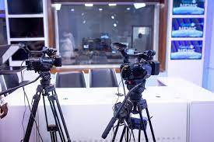

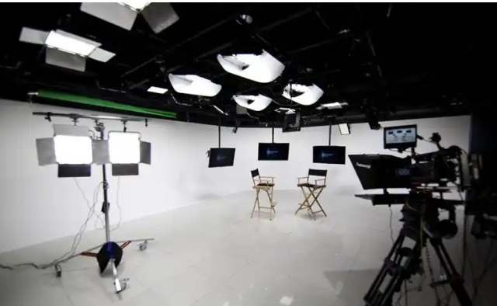
Lighting Equipment: Lighting equipment is essential for setting the mood, atmosphere, and tone of a production. This includes various types of lights such as key lights, fill lights, and backlights, as well as accessories like diffusers, gels, and barn doors to control and manipulate light intensity and direction.

Headphone: is a device that boosts the audio signal from a source, such as a computer, smartphone, or music player, to a level that can drive headphones or speakers. Headphones are a pair of small loudspeaker drivers worn on or around the head over a user's ears.

Set Design Elements:
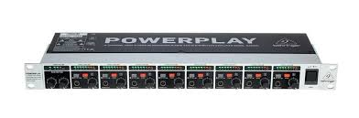
Set design elements encompass a wide range of props, furniture, and scenic elements that transform a soundstage into a vibrant and immersive environment. From furniture and decor to backdrops and set pieces, each element is carefully selected and arranged to enhance the visual storytelling experience.

Teleprompters:
Teleprompters are invaluable tools for presenters and actors, providing them with a script or cue cards displayed on a screen in front of the camera lens. This allows performers to deliver lines and dialogue confidently while maintaining eye contact with the audience.

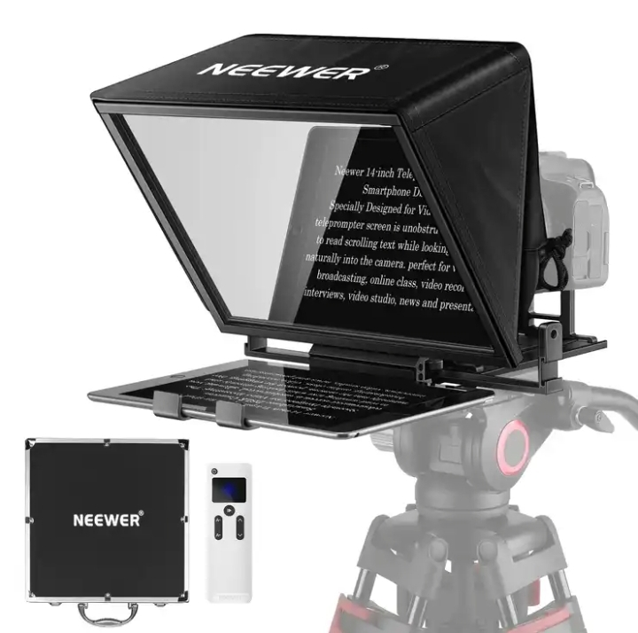

Graphics and Visual Effects:
Graphics and visual effects add depth, context, and visual interest to broadcast productions. This includes on-screen graphics, animations, virtual sets, and augmented reality elements that enhance storytelling and engage viewers in new and exciting ways.
Control Room Equipment:
The control room is the nerve center of the studio, housing equipment such as video switchers, audio mixers, and computer systems that facilitate real-time monitoring, editing, and broadcasting of live and recorded content.

3.1 DEPARTMENTS IN SBS AND THEIR FUNCTIONS
SBS has the following departments:
- Administrative department: This department handles the day to day business of a television station .They see to staff recruitment, training, promotions, etc. This department is also responsible for smooth management of the processes in SBS. Also they consult with other department heads regarding cash flow and expenditures. In SBS the branch manager oversees the activities of other departments and ensures proper working condition for staffs, hiring employees and ensures a safe workplace in all departments.
- News and current affairs department: This department is the local face of any television station. They are responsible for the compilation of news and keeping up to date with trending information, news, events and so on. In this department; there are various beat reporters who are assigned to different locations in Ilorin. Therefore, this department sees to the generation and presentation of news items and current affairs material as well as editing, writing/typing and printing the news in the station’s house-style. The department carries out research everyday as events/occurrences unfold to have their facts and figures as well as having accurate report for their listener. News anchors, reporters, meteorologists and sports anchors usually become recognizable personalities in their communities.
- Programme department: This department is sub-divided into two: programmes and production sections. The programmes department is in charge of programming while the production unit is made up of producers who produce programmes and presenters that do the presentations. In this department, there are the English and Yoruba newscasters as well as the sports broadcaster. The production department consists of the manager and assistant staff, e.g production staff, operations staff and on-air personalities.
- Engineering department: This department handles the technical aspects of broadcasting and on air time. It ensures broadcast signals are transmitted to the audience as well as see to the proper functioning of the studio equipment. Therefore, the department is in charge of all the technological and electronic machines/equipment in the radio station be it the transmitter, monitor, mixer and so on. Some of the engineers in this department record, work on and edit recorded materials in the recording studio before it is being broadcast. Under a chief engineer otherwise known as director of broadcasting operations, there are host of managers like engineers and studio crew members including show directors, cameramen, audio board operators, photographers, videographers, tape room editors and engineering technicians.
- Sales and marketing department: This department generate revenue. They are responsible for generating direct revenue for the broadcast station by selling air time to advertisers. Also they includes staffs like the voice talent, art directors etc
- Finance/account department: this department is in charge of handling all revenues and expenses in the TV station. The primary function is to ensure that dues from advertisers are collected in a timely manner and similarly all payments like utilities, salary and others are done on time.

CHAPTER FOUR
4.0 EXPERIENCE GAINED
During my four months program, I gained a lot especially in the news and current affairs department where I had the opportunity of learning and acquiring journalistic skills of sourcing for news, new gathering and editing fast.
4.1 INTERPERSONAL RELATIONSHIPS WITH THE ORGANIZATION
My four (4) months SIWES program at KW TV Ilorin was very fantastic, because the staffs of the Station are very friendly, disciplined and they are always there for us at all time to lecture us what Advertisement is all about.
This make all SIWES student to be very close and gain more experience from the great Staff of SBS Ilorin
4.2 SUGGESTION FOR IMPROVEMENT OF THE PROGRAM
The industrial training fund should have up and hold a committee on inspection student in their various organization that they are attached to as this will improve the level of seriousness of the student to the program. Also the federal government in collaboration with the industrial training fund (ITF) to increase the student allowance for the program as this will encourage them in active participation.

CHAPTER FIVE
5.0 CONCLUSION
This industrial training has afforded me the basic practical and theoretical knowledge that I may not have gotten from the lecture room. It also gave me the opportunity to have a feel of what it would be like after graduation when I start working.
At the conclusion of my internship at SBS, I can effectively source for news in their print form and edit in the proper radio format.
What made learning faster for me apart from the theoretical background I had in school. I was also shown recognition and was loved by everyone due to my hard work. Other benefits included opportunity to observe is access to the recording studios. I never for once was useless at the radio station during my SIWES because there is access to the internet which facilitated my work, research, had opportunity of accessing social network, sites, blogs and so on.
Finally the internship has bridged the gap between academic theory and practical and has built a good degree of confidence especially in my abilities to perform. It has also given me a first-hand experience of the entire broadcast media especially radio. I can confidently say that the experience gotten from this training was a worthwhile experience.
5.1 RECOMMENDATION
In case of next time, I.T supervisors should try their best in visiting I.T students to know how they are faring and observe them rather than not going at all or just visit once.
Also, SIWES supervisors should see to ensuring students go out on their fields by making it mandatory for every organizations

