
TECHNICAL REPORT
ON
STUDENT INDUSTRIAL WORK EXPERIENCE
SCHEME (SIWES)

HELD AT

ROCKWELL SUITE
1, GBETO STREET, OFF IWAYA,
YABA LAGOS STATE

BY

OKELEYE AYOMIDE OYINKANSOLA
ND/23/HMT/PT/0094

SUBMITTED TO
THE DEPARTMENT OF HOSPITALITY MANAGEMENT,
INSTITUTE OF APPLIED SCIENCES (I.A.S.)
KWARA STATE POLYTECHNIC, ILORIN
IN PARTIAL FULFILMENT OF THE REQUIREMENTS FOR THE AWARD OF NATIONAL DIPLOMA (ND) IN
HOSPITALITY MANAGEMENT

AUGUST – NOVEMBER, 2024
CERTIFICATION
This is to certify that the bearer has successfully completed the Student Industrial Work Experience (SIWES).

Department Coordinator Date

SIWES Director Date

DEDICATION
This report is dedicated to the Almighty God, the giver and sustainer of life, for His unconditional love and mercy granted to me throughout the period of my Industrial Training.

ACKNOWLEDGEMENTS
My acknowledgement goes to Allah, the most gracious, the most merciful and also to my Parents, Mr. and Mrs. Okeleye, for their parental care over me.

TABLE OF CONTENTS
Cover Page i
Certification ii
Dedication iii
Acknowledgement iv
Table of contents v
Chapter One
1.1 Meaning of Siwes 1
1.2 Background of Siwes 1
1.3 Objectives of Siwes 2
Chapter Two
2.1 Brief History of the Establishment 2
2.2 Mission 2
2.3 Organization Structure of the Establishment 3
2.4 Various Department in the Establishment and their Functions 3
Chapter Three
3.1 Common Equipments and Utensil Used in the Kitchen
And Measuring Tools 7
Chapter Four
4.1 Work Actually Carried out with Clear Statement on Experience Gained 12
Chapter Five
5.1 Problems Encountered During Siwes 16
5.2 Recommendations 16
5.3 Conclusion 17

CHAPTER ONE
1.1 Meaning of Siwes
Student industrial work experience scheme is a programme (SIWES) organized by the federal government with headquarter in Jos for tertiary institution to give them the practical knowledge of their course.
1.2 Background of Siwes
The federal government of Nigeria in 1973 introduced the student industrial work experience scheme (SIWES).it is the accepted skill training programme which is part of the approved minimum academic standard in the various degree programme for all Nigeria universities, polytechnic and college of education.
It us an effected to the bridge for the gap existing between theory and practice does all courses of engineering and technology, science agriculture, medical management and other professional education programme in Nigeria tertiary institutions.
It is aimed in expressing student to machine and equipment professional working method and the way to safeguard the working of student and organization. The student working experience scheme (SIWES) is founded by the Industrial Training Fund Commission (ITE) and the National Universities Commission (UNC).
1.3 Objectives of Siwes
Specially, the objectives of the Student Industrial Training Work Scheme
(SIWES) are:
- To provide a venue for all students
- To acquire industrial skill and experience in the course of study
- To prepare for the situation they likely to meet after graduation
- To expose students for the working method and experience

CHAPTER TWO
Description of the Establishment of the Attachment
2.1 Brief History of the Establishment
The establishment is located at 1, Gbeto Street, Off Iwaya, Yaba Lagos State. It started operating in Lagos State in 2014, the June to be precise where we built our 1st branch of the hotel within 1 year, our Lagos branch is commissioned to extend our hospitality service to Lagos State people at large.
2.2 Mission
Expansion vision with multiple branches across Nigeria and also improving on our infrastructures and service delivery from time to time.
Objective of the Establishment
1. It provides a lodging centre for Individuals.
2. For event planning and social function organizing centre.
3. It provides laundry services.
4. It provides gymnastic house for exercises watch of weight.
5. Its Kitchen - provides food and other edible substances for human Consumption.

2.3 Organization Structure of the Establishment

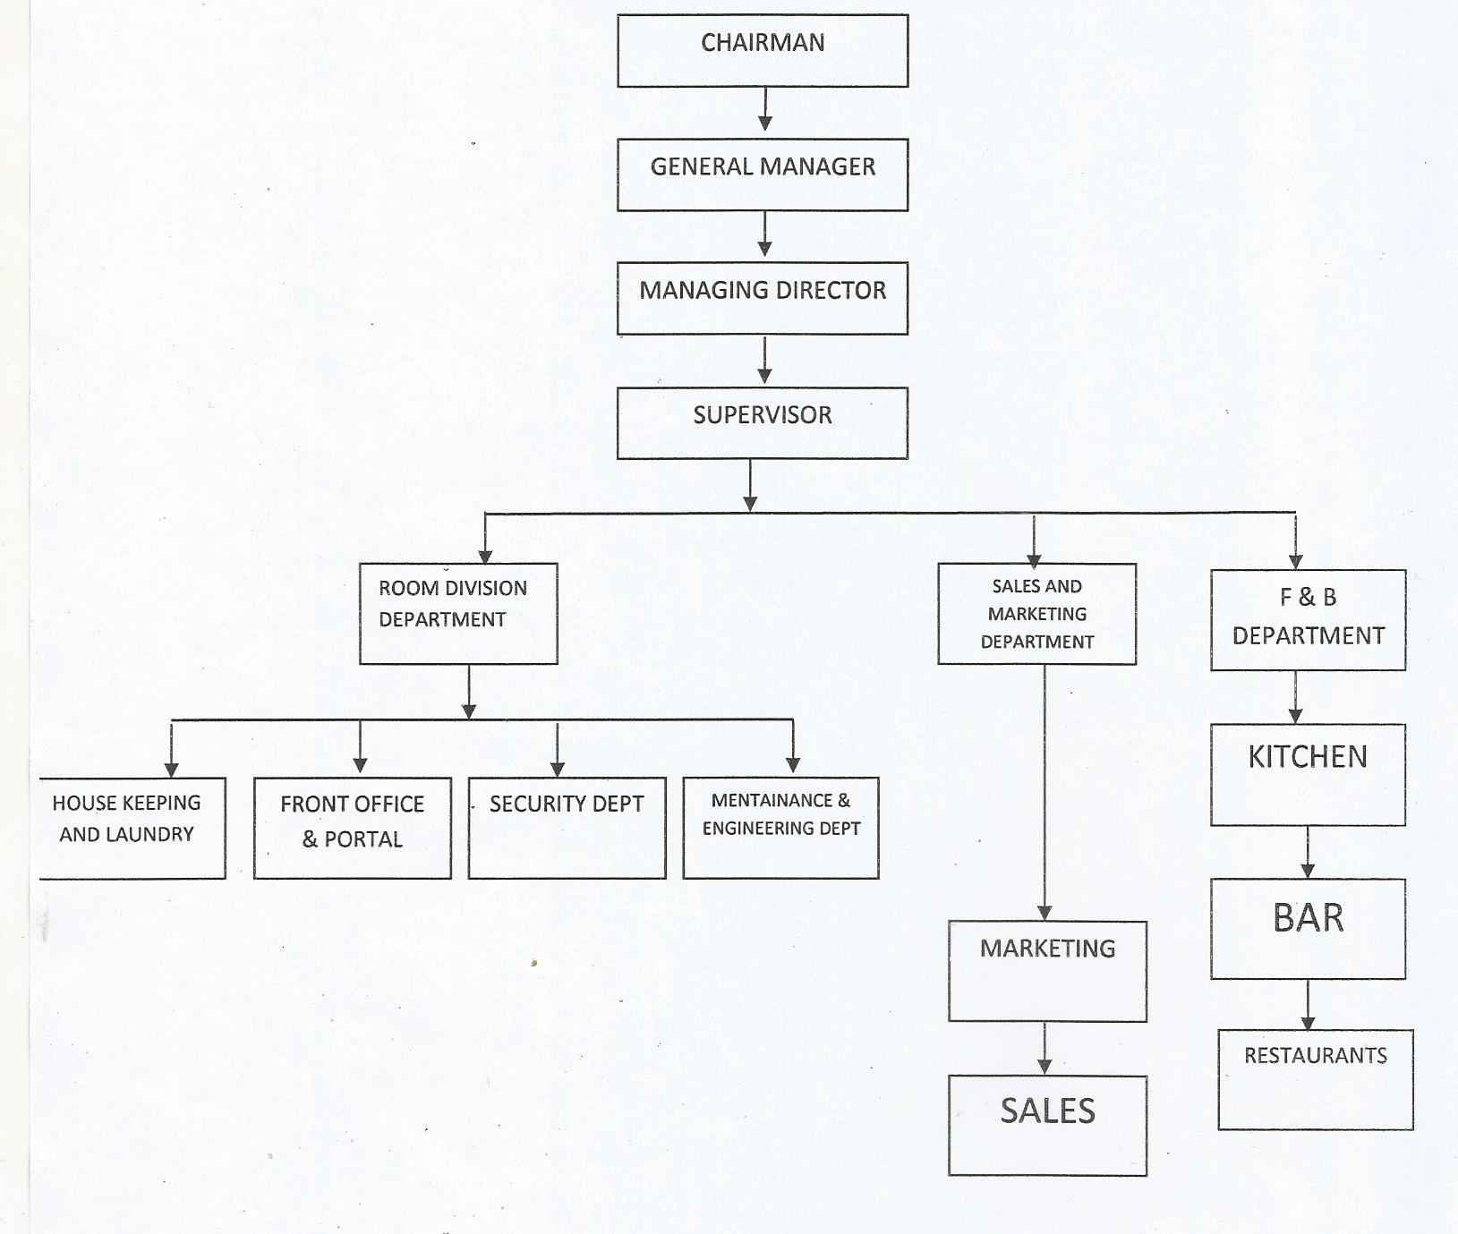
2.4 The Various Department/ Group/ Section in the Establishment and Their Function
Managing Director (MD):- The Managing Director is the decision maker, he says what happen in the Establishment and other Staff takes order from him. He is the one that Finances the Company and assign payment for Staffs.
General Manager (GM):- The General Manager is the one in command. He is the most senior employee in the Company. The Manager reports directly to the Managing Director, He is responsible for the overall strategy, Planning, Coordination and Management of Business affairs of an Organization .
Supervisor: - The Supervisor Supervises the work been done in the various sections he/she tries to find out where wrongs are been done and does correction where necessary and penalizes when necessary.
Accountant: - The accountant is in charge of keeping records of all the expenditure and income earned in a company and responsible for payment of workers.
Auditors: - The Auditor examines person and organization financial records to verify their accuracy, detect frauds and identify opportunities for improving financial processes.
Chef: - The Chef is the most senior cook in the Hotel, she gives directives to the other cooks, and she is in charge of the activities that take place in the Kitchen.
Head of Reception: - The head of reception is in charge of the activities that is
been run in the reception.
Head of the House keeping: - The head of housekeeping is in charge of the activities in the rooms, he makes sure that things are the way they should be in the various rooms.
Cook:-The cook specializes in various duties like producing, manufacturing, preparing different dishes to the Hotel.
Assistant Head of Reception: - The assistant head of reception seconds the head of reception, he takes charge when the head of reception is absent.
Cleaners: The cleaner keeps the environment tidy: they clean the rooms, grasses, sweep and wash the places.
Dry Cleaner: The dry cleaner, washes, dry and iron the clothes of guest, they also wash the towel and bed spread used in the rooms.
Chief Security: The chief security makes sure that there enough security, he direct the security people on how to be on alert.
Security Men: - The security men guard the environment and makes sure that there is enough security.
Electrician: The electrician repairs all the electrical appliances, and services the worn-out ones.
Plumber: The plumber repair and fix things such as water pipe, toilet, sinks e.t.c
Computer: The computer operator does the typing of duties roaster, and other things needed to do with computer:.
Restaurant: The restaurant server, they prepare food to the customers, they are people that also gives information to the kitchen on what to prepare.
Barman: The barmen serve drinks to customer.
The Various Department or Sections in The Establishment and Their Functions
1. Reception
2. Kitchen / restaurant / bar
3. Laundry
4. Gymnastic house
5. House keeping
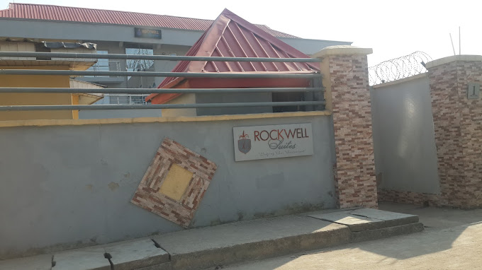
1. Reception: This is where guest and visitors go first when they are arriving in the hotel. They show the room to the guests and give them the attention needed for comfort ability. They know when the guest checks in and check out.
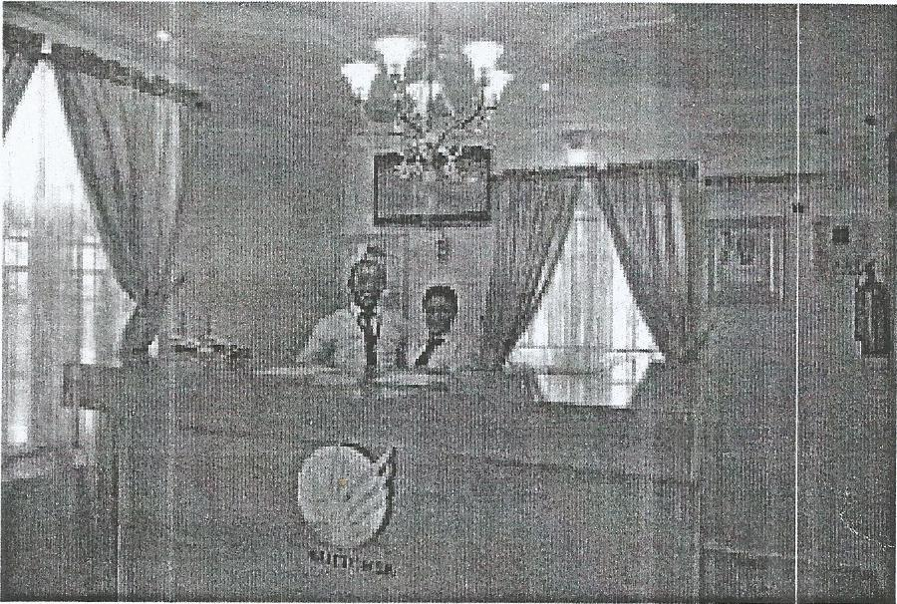
2. Restaurant and Bar: The bars serve drinks to the guest, alcoholic and non- alcoholic drinks are sold as well.
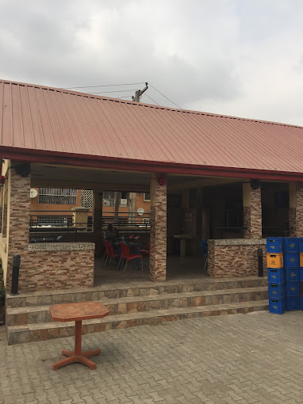
3. Laundry: The laundry section is where the clothes of the guest are been laundered including the bed spreads.
4. Gymnastic House: Gymnastic house is where exercise are been done, there are machines that are been used for exercise in the Gymnastic House.
5. House Keeping: The Housekeeping tides the rooms of the 0ffices of the Management.
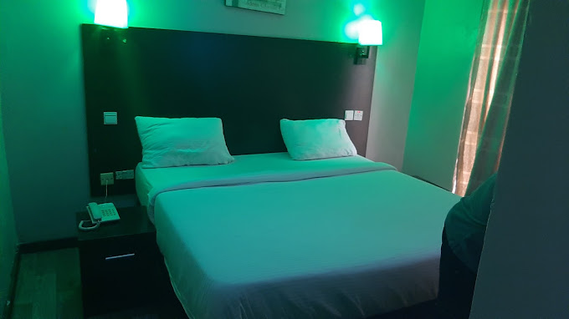

Kitchen: The kitchen is the place where all kinds of dishes like fried rice, boiled yam, egg sauce, afang soup, egusi soup, vegetable soup, e.t.c are produced. The restaurant does the serving of the dish to the guest.
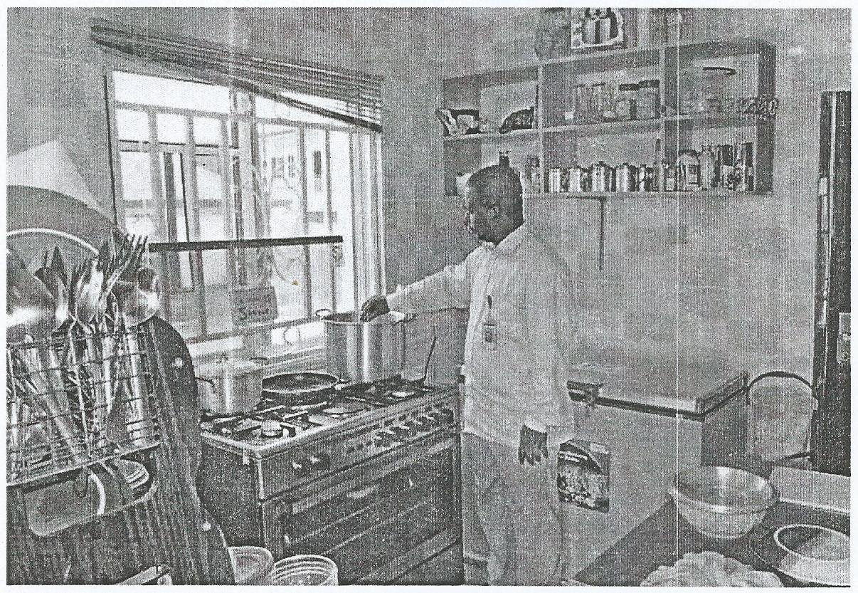

CHAPTER THREE
Common Equipments and Utensil used in the Kitchen and Measuring Tools
Pot
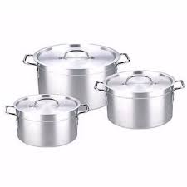
It is used to cook to prepare stews , soups , and other food.
Spoon and Knife
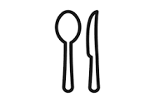
The knives are used to portion the food. Dinner Spoon (Table Spoon) − It has elongated round cup. It is used to eat main course food items. It can pick up just the right amount of rice, stew, or curry.
Broom and Parker
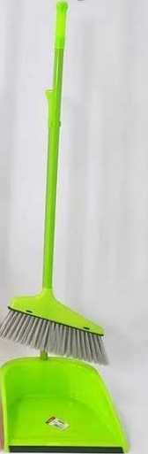
A broom is a cleaning tool consisting of usually stiff fibers attached to, and roughly parallel to, a cylindrical handle, the broomstick.
Frying Pan
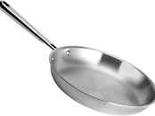
A frying pan, frypan, or skillet is a flat-bottomed pan used for frying, searing, and browning foods.
Bucket
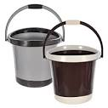
Storing food, ingredients and cleaning products safely is essential, and one of the best ways to do this is with plastic buckets.
Table

Food preparation was generally done at the kitchen table as it was the only work surface in an era before units. The table was used as an ironing board and for washing up in homes lacking a sink.

Tea Cup

It is used with a saucer for hot beverages.
- Liquid measures are made of glass or clear plastic
- Measure things like milk, water, and vegetable oil.
- Common sizes: 1 cup, 2 cup, and 4 cup
- Dry measures are made of metal or plastic
- Measure things like flour, sugar, shortening, and peanut butter
- Sold in sets: 4 cup, ½ cup, and 1 cup
- Measuring spoons are made of metal or plastic
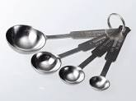
- Measure small amounts of liquid or dry ingredients
- Sets include: 4 teaspoon, ½ teaspoon, 1 teaspoon, and 1 tablespoon
- You can also use kitchen scales, which give a precise measurement • Types: balance scales, mechanical scales, and digital scales.
Mixing Tools
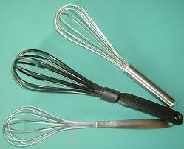

- Wooden spoons are used for stirring and mixing
- Slotted spoons are used to remove pieces of food from liquid
- Heavy metal spoons are used to stir thick mixtures
- Rotary beater used to beat, blend, and incorporate air into food
- Whisk is a mixing tool made of loops of wire attached to a handle, to incorporate air into food
Baking Tools
- Sifter used to blend dry ingredients and remove lumps
- Pastry blender is made of several thin, curved pieces of metal attached to a handle
- Pastry brushes used to brush butter or sauce on foods
- Pastry cloth keeps the dough from sucking to the counter
- Rolling pin used when rolling out dough or pastry
- Stockinette covers the rolling pin and prevents the dough from sticking to the rolling pin
- Bent edge spatula used to remove cookies from a baking tray
- Also used to turn meats, fish, pancakes, eggs, and omelets
- Straight edged spatula used to spread cake icings/meringues and level dry ingredients
- Flexible spatulas used to scrape bowls/saucepans and fold ingredients into
One another
Thermometers
- Oven safe thermometers designed to be placed in food while it is cooking
- Instant read thermometers inserted into a food at the end of cooking
- Candy thermometers marked with different temperatures needed for different kinds of candy
- Deep fat thermometers register oil temperature for deep frying foods (doughnuts and French fries)
Cutting Tools
- Kitchen shears used to snip herbs and trim vegetables
- Also used to cut meat, dough, cookies, and pizza
- Poultry shears cut through fowl and fish bones
- Peeler removes the outer surface of fruits and vegetables
- Shredder grater a four sided metal tool used to shred and grate food (cheese and cabbage)
- Cutting boards used when cutting and chopping foods to protect tables and countertop
Care of Kitchen Utensils
Consider the following features when buying cooking and baking utensils:
- Utensils should be sturdy and well balanced. All edges should be smooth. Pan bottoms should be flat for good heat conduction.
- Handles should be heat resistant, sturdy, and securely attached.
- Lids should be well constructed should fit tightly.
- Utensils should be light enough to handle comfortably and safely.
- Utensils should be able to stack or hang from a rack for storage.

CHAPTER FOUR
Work Actually Carried out with Clear Statement on Experience Ground
My having the true fact about the practice carried out at Comfort Hotels has exposed me to a lot of great experience after participating majorly as a source of assistance in various units. The following are also the experience gained in the organization:
Laptop

The following are the uses of the laptop in the organization:
- How to check quest for a room
- How to make reservation
- How to make accountability to the room
- To receive and send mails
- Used to maintain record and lots more.
Telephone

Hotels use telephone systems to facilitate communication between guests and various departments like housekeeping, room service, and front desk. Prompt and courteous assistance through phone calls greatly influences guest satisfaction.

General Experience Acquired: My general experiences are as follows;
1. Learnt how to serve dishes especially African dishes
2. I learnt how to prepare African dishes
3. I learnt how to make use of some of the equipment in the Kitchen.
4. I learnt about Hotel Management.
Making of Dishes Boiled Yam Egg Sauce Recipes: 4 slice of Yam, 2fresh egg, 5 seed of fresh tomatoes, 2 seed of pepper, tea spoonful of salt, a cube of maggi, Onions, Carrots, Green beans, Ground nut oil, some quantity of water. Peel the slices yam, wash and boil. Slice the Tomatoes, Onions and pepper. Cut the carrot and green beans then put the groundnut oil on the fire, allow to heat, add the salt, put the Onion and allow to fry a bit then pour the tomatoes, and allow to try, then put the carrot and green beans and allow to fry then pour the beated egg the maggi and then remove from the heat dish into a flat plate with the Boiled yam.
White Rice with Stew Recipes 3 cups of Rice, a tin of Tomatoes, 8 seeds of fresh tomatoes, 4 seeds of pepper, 1 Onion, Groundnut oil teaspoon full of salt, vilogram of Meat, Curry leave, Curry powder, them, 2 cubes of maggi, some quantity of water.
Method of Preparation
Wash the Rice and par boil it, the boil finally put the groundnut oil on the fire and add salt, Onions and allow to fry, then put the grinded tomatoes and allow to fry, then add the tin tomatoes and allow to fry, then Spice the stew with curry and thyme, after that you add the stewed meat and add the curry leave and allow to boil dish into a plate with white Rice.
Jollof Rice: 3cups of Rice, a tin of tomatoes, 4 seeds of fresh tomatoes, 2 seeds of pepper, 1 Onions, groundnut oil 1 teaspoonful of salt, kilogram of meat, curry powder, thyme, 2 cubes of magi cube, carrot, green beans, and some quantities of water.
Method of Preparation
Wash the rice and parboil it, then heat the groundnut oil and add salt, onions and allow frying. Put the grounded tomatoes and pepper and allow to fry. Then add the tin tomatoes, and allow frying, spicing the stew with curry and thyme, magi cubes after, pouring the stew and rice the stock (meat water) and stir, then fry the stewed meat, dish the rice with meat.
Fried Rice 2cups of rice, carrot, green beans, green pepper, 1 onions nutmeg grinded, groundnut oil, butter, 2 cubes of magi, thyme, ginger, curry, kg of meat, and 1teaspoon of salt, some quantity of water, green peas and cabbage.
Method of Preparation
Wash and parboil rice, wash and cut the carrot, green beans, green pepper, cabbage, ginger, onions, stewed the meat, with the liver. Then pour the parboiled rice into the stock (meat water) and allow to boiled, then heat the butter and groundnut oil. add the carrot, green beans, green peas, green pepper, onion, ginger and allow fry. Then add maggi cube, curry and thyme, pour the cooked rice and stir, then add I the liver and cabbage and stir, dish in a plate.
Granised Indomie With Plain Omelette Recipe: 2sachet of Indomie, 1 fresh tomato, 1 fresh pepper Onions, groundnut oil, 2egg, carrot green beans water.
Method Of Preparation
Add water to the pot and apply heat, then allow it to heat very well, then add the Indomie and allow to boil, then sieve it and put the empty pot on fire add groundnut oil, Onions, tomatoes, pepper, carrot, green beans then the spice of the Indomie and allow to fry then add the parboiled Indomie and stir, then fry the egg an remove from heat dish the garnished Indomie with the plain Omelette in a plate.
Edikan ikong:
- 1kg Spinach/fluted Pumpkin leaves(Ugwu)
- 200g Water leaves
- 500g of assorted meat(cow tripe (shaki),snails, cow's skin(kanda),
- Stockfish(optional)
- Smoked fish
- 250ml palm oil
- 1 cup Periwinkles(optional),. but it gives the soup a boost
- 2 tablespoons ground crayfish
- 2 stock cubes
- 1 medium sized onion
- 2 scotch bonnet Pepper a.k.a fresh pepper
- Salt to taste
White Soup: 300g Goat meat, stockfish, dry fish, 2 seasoning cube, salt, 250g yam, cubed, 6 cups stock + water, 1/2 cup+2 tablespoons ground crayfish, scotch bonnet (fresh pepper), 8g Ogili okpei or 5g 0gili isi, 1/4 teaspoon ground uziza seed, 5g uziza leaves, 8g utazi leaves, 1 tablespoon palm oil.
Method of Preparation
Wash meat and stockfish put in a pot and season with seasoning cubes and salt. Add water and boil till almost tender. Place yam cubes in a small pot and boil till soft. Pound with mortar and pestle, Potato masher or food processor, to get thick paste. Soak dry fish in boiling hot water for 2 minutes, drain and rinse in cold water. Remove bones and add to the boiling meat. Boil until meat is tender. Add enough water to the stock to make up to 6 cups. Add crayfish, pepper, ogili okpei and ground uziza seed. Stir and add yam in big lumps. Add palm oil, if using, cook till soup thickens. If there are still lumps of yam remaining when the soup has thickened, remove them (chef's delicacy). Shred uziza and utazi leaves, add to the soup.
Cook for 3 minutes and take off the heat. Serve with pounded yam or any swallow of your choice.
Coslow Salad Recipes: Cabbage, Carrot, fresh tomatoes, green pepper and mayonnaise.
Method of Preparation
Wash the Cabbage, Carrot fresh Tomatoes, and Green Pepper in salty water. Then cut the Cabbage, the carrot will not be cut in cubes but will be granted (Sliced with grater), the fresh tomatoes will be sliced and the green pepper cut in cubes. Then the Cabbage, Carrot, fresh tomatoes, green pepper will be mixed together with the margarine and serve with either, Jollof rice or Fired Rice

CHAPTER FIVE
Problems Encountered During Siwes
I encountered numerous problems during my Industrial training programme in my place of attachment. The Major Payment Areas are Highlight Below
- Late Payment Salary: The establishment normally pays their salary very late and I.T. student find it very difficult to cope with transportation, at times there will be no money for transportation. By so doing the person have to walk on feet, and these bring about latest to duty.
- Problem of Light: Light is the major things an establishment needs for proper running, and also for comfort of the guest and functioning of the facilities and equipment in an establishment but the absent of light bring about discomfort of guest and poor management of the establishment.
- Inadequate Facilities: The establishment didn't provide any accommodation for the IT and Siwes Students.
- Communication: There was poor and ineffective information dissemination due to complex links the establishment.
- Poor Security: The establishment did not provide security, which makes SIWES Students to be at risk, Arm robbers so disturb at night most times which is a threat to the lives of Students.
- Problem of Securing a Place of Attachment: I had most of problem searching for a place of attachment for my SIWES, because most establishment my placement request.
Recommendations
1 The establishment should provide a very good security in establishment for comfort of the I.T Student and SIWES Students, the guest and their main Staff.
2. The establishment should provide adequate light for the establishment, for the comfort of guest, I T/ SIWES Student, Staffs and for proper functioning of equipment and facilities.
3. The establishment should make sure that before the end of each month that salary should be paid. So that the SIWES Student will be care of their transportation to work.
4. The establishment should provide a good accommodation for the IT and SIWES Students in establishment.
5. The Industrial Training fund should compile list of employers and available training places for Industrial attachment and forward such list to the Coordinating agencies.
6. The Federal Government should make it mandatory for all ministries, Companies and government parastatals to provide attachment place for Students.
Conclusion
Industrial Training is very important educative and interesting, it is a programme that exposes undergraduate toward of paid. It makes s of responsibility and be diligent to work. Extending the programme to more than four month will be better for the student to have more time to learn and gain all the practical experiences needed. Summary of Attachment Activities The Industrial attachment programme also known as student Industrial work experience Scheme (SIWES) İs an appreciable skills acquisition programme designed to expose Students to the real life working experience. The Student to the practical oriented aspects of their chosen professions so as to achieve the much needed technological advancement for the Nation. This SIWES report gives and contains a full explanation of the activities carried out by me. The report explains the details of the event and activities and outlined under each chapter. It started with an introduction, objectives of the programme in chapter-i. And Chapter-ii talks about different section and their function. Chapter three/four explains the activities been carried out during the programme, finally chapter five being the last chapter highlighted problem, then the report was concluded with sample.

