
A TECHNICAL REPORT ON
STUDENT INDUSTRIAL WORK EXPIRENCE SCHEME (SIWES)

HELD AT :
FAME 104.5FM
1, Oseni Bello Close, Opposite Disu Street, Aina Obembe Road, Off Oluwaga, Ipaja Lagos, Lagos, Nigeria

Written By :
OLOYEDE TAIWO HABEEB
ND/23/MAC/PT/0849
SUBMITTED TO
THE SIWES COORDINATOR, DEPARTMENT OF MASS COMMUNICATION,
KWARA STATE POLYTECHNIC, ILORIN, KWARA STATE, NIGERIA

IN PARTIAL FULFILMENT OF THE REQUIREMENT FOR THE AWARD OF NATIONAL DIPLOMA (ND) MASS COMMUNICATION DEPARTMENT

PREFACE
In presenting this work, I would like to preface it by expressing gratitude for the invaluable learning experience gained during my 3-month placement at Fame 104.5FM. This period has allowed me to immerse myself in the intricacies of television production, navigate challenges, and acquire practical skills that extend beyond the classroom. The exposure to diverse equipment and collaborative projects has shaped my perspective on the dynamic nature of the broadcast industry. This preface sets the context for the insights and recommendations shared, reflecting the culmination of a rewarding and hands-on experience in the realm of television media.
DEDICATION
I dedicate this technical report to the Almighty, the giver of knowledge, wisdom and who is rich in mercy.

ACKNOWLEDGEMENT
All adoration and glory are due to the Almighty for His Love, guidance and protection. I thank him for the perfect health, wisdom, knowledge, strength and opportunity to complete this stage of Academic in peace.
My Profound gratitude goes to my, Parents and every individual that supported me throughout the Student Industrial Work Experience. thanks so much for your support and care.

TABLE OF CONTENT
Title page i
Preface ii
Dedication iii
Acknowledgements iv
Table of content v
TABLE OF CONTENTS
CHAPTER ONE
  - Background of SIWES 1
  - Objectives of SIWES 2
CHAPTER TWO
2.1. Brief History of The Establishment of Attachment 3
2.2. Departments/Units in the Establishment and their Functions 3
CHAPTER THREE
3.0 Work Experience 5
CHAPTER FOUR
4.1 Challenges Encountered During the Programme 11
4.2 Executive Summary 11
CHAPTER FIVE
5.1 Recommendations 12
5.2 Conclusion 12

CHAPTER ONE

1.0 Introduction
1.1 Background
The Industrial Training fund established by decree 43 was introduced in 1971, vis-à-vis the birth of the Students Industrial Work Experience Scheme (SIWES) the same year by the Federal Government of Nigeria (FGN). It is against this background that the industrial training fund (ITF) initiated, designed and introduced SIWES Scheme in 1973 to acquaint students with the skills of handling employers’ equipment and machinery.
The Industrial Training Fund (ITF) solely funded the scheme during its formative years. However, due to financial constraints, the fund withdrew from the scheme in 1978. The Federal Government, noting the significance of the skills training, handed the management of the scheme to both the National Universities Commission (NUC), and the National Board for Technical Education (NBTE) in 1979. The management and implementation of the scheme was however, reverted to the ITF by the Federal Government in November, 1984 and the administration was effectively taken over by the industrial training fund in July 1985, with the funding solely boned by the Federal Government. It is an integral part of the requirements for the award of Certificates, Diplomas and Degrees in institutions of higher learning, e.g. Colleges of Education, Polytechnics, Universities, etc.
Student Industrial Work Experience Scheme (SIWES) exposes students to industry based skills necessary for a smooth transition from the classroom to work environments. It accords students of tertiary institutions the opportunity of being familiarized, exposed, and prepare students of universities, polytechnics, college of technology, college of agricultures and college of education for the industrial work situation they are likely to meet after graduation and to the needed experience in handling machinery and equipment which are not found in such an educational institution.

1.2 Objectives of SIWES
- To provide students with relevant practical experience.
- To satisfy accreditation requirements set by the Nigerian Universities Commission (NUC).
- To familiarize students with typical environments in which they are likely to function professionally after graduation.
- To provide student an opportunity to see the real world of their discipline and consequently bridge the gap between the University work and actual practice.
- To change the orientation of students towards labour market when seeking for job.
- To help students access area of interest and suitability for their chosen profession.
- To enhance students, contact for future employment
- To provide access to equipment and other facilities that would not normally be available in the University workshop
- To enlist and enhance industry involvement in university education.
- Summarily the objective of the Student Industrial Work Experience Scheme.
- To solve, the problem of inadequate practical skills, preparatory for employment in industries by Nigerian graduates of tertiary institution.
- To promote and encourage the acquisition of skills in industry and commerce, with a view of generating a pool of indigenous trained manpower sufficient to meet the needs of the economy.

CHAPTER TWO

2.1 OBJECTIVE OF ESTABLISHMENT OF ATTACHMENT
Objectives of FAME 104.5 FM Lagos
- Provide Quality Entertainment – Deliver engaging music, talk shows, and programs that cater to a diverse audience.
- Disseminate Accurate Information – Ensure timely and credible news updates on local, national, and international events.
- Promote Public Awareness – Educate the public on social, economic, and political issues through discussions and expert opinions.
- Support Local Talent – Showcase and promote Nigerian artists, creatives, and entertainers in the music and media industry.
- Encourage Community Engagement – Provide a platform for audience participation through phone-in segments, social media interactions, and public discussions.
- Advertise and Promote Businesses – Offer promotional opportunities for businesses through radio commercials, sponsorships, and partnerships.
- Enhance Media Innovation – Adopt modern broadcasting technologies and digital platforms to improve service delivery and listener experience.
- Foster Cultural Appreciation – Celebrate Nigeria’s rich cultural heritage through programs that highlight traditional values, languages, and music.
- Promote Positive Social Change – Advocate for societal development through programs focused on education, health, and social responsibility.
- Expand Listener Reach – Increase the station’s audience base through strategic marketing, online streaming, and collaborations.

2.2 Departments/Units in the Establishment and their Functions
- Program Unit
A programme or project management office is a single, central support structure, designed to aid change and delivery initiatives within an organization. This applies particularly in an organization where there is a lot of ongoing programme and project activity. Without such a PMO, an organization is forced to replicate support arrangements over and over again as programmes and projects come and go.
- Marketing Unit
Promotes business and drives sales of its products or services in the media. It provides the necessary research to identify your target customers and other audiences. Depending on the company's hierarchical organization, a marketing director, manager or vice president of marketing might be at the helm.
- Technical Unit
The technical manager is a versatile position that requires sufficient managerial skills as well as sufficient technical skills. A technical manager should be able to perform all necessary tasks related to company systems including troubleshooting any technical issues.
- Admin Unit
Administration department is backbone of an organization. An effective administrator is an asset to an organization. He or she is the link between an organization's various departments and ensures the smooth flow of information from one part to the other.
- News and Current Affairs Unit
Current affairs are a genre of broadcast journalism. The news departments are responsible for putting down headline about current matters together.
- Account and Auditory Unit

CHAPTER THREE
3.0 WORK EXPERIENCE

3.1 Introduction to News
Introduction to news refers to the initial segment or presentation of news content within a media outlet, whether it's a newspaper, radio broadcast, television program, or online news platform. It serves as the gateway to informing audiences about current events, developments, and issues of relevance. The introduction typically outlines the major headlines and stories that will be covered, providing a brief overview to grab the audience's attention and set the tone for the news program. It may include key highlights, breaking news updates, and teasers to encourage viewers or listeners to engage further with the news content. The effectiveness of the introduction is crucial in capturing the audience's interest and establishing the credibility of the news source.
Various sources of News
Newspapers: Traditional print publications offering in-depth reporting on local, national, and international news.
Television: News broadcasts on networks and cable channels provide visual coverage of current events, often supplemented with analysis and interviews.
Radio: News radio stations deliver updates and reports throughout the day, covering a wide range of topics.
Online News Websites: Digital platforms operated by news organizations provide articles, videos, and multimedia content on breaking news and in-depth reporting.
Social Media: Platforms like Twitter, Facebook, and Instagram serve as sources of news through posts, tweets, and live streams shared by individuals, news outlets, and organizations.
Wire Services: Agencies like The Associated Press (AP) and Reuters distribute news stories, photos, and videos to media outlets globally.
Magazines: Periodical publications offer feature articles, analysis, and commentary on current events, politics, culture, and more.
Government Agencies: Official statements, press releases, and reports from government departments and agencies contribute to news coverage.
Press Releases: Organizations issue press releases to share announcements, updates, and information with the media and the public.
Academic Research: Studies and reports from universities and research institutions provide data and analysis on various topics covered in the news.
Interviews and Expert Commentary: News outlets interview experts, analysts, and stakeholders to provide context and insight into news stories.
Citizen Journalism: Individuals use digital tools and platforms to report on events and share firsthand accounts, photos, and videos, contributing to news coverage from diverse perspectives.
3.2 News Writing and News reporting
News writing and news reporting are integral components of journalism, each playing a distinct role in the dissemination of information to the public.
News writing involves crafting articles, reports, or stories that convey factual information in a clear, concise, and engaging manner. Journalists who specialize in news writing strive to present the facts objectively, without bias or personal opinion, adhering to the principles of accuracy, fairness, and balance. They carefully research their topics, gather relevant data and quotes from credible sources, and organize their content in a way that is easy for readers to understand and follow. Whether it's breaking news, investigative pieces, or feature stories, news writing serves as the foundation for informing and educating the public about current events, issues, and developments in society.
On the other hand, news reporting involves the on-the-ground gathering and presentation of information by journalists who serve as frontline observers and eyewitnesses to events as they unfold. Reporters often conduct interviews, attend press conferences, and observe firsthand the happenings in their assigned beats or areas of expertise. Their role is to provide real-time updates, analysis, and context to give audiences a comprehensive understanding of the story. Through diligent observation, critical thinking, and ethical reporting practices, news reporters serve as the eyes and ears of the public, bringing important events and stories to light and holding those in power accountable for their actions.
Together, news writing and news reporting form the backbone of journalism, serving the vital function of keeping society informed, engaged, and empowered in an ever-changing world.
3.3 Programme
Programmes refer to activities broadcasted on radio or television stations with the aim of informing, educating, or entertaining the audience.
Types of Programme
Types of Programmes encompass a diverse array of content tailored to meet the multifaceted needs of audiences worldwide. Within this spectrum, Educational Programmes serve as invaluable tools for fostering intellectual growth and expanding knowledge horizons. These programmes often feature informative documentaries, thought-provoking discussions, and engaging tutorials designed to stimulate curiosity and promote lifelong learning.
On the other hand, Entertainment Programmes serve as the cornerstone of leisure and recreation, offering viewers a delightful escape from the routines of daily life. These programmes span a wide range of genres, including captivating dramas, uproarious comedies, thrilling action series, and mesmerizing reality shows, all crafted to engage and entertain audiences across various demographics. Whether it's a gripping crime thriller or a heartwarming family sitcom, entertainment programmes play a pivotal role in enriching cultural experiences and fostering communal bonds through shared moments of laughter, excitement, and joy.
3.4 Some equipment available at the place of attachment.
Equipment include:
- Reel to reel audio tape recording:
is a form of magnetic tape audio recording in which the recording medium is held on a reel, rather than being securely contained within a cassette. In use, the supply reel or feed reel containing the tape is mounted on a spindle; the end of the tape is manually pulled out of the reel, threaded through mechanical guides and a tape head assembly, and attached by friction to the hub of a second, initially empty take-up reel.
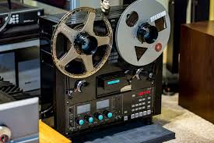

- Long grammar phone (Micro-Phone) A microphone is a device that translates sound vibrations in the air into electronic signals or scribes them to a recording medium. Microphones enable many types of audio recording devices for purposes including communications of many kinds, as well as music and speech recording.


- Sound mixing board
The sound mixing board, also known as an audio mixer, plays a crucial role in a radio station by allowing operators to control and balance various audio inputs. It enables the blending of different sound sources such as microphones, music players, and pre-recorded segments, ensuring smooth transitions between them. Operators can adjust volume levels, apply equalization for clarity, add effects if needed, and monitor audio quality in real-time. Additionally, the mixer facilitates communication between hosts, guests, and technical staff by providing features like talkback systems and headphone monitoring. Overall, the sound mixing board is the central hub for managing audio content and ensuring broadcast quality in a radio station.
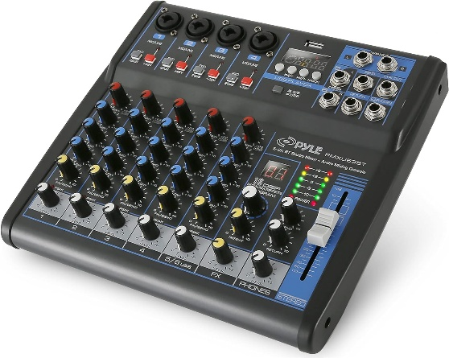

Headphone

In Harmony FM radio station, headphones are essential tools for various tasks such as monitoring audio quality during live broadcasts, editing recorded segments, conducting interviews, and communicating with other staff members. They enable DJs and producers to cue up music, listen to caller feedback, and ensure smooth transitions between songs. Additionally, headphones facilitate communication between hosts, producers, and technical staff, allowing for seamless coordination during broadcasts. Overall, headphones play a crucial role in maintaining the professionalism and quality of the station's programming.

- Deck to the Cassette
A cassette deck is a type of tape machine for playing and recording audio compact cassettes. Consumer electronics formerly used the term deck to distinguish them from a tape recorder, the "deck" being part of a stereo component system, while a "tape recorder" was more portable and usually had a self-contained power amplifier (and often speakers).

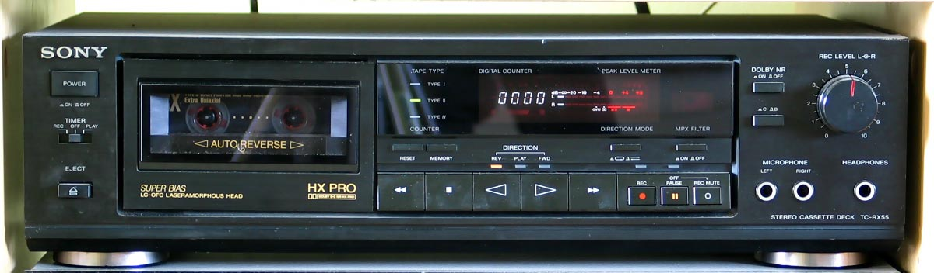

Other software’s include the audibling and Nero software

- Studiomonitor
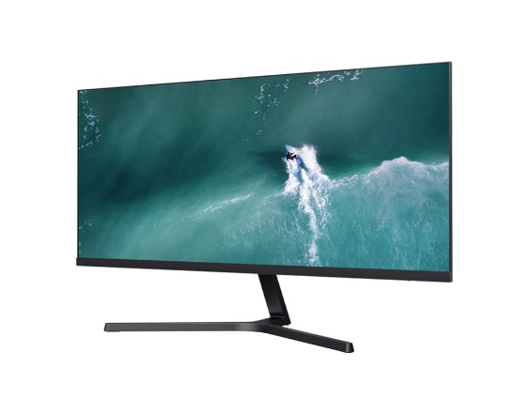
Studio monitors are precision speakers used in recording studios for accurate audio reproduction. They provide a flat frequency response, avoiding any bias towards specific frequencies. This neutrality allows engineers to make precise adjustments to recordings and mixes. Studio monitors ensure consistency and quality across different playback systems.

Tips in making a good Radio Presentation
- Aim to create
- Understandhow, when, why and what the listener is saying
- Know your listeners
- Make your listener care
Program Format
The type of the programs format is documentary, features, interview,
Discussion, ox pop, routine reporter, drama, testimonial, talk, chit-chat, montage, phone in programmes,

CHAPTER FOUR

4.1 Challenges Encountered During the Programme
Life they say is not a bed of roses and whatsoever that has advantages also have its disadvantages. In as much as the SIWES Programme is a wonderful programme which has been designed to help the students have a practical knowledge of their various courses of study, it is note-worthy to also mention some of the problems encountered during the programme.
Problems of Securing a Place of Attachment
Securing a place of attachment for industrial training programme was a very big challenge to me. This is due to the fact that there are very limited establishment that accepts students undergoing industrial training. While I was searching for a place of attachments, I got to find out most of the establishments that accepts students had already taken the maximum number of students needed, while others would just reject the request giving one reason or the other.

4.2 Executive Summary
The gains of this exercise are immense; that it was worth the while is grossly an understatement. Being accorded another opportunity in life to be exposed to the rudiments of work places outside the class room teaching is an experience of a life time.
Furthermore, the exposure to practical tools, and working features had engendered better understanding of lessons thought in the class room and charted a course for career development in food science.

CHAPTER FIVE
RECOMMENDATION AND CONCLUSION
5.1 Recommendation
- Tertiary institutions need to comply with the standards set for proper implementations of SIWES to enable students derive the greatest benefits from participation in the scheme.
- Tertiary institutions need to provide adequate logistics (mobility, internet service etc.) and adequate funding to make their SIWES units functional.
- Students should be well prepared through meaningful orientation programmes by institutions before embarking on SIWES. A book, such as the “Guide to successful participation in SIWES” would be useful in achieving the purpose if read before, during and after SIWES by participants.
- Quality assurance of SIWES, through adequate supervision of participants by the relevant stakeholders (institutions, employers and ITF) would ensure that the scheme meets its objectives vis-à-vis the principles of cooperative education or work-integrated learning.
5.2 Conclusion
The Student Industrial Work Experience Scheme (SIWES) plays a significant role in human resource development, it helps students develop new skills and enlightens them of what the present society holds for them after graduation and helps them adapt accordingly. As a result of the programme, I am now more confident to build my future My four (4) months industrial attachment with Radio Kwara Ilorin has been one of the most interesting, productive and instructive experience in my life. Through this training, I have gained new insight and more comprehensive understanding about the real industrial working condition and practice; it has also improved my soft and functional skills. All these valuable experience and knowledge that I have gained were not only acquired through the direct involvement in task but also through other aspect of training such as work observation, interaction with colleges, superior and other people related to the field.

