
A TECHNICAL REPORT ON
STUDENT INDUSTRIAL WORK EXPIRENCE SCHEME (SIWES)

HELD AT :
IFEFOL BUSINESS CENTRE & COMPUTER COLLEGE
302, Ayobo-Ipaja Rd, Church B/stop, Ipaja, Lagos

Written By :
OLOYEDE KEHINDE MONSURU
ND/23/COM/PT/0222

SUBMITTED TO
THE SIWES COORDINATOR, DEPARTMENT OF BUSINESS ADMINISTRATION,
KWARA STATE POLYTECHNIC, ILORIN, KWARA STATE, NIGERIA

IN PARTIAL FULFILMENT OF THE REQUIREMENT FOR THE AWARD OF NATIONAL DIPLOMA (ND) IN PUBLIC ADMINISTRATION

PREFACE
In presenting this work, I would like to preface it by expressing gratitude for the invaluable learning experience gained during my 3-month placement at Ifefol Business Centre & Computer College This period has allowed me to immerse myself in the intricacies of Data management, navigate challenges, and acquire practical skills that extend beyond the classroom. The exposure to diverse equipment and collaborative projects has shaped my perspective on the dynamic nature of the broadcast industry. This preface sets the context for the insights and recommendations shared, reflecting the culmination of a rewarding and hands-on experience in the realm of Business Administration.

TABLE OF CONTENTS
TITLE PAGE i
PREFACE ii
TABLE OF CONTENT iii
DEDICATION iv
ACKNOWLEDGEMENT v
CHAPTER ONE
1.1 Introduction To SIWES 1
1.2 History of SIWES 1
1.3 Aim and Objective of SIWES 2
CHAPTER TWO
2.1 Objectives of the Establishment 3
2.3 Various Department in the Establishment 3
CHAPTER THREE
ACTUAL WORKDONE WITH EXPERIENCE GAINED
3.1 Office Equipment 4
3.2 Introduction to Microsoft Office Suite 7
3.3 Introduction to CorelDraw 8
CHAPTER FOUR
4.1 Executive Summary 10
4.2 Challenges Encountered 10
CHAPTER FIVE
5.1 Conclusion 11
5.2 Recommendation 11

DEDICATION
I dedicate this report to Almighty God, who has been all in all from the beginning of my attachment to the end of the SIWES program all glory belongs to Him.
I also dedicate the SIWES report to my lovely family for their financial support and spiritual advice during the, Period of attachment.

ACKNOWLEDGEMENT
I thanked God for the glory, honour, mercy and adoration I received during the time of my industrial training and course of study.
I also appreciate my family and friends for all their support especially financially during my SIWES program.
More so, my gratitude also goes to every individual that contributed to the completion of my industrial training, may Almighty bless them all and their household.
CHAPTER ONE
1.1 INTRODUCTION TO SIWES
The Students’ Industrial Work Experience Scheme (SIWES) is a program that is coordinated by the Industrial Training Fund (ITF), in conjunction with the National University Commission (NUC).
The SIWES program is designed to engage students in various degree programs in order to provide the student with practical experience in various fields of study and to expose them to actual working conditions.
This program involves the ITF, students and industries. It is meant to bridge the gap between theory and practical work, sharpen students’ skills and understanding of actual work processes and also provide an avenue to acquire more knowledge.
The Student Industrial Work Experience Scheme [SIWES] is the accepted skill training program which forms part of approved medium academic standards in the various degrees program of the Nigeria tertiary institutions.
This scheme helps student in their various field to know or have knowledge and picture of what they have been studying in school which enable the student to practicalize the theoretical aspect of his profession. This scheme contributes largely to prepare the student for any future engagement exposing him to atmosphere of veracity and adaptation
1.2 HISTORY OF SIWES
The early phase of science and technology in Nigeria was characterized by the theoretical lectures in polytechnics and universities which have proven to be an ill method of teaching students in Universities and Polytechnics graduate with little or no technical experience in their course of study.
In the same vein, students’ inability to contribute to the society in hampering the growth and development of our country it was in this view SIWES was introduced to the industrial and Education sector.
SIWES is the acronym for Student’s Industrial Work Experience Scheme. SIWES was established in the year 1973 in order to improve the standard of Education in Nigeria.
SIWES was funded by ITF (Industrial Training Funds) during it early stage not until it was difficult to continue for economic stress: then the responsibility was shared between Industrial Training Funds (ITF) and the Federal Government.
SIWES is a scheme for the duration of sixteen weeks (4 months). SIWES is done after the first year in polytechnics (ND1) and done after second year or third year in University depending on the institution.
1.3 AIMS AND OBJECTIVE OF SIWES
- Student industrial work experience scheme [SIWES] provide avenue for student to acquire industrial skill and experience in their approved course of study
- Expose students to work methods and techniques in handling equipment and machinery that may not be available in their institutions;
- Enlist and strengthen employers’ involvement in the entire educational process through SIWES.
- To provide opportunity for students to apply their knowledge in real work situations thereby bridging the gap between theory and practice.
- To earnest placement and strengths employee’s involvement in the education process of preparing student for employment in industries.
- To ease the transition from school to the world of work and enhance students contact for later job.

CHAPTER TWO

2.1 OBJECTIVE OF ESTABLISHMENT
Objectives of Ifefol Business Centre and Computer College
- To Provide Quality Computer Training – Offer comprehensive training in computer literacy, Microsoft Office packages, Corel Draw, and other relevant software applications.
- To Enhance Digital Skills – Equip students and clients with essential digital skills needed for academic, professional, and business growth.
- To Offer Professional Printing Services – Provide high-quality printing, photocopying, and document processing services to meet customer needs.
- To Promote Technological Advancement – Introduce students to modern computer applications and tools that enhance efficiency in various fields.
- To Foster Entrepreneurship – Train individuals in digital skills that enable them to establish and manage their own businesses.
- To Support Academic and Business Documentation – Assist students, professionals, and businesses with document formatting, project typing, and other administrative services.
- To Ensure Continuous Learning and Development – Update training programs regularly to align with technological advancements and industry demands.
2.2 VARIOUS DEPARTMENT IN THE ESTABLISHMENT
- Chief Executive Officer (CEO)
- General Manager
- Head of Training Department
- Head of Printing & Graphics Unit
- ICT Instructor(s)
- Administrative Officer
- Technical Support Officer
- Finance & Accounts Officer
- Customer Service Representative

CHAPTER THREE
ACTUAL WORKDONE WITH EXPERIENCE GAINED
During my Students Industrial Working Experience Scheme (SIWEST at the IFEFOL BUSINESS CENTRE & COMPUTER COLLEGE, I was able to learn and gain a lot of Industrial and organizational experience.
3.1 OFFICE EQUIPMENTS
Identification Of Office Equipment and Their Functions
I get to know more about Various office equipment utilized to enhance administrative efficiency, record-keeping, customer service, and sales processing. These devices play crucial roles in streamlining business operations, ensuring smooth communication, and improving overall workflow. Below are list of Office Equipment and Their Functions:
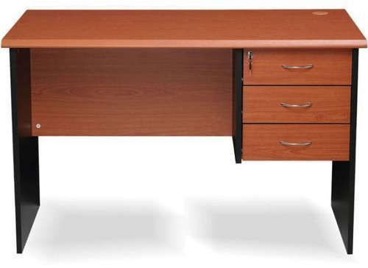
OFFICE DESK
Office tables, or desks, serve as the primary workspace for various tasks, including writing, computer work, and meetings, and they also play a crucial role in organizing and storing essential items


STAPLER
Staplers primarily serve to bind sheets of paper together, but can also be used for other tasks like removing dirt or blockages with a straightened pin, or even in a surgical setting to close wounds with surgical staples.


RULER

In an office setting, a ruler serves as a fundamental tool for measuring, drawing straight lines, and guiding cuts or scores, aiding in tasks like document organization, creating visuals, and ensuring precision in various tasks

STAMP PAD AND STAMP
In an office setting, stamps and stamp pads are used to imprint information, like logos, signatures, or dates, on documents, and can be used for tasks like marking incoming mail, approving documents, or authenticating legal papers

PERFORATOR
In an office setting, a perforator (or punching machine) is used to create holes in documents, letters, and file jackets, which facilitates filing and organization.
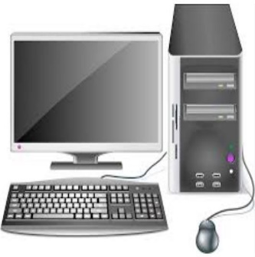
Computer: Used for processing business data, managing inventory using Microsoft Excel, writing invoices, scanning and storing documents, and handling payroll records.
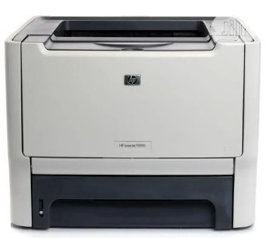
Printer: Used to produce hard copies of invoices, receipts, payroll documents, and other business records required for customer and administrative use.

Photocopier Machine: Duplicates essential business documents such as receipts, invoices, staff records, and sales reports for record-keeping.
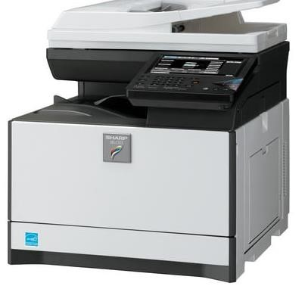
Point-of-Sale (POS): Machine Processes customer transactions, allowing for secure and efficient payment via credit/debit cards, reducing reliance on cash payments.
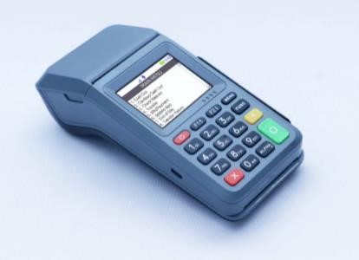
Scanner: Converts physical documents into digital files for secure storage, record-keeping, and easy retrieval.
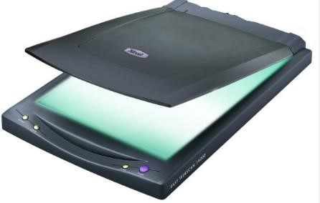
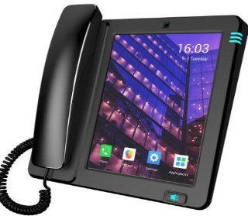
Telephone (Landline and Mobile): Facilitates communication with customers, suppliers, and employees, ensuring seamless business operations.

Binding Machine: Used to assemble and organize hard copies of business reports, invoices, and other important documents for easy reference.
Laminating Machine: Protects important documents (e.g., business licenses, certifications, and ID cards) by sealing them in a plastic covering to prevent damage.
3.2 INTRODUCTION TO MICROSOFT OFFICE SUITE
Microsoft Word is a word processing application that is part of the Microsoft Office Suite. Microsoft Office Suite is a set of powerful applications that are designed to provide a rich set of tools for almost every conceivable business task for a small (and large) business or organization. Microsoft Office Suite has been designed so that the interface across all the applications is consistent. Obviously, this helps users to move from application to application to carry out their various business tasks. The primary applications that are included in Microsoft Office include the following:
Opening Word
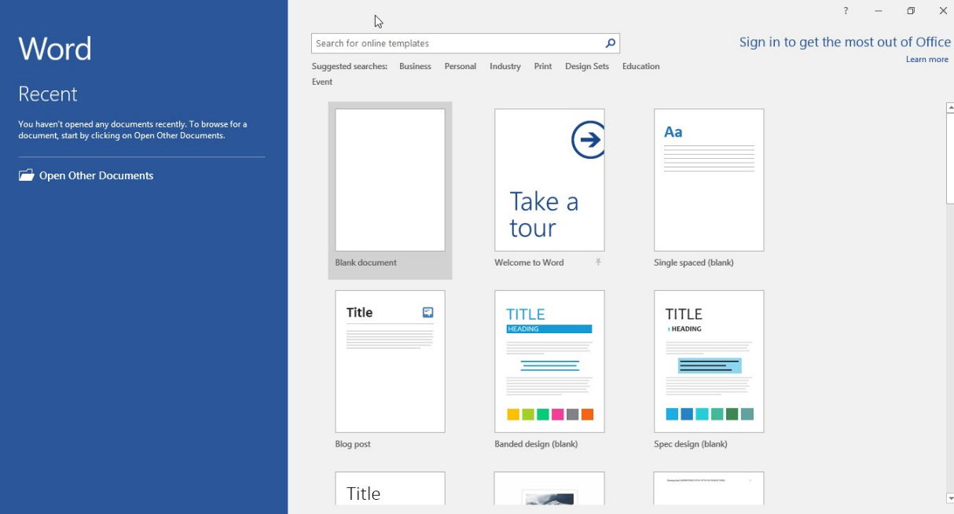
When you first open Word, you are presented with an array of choices. As shown in figure below, the left panel lists recent files that you have been working on. The middle panel provides a set of document types that you may use. The first two choices are templates for blank documents, which you will select if you are creating a new document without using a template.


Quick Access Toolbar

The Quick Access Toolbar, as seen in figure above, displays shortcut icons for frequently used tools. You can add buttons to this bar that you use frequently.

Ribbon Menu Tabs

The menu tabs along the top of the screen, as shown in figure above, provide major categories of tools and features available in Microsoft Word. Each of the tabs is associated with an entire set of menu items.
The “Home” Menu Tab
Figure below shows the specific menu items available under the “Home” tab. Each of the major menu areas is further organized into specific groups that are separated with vertical lines.
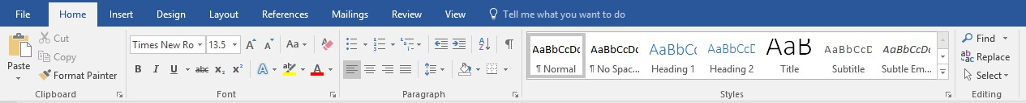

Introduction to Microsoft PowerPoint
Microsoft PowerPoint is a widely used presentation software developed by Microsoft as part of the Office Suite. It is designed to help users create professional and visually appealing slide-based presentations. PowerPoint allows users to combine text, images, charts, videos, animations, and transitions to enhance the effectiveness of their presentations.
PowerPoint is commonly used for business meetings, educational lectures, training sessions, and personal projects. The software provides various templates and design tools to make slides attractive and engaging. Users can also use slideshow mode to present their content in a structured and interactive manner.
With features like slide master, speaker notes, and collaboration tools, PowerPoint makes it easy to design, edit, and deliver presentations efficiently.
3.3 INTRODUCTION TO COREL DRAW
CorelDRAW is a powerful vector-based graphic design software developed by Corel Corporation. It is widely used for creating logos, business cards, posters, banners, illustrations, and other digital and print designs. Unlike raster-based software, CorelDRAW uses mathematical equations to create images, ensuring high-quality and scalable graphics.
The software provides various tools for drawing, shaping, coloring, and editing objects. Users can work with layers, text effects, and image tracing features to create detailed and professional designs. CorelDRAW is commonly used by graphic designers, printers, and advertising agencies due to its versatility and precision.
With an easy-to-use interface and extensive customization options, CorelDRAW enables users to create visually appealing designs efficiently. It supports multiple file formats and integrates well with other graphic design software, making it an essential tool for creative professionals.

Corel Draw Tools
- Pick Tool: It is a select tool that behaves like Photoshop’s Move Tool. To the tool’s bottom right corner, you will find various options like freehand pick and free transform.
- Shape Tool: On the selected image, shape, or even text, this tool will give nodes and handles. So once the nodes are selected, that part of the object can be curved into different textures like a smudge, smear, twirl, etc.
- Crop Tool: As the name suggests, it will help trim the selected image, shape, or text.
- Zoom Tool: Let’s you zoom to any minute part of the shape or text that can create or edit so that the designer can correct the discrepancies accordingly.
- Freehand Tool: This tool is where most of the magic happens. This tool has several drawing options that let you create and draw any design.
- Artistic Media Tool: This tool is like a freehand brush, spray, or pen. So in case you wish to create Calligraphic Text or Graffiti, this tool will be useful.
- Rectangle Tool: This tool will help create the shape of a rectangle. I
- Ellipse Tool: This tool lets you create an elliptical shape like a circle.
- Polygon Tool: The polygon tool creates shapes with more than 4 sides.
- Text Tool: The text tool here will help create text characters and text boxes..
- Parallel Dimension Tool: A lot of civil engineers and architects use Corel Draw. So here’s a ready tool to display dimensions in various shapes like this.
- Straight-line connector Tool: This tool will help connect different sides in any shape between sides or right angles while keeping the sides separated.
- Drop shadow Tool: This is the effect-giving tool. It will bevel, emboss, drop shadow, extrude, etc., any part of the selected shape or text being designed.
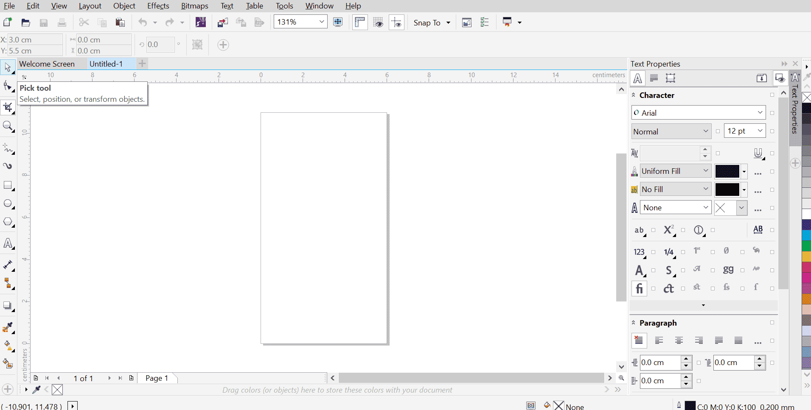
CHAPTER FOUR
4..1 EXECUTIVE SUMMARY
The Student Industrial Work Experience Scheme (SIWES) at Ifefol Business Centre and Computer College provided practical exposure to office operations, computer training, and digital design. The training covered the introduction to office equipment, including computers, printers, and scanners, essential for administrative and business tasks. Additionally, hands-on experience was gained in using Microsoft Office Suite, focusing on Word, Excel, and PowerPoint for document processing, data management, and presentations. The training also included CorelDRAW, a powerful graphic design software used for creating professional visual content such as logos, business cards, and banners. This experience enhanced my proficiency in office technology and digital tools, equipping me with essential skills for modern business and design applications.
4.2 CHALLENGES ENCOUNTERED
During my SIWES training at Ifefol Business Centre and Computer College, several challenges were encountered. Firstly, there were occasional power outages, which disrupted training sessions and affected workflow efficiency. Secondly, limited access to advanced computer systems and software sometimes restricted the learning process, as some tasks required higher processing power. Additionally, the availability of training materials and practical resources was sometimes insufficient, making it difficult to practice extensively. Furthermore, the learning pace varied among trainees, which occasionally slowed down group training sessions. Lastly, internet connectivity issues posed difficulties in accessing online resources and tutorials for further learning and research.

CHAPTER FIVE
5.1 CONCLUSION
The SIWES training at Ifefol Business Centre and Computer College provided valuable hands-on experience in computer operations, office equipment usage, and software applications such as Microsoft Office Suite and CorelDRAW. The program enhanced my technical skills, improved my understanding of digital tools, and gave me practical exposure to real-world office and business center operations. Despite some challenges such as power outages and limited access to advanced resources, the training was insightful and contributed significantly to my professional development. Overall, the experience reinforced the importance of technology in modern business environments and prepared me for future career opportunities in the field of information and communication technology.
5.2 RECOMMENDATIONS
Recommendation
To improve the SIWES experience at Ifefol Business Centre and Computer College, the following recommendations should be considered:
- Improved Power Supply – The organization should invest in alternative power sources such as inverters or generators to ensure uninterrupted workflow and training.
- Upgrade of Equipment and Software – The center should provide the latest versions of Microsoft Office Suite and CorelDRAW, along with high-speed computers, to enhance learning efficiency.
- Structured Training Program – A well-organized curriculum with practical sessions should be introduced to help students grasp concepts more effectively.
- More Training Resources – Availability of training manuals, video tutorials, and real-time projects will enhance students' understanding of digital tools.
- Better Internet Access – A stable internet connection will improve research, online training, and access to updated software features.
- Extended Hands-on Sessions – More practice sessions should be incorporated into the training to reinforce skills learned during theoretical lessons.

