KWARA STATE POLYTECHNIC ILORIN
STUDENTS INDUSTRIAL WORK EXPERIENCE SCHEME (SIWES)

A TECHNICAL REPORT OF TRAINING UNDERTAKEN AT PROF. SHEHU AHMAD JIMOH LIBRARY, KWARA STATE POLYTECHNIC ILORIN
(AUGUST - NOVEMBER 2024)

BY
ABDULLAHI HALIMAH
ND/23/LIS/FT/0136
SUBMITTED TO THE DEPARTMENT OF LIBRARY AND INFORMATION SCIENCE
INSTITUE OF INFORMATION AND COMMUNICATION TECHNILOGY

JANUARY, 2025

ACKNOWLEDGMENT
I express my heartfelt gratitude to the management of Kwara State Polytechnic Library, Ilorin, for providing an enabling environment to conduct my industrial training. My deepest appreciation goes to my supervisor, for his mentorship, patience, and invaluable insights throughout my training period. I also appreciate all the staff members of the library, especially those in the Technical, Circulation, and Reference, Serial, Acquisition and E-Library Units, for their cooperation and guidance.
I acknowledge my institution, Kwara State Polytechnic, for creating the opportunity for students to gain practical experience through the SIWES program. Lastly, I am grateful to my family and friends for their continuous encouragement and support during this program.

TABLE OF CONTENTS
- Title page
- Acknowledgement
- Chapter One: Introduction ……………………………………..
1.1 Background of SIWES…………………………………..
1.2 Objectives of SIWES……………………………………..
1.3 Importance of SIWES to Library and Information Science Students…………………………………………………….
1.4 Organization of the Report……………………………
- Chapter Two: Organizational Profile…………………………….
2.1 History of Kwara State Polytechnic Library…………
2.2 Vision and Mission of the Library……………………
2.3 Organizational Structure……………………………..
2.4 Services Rendered by the Library……………………
- Chapter Three: Activities and Experience Gained……………
3.1 Cataloging and Classification Activities………………
3.2 Circulation Desk Activities…………………………….
3.3 Reference Services………………………………………
3.4 Shelving and Shelf Reading…………………………….
3.5 ICT-Related Library Services………………………….
- Chapter Four: Challenges Faced………………………………...
4.1 Infrastructural Challenges……………………………
4.2 Technological Constraints…………………………….
4.3 Limited Duration of Training…………………………
4.4 User-Related Challenges
- Chapter Five: Recommendations and Conclusion……………..
5.1 Recommendations……………………………………….
5.2 Conclusion……………………………………………….
- References…………………………………………………………
- Appendices………………………………………………………...

CHAPTER ONE:

INTRODUCTION

1.1 Background of SIWES
The Student Industrial Work Experience Scheme (SIWES) was established by the Industrial Training Fund (ITF) in 1973 to bridge the gap between theoretical knowledge and practical application for students in tertiary institutions. It is designed to expose students to the real-world work environment, helping them develop relevant technical and professional skills needed in their chosen fields. SIWES also serves as an avenue for students to familiarize themselves with workplace ethics, culture, and dynamics.

1.2 Objectives of SIWES
The primary objectives of SIWES are as follows:
- Provide students with practical work experience to complement classroom learning.
- Enhance students’ understanding of industrial processes and workplace dynamics.
- Equip students with skills that increase their employability in their respective fields.
- Foster partnerships between academic institutions and industries for mutual benefit.

1.3 Importance of SIWES to Library and Information Science Students
For students of Library and Information Science, SIWES is essential in providing exposure to the practical aspects of librarianship. It helps students to:
- Understand cataloging and classification systems used in organizing library resources.
- Learn how to manage library users and address their information needs.
- Gain experience in using library automation systems like KOHA.
- Develop organizational and interpersonal skills through interactions with library staff and patrons.

1.4 Organization of the Report
This report is structured into five chapters:
- Chapter One introduces the SIWES program and its relevance to my academic discipline.
- Chapter Two provides an organizational profile of Kwara State Polytechnic Library, including its history, structure, and services.
- Chapter Three discusses my activities and experiences during the training.
- Chapter Four highlights the challenges encountered and how they were addressed.
- Chapter Five presents recommendations for improving the SIWES program and concludes the report.

CHAPTER TWO
2.1 DESCRIPTION OF PROF. SHEU AHMED JIMO H LIBRARY, KWARA STATE POLYTECHNIC
Prof. Sheu Ahmed Jimoh Library, Kwara State Polytechnic, Kwara state, is an Academic library which was established to support learning, teaching and research in the polytechnic. This establishment follows the principle of Library of Congress Classification Scheme in their Technical unit. The Library System is divided into seven (7) major units namely; Polytechnic Librarian Office, Reader Service unit, Technical service unit (Cataloguing and Classification Units), Serial unit, Acquisition Unit, E-library unit and Administrative unit.
2.2 LOCATION AND BRIEF HISTORY OF PROF. SHEU AHMED JIMOH LIBRARY, KWARA STATE POLYTECHNIC
The polytechnic library, popularly known as The Prof. Sheu Ahmed Jimoh Library, Kwara State Polytechnic, started functioning since 1973, when the polytechnic was established as one of the academic units in the polytechnic environment. This library was formally called KWARATECH Library which was later changed to Prof. Sheu Ahmed Jimoh Library, Kwara State Polytechnic. This library is strategically located at the center of the campus to ease accessibility from every direction of the campus. Up to date, it has been performing its academic roles in order to support learning, teaching and research in the institution. The library experienced a considerable growth since its establishment. There is development in area such as the size of the library building itself, the material collection, equipment, staffing and other changes which can only be measured by how relevant the library has continued to be, despite the rapid development of the institution. It is not an over statement to say that the polytechnic library is one of the most transformed units in Kwara State Polytechnic.
For instance, the original library building is now just section housing the Bookshop and the Internal Audit unit. Unlike in the early days when staffs are bunched together in a common open office system and the library was operating without the necessary library facilities, the library is now on its own permanent site which was completed in 2015 and thus had been able to put its feet down and spread wings to provide a sophisticated library service in line with the current trends in information dissemination. The trend of the development of the parent institution could be said to be geometrical and as a result the library is being affected positively.
OBJECTIVE OF PROF. SHEU AHMED JIMOH LIBRARY, KWARA STATE POLYTECHNIC
• To provide adequate and comfortable physical facilities for private or general studies.
• To provide for the need of academic community.
• To provide conducive reading/study area for students.
General Information on Hours of Opening in the Library
Membership of the Library
On completion of the registration cards, membership is open to the following:
- All students of the Polytechnic
- All members of the senior staff
Such person as may be determined from time to time by the polytechnic Librarian.
This category of members must make personal application to the designated librarian for such permission, by the polytechnic Librarian which will be treated on its own merit. Each registered member is issued with a registration card a readers’ ticket as follows:

Students - 2 tickets each
Staff: - 4 tickets each
Students keep their borrower’s tickets when not in use, but those for senior staff are held in the library. A registered reader who lost his borrower’s ticket need to report immediately at the circulation desk. A duplicate may be issued on payment of a replacement fees, but only after one month from the date the loss was reported but if the user fails to report the loss of readers’ ticket immediately, no replacement will be issued for the remaining period of the session
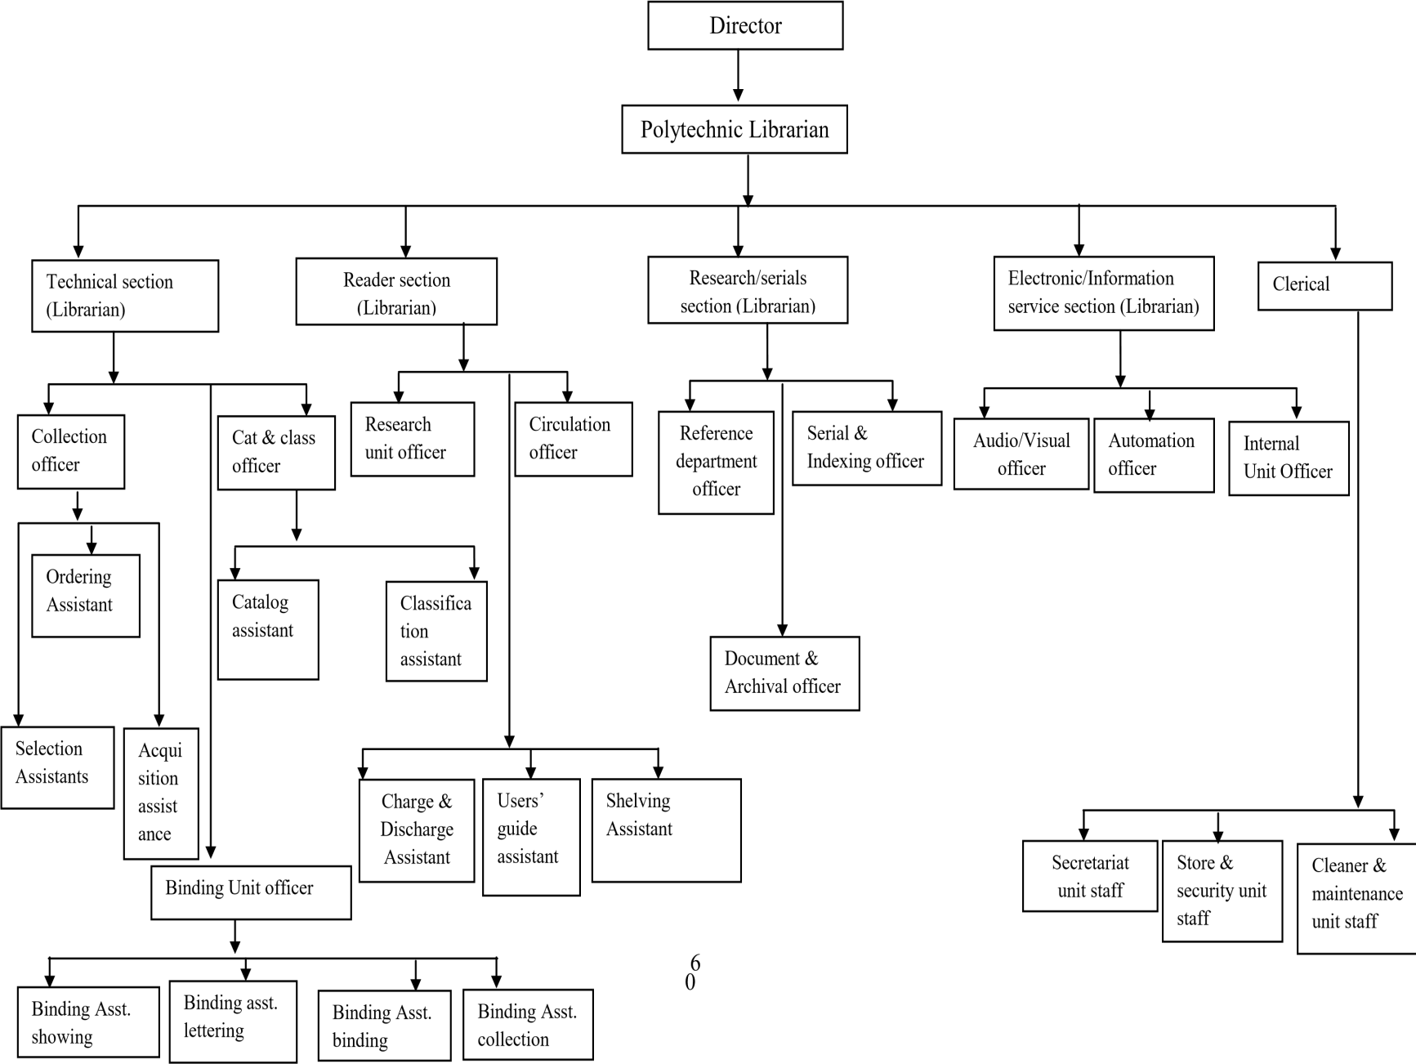
ORGANOGRAM OF PROF. SHEU AHMED JIMOH LIBRARY, KWARA STATE POLYTECHNIC
2.4 VARIOUS SECTIONS/UNIT THEIR FUNCTIONS
For administrative convenience, the library system is divided into five major units namely;
- Acquisition Unit
- Technical Services Section (Cataloguing and Classification Units)
- Reader Services
- Serial Unit
- E-library Unit
DEPARTMENTS IN PROF. SHEU AHMED JIMOH LIBRARY, KWARA STATE POLYTECHNIC AND THEIR FUNCTIONS

Acquisition Unit
This unit carries out all the procedure of collection development which is an integrated process through which information materials are gathered in a particular library through the Concept of Collection Development Policy. In other words, this is the unit in which library collection in whatever form comes into the library and without the acquisition department there won’t be a library collection and if at all there is, the collection will be full of irrelevant materials that are not needed which will inhibit the purpose of the library to provide relevant materials to its users.
Functions of Acquisition Unit Section
The following are the functions of acquisition unit;
      - Identification and selection of information material with the use of publisher’s catalogue, BIP/BOP, etc.
      - Ordering for information materials, checking ordering slip, verification of newly acquired materials
      - Conservation and preservation of information material
        - Accessioning, stamping and carding before moving the newly acquired materials to the cataloguing and classification unit for further processing
        - Creation of database to record newly acquired information materials
        - Repairing/binding of worn-out materials
        - Weeding of outdated materials
Technical unit [Cataloguing and Classification Unit]
This unit consists of the professional librarians that have undergone several training in librarianship and have cognate experience in librarianship to bring orderliness to the information materials acquired into the library. That is, in this unit all the technical processes on a book are done before it is placed on the shelve for public consultation. In this department, Anglo American Cataloguing Rule II is used for descriptive cataloguing of the information materials while Library of Congress Classification Scheme is use to classify information materials into different classes.
Functions of Cataloguing and Classification Unit
- Descriptive Cataloguing of the newly acquired information materials with the use of AACRII.
- Classification of library materials manually with the use of Library of Congress Classification Scheme.
- Preparation of information materials which has to do with spine labeling of the information materials for easy retrieval.
READERS SERVICE
This unit is the image maker of the polytechnic library in terms of dissemination of stored information to the users.
Functions of Readers’ Service Unit
The following are the functions of readers’ service Unit
        - Shelving and Shelf reading of the information resources
        - Registration of library users
        - Taking Statistics of library users
        - Charging and Discharging of the information resources;
- Answering the users’ queries.
SERIAL UNIT
The serial unit seems to be the research unit of the library because it takes care of some information materials such as Journals, Theses, Dissertation, Newspapers, Bulletins, Past Projects etc. which can be consult by the information user. In this unit information materials are acquired through subscription. They normally subscribe to: Punch, Herald, The Nation, Guardian.
Functions of Serial Unit
The following are the function of serial unit;
        - Captioning of bibliographic information in the daily newspaper
        - Properly organizing the information materials in the serial unit such as journals, project, dissertation, thesis, newspapers and magazine
        - Selection of relevant information material to meet the information need of the patron
Electronic Library (E-Library)
This is a sub-section in the library in which collections are stored in electronically or digital formats (as opposed to print, microform, or other media) and accessible by computers. Their collection contents are stored locally, and can be accessed remotely via computer networks. This section can also be term as the digital library.
Functions of Electronic Library (E-Library)
        - Managing electronic resources
        - Searching and retrieving information materials electronically
        - Internet browsing
Administrative Unit
this consists of the secretariat officers that documents and give reports to the librarian office, they keep the tracks of daily reports and activities that flows in and out of the library. Their experiences in the work of secretariat assist the librarian in the administration of the library activities. However, the librarian is the head of the unit because the administrative office is attached to the librarian office.
Function of the Administrative Unit
- Keeping of records.
        - Receiving and dispatching of mails.
        - Maintaining and organizing the records received within and outside the library.

CHAPTER THREE

ACTIVITIES AND EXPERIENCE GAINED
This chapter details the various activities I engaged in during my industrial training at Kwara State Polytechnic Library. Each activity provided an opportunity to gain practical skills, understand library operations, and improve my ability to work effectively within a professional environment.

3.1 Cataloging and Classification Activities
Cataloging and classification form the foundation of library organization. I was introduced to the Library of Congress Classification (LCC) system and trained on how to classify books and assign appropriate call numbers. My tasks included:
- Creating Catalog Records: I learned to describe books by recording their title, author, edition, publisher, and publication date. This information was entered into the library catalog system.
- Assigning Call Numbers: Using the LCC system, I assigned unique call numbers to each book to facilitate easy retrieval.
- MARC Standards: I was introduced to the Machine-Readable Cataloging (MARC) format, which is used to create standardized bibliographic records.
- Hands-On Practice: I processed a variety of materials, including textbooks, journals, and non-book materials like audiovisual items.
This activity improved my understanding of bibliographic description, classification schemes, and the importance of accurate cataloging in ensuring effective library operations.

3.2 Circulation Desk Activities
The circulation desk serves as the focal point for library-user interaction. My duties included:
- User Registration: Assisting new users in registering for library membership.
- Lending and Returning Materials: Issuing and receiving books while maintaining accurate records using the library's automated circulation module.
- Managing Overdue Fines: Keeping track of overdue materials and calculating fines as per the library policy.
- Reservation Services: Handling user requests to reserve books currently checked out.
Through these activities, I learned customer service skills, time management, and the use of library automation software for circulation management.

3.3 Reference Services
The reference unit is critical in guiding users to appropriate resources and providing research assistance. My experience included:
- Assisting Users: I guided users in finding books, journals, and electronic resources relevant to their academic needs.
- Answering Queries: Responding to inquiries about library resources, services, and policies.
- Reference Material Management: Ensuring that encyclopedias, dictionaries, and other reference books were in their designated locations.
This unit enhanced my research skills and taught me the importance of effective communication and problem-solving in user services.

3.4 Shelving and Shelf Reading
Shelving and shelf reading ensure the proper arrangement and maintenance of library collections. My responsibilities were:
- Arranging Books: Placing books on shelves according to their call numbers.
- Shelf Reading: Identifying misplaced items and correcting their arrangement to maintain the orderliness of the library.
- Labeling: Checking the clarity and accuracy of spine labels on books for easy identification.
These tasks sharpened my attention to detail and reinforced my understanding of the importance of maintaining an organized library.

3.5 ICT-Related Library Services
The library's ICT unit introduced me to the technological aspect of librarianship. My activities included:
- KOHA Library Management System: I observed and practiced using KOHA for cataloging, circulation, and inventory management.
- Electronic Resources: Assisting users in accessing e-books, online journals, and databases.
3.6 Serial Unit
- Introduction to serials management: Understanding the importance of periodicals, journals, and magazines.
- Managing subscriptions: Handling renewals, cancellations, and payments.
Cataloging and classifying serials according to library standards.
Handling Serial Issues:
- Receiving and checking serials issues for completeness.
- Binding and preservation of old or damaged issues.
- Creating and managing the serials holdings list.
3.7 Acquisition Unit
- Introduction to acquisition: Overview of the process for selecting and acquiring library materials.
- Identifying appropriate suppliers and handling procurement requests.
- Receiving and processing new acquisitions: Checking delivery accuracy and condition of materials.
- Cataloging newly acquired materials into the system.
- Maintaining records of purchase orders, invoices, and receipts.
TOOLS AND EQUIPMENT USED, THEIR FUNCTIONS AND USAGE DESCRIPTION
The following are the equipment and tools used in all sections visited including their function and usage description:
- Stamp and Stamp Pad
- Anglo American Cataloguing Rule 2(AACR2)
- Library of Congress Subject Headings (LCSH)
- Library of Congress Classification Scheme
- Anti-Theft Device
- Accession Resgister
- Computer
- Catalogue Card
- Stylus Pen and Fluid Tape
- Permanent Marker and Sticker
- Gum
- NEWSPAPER RACK
STAMP AND STAMP PAD
These tools are used majorly in the collection development division and serial unit. In the collection development division, some of the stamps are attached to every book in the library, such as: ownership stamp, edge stamp, secret stamp and accession stamp. Tet fund stamp is only attached to books that are acquired through Tet fund, edge and secret stamp are used to indicate that the information materials belong to the library. The accession stamp indicates the spaces for accession number, call number and date.
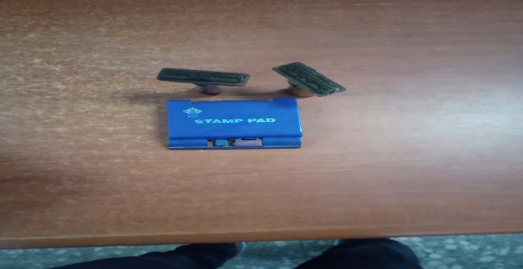

LIBRARY OF CONGRESS SUBJECT HEADINGS (LCSH)
It is used to confirm formulated subject for information materials(books) during descriptive cataloguing. According to the cataloguing rule the subject written in bold should be adopted for usage.
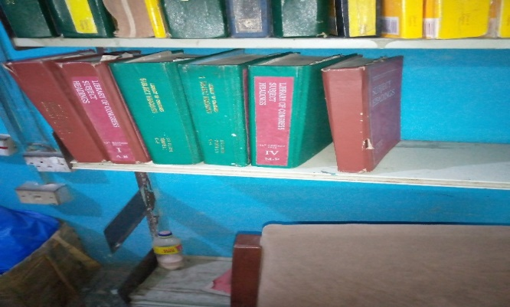
LIBRARY OF CONGRESS CLASSIFICATION SCHEME
Library of congress classification scheme: is used for deriving classification number for library information materials. Library of congress classification scheme (LCCS) comprising of different subjects.
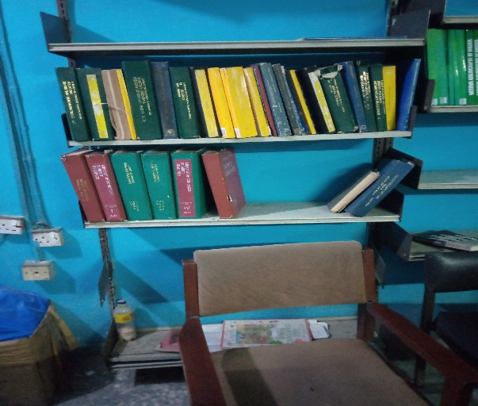
COMPUTER
This is available in all the offices of the library, every division and unit make use of computer for documentation, storage, editing and accessing of information.
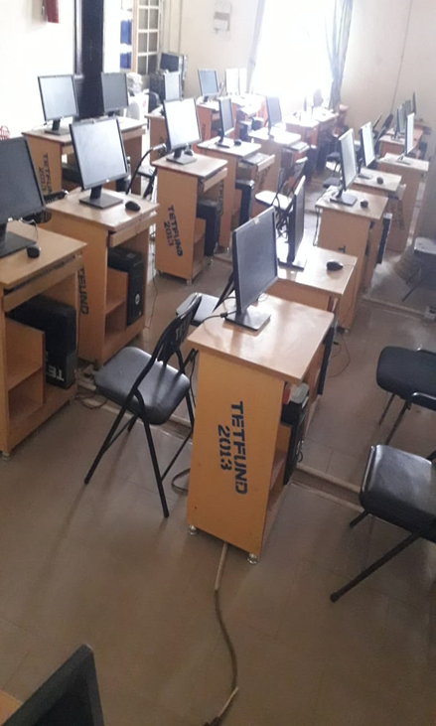
NEWSPAPER RACK
This is used to display daily newspapers.
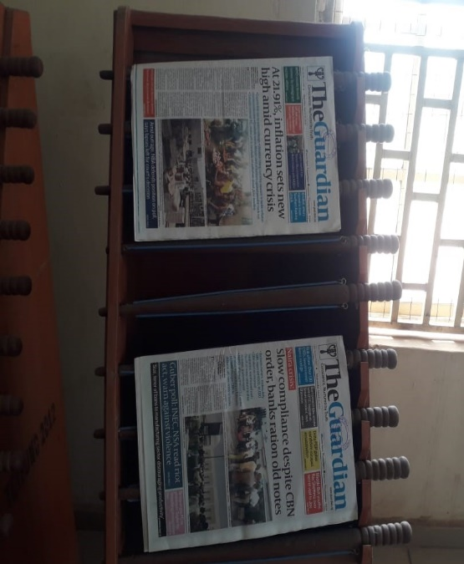

CHAPTER FOUR:

CHALLENGES FACED
Although the SIWES program was rewarding, it came with challenges that required adaptability and problem-solving skills.

4.1 Infrastructural Challenges
Frequent power outages were a significant hindrance to daily operations, especially when using electronic resources and library automation systems. This sometimes delayed the completion of tasks and interrupted user services.

4.2 Technological Constraints
The library had limited access to modern ICT tools, which restricted my exposure to advanced automation technologies. Some systems, such as the OPAC library management system, were not fully optimized, limiting their functionality.

4.3 Limited Duration of Training
The duration of the SIWES program was too short to gain in-depth knowledge of all library departments. Some areas, such as acquisitions and special collections, received minimal attention due to time constraints.

4.4 User-Related Challenges
Interacting with users posed challenges, such as dealing with frustrated patrons when materials were unavailable or providing guidance to those unfamiliar with library systems. These situations required patience, effective communication, and conflict resolution skills.

CHAPTER FIVE:

RECOMMENDATIONS AND CONCLUSION

5.1 Recommendations
- Upgrade Library Infrastructure: Providing backup power supply systems would minimize disruptions caused by power outages.
- Invest in Modern Technology: Equipping the library with advanced automation tools and software would enhance efficiency and expose students to industry standards.
- Extend Training Duration: Lengthening the SIWES period would allow for more comprehensive learning and exposure to all library departments.
- User Education Programs: Regular workshops and training sessions for library users on how to navigate library systems and utilize electronic resources effectively.
- Expand Digital Resources: Increasing the availability of online journals, databases, and e-books to cater to the diverse needs of library users.

5.2 Conclusion
The SIWES program at Kwara State Polytechnic Library, Ilorin, was an enriching experience that bridged the gap between theoretical knowledge and practical application. The training allowed me to develop essential skills in cataloging, user services, and library automation. Despite the challenges, the experience was invaluable, and the knowledge gained will significantly contribute to my professional development in Library and Information Science.

REFERENCES
- Industrial Training Fund (ITF). (1973). SIWES Handbook.
- Kwara State Polytechnic Library. (n.d.). Library Policies and User Guide.
- Ranganathan, S. R. (1931). The Five Laws of Library Science.
- University of Ibadan. (2020). Library Automation Practices in Nigerian Libraries.
This exposure enhanced my technical skills and understanding of the role of ICT in modern library operations.

APPENDICES
Training Schedule
  - Week 1: Orientation and introduction to the library environment.
  - Week 2-4: Cataloging and classification training.
  - Week 5-7: Circulation desk activities and user services.
  - Week 8-10: Reference services and ICT operations.
  - Week 11-13: Serial Unit
  - Week 14-16: Acquisition Unit
Sample Catalog Record
  - Title: Introduction to Library Science
  - Author: John Doe
  - Call Number: Z665.D68

