

TECHNICAL REPORT
ON
STUDENT INDUSTRIAL WORK EXPERIENCE SCHEME (SIWES)

HELD AT
KWARA STATE MINISTRY OF ENERGY
P.M.B. 1574, ILORIN KWARA STATE

PRESENTED BY
AHMED BASIT BOLAJI
ND/23/EEE/PT/0059

SUBMITTED TO
Department of Electrical and Electronic Engineering,
Institute of Technology
Kwara State Polytechnic, Ilorin
In Partial Fulfillment of the Award of National Diploma (ND) in Electrical and Electronic Engineering
AUGUST – DECEMBER 2024

DEDICATION
This work is dedicated to the Almighty God, for their love, mercies, guidance and protection during and even after this work.
This work is also dedicated to my lovely and caring parents and wonderful brothers and sisters for their love, support and encouragement.

ACKNOWLEDGEMENT
I wish to acknowledge and thank everyone who contributed one way or the other towards the success of my industrial training.
My special thanks goes to the management of and my supervisor for their numerous contribution and effort to make this research a success.
Also my beloved mother and my colleagues for giving me the great opportunity.
I want to say a big thanks to my siblings and my friends for their support and love also my friends for their encouragement and advice.

ABSTRACT
The Student Industrial Work Experience Scheme (SIWES) Relevance to the Department of Electrical and Electronic Engineering was researched upon. The instruments used was practicalized and this practical were used to answer the research questions. The results were collected and analyzed in the chapters that make up this study report and project works.
Based on the analysis, Major findings emerged revealing that students did receive practical work on the job training. The SIWES scheme further exposes students to proper methods of using and handling electrical and electronic technology equipment and development at KWARA STATE MINISTRY OF ENERGY.
However, the study concluded that if students are adequately exposed to research materials and facilities, if students are provided with thorough and proper supervision by supervisors, if orientation towards equipment and machinery handling was well fashioned out, there will necessarily be an upsurge in performance rates Therefore, the researcher recommends the following
That employers ought to accept students supervisors need to be attached to individual’s students. Students should be allowed to express and get themselves exposed to electrical and electronic technology practices in order to acquire a deeper orientation before the commencement of the programme if adequate performance is to be guaranteed.

CHAPTER 1
Student Industrial Work Experience Scheme
The Students Industrial Work Experience Scheme (SIWES), is a skills Development programme initiated by the Industrial Training Fund (ITF), in 1973 to bridge the gap between theory and practice among students of Engineering and technology in Institutions of Higher Learning in Nigeria. It provides for on-the-job practical experience for students as they are exposed to work methods and techniques in handling equipment and machinery that may not be available in their Institutions.
SIWES was established by ITF in 1973 to solve the problem of lack of adequate practical skills preparatory for employment in industries by Nigerian graduates of tertiary institutions.
The Scheme exposes students to industry based skills necessary for a smooth transition from the classroom to the world of work. It affords students of tertiary institutions the opportunity of being familiarized and exposed to the needed experience in handling machinery and equipment which are usually not available in the educational institutions.
Participation in SIWES has become a necessary pre-condition for the award of Diploma and Degree certificates in specific disciplines in most institutions of higher learning in the country, in accordance with the education policy of government.
Duration – Four months for the Polytechnics.
Aim of the Study
The aim of the study was to evaluate the impact of SIWES on Technical Skills Development in the Nigerian economy. This is to enable Institutions of Higher Learning and other Stakeholders assess the performance of their roles in the Scheme.
THE ROLE OF THE INDUSTRIAL TRAINING FUND
The Industrial Training Fund (ITF) was established by the decree 47 of 1971 constitution and charged with the responsibility of promoting and encouraging the acquisition of industrial skills, with the view of generating a collection of indigenous trained manpower, sufficient enough to enhance and meet the needs of the economy so as to promote development. Supervision of students, organizing orientation programs, and disbursing allowances to students are some of the roles played by the industrial training fund in the implementation of SIWES.

THE SCOPE AND IMPORTANCE OF SIWES
The scheme covers all science and technological based students in monotechnics, polytechnics and universities in Nigeria, resulting in a high population of students which is easily managed because of the public and private industries that partake in the scheme. SIWES enables students acquire industrial know-how in their field of study particularly in technological based courses. It also enables students experience the application of theoretical knowledge in solving real life problems.

THE ROLE OF THE STUDENT AND THE INSTITUTION
The role of the student is to partake in the program in such a way that he/she will achieve maximum benefit from the program. The student is advised to ask questions, be submissive, and adhere to all the rules and regulations of the organization where he is attached. Identification of placement opportunities, funding of SIWES supervisors and assessment of the student are some of the roles played by the institutions to ensure smooth running of the program.

CHAPTER 2
About The Organization
The Ministry of Energy is a government institution responsible for formulating and implementing energy policies, regulations, and programs to ensure sustainable energy development. Its primary role is to manage and oversee the energy sector, including electricity, renewable energy, oil, gas, and other energy resources.

Key Functions of the Ministry of Energy

- Policy Formulation & Implementation
Develops national energy policies and strategies.
Ensures compliance with international energy agreements.

- Regulation & Oversight
Supervises energy generation, distribution, and consumption.
Regulates tariffs, licensing, and operational standards.

- Energy Production & Distribution
Oversees power plants, oil refineries, and gas infrastructure.
Ensures stable and affordable energy supply.
- Promotion of Renewable Energy
Encourages investment in solar, wind, hydro, and bioenergy.
Implements projects for clean and sustainable energy solutions.

- Infrastructure Development
Develops national power grids, pipelines, and refineries.
Supports rural electrification and energy access programs.

- Research & Innovation
Funds research on energy efficiency and new technologies.
Collaborates with universities and private sector innovators.

- Energy Security & Sustainability
Ensures energy reserves and emergency preparedness.
Implements environmental regulations to reduce emissions.

- Collaboration with Stakeholders
Works with international organizations, private investors, and local communities.
Develops public-private partnerships for energy projects.

Departments & Agencies under the Ministry
- Electricity & Power Regulation Department
- Renewable Energy Development Agency
- Oil & Gas Regulatory Authority
- Energy Research & Development Institute
- Rural Electrification Program

The Organization Organogram
The organogram of a Ministry of Energy typically follows a hierarchical structure that includes different departments and agencies responsible for energy policy, regulation, and implementation. While specific structures vary by country, a general organogram looks like this:

Ministry of Energy Organogram

1. Minister of Energy

- The highest authority in the ministry, responsible for policy direction and national energy strategy.

2. Deputy Minister(s) of Energy

- Assist the Minister in overseeing different energy sectors such as electricity, renewable energy, oil and gas, etc.

3. Permanent Secretary (or Director-General)

- The chief administrator responsible for executing policies, coordinating departments, and managing resources.

4. Departments/Divisions

Each department focuses on a specific energy sector:

- Department of Electricity & Power Generation

Oversees electricity production, grid management, and distribution.

- Department of Renewable Energy

Develops policies and projects for solar, wind, hydro, and bioenergy.

- Department of Petroleum & Gas
Regulates oil and gas exploration, refining, and distribution.

- Department of Energy Regulation & Policy

Sets energy laws, pricing policies, and compliance standards.

- Department of Research & Development

Conducts studies on new energy technologies and efficiency improvements.

- Department of Finance & Administration

Manages the ministry’s budget, procurement, and human resources.

- Department of Rural Electrification & Access

Focuses on expanding energy access to remote areas.

5. Agencies & Regulatory Bodies

These operate under the ministry to regulate and implement energy policies:

- Energy Regulatory Commission (sets tariffs, ensures compliance)

- National Oil & Gas Corporation (manages state participation in petroleum)

- Renewable Energy Agency (promotes clean energy projects)

- Electricity Transmission & Distribution Authority

ORGANIZATION CHART
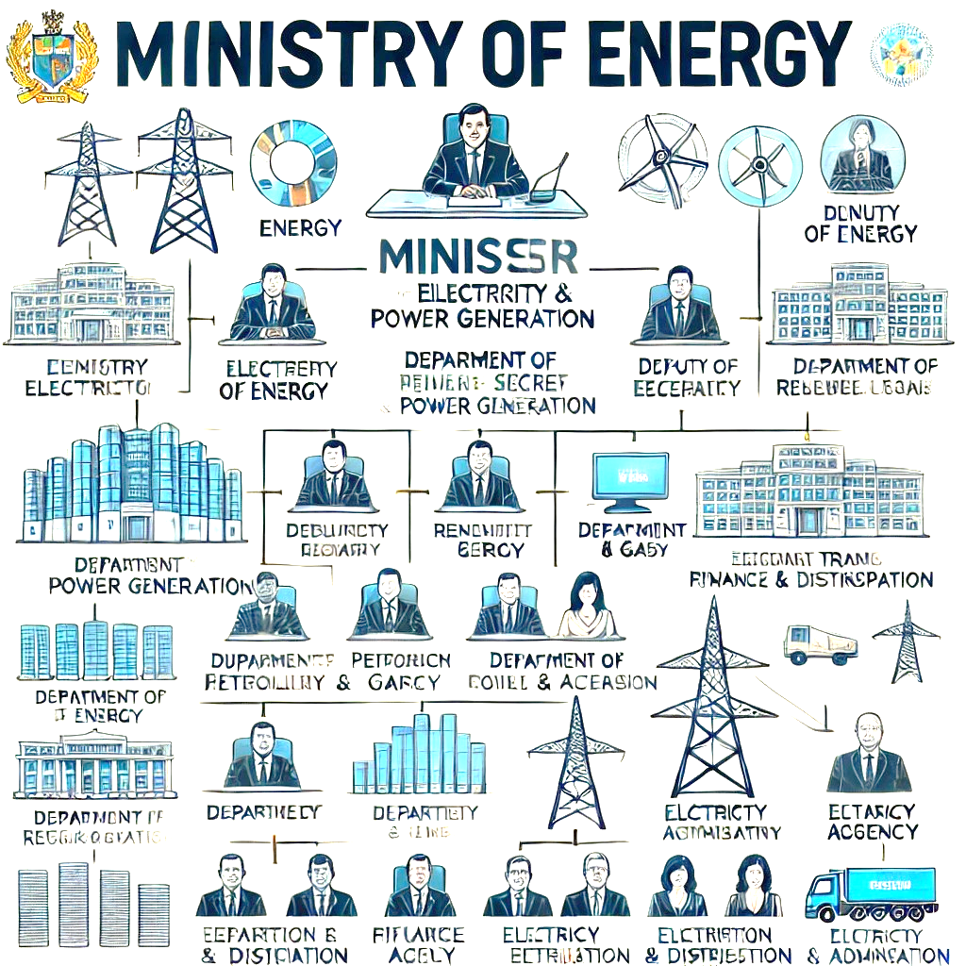

CHAPTER 3
  - Household Electricity
Objective

The purpose of this report is to understand and analyze household electricity, including power consumption, circuit components, safety measures, and energy efficiency.

Introduction

Household electricity is the system that powers appliances, lighting, and devices in a home. It operates on alternating current (AC), typically at 230V (in most countries) or 120V (in North America), and is distributed through circuits connected to a main electrical panel.

Materials and Equipment

- Multimeter (for voltage, current, and resistance measurement)

- Circuit breaker panel (for observation)

- Light bulb and socket

- Extension cord

- Electrical load (e.g., an iron, heater, or fan)

- Insulated screwdriver

- Electrical safety gloves

Procedure

1. Identifying Household Electrical Components

- Locate the main distribution board and identify circuit breakers.

- Identify major electrical appliances and their power ratings.

- Observe the types of wiring used in the house.

2. Measuring Voltage and Current

- Use a multimeter to measure the voltage at a wall socket.

- Connect a light bulb to an extension cord and measure the current drawn using a clamp meter.

3. Calculating Power Consumption

Power consumption is given by the formula:

P = V \times I
- = Power (Watts)

- = Voltage (Volts)

- = Current (Amperes)

Example: If a heater operates at 230V and draws 8A, the power consumption is:
P = 230V \times 8A = 1840W = 1.84kW \text{Energy} = P \times \text{Time} = 1.84kW \times 5h = 9.2kWh
4. Understanding Circuit Protection

- Observe how circuit breakers trip when there is an overload.

- Identify grounding wires and their role in preventing electric shocks.

5. Safety Measures in Household Electricity

- Always turn off power before working on electrical components.

- Never overload sockets to prevent overheating.
- Use insulated tools when handling electrical systems.

- Ensure earth connections are in place for appliances like water heaters.

6. Improving Energy Efficiency

- Use LED bulbs instead of incandescent ones.

- Unplug devices when not in use to avoid phantom loads.

- Use energy-efficient appliances with high star ratings.

Observations and Results

- Measured wall socket voltage: 230V (varies slightly based on location).

- Light bulb power consumption: 60W (observed with a 230V bulb).

- Household appliances such as refrigerators and air conditioners consume significant energy.

- Circuit breakers effectively protect against overcurrent.

  - Electrical Work
1. Introduction

Electrical power is the rate at which electrical energy is transferred or converted into other forms, such as heat, light, or mechanical energy. It is an essential concept in electrical engineering and is measured in watts (W).

2. Understanding Electrical Power

The basic formula for power:

P = V \times I

P = Power in watts (W)

V = Voltage in volts (V)

I = Current in amperes (A)

Types of Electrical Power:

- DC Power: Used in batteries and low-voltage circuits.

- AC Power: Used in household and industrial electricity. It includes:

3. Practical Observations

During my practical lessons, I performed experiments related to electrical power, including:

- Measuring Voltage and Current: Using a multimeter to determine power in a circuit.

- Power Consumption of Appliances: Calculating power usage of different electrical devices.

- Power Factor: Understanding efficiency in AC circuits.

4. Safety Precautions

- Avoid overloading circuits to prevent overheating.
<
- Use proper insulation and grounding.

- Follow standard safety guidelines while working with electrical systems.

‘Power’ in an Electrical Work
In electrical work, power refers to the rate at which electrical energy is transferred or converted into another form, such as heat, light, or mechanical energy. It is measured in watts (W) and is given by the formula:

- Apparent Power (S):

S = V \times I

- Real Power (P):

P = V \times I \times \cos(\theta)

- Reactive Power (Q):

Q = V \times I \times \sin(\theta)

The power factor () represents how efficiently power is being used.

Energy and Power Relationship:

- Energy (E) is the total amount of work done over time:

E = P \times t

Key Considerations in Electrical Work:

- Overloading Circuits: Exceeding power ratings can cause overheating and fire hazards.

- Efficiency: Power losses occur due to resistance (heat loss).

- Safety: Proper grounding and circuit protection (fuses, breakers) prevent electrical faults.

CHAPTER 4
CHALLENGES OF ENGINEERING FOR SIWES
The Student Industrial Work Experience Scheme (SIWES) for engineering students comes with several challenges, including:

1. Difficulty Finding Placements

- Many companies have limited SIWES slots.

- Some organizations require strong connections or prior experience.

- Unpaid internships can be financially challenging.

2. Adapting to Workplace Environment

- Adjusting to strict work ethics and discipline.

- Dealing with supervisors who may not be supportive.

- Managing expectations when tasks are different from classroom learning.

3. Practical vs. Theoretical Knowledge Gap

- Some students struggle to apply classroom theory to real-world tasks.

- Work might involve outdated or different technologies than what was taught in school.

4. Safety and Technical Challenges

- Exposure to hazardous environments (electrical, mechanical, chemical risks).

- Lack of hands-on experience leading to difficulty handling tools or equipment.

5. Communication and Teamwork Issues

- Difficulty working with professionals who expect a certain level of skill.

- Struggling to communicate technical ideas effectively.

6. Financial and Logistical Issues

- Transport and accommodation costs if the company is far from home.

- Limited stipends or unpaid internships can add financial stress.

7. Limited Learning Opportunities

- Some companies assign repetitive or clerical tasks instead of real engineering work.

- Workload might be too light, leading to boredom and minimal skill acquisition.

CHAPTER 5
CONCLUSION
This practical study provided a clear understanding of household electricity, its components, power consumption, and safety measures. By analyzing energy usage. It also enhance understanding that electrical power is crucial for efficient electrical work. This knowledge helps in designing, troubleshooting, and maintaining electrical systems safely and effectively.
During the course of the four months’ period of SIWES (Student Industrial Work Experience Scheme) at KWARA STATE MINISTRY OF ENERGY, I have acquired technical skills in the field of Household Electricity, Electrical work power and technical skills such as managerial skills, and have had the opportunity to experience the application of theoretical knowledge acquired in the classroom to solve real problems. Thus, SIWES has been a success, because I have gained knowledge that ordinarily would not be obtained in the lecture hall.

RECOMMENDATION
As a result of difficulties experienced during the four months SIWES program, I would like to recommend the following changes: The duration of SIWES should be extended so as to enable students be more experienced. The ITF should make monthly allowance available for students, so as to put an end to financial difficulties that may arise as a result of transport problems. The Institutions and ITF should help students to get a place of attachment so that the program may commence as planned.
The following recommendations were based on the findings of the study and as a solution to the identified problems.
PROPER COORDINATION AND SUPERVISION OF THE EXERCISE: The various bodies involved in the management of the SIWES exercise i.e. Industrial Training Fund (ITF), NUC, NBTE and NCCE should come together and fashion out a modality that will ensure smooth operation of the SIWES exercise. Efforts should be made to ensure that students attached to the organization are properly supervised to ensure that what they are doing is in line with the objectives of the SIWES exercise.

The various bodies involved in the management of the SIWES programme should liaise with the various industries ahead of time so as to minimize or reduce to the barest minimum the high level of refusal to accept students for their industrial training participation.
ISSUING OF LOG BOOKS/IT LETTERS ON TIME: The log books used by the student during the industrial training period and the IT letters should be issued to the students at the end of the first semester exam as against the end of second semester examination as this will afford the students enough time to search for place that are relevant to their field of study.
EMPLOYMENT OF EXPERTS: The various institutions should endeavor to employ experts in the areas of career development to manage the student's industrial placement centers.

