A TECHNICAL REPORT ON
STUDENT INDUSTRIAL WORKING EXPERIENCE SCHEME (SIWES)

HELDAT
UNIQUE ENTERPRISE

Prepared by:

ELEWADE OMOLABAKE MARIAM

ND/23/BAM/PT/0927

SUBMITTED TO:
DEPARTMENT OF BUSINESS ADMINISTRATION
INSTITUTE OF FINANCIAL MANAGEMENT STUDIES KWARA STATE POLYTECHNIC, ILORIN

IN PARTIAL FULFILLMENT OF THE AWARD OF THE REQUIREMENT OFTHE AWARD OF NATIONAL DIPLOMA IN BUSINESS ADMINISTRATION

AUGUST.–NOVEMBER.2024

DEDICATION
I dedicate this technical report to the Almighty God, the giver of knowledge,wisdom and who is rich in mercy.

ACKNOWLEDGEMENT
I would like to begin by expressing my heartfelt gratitude to the Creator of heaven and earth, the One who knows the beginning and the end, the Alpha and the Omega, the Almighty Allah for His guidance and blessings throughout this journey.
I am deeply grateful to my beloved parents, Mr. and Mrs. ELEWADE, whose unwavering support and prayers have been my foundation. To my brothers and dear friends, your encouragement and companionship have meant the world to me.
My special thanks go to my Siwes supervisor for his guidance,mentorship,and invaluable insights during this program. I also extend my profound appreciation to everyone who supported me during my SIWES experience. May the Almighty God bless, protect, sustain, and guide you through all of life’s journeys.
Lastly, I wish to express my sincere regards to the school’s Board of Trustees and the entire staff of the business administration department for their dedication and support. Once again, a big thank you to everyone who contributed to making this experience a memorable and successful one.

TABLE OF CONTENT
Title page
Table ofcontent ii
Dedication iii
Acknowledgements iv
TABLE OF CONTENTS
CHAPTER-ONE
  - Background of SIWES
  - Objectives of SIWES
CHAPTER TWO
  - Organizational Background
2.2 Departments inUnique Enterprise
CHAPTER THREE
- Key Projects and Assignments
- CHAPTER FOUR
- Key Knowledge Gained from the Siwes Training Programme
CHAPTER FIVE
  - Challenges 11
  - Conclusion 11
  - Recommendation 12

CHAPTER ONE INTRODUCTION

Industrial Training Fund(ITF)and SIWES

CHAPTER ONE
1.0 INTODUCTION
The origin of Industrial Training could be traced to the advent of industrial revolution
which ushered in steam engines, power driven machines and a new system of production in
Europe. The function satisfactorily then, workers needed to deport from their craft capabilities
and embrace knowledge and understanding which the new technologies offered in work –
settings via practical training. Therefore, the need prompted higher citadels of learning to
commence application of practical and technical affairs.
The concept thrived between 1824 and 1830 extensively to warrant the creation of
technical and engineering courses. These courses where established for at Reasselea. Polytechnic
institute, USA, and secondly at Colombia University to on the new scientific curriculum that
necessitated the Greek or latin language indusu, the effect of this concept has been argued and it
lead to the spread or escalation of science, engineering and technical education in several tertiary
institutions in American and Europe towards the end of 19th century.
The products of these instructions were trained through systematic instruction with a
body of knowledge in engineering and science which was theoretical and universal. Hence, they
had broad ideas on fundamental knowledge to the workability of various engineering systems but
lacked an indepth foundation on practical knowledge needed for effective production in certain
jobs.
The gap between theoretical knowledge and practical training was therefore noticed for
bridging and it necessitated, science and engineering students complementary their theoretical
knowledge with practical training in industries so as to become productive in their career after
graduation. This prompted the innovation that later took place in the 20th century with the
introduction of cooperative education through Herman Schneider, the Dean, college of
engineering, university of Cincinnat.
Therefore, engineering students started attending classes to acquire theoretical knowledge
and also engaged in trainings with the same duration in companies for practical experiences.

ObjectivesoftheStudentsIndustrialWorkExperienceScheme (SIWES)

- Toprovidestudentstheopportunitytotesttheirinterestinaparticularcareerbeforepermanent commitments are made.
- Toprovideanavenueforstudentsininstitutionsofhigherlearning,acquireindustrialskillsand experience in their course of study.
- To provide and prepare students for the industry trial work situations ion they-are to-meet after school.

- To aid students in adjusting from college to full-time employments

- To provide students the opportunity to develop attitudes conducive to effective interpersonal relationships.
- To increase students sense of responsibility.

- Tomakestudentsacquiregoodworkhabits.

- To provide students with an opportunity to apply their knowledge in real work situation thereby bridging the gap between theory and practice.

CHAPTER TWO INTRODUCTION

OrganizationalBackground

Unique Enterprise is a renowned fashion brand located at No 4, Alimi way, Primate Street, ilorin kwara state , they specialize on indomie, spaghetti, biscuits etc. The main target is to reduce price and provide customers need profitably. The pricing technique used in the company, are full most pricing method . It is the policy of the company to settle dispute and crisis by making dialogue or constitution ambudism in order to make workers to be satisfied with their job and also to make them have a sense of belonging.

2.2 Departments In Unique Enterprise

Unique Enterprise operates through a well-structured system of departments, each playing a crucial role in ensuring efficiency, quality, and customer satisfaction. The key departments include:

Customer Service and sales Department
Ensuring a seamless shopping experience, this department handles customer inquiries, takes orders, processes payments, and ensures that clients receive excellent service and satisfaction.

Marketing and Branding Department
This team focuses on promoting unique enterprise through advertising, social media engagement, and brand awareness strategies, ensuring the store reaches a wider audience.

Quality Control Department
Responsible for maintaining high standards, this department inspects all products before they reach customers,.

CHAPTER THREE
KEY PROJECT AND ASSIGNMENTS

3.1 Key Projects/Assignments and Achievements

During the Student Industrial Work Experience Scheme (SIWES) at Unique Enterprise multiple projects, assignments, and responsibilities were undertaken, significantly contributingto the store's operational efficiency. The practical experience gained aligns with key business administration principles, inventory control methodologies, and customer service management, reinforcing theoretical knowledge acquired in an academic setting.

- Inventory and Stock Management Optimization: Inventory control is a critical aspect of supply chain management, ensuring seamless operations in the store. Key achievements include:

Application of microsoft Excel in inventoryManagement:
    - Developed proficiency in using Excel spreadsheets for stock monitoring by applying fundamental formulas such as SUM, COUNTIF, and IFERROR, which are crucial in data validation and error handling.
    - Assisted in maintaining real-time stock records, ensuring an efficient tracking system that prevents understocking and overstocking.

PhysicalStockAuditingandVerification:
    - Conducted manual stock reconciliation by cross-checking system records with physical inventory, ensuring accuracy in documentation.
    - Participated in weekly stock-taking exercise, ensuring that discrepancies were promptly identified and corrected, a practice essential for maintaining optimal inventory levels.

- Customer Relations and Front Desk Operations: Customer service excellence is fundamental in retail businesses,particularly in the store, where client satisfaction drives revenue growth.

PayrollandAdministrativeResponsibilities

    - Financial management, particularly payroll administration , plays a vital role in employee satisfaction and business stability.

CHAPTER FOUR

4.1 KEY KNOWLEDGE GAINED FROM THE SIWE STRAINING PROGRAMME

During my Student Industrial Work Experience Scheme (SIWES) at Unique Enterprise , I gained hands-on experience in various aspects of Office Equipment, business administration, inventory management, customer service. Key experience gained included:

Identification Of Office Equipment and Their Functions
I get to know about Variousofficeequipmentutilizedtoenhance administration efficiency, record-keeping, customer service, and sales processing. These devices play crucial roles in streamlining business operations, ensuring smooth communication, and improving overall workflow. Below are list of Office Equipment and Their Functions:

Computer:Used for processing business data, managing inventory using MicrosoftExcel,writing invoices, scanning and storing documents, and handling payroll records.
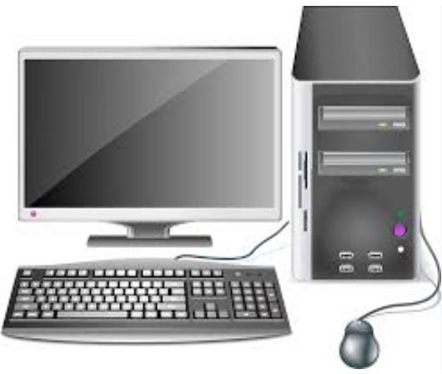
Printer:Used to produce hard copies of invoices,receipts,payroll documents,and other business records required for customer and administrative use.
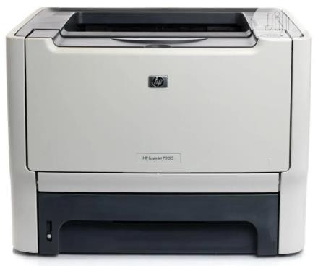

Photocopier Machine: Duplicates essential business documents such as receipts, invoices, staff records, and sales reports for record-keeping.
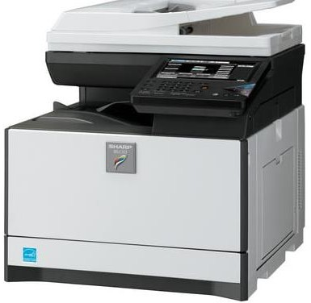
Point-of-Sale(POS):MachineProcessescustomertransactions,allowingforsecureandefficient payment via credit/debit cards, reducing reliance on cash payments.


FinancialDocumentationandPayroll Processing

Financialdocumentationinvolvesrecording,storing,andmanagingfinancialtransactionssuchas invoices, sales records, payroll, and expenses. Payroll processing refers to calculating and distributingemployeesalaries,includingdeductionsandbenefits. I gained in -depth knowledge of preparing invoices, handling payroll records, and maintaining financial accuracy. Observing payroll management processes gave me insights into salary calculations, tax deductions, and employee benefits. Accurate financial documentation ensures compliance with financial regulations, minimizes errors, and enhances transparency in business operations. Payroll processing is essential for employee satisfaction and legal compliance regarding wages and tax obligations.

CustomerRelationsandFrontDesk Operations

Customerrelationsreferstothestrategiesandprocessesabusinessusestointeractwithandsatisfy its customers. Front desk operations involve handling inquiries, issuing invoices, processing transactions, and addressing customer concerns. Interacting with customers taught me effective communication,problem-solving,andtheimportanceofprofessionalism.I learned how to process transactions, issue invoices, and address customer concerns politely and efficiently. Good customerrelationsincreasecustomerretention,enhance brand loyalty ,and drive business growth. Front desk operations ensure efficient service delivery, professional communication, and streamlined business transactions.

DigitalRecord-Keepingand AdministrativeEfficiency

Digital record-keeping involves scanning, storing, and managing business records electronically for quick access and long-term storage. It replaces manual filingsystems with computerized data management tools. I was trained in scanning, organizing, and securing digital business records, reducing reliance on manual filing systems.
- I also learned how to retrieve and manage customer and financial records digitally. Digital documentation improves accuracy, enhances security, and allowseasyretrievalofimportantbusinessrecords.Itreducespaperwork,savestime,andensures compliance with data protection regulations.

In one word, My SIWES experience at Unique Enterprise provided me with comprehensive exposure to business administration functions. I developed practical skills in financial documentation, customer relations, digital operations, and supply. These competencies are essential for ensuring business efficiency, optimizing resources, and driving sustainable growth.

This training has equipped me with the ability to analyze business challenges, propose effective solutions, and implement best practices for operational success. The hands-on experience has bridged the gap between theoretical knowledge and real-world business applications, making me better prepared for a future career in business administration.

CHAPTER FIVE
CHALLENGES,RECOMMENDATIONS,AND CONCLUSION

Challenges

During my Student Industrial Work Experience Scheme (SIWES) at Unique Enterprise , Encountered several challenges that tested my ability to adapt, learn, and apply my knowledge of business administration in areal-world setting.These challenges,while demanding, significantly contributed to my professional growth.
Limited initial Experience in Business Administrative Processes:At the start of my internship, I faced difficulties understanding core business administration tasks such as inventory management, payroll processing, and financial documentation. However, through continuous practice and guidance from my supervisor, I developed proficiency in these essential business functions.
Lack of Financial Incentives for Siwes Students:While Siwes provided invaluable practical knowledge,the lack of financial compensation poseda challenge,especially for students had to cover transportation and other expenses. A small stipend for interns could serve as motivation and enhance productivity.
Technical Challenges with Office Equipment: The photocopier, scanner, POS machine, and other office equipment occasionally developed technical faults, causing delays in administrative processes. Learning basic troubleshooting and maintenance techniques became necessary to ensure smooth workflow and prevent operational inefficiencies.

Conclusion

The Student Industrial Work Experience Scheme (SIWES) at Unique Enterprise provided me with invaluable hands-on experience in business administration, enhancing my understanding of key administrative functions such as inventory management, financial documentation,payroll processing,and customer relations. Through practical engagement in these tasks, I developed essential workplace skills,including effective communication,problem-solving, multitasking, and digital proficiency in business tools like Microsoft Excel.

Despite the challenges encountered, such as handling customer complaints, managing high workloads, and adapting to technical and inventory-related issues, these obstacles ultimately contributed to my professional growth, resilience, and adaptability in a real-world business environment.Additionally,my exposure to various administrative duties deepened my knowledge of business operations, stock control, and financial record-keeping,which are vital components of any successful organization.
The insights gained from this experience have reinforced my passion sion for business administration and have equipped me with the necessary skills to navigate the corporate world with confidence. Moving forward,Ibelievethatimplementingtherecommendationsproposed—such as structure departmental exposure, investment in modern business tools, financial support for interns, and digital skills training—will further enhance the Siwes program, ensuring that future students gain even greater practical knowledge and professional competence.
Overall,thisexperiencehasbeenasignificantsteppingstoneinmyacademicandcareerjourney, preparing me for future roles in business administration and corporate management. The lessons learnedwillremaininvaluableas Icontinuetodevelopmyexpertiseandcontributemeaningfully to any organization I become a part of.

Recommendations

Based on my industrial work experience, I propose the following recommendations to improve the SIWES program and enhance its benefits for future students:
    - ComprehensiveDepartmentalExposure:All students undergoing SIWES,especially business-related organizations, should be given the opportunity to work across various departments,suchasinventorymanagement,financial records,sales,and customers service. This will ensure a holistic learning experience and allow students to discover areas where they excel.
    - Investment in Modern Business Tools and Equipment: Private organizations should invest in modern office equipment to facilitate administrative efficiency. Upgraded computers, payroll software, efficient POS systems, and stock management applications will help streamline operations, reduce errors, and enhance productivity.

    - Provision of Financial Support for SIWES Students: Given that students actively contribute to business operations, organizations should consider offering stipends or transportation allowances. This will motivate students, enhance commitment, and reduce financial strain, particularly for those who live far from their place of primary assignment (PPA).
    - IncorporationofDigitalSkillsTraining:Businessorganizationsshouldprovidetraining on digital tools such as Microsoft Excel, accounting software, and customer management systems. These digital skills are essential in modern business administration and will significantly benefit students beyond their internship period.
    - StructuredFeedbackandEvaluation:Companiesshouldimplementstructuredfeedback sessions for SIWES students, allowing them to identify their strengths and areas for improvement. Regular evaluations from supervisors will help students develop professional competencies and enhance their future career prospects.

