

TECHNICAL REPORT ON STUDENT INDUSTRIAL WORK EXPERIENCE SCHEME (SIWES)

HELD AT:
LAFIAGI SUGAR COMPANY LIMITED (BUA), I, PUTA ROAD, LAFIAGI KWARA STATE

WRITTEN AND SUBMITTED BY:

ABUBAKAR NURUDEEN
MATRIC NO: ND/23/MEC/PT/0007

SUBMITTED TO:
DEPARTMENT OF MECHANICAL ENGINEERING
INSTITUTE OF TECHNOLOGY (I.O.T)
KWARA STATE POLYTECHNIC, ILORIN
P.M.B. 1375 ILORIN, KWARA STATE

IN PARTIAL FULFILLMENT OF THE REQUIREMENT FOR THE AWARD OF NATIONAL DIPLOMA (ND) CERTIFICATE IN MECHANICAL ENGINEERING

AUGUST – NOVEMBER, 2024

DEDICATION
I Abubakar Nurudeen dedicate this technical report to my family, whose their support and encouragement have been driving me through my academic and professional pursuit. Their belief in my abilities and their sacrifices have inspaire me to pursue my passion for mechanical engineering. This achievement is a statement to their love, guidance, and unwaveing faith in my abilities.

ACKNOWLEDGEMENT
Al-hamdullilahi Robilalamin
My lord indeed I am truly in great need of my good you would send down to me notably I am blessed to have family.
During my industrial training at lafiagi sugar company limited (BUA). I have the privilege of working and learning with professionals and in expert industry. Which they provide guidance and support throughout my industrial training experience with this.
I will like to acknowledge and express my gratitude to the following individuals.
Engr. Ishiaka Rafiu mechanical engineering department manager, Engr Bahramampa Assistant mechanical engineering manager, Engr. Mohammed Ibrahim Dailami Mill house engineer, my mentor, Engr. Buhur Sulaiman Boller house engineer.
This individual play a vital role in my industrial training experience providing full support guidance, encouragement and advises. I am grateful for their expertise, kindness and insight in me.
Additionally I will like to share my regard, and express my appreciation to the entire team of (BUA LASOCO) that is the whole industrial for their support, kindness and gaudiness in my industrial training and for them making the industry environment comfortable for me.

TABLE OF CONTENTS
Title Page i
Dedication ii
Acknowledgement iii
Table of Content iv
Executive Summary v
CHAPTER ONE: INTRODUCTION
  - Background 1
1.2 Objectives 1
CHAPTER TWO: DESCRIPTION OF THE ESTABLISHMENT OF ATTACHMENT

2.1 Location and Brief history of establishment 3
2.2 Objectives of establishment 3
2.3 Organization structure (including organogram) 4
2.4 The various department/unit in the establishment and their function 6
CHAPTER THREE AND FOUR
Report on work actually carried out with clear statement on experienced
gained 7
CHAPTER FIVE: SUMMARY, CONCLUSION AND RECOMMENDATION
5.1 Summary of attachment activities 15
5.2 Problems encountered during the program 15
5.3 Suggestions for the improvement of the scheme 15
EXECUTIVE SUMMARY
The establishment of the student industrial experience (SIWES) dates back to 1973 initiated the industrial training fund (ITF) with the primary objective of fostering the acquisition of practical skills across diverse industries and enterprises. It over arching goal is to cultivate a proficient workforce capable of fulfilling the evolving needs of economy. This technical report provides a comprehensive detail of my industrial training at Lafiagi Sugar company Limited (BUA LASUCO).
During my 16 weeks industrial training at lafiagi sugar company limited in lafiagi Kwara State Nigeria. I had the opportunity to intern at both mechanical engineering department under power plant section and the installation department my primary objective was to bridge the gap between theoretical knowledge gained in the classroom and practical application in the industries. Thus developing my professional concept of mechanical engineering.

CHAPTER ONE
1.1 Background
The field of mechanical engineering is a dynamic multicoated discipline that demands. Seedless integration of theoretical with practical application in real-world scenarious.
As a mechanical engineering student in Kwara State polytechnic Ilorin. I recognized the importance of gaining experience in an industrial training which give me to know more about the field and develop my motivations and courage to a an mechanical engineer.
To this end I undertook 16 weeks of industrial training at lafiagi sugar company limited (BUA LASOCO) in Kwara State.
Lafiagi sugar company stands of the forefront of technological innovation in the defense. Industry specialized in manufacturing and production of sugar can and to serve Nigerians’ citizens with their needs and want in other to make better living in the country.
1.2 Objectives
Through this industrial training I do not only acquire technical skills but also know depper and understands practical application of mechanical engineering principle of provisional settings.
The primary of my industrial training was to bridge the gap between theoretical concept learned in the classroom and their application in a real word industrial setting. By interning at the both mechanical engineering department and equipment installation department to I aimed to gain firsthand experience in power plant mechanical field and equipment installation field.

CHAPTER TWO
2.1 Location
Lafiagi Sugar company limited (BAA LASUCO) located at a town in Kwara Stated EDU Local government Lafiagi establish with a commitment to excellence and innovation (LASUCO BUA) has continually pushed the boundaries of technological advance to deliver world class best product and services.
2.2 History Briefly
Lafiagi sugar company, non owned by BUA Group has a rich history the company was previously state –owned and was acquired by BUA Group through a privatization exercise in 2008, at the time of acquisition, the company had been demand for 23 years due to technical issues that lead to withdrawal of its initial Indian partner, Mehta group.
After acquiring the company, BUA Group began to revamp and expand it operations. The group invested in developing a 20,000-hectere sugar in lafiagi plantation an a 200,000-ton sugar milling plant in lafiagi Kwara State. The project include 200,000 ton sugar refinery and an ethanol plant that will produce 25 million letters of ethanol annually.
Today lafiagi sugar company is a key player in Nigeria’s sugar industry with BUA group being the largest refiner of sugar in the country. The company’s operations are expected to reduce Nigerian reliance on imported sugar and creast thousand of job for locals.
Objective of establishment
Lafiagi sugar company limited stand as a standard innovation and were ready to motivate the country with a perfect and wanted objective by the citizens.
Which they are:
- Self-sufficienary in sugar production
- Job creation and economic growth
- Agricultural development
- Sugar reefing and processing
- Diversification of product
- Contribution to Nigeria’s sugar master plan
- Community development
There are the standard objective state by the industry.
2.3 Organization Structure Including Organogram Board of Directors
1. Chairman
2. Managing director
3. An excretive director
4. Independent director
Executive management
- Managing director
- Deputy managing director
- Human resources
Department
1. Addmine 2. Mechanical engineering
3. Electrical engineering 4. Civil engineering
5. Estate management department 6. Agricultural department
7. Store department 8. Auditor department
9. Purchase department 10. CSO
11. Security 12. Cleaner
2.3 ORGANIZATION ORGANOGRAM
LAFIAGI
SUGAR COMPANY LTD
GROUP MANAGING DIRECTOR
SGM Mgr
H.R MANAGER
PROCESSING MANAGER
RISK MANAGER
ADMIN
MANAGER
AUDITOR
MANAGER
MECHANICAL
MANAGER
H.R
OFFICER
SAFETY OFFICER
DRIVER
AUDITOR OFFICER
ASSISTANT MANAGER
NURSE
CLEANERS
ELECTRICAL MANAGER
ASSISTANT ELECTRICAL MMANAGER
ELECTRICAL OFFICER
CIVIL MANAGER
ASSISTANT CIVIL MANAGER
ARCHITECTURE MANAGER
SOUVIOR MANAGER
ASSISTANT
SOUVIOR
SOURVIOR
OFFICER
AGRICULTURAL MANAGER
ASSISTANT
AGRICULTURAL
MANAGER
AGRICULTURAL
OFFICER
IRRIGATION
OFFICER
FARM OPERATORS
2.4 The various department/unit in the establishment and their function
1. Mechanical department: Responsible for carrying out maintenance in the plants and in the operation. Supervising the contractor.
2. Civil department: Dedicated to supervise and work together with the contractors about the construction and building of the project.
3. Electrical department: Required to the installation and repairing of all electrical equipment and installation light for the project.
4. Safety Department: Responsible for required for over linking out of staff and other workers in industry to make sure they are well protect form danger in the industry.
5. Agric Department: Dedicated for cultivating and cropping of all sugar can and irrigation process.
6. Admire: Responsible for all there needs and want in the company.
7. Store department: For out looking and looking out of company properties
8. Purchase department: Responsible for purchasing all the needs in the industry
9. Security: Responsible for securing the industry and protect the staffs danger.

CHAPTER THREE
3.1 Work Carried out During Siwes
My industrial training at Lafiagi sugar company provided me a multifaceted experience encompassing diverse projects and responsibilities across the sugar came production equipment and development department each department offered unique opportunities for learning and growth allowing me to gain insight into various as peels of mechanical engineering in power plant aspect and installation.
My learning outcomes will describe the current position of the company although the company’s aim is to produce sugar from sugar care but the company is not yet set for the production the company is still in construction.
Mechanical department
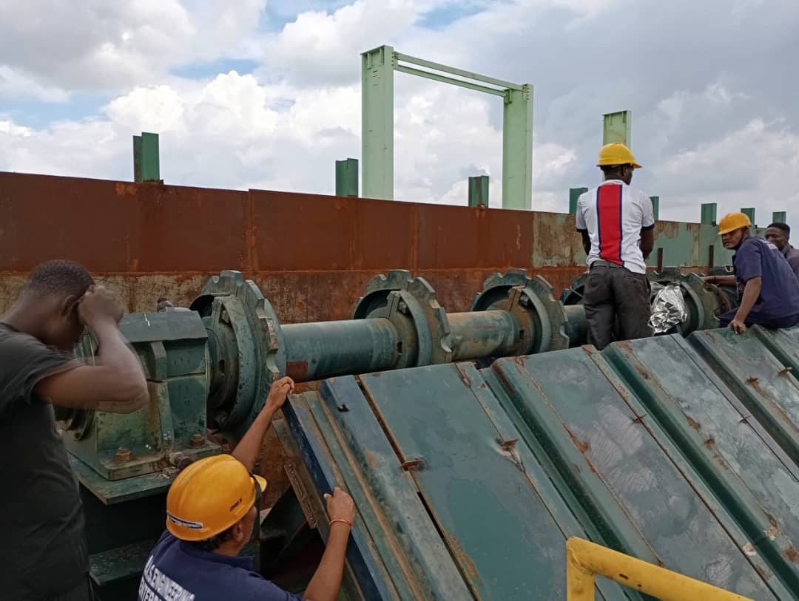
- Maintenance in feeder table over head shaft: To carry out the maintenance by opening the shaft plumber blocks and checking of the bearing condition if its okay and well set. After the checking we now lubricate the bearings and the plumber block inner wall to make the bearing move efficiently and couple them back together.

- Checking of bargas convior roller and plumber blocks by opening the plumber bocks and checking the bearing conditions after the checking we lubricate and couple back and make sure the rollers well.
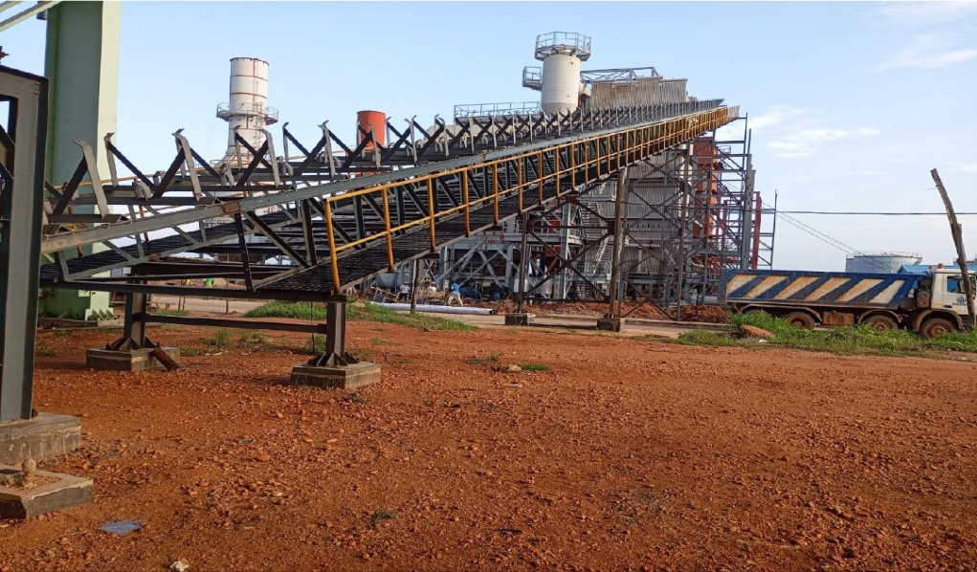

- Cutting of gasket in 1, million liters water tank selection of Jasket measuring the outlet diameter and transferring the measurement on the jasket and mark out the centre on the jasket after the measurement then the jasket was cut using hammer and tissue as the cutting tool.
4. Catting of pipe rack fabrication equipment using gas cutter
i. Cutting of pipe rack base plate: Measure the accurate size of the base plate and mark out the centre then cut using gas cutter.
ii. Cutting at pipe rack beam: Measure the length of the beam according to the drawing giving the cut using gas cutter.
iii. Cutting of pipe rack coloum supporting angle ions: Measure the ion and cut using gas cutter.
iv. Fabrication of pipe racks before the fabrication the needed materials where slufted to the fabrication unit, such base plat, beams, colours, supporting angle in. Then the fabrication took place by assembling them together to form the piper rack after the assembling are welding was use to join them together.
v. Sorting out of mill materials such as mill juice tank gutter, juice tank pumps.
vi. Positioning of the sorted mil materials on their position by positioning the juice tank gutter by connecting the juice tank gutter with the juice tray using an are welding to connect them and joined them together.
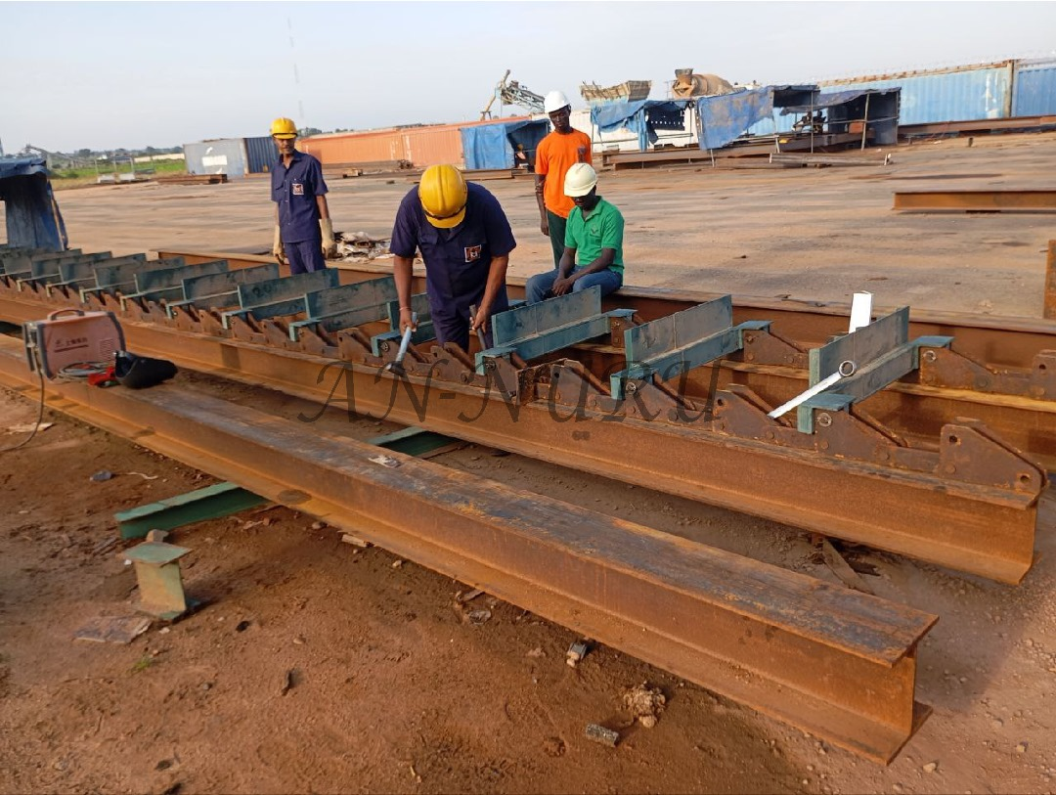
vii. Making the alignment and settings of the juice tank outlet with the juice tank pumps the center to centre where taken making it align measuring the distances from the possible fitted area and make the settings to make them aligned.

Installation Unit
- Assembling of feeder table chain and rakes laying the chase on the floor position the rake and connect them to their using chain lines and aseting pin.
- Installing and positioning of feeder table over head shaft on the beam base connected to the fedder table laying beam.
- Aligning the shaft together to make it aqurate using alignment line by tensioning me line and make there distance between the wall the same.
- Position of fedder table slop plate bean marking out the position for each beams positioning them on their position them weld them using are welding.
- Errection of pipe racks bean on there concrete according to the industry pipe rack layout erecting it and pluming it to make the alignment.
- Installation of fabrizer stood: Positioning of the stoods on both sides making the two sides centers align and lock the stoods.
- Positioning of juice tank pumps on their concrete base.
- Installation of some minor equipment such as:
- Pipe racks
- Installation of assembled (RBC)
Returning bargas convior elevator
- Fabrizer stoods
- Juice pumps
- Electric motors
Experienced gained during the industrial training
During my 14 weeks of industrial training I was not able work with the professionals only I was not able to work with the professional only I was able to learn some specific terminologies about the industry and power plant.
- Auto CAD: I was able to know more about AUTO CAD and to inter print Autocad drawing in reality work during operation: During the periods I was able to learn little things about how to draw a project work using Autocad
- Safety in industry: I was able to know more about safety rules in the industry and the slogans of safety and rules behind every area in the industry interms of safety.
- Affective communition critical thinking and problem solving: engaging in complex maintenance about the industry units tasks challenge me to think critically and approach problems analytically.
Maintenance in mill house
Maintenances taken place in mill house and areas to be maintenance.
- Dismount of mill and checking of mill bearings and rovers, journers
- Repairing/refilling of trash plate and scrapper
- Checking of rollers
- Checking of inter rakes carrier and chain links
- Dismounting and maintain of mill juice pump
- Maintenance of mill drive gear box and oil pump
- Maintenance of Hill and hydraulic system
- Maintenance of came grab and oil system
- Maintenance of mill cooling towers
- Maintenance of febrizer
- Checking of the hammer teeps
- Checking of the ND and D bearing condition
- Checking of the hydraulic plates
- Checking of hydraulic system
- Checking of the hobs
12. Maintenance of Cane carrier
- Checking of the can chopper and levelller knifes bearing conditions
- Checking of the state and wrapper
13. Maintenance of cane feeder table and equalizer
1. Checking of chain/link, rakes head shaft drive and tale shaft.
14. Maintenance of all mill gear box by drawing of old oil and refill new oil
1.5 Maintenance of rotary scream
i. Cleaning of the scream
ii. Checking of the imbition nozzle
iii. Checking of rotary scream drive gear box
iv. Lubrication of fly wheel drum

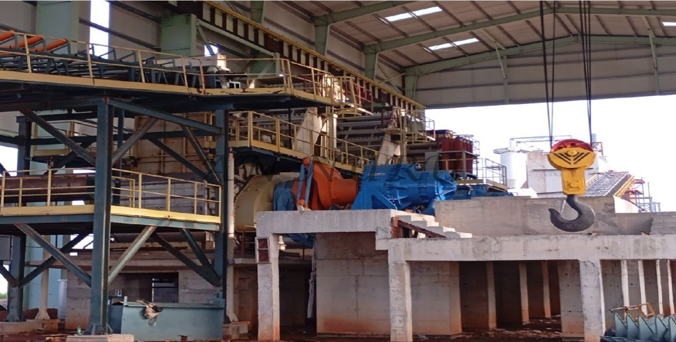

With this I am able to know the full operation to carry out during maintenance in mill house. So far the company is still in construction.
Description of common work tools
The basic tools and equipment generally used for war at the company for the project.

1. Portable grinder: It is a hardheld tools used for grinding cutting or polishing.

2. Bench drilling machine: This is a machine which is used to drill holes on component of cook pies with the aid of drills bits.
3. Welding machine: It is a machine used to weld to or more component work pies together.

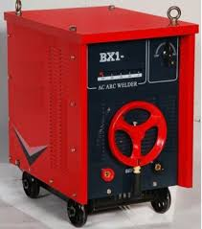

4. Measuring tape: This a flexible rule, use to measure size or distance on the work piece.


CHAPTER FIVE
SUMMARY OF ATTACHMENT ACTIVITY
This report provides a comprehensive overview of my industrial training experience at (BU LASUCO) deterting the task project and challenges encountered during the program I expand my contribution to the mechanical engineering department where I learn about, production of sugar can processes, equipment used for the production, interpretation of AUTOCAD to practical and work, welding and fabrication, maintenance taken out in the units such as:
- Mill house
- Boiler house
- Water treatment
- Clearifier
- Refinery
- Ethanol
Problem encountered
During the program I encountered the problem of learning things that has not being installed since the industry is still in construction. There are little difficulties in knowing something. I was just introduce to some Area in the industry while they are not yet installed.
Suggestions for the improvement of the scheme.
The company’s share holders should be 100% sure of completing the project as soon as possible to make perfect learning and better understanding for another coming set of student.

