
TECHNICAL REPORT
ON
STUDENT INDUSTRIAL WORK EXPERIENCE
SCHEME (SIWES)

HELD AT

KWARA STATE BROADCASTING CORPORATION
NO. 2, POLICE ROAD G.R.A ILORIN KWARA STATE

BY
YUSUF GBEMISOLA FAIDAT
ND/23/MAC/PT/0127

SUBMITTED TO:
THE DEPARTMENT OF MASS COMMUNICATION, INSTITUTE OF INFORMATION AND COMMUNCATION TECHNOLOGY (IICT), KWARA STATE POLYTECHNIC, ILORIN.

IN PARTIAL FULFILMENT OF THE REQUIREMENTS FOR THE AWARD OF NATIONAL DIPLOMA (ND) IN MASS COMMUNICATION

CERTIFICATION
This is to certify that the bearer has successfully completed the Student Industrial Work Experience (SIWES).

Department Coordinator Date

SIWES Director Date

DEDICATION
This report is dedicated to the Almighty Allah, the giver and sustainer of life, for His unconditional love and mercy granted to me throughout the period of my Industrial Training.
ACKNOWLEDGEMENTS

I thank Almighty Allah for the glory, honor, adoration and mercy I received during the course of my study and when undergoing my industrial Training

My appreciation also goes to my supervisor, during my training who accessibility, untiring effort, patience and guidance and suggestions fabulously contributed to the completion of this report. Who do not just teach me but makes me understood all his teaching, may Almighty Allah continue to guide and protect him and his house hold.

My appreciation also goes to my parent for their support during my training. may Almighty Allah continue to guide and protect them.

TABLE OF CONTENT
Title Page
Certification
Dedication
Acknowledgement
Table of Contents
CHAPTER ONE: INTRODUCTION
1.1 Background to the Study
1.2 Objectives of SIWES
CHAPTER TWO: DESCRIPTION OF ESTABLISHMENT
2.1 Location and Brief History of Radio Kwara
2.2 Objectives of the Radio Kwara
2.3 Organizational Structure of Radio Kwara
2.4 The various Dept/Unit in the Radio Kwara
CHAPTER THREE:
3.1 Actual Work Done with Experience Gained
3.2 Equipment’s used at Radio Kwara
3.3 Live Programs at Radio Kwara
CHAPTER FOUR:
4.1 Summary and Conclusion
4.2 Challenges Encountered
4.3 Suggests for the Improvement

CHAPTER ONE
INTRODUCTION
  - Background
The S.I.W.E.S. was launched in 1973 by the Industrial Training Fund (I.T.F) as a programme designed to impart the undergraduate of the nation’s tertiary institutions studying various professional courses with the practical methods of performing professional functions to real life situations on site, in the office or even the factory and how they apply themselves mentally, intellectually and physically in relation to what they have been taught in the classrooms theoretically. It works with the following professional bodies to function effectively across the tertiary institutions nationwide. These are the Nigeria University Commission (N.U.C), National Board for Technical Education (N.B.T.E.) and the National Commission for Colleges of Education (N.C.C.E.). Thus, equipping the students with the necessary skills and technical knowledge to make them highly competitive and professional individuals in the Labour Market
The scheme as conducted by the Industrial Training Fund (I.T.F) through their representative liaison units and offices situated within the various institution and in major cities or towns in Nigeria with the necessary industrial rudiments needed to corroborate, practicalize and then actualize the required technical knowledge. The Industrial Training experience not only puts them in real life situations buts also exposes their practical knowledge of the course of study, consequently perfecting this knowledge thereby producing very competent and versatile professionals.
1.2 Aim and Objective of SIWES
The aim of S.I.W.E.S is to bridge the gap between the level of knowledge acquired in tertiary institutions and the practical application of such knowledge in the field of work.
The Objectives are:
- To provide an avenue for students in industries of higher learning to acquire industrial skills and experience in their course of study.
- To prepare students for the work situations they are to meet after graduation.
- To expose students to work methods and techniques in handling equipment and machinery that may not available in the educational institution.
- To make transition from school to the world of work easier and enhance students contact for later job placements.
- To improve student’s interpersonal relationship with others in their field.
To prove students an opportunity to apply his/her knowledge in real work situation, thereby bridging the gap between college work and actual practice

CHAPTER TWO

DESCRIPTION OF ESTABLISHMENT OF ATTACHMENT

LOCATION AND BRIEF HISTORY OF RADIO KWARA
Ilorin was the first location in Kwara State where broadcasting services were provided by the Kwara State Broadcasting Corporation (also known as “Radio Kwara”). These services began in 1956 as a relay station. In those days, people referred to it as the provincial broadcasting house.
The one quarter kilowatt (kW) medium wave transmitter that was employed at the time could only reach an area within an eight kilometer radius of Ilorin.
However, the Kwara State Broadcasting Corporation as it is now was not one of the beneficial byproducts of the first state to be created in Nigeria. It did not come into existence until the adoption of the Kwara Edict No. 3 of 1979, but it took effect back on April 10th, 1978.
Due to the state of Kwara’s topography, it was decided that it should be covered with both medium and shirt wave transmitters when it was created in 1967. This was part of a larger master plan that was developed and approved for the entire nation at the same time. This plan was based on the number and capacity of transmitters as well as the mode of transmission that were to be sited in each new state.
These facilities wave put into use is from 19th December, 1976; however, as a result of a directive from the federal government, the short wave transmitter was shut down in 1976. Instruction work began in 1974 in the modern studio/broadcasting house at the 10kw short wave and 20kw medium wave transmitting station sites. On April 1st, 1978, a decree was issued in camphene with the federal government that transfers all radio Nigeria stations on the state to their respective host states. On September 5, 1978, Mr. Horation Agedoti of radio corporation in Lagos reframed the formal handing over of the station by the NBA to the Kwara state government. At that time, all of the existing staff members were given the option of either continuing to work for corporation or moving on to work for Federal Radio Corporation. Those employees who made the decision to remain on staff were kept.
Despite the enormous progress, the transmitting stations at Bin Do Eko suffered a major setback in 1991 when the 840-foot tower mast was damaged by a lightning strike. This occurred despite the fact that the stations had made enormous achievements. When you take into consideration that the transmitting station had by that point become an essential component of Radio Kwara and a reliable ally in the fulfillment of its statutory obligation, this situation became a significant obstacle that needed to be addressed immediately.
Between the years 2000 and 2002, efforts were made to resurrect the station. As a result of these efforts, a new tower mast and a 50 kW thom cast transmitter were installed so that normal broadcast could resume. In spite of the efforts made by the administration of Alhaji Mohammed Lawal, there was still an insufficient amount of transmitter. On the other hand, the government of Dr. Bukola Saraki, who took office in May 2003 and immediately began renovating the station, awarded a contract for the provision of contemporary studio equipment and an additional 50Kw Harris transmission, bringing the total cost to nearly #300,000,000.
Due to this one-of-a-kind breakthrough, “Radio Kwara” has become not only one of the few radio stations in Nigeria with digital studios installed, but also one of the first stations in Nigeria to comply with the global directive in converting from analogue to digital broadcasting.

2.2 OBJECTIVES OF RADIO KWARA
Radio Kwara aims to build a broadcast giant that promotes societal values and human development through digital studio equipment and transmitters, performance-driven innovative and quality services.
- Promoting Societal Values and Human Development:
The station's mission is to contribute to the betterment of society and the growth of individuals within the state.
- Providing a Platform for News, Talk Shows, and Entertainment:
Radio Kwara offers a diverse range of programming, including news, talk shows, and entertainment programs, catering to a wide audience.
- Using Digital Studio Equipment and Transmitters:
The station has invested in digital studio equipment and transmitters to ensure high-quality broadcasts and to comply with global digital broadcasting directives.
- Educating, Informing and Entertaining the Public
Radio Kwara aims to educate, inform and entertain people of what is happening around them.
- "The People's Station" with the Slogan "My Radio... My State...":
Radio Kwara is known as "The People's Station" and its slogan "My Radio... My State..." reflects its focus on serving the people and the state of Kwara.

2.3 ORGANIZATIONAL STRUCTURE OF RADIO KWARA
DEP A/R
ADMIN
C.A.D
A.C.A.O
A.O.I
STAFF OFFICE
C.E.O
DEP A/R
ENGINEERING
CHIEF TECH
CHIEF
ENGINEER
CORPORATION SECRETARY
CONTROLLER TECH
CONTROLLER
ENGINEER
DEPUTY DIRECTOR PROGRAMME
DEPT. DIR NEWS AND CURRENT AFFAIRS
MANAGER PROGRAMME
DEPT. DIR NEWS AND CURRENT AFFAIRS
CHIEF PRODUCER
CONTROLLER NEWS
CONTROLLER PROGRAMME
PRN CURRENT AFFAIRS OFFICERS
CONTROLLER CURRENT AFFAIRS
PRIN TECH OFFICERS
PRINCIPAL
ENGINEER
PRIN PRIN REP EDIT
TECHNICAL OFFICER
PRINCIPAL ENGINEER
SENIOR ENGINEER
PRIN PRO
SENIOR TECHNICAL OFFICER
CLERIMAO TYPIST
PRIN PRESS OFFICER
SENIOR REP
SENIOR EDIT
SENIOR PROD
SENIOR PRESS OFFICER
REPORTER
EDITOR
SENIOR CURRENT OFFICERS
CONTROLLER FINANCE CALLOMAND
PRINCIPAL FINANCE OFFICER
METHOD OF ACCOUNT
ACCOUNT CLERKS

2.4 THE VARIOUS DEPARTMENTS AND UNIT IN RADIO KWARA

1. Programming Department
- Role: This is the core department responsible for creating and managing the station's on-air content.
- Key Functions:
  - Designing and scheduling programs, including music, news, talk shows, and advertisements.
  - Managing the playlist and ensuring the content aligns with the station's target audience and brand identity.
- Team Members: Program director, producers, announcers, and on-air talent.

2. Production Department
- Role: Focuses on creating and editing content for on-air use.
- Key Functions:
  - Producing jingles, promos, commercials, and other audio content.
  - Editing pre-recorded programs and interviews to maintain high-quality audio.
  - Working closely with the programming department to align production with the station’s needs.
- Team Members: Sound engineers, editors, and production assistants.

3. News Department
- Role: Responsible for gathering\, verifying, and presenting news.
- Key Functions:
  - Conducting research and interviews to gather accurate and timely information.
  - Writing and editing news scripts for live or recorded broadcasts.
  - Broadcasting news bulletins, weather updates, traffic reports, and public service announcements.
- Team Members: News anchors, reporters, and editors.

4. Sales and Marketing Department
- Role: Drives revenue generation through advertisements and sponsorships.
- Key Functions:
  - Selling airtime to advertisers and managing client relationships.
  - Developing promotional campaigns and sponsorship opportunities.
  - Collaborating with the programming team to ensure advertisements are integrated seamlessly.
- Team Members: Sales executives, account managers, and marketing specialists.

5. Engineering and Technical Department
- Role: Ensures the station's technical infrastructure operates smoothly.
- Key Functions:
  - Maintaining and repairing broadcast equipment, including transmitters, consoles, and microphones.
  - Monitoring signal strength and quality to ensure consistent broadcasts.
  - Implementing upgrades to improve technology and reduce downtime.
- Team Members: Broadcast engineers, technicians, and IT specialists.

6. Administrative and Human Resources Department
- Role: Manages the station's overall operations and personnel.
- Key Functions:
  - Handling recruitment, training, and performance management for staff.
  - Overseeing finances, including budgeting, payroll, and procurement.
  - Ensuring compliance with legal and regulatory requirements.
- Team Members: HR managers, accountants, and administrative officers.

7. Traffic Department
- Role: Manages the scheduling and placement of commercials and other non-program content.
- Key Functions:
  - Coordinating with the sales department to schedule client advertisements.
  - Ensuring that ads are aired at the right time slots without disrupting programming flow.
  - Monitoring the compliance of commercial airtime with contractual agreements.
- Team Members: Traffic manager and coordinators.

8. Promotions and Events Department
- Role: Enhances the station's public image and audience engagement.
- Key Functions:
  - Organizing contests, giveaways, and live events to attract and retain listeners.
  - Managing the station’s social media presence and online engagement.
  - Building relationships with community leaders and sponsors to increase visibility.
- Team Members: Promotions manager, event planners, and social media coordinators.

CHAPTER THREE
ACTUAL WORK DONE WITH EXPERIENCE GAINED
3.1 Introduction
This to initiates, coordinates, supervise, and control matters such as funding, hiring key personnel, contracting and arranging for distributors. This also is involved throughout all phases of the process from the development to completion of the production. The also include how to set-up live shows on the studio.

Granting of Interview
About 90 percent of everything in a news story is based on some form of interviewing - either in person, by telephone or occasionally by correspondence.

Types of Interviews
Interviews are as varied as the people who grant them, the journalists who conduct them and the news that suggests them. Rarely are interviews so mechanical that they can be reduced to standard formulas or categories. Several types, however, deserve special attention because they are the ones that occur most frequently. They are as follows:
News Interview: The news interview is based on "hard news," some event or development of current and immediate interest.
Telephone Interview: The telephone interview, a modified version of the news interview, has a number of obvious advantages, and at the same time, it has several limitations that challenge a resourceful journalist.
Casual Interview: An accidental encounter between a journalist and a news source on the street or at a social gathering can often result in a tip that arouses the curiosity of a writer.
Personality Interview: In the personality interview an effort is made to let the reader see the appearance, mannerisms, background and even the character of the subject.

Writing of News
The following are procedures on how to write and make a good news story:

1) Choose are cent, News worthy event or topic
There are a few points that we need to discuss when it comes to this step. The first of which is, of course, knowing when something is newsworthy and when something is not.
A newsworthy story is anything happening in your community that might interest readers. It should be unique, active, and impactful. For example, covering a business (if it isn’t new or offering any particular changes) isn’t particularly newsworthy, especially if it’s always been there. But covering a new business in the area is absolutely newsworthy, and will bring the company to the attention of your readers.

Conducttimely, In-Person Interviews with Witnesses
The hardest part about writing a news story is getting interviews with the right people. If there was a robbery at a local grocery store, you’d need to talk to the store manager and, if possible, the cashier or employee involved. You should not ask a family that shops at the store frequently (unless they were witnesses) or a random community member.

Construct Your Piece
Now that you have the materials that you need to continue, start putting your piece together. Start with the necessary information, and let the rest trickle down. You’ll start to get a feeling for this process as you continue to write journalistically.

Insert Quotations
Some writers choose to add quotations as they write. Others decide to add their quotations at specific points in the story, after it’s already been developed. Either way, place your quotes and be sure to identify key people in the story by their full name, occupation, and age.
3.2 Equipment’s used at Radio Kwara
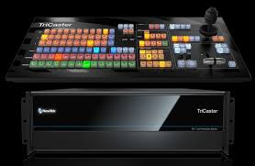
- Tricaster: Is also used to broadcast live program while the playout system is used for recorded programs. When there is no live show going on recorded program are being played through it.

- Video Camera: Is a camera used for electronic motion picture acquisition, initially developed for the television industry but now common in other applications as well. There are types of shots using the Zoom, the Close up Shot, Medium Close up (MC) and the Medium long shot (MLS).
Experiences using the camera
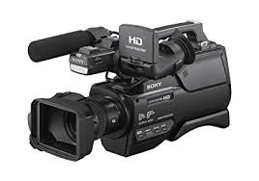
Colour adjustment, Cropping, framing and composition of picture including the layout, PAN, the movement of camera from right to left. Tilt movement which include the up and down tilt movement. Light and create visual image, there are different types of light which is the fill light, the back light, the hard light, and the spot light.

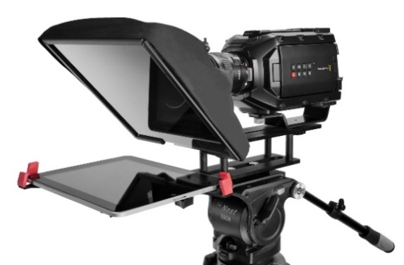
- Teleprompter: Is a display device that prompts the person speaking with an electronic visual text of a speech or script using a teleprompter is similar to using cue cards. I heard experiences on how weather forecast script to the teleprompter by highlighting all first then copy the document and clicking the teleprompter software, then add script and paste, then connect the teleprompter. A laptop was used to operate it to make it move fast and slow. Which was normally carried out by Mrs. Kemi Olorufemi.

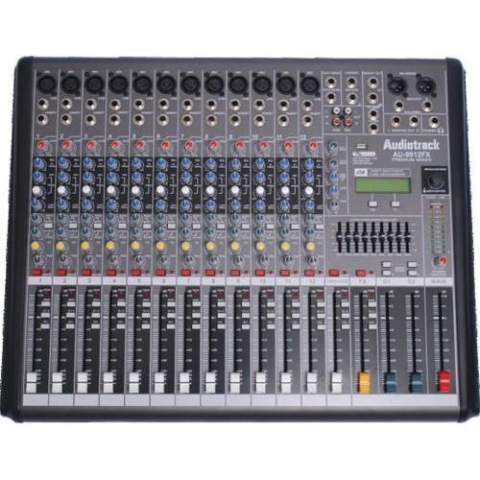
- Audio mixer: A mixer is an electronic device which is often used for changing the quality and the levels of audio signals. It is also known as a mixing console, an audio mixer, or a soundboard. Using a mixer is the most convenient way to route or combine various audio signals and even change the timbre and dynamics of the sound.

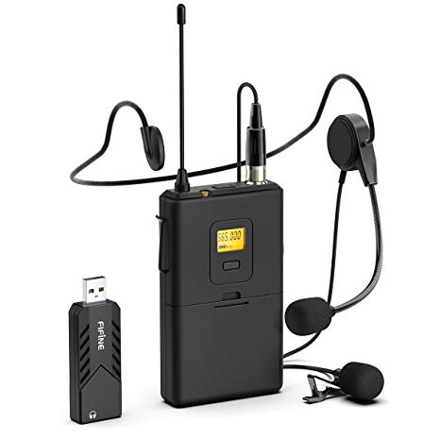
- Lapel microphone: Is a small microphone used for television, theatre, and public speaking, in order to allow for hands-free operation.

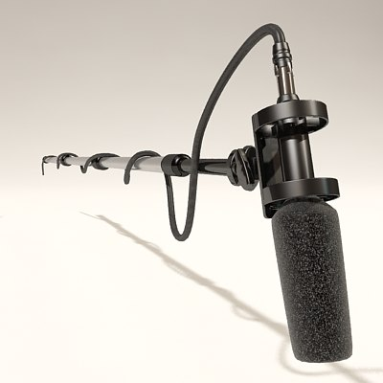
- Boom mic: is used to pick up sounds of the presenter and the guests, from ascending to decending order in all angels of the studio.

- Kenflo Lights: Is mainly used in the studio to clear shadows of an object, to also have a clear image of the subject or talent
Type of Light
1. Fill Light is placed by the side of the subject to cast out shadow or to fill out shadows
2. Back lights are placed at the back of the subject to light him/her from behind.
3. Hard Light close to the natural light, source from the sun
4. Spot light is controlled narrowly focused beam of light.
5. Standing light is mainly used to have a clear picture or visual of the object behind the scene while a program or interview is being conducted
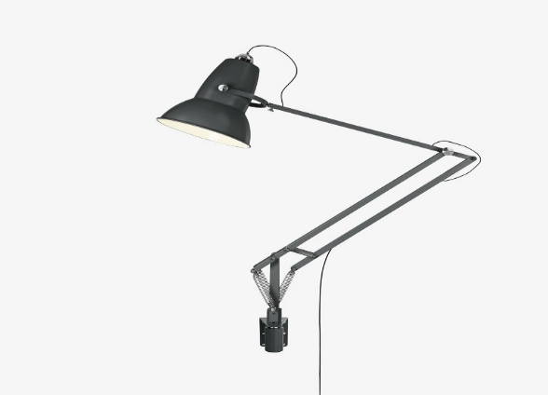
3.3 Live Programs on Radio Kwara
Radio Kwara, which includes Midland FM (99.1 MHz), broadcasts a variety of programs, including news, entertainment, and religious programming, with some programs being live from their studios in Ilorin, Kwara state.
- News and Current Affairs:
Radio Kwara provides up-to-the-minute news, breaking news, and feature stories, covering Nigerian news and local and regional perspectives.
- Entertainment:
The station offers entertainment programming, including music and other shows.
- Religious Programming:
Radio Kwara has religious programs like "Imole Islam On Radio" and "One FM radio the gospel rhythm".
- Business, Science, Technology, and Health News:
Radio Kwara also covers business, science, technology, and health news.

CHAPTER FOUR
SUMMARY CONCLUSION AND RECOMMENDATION

4.1 SUMMARY OF ATTACHMENT ACTIVITIES
This is a complete report of an industrial training program carried out during my SIWES (2023/2024) at Radio Kwara. Activities including field work such as news writing and report, different types of interview, news editing, Advertising, photo news and caption and so on.
The experience gained has given me a sound knowledge on media house in general which has helped prepare me for the future journalism work.

4.2 CHALLENGES ENCOUNTERED
The success of my training is undisputed, but it was not devoid of rough edges. I experienced some challenges, among these are:
    - The issue of expensive transportation was the problem of transportation because my place of attachment was a little bit far from my.
    - The bureaucratic system is rigid and before things are done its takes so much time. This affected the conducive working environment for the members of staff in that whenever machines are bad and need repairs it takes so much time before it gets attended to. This system made work so tedious and cumbersome.
    - Lastly the issue of industrial base I was unable to get in touch with my survive till I ended my program which gave me a lot of worry and concern.

4.3 SUGGESTIONS FOR IMPROVEMENT OF THE SCHEME
    - Students should be paid their allowance on time to ensure motivation
    - Selection of placement should not be left to students. Polytechnics should make a means of allocating students to related companies
    - Visiting of students during the program should been sured by the ITF
    - Seminars should be organized for establishments to acquaint them with their roles towards students on training
    - Government should participate fully in the provision of equipment in the placement centers

4.4 CONCLUSION
The period has contributed immensely to my academic experience. Students Industrial Working Experience Scheme (SIWES) is an important program for all students. It helps in tackling the issue of unemployment amongst youth as it teaches us way to be independent. The exercise made me understood part of what is expected as a journalist in the practice. It helped groom my relationship skills especially in areas where team work are required and communicating with the staffs and students alike. It has exposed me to work ethics and routines.
The problems, if not tackled, will make it lose its usefulness and vitality not with standing the benefits of it.
Finally, I do hope the program will be improved so as to enhance manpower development and student’s skill in their respective field of study.

