KWARA STATE POLYTECHNIC,ILORIN ,NIGERIA

A TECHNICAL REPORT ON

STUDENT INDUSTRIAL WORK EXPERIENCE SCHEME
(SIWES)

UNDERTAKEN AT:
BIOMEDICAL LIMITED ,ILORIN,NIGERIA

COMPILED AND WRITTEN BY :
SHITTU OLALAKAN ABDULMUIZ
(ND/23/MEC/PT/0213)

SUBMITTED THE :
DEPARTMENT
MECHANICAL ENGINEERING

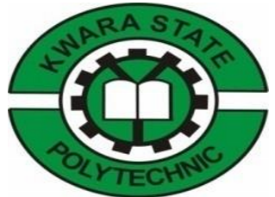

CHAPTER ONE
1.0 INTRODUCTION TO STUDENTS’ INDUSTRY WORK EXPERIENCE SCHEME (SIWES)
The Students’ Industrial Work Experience Scheme (SIWES) was initiated in 1973 by the Federal Government of Nigeria under the Industrial Training Fund (ITF) to bridge the gap between theory and practice among products of our tertiary Institutions. It was designed to provide practical training that will expose and prepare students of Universities, Polytechnics, and Colleges of Education for work situation they are likely to meet after graduation. Before the establishment of the scheme, there was a growing concern among the industrialists that graduates of institutions of higher learning lacked adequate practical background studies preparatory for employment in industries. Thus the employers were of the opinion that the theoretical education going on in higher institutions was not responsive to the needs of the employers of labour. As a result of the increasing number of students’ enrolment in higher institutions of learning, the administration of this function of funding the scheme became enormous, hence ITF withdrew from the scheme in 1978 and was taken over by the Federal Government and handed to National Universities commission (NUC), National Board for Technical Education (NBTE) and National Commission for Colleges of Education (NCCE). In 1984, the Federal Government reverted back to ITF which took over the scheme officially in 1985 with funding provided by the Federal Government.
The Student Industrial Work Experience Scheme (SIWES) is a mandatory program designed to expose students to real-world industrial practices, bridging the gap between theoretical knowledge and practical application. As a student of [Your Course of Study], I was posted to the Engineering Department of [Pharmaceutical Company Name] to work as a welder. This report details my experiences, activities, and skills acquired during the internship
1.1 PROFLIE OF ITF
The industrial Training Fund Programe is essential in order for student to acquire practical and technical knowledge in various professions which is certainly different from theories. The ITF office are in various state with its head quarter in mango (Jos Plateau State )
1.2 FUNCTION OF MECHANICAL ENGINEERING DEVELOPMENT BOARD:-
Mechanical engineers design power-producing machines, such as electric generators, internal combustion engines, and steam and gas turbines, as well as power-using machines, such as refrigeration and air-conditioning systems. Mechanical engineers design other machines inside buildings, such as elevators and escalators
.
1.3 ROLE OF ITF IN SIWES
- The ITF give the student allowance through liaison office.
- The ITF liaise with the siwes agencies to ensure prompt receive of replacement list.
- The ITF co-operate direct and finance the programe
- The ITF liaise with sister’s to ensure payment of student allowances.
1.3 OBJECTIVE OF THE SIWES
The siwes is aimed at improved the technical ability of science student in developing the nation the following are some of the objective
. To inspire and prepare student for work ahead of them after graduation.
. To expose them to what they might meet in future after school’
. To give student practical orientation relating to course of student
. To enable them practicalise what they have studied in theories

CHAPTER TWO
2.0 DESCRIPTION OF THE ESTABLISHMENT OF ATTACHMENT
2.1 LOCATION AND BRIEF HISTORY OF ESTABLISHMENT
BIOMEDICAL LIIMITED is an indigenous Pharmaceutical Company and the Pioneer Manufacturers of intravenous fluids in Nigeria. As a curtain-raiser, Biomedical Limited was incorporated in 1978 and commenced commercial production of a complete range of intravenous infusions on 21st of August, 1981. Its Factory is situated at 1, Ohimege Road, Industrial Estate, Gaa Imam, Ilorin Kwara state, Nigeria. It has been meeting the critical healthcare needs of the country for over 30 years and has built ultimate confidence and competence in local manufacture and distribution of innovative, quality and affordable pharmaceutical products. The first intravenous infusion factory in Nigeria is the brain-work of Biomedical Limited through the product of years of researches and meticulous planning. They take pride in BioFLEX brands with their outstanding pouches that are free, safe and double ports for easier administration.
2.2 OBJECTIVES OF THE ESTABLISHMENT
To ensure strict adherence to the pre-determined quality, all their products undergo careful and painstaking quality control checks to be in conformity with highest pharmaceutical standard. BioFLEX fluids are germane to the successful surgery of any kind. They are therefore, a strategic player, a critical care company in the healthcare sector which has a strong commitment to continual production of quality pharmaceuticals in line with global best practices.
2.3 ORGANISATIONAL STRUCTURE
An organizational structure defines how activities such as task allocation, coordination, and supervision are directed toward the achievement of organizational aims. Organizational structure affects organizational action and provides the foundation on which standard operating procedures and routines rest. It determines which individuals get to participate in which decision-making processes, and thus to what extent their views shape the organization’s actions. Organizational structure can also be considered as the viewing glass or perspective through which individuals see their organization and its environment.
An organization can be structured in many different ways, depending on its objectives. The structure of an organization will determine the modes in which it operates and performs. Organizational structure allows the expressed allocation of responsibilities for different entities such as the branch, department, workgroup, and individual. Organizations need to be efficient, flexible, innovative and caring in order to achieve a sustainable competitive advantage.
BIOMEDICAL LIMITED uses a Bureaucratic type of organizational structure and it goes thus; starting with the
- CHAIRMAN: The primary role is to ensure that the board is effective in its task of setting and implementing the company’s direction and strategy.
- MANAGING DIRECTOR: is responsible for giving strategic guidance and direction to the board to ensure that the company achieves its financial vision, mission and long term goals.
- EXECUTIVE DIRECTOR-TECHNICAL: is responsible for working closely with the director to determine how the scenery will be built and out of what materials.
- EXECUTIVE DIRECTOR-COOPERATE SERVICES: is responsible for supporting, developing and implementing strategic plans in accordance with the companies mission and vision statements; managing the administration function of the company, and coordinating office processes and procedures to ensure organizational and operational effectiveness and efficiency.
- R&D STRATEGIC PLANNING: is responsible for research of new products and machines for the development of the organization.
- QUALITY ASSURANCE MANAGER: they play crucial role in business by ensuring that products meet certain thresholds of acceptability. They plan, direct or coordinate quality assurance programs and formulae. They also work to improve an organization’s efficiency and profitability by reducing waste.
- PRODUCTION MANAGER: ensures that manufacturing processes run reliably and efficiently. Their responsibilities include planning and estimating, negotiating and agreeing budgets and timescales with clients and managers.
- FACTORY MANAGER/SUPERITENDENT PHARMACY: the factory manager oversee manufacturing operations and supervise operators. They also improve manufacturing productivity and to reduce lead times of the company. While the superintendent pharmacy is responsible for the provision of exceptional, professional pharmaceutical services. Also act as a responsible pharmacist, lead and develop standards of excellence.
- MARKETING MANAGER: is responsible for tracking and analyzing the performances of advertising campaigns, managing the marketing budget and ensuring that all marketing material is in line with the company’s brand.
- FINANCE MANAGER: is responsible for reviewing financial reports, monitoring accounts, and preparing activity reports and financial forecasts. They also investigate ways to improve profitability, and analyze markets for business opportunities, such as expansion, mergers or acquisitions.
- ADMINISTRATIVE MANAGER: role is to oversee the administrative operations of the industry. They are in charge of the department’s day-to-day functions as well as supervising and supporting staff.
- CHIEF ENGINEER: is the senior most technical officer of the technical department in the industry and holds overall leadership and responsibilities of the department.
- MAINTENANCE OFFICER: is responsible for keeping records of equipment manuals and user guides, as well as maintenance practices and repair work done on all facilities and equipment. They use these records to schedule future maintenance practices and detect repeat malfunctions.
- TECHNICIANS: is a worker in a field of technology who is proficient in the relevant skill and technique, with a relatively practical understanding of the theoretical principles.
- WATER PROCESSING ENGINEER: is responsible for supply, manage and maintain clean water. They are technicians that work on the water treatment machines and equipment.
- NATIONAL SALES COORDINATOR: is responsible for coordinating the sales team nationally by managing schedules, filling important documents and communicating relevant information. Ensuring the adequacy of sales-related material and responding to complaints from customers and give after sales support when requested.
- ACCOUNT OFFICER: is responsible for managing the financial bookkeeping of a business or organization. Each day, an accounts officer processes invoices, records payment, and track expenses of the organization. In some cases, an accounts officer supervises other staff members who assist with the bookkeeping duties.
- STORE OFFICER: they exercise general control over all activities in store department, to ensure safe keeping both as to quality and quantity of materials, to maintain proper records etc.
- QUALITY CONTROL CHEMIST: utilizes chemistry lab skills to test and measure materials.
- MICROBIOLOGISTS: works in the quality control and assurance department and their primary role is to ensure the quality of raw materials before they are processed in the production area.
- QUALITY ASSURANCE OFFICER: is responsible for administering audit of the goods or products which have already been checked for quality.
- PRODUCTION PHARMACIST: are involved in the discovery and development of safe, effective and medicines. They can work at any stage of the process, drugs including research, development, clinical trials, overseeing production, quality testing, marketing and applying to have the drug legally registered.
- PRODUCTION SUPERVISOR: accomplishes manufacturing staff results by communicating job expectations; planning, monitoring, and appraising job results; coaching, counselling, and disciplining employees; initiating, coordinating, and enforcing systems, policies, and procedures.
- LABORATORY ASSISTANT: are responsible for helping technologists and scientists during lab tests and research by processing samples, classifying results and recording findings.
- SALES REPRESENTATIVES: responsible for services existing accounts, obtains orders, and establishes new accounts by planning and organizing daily work schedule to call on existing or potential sales outlets and other trade factors. Also focuses on sales efforts by studying existing and potential volume of dealers.
- STORE KEEPER: receives all materials into the store and ensure proper storage. Maintain accuracy between actual stock balance and records in the system. Also responsible for safety and security of stores items.
- ADMINISTRATIVE OFFICER: act as the point of contact for all employees, providing administrative support and managing their queries. Main duties include managing office stock, preparing regular reports e.g. expenses and office budgets and organizing company records.
- FILLERS: are responsible for filling product into pouches or infusion bags.
- PACKAGERS: are responsible for packaging product into carton of different sizes.
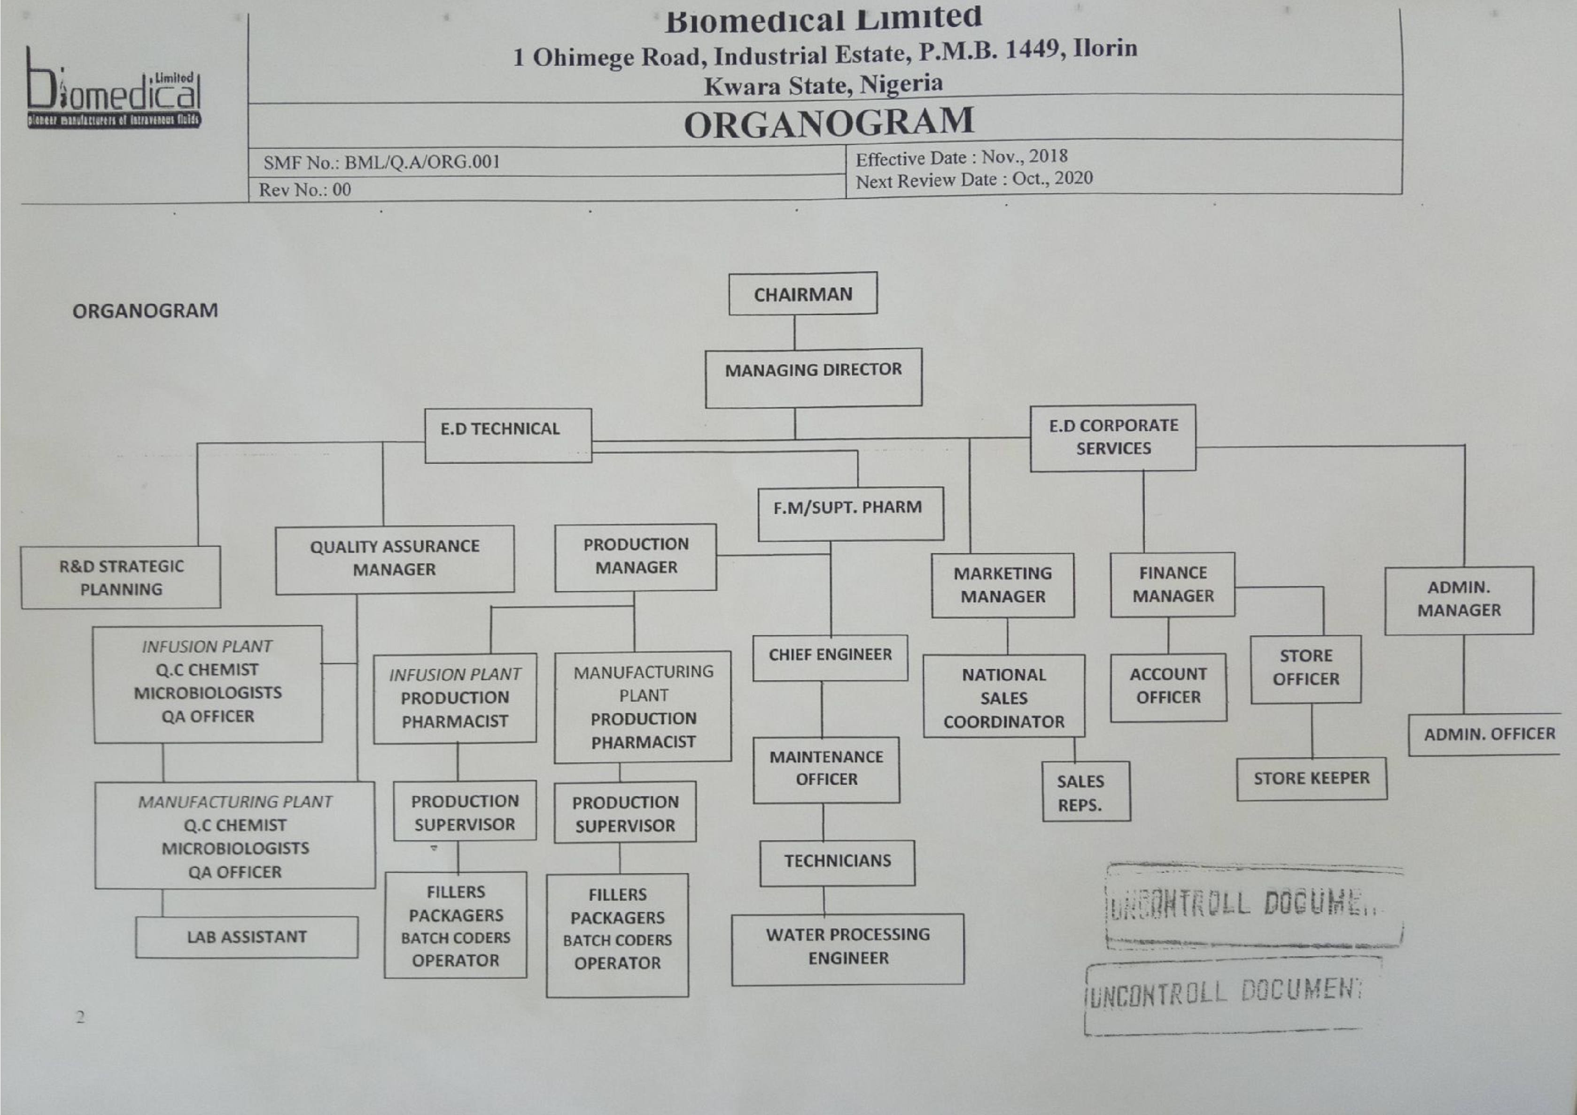
- BATCHCODERS: are responsible for coding of pouches or infusion bags i.e. coding the pouches with the batch no., production date and expiry date.

CHAPTER THREE
WORK DONE AND EXPERIENCE GAINED

3.1 BOILER
A boiler or vaporized fluid exits the boiler for use in various processes or heating applications; ^{[1] [2]} including water heating, central heating, boiler- based power generation, cooking, and sanitation. In a fossil fuel power plant using a steam cycle for power generation, the primary heat source will be combustion of coal, oil, or natural gas. In some cases byproduct fuel such as the carbon-monoxide rich off gasses of a coke battery can be burned to heat a boiler; biofuels such as bagasse, where economically available, can also be used. In a nuclear power plant, boilers called steam generators are heated by the heat produced by nuclear fission. Where a large volume of hot gas is available from some process, a heat recovery steam generator or recovery boiler can use the heat to produce steam, with little or no extra fuel consumed; such a configuration is common in a combined cycle power plant where a gas turbine and a steam boiler
recent times, the high price of copper often makes this an uneconomic choice and cheaper substitutes (such as steel) are used are used. In all cases the combustion product waste gases are separate from the working fluid of the steam cycle, making these systems examples of External combustion engines.
The pressure vessel of a boiler is usually made of steel (or alloy steel), or historically of wrought iron. Stainless steel, especially of the austenitic types, is not used in wetted parts of boilers due to corrosion and stress corrosion cracking. ^{[3]} However, ferrite stainless steel is often used in super heater sections that will not be exposed to boiling water, and electrically-heated stainless steel shell boilers are allowed under the European "Pressure Equipment Directive" for production of steam for sterilizers and disinfectors. ^{[4]}
In live steam models, copper or brass is often used because it is more easily fabricated in smaller size boilers. Historically, copper was often used for fireboxes (particularly for steam locomotives), because of its better formability and higher thermal conductivity; however, in moreinstead.
For much of the Victorian "age of steam", the only material used for boiler making was the highest grade of wrought iron, with assembly by riveting. This iron was often obtained from specialist ironworks, such as those in the Cleator Moor (UK) area, noted for the high quality of their rolled plate, which was especially suitable for use in critical applications such as high-pressure boilers. In the 20th century, design practice moved towards the use of steel, with welded construction, which is stronger and cheaper, and can be fabricated more quickly and with less labour. Wrought iron boilers corrode far more slowly than their modern-day steel counterparts, and are less susceptible to localized pitting and stress-corrosion. That makes the longevity of older wrought-iron boilers far superior to that of welded steel boilers [citation needed].
Cast iron may be used for the heating vessel of domestic water heaters. Although such heaters are usually termed "boilers" in some countries, their purpose is usually to produce hot water, not steam, and so they run at low pressure and try to avoid boiling. The brittleness of cast iron makes it impractical for high-pressure steam boilers.
The source of heat for a boiler is combustion of any of several fuels, such as wood, coal, oil, or natural gas. Electric steam boilers use resistance- or immersion-type heating elements. Nuclear fission is also used as a heat source for generating steam, either directly (BWR) or, in most cases, in specialized heat exchangers called "steam generators" (PWR). Heat recovery steam generators (HRSGs) use the heat rejected from other processes such as gas turbine.
To define and secure boilers safely, some professional specialized organizations such as the American Society of Mechanical Engineers (ASME) develop standards and regulation codes. For instance, the ASME Boiler and Pressure Vessel Code is a standard providing a wide range of rules and directives to ensure compliance of the boilers and other pressure vessels with safety, security and design standards. ^{[6]}
Historically, boilers were a source of many serious injuries and property destruction due to poorly understood engineering principles. Thin and brittle metal shells can rupture, while poorly welded or riveted seams could open up, leading to a violent eruption of the pressurized steam. When water is converted to steam it expands to over 1,000 times its original volume and travels down steam pipes at over 100 kilometers’ per hour. Because of this, steam is a great way of moving energy and heat around a site from a central boiler house to where it is needed, but without the right boiler feed water treatment, a steam-raising plant will suffer from scale formation and corrosion. At best, this increases energy costs and can lead to poor quality steam, reduced efficiency, shorter plant life and unreliable operation. At worst, it can lead to catastrophic failure and loss of life. Collapsed or dislodged boiler tubes can also spray scalding-hot steam and smoke out of the air intake and firing chute, injuring the firemen who load the coal into the fire chamber. Extremely large boilers providing hundreds of horsepower to operate factories can potentially demolish entire buildings. ^{[7]}
A boiler that has a loss of feed water and is permitted to boil dry can be extremely dangerous. If feed water is then sent into the empty boiler, the small cascade of incoming water instantly boils on contact with the superheated metal shell and leads to a violent explosion that cannot be controlled even by safety steam valves. Draining of the boiler can also happen if a leak occurs in the steam supply lines that is larger than the make-up water supply could replace. The Hartford Loop was invented in 1919 by the Hartford Steam Boiler Inspection and Insurance Company as a method to help prevent this condition from occurring, and thereby reduce their insurance claims.
Boiler fittings and accessories: Pressuretrols to control the steam pressure in the boiler. Boilers generally have 2 or 3 pressuretrols: a manual-reset pressuretrol, which functions as a safety by setting the upper limit of steam pressure, the operating pressuretrol, which controls when the boiler fires to maintain pressure, and for boilers equipped with a modulating burner, a modulating pressuretrol which controls the amount of fire.
- Safety valve: It is used to relieve pressure and prevent possible explosion of a boiler.
- Water level indicators: They show the operator the level of fluid in the boiler, also known as a sight glass, water gauge or water column.
- Bottom blow down valves: They provide a means for removing solid particulates that condense and lie on the bottom of a boiler. As the name implies, this valve is usually located directly on the bottom of the boiler, and is occasionally opened to use the pressure in the boiler to push these particulates out.
- Continuous blow down valve: This allows a small quantity of water to escape continuously. Its purpose is to prevent the water in the boiler becoming saturated with dissolved salts. Saturation would lead to foaming and cause water droplets to be carried over with the steam – a condition known as priming. Blow down is also often used to monitor the chemistry of the boiler water.
- Trycock: a type of valve that is often use to manually check a liquid level in a tank. Most commonly found on a water boiler.
- Flash tank: High-pressure blow down enters this vessel where the steam can 'flash' safely and be used in a low-pressure system or be vented to atmosphere while the ambient pressure blow down flows to drain.
- Automatic blow down/continuous heat recovery system: This system allows the boiler to blow down only when makeup water is flowing to the boiler, thereby transferring the maximum amount of heat possible from the blow down to the makeup water. No flash tank is generally needed as the blow down discharged is close to the temperature of the makeup water.
- Hand holes: They are steel plates installed in openings in "header" to allow for inspections & installation of tubes and inspection of internal surfaces.
- Steam drum internals, a series of screen, scrubber & cans (cyclone separators).
- Low-water cutoff: It is a mechanical means (usually a float switch) or an electrode with a safety switch that is used to turn off the burner or shut off fuel to the boiler to prevent it from running once the water goes below a certain point. If a boiler is "dry-fired" (burned without water in it) it can cause rupture or catastrophic failure.
- Surface blow down line: It provides a means for removing foam or other lightweight non-condensable substances that tend to float on top of the water inside the boiler.
- Circulating pump: It is designed to circulate water back to the boiler after it has expelled some of its heat.
- Feed water check valve or clack valve: A non-return stop valve in the feed water line. This may be fitted to the side of the boiler, just below the water level, or to the top of the boiler.^{[11]}
- Top feed: In this design for feed water injection, the water is fed to the top of the boiler. This can reduce boiler fatigue caused by thermal stress. By spraying the feed water over a series of trays the water is quickly heated and this can reduce lime scale.
- Desuperheater tubes or bundles: A series of tubes or bundles of tubes in the water drum or the steam drum designed to cool superheated steam, in order to supply auxiliary equipment that does not need, or may be damaged by, dry steam.
- Chemical injection line: A connection to add chemicals for controlling feed water ph.
- Main steam stop valve
- Steam traps
- Main steam stop/check valve: It is used on multiple boiler installations.
- Fuel oil system: fuel oil heaters
- Gas system
- Coal system
- Soot blower
- Pressure gauges
- Feed pumps
- Fusible plug
- Insulation and lagging
- Inspectors test pressure gauge attachment
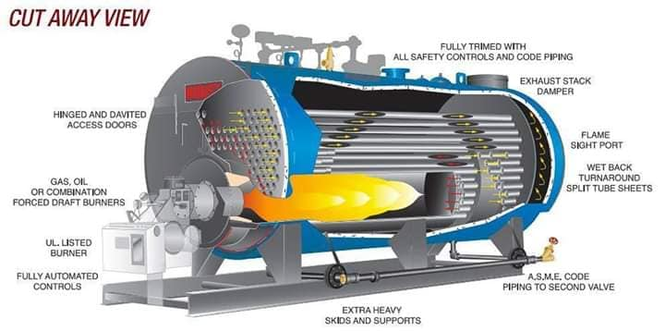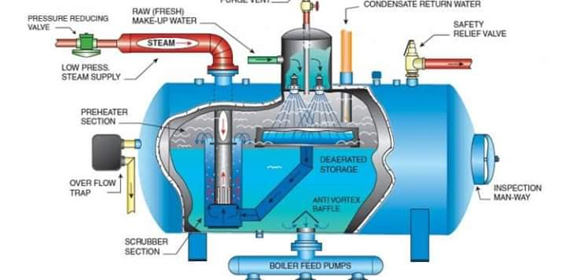3.2 COMPRESSOR
A compressor is a mechanical device that increases the pressure of a gas by reducing its volume. An air compressor is a specific type of gas compressor. Compressors are similar to pumps: both increase the pressure on a fluid and both can transport the fluid through a pipe. As gases are compressible, the compressor also reduces the volume of a gas. Liquids are relatively incompressible; while some can be compressed, the main action of a pump is to pressurize and transport liquids. Gas compressors are used in various applications where either higher pressures or lower volumes of gas are needed: In pipeline transport of purified natural gas from the production site to the consumer, a compressor is driven by a gas turbine fueled by gas bled from the pipeline. Thus, no external power source is necessary. Petroleum refineries, natural gas processing plants, petrochemical and chemical plants, and similar large industrial plants require compressing for intermediate and end-product gases.
Refrigeration and air conditioner equipment use compressors to move heat in refrigerant cycles (see vapor-compression refrigeration). Gas turbine systems compress the intake combustion air. Small-volume purified or manufactured gases require compression to fill high pressure cylinders for medical, welding, and other uses. Various industrial, manufacturing, and building processes require compressed air to power pneumatic tools. In the manufacturing and blow moulding of PET plastic bottles and containers. Some aircraft require compressors to maintain cabin pressurization at altitude. Some types of jet engines—such as turbojets and turbofans—compress the air required for fuel combustion. The jet engine's turbines power the combustion air compressor. In SCUBA diving, hyperbaric oxygen therapy, and other life support devices, compressors put breathing gas into small volume containers, such as diving cylinders.[26][27] In surface supplied diving, an air compressor frequently supplies low pressure air (10 to 20 bar) for breathing. Submarines use compressors to store air for later use in displacing water from buoyancy chambers to adjust depth. Turbochargers and superchargers are compressors that increase internal combustion engine performance by increasing the mass flow of air inside the cylinder, so the engine can burn more fuel and hence produce more power. Rail and heavy road transport vehicles use compressed air to operate rail vehicle or road vehicle brakes—and various other systems (doors, windscreen wipers, engine, gearbox control, etc.). Service stations and auto repair shops use compressed air to fill pneumatic tires and power pneumatic tools. Fire pistons and heat pumps exist to heat air or other gasses, and compressing the gas is only a means to that end. Rotary lobe compressors are often used to provide air in pneumatic conveying lines for powder or solids. Pressure reached can range from 0.5 to 2 bar g. [28]
3.3 BATCH CODING MACHINE
Batch printing machines, marking machines, date printing machines are used in the following applications: Pharmaceutical & other packaging industries to print Batch No.., Mfg. Date., Exp. Date., Retail Price etc. on their plain or laminated & varnished Labels/Cartons, Polypack Bags, Pouches, tin Bottoms, Cotton Bags, bottles, jars or any solid surfaces etc. Adding special information at the time of actual packing. [1] Adding price change or special offer on existing labels/cartons. Batch coding machines are categorized in the following two categories; Contact coding type and Noncontact coding type. These coding machines are further sub categorized into the following types depending on their mode of operation:
- Automatic: Once set works automatically with the operator only having to look after its working and settings. Feeding, printing, collecting operation are done automatically, however these features vary in the different makes of machines.
- Semi-automatic: The machine works on its own but the feeding and collecting has to be done by hand.
- Hand operated or manual: Feeding as well as the machine are operated manually. They are suitable for small production and are highly portable.
- Online: These machine works automatically online with other machines or they can be of continuous type with feeding from other machine, by hand or other feeding mechanisms, but are integrated or attached in line with other online machines.

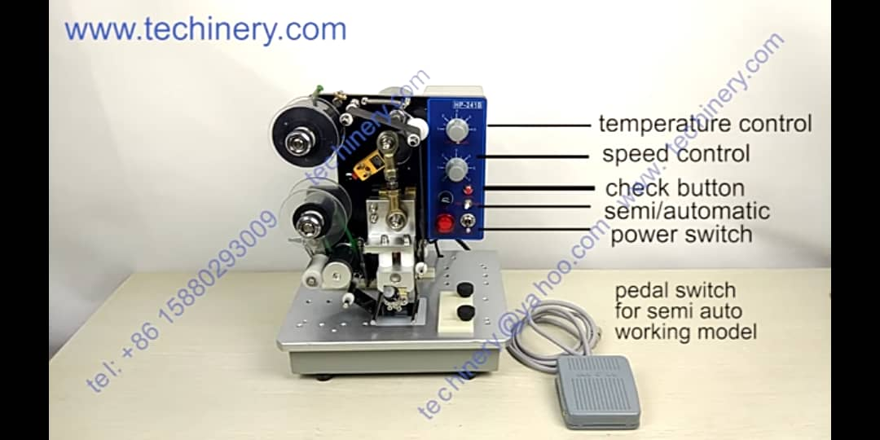

3.4 AUTOCLAVE
An autoclave is a pressure chamber used to carry out industrial and scientific processes requiring elevated temperature and pressure different from ambient air pressure. Autoclaves are used in medical applications to perform sterilization and in the chemical industry to cure coatings and vulcanize rubber and for hydrothermal synthesis. Industrial autoclaves are used in industrial applications, especially regarding composites. Many autoclaves are used to sterilize equipment and supplies by subjecting them to pressurized saturated steam at 121 °C (249 °F) for around 15–20 minutes depending on the size of the load and the contents [1] The autoclave was invented by Charles Chamberland in 1884,[2] although a precursor known as the steam digester was created by Denis Papin in 1679.[3] The name comes from Greek auto-, ultimately meaning self, and Latin clavis meaning key, thus a self-locking device.[4].
Sterilization autoclaves are widely used in microbiology, medicine, podiatry, tattooing, body piercing, veterinary medicine, mycology, funerary practice, dentistry, and prosthetics fabrication. They vary in size and function depending on the media to be sterilized and are sometimes called retort in the chemical and food industries. Typical loads include laboratory glassware, other equipment and waste, surgical instruments, and medical waste. [5][6]. A notable recent and increasingly popular application of autoclaves is the pre-disposal treatment and sterilization of waste material, such as pathogenic hospital waste. Machines in this category largely operate under the same principles as conventional autoclaves in that they are able to neutralize potentially infectious agents by using pressurized steam and superheated water. A new generation of waste converters is capable of achieving the same effect without a pressure vessel to sterilize culture media, rubber material, gowns, dressings, gloves, etc. It is particularly useful for materials which cannot withstand the higher temperature of a hot air oven. [7].
Autoclaves are also widely used to cure composites and in the vulcanization of rubber. [8] The high heat and pressure that autoclaves generate help to ensure that the best possible physical properties are repeatable. The aerospace industry and sparmakers (for sailboats in particular) have autoclaves well over 50 feet (15 m) long, some over 10 feet (3.0 m) wide.[citation needed]. Other types of autoclaves are used to grow crystals under high temperatures and pressures. Synthetic quartz crystals used in the electronics industry are grown in autoclaves. Packing of parachutes for specialist applications may be performed under vacuum in an autoclave, which allows the chutes to be warmed and inserted into their packs at the smallest volume.
A medical autoclave is a device that uses steam to sterilize equipment and other objects. This means that all bacteria, viruses, fungi, and spores are inactivated. However, prions, such as those associated with Creutzfeldt–Jakob disease, and some toxins released by certain bacteria, such as Cereulide, may not be destroyed by autoclaving at the typical 134 °C for three minutes or 121 °C for 15 minutes.[citation needed] Although a wide range of archaea species, including Geogemma barosii, can survive and even reproduce at temperatures above 121 °C, none of them are known to be infectious or otherwise pose a health risk to humans; in fact, their biochemistry is so different from our own and their multiplication rate is so slow that microbiologists need not worry about them.[citation needed].
Autoclaves are found in many medical settings, laboratories, and other places that need to ensure the sterility of an object. Many procedures today employ single-use items rather than sterilizable, reusable items. This first happened with hypodermic needles, but today many surgical instruments (such as forceps, needle holders, and scalpel handles) are commonly single-use rather than reusable items (see waste autoclave). Autoclaves are of particular importance in poorer countries due to the much greater amount of equipment that is re-used. Providing stove-top or solar autoclaves to rural medical centers has been the subject of several proposed medical aid missions. [Citation needed]. Because damp heat is used, heat-labile products (such as some plastics) cannot be sterilized this way or they will melt. Paper and other products that may be damaged by steam must also be sterilized another way. In all autoclaves, items should always be separated to allow the steam to penetrate the load evenly.
Autoclaving is often used to sterilize medical waste prior to disposal in the standard municipal solid waste stream. This application has become more common as an alternative to incineration due to environmental and health concerns raised because of the combustion by-products emitted by incinerators, especially from the small units which were commonly operated at individual hospitals. Incineration or a similar thermal oxidation process is still generally mandated for pathological waste and other very toxic or infectious medical waste. In dentistry, autoclaves provide sterilization of dental instruments according to health technical memorandum 01-05 (HTM01-05). According to HTM01-05, instruments, once sterilized using a vacuum autoclave, can be kept for up to 12 months using sealed pouches. [10]. in most of the industrialized world medical-grade autoclaves are regulated medical devices. Many medical-grade autoclaves are therefore limited to running regulator-approved cycles. Because they are optimized for continuous hospital use, they favor rectangular designs, require demanding maintenance regimens, and are costly to operate. (A properly calibrated medical-grade autoclave uses thousands of gallons of water each day, independent of task, with correspondingly high electric power consumption.).
There are physical, chemical, and biological indicators that can be used to ensure that an autoclave reaches the correct temperature for the correct amount of time. If a non-treated or improperly treated item can be confused for a treated item, then there is the risk that they will become mixed up, which, in some areas such as surgery, is critical. Chemical indicators on medical packaging and autoclave tape change color once the correct conditions have been met, indicating that the object inside the package, or under the tape, has been appropriately processed. Autoclave tape is only a marker that steam and heat have activated the dye. The marker on the tape does not indicate complete sterility. A more difficult challenge device, named the Bowie-Dick device after its inventors, is also used to verify a full cycle. This contains a full sheet of chemical indicator placed in the center of a stack of paper. It is designed specifically to prove that the process achieved full temperature and time required for a normal minimum cycle of 134 °C for 3.5–4 minutes.
To prove sterility, biological indicators are used. Biological indicators contain spores of a heat-resistant bacterium, Geobacillus stearothermophilus. If the autoclave does not reach the right temperature, the spores will germinate when incubated and their metabolism will change the color of a pH-sensitive chemical. Some physical indicators consist of an alloy designed to melt only after being subjected to a given temperature for the relevant holding time. If the alloy melts, the change will be visible. [Citation needed]. Some computer-controlled autoclaves use an F0 (F-nought) value to control the sterilization cycle. F0 values are set for the number of minutes of sterilization equivalent to 121 °C (250 °F) at 100 kPa (15 psi) above atmospheric pressure for 15 minutes. Since exact temperature control is difficult, the temperature is monitored, and the sterilization time adjusted accordingly
3.5 RO (Reverse Osmosis)
Reverse osmosis (RO) is a water purification process that uses a partially permeable membrane to remove ions, unwanted molecules and larger particles from drinking water. In reverse osmosis, an applied pressure is used to overcome osmotic pressure, a colligative property that is driven by chemical potential differences of the solvent, a thermodynamic parameter. Reverse osmosis can remove many types of dissolved and suspended chemical species as well as biological ones (principally bacteria) from water, and is used in both industrial processes and the production of potable water. The result is that the solute is retained on the pressurized side of the membrane and the pure solvent is allowed to pass to the other side. To be "selective", this membrane should not allow large molecules or ions through the pores (holes), but should allow smaller components of the solution (such as solvent molecules, i.e., water, H2O) to pass freely. [1]. in the normal osmosis process, the solvent naturally moves from an area of low solute concentration (high water potential), through a membrane, to an area of high solute concentration (low water potential). The driving force for the movement of the solvent is the reduction in the free energy of the system when the difference in solvent concentration on either side of a membrane is reduced, generating osmotic pressure due to the solvent moving into the more concentrated solution. Applying an external pressure to reverse the natural flow of pure solvent, thus, is reverse osmosis. The process is similar to other membrane technology applications.
Reverse osmosis differs from filtration in that the mechanism of fluid flow is by osmosis across a membrane. The predominant removal mechanism in membrane filtration is straining, or size exclusion, where the pores are 0.01 micrometers or larger, so the process can theoretically achieve perfect efficiency regardless of parameters such as the solution's pressure and concentration. Reverse osmosis instead involves solvent diffusion across a membrane that is either nonporous or uses nanofiltration with pores 0.001 micrometers in size. The predominant removal mechanism is from differences in solubility or diffusivity, and the process is dependent on pressure, solute concentration, and other conditions. [2] Reverse osmosis is most commonly known for its use in drinking water purification from seawater, removing the salt and other effluent materials from the water molecules.
Treatment with reverse osmosis is limited, resulting in low recoveries on high concentration (measured with electrical conductivity) and fouling of the RO membranes. Reverse osmosis applicability is limited by conductivity, organics, and scaling inorganic elements such as CaSO4, Si, Fe and Ba. Low organic scaling can use two different technologies, one is using spiral wound membrane type of module, and for high organic scaling, high conductivity and higher pressure (up to 90 bars) disc tube modules with reverse-osmosis membranes can be used. Disc tube modules were redesigned for landfill leachate purification that is usually contaminated with high levels of organic material. Due to the cross-flow with high velocity it is given a flow booster pump that is recirculating the flow over the same membrane surface between 1.5 and 3 times before it is released as a concentrate. High velocity is also good against membrane scaling and allows successful membrane cleaning.
Reverse Osmosis water purification process is a simple and straightforward water filtration process. It is accomplished by water pressure pushing tap water through a semipermeable membrane to remove impurities from water. This is a process in which dissolved inorganic solids (such as salts) are removed from a solution (such as water).
Basic Components of a Reverse Osmosis System:
- Cold Water Line Valve: Valve that fits onto the cold water supply line. The valve has a tube that attaches to the inlet side of the RO pre filter. This is the water source for the RO system.
- Pre-Filter(s): Water from the cold water supply line enters the Reverse Osmosis Pre Filter first. There may be more than one pre-filter used in a Reverse Osmosis system, the most common being sediment and carbon filters. These pre-filters are used to PROTECT the RO membranes by removing sand silt, dirt, and other sediment that could clog the system. Additionally, carbon filters may be used to remove chlorine, which can damage the RO membranes.
- Reverse Osmosis Membrane: The Reverse Osmosis Membrane is the heart of the system. The semipermeable RO membrane is designed to remove a wide variety of both aesthetic and health-related contaminants. After passing through the membrane, the water goes into a pressurized storage tank where treated water is stored.
- Post filter(s): After the water leaves the RO storage tank, but before going to the RO faucet, the treated water goes through a final “post filter”. The post filter is usually a carbon filter. Any remaining tastes or odors are removed from the product water by post filtration “polishing” filter.
- Automatic Shut Off Valve (SOV): To conserve water, the RO system has an automatic shut off valve. When the storage tank is full, the automatic shut off valve closes to stop any more water from entering the membrane and blocks flow to the drain. Once water is drawn from the RO faucet, the pressure in the tank drops; the shut off valve then opens to send the drinking water through the membrane while the contaminated wastewater is diverted down the drain.
- Check Valve: A check valve is located in the outlet end of the RO membrane housing. The check valve prevents the backward flow of treated water from the RO storage tank. A backward flow could rupture the RO membrane.
- Flow Restrictor: Water flowing through the RO membrane is regulated by a flow restrictor. There are many different styles of flow controls, but their common purpose is to maintain the flow rate required to obtain the highest quality drinking water (based on the gallon capacity of the membrane). The flow restrictor also helps maintain pressure on the inlet side of the membrane. Without the additional pressure from the flow control, very little drinking water would be produced because all the incoming water would take the path of least resistance and simply flow down the drain line. The flow control is most often located in the RO drain line tubing.
- Storage Tank: The standard RO storage tank holds from 2 - 4 gallons of water. A bladder inside the tank keeps water pressurized in the tank when it is full. The typical under counter Reverse Osmosis tank is 12 inches in diameter and 15 inches tall.
- Faucet: The RO unit uses its own faucet, which is usually installed on the kitchen sink. Some areas have plumbing regulations requiring an air gap faucet, but non-air gap models are more common
- Drain line: This line runs from the outlet end of the Reverse Osmosis membrane housing to the drain. The drain line is used to dispose of the wastewater containing the impurities and contaminants that have been filtered out by the reverse osmosis membrane.

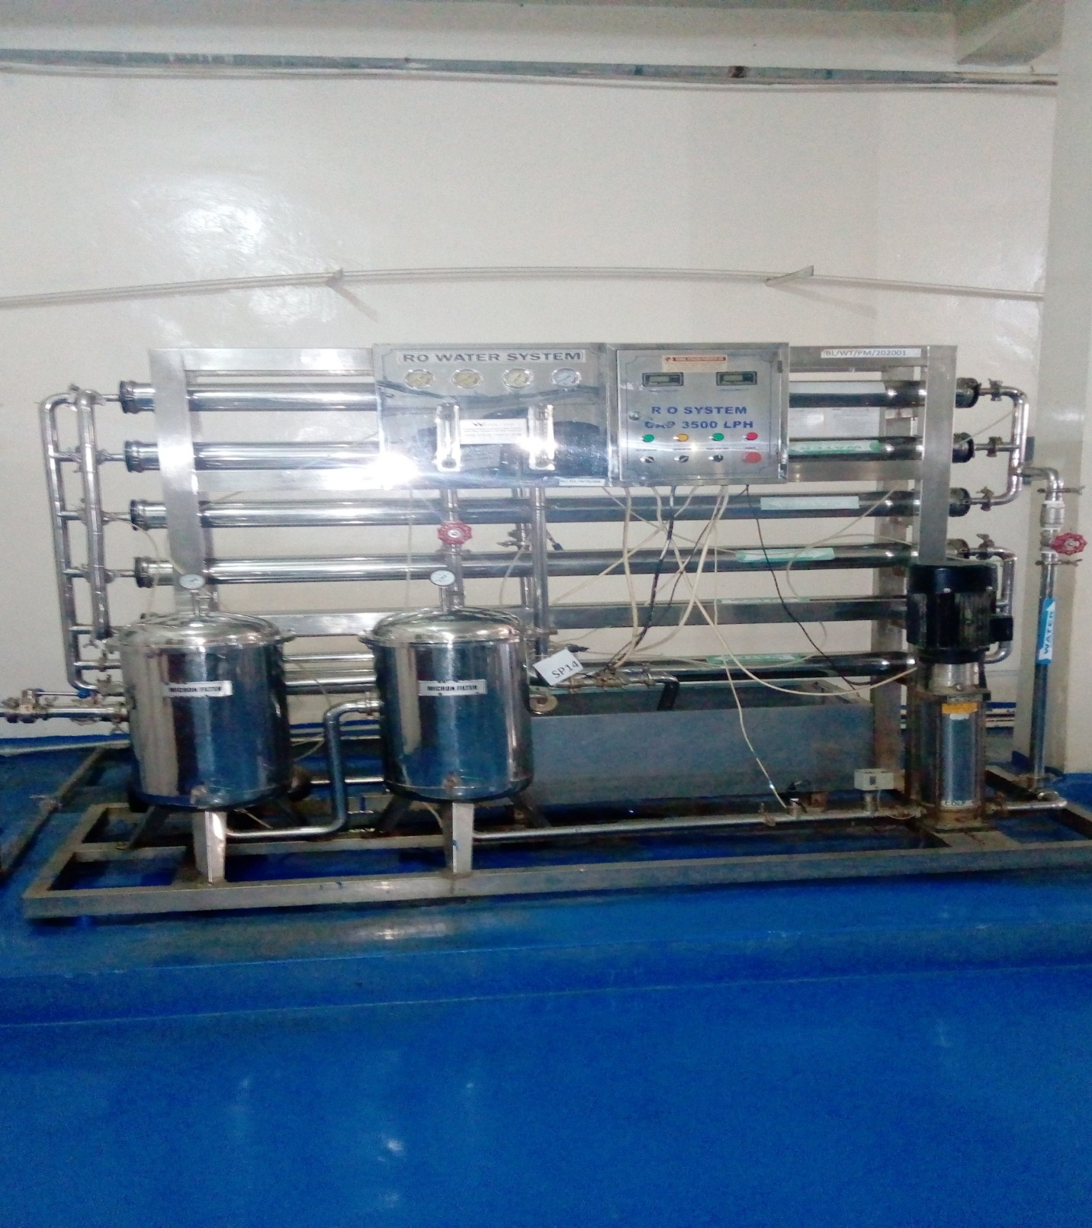

FABRICATION
Fabrication is the process of constructing products by combining typically standardized parts using one or more individual processes. This term is often associated with metal fabrication, which involves the production of metal structures through various methods such as cutting, bending, and assembling. The goal of fabrication is to create a complete assembly made from smaller sub-assemblies that can be utilized in larger manufacturing processes.
One of the key aspects of modern fabrication is the use of technology, particularly computer-aided design (CAD) and computer numerical control (CNC). CAD allows designers to create detailed models and plans for the products being fabricated, while CNC technology enables machines on the factory floor to execute these designs with high precision. This integration of technology not only enhances the quality standards of production but also leads to quicker assembly times and better material utilization.
The fabrication process typically includes several steps:
- Design: The initial phase involves creating a design that outlines specifications for the product. This can be done using hand-drawn diagrams for simpler projects or advanced CAD software for more complex designs.
- Forming: After finalizing the design, raw materials are shaped into components through various methods such as cutting, bending, welding, and machining.
- Assembly: The formed parts are then assembled together to create a finished product or sub-assembly.
- Finishing: Once assembled, finishing processes may be applied to enhance durability and aesthetics. This could include painting, coating, or polishing.
- Installation and Maintenance: For larger projects, professional installation may be required. Additionally, routine maintenance is essential to ensure longevity and optimal performance of fabricated products.
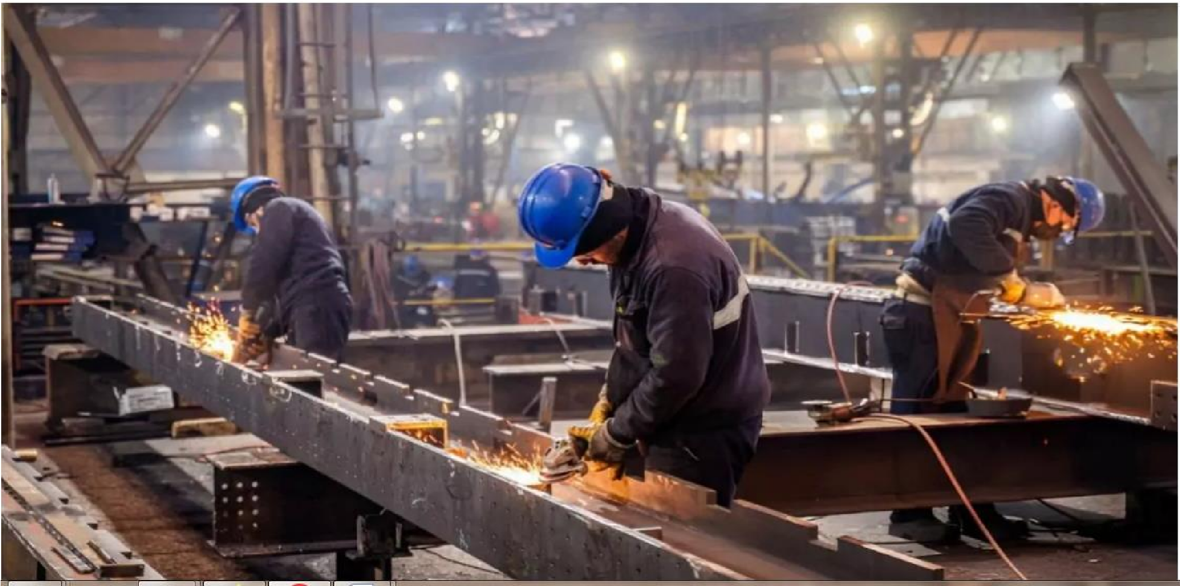
WELDING
Welding is a fabrication process that joins materials, primarily metals or thermoplastics, by using high temperatures to melt the parts together.
This melting allows the materials to fuse as they cool, forming a strong joint known as a weldment. The process typically involves the addition of a filler material, which creates a molten pool (the weld pool) that solidifies to form a joint that can be stronger than the base materials themselves.
Types of Welding Processes
There are several welding processes, each utilizing different energy sources and techniques:
- Gas Metal Arc Welding (GMAW/MIG): This method uses a thin wire as an electrode and is commonly employed in construction and automotive applications. A shielding gas is used to protect the weld from contamination.
- Gas Tungsten Arc Welding (GTAW/TIG): Known for its precision, this technique uses a non-consumable tungsten electrode and is ideal for welding thin and non-ferrous metals such as aluminum.
- Shielded Metal Arc Welding (SMAW): Often referred to as stick welding, this manual technique employs a flux-coated electrode and is popular among home-shop welders due to its low cost.
- Flux Cored Arc Welding (FCAW): Similar to MIG welding but with variations that allow for outdoor use, FCAW involves continuously feeding a wire while welding.
- Submerged Arc Welding (SAW): This process involves covering the weld area with granular flux to protect it from contamination during welding.
- Other Methods: Additional techniques include gas
welding/oxyacetylene welding, thermit welding, electron beam welding, plasma arc welding, and resistance welding.
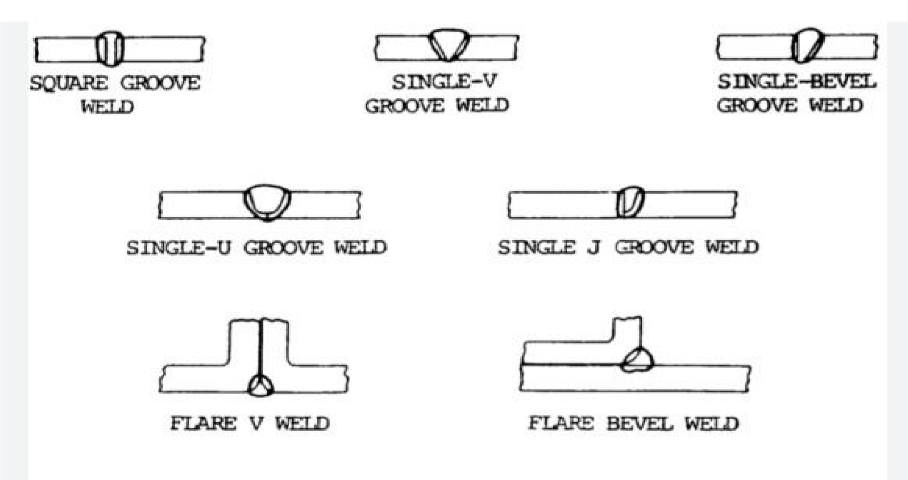

CHATER 4
PROBLEM ENCOUNTERED, CONCLUSION AND RECOMMENDATION
4.1 PROBLEM ENCOUNTERD
It is ciritical clear that SIWES it an experience programme for all student because it is in this programme that student will be impact to withstand the challenges of life in the office after graduation.
.
4.2 CONCLUSION
Interesting, productive, instructive and educative experience of my life. Through this training, I have gained the insight and more comprehensive understanding about the real industrial working condition and practice and also improved my soft and functional skills.
All these valuable experiences and knowledge that I have gained were not only acquired through the direct involvement in task but also through other aspects of the training such as: work observation, supervision, interaction with colleagues, supervisors, superior and other people related to the field. It also exposed me to some certain things about medical environment. And from what I have undergone, I am sure that the industrial training programme has achieved its primary object.
4.3 RECOMMENDATION
. To the Organization
- Facilitation; The management of Biomedical Limited should get more facilities such as vehicles, machines so as to enable smooth running of the company’s activities and respond to the dynamic competition environment. This technological will enable the organization to change from manual to automatic methods of operation.
- More opportunities to students to do intern in their organization; the intern would also recommend the Organization to continue giving internship placements to as many students as they can because some miss the experience which is also important requirement of the University due to the fact that they failed to get placements.
- Serious supervision to the workers and students, the organization should increase and ensure more supervision over the employees in order to work effectively and also eliminate workers who relax, work lazily and perform actively after seeing their supervisors.

