A TECHNICAL REPORT ON
STUDENT INDUSTRIAL WORKING EXPERIENCE SCHEME (SIWES)
HELD AT
GLOBAL LINK MANAGEMENT
3 AJIA STREET KOSUBOSU KWARA STATE

PRESENTED BY
MORUF ADAM AYOMIDE
ND/23/BAM/PT/0937

SUBMITTED TO
DEPARTMENT OF BUSINESS ADMINISTRATION, INSTITUTE OF FINANCE AND MANAGEMENT STUDIES (IFMS) KWARA STATE POLYTECHNIC, ILORIN.
IN PARTIAL FULFILMENT OF THE REQUIREMENTS FOR THE AWARD OF NATIONAL DIPLOMA (ND) IN BUSINESS ADMINISTRATION DEPARTMENT.

SEPTEMBER 2024 TO DECEMBER, 2024
TABLE OF CONTENTS
Introduction to SIWES
History of SIWES
Aims and Objective of SIWES
Various Department
Organogram Global link Management
Various Department
Problems encountered during the programme
Experience Gained
Conclusion
Recommendations

1.1 INTRODUCTION/MEANING OF SIWES
The student industrial working experience scheme (SIWES) is an accepted skill training program which forms part of approved minimum academic standards in the various degrees program of the Nigeria tertiary institutions.
This scheme help student in their various field to know or have knowledge and clear picture of what they have been studying in school which enables the student to practice the theoretical aspect of his or her profession. This scheme contributes to the large way of preparing the student for any future engagement, exposing him or her to atmosphere of versatility and adaption.
1.2 HISTORY OF SIWES
Student industrial experience scheme SIWES was established by ITF in 1973 to solve the problem of lack of adequate practical skills preparatory for employment in industrial by Nigerian graduates of tertiary institutions. The scheme exposes student to industry based skills necessary for a smooth transition from the classroom to the world of work it affords students of tertiary institutions the opportunity of being familiarized and exposed to the needed experience in handling machinery and equipment which are usually not available in the educational institutions.
Participation in SIWES has become a necessary pre-condition for the award of Diploma and Degree certificate in specific discipline in most institutions of higher learning in the country, in accordance with the education policy of government.
Operators: - The ITF, the coordinating agencies (NUE, NCCE, NBTE) employers of labour and the institutions.
Funding: - The federal Government of Nigeria
Duration: - Four months for Polytechnic and College of Education, and six months for the University.
1.3 AIMS OF SIWES
- Student Industrial Work experience scheme (SIWES) provide avenue for student to acquire industrial skill and experience in their choose course of study.
- It prepares student for their industrial work experience which they are likely to meet after graduation.
OBJECTIVE OF SIWES
- To provides avenue for students in institutions of higher learning to acquire industrial skills and experience in their course of study.
- It prepares students for post graduation working situation.
- To expose students to working methods and techniques in handling equipments and machinery that may not be available in educational institution.
- To provide opportunity for students to apply their knowledge in working situation, thereby bridging the gap between theory and practice
- To ease the transition from school and labour market, which enhances students contact for later job.
- For Ernest placement and strengthens employee’s involvement in the educational process of preparing student for employment in industries.
2.1 ORGANOGRAM GLOBAL LINK MANAGEMENT
The organogram below shows the current management structure, hierarchy of Global link
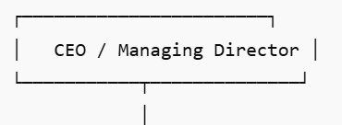

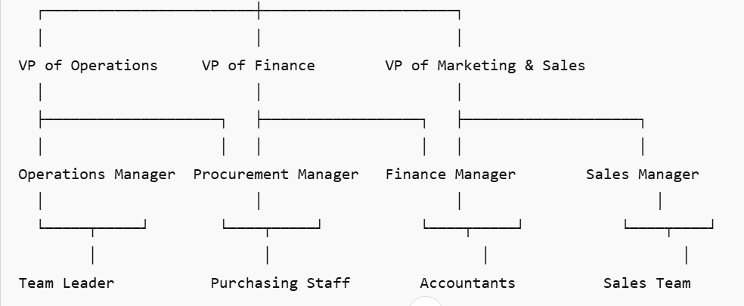

2.2 1. MANAGEMENT/LEADERSHIP
Functions:
- Strategic Decision-Making: In small businesses, the management team is often composed of the business owner(s) or a small group of managers who are responsible for setting the overall direction of the business, long-term goals, and strategies.
- Resource Allocation: Deciding where to allocate resources (financial, human, physical) to optimize business performance and growth.
- Problem-Solving: Resolving any issues that arise across departments and addressing customer complaints or operational challenges.
- Leadership: Inspiring and guiding employees, maintaining morale, and ensuring that all team members understand the company's vision and goals.
- Relevance: In small businesses, the management team typically handles multiple roles and is responsible for the overall success of the business. Understanding how management functions is critical for anyone studying business administration.

2. Sales and Marketing Department
Functions:
- Sales Strategy: This department is responsible for identifying sales opportunities, setting sales goals, and implementing strategies to increase revenue.
- Customer Relationship Management (CRM): Building and maintaining strong relationships with customers, ensuring repeat business, and generating word-of-mouth referrals.
- Marketing Campaigns: Developing marketing strategies to promote products or services, including traditional advertising (flyers, posters, radio ads) and digital marketing (social media, email marketing, search engine optimization).
- Market Research: Gathering information on competitors, industry trends, and customer preferences to make informed decisions on pricing, product offerings, and promotional activities.

3. Finance and Accounting Department
Functions:
- Financial Planning and Budgeting: In small businesses, the owner or a small finance team typically handles the budgeting, forecasting, and financial planning to ensure profitability and financial stability.
- Bookkeeping and Record-Keeping: Keeping accurate records of all transactions, including expenses, income, and tax-related items.
- Payroll: Ensuring that employees are paid accurately and on time, including managing deductions for taxes, insurance, and benefits.
- Financial Reporting: Preparing financial statements, such as income statements, balance sheets, and cash flow statements, which are crucial for understanding the financial health of the business.
- Tax Management: Ensuring that the business complies with tax regulations by filing necessary returns and paying required taxes.

4. Operations and Production Department
Functions:
- Product Development: Developing or sourcing the products or services the business offers. This may include designing, manufacturing, or sourcing from suppliers.
- Quality Control: Ensuring that products meet the required standards before being sold to customers.
- Inventory Management: Keeping track of raw materials, finished goods, and ensuring that the business has enough stock to meet customer demand without overstocking, which ties up resources.
- Logistics and Supply Chain Management: Managing the delivery of raw materials, products, and services to customers in a timely and efficient manner.

5. Customer Service Department
Functions:
- Customer Support: Handling customer inquiries, issues, complaints, and returns. In small businesses, this function might be performed by the owner or a small customer service team.
- Building Customer Loyalty: Offering personalized services and fostering strong relationships with customers to encourage repeat business.
- Feedback Collection: Gathering feedback from customers to improve products, services, and the overall customer experience.

6. Human Resources (HR) Department
Functions:
- Recruitment and Staffing: In small businesses, HR is often managed by the owner or a small team responsible for hiring new employees, handling interviews, and making job offers.
- Employee Benefits and Compensation: Managing salaries, employee benefits, and ensuring that employees are paid fairly and on time.
- Employee Development: Training employees to improve their skills, offering professional development opportunities, and ensuring that staff members perform at their best.
- Compliance with Labor Laws: Ensuring that the business complies with labor laws regarding working hours, safety, wages, and other employee rights.

7. Legal and Compliance Department
Functions:
- Legal Contracts: In small businesses, a legal team (often an external lawyer or consultant) may manage contracts with suppliers, clients, and employees.
- Regulatory Compliance: Ensuring the business adheres to industry regulations, local government laws, and licensing requirements.
- Dispute Resolution: Handling any legal disputes that may arise, such as issues with vendors, customers, or employees.
- Intellectual Property Protection: In some small businesses, protecting intellectual property such as trademarks, copyrights, and patents may be a priority, especially for those in technology or product design.
3.1 TECHNICAL TRAINING EXPERIENCE
The primary objectives of my SIWES training were to:
- Gain practical knowledge in business management and operations.
- Understand the functioning of a small-scale business in terms of inventory management, finance, and customer service.
- Learn how to apply theoretical concepts from business administration in real-world situations.
- Develop skills in handling day-to-day business tasks, including marketing, accounting, and human resource management.
During my SIWES placement, I was involved in a wide variety of tasks that provided exposure to different areas of the business:

a) Financial Management and Bookkeeping
One of my key responsibilities was assisting in maintaining the business's financial records. This involved:
- Updating ledgers and journals: I assisted with the recording of sales and purchases, ensuring that all transactions were accurately documented.
- Preparing daily sales reports: I helped in generating daily sales reports, which helped management track performance.
- Inventory tracking: I participated in tracking the stock levels and ensuring that the inventory was in line with sales projections.

b) Inventory and Supply Chain Management
In a small-scale business, inventory management is crucial to avoid stockouts or overstocking, which can lead to unnecessary costs. My activities included:
- Stocktaking and inventory management: I was involved in periodic stocktaking and updating the inventory management system.
- Vendor communication: I interacted with suppliers to manage orders and ensure the timely arrival of goods.
- Replenishment strategies: I learned how the business assesses which products need to be replenished based on customer demand and historical sales data.

c) Marketing and Customer Relations
I was also involved in marketing and improving customer relationships. These activities included:
- Creating promotional materials: I assisted in creating flyers and posters for in-store promotions.
- Customer engagement: I learned to handle customer inquiries, resolve complaints, and ensure a high level of customer satisfaction.
- Social media: The business maintained a presence on social media, and I helped with posts aimed at attracting new customers and retaining existing ones.

d) Human Resource Management
While the business did not have a large staff, I observed how human resources were managed at a small scale:
- Employee scheduling: I observed how work schedules were created to ensure there was adequate staff coverage for peak hours.
- Payroll: I helped track employee hours for payroll purposes and observed how salaries were processed.
- Recruitment: I participated in the hiring process by helping to screen resumes and conduct initial interviews for new hires.
4.1 PROBLEMS ENCOUNTERED DURING THE PROGRAMME
However, I encountered a little problem in funding during my three months attachment.
Firstly, I was overloaded, I worked from Monday to Friday and it was difficult for me to transport myself to and fro. This is because I wasn’t officially paid. Also, the inconsistent power supply made learning quiet slow for me, because sometimes there wouldn’t be power supply to charge the system.
4.2 EXPERIENCE GAINED
Discipline in the operation department of Queensway Hospital Lagos, I`ve get to realized the Efficiency of statistics in an organization, Also it help me a lot in the practical aspect of my course of study, I learnt how to be patient when collecting the data from members of the public and it also enable me to know how to deal with real calculations on statistics, and it also enhances my ability and integrity and it also enable me to know more on each topics and different analysis in statistics. I learnt a lot during my SIWES, not only in academic field but I also learnt how to interact and associate with elderly people most especially strangers. The student industrial work experience scheme (SIWES) program had been so helpful to student irrespective of their course of study.
5.1 CONCLUSION
With the little experience gained during the course of my SIWES program bought me great knowledge in such a way that it exposed me to various aspects of data collection, organization, summarization, presentation, analyzing and interpretation with statistical terms.
5.2 RECOMMENDATIONS
So far, it is believed that statistics cannot skip- through in the activities of our co- existence. Therefore, the organization should continue to give room for students more comprehensive practical training by having permanent professional statistics.
The industrial training program is an import aspect and on educating scheme, however wishes to recommend that:
- Other student in management field should give an ultimate taste of this benefit for more and office practice experience.
- The school should take adequate provision of transport for the supervisors so that they can be visiting the student field and most in office alone
- The industrial training fund (ITF) officers are implored to make a brilliant arrangement for the payment of the allowance in appropriate time preferable every month so that the string of the student who is doing this programmed will not be in vain.
- Provision of adequate funds for the I.T and SIWES students for at least transportation fare.
- This programme is actually relevant to all course of study, it has really exposed me to the reality of practical aspect of the theoretical work I have been taught in school.
- Therefore, I hereby recommend that the Industrial Training officials should also this SIWES programme.

