TECHNICAL REPORT ON
STUDENTS INDUSTRIAL WORK EXPERIENCE SCHEME (SIWES)
OBSERVED AT
TNM MEDIA ACADEMY LIBRARY, IBADAN
(BETWEEN AUGUST, 2024 – NOVEMBER, 2024)
BY
ABDULROHEEM MUBARAK GBOLAHAN
ND/23/LIS/FT/0106

SUBMITTED TO
DEPARTMENT OF LIBRARY AND INFORMATION SCIENCE
INSTITUTE OF INFORMATION AND COMMUNICATION TECHNOLOGY
KWARA STATE POLYTECHNIC, ILORIN

FEBRUARY, 2025

Table of contents
Title page
Table of contents
Report overview
Chapter One 1
1.1 background to the report
1.2 Aims and Objectives of SIWES
Chapter Two
2.1 locatioN and history of place of attachment
2.2 organization chart
2.3 division/section in the library
Chapter three
3.1 TECHNICAL DEPARTMENT
3.2 Circulation and redears services
3.3 reference department
3.4 REsearch unit
3.5 serial services
3.6 automation/e-library unit
3.7 Reserved unit
Chapter four
4.1 Equipment used and the details of their usage.
Chapter five
Conclusion and Recommendations
5.1 Conclusion
5.2 Recommendation

REPORT OVERVIEW
The Student Industrial Work Experience Scheme (SIWES) is a program that is meant to train students to gather practical experience in their various departments. Students are to be exposed to their place of work (attachment) during the training period. This report contains the experience gathered during the 16 weeks (Four Months) training program which was held at TNM Media Academy Library. The report also includes the description of the organization and the work done during the period.

CHAPTER ONE
INTRODUCTION
1.1 Background
This program was established by ITF in 1973 to solve the problem of lack of adequate practical skills preparatory for employment in industries by Nigerian undergraduate of tertiary institutions. The Scheme exposes students to industry based skills necessary for a smooth transition from the classroom to the world of work. It affords students of tertiary institutions the opportunity of being familiarized and exposed to the needed experience in handling machinery and equipment which are usually not available in the educational institutions.
Before the inception of the Scheme, there was a growing concern among Nigerian industrialists that graduates of institutions of higher learning lacked adequate practical background experience necessary for employment. So, employers were of the opinion that the theoretical education provided by higher institutions did not meet nor satisfy the needs of the economy. It was against this background that the Fund during its formative years, introduced SIWES to provide students with the opportunity of exposure to handle equipment and machinery in Industry to enable them acquire prerequisite practical knowledge and skills (ITF and UNIJOS, 2011). This program (SIWES) is a three credit unit course in some university and other tertiary institution which must be met by students before graduation in order to gather practical knowledge of the theoretical aspect that they have learnt during the course of their study in university. This is the reason why it is mandatory for the students in the department of Library and Information Science, University of Ilorin, to go to different library to acquire practical knowledge of librarianship.

1.2 Aims and Objectives of the Scheme
The following are the aims and objectives of Scheme as summarized by the federal government in its Gazette of April, 1978 as follows:
- To provide students the opportunity to test their interest in a particular career before permanent commitments are made.
- To help students to develop skills in the application of theory to practical work situations.
- To provide students the opportunity to test their aptitude for a particular career before permanent commitments are made.
- To help students to develop skills and techniques directly applicable to their careers.
- To provide students the opportunity to develop attitudes conducive to effective interpersonal relationships.

CHAPTER TWO
DESCRIPTION OF TNM MEDIA ACADEMY LIBRARY
TNM Media Academy Library is a private library which was established to support learning and learning in the academy. This establishment follows the principle of Dewey Decimal Classification Scheme in their Technical unit. The Library System is divided into three (3) major units namely; Reader Service unit, Technical service unit and Electronic services unit.
2.1 UNIT/Division/section
- Readers services unit
- Technical services unit
- Reference unit
- Electronic services unit
2.1.1 Readers services division
This unit establishes direct contact with the library users. It takes custody of materials that have been processed in the technical service division and makes them available to users in an organized and controlled system. The division coordinates the activities of the sections under it. The sections include circulation section, document section, reference section, and thesis and dissertations section.
- Circulation section: this is one of the public relations sections of the library. The head of the section is usually circulation librarian. It processes the registration of new library users, charge and discharging of books out to users. Circulation staff also prepares library bills for damaged, long overdue, or lost materials. They are often responsible for shelving new and returned materials as they frequently provide lost and found services.
Routines of the circulation section.
- Register new library users.
- Charge books out to users.
- Discharge returned books.
- Keeps statistics and generate reports of library users and library materials consulted.
- Display and shelf new books.
- Reshelf used books.
- Consult shelve reading.
- Maintain books on the open shelves.
- Maintain books on reserved and other closed access shelves and keep statistics of usage.
- Shelving of new materials.
- Allocation of carrels to users.
- Handling reserve materials.
- Answering user’s queries.
- Reference section: this is headed by a reference librarian. The materials are meant for consultation only and are therefore not to be borrowed or taken out of the library. This is also public relations section of the library. Books are freely available on the shelves for consultation and books consulted are to be left on the table for statistical purposes. They are also responsible for reference and referral services. They perform interlibrary loan and lending on behalf of the library. The houses reference materials such as encyclopedia, Dictionaries, biographies, gazette, gazetteers, maps, handbooks, index, almanac, abstract, atlas, etc.
Routines
- Provides answers to reference queries.
- Maintain reference collections on closed shelves.
- Provides answers to directional and non-directional queries.
- Processes inter library requests.
- Teaches clientele how to use special reference materials.
- Maintains statistical and generates reports of reference materials consulted.
- Shelving and shelve reading of reference materials.
- Carrying out interlibrary loan on behalf of the library.
2.1.2 Technical services department
They carry out technical activities in the library. The division comprises acquisition, cataloging and classification section, serial and bindery units. The primary responsibility of the division is to coordinate activities taken place in the section.
- Acquisition section: this section involves the selection and acquisition of selected material for the academy in all formats including digital items and maintaining the necessary records related to acquisitions. The collection development policy of the academy is paramount in determining the relevance and quality of material to be acquired. This section requires the processing of information materials before they are made available to users. The acquisition section has various identification stamp used on different information materials. They are the donation stamp, edge stamp, security stamp, accession stamp, purchase stamp, spine stamp, and cancelled stamp.
Information materials are acquired in the library either through purchase, donation or gift.
Routines performed in the acquisition section.
- Collection development i.e. procurement of books through purchase donations, gifts and endowment.
- Keeping records of books purchased.
- Verification of books on order.
- Accessioning and stamping of books purchased.
- Facilitating books purchases between library clientele and publishers for personal use.
- Preparation of list of new arrivals (books).
- Sending orders to vendors.
- Harvesting books selected by department.
- Dispatch books to cataloguing and classification section.
- Receiving gifts and donation from individuals and corporate bodies.
- Cataloging and classification section: This section involves the process of creating and maintaining bibliographic and authority records of books, serials, recordings (audio and video), cartographic materials which are the properties of library. This is the engine room of any library. They provide bibliographical information of materials and materials are assigned subject, location, and class mark referred to as classification.
Classification section: they simply identifies the subject of a new material (subject cataloging) after receiving them from the acquisition section and assigning the classification number to the material. It uses the sears list of subject heading and after the subject has been determined, it direct the cataloguer to the schedule, after which the location of the material has been determined, then the cutter table will be used to cut the author's name and differentiate a material that has same subject title from one another.
The materials used in classifying materials include,
- Subject heading.
- Schedule.
- Cutter table.
Cataloging section: describes the content of a document on a 3×5 card referred to as descriptive cataloguing. Using the author's name, publishers, pagination note area, subject, accession number and location mark are made available before classification is done for easy retrieval and use. They make use of the Dewey Decimal Classification Scheme (DDC) and the type of cataloging is as follows:
- Descriptive cataloguing
- Subject cataloging
- Cataloguing in publications
- Online cataloging.
Descriptive cataloguing: this can be single entry, double entry, multiple entry, cooperate bodies, edited material, etc. It is the description of an information material on the catalogue card by providing the bibliographic details of the material. The name of the author or title are mostly used as the assess point here.
Subject cataloguing: it focus on the subject content of the material. This content can be gotten from the book back page, introduction page, preface, or the content page, before the subject can be determined.
Cataloging in publication: this is when a book has already been classified and catalogued from publication. And it can be found on the verso page of the material. You only have to transfer the information on the catalogue card.
Online cataloguing: this is the process of transferring the information on the catalogue card to the library software (KOHA).
Routines performed in the catalogue and classification section.
- Catalogue library materials.
- Classify library materials.
- Manually and electronically create and maintain records of the library holdings.
- Label library materials.
- Move the processed library materials to their designated sections. E.g. (circulation, reference, and serial sections).
- Providing current awareness services.
- Recording of daily newspaper.
- Record materials acquired by the library.
- Weeding and recording of obsolete materials from the shelve.
2.1.3 Electronic support service UNIT
They ensure that all manually handled library services are carried out electronically. It oversees three sections namely; automation section, electronic library, and digital library section.
- Automation section: it ensures that all activities that are handled manually should be done on the computer system. This is done to enhance easy retrieval of information and organization of the information materials.
Routine of the automation section.
- they ensures that bibliographic details of all library materials and information about the patrons of the library are carefully uploaded unto the library server by the circulation and technical section of the library.
- They handle all technical challenges that may crop up while inputting bibliographic details of the library into the server.
- Attend to challenges resulting from system upgrading and also maintains server operation.
- They also ensure that the internet connectivity of the library are in order.
- It also serve as the manual way of keeping the library data.
- Digital library section: this section enables users to have access to the institutional repository of the library. It is responsible for the retrospective conversion of library materials to digital format. The make use of the digital machine, computer, ups, etc
Routines of the digital library section.
- This section is responsible for creating, developing and maintaining the institutional repository system, which contains the intellectual properties of the university.
- It is an open access system, which staff and student can access for research, teaching and learning.
- Digitization of both thesis and dissertations
- Uploading of publication of each department on the institutional repository.
- Electronic library: this section directly assists students and staff to use the computer facilities to access the internet, provide wireless internet services and provides access to the subscribed and free databases of the library for their research.
Routines of the electronic library.
- This section develops and implements library programmes for students and staff on the search for qualitative academic e-journal and e-books from the e-library.
- Online dissemination of current resources acquired.
- Retrospective conversion.
- Provision of selective dissemination of information.
- Maintenance and repairs of electronic gadgets.
- Provides on hand training for students on SIWES program.

Chapter three
aCTUAL experience gained AT TNM Media Academy Library
- I was taught the Charging and discharging of library materials.
- I took part in the Library statistics done at regular intervals of 4 hours, at 10 am and 1 pm.
- Shelving and shelf reading of library materials on daily basis.
- I engaged in the arrangements of newly acquired library materials on the shelf
- Registering of new library users that want to make use of the information materials in the library.
- I received processed materials from the cataloging and classification section.
- I engaged in recording of books that are received from the catalogue and classification section.
- I administer accession number to newly acquired books.
- Classify materials using DDC.
- Cataloguing of library materials on the catalogue card.
- The difference between automation and digitization.
- The difference between subscribed and non-subscribed databases.
- How to assist student search for needed information using that subscribed and non-subscribed databases.

Chapter four
Equipment used and the details of their usage
- Computers: computers are used for easy accessing of information and are used to enter the information on the card catalogue to the library software Computers can be use in a Library to keep records of books and number of books that are available in the book stalk. It is used to access the databases of the library.
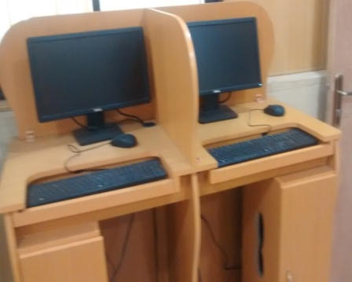

- Ups: It is used in the library because of power failure. It enables the operator to save documents before the computer system shut down to avoid loose of data and effort.
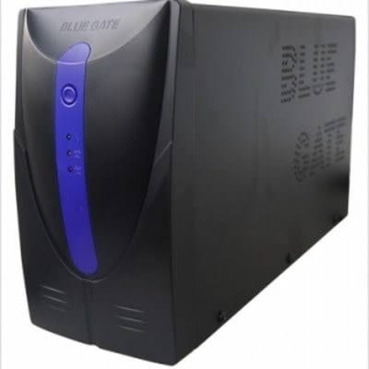

- Library shelf's: This allows the material to be arranged properly in order for easy access by the users and the library staffs.
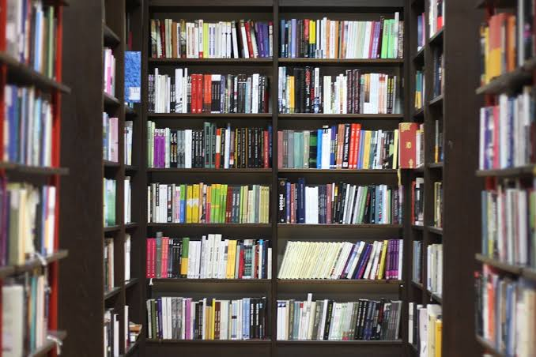

- 3 by 5 CARD: this is the card used when cataloguing a book and it is used in cataloguing section by writing the descriptive details of a material in an orderly manner for easy access. After been used to catalogue the material they are kept in a drawer for record use.


- Book End: it used between books to ensure they are well arranged by putting one at the beginning and other at the end of the book on the shelf.
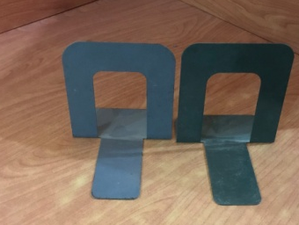
- Stamps: they are used on the information materials that are aquired in the library. It comprises of different stamp such as the date stamp, Security stamp, Edge stamp, identification stamp, Gift stamp, accession stamp and Ownership stamp, stamped on the information material. Accession stamp is for inserting the accession number, Edge stamp display library name and it is stamped on the edge of book, Ownership is to display the means of acquiring the material and Gift stamp is used when the material are donated to the library so the name of the donor can be written on it.
- Cutter table: it is used to determine the author name after a book has been catalogued and classified.

Chapter five
Summary, conclusion and recommendation
5.1 summary
In the course of my attachment at TNM Media Academy Library, I learnt how to shelve, re-shelve, catalogue, discharge, acquire, and stamp library materials. During my course of learning, I observed that the class lectures are theory and are not complete without the SIWES training. There is need to balance the scale between the school system and the industry in raising the technical literature of the students. Also, I gained a profound knowledge, practical skills and understanding partaking to my profession.
5.2 Conclusion
This report covers the experience gathered during the students’ industrial work experience scheme SIWES program held at TNM Media Academy Library. I learnt the basic practical and theoretical knowledge that I may not have gotten from the lecture room. It also gives me a feel of what it would be like after graduation, when I start working in a library organization. It is therefore an understatement to conclude that SIWES is of great benefit to students of tertiary institutions. Proper and effective administration of the scheme will go a long way in boosting and enhancing the competencies of the work force of the country.
5.3 Problem encountered during the program
During my training, I came across challenges which hinder my training. They include;
- There is no maintenance of the ICT facilities which has caused it to break down and crash and most of the services are being rendered manually.
- There is no proper training and retraining of the staff.
- Lack of automation.
- Most materials got completely damaged as the bindery section is not functioning.
5.4 Recommendations
Based on my experience during the exercise, I hereby recommend the following:
- There should be alternative power supply in the library so as to not hinder the study of the student currently studying in the library.
- Experienced staff should be assigned to the students.
- The SIWES coordinator should provide Scheme of what the organization are to teach the students.
- The bindery section should be provided for to enhance the protection of materials.
- There should be proper maintenance of the ICT facilities and training of staff and also back up of data for further use.
- The SIWES officials should invigilate the students at their respective place of attachment to ensure discipline.
- Organization should accept student in order to gain the expected experience.
- Materials should be processed, checked, and dispatched immediately to ensure that the materials are available on the shelf at the needed time.

