lOMoARcPSD|53701657



A REPORT ON STUDENT INDUSTRIAL WORK EXPERIENCE (SIWES) UNDER THE STUDENTS’ INDUSTRIAL WORK EXPERIENCE SCHEME

UNDERTAKEN @

CAPTAIN COOK BAKERY

LOCATED MOKOLA ROUNDABOUT, IBADAN

BY

HUSSAIN RAMADAN OLALEKAN
ND/23/PAD/PT/0157

SUBMITTED TO

THE DEPARTMENT OF PUBLIC ADMINISTRATION,
INSTITUTE OF FINANCE AND MANAGEMENT STUDIES,
KWARA STATE POLYTECHNIC, ILORIN

IN PARTIAL FULFILMENT OF THE REQUIREMENT FOR THE AWARD OF NATIONAL DIPLOMA (ND) IN PUBLIC ADMINISTRATION

AUGUST – NOVERMBER 2024

PREFACE
The writing of this SIWES report is manufacture by the school authority that before attaining the certificate of National Diploma (ND) in Mass Communication. Each student must undergo the three (3) months SIWES programme.
The SIWES record therefore contains the work done within the three months.

TABLE OF CONTENTS
Title page
Preface
Table of contents
CHAPTER ONE
1.1 Introduction
1.2 Brief History of SIWES
1.3 Aims and Objectives of SIWES
CHAPTER TWO
2.1 Brief history of the Organization
2.2 Organizational chart of the company
2.3 Various Department and their functions
2.4 Vision and Mission of the Organization
CHAPTER THREE
3.1 Experience Acquired
3.2 Work Done
CHAPTER FOUR
3.1 Executive Summary
CHAPTER FIVE
5.1 Problem Encountered during the Attachment and Solution
5.2 Conclusion
5.3 Recommendations

lOMoARcPSD|53701657

CHAPTER ONE

1.0 INTRODUCTION

The student industrial works experience scheme (SIWES) is a skills development program establish by the Industrial Training Fund {ITF} in 1973 to bridge the gap between theory and practice among Engineering and Technology in Institution of Higher Learning in Nigeria. It provides for on- the job practical experience for student as they are exposed to work methods and techniques in handling equipment and machinery that may not be available in their institution. The scheme also prepares student for works situation they are likely to meet after graduation.

1.1 OBJECTIVE OF SIWES

The objective of the students industrial work experience scheme (SIWES) are

a. To Provide an avenue for student in institution of high learning to acquire industrial skills and experience in their course of study.

b. To Prepare student for the industrial work situation they are to meet after graduation.

- To Expose student to work method and techniques in handling equipment and machinery that may not be available in their institutions.

- To Make the transition from school to the world of work easier and enhance student contacts for later job placement.

1

lOMoARcPSD|53701657

- To Provide student with an opportunity to apply their knowledge in real work situation thereby bridging the gap between theory and practical.

1.2 ROLE OF THE STUDENT DURING SIWES

My role as a SIWES student was to stay focused and learn from practical knowledge being impacted by my industry based supervisor and also take part in all the processes involved in production of bread as a final product. Also as a SIWES student, I am obliged to comply with the rules and regulations binding on all the workers in the industry and to take appropriate record of all training activities and other assignments during the SIWES program in my logbook.

1.3 THE LOGBOOK

Logbook is a book which is designed to assist the student to keep accurate record of their training during SIWES. It shows the department / section of the industry / company where a student has worked and the period spend in each department /section. The logbook must also be checked and signed by the supervisor.

lOMoARcPSD|53701657

CHAPTER TWO

2.0 GENERAL OVERVIEW OF THE INDUSTRY

Captain Cook bakery is a family-owned and customer-focused food business, founded in 2005, and operates over 15 locations nationwide. The company has latest technologist and also adheres to the rules and regulation of NAFDAC which has been banned with the use of materials such as bromate which could cause a disease known as cancer and other health hazard in human body.

2.1 ESTABLISMENT ORGANOGRAM
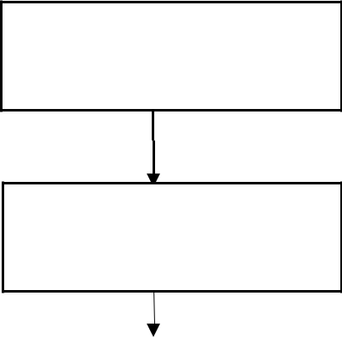

MANAGING DIRECTOR

GENERAL MANAGER
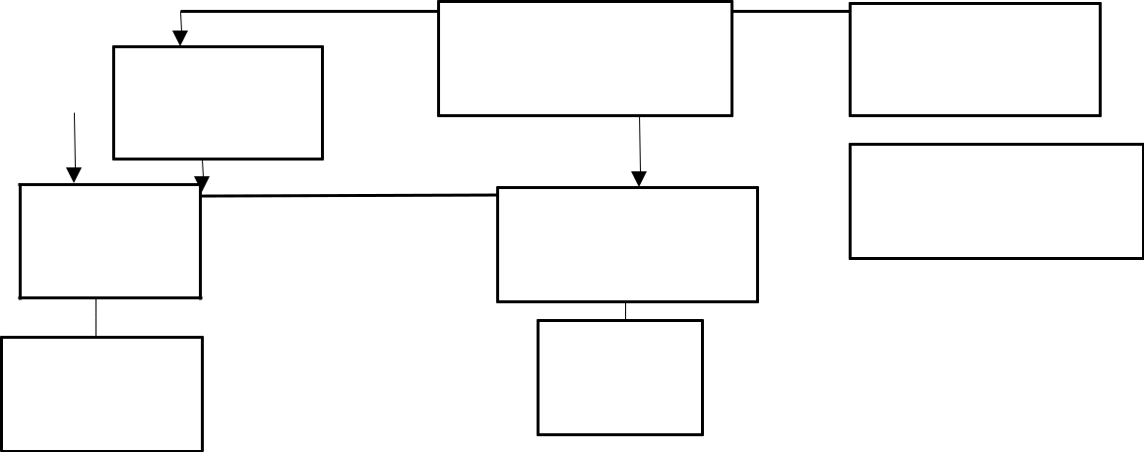

SALES MANAGER

PRODUCTION

MANAGER

BAKERY | DRIVER

TECHNICIAS

ACCOUNTANT

CASHIER

BAKER

SALES

2.2 UNITS IN THE ESTABLISHMENT

lOMoARcPSD|53701657

There are different units in the establishment which include

WEIGHING UNIT: this is an extension of the store unit where the weighing process are done.

MIXING UNIT: this is a production section, the equipment are of mechanical mixer and a mixing bowl for mixing all ingredients.

KNEADING UNIT: this is also a production section, whereby the mixed dough are milled

MOULDING UNIT: here the dough is scale into different size and mould.

PANNING AND PROOFING UNIT: these consist of a large space where creamed dough is being apply to the baking pan and expose to proofing.

BAKING UNIT: A section that is equipped with one of the best oven that is recommended by NAFDAC.

SHELF DRESSING, SLICING AND PACKAGING UNIT: Duster, dressing, knife, twist, nylon, slicer and shelves with which bread is properly arranged before distribution are placed here Deformed bread is also rejected here.

MARKETING DISTRIBUTION UNIT: this is a place where package bread are sold to the wholesaler retailer and final consumer

2.3 PROCEDURE FOR PRODUCTION OF BREAD

The following are the procedure for production of bread;

- The weighed flour was poured into the mixing machine

- The weighed ingredient (sugar, salt, yeast, preservatives.) where poured into the flour.

- The ingredients were mixed together with the mixing machine to form dough

- The dough was then placed on the milling machine.

MoARcPSD|53701657

- It was rolled and mixed properly. (During milling, little butter and flour was added to it.)

- The dough were sliced and weighed and kept on the table to be rolled.

- After rolling, it will be creamed and then placed into the pan and left to improve for some minutes or even hours depending on the weather and season sometimes.

- After the yeast proving. It was placed in the oven at 200ºc (temperature of the oven) and left for few minutes.

- After baking, it was allowed to cool and then packaged inside each nylon according to their size.

lOMoARcPSD|53701657

CHAPTER THREE

3.0 MAJOR ACTIVITIES DURING SIWES

The major activities during the SIWES program are majorly on the production of bread. Bread is the final product of dough. The equipment used in bread production are Listed below:

Mixing Bowl

Kneading machine Divider/Knife

Molding Machine Oven and Paddle Slicing Machine Baking pan

Scale

3.1.1 MIXING BOWL

This is a bowl used in mixing of ingredient before kneading or milling. The mixing machine makes use of electricity for it operation while the bowl is protected against rusting through anti-corrosive paint in order to avoid contamination during mixing. The mixing bowl is operated manually by hand and is used only in the absence of the mixing machine, because mixing machine makes work faster and easier.

3.1.2 KNEADING MACHINE

Kneading machine is a equipment used to smoothen a rough dough. The machine is of two parts which are the miller / kneader and a motor engine which produce the driving force. Between these two is a belt, joining then together that makes it to be able to

lOMoARcPSD|53701657

achieve its function. Careful attention is taken when operating the machine, because it is the most dangerous of all and its require an expert for operation

3.1.3 DIVIDER/KNIFE

This machine is very sample and faster. it divides the dough into same size as require. Large dough is cut, weighed and spread into the divider plate.

3.1.4 MOULDING MACHINE OR HAND

This is a machine used for folding dough into the require for form

3.1.5 OVEN AND PADDLE

Oven is an equipment that provide the thermal energy needed for the baking of bread. There are different types of oven base on the material with which it is made of Earth oven, ceramic oven, metal oven, etc and there are many other ovens that are equipped with computer applications, thermostat, thermometer etc. It enables it to perform more functions. The thermometer helps to detect the temperature of the oven. Paddle is the tool that is used in loading and offloading an oven

3.1.6 SLICING MACHINE

This is a machine used in slicing of bread after baking. The machine used electric current in its operation.

3.1.7 BAKING PAN

Moulded dough are put into the baking pan for proofing, and later loaded into the oven. The shape and size determine the shape of the bread.

3.1.8 SCALE

The scale is used in weighing of ingredient before mixing. It is also used after milling to get the accurate measurement of the dough.

lOMoARcPSD|53701657

3.2 INGREDIENTS USED AND THEIR FUNCTION

The various raw materials used for bread production are:

- Flour

2 Yeast

3 Salt

4 Sugar

5 Butter

6 Water

7 Improve

8 Enzyme dough conditioner

9 Preservative

FLOUR:This is the main ingredient used in production of bread, flour is a powdering substance which is been obtained from wheat (which is the most common), cassava, corn etc it has various brand name: like golden penny product,Dangoteflouretc the net weight of a bag of flour is 50kg

YEAST: This ingredient brings about fermentation which causes the dough to rise. It is natural yeast. Its biological name is Saccharomyces cerevisiae.Thisis applied to the dough during mixing of ingredient; the amount of yeast needed for bread production depends on the weather and season

SALT: its main function is the addtaste to the production although bread at times can be baked without salt but it will not be good as the product that has it. Industrial salt are used in baking, its chemical name is sodium chloride (Nacl).

SUGAR: This is one of the important ingredient used in bread production, its react with heat in the oven during baking produce a brownish colour at the crust of the bread, such reaction is known as criminalisationreaction.It helps infermentation it also aid taste of the product.

BUTTER: It is used during various stage of bread production. Duringthe mixing stage it is added as an ingredient and is also added during milling to ensure a smooth operation

lOMoARcPSD|53701657

while using the milling machine. Butteris added to the moulded dough and also in the inner part of the baking pan.

WATER: Water hydrates the yeast and the flour. It dissolved the sugar and the salt. The full stop amount of water in dough depends on how much water the flour can absorb. IMPROVAL: This is the ingredient added to bread during mixing period its function are:

To Increase water absorption.

To Reduction of dough stickiness.

To simplify the work of the baker

ENZYME DOUGH CONDITIONAL (EDC): It helps in speeding up of the reaction of the yeast with dough. It is a liquid ingredient used in warm water.

- it improves dough yield and increase loaf count

- it helps in the improvement of gas oxidation in dough

- it strengthens all dough and prevents it from falling

- it strength the gluten structure of bread

PRESERVATIVE: This is an additive that helps in preserving the bread after baking. It increase it life span for about seven (7) days

3.3 BASIC PROCESSES IN BREAD PRODUCTION

In order to get a good product, these processes have to be followed.

3.3.1 WEIGHING OF RAW MATERIAL

The entire raw ingredients to be used for production are to be measure in order to get accurate weight of the product. Raw material weighed accurately will give good Palatability, nutritious and presentable product.

Below are the weights of ingredient used for a bag of flour

lOMoARcPSD|53701657


S/N | INGREDIENT | WEIGHT
1 | A bag of flour | 50kg
2 | Yeast | This depend on temperature of the
 |  | environment
3 | Butter | __________
4 | Improver | 150g
5 | Salt | 400g
6 | Sugar | 5kg
7 | EDC | 100g
8 | Water | 15litre
9 | Preservative | 200g

The apparatus used in weighing is the weighing balance or scale which may be digital or analog and may be graduated in kilogram or in gram.

3.3.2 MIXING OPERATION

This is the second stage in bread production. It is a process in which the whole ingredient are mixing together. The solid material are first mixed together for about 7-10mins before the liquid ingredient which would have been mixed in a bowl will be added later, the ingredient may be mixed by hand using mixing bowl, but for higher productivity the mixing machine or mixer is used.

3.3.3 KNEADING / MILLING OPERATION

This process is done after mixing. The more the dough is mixed, the less kneading it requires and vice versa. The gluten is developed by kneading of the dough, also co₂ are evolve In kneading the dough, the dough is flattened with heel of the hand and folded over with the other hand. If the dough is soft as it should be, it is easy to knead, if the contain much flour, it becomes stiff and hard to fold, butter is added during kneading to enable a smooth operation.

3.3.4 CUTTING, WEIGHING AND DIVIDING OPERATIOND|53701657

After kneading, the smooth dough would to be divided depending on the size of the bread require. The dough is cut, weighed on a scale, at times a divider is used.T here are various size of bread;

i Large

- Medium

- Short long

- Small

The material or instrument used are; knife, scale, pan and divider

3.3.5 MOULDING OPERATION

After cutting, weighing and dividing moulding is done. These take place in same section.Moulding give shape to bread. The dough is pressed to allow air to escape, it is then folded from the side to form a rectangular shape, after which it is folded toward the front side and pressed firmly to seat, it is folded again and rotated to the desired shape. Moulding of dough can also be used by the aid of molding machine.

3.3.6 CREAMING OPERATION

This is the process whereby a mixture of butter, groundnut oil and some other liquid ingredient are being rubbed on a moulded dough purposely to have a good texture flavor and removal of bread easily from baking pan after baking.

3.3.7 PANNING OPERATION

An aluminum pan is used for baking because it is a good conductor of heat, the pan has to be cleaned by removing all dirt. The cream dough are carry into a pan and cover

‘Cap it up’cover are mainly used for the bread not to over rise during baking.

3.3.8 PROOFING
ARcPSD|53701657

After panning proofing takes place when the dough rise after it has been left in a dry place for some time due to the action of some enzymes with Co₂gas.These enzymes are known as starch enzymes convert maltose to glucose and finally convert glucose to ethanol.

Below is Fermentation that occurs during proofing in bread production.

2C₆ H₁₂ O₆ + yeast 2C₂ H₅ OH + 2CO₂

3.3.9 BAKING

Baking is an essential process in bread production. It is the process by which proofed bread is exposed to heat. The heat is supplied by an oven. An oven is thermally insulated chamber used for the heating, baking of a substance are commonly used for cooking. There are varieties of oven based on the materials which is made of Earth oven, ceramic oven, concrete oven, metal oven, etc and the fuel with which it operates, gas, coal, electricity, etc Oven also varies based on how it is controlled, modern ovens are equipped with thermostat which switches it On/Offat a particular temperature and some switching On/Off when the bread is baked to a desired degree or by considering the moisture content. The pans are set into the oven with a paddle to arrange then accordingly.

D|53701657
3.4 FLOW CHART OF BREAD PRODUCTION

RAW MATERIALS

WEIGHTING

MIXING

MILLING

CUTTING

SCALING

MOULDING

CREAMING

PLANNING

PROOFING

BAKING

COLLECTING

COOLING

PACKAGING

BREAD

CHAPTER FOUR

D|53701657

4.0 KNOWLEDGE GAINED DURING SIWES PERIOD

During my SIWES at Kodun Kopo Kope, I gained more knowledge that have enlighten me in the field of food science and technology. It has also been a source of practical knowledge to establish or work in a bakery industry. I have been exposed to several machines and equipments that I have not been able to operate before. With the support of my industrial based supervisor and some other workers, all process involved in the production of bread are now easier to me to carry out. The SIWES have exposed me to the field of entrepreneurship.

CHAPTER FIVE

lOMoARcPSD|53701657

5.0 CONCLUSION AND RECOMMENDATION

5.1 CONCLUSION

The SIWES programme undergo at SWISS Bread, afforded me in depth exposure to all processes involved in the production of bread. The programme has been highly enlightening, beneficial, interesting and also as job opportunity. The objective of which the scheme was set was however undergone and achieved.

5.2 RECOMMENDATION

Having completed the four months industrial training, I realized that it is beneficial for all students to undergo such training to assist them acquire needed practical knowledge which will guide them to working or establishing an industry.

So I recommend that the following under listed parts should be implemented,

- There should be a proper supervision of the student concerned by both ITF officials and the institute based supervisors.

- Sending students specifically to establishment where the stipulated aims and objectives of SIWES would be achieved.

- Payment of befitting students allowance to assist in student’s finances during the period of training.

REFERENCES

Ahukannah .L.I (2002). Office practice today: Owerri: polytechnic publishers Ltd

Enakali.C.O (2008). Industrial Training Manual: Kogi: CHAND & Company Ltd

Rufus Giwa Polytechnic (2015).Student Industrial Work ExperienceScheme: OwoUnix Publishers.

16

