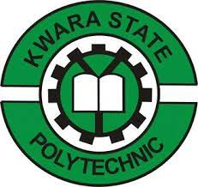

A TECHNICAL REPORT
ON
STUDENT INDUSTRIAL WORK EXPERIENCE SCHEME
(SIWES)

HELD AT
KWARA STATE TELEVISION AUTHORITY
APATA YAKUBA ILORIN KWARA STATE
BY
AYORINDE CHRISTIANAH AYOBAMI
ND/23/MAC/PT/0091

SUBMITTED TO:
THE DEPARTMENT OF MASS COMMUNICATION
(INSTITUTE OF TECHNOLOGY) KWARA STATE POLYTECHNIC
IN PARTIAL FULFILMENT OF THE REQUIREMENT FOR THE AWARD OF NATIONAL DIPLOMA (ND) IN MASS COMMUNICATION

AUGUST - DECEMBER 2024
PREFACE
The student industrial work experience scheme (SIWES) helps in exposing students to the practical application of their course and to get used to equipment and machines used in the factory. The SIWES was established to promote student skills in industrial practice and pre-expose them to working experience in industrial setting.
The SIWES program covered a period of four months from August to December 2024 and it is a partial fulfilment of a two years academic program to obtain an OND certification in Engineering. The report explains the description of the work done.

DEDICATION
I dedicate this report first and foremost to Almighty God who has been their right from the beginning to this very point. Special dedication also to my ever supportive parents, for their relentless support and compassion towards me during the course of my three months SIWES training.
ACKNOWLEDGEMENTS
I thank God Almighty for the glory, honor, adoration and mercy I received during the course of my study and when undergoing my industrial training.
My appreciation also goes to my industrial based lecturer, whose accessibility, untiring effort, patients and guidance and suggestions fabulously contribution to the completion of this report, may God continue to guide and protect her and her family.
Mostly, my application goes to the director of administration, for accepting me into the organisation and support, may God Almighty be with him and his household.

TABLE OF CONTENT
Title Page
Preface
Dedication
Acknowledgement
Chapter One
1.0 Introduction/Meaning Of Siwes
1.1 Brief History Of Siwes
1.2 Aims And Objectives Of Siwes
Chapter Two
2.0 History Of The Organization
2.1 Organogram Of The Organization
2.2 Various Departments And Their Function
2.3 Instrument In The Studio
2.4 Vision And Mission Of The Organization
Chapter Three
3.0 Experience Acquired
3.1 Work Done

Chapter Four
4.0 Executive Summary
Chapter Five
5.0 Challenges
5.1 Encountered
5.2 Recommendation
5.3 Conclusion

CHAPTER ONE
1.1. INTRODUCTION/MEANING OF SIWES
The Students' Industrial Work Experience Scheme (SIWES) was founded to be a skill training program to help expose and prepare students of universities, Polytechnics and colleges of education for the industrial work situation to be met after graduation. The Scheme affords Students the opportunity of familiarizing and exposing themselves handling equipment and machinery that are usually not available in their institutions
Before the establishment of the Scheme, there was a growing concern that graduates of our Institutions of higher learning lacked adequate practical knowledge and that the theoretical education in Higher Institutions was not responsive to the needs of the Employers ‘of Labour.

1.2. BRIEF HISTORY OF SIWES
SIWES was founded in 1973 by ITF (Industrial Training Funds) to address the problem of tertiary institution graduates' lack of appropriate skills for employment in Nigerian industries.
The ITF (Industrial Training Fund) organization decided to aid all interested Nigerian students and created the SIWES program. The federal government officially approved and presented it in 1974. During its early years, the scheme was entirely supported by the ITF, but as the financial commitment became too much for the fund, it withdrew in 1978. The National Universities Commission (NUC) and the National Board for Technical Education (NBTE) were given control of the scheme by the federal government in 1979. The federal government handed over supervision and implementation of the scheme to ITF in November 1984. It was taken over by the Industrial Training Fund (ITF) in July 1985, with the federal government bearing entire responsibility for funding.

1.3. AIMS/OBJECTIVES OF SIWES
The Industrial Training Fund’s Policy Document No. 1 of 1973 which established SIWES outlined the objectives of the scheme as:
- Provide an avenue for students in Institutions of higher learning to acquire
industrial skills and experience in their respective courses of study.
- Prepare students for the Industrial Work situation they are likely to experience
after graduation.
- Expose students to work methods and techniques of handling equipment and
machinery that may not be available in their
Institutions.
- Make the transition from school to the world of work easier; and enhance
students’ networks for later job placements.
- Provide students with an opportunity to apply their knowledge to real work
situations, thereby bridging the gap between theory and practice; and
- Enlist and strengthen Employers’ involvement in the entire educational
process; thereby preparing the students for employment in Industry and Commerce.

CHAPTER TWO

2.1 History of the Organization
Kwara State Television Authority, is a specialized arm of the NTA charged with the responsibility to:” Promote Learning” for the children and youths on television by applying formal and non-formal methods with the objective to aid and identify excellence.
What began as Development Communication Pilot Project (DCPP) was a World Bank assisted project which was co-financed through counterpart funding by the Federal Government of Nigeria. The project was directly supervised by the World Bank with the Federal Government. Kwara TV Kwara was officially commissioned by His Excellency.
The Centre was established to produce entertainment based Educational Programmes both formal and non-formal and instructional materials.
Kwara TV has five outstanding programmes showing on the Network Service of NTA.
Below are the lists of our Programmes:
• Fun Bus | - 5:00pm (Monday)
• Our History | - 10:30pm (Monday)
• Work It Out | - 5:00pm (Wednesday)
• Take A Step | - 5:30pm (Wednesday)
• Lens- 3:30pm (Thursday)
FUN BUS is an educational based entertainment programme aimed at developing talents in children and gives them an ability to learn in an informal environment.
OUR HISTORY is a public enlightenment Television Programme intended to re-awaken the importance of history in our society and make the study of History more interesting with visuals, illustrations and graphics. We will study Africa history and culture in the programme.
Work It Out: This is a 25 minutes programme and largest running mathematics quiz programme that has been on the Network service of NTA since 2002. It is a mathematics quiz programme for students in the junior secondary school classes. Work It Out is designed to test the aptitude and ability of students in mathematics.
Take A Step: This is a general quiz programme covering subject such as English,
Mathematics, Biology and Economics leading to the Senior School Certificate Examination. In addition, students are exposed to answering questions on professions and vocations as a means of counseling and introducing them to making informed choices of life careers
LENS is a magazine programme that is created to showcase and celebrate creative professionals in Fashion, Photography and Music. It will look into various topical interests among the professionals. In addition, Lens will review various aspects of Fashion. Photography, Music and people. Basically, Lens will give an expose into Fashion, Photography, Music and Reviews; these are the major areas of this 30 minutes magazine show that will enlighten and entertain Negative views about the African man, taking Nigeria as an exclusive example.
The Centre also embarked on projects to facilitate the teaching of Science and
Technology in Secondary Schools by organizing an annual event tagged “Kwara TV
EXPO” The EXPO provides a forum for discovering and identifying new talents in Arts, Science and Technology as well as promoting national unity and social integration amongst the children.
The station Its usual way celebrates children annually by organizing the Children’s Day and Christmas parties.
Kwara TV is a top rank television production Centre.
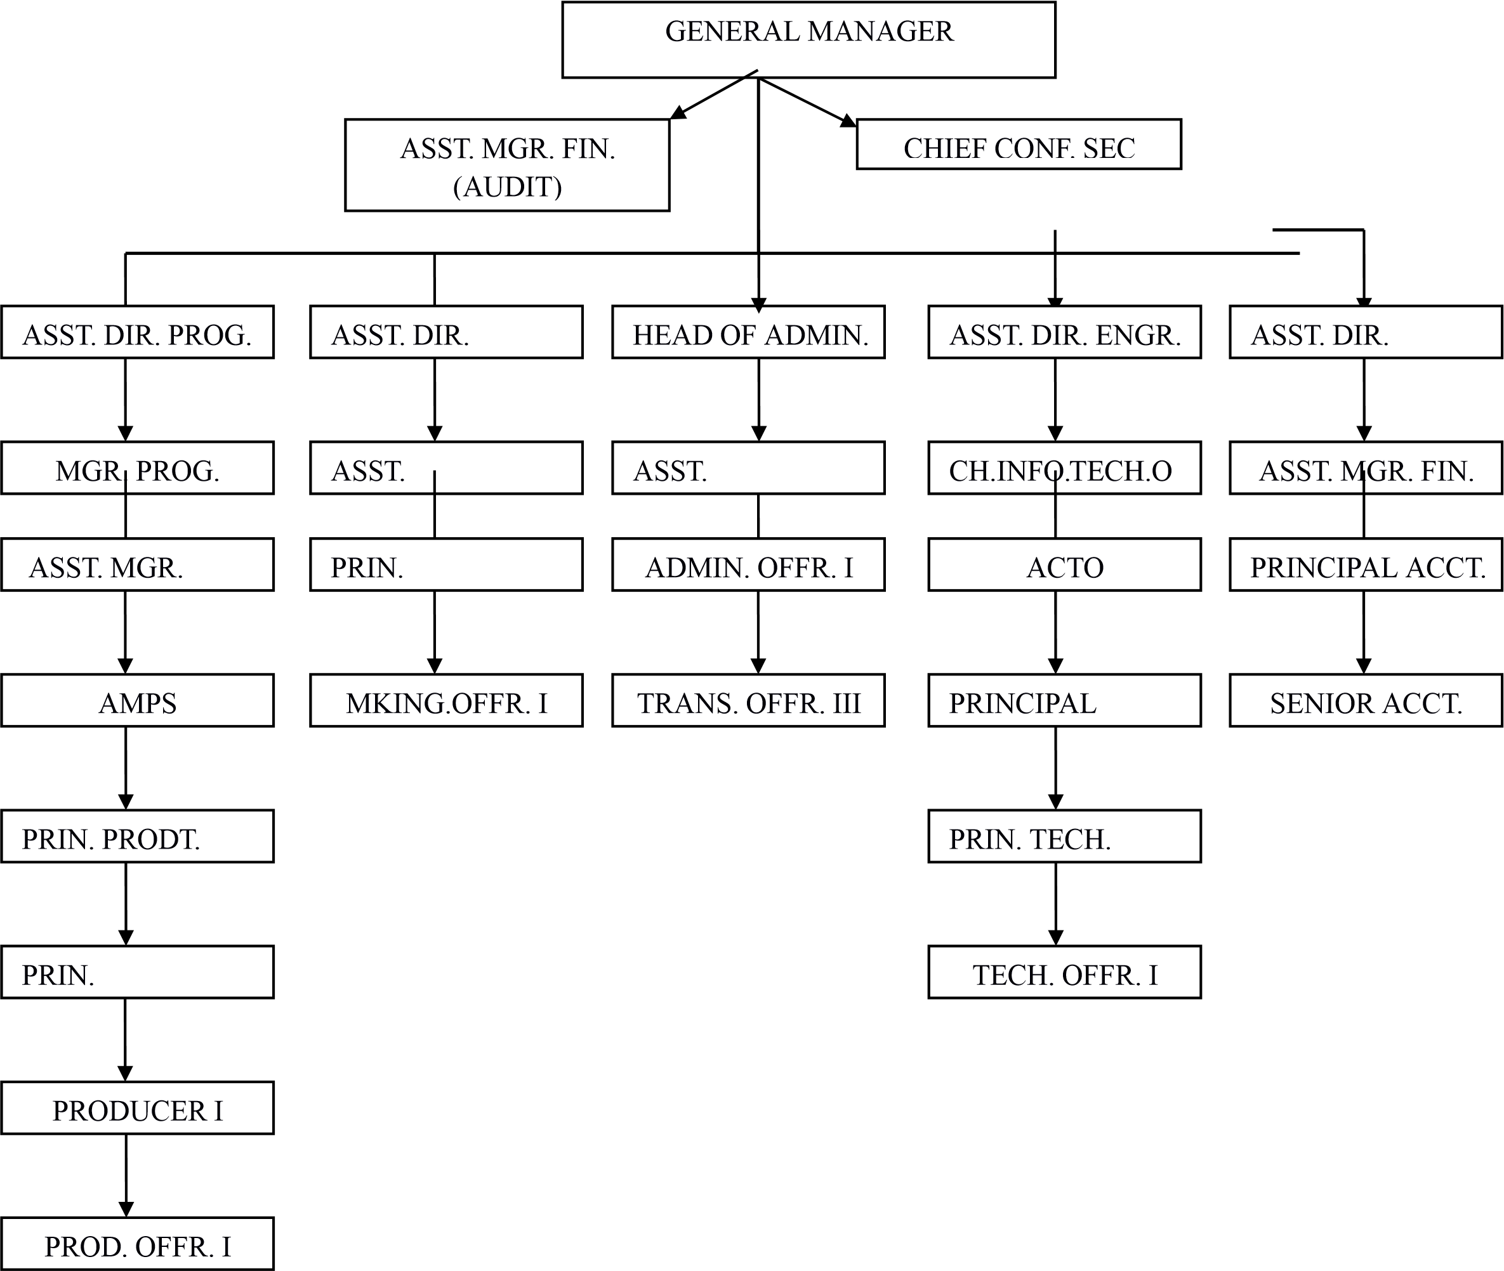
2.2 ORGANOGRAM OF THE ORGANIZATION

2.3 VARIOUS DEPARTMENTS AND THEIR FUNCTIONS
Administration Department
Safety and security management: Overseeing the security and safety of staff and the entire premises ensuring productivity and effective performance within the Organization Maintenance and management of all office facilities providing office stationary and other materials or items used to drive efficient outcome providing staff welfare, healthy and Conducive environment transport management and maintenance.
Maintenance of file Registry: personal, confidential and subject files
Ensuring disciplinary procedures and other matters relating to staff discipline
Programmes Department Production of Educational and Entertainment programmes
Monitoring and managing the desired quality of output needed during and after production processes Script writing and content development and ideals for ETV programmes Overseeing matters relating to school excursion Research, fact finding, data collection, information processing and educative perspective about a subject matter to be carefully considered before it’s used for production maintaining positive relationships with schools participating in Kwara TV programmes
Finance
Financial planning
Financial resources allocation
Bank Reconciliation
Regular File Registry maintenance of all financial transactions done or carried out over a period of time (personal and subject files)
Monthly financial report sent to Headquarters
Marketing Department
Sourcing for sponsorship of events and ETV programmes
Overseeing matters relating to school excursion in terms of sorting out interested school maintaining present relationships and looking for new clients
Managing and creating the Organization’s image sorting out for schools to participate in ETV programmes Maintaining positive relationships with schools participating in
Kwara TV programmes.
Engineering Department
Maintenance repairs and servicing of all office equipments and appliances
Operating and configuration of various equipment/devices/systems used in production of programmes and other office activities.
Maintaining records of daily usage of various devices/equipment
Monitoring the consumption of power used (electricity or generator)
Maintaining and controlling the quality of output during production processes
Installation of Lighting, sound and other relevant equipment used in the studio for production and other events
Store keeping of all office items stationaries, other items and handling of all spare keys.
2.4 INSTRUMENT IN THE STUDIO
●VIDEO CAMERAS
●REDHEAD LIGHT
●MICROPHONE
●HEADPHONE
●PROFESSIONAL TRIPOD
●A COMPUTER
● DIGITAL BETA CAM
●VIDEO MIXER
●VIDEO TAPE RECORDER
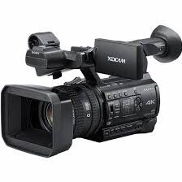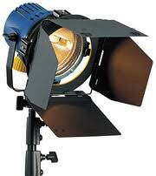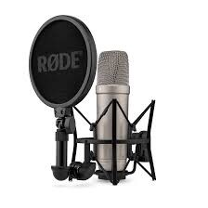
VIDEO CAMERA REDHEAD LIGHT MICROPHONE
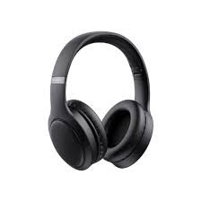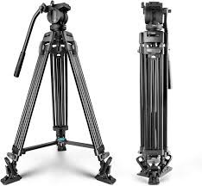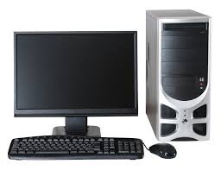
HEAD PHONE PROFESSIONAL TRIPOD COMPUTER
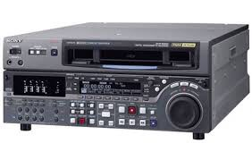
DIGITAL BETA CAM
2.5 Vision and Mission of the Organization
Vision
To be a world-class television network
Mission
To provide excellent television services worldwide and project the true African perspectives
Objective
To influence, promote, sustain and improve Nigerian’s positive societal values through social, cultural, economic, political and technological programmes and to preserve Nigerian culture and promote cultural and political awareness in the country and beyond.

CHAPTER THREE

3.1. Experience Acquired
My experience at Kwara TV, was a productive and wonderful experience. I can say that the Four months program was a great help cause studying Mass communication without practical could be regarded as a waste of time without having any experience in the field of mass communication.
I was opportune to learn how to edit on Adobe premiere, photoshop, how to write a report on a program transmitted, how to set up a camera, red head light, microphone, how to interview, how to make a jingle and voice over.
3.2. WORK DONE
My first day at Kwara TV, An introduction was made between the New IT Students to the staffs and Management of the Organization. Also a short tour around the TV Station.
In my First week of resumption, I practicalised on making a puzzle game on cardboard for a children program. I also learnt about the Software ( Adobe Premiere Proc) use for editing Videos and also how to use Microsoft word.
Second week, we had a. Training at the Tv Station for the IT and staffs with the theme Adminstrative Procedure” by the General Manager of the Tv station. It was really educative.
After the training I went to the Editing room to practice editing, I was asked to edit a clip after observing the Editor for some hours and I did a great job on my first editing.
Third week, I continued practicing editing with Adobe premiere proc.
Fourth Week, A video Production for a popular show on Kwara TV “Weekend
Deals” I was opportune to be part of the Production, I was taught on how to set up A Red Head light, Tripod and also set a camera and test a white balancing. It was an interview with marriage counselor about celebrity marriages. The question asked by the interviewer was:
1. Why does celebrity marriage fail
- How does the opinion of the people affect their marriage
- How does fake life affects the celebrity marriage
- Keys to a successful marriage
Fifth week, I was asked to write a report on my experience for the video production.
Sixth week, We started working on editing the videos recorded from the interviews, I was assigned to search for celebrities photos and videos then copy it to hard drive so it will be used for editing.
Seventh week, My supervisor told me to add a sound and pictures with text on
Adobe premiere all by myself with out any help. So I added a Christmas sound ( Feliz-Navidad) and added several Christmas pictures . It was really fun editing it. I also learnt editing with Adobe Photoshop. Made a Christmas flier for the upcoming Kwara TV 2023 Christmas party.
Eighth week, I assisted the editor to compile previous videos of the children Christmas party for a new Christmas jingle to be edited. After editing the Christmas jingle then we added the jingle in all the programs for promotion.
Ninth week, Kwara TV celebrated its 22nd year of existence. So we had a small party with the staffs and management. The event was covered to be packaged for a two minutes news report send for transmission to the headquarters. So we interviewed the General manager of Kwara TV for a brief history of Kwara TV. Also interviewed the General Manager of NTA channel 10. The next day started working on editing the videos recorded from the event.
Tenth week, I assisted the editor with editing.

CHAPTER FOUR

4.1. EXECUTIVE SUMMARY
The Four Months Program(SIWES) was a great opportunity and also equipped me in merging what I learnt in lecture room to what I actually learnt during the program.
I got to know how a video camera is set up, how to place a Tripod, how to interview an expert, how to write a report, how to edit videos on Adobe Premiere, How to make a fluent and persuasive voiceover, how to capture rushes.
It was really a productive program.

CHAPTER FIVE

5.1. CHALLENGES ENCOUNTERED
At first I couldn’t edit the videos cause I had to type in questions on the screen for a quiz show. It was a bit hard cause one has to be smart and then be creative. It takes an expert in editing to do it.
5.2. RECOMMENDATIONS
This student Industrial Work Experience Scheme (SIWES) programme should be made compulsory and mandatory for all students. The student involved should be orient about benefit and essence of SIWES.
Student should be made aware of and get corrected that SIWES is not for money acquisition rather it is for knowledge, experience and practical exposure to his/her course of study for future benefits proper welfare of student should be catered for (in terms of treatment).

5.3. CONCLUSION
The Student Industrial Work Experience Scheme (SIWES) ended successfully, and as a student of Mass communication, I have learnt a lot and it has prepared me to work as A Journalist in any Tv station.
And I believed with what I have learnt I will be able to give the expected service in the field of Mass communication.
First and foremost I appreciate the effort of my supervisor at the Organization once again, I would also say. One of the objectives of SIWES stated earlier has a very good effect in my career as well.
The exposure under this scheme has really widened my horizon with wide exposure of experience in this field.

