

A REPORT ON STUDENT INDUSTRIAL WORK EXPERIENCE (SIWES) UNDER THE STUDENTS’ INDUSTRIAL WORK EXPERIENCE SCHEME

UNDERTAKEN @

AREA ONE VENTURES

LOCATED OKE OYI OJA, ILORIN

BY

OWOKONIRAN MUBARAK ADELEKE
ND/23/BAM/PT/0079

SUBMITTED TO

THE DEPARTMENT OF BUSINESS ADMINISTRATION,
INSTITUTE OF FINANCE AND MANAGEMENT STUDIES,
KWARA STATE POLYTECHNIC, ILORIN

IN PARTIAL FULFILMENT OF THE REQUIREMENT FOR THE AWARD OF NATIONAL DIPLOMA (ND) IN BUSINESS ADMINISTRATION

AUGUST – NOVERMBER 2024

PREFACE
The writing of this SIWES report is manufacture by the school authority that before attaining the certificate of National Diploma (ND) in Mass Communication. Each student must undergo the three (3) months SIWES programme.
The SIWES record therefore contains the work done within the three months.

TABLE OF CONTENTS
Title page
Preface
Table of contents
CHAPTER ONE
1.1 Introduction
1.2 Brief History of SIWES
1.3 Aims and Objectives of SIWES
CHAPTER TWO
2.1 Brief history of the Organization
2.2 Organizational chart of the company
2.3 Various Department and their functions
2.4 Vision and Mission of the Organization
CHAPTER THREE
3.1 Experience Acquired
3.2 Work Done
CHAPTER FOUR
3.1 Executive Summary
CHAPTER FIVE
5.1 Problem Encountered during the Attachment and Solution
5.2 Conclusion
5.3 Recommendations

CHAPTER ONE
1.1 INTRODUCTION
Student Industrial Work Experience (SIWES) is a three months programme setup by the federal government for professional student in Mass Communication and other elected courses which is controlled, in which the headquarter is in Kaduna State in affiliation with Industrial Training Fund (ITF) at Jos.
However, the government introduced the programme in other to assist students to be familiar with the practical aspect of their profession i.e. Mass Communication.
Student Industrial Work Experience (SIWES) is a programme setup by National Board of Technical Board (NABTEB) for its practical improvement of mass communication. The programme is setup during the period of three months which is corresponding with a body known as Industrial Training Fund (ITF).

1.2 BRIEF HISTORY OF SIWES
Prior to the establishment of the scheme, there was growing concern among our industrialists that graduates of our institutions of higher learning lacked adequate practical background studies preparatory for employment in industries. Thus, the employers were of the opinion that theoretical education going on in higher institutions was not responsive to the need of the employers oflabour.
It is upon this background that the rationale for initiating and designing the scheme by the Industrial Training Fund, during its formative years- 1973/1974- was introduced to acquaint students with the skills of handling employers’ equipment andmachinery.
The ITF solely funded the scheme during its formative years. But as the financial involvement became unbearable to the fund, it withdrew from the scheme in1978. In 1979, the Federal Government handed the scheme over to both the National University Commission (NUC) and the National Board for Technical Education (NBTE). Later the Federal Government in November 1984, reverted the management and implementation of the SIWES programme to ITF and it was effectively taken over by the Industrial Training Fund in July 1985 with the funding being solely borne by the FederalGovernment.
1.3 AIMS AND OBJECTIVES OF THE PROGRAMME
The aims and objectives are as follows:
- To provide wide practical experience of the industrial Student in Various Studies.
- To give inspiration, commitment and dedication to the student
- To enlighten the student about various aspect of their course of study
- To hasten the level of understanding and studying since they had been exposed to practical aspect of their course.

CHAPTER TWO

2.0 INTRODUCTION

In Area one Ventures, I was able to identify the basic types of computers, the components of computers and their uses. Also, I was able to identify and differentiate between inputs and outputs devices as well as their uses. During this period, I was able to also acquire basic knowledge on how to connect a computer to the internet using a modem. Software and Hardware packages were also introduced to us and we were thought on the differences, similarities and how both of them work hand in hand to function or perform tasks. Finally, I was introduced to some office packages and was taught some packages such as: word processing, word presentation and excel spreadsheet.

2.1 DESCRIPTION OF AREA ONE VENTURES

Area one Ventures cybercafé was established in 2013 and it is a private organization owned by an individual.

It is located in Oke Oyi, in Ilorin East Local Government Area of Kwara State.

2.2 ORGANIZATIONAL STRUCTURE OF AREA ONE VENTURES CYBERCAFE
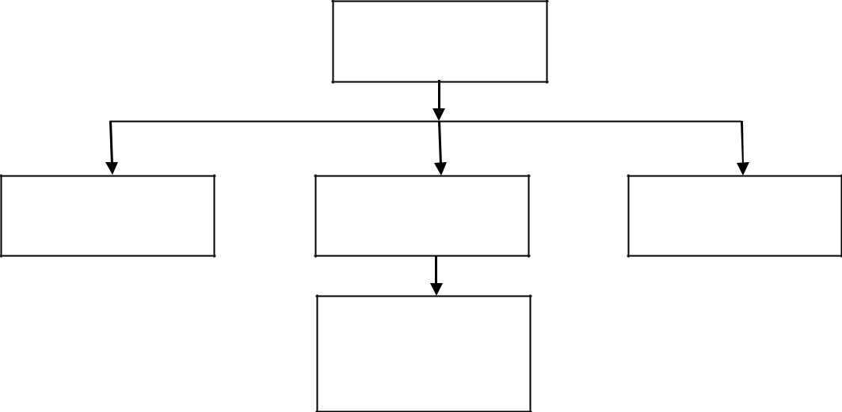

MANAGER

SALES

REPRESENTATIVE

ACCOUNT

MANAGER

I.T AND SIWES

STUDENTS AND

APRPENTICES

TRAINING OFFICER

Fig. 1.0 Organizational structure of Area one Ventures Cybercafé

3

CHAPTER THREE

3.0 SKILLS AND EXPERIENCE GAINED DURING THE TRAINING

I was assigned to printing and photocopy section where I was taught about Microsoft office suite

(Microsoft Word and Microsoft Power Point) then I was also taught how to print and photocopy

document.

3.1.0 PRINTING DEVICES

There are various printing devices, some of these are devices are categorized into laser jet, disc jet,

dot matrix printer and so on.

3.1.1 PRINTERS

Printing is the process of transferring digital information to a printing device which converts this information into raw facts in form of hard copy. The device which carries out a printing process is called a printer.
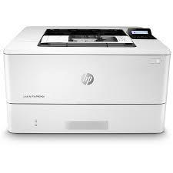

Figure 3.0 Laser Printer

4

3.1.3 Photocopying

Photocopying is the process of photographically reproducing a document of text, illustrations, or other graphic material. A photocopier is a machine that duplicates a document into many copies by combining scanning and printing technologies. It first scans the document and keeps the content a volatile memory then reproduces the document by sending the content in its memory back to the printing device. There are various types of photocopying machines and some are capable of scanning, printing, editing and duplicating documents.
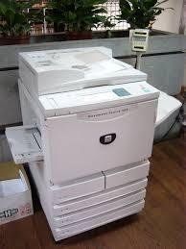

Figure 3.1 photocopier

3.2 MICROSOFT OFFICE SUITE

I was also introduced to Microsoft office suite where I was taught Microsoft word and Microsoft power point. Microsoft Office is the collective name for Microsoft's set of home and business productivity software. The MS suite of programs includes Microsoft Word, a word processing

tool; Microsoft Excel, a spreadsheet program; Microsoft PowerPoint, used for creating

5

interactive presentations; Microsoft Outlook, used for email and calendar management;

Microsoft Access, a database management program; and Microsoft OneNote, a note-taking

application.
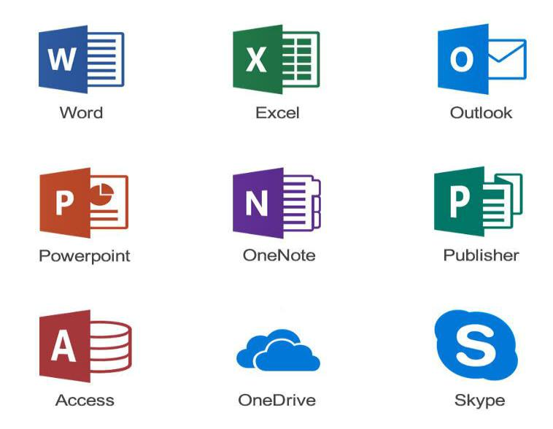

Fig. 3.3 Microsoft Office Suit

3.2.1 MICROSOFT WORD

Microsoft Word OR MS-WORD (technologically advanced by Microsoft) is a Graphical WORD processing program that users can type with. It is made by the computer company MICROSOFT. Its purpose is to allow users to type and save documents. Similar to other WORD processors, it has helpful tools to make documents.

6

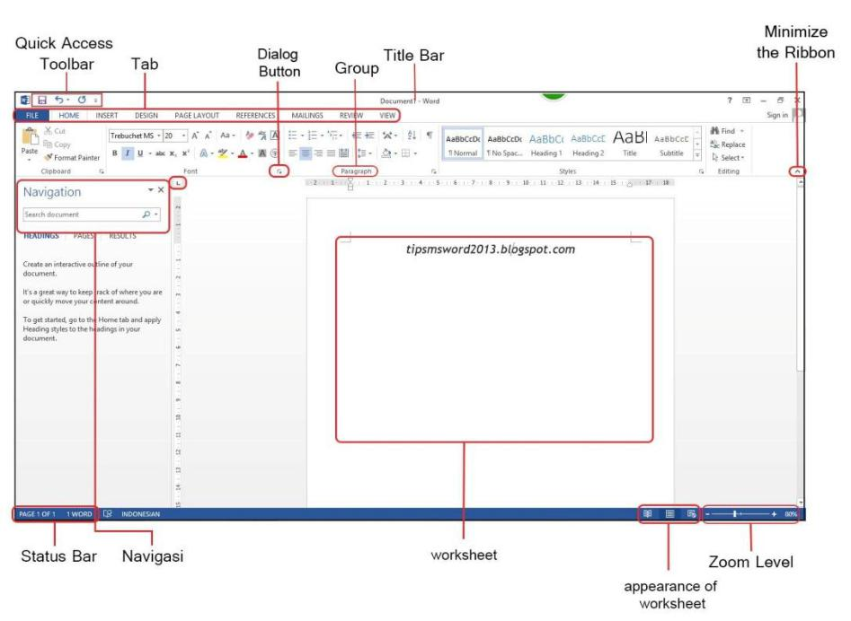

Figure 3.3 Microsoft Word 2013

3.2.2 MICROSOFT WORD WINDOW ELEMENTS

- Title bar

- Menu Bar

- Toolbars

- Status Bar

TITLE BAR

The title bar contains the name of the file or application. In many graphical user interfaces,

including the Macintosh and Microsoft Windows interfaces.

7

MENU BAR

The Menu bar lists File, Edit, View, Insert, Format, Tools, Table, Window, Help. Point with your

mouse to any of those words and then click your mouse button to display the particular menu.

STATUS BAR

The status bar is the area at the bottom of the word window that indicates information about the current document. It displays information about what page you are on, as well as your line number on the page and character number on the line

3.3 MICROSOFT POWER POINT

Microsoft PowerPoint is a powerful presentation tool developed by Microsoft. It is a standard component of the company's Microsoft Office suite software, and is bundled together with Word, Excel and other Office productivity tools. The program uses slides to convey information rich in multimedia.

3.1.1 ELEMENTS IN MICROSOFT POWERPOINT

There are five elements in Microsoft word PowerPoint which are listed below

- User Interface

The most visible element of PowerPoint is its user interface—the screens, dialog boxes, buttons, panes, and other parts of the application window. The biggest part of the interface is the pane for creating and editing slides.

- Slides

8

The slide is the PowerPoint element on which you insert text, graphics, audio,

video, and animations. You can create new slides by pressing “Ctrl-M” or by clicking “New Slide” on the Home tab.
- Content

PowerPoint's content types include static text and graphics, audio, video, and animation created inside PowerPoint itself. Most of the commands for creating content are on the Insert tab.

- Formatting

Formatting commands are the PowerPoint element with which you decorate the content on your slides.

- Presentation Playback

The final slide presentation will be the only PowerPoint element that your audience

sees, if you’ve saved the presentation with the extension PPSX.

9

CHAPTER FOUR

4.0 DEFINITION OF LOGICAL TERMS

MICROSOFT WORD

Microsoft Word or MS-WORD (technologically advanced by Microsoft) is a Graphical WORD processing program that users can type with. It is made by the computer company MICROSOFT. Its purpose is to allow users to type and save documents. Similar to other WORD processors, it has helpful tools to make documents.

MICROSOFT POWER POINT

Microsoft PowerPoint is powerful presentation software developed by Microsoft. It is a standard component of the company's Microsoft Office suite software, and is bundled together with Word, Excel and other Office productivity tools. The program uses slides to convey information rich in multimedia.

4.1 SHORTCUTS USED IN MICROSOFT WORD

 | SHORTCUT |  |  |  |  |  | DESCRIPTION
 | Ctrl+A |  |  |  |  |  | Select all contents of the page.
 | Ctrl+B |  |  |  |  |  | Bold highlighted selection.
 | Ctrl+C |  |  |  |  |  | Copy selected text.
 | Ctrl+D |  |  |  |  |  | Open the font preferences window.
 | Ctrl+E |  |  |  |  |  | Aligns the line or selected text to the center of the screen.
 | Ctrl+F |  |  |  |  |  | Open find box.

10

 | Ctrl+I |  |  |  |  |  |  |  |  |  | Italic highlighted selection.
 | Ctrl+J |  |  |  |  |  |  |  |  |  | Aligns the selected text or line to justify the screen.
 | Ctrl+K |  |  |  |  |  |  |  |  |  | Insert a hyperlink.
 | Ctrl+L |  |  |  |  |  |  |  |  |  | Aligns the line or selected text to the left of the screen.
 | Ctrl+M |  |  |  |  |  |  |  |  |  | Indent the paragraph.
 | Ctrl+N |  |  |  |  |  |  |  |  |  | Opens new, blank document window.
 | Ctrl+O |  |  |  |  |  |  |  |  |  | Opens the dialog box or page for selecting a file to open.
 | Ctrl+P |  |  |  |  |  |  |  |  |  | Open the print window.
 | Ctrl+R |  |  |  |  |  |  |  |  |  | Aligns the line or selected text to the right of the screen.
 | Ctrl+S |  |  |  |  |  |  |  |  |  | Save the open document. Like Shift+F12.
 | Ctrl+T |  |  |  |  |  |  |  |  |  | Create a hanging indent.
 | Ctrl+U |  |  |  |  |  |  |  |  |  | Underline the selected text.
 | Ctrl+V |  |  |  |  |  |  |  |  |  | Paste.
 | Ctrl+W |  |  |  |  |  |  |  |  |  | Close the currently open document.
 | Ctrl+X |  |  |  |  |  |  |  |  |  | Cut selected text.
 | Ctrl+Y |  |  |  |  |  |  |  |  |  | Redo the last action performed.
 | Ctrl+Z |  |  |  |  |  |  |  |  |  | Undo last action.

11

CHAPTER FIVE

5.0 SUMMARY, CONCLUSION AND RECOMMENDATION

5.1 SUMMARY

During my period at Area one Ventures Cybercafé as a SIWES student, I recorded some information materials for the company and I also did some activities such as: Microsoft Office suite (Microsoft Word and Microsoft PowerPoint). I was able to know some elements in Microsoft word and Microsoft PowerPoint.

5.2 RECOMMENDATION

Based on my experience during the industrial training I hereby recommend the following:

- The institution should assist in securing placement for students by liaising with established organization.

- The institution should improve coordination during the SIWES programme to help assess the quality of training under gone by the students.

- This kind of program should be conducted often to expose students to the working experience or condition of the broadcast industry.

- The student’s supervisor from the institution should try to visit the student regularly during the industrial training

- The student should endeavor to stop truancy towards work and improve their relationship with the employees and their co-workers to make out the best during the training program.

12

- Lastly I will also like recommend that this program should continue and future participants should develop more attitudes towards the program because it helps one develop more interest in his or her discipline.

5.3 CONCLUSION

In conclusion, there were many things that I have experience and learnt during this period. The whole training period was very interesting, instructive and challenging. Through this training, I was able to gain new insights and more comprehensive understanding about the real industry working condition and practice. It has also provided me the opportunities to develop and improve my soft and functional skills. All of this valuable experience and knowledge that I have gained were not only acquired through the direct involvement in task given but also through other aspect of the training such as work observation, interaction with colleagues, superior, and other people related to the field. From what I have undergone, I am very sure that the industrial training program

has achieved its entire primary objectives. It’s also the best way to prepare students to face the real working life. As a result of the program now I am more confident to build my future career which I have already started.

13

