
A REPORT ON COMPLETION OF STUDENT
INDUSTRIAL WORK EXPERIENCE SCHEME (S.I.W.E.S).

HEAD AT:
KWARA STATE BROADCASTING COOPERATION, ILORIN, KWARA STATE

PRESENTED BY:
ADEDAYO MARVELOUS GBEMISOLA
ND/23/MAC/PT/0798

A SIWES REPORT SUBMITTED TO DEPARTMENT OF MASS COMMUNICATION, INSTITUTE OF INFORMATION AND COMMUNICATION TECHNOLOGY, KWARA STATE POLYTECHNIC, ILORIN
IN PARTIAL FULFILMENT OF THE REQUIREMENTS FOR THE AWARD OF NATIONAL DIPLOMA (ND) IN THE DEPARTMENT OF MASS COMMUNICATION

MARCH, 2025

CERTIFICATION
This is to certify that ADEDAYO MARVELOUS GBEMISOLA with Matriculation number ND/23/MAC/PT/0798 of the Department of Mass Communication, Institute of Information and Communication Technology, Kwara State Polytechnic Ilorin, Kwara State, has successfully completed her four months Student Industrial Work Experience Scheme (SIWES) at Radio Kwara, Ilorin Kwara State.

ADEDAYO MARVELOUS GBEMISOLA
(Student) Signature/Date

DEDICATION
This work is foremost dedicated to Almighty God for His unquenchable love and gift of life during the pleasant course of my SIWES program, and my Parent MR. AND MRS. ADEDAYO for their financial support and unseasonal advice toward my academic pursuit.

ACKNOWLEDGEMENTS
With an immense gratitude, I want to acknowledge the Almighty God (most superior) for His continuous love, grace and faithfulness, and his providence throughout the period of my SIWES programme. I want to acknowledge the effectual effort of the Radio Kwara, Ilorin for their amicable discharge of their duties.
I also acknowledge all the industrial base supervisor MR. JOSEPH ALABI for his cordial tutorship of all I need to know about the administration.
I say thank you to you all for the opportunity and privilege granted to me to serve under your amicable organization.

ABSTRACT
This report holds a review of the Student Industrial Work Experience Scheme (S.I.W.E.S), at the Radio Kwara, Ilorin. The nature of this report spans the duration and findings during the program, including duties of an administrative office in the Secret Registry, daily activities and procedures through which files are received, record and documentation.

CHAPTER ONE

1.0 Introduction
1.1 Background
The Industrial Training fund established by decree 43 was introduced in 1971, vis-à-vis the birth of the Students Industrial Work Experience Scheme (SIWES) the same year by the Federal Government of Nigeria (FGN). It is against this background that the industrial training fund (ITF) initiated, designed and introduced SIWES Scheme in 1973 to acquaint students with the skills of handling employers’ equipment and machinery.
The Industrial Training Fund (ITF) solely funded the scheme during its formative years. However, due to financial constraints, the fund withdrew from the scheme in 1978. The Federal Government, noting the significance of the skills training, handed the management of the scheme to both the National Universities Commission (NUC), and the National Board for Technical Education (NBTE) in 1979. The management and implementation of the scheme was however, reverted to the ITF by the Federal Government in November, 1984 and the administration was effectively taken over by the industrial training fund in July 1985, with the funding solely boned by the Federal Government. It is an integral part of the requirements for the award of Certificates, Diplomas and Degrees in institutions of higher learning, e.g. Colleges of Education, Polytechnics, Universities, etc.
Student Industrial Work Experience Scheme (SIWES) exposes students to industry based skills necessary for a smooth transition from the classroom to work environments. It accords students of tertiary institutions the opportunity of being familiarized, exposed, and prepare students of universities, polytechnics, college of technology, college of agricultures and college of education for the industrial work situation they are likely to meet after graduation and to the needed experience in handling machinery and equipment which are not found in such an educational institution.
1.2 Objectives of SIWES
- To provide students with relevant practical experience.
- To satisfy accreditation requirements set by the Nigerian Universities Commission (NUC).
- To familiarize students with typical environments in which they are likely to function professionally after graduation.
- To provide student an opportunity to see the real world of their discipline and consequently bridge the gap between the University work and actual practice.
- To change the orientation of students towards labour market when seeking for job.
- To help students access area of interest and suitability for their chosen profession.
- To enhance students, contact for future employment
- To provide access to equipment and other facilities that would not normally be available in the University workshop
- To enlist and enhance industry involvement in university education.
- Summarily the objective of the Student Industrial Work Experience Scheme.
- To solve, the problem of inadequate practical skills, preparatory for employment in industries by Nigerian graduates of tertiary institution.
- To promote and encourage the acquisition of skills in industry and commerce, with a view of generating a pool of indigenous trained manpower sufficient to meet the needs of the economy.

CHAPTER TWO

2.0 DESCRIPTION OF THE ESTABLISHMENT OF ATTACHMENT
2.1 Location and Brief History of Establishment
Ilorin was the first location in Kwara State where broadcasting services were provided by the Kwara State Broadcasting Corporation (also known as “Radio Kwara”). These services began in 1956 as a relay station. In those days, people referred to it as the provincial broadcasting house.
The one quarter kilowatt (kW) medium wave transmitter that was employed at the time could only reach an area within an eight kilometer radius of Ilorin.
However, the Kwara State Broadcasting Corporation as it is now was not one of the beneficial byproducts of the first state to be created in Nigeria. It did not come into existence until the adoption of the Kwara Edict No. 3 of 1979, but it took effect back on April 10th, 1978.
Due to the state of Kwara’s topography, it was decided that it should be covered with both medium and shirt wave transmitters when it was created in 1967. This was part of a larger master plan that was developed and approved for the entire nation at the same time. This plan was based on the number and capacity of transmitters as well as the mode of transmission that were to be sited in each new state.
These facilities wave put into use is from 19th December, 1976; however, as a result of a directive from the federal government, the short wave transmitter was shut down in 1976. Instruction work began in 1974 in the modern studio/broadcasting house at the 10kw short wave and 20kw medium wave transmitting station sites. On April 1st, 1978, a decree was issued in camphene with the federal government that transfers all radio Nigeria stations on the state to their respective host states. On September 5, 1978, Mr. Horation Agedoti of Radio Corporation in Lagos reframed the formal handing over of the station by the NBA to the Kwara state government. At that time, all of the existing staff members were given the option of either continuing to work for corporation or moving on to work for Federal Radio Corporation. Those employees who made the decision to remain on staff were kept.
At the time of the takeover by the state government, the state already possessed a broadcasting house and a transmitting station that were located at their current locations. The two inherited ten kW transmitters were both very old; in fact, by the time the station was taken over in 1978, only one of the transmitters was functioning adequately.
The decree that transferred the federal radio station in Ilorin to the government of the state of Kwara in 1978 allowed the federal government to boost the transmitting capacity of Radio Kwara, which was a service of the Kwara state government. After then, the station emitted two medium-wave signals of 50 kilowatts each at Budo Eko. As a result of this turn of events, the state government gave its stamp of approval to a suggestion made by the corporation to build four imported 10 kW medium wave transmitters in the periphery area of what was then the state of Kwara in order to ensure adequate coverage. The Egba title was bestowed to two of them. One of them was located at Okike, close to Okene (both of which are now in Kogi State), and the other was located at Koro, in New Bussa (which is now in Nigeria Skew). Each of the three stations that had been reserved was eventually built and put into operation.
Despite the enormous progress, the transmitting stations at Bin Do Eko suffered a major setback in 1991 when the 840-foot tower mast was damaged by a lightning strike. This occurred despite the fact that the stations had made enormous achievements. When you take into consideration that the transmitting station had by that point become an essential component of radio kwara and a reliable ally in the fulfillment of its statutory obligation, this situation became a significant obstacle that needed to be addressed immediately.
Between the years 2000 and 2002, efforts were made to resurrect the station. As a result of these efforts, a new tower mast and a 50 kW thom cast transmitter were installed so that normal broadcast could resume. In spite of the efforts made by the administration of Alhaji Mohammed Lawal, there was still an insufficient amount of transmitter. On the other hand, the government of Dr. Bukola Saraki, who took office in May 2003 and immediately began renovating the station, awarded a contract for the provision of contemporary studio equipment and an additional 50Kw Harris transmission, bringing the total cost to nearly #300,000,000.
Due to this one-of-a-kind breakthrough, “Radio Kwara” has become not only one of the few radio stations in Nigeria with digital studios installed, but also one of the first stations in Nigeria to comply with the global directive in converting from analogue to digital broadcasting.
2.3 Departments/Units in the Establishment and their Functions
- Program Unit
A programme or project management office is a single, central support structure, designed to aid change and delivery initiatives within an organization. This applies particularly in an organization where there is a lot of ongoing programme and project activity. Without such a PMO, an organization is forced to replicate support arrangements over and over again as programmes and projects come and go.
- Marketing Unit
Promotes business and drives sales of its products or services in the media. It provides the necessary research to identify your target customers and other audiences. Depending on the company's hierarchical organization, a marketing director, manager or vice president of marketing might be at the helm.
- Technical Unit
The technical manager is a versatile position that requires sufficient managerial skills as well as sufficient technical skills. A technical manager should be able to perform all necessary tasks related to company systems including troubleshooting any technical issues.
- Admin Unit
Administration department is backbone of an organization. An effective administrator is an asset to an organization. He or she is the link between an organization's various departments and ensures the smooth flow of information from one part to the other.
- News and Current Affairs Unit
Current affairs are a genre of broadcast journalism. The news departments are responsible for putting down headline about current matters together.

CHAPTER THREE
3.0 WORK EXPERIENCE
3.1 Production of Scripts
The production and orientation are carried out in the programming unit during Mondays’ which include material which combine analog to digital. This production unit include all material use for recording and producing script needed in the mass media. The script include write-up that have being mechanized.
Type of Scripting
- Mechanized Scripting: This is written in the form of an essay which have introduction, body, conclusion, and signature. This include what to do, who should, how and when-link-dufftall-transaction-linking on insert to another place and emphasis on every program e.g. Supreme FM. 96.1 channel 1107, channel 492.1, etc.
Part of Mechanized Scripts
- Introduction
- Main body
- Conclusion
- Signature
3.1.1 Program Plan
- Program title (duration: 30minutes)
- Presentation of MUZHA KWEHA
- The Sky Presentation
- Music
3.2 Equipment’s used at FRCN
Equipment include:
- Reel to reel audio tape recording:
is a form of magnetic tape audio recording in which the recording medium is held on a reel, rather than being securely contained within a cassette. In use, the supply reel or feed reel containing the tape is mounted on a spindle; the end of the tape is manually pulled out of the reel, threaded through mechanical guides and a tape head assembly, and attached by friction to the hub of a second, initially empty take-up reel.
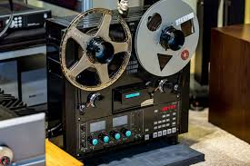

- Long grammar phone (Micro-Phone)
A microphone is a device that translates sound vibrations in the air into electronic signals or scribes them to a recording medium. Microphones enable many types of audio recording devices for purposes including communications of many kinds, as well as music and speech recording.

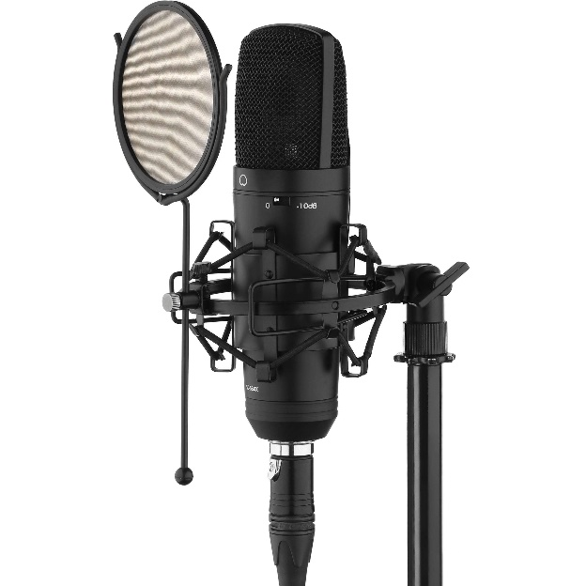

- Cassette (Tape)
The Compact Audio Cassette or Music-cassette, also commonly called the cassette tape or simply tape or cassette, is an analog magnetic tape-recording format for audio recording and playback

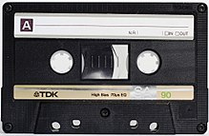

- CD

Compact disc (CD) is a digital optical disc data storage format that was co-developed by Philips and Sony and released in 1982. The format was originally developed to store and play only sound recordings (CD-DA) but was later adapted for storage of data (CD-ROM). Several other formats were further derived from these, including write-once audio and data storage (CD-R), rewritable media (CD-RW), Video Compact Disc (VCD), Super Video Compact Disc (SVCD), Photo CD, PictureCD, CD-i, and Enhanced Music CD.

- Deck to the Cassette
A cassette deck is a type of tape machine for playing and recording audio compact cassettes. Consumer electronics formerly used the term deck to distinguish them from a tape recorder, the "deck" being part of a stereo component system, while a "tape recorder" was more portable and usually had a self-contained power amplifier (and often speakers).
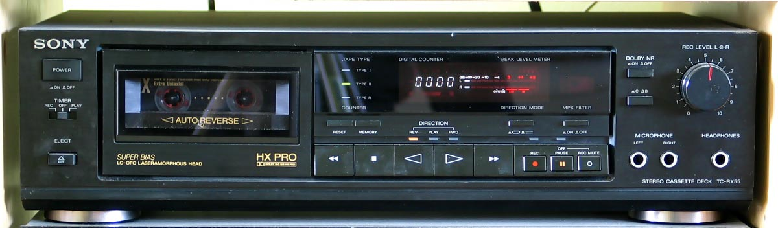
Other software’s include the audibling and Nero software
- Dubby Machine
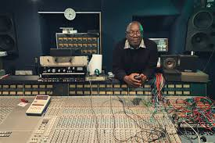
This is used in transforming radio cassette from one to another that is from one radio cassette other radio cassettes.

3.3 Radio Media
Radio is the technology of using radio waves to carry information, such as sound and images, by systematically modulating properties of electromagnetic energy waves transmitted through space, such as their amplitude, frequency, phase, or pulse width.

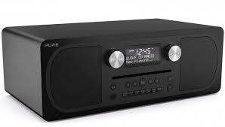
The Radio media is the largest in Africa but a kind of the oldest broadcasting network of Nigeria. It was gotten from radio-Nigeria operate as a network Kaduna State Media Cooperation (KSMC) news rooms give timely information of the program from the program unit which is the heart beat of the media.
Tips in making a good Radio Presentation
- Aim to create
- Understand how, when, why and what the listener is saying
- Know your listeners
- Make your listener care
3.4 Program Format
The type of the programs format is documentary, features, interview,
Discussion, ox pop, routine reporter, drama, testimonial, talk, chit-chat, montage, phone in programmes,

CHAPTER FOUR

4.1 Difficulties Encountered During the Programme
Life they say is not a bed of roses and whatsoever that has advantages also have its disadvantages. In as much as the SIWES Programme is a wonderful programme which has been designed to help the students have a practical knowledge of their various courses of study, it is note-worthy to also mention some of the problems encountered during the programme.
1. Problems of Securing a Place of Attachment
Securing a place of attachment for industrial training programme was a very big challenge to me. This is due to the fact that there are very limited establishment that accepts students undergoing industrial training. While I was searching for a place of attachments, I got to find out most of the establishments that accepts students had already taken the maximum number of students needed, while others would just reject the request giving one reason or the other.
2. Working Time
As an IT student working in FRCN, I was meant to work for twelve (12) hours in a day, five days in a week (i.e. Mondays to Friday). I barely had time to attend to my personal needs. Not just that IT students had to work all day, but also, the work load was quite much. Most times IT students would be asked to work overtime even without any incentive attached to it and students have no option but to comply every given instruction.
3. Finance
Stipends given to me during my industrial training programme is nothing to write home about. The stipend was so little that it could not even cover up for my daily transportation fair not to even mention my feeding fee; therefore, making me spent more from my personal savings. Despite the fact that the stipend was little, it was delayed. Most students ended their programme without receiving their complete stipend due to late payment from firm and we are also asked to pay for the practical we are going to conduct which makes student loose interest in participating.
4. Inaccessible Machines
In FRCN, industrial training students were not opportune to access most of the automated analyzers because they are not available Instead, we were being told to make research of such machine which does not assist us in learning better going with the saying “practice makes perfect” and not “plain research makes one perfect”. One of the objectives of SIWES is to expose students to work methods and techniques in handling equipment’s and machineries that may not be available in their universities, thus, the above stated objective of SIWES is not been fulfilled completely.
The difficulties encountered during the programme among others include;
- Inadequate monitoring of students on industrial training;
- Lack of cooperation and support from organization;
- Delay in release of fund for supervision and student’s industrial training allowances;
- Student’s reports were not corrected.

4.2 Summary of Attachment Activities
The gains of this exercise are immense; that it was worth the while is grossly an understatement. Being accorded another opportunity in life to be exposed to the rudiments of work places outside the class room teaching is an experience of a life time.
Furthermore, the exposure to practical tools, and working features had engendered better understanding of lessons thought in the class room and charted a course for career development in food science.

4.3.0 General Appraisal
4.3.1 Suggestion for Improvement & Recommendations of the Scheme ways of Improving the Programme
SIWES programme can be improved by the various actors in the programme which include the Federal Government of Nigeria (FGN), Industrial Training Fund (ITF), Supervisory Agencies (NUC, NCCE, and NBTE), the Institutions, and the Employers.
A. The Federal Government of Nigeria
- The Federal Government should make it mandatory to all ministries, companies, and other organization to offer placement and as well as accept students for industrial attachment.
- The Federal Government should increase the fund being provided for the SIWES programme and other educational programmes in general for effective and productive implementation of the scheme.
B. The Industrial Training Fund (ITF)
- The Industrial Training Fund should provide a strong insurance policy covered for students on SIWES programme.
- The ITF should provide logistic and material necessary for the effective administration of the scheme.
- The ITF should formulate policies and guidelines for SIWES programme for enhancement to all SIWES participating bodies, institutions and companies involved in the scheme.
- The ITF should provide information on companies for the attachment and help in the placement of students.
C. The Supervisory Agency
- The supervisory agency should liaise with the Industrial Training Fund to ensure the implementation of all federal government policies on the scheme.
- The supervisory agency should ensure adequate funding of the SIWES unit in all the institutions for effective administration of the scheme.
- The supervisory agency should research into the development of the scheme in line with advances in technological development.
- The supervisory agency should develop, monitor and review job specification in collaboration with the institution toward the maintenance of the National Minimum Academic Standard for the entire programme approved for SIWES.
D. The Institution
- The Institution should help identify placement opportunities for student attachment with employers.
- The Institution should ensure regular visitation of their students on industrial training to monitor their welfare and improvement status.
- The Institution should have adequate information on some of the challenges facing the firm and the student; it should be noted and treated immediately.
- The Institution should ensure payment of student’s allowances and other outstanding financial challenges.
E. The Employer
- The Employers should accept students for industrial training attachment.
- The Employer should allow the students to have access to some of their useful equipment and other useful facilities.
- The Employer should provide welfare services like drugs and other medication and show good hospitality to students.
4.4 Advice for Future Participants
I strongly recommend that future participants should bear the following in mind;
- The student should be focused to avoid disputing the reputation of the institution in their place of industrial attachment and they should also bear in mind the objective of the scheme and show commitment, diligence and honesty.
- The student should obey and adhere strictly to all rules and regulations of the company; they should respect the industrial based supervisors as well as other staffs of the company because the moral standard of the student is also evaluated.
- The student should avoid change of placement without seeking permission from the institutional based supervisor, the employer and the industrial training fund.
- The student should handle the equipment if the firm with great care and they should take pride in protecting the interest of the company throughout the period of industrial attachment.
4.5 Advice for the SIWES managers
- The SIWES managers should give attention to student welfare on industrial training and the students allowance should be increased as a result as high cost of living in our society.
- Technologists from various departments or program should be involved in the drafting of time table for students on IT to ensure that students are always sent into areas where activities that will result in learning experience are taking place.

CHAPTER FIVE
RECOMMENDATION AND CONCLUSION
5.1 Recommendation
- Tertiary institutions need to comply with the standards set for proper implementations of SIWES to enable students derive the greatest benefits from participation in the scheme.
- Tertiary institutions need to provide adequate logistics (mobility, internet service etc.) and adequate funding to make their SIWES units functional.
- Students should be well prepared through meaningful orientation programmes by institutions before embarking on SIWES. A book, such as the “Guide to successful participation in SIWES” would be useful in achieving the purpose if read before, during and after SIWES by participants.
- Quality assurance of SIWES, through adequate supervision of participants by the relevant stakeholders (institutions, employers and ITF) would ensure that the scheme meets its objectives vis-à-vis the principles of cooperative education or work-integrated learning.
5.2 Conclusion
The Student Industrial Work Experience Scheme (SIWES) plays a significant role in human resource development, it helps students develop new skills and enlightens them of what the present society holds for them after graduation and helps them adapt accordingly. As a result of the programme, I am now more confident to build my future My four (4) months industrial attachment with Federal Radio Cooperation of Nigeria (FRCN) has been one of the most interesting, productive and instructive experience in my life. Through this training, I have gained new insight and more comprehensive understanding about the real industrial working condition and practice; it has also improved my soft and functional skills. All these valuable experience and knowledge that I have gained were not only acquired through the direct involvement in task but also through other aspect of training such as work observation, interaction with colleges, superior and other people related to the field.

