

A TECHNICAL REPORT ON
STUDENT INDUSTRIAL WORK EXPERIENCE SCHEME (SIWES)

HELD AT
GERIN FM 99.5
1B AHMAN PATIGI ROAD, OFF AHMADU BELLO WAY,
GRA ILORIN, KWARA STATE.

BY

ODESANYA RUTH TEMIDAYO
MATRIC NO: ND/23/MAC/PT/0373

SUBMITTED TO
DEPARTMENT OF MASS COMMUNICATION,
INSTITUTE OF INFORMATION COMMUNICATION TECHNOLOGY (I.I.C.T)
KWARA STATE POLYTECHNIC, PMB 1375 ILORIN KWARA STATE.

AUGUST – NOVEMBER, 2024.
DEDICATION
This report is dedicated to Almighty GOD for making everything easy for me throughout my Student Industrial Work Experience Scheme (SIWES) programme and to my parent Mr. & Mrs. ODESANYA for their contribution to the success of this project. May Almighty God give you long life and prosperity (Amen).

ACKNOWLEDGEMENT
All praise, glory, honour and adoration to Almighty GOD, the author and the giver of wisdom, knowledge and understanding for the success of this programme.
I appreciate my parents which are my source to this world Mr. & Mrs. ODESANYA for their parental and spiritual support because without their maximum understanding and support, this experience would have not come into existence including my brother and sister for their support.

PREFACE
The Student Industrial Work Experience Scheme (SIWES) is a National Diploma Curriculum of the Department of Mass Communication, Kwara State Polytechnic Ilorin. The programme was established by the Industrial Training Fund (ITF) in 1973 to 1974.
It is designed to acquire the student with life situation in industries as well as supplies in a more practical manner and their knowledge in practical activities and other practical field during their course of study.

TABLE OF CONTENTS
Title page
Dedication
Acknowledgement
Preface
CHAPTER ONE: INTRODUCTION
1.1 ABOUT SIWES
1.2 IMPORTANCE OF SIWES
1.3 OBJECTIVES OF SIWES
CHAPTER TWO
2.1 HISTORICAL BACKGROUND OF HARMONY FM 103.5
2.2 ORGANIZATION CHART
2.3 VARIOUS DEPARTMENTS IN THE CORPORATION
CHAPTER THREE
3.1 STUDIO EQUIPMENT
CHAPTER FOUR
4.0 WORK DONE
CHAPTER FIVE
5.0 SUMMARY OF ATTACHMENT ACTIVITIES
5.1 RECOMMENDATIONS & SUGGESTION FOR IMPROVEMENT OF THE SCHEME
5.3 CONCLUSION

CHAPTER ONE
INTRODUCTION
1.1 ABOUT SIWES
SIWES stands for acronym for Student Industrial Work Experience Scheme.
The Student Industrial Work-Experience Scheme (SIWES) is a planned and supervised training intervention based on stated and specific learning and career objectives, and geared towards developing the occupational competencies of the participants. It is a programme required to be undertaken by all students of tertiary institutions in Nigeria pursuing courses in “specialized engineering, technical, business, applied sciences and applied arts”. The federal government on 8th October 1971 established the industrial training (ITF) in order to acquaint the students on the industrial work method. The SIWES which is a subsidiary formed in 1973 was initiated to improve the students’ technical abilities to expose them to industrial culture thereby getting the acquainted with the role to play towards the technological advancement of the nation. It creates an avenue on environment in which the students are being exposed to areas of their various disciplines which enhances their mental and creative minds in the aspects of technology and development. . It creates an avenue on environment in which the students are being exposed to areas of their various disciplines which enhances their mental and creative minds in the aspects of technology and development. It is therefore a practical aspect of the academic work, which students may not be opportune to carry out throughout their stay in the higher institution.
1.2 IMPORTANCE OF SIWES
- It provides students with an opportunity to apply their theoretical knowledge in real life situations.
- It exposes students to more practical work methods and techniques.
- It strengthens links between the employers, universities and industrial training fund (ITF)
- It also prepares the students for the labour market after graduation.
1.3 OBJECTIVES OF SIWES
Specifically, the objectives of the students’ industrial work experience scheme are to
- Prepare students for the work situation they are likely to meet after graduation.
- Provide an avenue for students in the Nigerian Universities to acquire industrial skills and experience in their course of study.
- Make the transition from the university to the world of work easier, and thus enhance students’ contacts for later job placements;
- Enlist and strengthen employers’ involvement in the entire educational process of preparing university graduates for employment in industry.
- Provide students with an opportunity to apply their theoretical knowledge in real work situation, thereby bridging the gap between university work and actual practices; and Expose students to work methods and techniques in handling equipment and machinery that may not be available in the universities.

CHAPTER TWO
2.1 HISTORICAL BACKGROUND OF GERIN FM 99.5
The idea of establishing a radio station (GERIN fm 95.5) came from the concern and passion of some Ilorin patriots for the development of the Emirate Community. Ilorin, being the headquarters of both the Ilorin Emirate and Kwara State; has grown from a pre-colonial town into an expanding metropolis. This growth, though desirable; has equally brought challenges that threatened the cultural heritage of the Ilorin Emirate. Besides, the growth is also opening up tremendous opportunities in all spheres of lives. This must be equally harnessed for our teeming youths.

Objectives
GERIN fm 95.5 was conceived as a community broadcasting station to serve as a rallying point for the people of the Ilorin Emirate and environs. Specifically, the Station will provide leadership in articulating the development NEEDS of the people; moderates their WANTS while vigorously promoting the consensus of the community on issues. It is also to serve the Ilorin Emirate community in providing timely, national and international news and information that are considered relevant to the community. The station shall identify and transmit local music and other music and entertainment materials in line with the cultural values of the people of the Ilorin residents.
The foregoing are listed below as specific objectives:
- To promote the Ilorin language and culture towards retaining our cultural heritage in the context of contemporary society.
- To disseminate information and analysis of issues and events that is of local, national and international importance.
- To generate revenue, in line with the NBC guidelines on community broadcasting; through the sale of air-time and to promote other commercial activities like product exhibitions, shows, events and joint promotion of products and social activities.
- To install and maintain equipment for gathering, processing and transmission of information on radio
- To mobilize the community for development aspirations and defend their interest as appropriate
- To facilitate the achievement of these objectives through relevant support services
- To facilitate the building of economic community that is line with modern ICT requirement
- To use the facility of the station to promote educational aspiration of the community through educational broadcasting approach.
Our mission

Our mission is to provide quality programming for cultural education, reliable information and entertainment needs of the Ilorin Emirate Communities.

Vision Gerin FM 95.5 Ilorin
To be the leading station for the promotion of cultural awakening and re-orientation

Programming Policy and Philosophy
Primarily, GERIN 95.5FM is established to provide specialized broadcasting for educational purposes. Educational broadcasting is the use of broadcasting, in this case radio, to achieve formal, informal, non- formal and other forms of education as may be defined by experts in the area. Furthermore, educational broadcasting combines the traditional functions of broadcasting of Information (news and current affairs), education (enlightenment and educative programmes), Entertainment (relaxation and amusement) with the traditional educational functions of developing the intellectual, moral and skills capabilities of citizens. Therefore, Gerin FM 95.5 shall be guided by this objective in its programming conception, design and transmission.

2.2 ORGANIZATION CHART
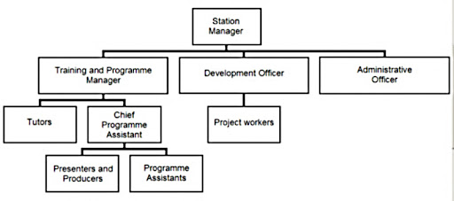

2.3 VARIOUS DEPARTMENTS IN THE CORPORATION
GERIN fm 95.5 Broadcasting Corporation has various departments through which it operates it day-to-day broadcasting activities.
The corporation is divided into six broad departments, where it carryout the smooth running of its programmes and coordinating all its activities. The available departments are;
- News & Current Affairs Department
- Administrative Department
- News and Current Affairs Department
- Programme Department
- Engineering Department
- Finance and Marketing department
1. NEWS & CURRENT AFFAIRS DEPARTMENT
This is an important department in the broadcasting organization that solely responsible for the day-to-day preparation of news story report, information and current affairs for the public audience.
In GERIN fm 95.5 this department is headed by a director and it is divided into two units viz: News unit and Current affairs unit.
- News Unit
This is the unit that solely responsible for the daily preparation of news, commentaries and broadcast it to the heterogeneous audience. They are in charge of news production and it comprise different staffs among whom the editors, reporter, proof reader, re-writers, desk-editor, news-caster and those that will align the news bulletin (from local to foreign), compu-graphist, typist, etc and it is being held by an Editor-in-Chief.
- Current Affairs Unit
This is the unit that specializes on current affairs programmes such as political talk, sport review, public enlightenment, environmental, highlight etc some of this programme are not live programme, they were recorded and played later, some of which guest were invited. After such recording, the programme is then edited by expert and producer before broadcasting.
The main objectives of this unit are to enlighten the audience more on the various issues of interest currently happening in the society.

2. PROGRAMME DEPARTMENT
This department consists of seasoned broadcasters, producers and presenters of high standard of productions. It is been divided into four different units viz: Audio Unit, Presentation Unit, Entertainment and Public enlightenment units.
- Audio Unit
- Presentation Units
- Entertainment Units
- Public Enlightenment Unit
3. MARKETING AND COMMERCIAL DEPARTMENT
As the soul of every organization, marketing and commercial department in GERIN fm 95.5 is the department where most of the station revenue is been generated through the selling of airtime on radio, receiving adverts and commercial etc.
4. RESEARCH PLANNING LOGIC AND STATISTIC DEPARTMENT
This is department that is in charge of the station statistical plans, logic and research projects. It stands responsible for the documentation and presentation of modern and digital information materials such as Audio Compact Disc (CD) both empty and recorded, cassettes, records, newspaper, journal, magazines etc.
The department also provides a standard internet service for the station especially in the studio and newsrooms where the presenters and reporter can browse through to grab recent information needed for smooth running and delivering of standard programme on radio.
5. ENGINEERING DEPARTMENT
This is another important department that consists of the station and studio engineer, installation engineering, technicians etc whose responsibility is to provide better services to the station machineries, maintain and repair the station equipments. The department stands to put all the equipments in good conditions for smooth and excellent transmission of the station.
Engineers works in shift and their services round the clock rectify all fault discovered on any machineries needed for transmission and broadcasting. It is been divided into sub-unit of transmission, generating house, Radio workshop, Automobile and Air Conditioning Workshop units among others, each unit is head by a supervisor.
6. ADMINISTRATIVE DEPARTMENT
This is the department that involves in organizing training for staffs, interview for new applicants and employees, conduct and recommends staffs for promotions, etc as well as perform corporate services.

CHAPTER THREE
3.1 STUDIO EQUIPMENT

The Microphone
The seed, the origin, where everything is born: this is The Microphone.
Technically, the Microphone captures the sound and converts it into electrical impulses.
In practice, its primary responsibility is to carry the voice through to the listeners.
On the microphone depend: timbre, depth, clarity, body and softness of voice.
We can imagine it as the object that moves the speaker from the studio and makes him/her appear right in front of the listener.
It cannot be explained scientifically, but listeners unconsciously recognize the difference between a professional, good quality microphone, and a low quality, consumeristic one. Even if the budget is limited, an important part of it must still be destined to the microphone. In any case, today there are wonderful microphones at affordable prices.


Microphone Processor
To stabilize the voice of the speaker on a constant level, a Microphone Processor is necessary.
This is an audio compressor than can decrease the volume of the voice when it is too loud, or amplify it when it is too low. Doing so produces a sound that captures all the details of the voice but levels out volume changes. Too high a volume level could distort the signal; or, if too low, it could make speech incomprehensible. A microphone processor helps smooth the audio, minimizes background noise and cleans the signal. It helps with the mixer control, since it is not necessary to continuously adjust the level of the microphone. It also helps to get "Radio Sound", so that it always sounds at the right level and the speaker can concentrate on performance – rather than worry about being too close or too far from the microphone, or even speaking in too loud or too soft a voice.
Moreover, it gives more presence to the voice and allows to set it at higher level – because you are sure it will contain the peaks. Adding to it, it removes hissing noises such as those produced with words that contain an "s".
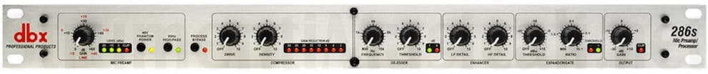

Headphones
Headphones allow you to listen carefully to the audio you broadcast.
These are connected to the same audio channel that feeds the speakers: when you plug in the headphones, the speakers will mute automatically.
If you want to have complete control over your audio, you need to be able to monitor it using headphones. You won't otherwise be able to monitor what the audio is like as well as ensure that your setup is working properly.


Headphone Distributor
In the studio there is often more than one person participating in the program. For this reason, a Headphone Distributor is necessary to connect several users to the same source.
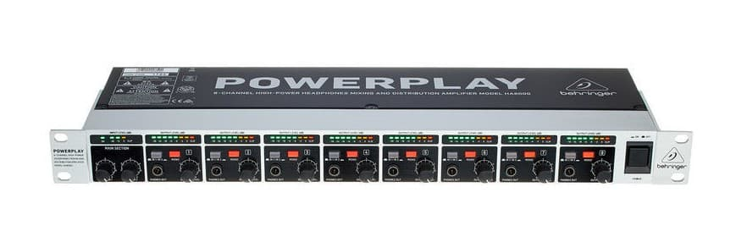
Headphone distributors have four, eight or more outputs; each one with an independent volume adjuster so as to allow each user to set a self-comfortable level.

Audio Mixer Console
At the heart of any studio is the Audio Mixer Console.
This is the interface used to control what’s heard on air, and to choose which sounds should be broadcasted.
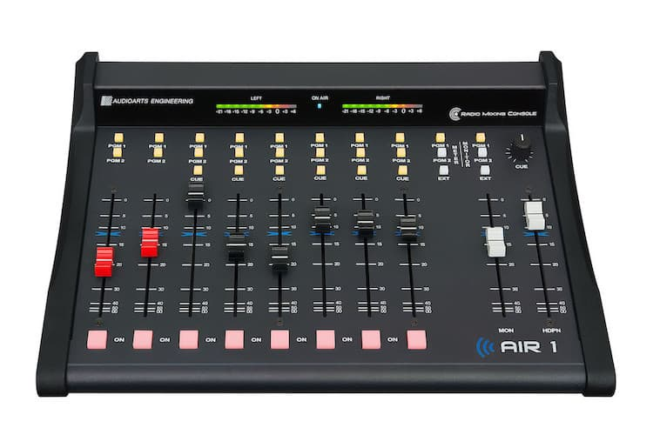
Each channel represents an “input”. The fader (slider) attenuates or amplifies the incoming signal; it can change the volume and the dynamics of the sources, and combine the various audio signals. The Audio Mixer Console is the device that allows us to monitor and control the audio.

Broadcast Audio Processor
The Audio Processor is a very important piece of equipment, as it is usually the last one you use before your audio is transmitted.
It improves and optimizes the sound quality of your Radio, thus giving it a unique sound with its own character.
You may choose between several mood sounds such as jazz, pop, rock, classical, etc. or even create your own sound.
Mainly designed for medium/small radios (local radio stations, community radios, web radios), the Audio Processor combines ease of use, flexibility and robustness.
It is indeed a combination of a multiband compressor/limiter and a parametric equalizer together with other effects.
It compresses the overall dynamics of the program, but it is also possible to increase the volume, because it prevents against over-deviation, clipping and other saturations – all effects that create distortion. The final result will be a “louder” and “bigger" sound for your radio.
There is a psychological reason behind it: when searching on the radio dial, people stop to listen at the radio that sounds louder, bigger and better – and this increases your audience.

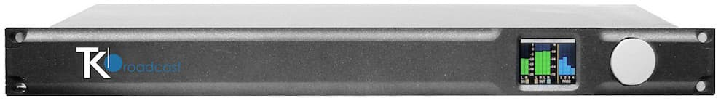

Active Monitor Speakers
Studio Monitor Speakers show you how the music sounds without headphones.
They must be of high quality, so that all the abnormal sounds can be detected.
It is also advisable to have another speaker, small and of low quality, to cross-check how the sound is even in this kind of speakers. Ultimately, the sound must be good but also understandable for every type of audience.
It is recommended to use speakers specifically designed for music, as they can provide the most accurate representation of the signal.
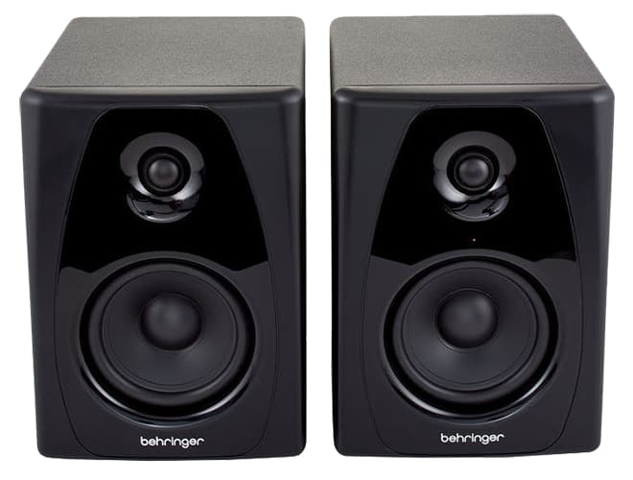

Telephone Hybrid
You also need a Telephone Hybrid Interface, to join the console with audios coming from phone calls. This is important if you want to take phone calls while you are on-air.
In simple terms, a Hybrid is an interface that connects two-wire phone lines into input and output XLRs. These XLR connectors are plugged into an audio console or I/O node. Many Hybrids also contain echo cancellation and an automatic equaliser.

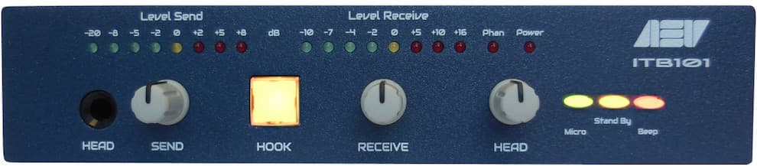

Computer with Automation and Playlist Software
Computer with an Automation Software.
This computer system makes it possible to play background music and commercials.
The software is called Automation Software or “Playout”, and it is designed to continually play music in the background.
The heart of these programs is the Playlist – which is a list with all the audio files that need to be played.
Most of the time these programs contain hotkeys, a music database, and a lot more.
They are computer programs especially designed to allow continuous audio playback, with exceptional granular control for Announcers and Programme Directors.
Most automation systems also contain a Music Database, Hot Keys (to play ad-hoc audio), an Audio Editor, a Segue Editor (to change the mix between the different elements), Interfaces for Website and RDS data, and a lot more.

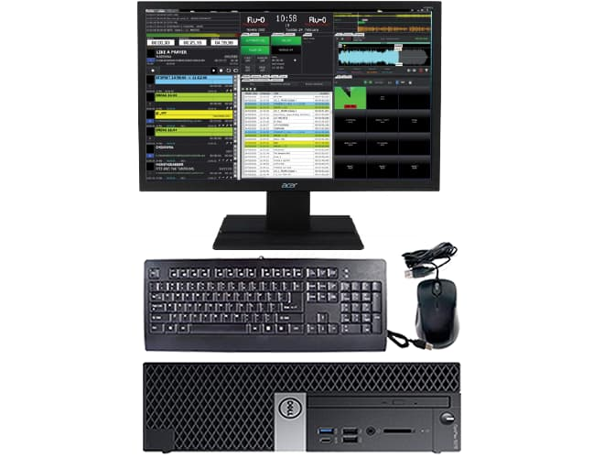

Tuner FM Receiver (good quality)
To monitor the real sound you are broadcasting a good quality Tuner is necessary.
This will also help you compare your on-air sound with that of your competitors.

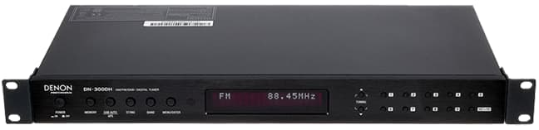
CHAPTER FOUR
4.0 WORK DONE
The first day at Harmony 103.5 fm I learnt about receiving and welcoming visitors into the reception and I was given the terms and conditions of the organization. I was taken into the production room where I was introduced to those I met there (Staffs) and my fellow students that came for the same purpose as mine. I was also shown the equipment that is necessary in the production studio.
I learnt how to edit a recorded program by cutting out the excesses in the program and also cut repeated words making it pleasant to the ears. I also learnt how to zoom in and minimize the voice in the program for editing.
How to record a file. We open an application called adobe go to file and click on “New the we click on audio which are of two types:
Mono – This is before recording and stereo is after recording
Editing of program - zoom into the voices of the anchors of the program you have selected for editing, by scrolling upward with your mouse but if you want to minimize it, you will scroll down.
Cutting of program – select whatever you want to cut such as mistakes repeated words and so on by using your mouse then press delete to delete the unwanted speech and error made by the anchor or guests on the programme.
Increasing and reducing of volume - you can reduce the volume of a recorded production/programme with the button labeled as “stereo or peak 5” it can also be used to increase the volume.
I learnt new things about media houses, the types of microphone which we have been taught in school earlier and the types of microphone we use in the studio for recording and for going live.
The types of microphone are: condenser microphone, dynamic, boundary, lavalier microphone and so on. We use adobe and amplitude for recording, these are the two common ones we use in media houses. There are two types of consoler (i) digital which is for video recording and (ii) the analogue which is for audio recording. A live programme was anchored on air same day.

CHAPTER FIVE

5.0 SUMMARY OF ATTACHMENT ACTIVITIES
The gains of this exercise are immense; that it was worth the while is grossly an understatement. Being accorded another opportunity in life to be exposed to the rudiments of work places outside the class room teaching is an experience of a life time.
Furthermore, the exposure to practical tools, had engendered better understanding of lessons thought in the class room and charted a course for career development in mass communication.
5.1 RECOMMENDATIONS & SUGGESTION FOR IMPROVEMENT OF THE SCHEME
I put forward the following suggestions and recommendations for future improvement of the scheme;
- Organizing workshops, seminars and symposium for students in various faculties in other to keep the student abreast of new technologies and innovations.
- Posting of students for SIWES should be done by the scheme to ensure conformity with course of study.
- A mass enlightenment campaign should be carried out, to enable industries and establishments know the importance of SIWES to the future of the student and the society at large.
- The scheme should also try to enforce the act guiding the establishment of the scheme, to serve as deterrent to those establishments who reject student for IT.
- School Curriculum should be organized in such a way that the SIWES exercise be carried out at a stretch of six months and not the intermittent arrangement of three months twice.
5.3 CONCLUSION
The Student Industrial Work Experience Scheme (SIWES) plays a significant role in human resource development, it helps students develop new skills and enlightens them of what the present society holds for them after graduation and helps them adapt accordingly.

