

A TECHNICAL REPORT
STUDENT INDUSTRIAL WORKING EXPERIENCE SCHEME
(SIWES)

Held at
KWARA STATE GEOGRAPHIC INFORMATION SERVICE, G.R.A COMMISSIONER LODGE WAY. ILORIN, KWARA STATE

Prepared by:
POPOOLA TAIWO ADESINA
ND/23/BLD/PT/OO41

SUBMITTED TO

DEPARTMENT OF BUILDING TECHNOLOGY
INSTITUTE OF APPLIED SCIENCE
KWARA STATE POLYTECHNIC, ILORIN

INPARTIAL FULFILLMENT OF THE AWARD OF THE REQUIREMENT OF THE AWARD OF NATIONAL DIPLOMA IN SCIENCE LABORATORY TECHNOLOGY (SLT)

Sept., – Dec., 2024

DEDICATION
I dedicate this technical report to the Almighty Allah, the giver of knowledge, wisdom and who is rich in mercy.

ACKNOWLEDGEMENT
I take this opportunity to express my profound gratitude and deep regards to the creator of heaven and earth, the one who knows the beginning and the end, the alpha and the omega, the Almighty Allah and also to my guides (MR & MRS POPOOLA, and to all those who has helped me during my SIWES programme. The blessings, help and guidance given by them, time to time has carry me so this far and shall carry on the journey of life on which I am about to embark. I also take this opportunity to express a deep sense of gratitude to compliment my mentor for his cordial support valuable information and guidance which helped me in completing my SIWES through various stages.

ABSTRACT

This technical report encapsulates my four-month attachment experience with KW-GIS Construction Company, a Building Technology consultancy firm. During this period, I delved into the practical application of Building Technology principles, transitioning from theoretical knowledge to hands-on structural design. I also acquired essential skills in manual design calculations, and participated in design, modelling and detailing of various residential and commercial projects. I also acquired knowledge in the steps, activities and processes involved in the actual execution of a project, and participated in many decision-making meetings in the course of construction, which helped me, enhance my mental ability and gave me insight to real-life problem-solving scenario. I was able to have practical knowledge in cost estimation and cost minimization in the course of construction. I obtained a practical knowledge of project supervision and management. The report outlines my extensive exposure to structural design, covering reinforced concrete and steel structures, my introduction to various software tools for structural analysis and my experience on site, as well as the challenges I encountered during the period of my training.

CHAPTER ONE

THE STUDENTS’ INDUSTRIAL WORKEXPERIENCE SCHEME(SIWES)

Introduction to SIWES

The need for polytechnic building technology graduates that are well equipped with the requisite expertise and knowledge to put to use the skills of the building technology profession and proficient in the use of tools (both hand and machine) of the trade cannot be over emphasized. There must be building technology graduates who have gone through building technology training right from the lecture rooms, workshops, laboratories, and industry itself. An engineer who has imbibed the necessary quest and prowess for entrepreneurship in the setting up of small-scale industrial and building enterprises will accelerate the pace of industrial development.
Students’ Industrial Work Experience Scheme (SIWES) is designed to provide each student opportunity for practical experience outside the Polytechnic through attachment to industrial establishments/companies, research stations, etc. The programme is designed to be hands-on intensive and therefore serves as a channel to integrate in-house entrepreneurship development skills. The Students’ Industrial Work Experience Scheme (SIWES) was created not only to expose the students to skill acquisition but also to inculcate in them the development of the right team spirit as well as expose them to rudimentary expectations for the world of work. SIWES is a course of study designed to enhance students’ relevant productive skills and employability after labor and therefore is a major requirement for an undergraduate of the above category.

History of SIWES

The Students’ Industrial Work Experience Scheme (SIWES) was initiated in 1973 by the Federal Government of Nigeria under the Industrial Training Fund (ITF) to bridge the gap between theory and practice among products of our tertiary Institutions. It was designed to provide practical training that will expose and prepare students of Universities, Polytechnics, and Colleges of Education for work situation they are likely to meet after graduation.
- Before the establishment of the scheme, there was a growing concern among the industrialists that graduates of institutions of higher learning lacked adequate practical background studies preparatory for employment in industries. Thus the employers were of the opinion that the theoretical education going on in higher institutions was not responsive to the needs of the employers of labour.
- As a result of the increasing number of students’ enrolment in higher institutions of learning, the administration of this function of funding the scheme became enormous, hence ITF withdrew from the scheme in 1978 and was taken over by the Federal Government and handed to National Universities commission (NUC), National Board for Technical Education (NBTE) and National Commission for Colleges of Education (NCCE). In 1984, the Federal Government reverted back to ITF which took over the scheme officially in 1985 with funding provided by the Federal Government.

Aim of SIWES

The aim of SIWES is to create an opportunity for students of various disciplines in Nigerian tertiary institutions to gain industrial work experience in their chosen fields of study, in relevant industries and establishments. This helps them to acquire necessary skills, which are needed in the advancement of their career in their field of study after graduation.

Objectives of SIWES

The Industrial Training Fund’s Policy Document No.1 of 1973,which established SIWES, outlined the objectives of the scheme. The objectives are to:
      - Provide an avenue for students in the Nigeria Polytechnics to acquire industrial skills and experience in their course of study.
      - Prepare students for the work situation they are likely to meet after graduation.

      - Expose students to work methods and techniques in handling equipment and machinery that may not be available in the university.
      - Provide students with an opportunity to apply their theoretical knowledge in real work situation thereby bridging the gap between university work and actual practice.
      - Make the transition from the Polytechnic to the world of work easier and thus enhance student’s contacts for later job placement.
      - The Scheme exposes students to industry-based skills necessary for smooth and unparalleled transition from the classroom to the field of work.

      - It affords students the opportunity of being familiar with and exposed to the required expertise in handling machinery and equipment which are usually not available in the educational institutions.
      - It exposes students to both the theoretical and practical aspects of their discipline, thus promoting creativity and skills in students.
      - It enhances employment and scholarship opportunities among students who can exhibit immense industrial skills and perform exceptionally well during training.
      - It establishes a relatively uniform national professional and apprentice ship training scheme in the country.
      - It creates opportunities for students to have a direct contact with the intermediate & senior professional staff in the industry.
      - It reduces the introduction of expatriate engineers, technologists and other professional personnel due to the quality training derived by students.
      - It encourages the involvement of employers especially the small-scale industries in the organization and development of training programs and facilities including the establishment of group training scheme centre in some critical areas of the economy.
      - It creates awareness to students on work-related problems and how to cope positively in difficult situations.

CHAPTER TWO

PROFILEOFTHECOMPANY

Brief History of Establishment

BASIT OPELOYERU & ASSOCIATES Construction Company is a Building/Structural Engineering firm based in Ibadan. The company was incorporated in 2020 as a limited liability company with a hundred percent Nigerian ownership. Since its establishment, the company focused on providing building technology services, which include building design and construction, project management and consultancy, building technology training, and interior and exterior decorations.
KW-GIS Construction Company utilizes high proficiency skills, exceptional acumen and incomparable uprightness to produce excellent designs that are not only affordable but also sustainable in the competitive world. KW-GIS Construction Company has a proven record of accomplishment and a reputation of delivering consultancy services to a large number of projects spanning all forms of engineering construction to consultancy (KW-GIS, n.d.). Their wealth of experience in this sector is the best with landmark projects associated with their name.
They have earned a strong reputation for their quality workmanship and have significantly contributed to the economic and social development of Southwest Nigeria. They have successfully completed numerous projects in the commercial, educational, government, and private sectors.

Address of Establishment

KW-GIS Construction Company is located at Commissioner lodge way. G.R.A Ilorin Kwara State, Nigeria.

Statements of the Establishment

Mission Statement

The mission of KW-GIS Construction Company is to deliver quality services to clients with the application of the latest and finest building technology, provide training and monitoring of resources via an environment suitable for both staff and client to achieve set goals.

Vision Statement

The vision of KW-GIS Construction Company is to continually develop and enhance the indigenous capacity and capabilities to become an absolute Nigerian leader in the provision of cutting-edge and excellent quality engineering and technical services.

Core Values

      - Consistency: Over the years, KW-GIS Construction Company consistently delivered excellence.

This is evident in the projects they have carried out and in the feedback; they have gotten from their clients.
      - Cost Reduction: They are resourceful people who like to work with a budget because they understand how the current economic situation has affected everyone in our country, Nigeria.
      - Client Confidence: At KW-GIS Construction Company, they believe that a satisfied client is the best business strategy of all. This is why they put a lot of time and energy into building solid client relationships.

Organizational Structure

KW-GIS Construction Company is run by the Managing Director/ Chief Executive Officer(CEO). The organizational structure of KW-GIS Construction Company is designed to ensure that the company can
provide its clients with the best possible service. The company has a strong focus on quality and customer satisfaction. KW-GIS Construction Company is organized into a number of departments, including:
- Construction Engineering Department: The Civil Engineering Department is responsible for the design, construction, and maintenance of building projects like structures, drainages, roads, and other infrastructure. This includes conducting surveys, engaging in research, analyzing results, planning the construction and supporting all technical issues during the project. The department is made up of engineers, builders, technicians, and labourers.
- Project Engineering/Management Department: The Project Engineering Department is responsible for the design and engineering of construction projects. This includes developing plans, specifications, and cost estimates. The department is made up of project engineers, project managers, estimators, and schedulers.
- Administrative Department: This unit is responsible for the recruitment, selection, training, and development of employees. The department also handles employee relations, compensation, and benefits. The department ensures the payment of remunerations to workers as at when due. It carries out the following activities, accounting, budgeting, forecasting, and treasury management. The department is made up of human resources professionals, accountants, and secretary.
- Engineering Design Training Department: This department is made of the Industry-based supervisor and the Industrial Trainee. This department takes full responsibility of the training of undergraduate and graduate students on engineering design.

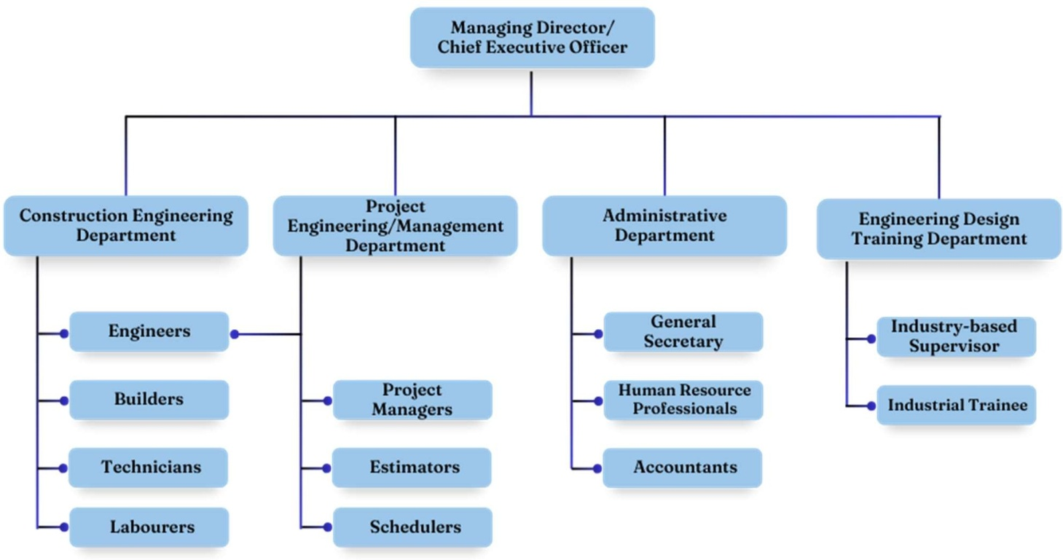

Figure01:Organogramof KW-GIS construction company

Use of Computer Software at KW-GIS Construction Company

Due to the specialization of KW-GIS Construction Company in structural engineering and consultancy, she employs the use of the following software for its operations: There are
- AutoCAD

- Beamax

- SAP2000Non-Linear
- Orion18
- Civil3D
- Tekla Structure
- Prota Structure
- Microsoft Word

- Microsoft Excel

- Microsoft Project(MSP)

- Google Earth

AutoCAD

AutoCAD is universally accepted CAD software due to its flexibility and versatility. It can be employedforuseinvariousfieldsofconstructionsuchasengineering,architectureandsurveying.It has a concept, which makes it look like one is using manual means in drafting, though much more refined.Ithascommandssuchasline,offset,trim,erase,arc,rectangle,dimension,matchproperties, among several others. A very important advantage of this software is its ability to be used alongside different building technology software like Orion18, Civil3D, SAP2000Non-Linear, Prota Structure, and so on, and its provisions for revisions, which can be carried out on drawings at a fast rate.
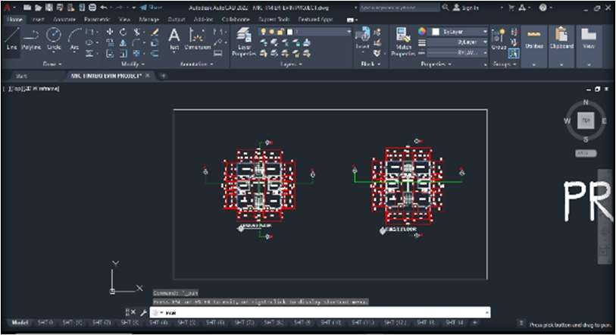
Figure02:ATypicalAutoCADWorkspace

Beamax

Beamax is a program that lets users graphically create, edit, and analyze continuous beams. It can support point and distributed loads, fixed, hinged, and roller supports. Beamax can also displays hear force, bending moment, and displacement curve graphically. The values of moment and hear forces gotten from Beamax is used to determine whether the beam of the structure will fail or its okay for execution.

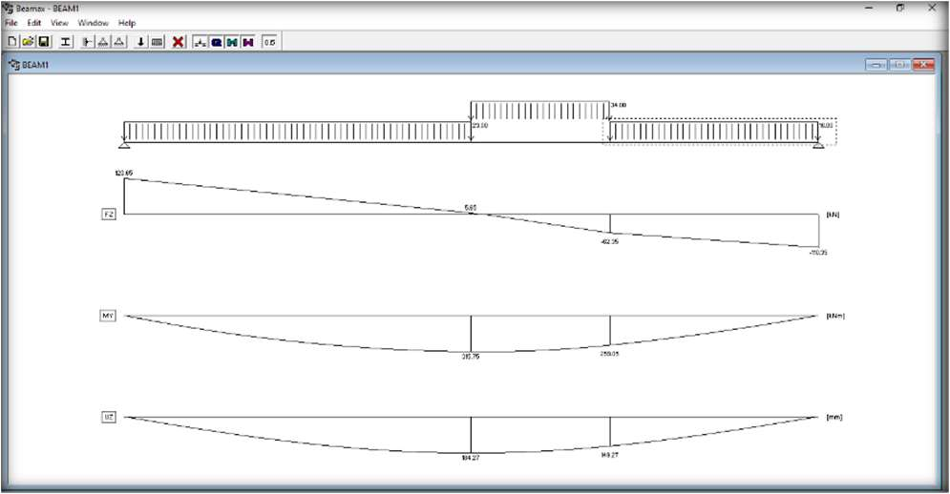
Figure03:ATypicalBeamaxWorkspace

SAP2000Non-Linear

SAP2000 is a structural software package that can be used to create and analyze structural models. A building-technology software can be used to analyze and design any type of structural system. SAP2000 can define masses based on object material properties, applied loads, or assigned masses and can perform step-by-step large deformation analysis.
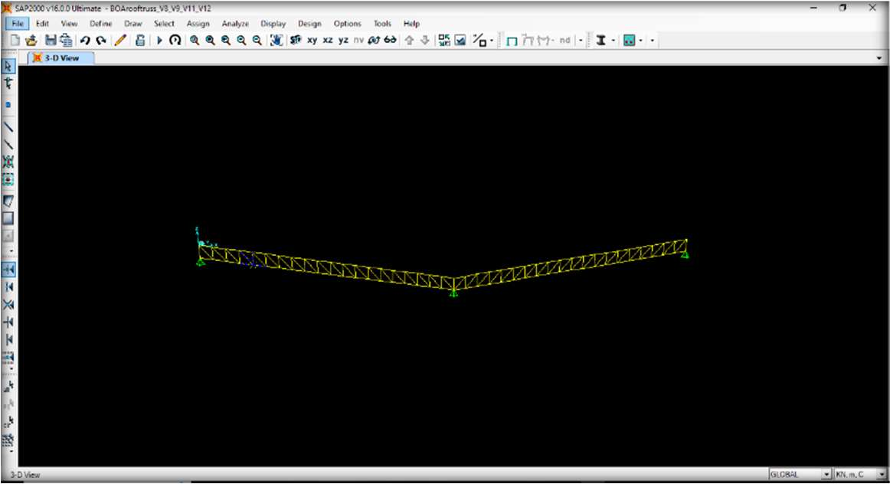At KW-GIS Construction Company, the software is used to model, analyze, and design structures such as buildings, roof truss, towers, and other types of infrastructure.
Figure04:ATypicalSAP2000Workspace

Orion18

This software is used to design all the structural members in the project. The software is developed for the analysis, design and drafting of Concrete Building Structures. Unlike general-purpose structural analysis programs, Orion is concentrated on accurate analysis, fast data preparation, automated reinforced concrete design and automated preparation of engineering drawings and details.
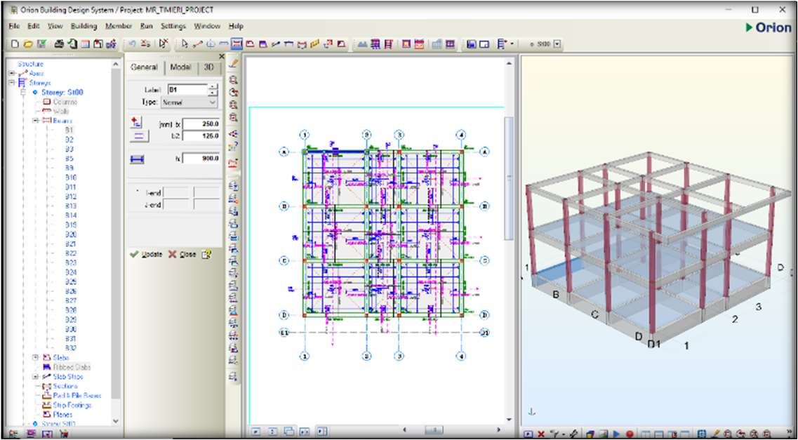
Figure05:ATypicalOrion18 Workspace

Civil3D

Civil 3D is a building technology design software that helps building technology design, create, and manage project plans. It is a Building Information Modeling (BIM) software that supports integrated features to improve drafting, design, and construction documentation.
At KW-GIS Construction Company, Civil 3D is tailored for designing and managing complex infrastructure projects. These projects include roads, highways, intersections, roundabouts, drainage, parcel layout, and pipes and grading.

Tekla Structures

Tekla Structures is a building information modeling (BIM) software, which allows users to create and manage 3D structural models in steel or concrete, and guide them through the process from concept to fabrication. Tekla Structures can model structures that incorporate different kinds of building materials, including steel, concrete, timber, and glass.
Tekla Structures is mainly used for steel and concrete detailing, precast and cast in-situ. It also includes Tekla Structural Designer, which allows users to design reinforced concrete buildings and steel buildings.

Prota Structure

Prota Structure is a design system used by structural engineers to model, analyze, and design buildings. It can calculate loads on structures and the ground, and calculate connections between building elements in steel structures. Prota Structure also uses Revit's analytical model data when importing models into its structure.
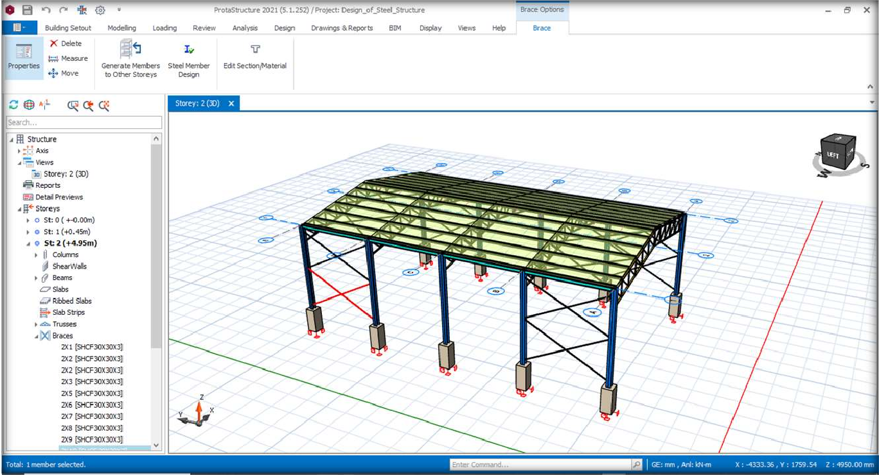

Figure06:ATypicalProtaStructureWorkspace

Microsoft Word

Microsoft Word is used at BOA Construction Company for typing proposals, structural calculation sheets, operational procedures, cost estimation, and other contractual documents that need to be typewritten before presenting them to the clients, stakeholders and other members in the online community of BOA Construction Company. In some cases, we use it to crop out undesired part of the 3D image extracted from the Orion 18 and convert it from bmp. file to png file.
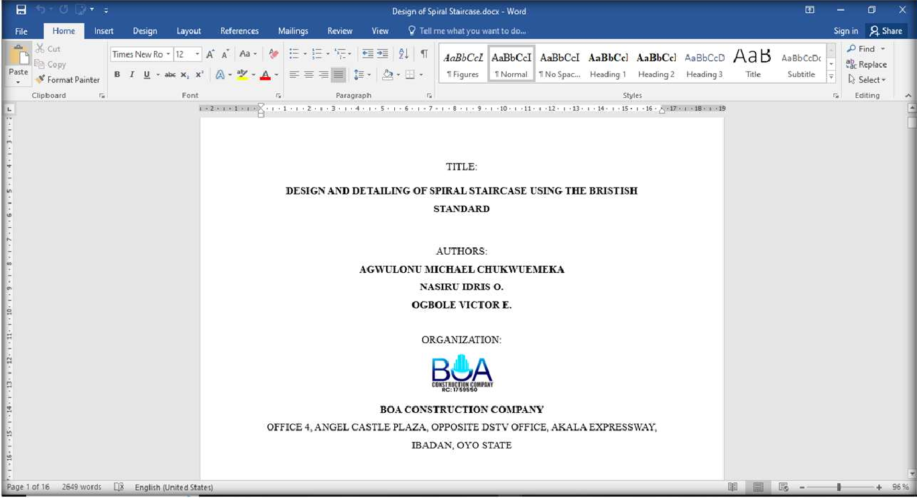

Figure07:ATypicalMicrosoftWordWorkspace

Microsoft Excel

MS Excel is widely used in civil engineering to manage project data, perform numerical modeling, andanalysis, and track project schedules and budgets. It also creates complex spreadsheets for design calculations, costestimation, and optimization. at KW-GIS Construction Company, there are excel files designed to help in calculating for slabloads, and in designing staircases and retaining wall. They are also used in knowing the are of reinforcement bars that will be provided to construct any structural member, as well as, the total number of reinforcements that will be needed using the necessary values of parameters needed and the values of moment and shear forces gotten from Beamax.

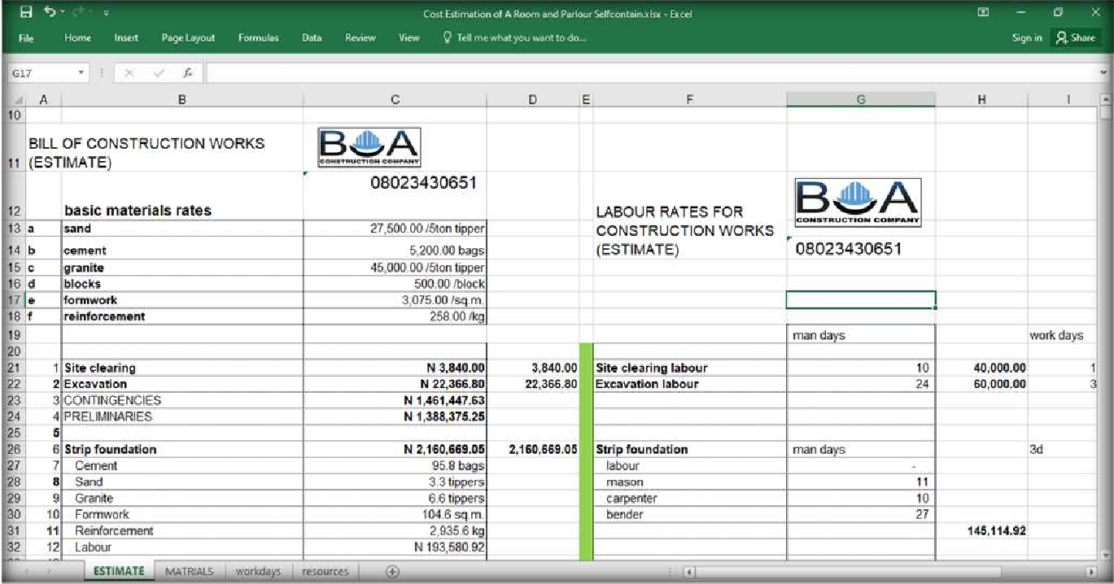

Figure08:ATypicalMicrosoftExcelWorkspace

Microsoft Project(MSP)

Microsoft Project (MSP) is a project management tool that can be used in civil engineering for planning, managing, and executing projects.MSP has features such as Gantt charts and project calendars. We also use MSP to create schedules, assign task store sources, and keep track of time. It can be used for small and large construction projects, and its main applications include:
- Planning and scheduling
- Resource management
- Cost management
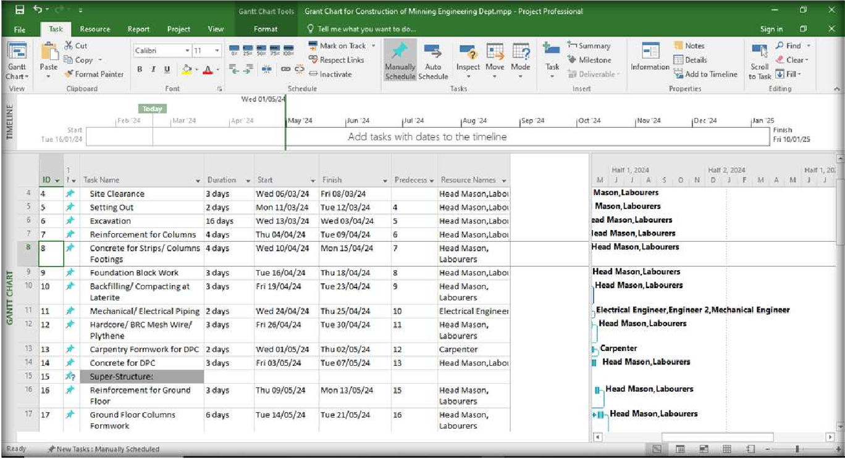

Figure09:ATypicalMicrosoftProjectWorkspace

Google Earth

Google Earth is a tool that provides access to aerial photography and services. It also offers tools for creating new data and a growing set of layers of data, such as terrain, directly into their Civil 3D projects, providing a powerful and versatile tool for project planning and design.
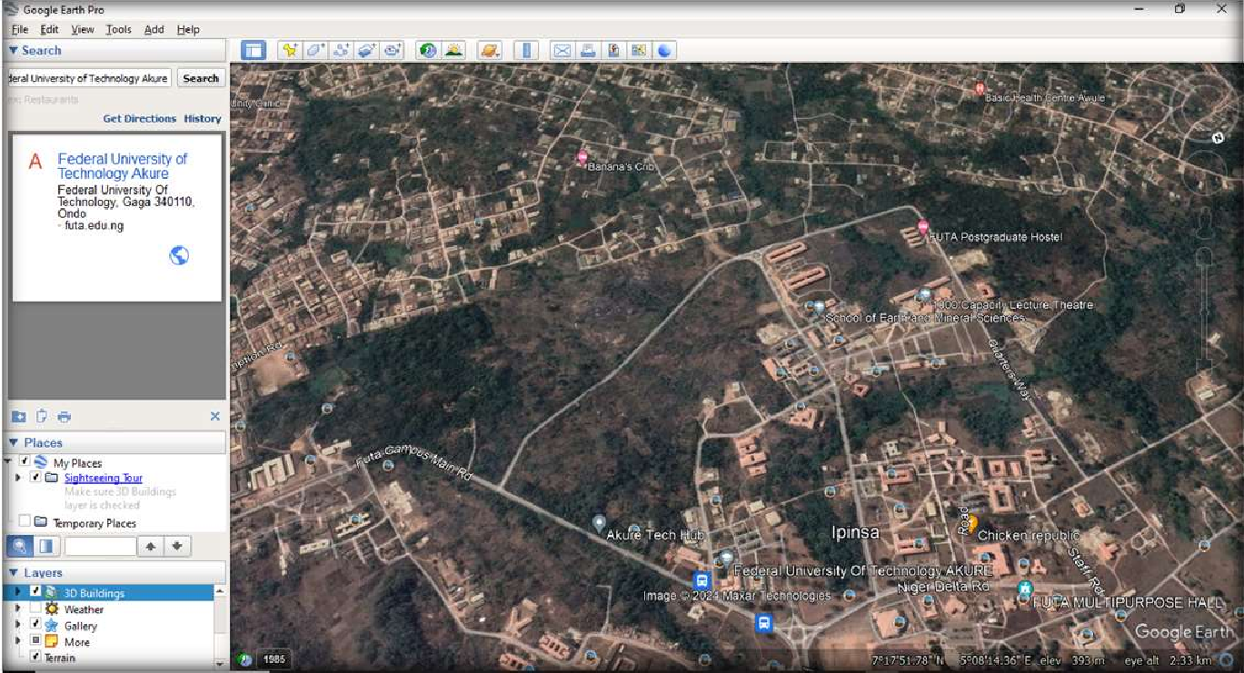

Figure10:ATypicalGoogleEarth Workspace

Safety Policy at KW-GIS Construction Company

KW-GIS places high importance on health and safety of staffs. Sick staff are not allowed on site and the healthy ones on site are adequately protected. The company health policies include statement of methods and process awareness, risk assessment at each critical stage of the project, active first aid care, provision and appropriate use of personal protection equipment, equipment assessment before use, inevitable accident record and analysis, and appropriate site layout.

Past Projects of the Company

Over a 3-year period, they have constructed, renovated, and been consulted on a wide variety of projects and building including:
    - Blocks of Classrooms

    - Auditorium

    - Residential developments

    - Supermarket

    - Polytechnic Facilities

    - Drainages

    - Road

    - Roof Trusses

Below are highlights of some recent jobs undertaken by the firm 2020 till date;

- Re-design of Proposed Residential Development for Mr. Aromolaran.
- Design and Construction of 3-Bedroom Flat at Ido Local Government, Ibadan, Oyo State

- Design of Warehouse for Jara Ajah.

- Construction and Supervision of the Drainage that BHN Limited, Lagos-Ogun Expressway.
- Design of Proposed Residential Development for Mr. Imran.

- Design of Proposed Residential Development for Mr. Timi eri Evans

- Design of Proposed Residential Development for Mr. Okwy Benjamin.

- Design of Proposed Residential Development for Monika Askia.

- Design of Proposed Islamic Center, Ikorodu, Lagos State.

- Supervision of Design Studio and Ancillary Facilities for Africa Centre of Excellence in Obafemi Awolowo University, Ile-Ife, Osun State.
- Design and Construction of a Supermarket Mallat Ikire, Osun State.

- Proposed Design of Block of 18 Classrooms for Government Technical College, Agidingbi, Lagos State.

- Proposed Block of Classrooms at Alaapa Village, via Aro, Abeokuta North LocalGovt.Area, Ogun State.
- Proposed Residential Development at Agric Phase3 Agbarho Layout Uvwiama Agbarho Ughelli LGA, Delta State.
- Proposed Development, located at Izo Npkor Rumuekpolu Rumuo who Eneka, Obio Akpor LGA, River State.
- Proposed Roof Arc Truss for ASUU Auditorium, Federal University of Agriculture Abeokuta, Ogun State.
- A Proposed Residential Development located at Ilashe Beach, Island Area, Lagos State.

CHAPTER THREE EXPERIENCE GAINED

Site Experience

Experience at the Design Studio and Ancillary Facilities in Obafemi Awolowo University, Ile-Ife, Osun State.
Project: Supervision of the Design Studio and Ancillary Facilities for Africa Centre of Excellence in Obafemi Awolowo University, Ile-Ife, Osun State
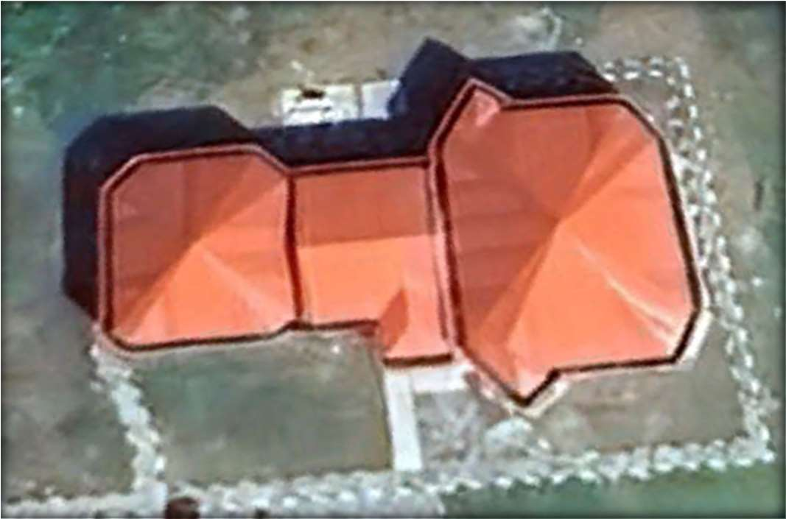

Figure11:ViewoftheDesignStudioandAncillaryFacilitiesinOAU,Ile-Ife,OsunStateusing Google Earth
Description: This project involved the construction of a storey building, which is to serve for academic purpose, office spaces and conference rooms. This project, which commenced by December 2022, was consulted by Multi-links Associates. Our company, KW-GIS Construction Company, was called upon to represent the consultant, Multi-links Associates, to take charge of the structural engineering of the project. There are two stages of construction involved in this project. The first stage is the work done on the Substructure, where a double wall for the strip wall and an expansion

joint between office areas and the design studio were introduced, while the second stage is the superstructure.

Contribution to the Project:

      - On the October 18, 2023, our team at KW-GIS Construction Company was called upon to the site when there was a complication during the construction project. We visited and toured the structure, identifying any errors and collaborating on effective solutions with the contractors.
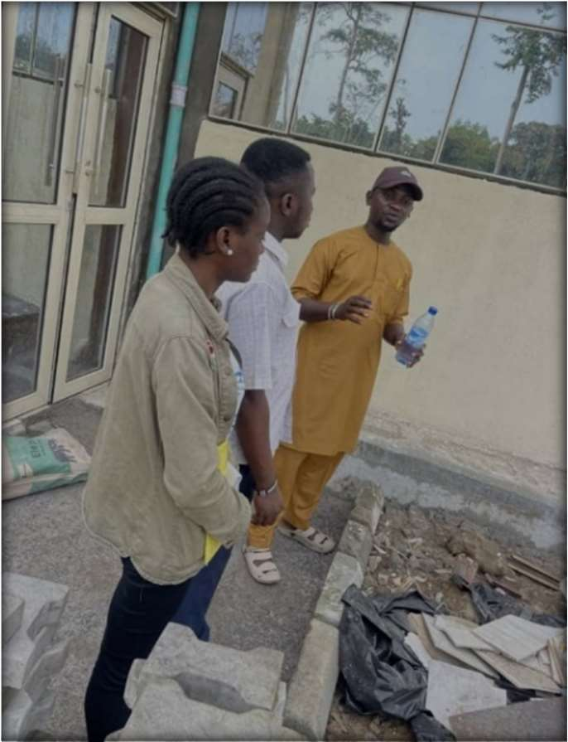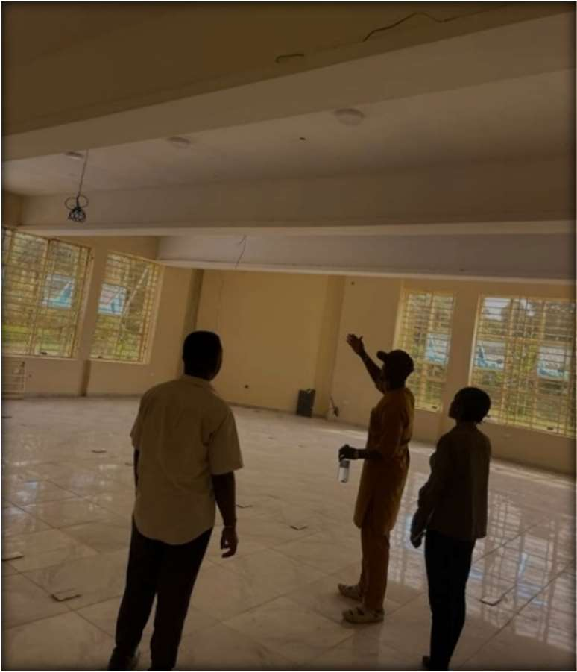
(a) (b)

Plate1aandb:Evaluation and Inspection of the Design Studio and Ancillary Facilitiesin OAU, Ile-Ife, Osun State
On the November 13, 2023, our team joined the officially handing-over ceremony in conjunction with the defect liability period. The defect liability period is a period for the contractor to rectify the latent defects being discovered in the building or brought to his attention by the architect or client's agent on the building project, after completion is deemed to have taken place. It was a profound, collaborative session where key stakeholders-the agents to the client, the architect, the contractor, the structural engineer, the procurement agents and others- convened.

Lessons Learned: Through this experience, I gained and learnt from the collaborative session during the project handing-over, as they focused on the following:
        - Thorough scrutiny and review of the project.

        - Assurance that all deliverables aligned with required quality standards.

        - Presentation of necessary documentation and records to the stakeholders.

        - Identification of areas primed for improvement.

        - Documentation of best practices to serve as guiding lights for future projects.

Experience at Ido Local Government, Ibadan, Oyo State

Project: Design and Construction of Self-contained units and a 3-Bedroom Flat at Ido Local Government, Ibadan, Oyo State
Description: On December12,2023, our team at KW-GIS Construction Company undertook the setting- out of a 3-Bedroom Flat at Ido Local Government, Ibadan, Oyo State. Our main objective was to accurately outline specific structures, including self-contained units and a three-bedroom building. To achieve this, we employed the3-4-5 method, utilizing pegs, hammers, taperules, and try squares. Despite the challenges posed by the irregular shape of the land, we remained focused on achieving precise measurements and establishing a square corner for the building.
Contribution to the Project: As a member of the team, my responsibilities included assisting in the setting-out process and ensuring the accuracy of measurements. I actively participated in driving pegs, pulling tape measures, and marking out specific dimensions for these lf-contained units and the three-

bedroom structure. Additionally, I collaborated with my colleagues to address the challenges posed by the irregular shape of the land, adjusting our measurements accordingly.
Processes Employed: The 3-4-5 method was employed for the setting-out process. This method is commonly used to establish square corners and ensure accurate measurements in construction projects. The steps involved included marking out the building line, establishing square corners, pulling tape measures, and pegging the dimensions for these lf-contained units and the three-bedroom structure.
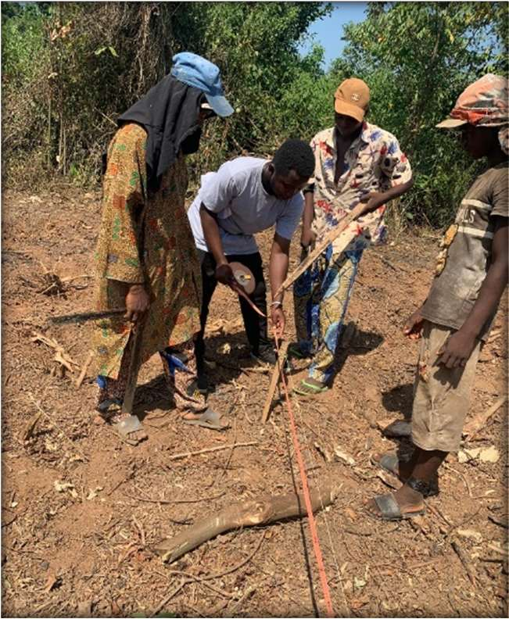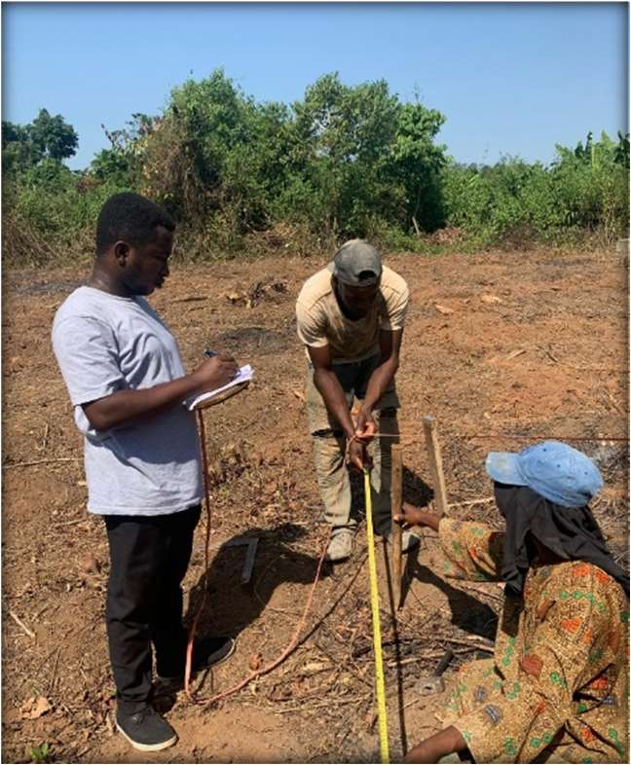
(a) (b)

Plate2aandb:Setting out of Self-containedunitsanda3-BedroomFlatatIdo Local Government, Ibadan, Oyo State
The 3-4-5 method of setting out employed involves the following:

      - The building line from the road was marked out by measuring the required distance or the line along the existing buildings to the proposed site was stretched.
      - The overall lengths of the building were marked out by driving pegs on the benchmark and establishing a square corner, laying the foundation for precise measurements.

      - Pulled at a measure from a point to another point and held it ready with hammer and peg.

      - Pulled a second tape from the fourth mark at another point on the ranging to another point on the first tape.
      - The dimensions for the room and parlour self-contained unit,4.0ft. from the benchmark, were marked out.
      - 34ft. for length and an additional 4.0ft. for the width was measured and each pegged accordingly.
      - Leaving a 9ft. space for a soak away, we then moved on to delineate the 3-bedroom structure.

Lessons Learned: Through this experience, I learned several valuable lessons. Firstly, the importance of adaptability in construction projects became apparent as we encountered the challenge of working with an irregularly shaped land. We had to adjust our measurements and techniques to ensure the accuracy of the dimensions we were setting out. Additionally, I gained a deeper understanding of the 3-4-5 method and its effectiveness in establishing square corners and maintaining the integrity of the building's structure. This experience also reinforced the significance of attention to detail and precision in construction work, as even slight deviations can have significant consequences. Overall, this project enhanced my knowledge and skills in setting-out processes and instilled in me a greater appreciation for the importance of adaptability and accuracy in construction projects.

Experience at BHN Limited, Lagos-Ogun Expressway

Project: Construction and Supervision of the Drainage Path at BHN Limited, Lagos-Ogun Expressway.
Description: BHN is an award-winning market leader in logistics and haulage. BHN Limited has a large area capacity and some structures in it are still under construction, managed by Eimar Construction and Consulting LTD. The project was assigned to our company, KW-GIS Construction, as a sub-contractor. It commences from December 12, 2023 and we were expected to finish up by January 6, 2024.
The project involves the creation of a channel or system that is designed to collect and redirect water away from a particular area. This is done to prevent water accumulation, flooding, and potential damage to structures and infrastructure. The process began with careful planning and design, took into consideration the topography and surrounding environment. It involved excavation and grading to create the desired slope or gradient for water flow. As the planning and design phase was completed, the construction process began.
Throughout the construction process, we adhered to design specifications, quality control measures, and safety guidelines. Regular inspections and monitoring are conducted to ensure that the drainage path is constructed to the required standards and can effectively manage water runoff.
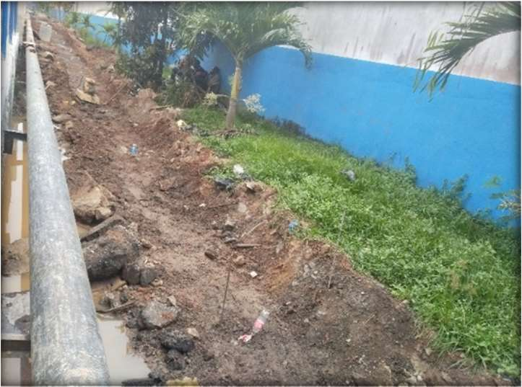
Plate3:ExcavationoftheDrainagePath

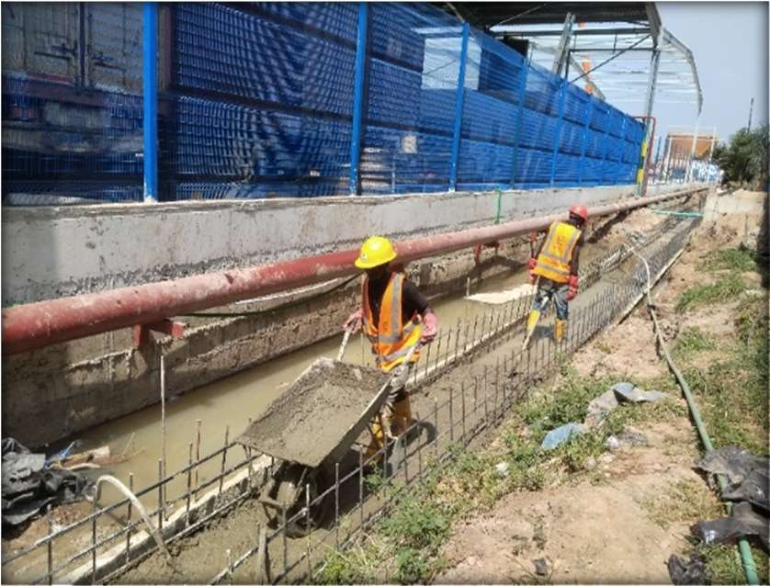

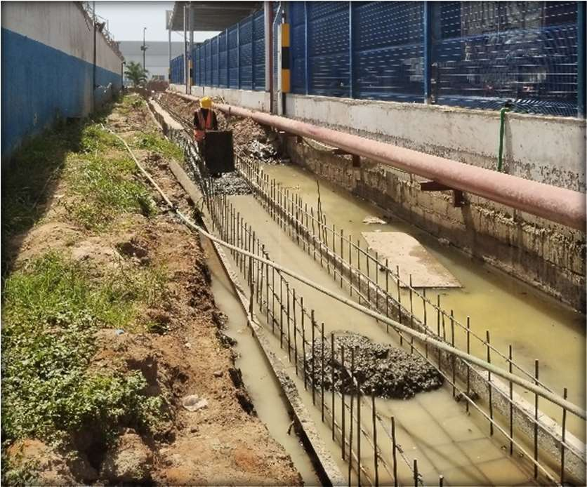Plate4:GradingoftheDrainagePath
Plate3:WorkinProgress-PouringConcrete Mix on the Drainage Path

Contribution to the Project: I was entrusted with supervisory responsibilities, which involved leading insight full meetings with the laborers. I assisted in operating the vibrator machine, ensuring uniformity in the concrete mixture and preventing segregation.
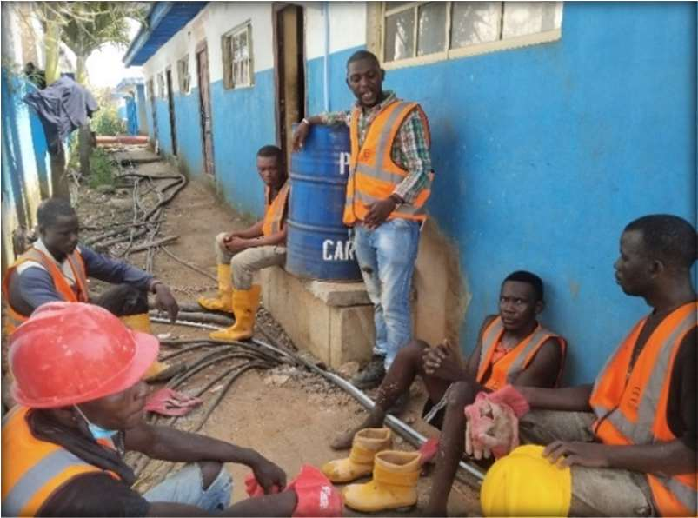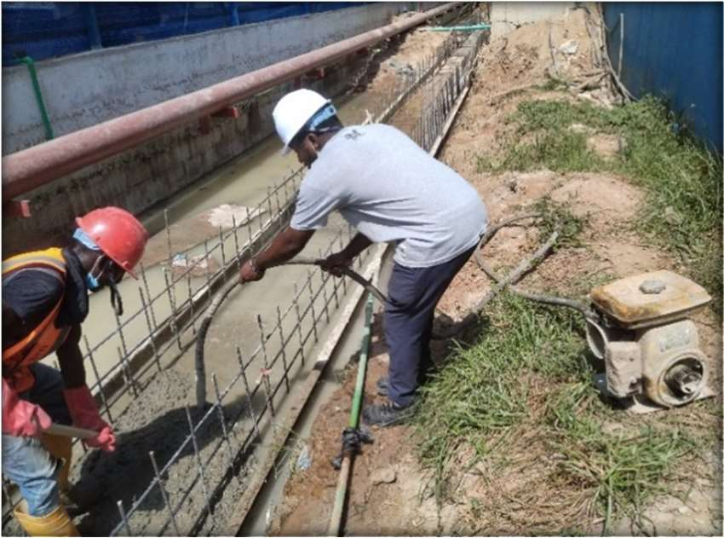
Plate6:Meeting with the Labourers Plate7:Vibrating the Concrete Mix Using Vibrator
Machine
Lessons Learned: My experience at BHN Limited taught me valuable lessons in leadership, communication, and the importance of fostering a harmonious work environment in construction. I learned that effective communication and proactive intervention are key in resolving conflicts and maintaining a positive atmosphere on site. Additionally, I realized the significance of attention to detail in executing construction tasks, particularly in concrete work.

Experience at the Engineering Design Studio

Design of Proposed Residential Development for Mr. Timieri Evin Ellington, Situated Along Harmony Avenue, Behind Jakande Estate, Off Isheri Road, Oshodi/Isolo Local Government Area, Lagos State.
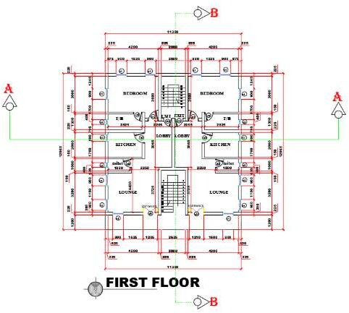
Figure12:First Floor Architectural Plan of Proposed Residential Development for Mr. Timieri
      - Design Data:

F_{CU}=20N/mm²

F_{y}=385N/mm²γ._{cοnc}=24N/mm²
C_{Cοv}(BeamandColumn)=25mm

C_{Cοv}(Foundation) = 50mm Thickness of Slab = 150mm Thickness of Raft Slab=200mm

Dimension of Floor Beams=225mmx450mm Dimension of Columns = 225 x 225mm
      - Manual Analysis and Design of Slab:
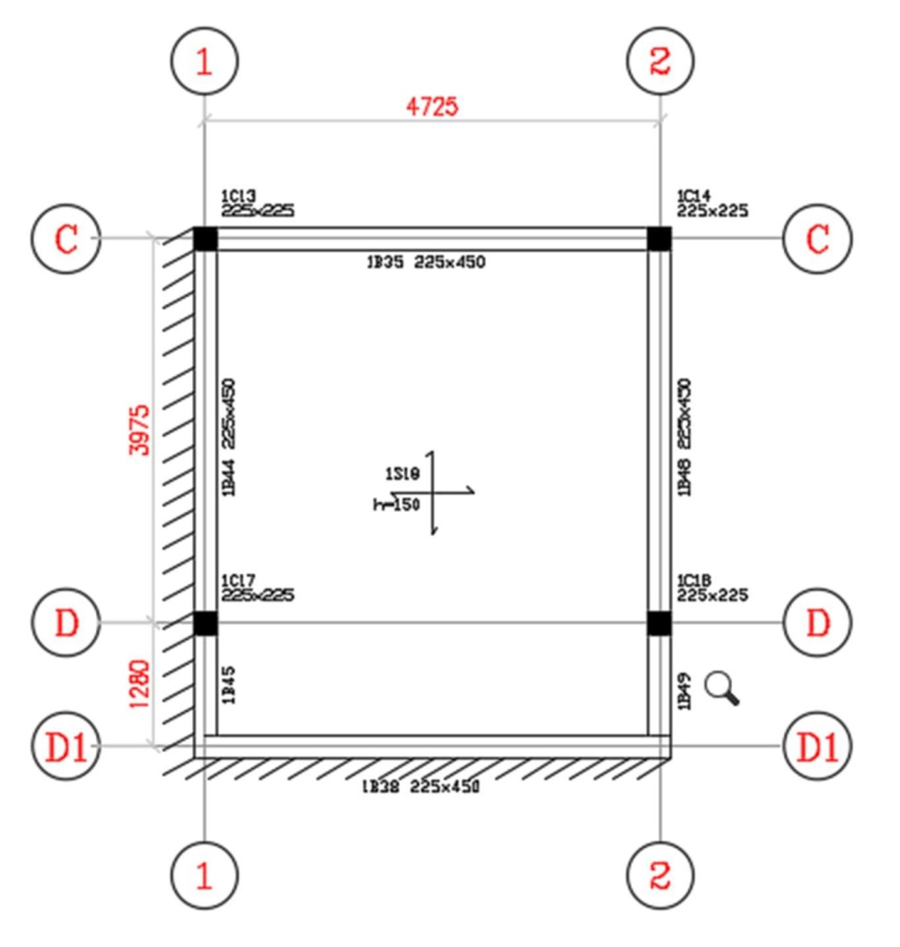
Figure 13: Critical Panel of the Floor Layout - Proposed Residential Development for Mr. Timieri The floor slab (panel) is spanning in two directions since the ratio (k) of the longer side (Ly) to the shorter side(Lx) is less than 2.It is also important to note that it is discontinuous at two adjacent edges.
Hence,k=ly=5.255=1.112(say1.2)
lx 4.725

- Slab Loading

Self-weigh to fload = Heigh to fSlab×γ._{cοnc}=0.15×24=3.6KN/m²

Finishes=0.05×24=1.2KN/m²

Partition=1 KN/m²

Total Dead Load, G_{k}=5.8KN/m²Live Load, Q_{K}= 2 KN/m²
FactorofSafety,n=1.4G_{k}+1.6Q_{K}=1.4×5.8+1.6×2=11.32KN/m²

Moments
Moment coefficients (α)Two adjacent edges discontinuous, picked from table3.14of the (BS 8110-1:1997, Structural Use of Concrete - Part 1: Code of Practice for Design and Construction, 1997);
Short
Mid−span=0.063,Continuous−edge=0.047

Long
Mid−span=0.034,Continuous−edge=0.045
Msx+=βsx+nlx²=0.063×11.32×(4.725)2=15.92KN. m
Msy+=βsy+nlx²=0.034×11.32×(4.725)2=8.59KN.m
Msx-=βsx-nlx²=0.047×11.32×(4.725)2=11.88KN.m
Msy-=βsy-nlx²=0.045×11.32×(4.725)2=11.37KN.m

Area Calculation for the ShortSpan:

Midspan (Msx+) = 15.92KN.m Effective depth ratio, d = h−C. construction:
d=150−25−6=119mm;

COV

−ф,assuming ϕ=12mmwillbeemployedforthe
2

b=1000mm(designing per unit width)

M 15.92×10⁶

k=
Fcu
bd²=20×1000×119²= 0.056,

Since k<0.156,singly reinforcement required.

z=d(0.5+√0.25−
k 0.9
)=d(0.98)

use 0.95d=0.95×119=113.05mm,

A M 15.92×106
Sreq= =

=385.02mm2

0.95zFy 0.95×113.05×385

Provide ϕ 12mm@200centre to centre spacing B1 A_{s} provided = 566mm²
Note:The above procedure will be repeated for Continuous Edge(Msx-) of the shorts pan.

Area Calculation for the Long Span:

Mid span (Msy+) = 8.59 KN.m Effective depth ratio, d=h−C. construction:

COV

−ф, assuming ϕ=12mm will be employed for the
2

d=150−25−6−12=107mm;
b=1000mm(designing per unit width)

M 8.59×10⁶

k=
Fcu
bd²=20×1000×107²= 0.038,

Since k<0.156, singly reinforcement required.

z=d(0.5+√0.25−
k 0.9
)=d(0.98)

use 0.95d=0.95×107=101.65mm,
A M 8.59×106 2
Sreq=0.95zfy=0.95×101.65×385=231.05mm

Provide ϕ 12mm@200centre to centre spacingB2 A_{s} provided = 566mm²
Note:The above procedure will be repeated for Continuous Edge (Msx-)of the short span.

- Deflection Check:
Actual Span=^{l} =4.725=39.71
d 0.119

Allowable Length= Basic^{l}×Mf
d

=26×2=52

Since Allowable Length,52>Actuallength,39.71,then Deflection is OK.

The area of steel provided satisfies serviceability limit state requirements. The full detailing of the floor slabs is as shown below.
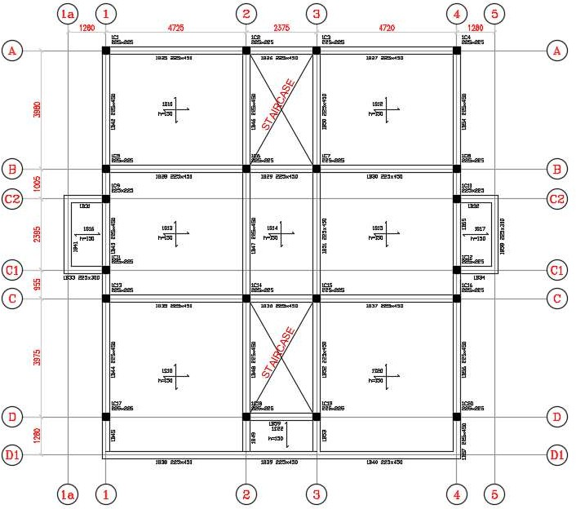

Figure14:The First Floor Slab, Column and Beam Layout of Proposed Residential Development for Mr. Timieri

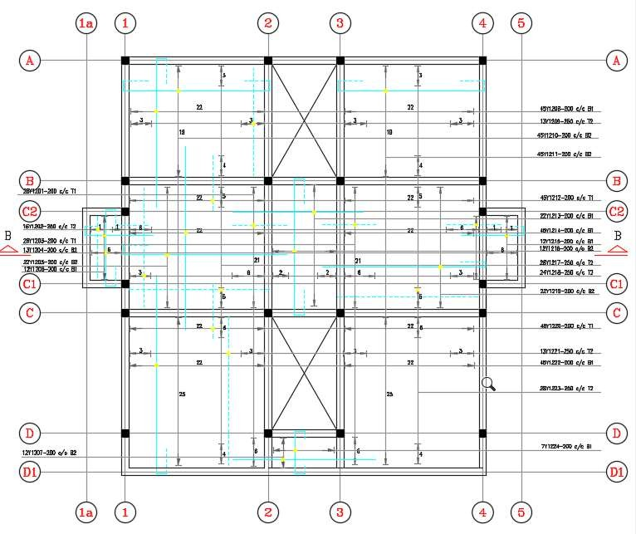

Figure15:The First floor Slab Reinforcement Details of Proposed Residential Development for Mr. Timieri
      - Design of Beam: Let us take Beam No 1 from the GA as a design case study: The loading of the beam has been carried out as shown below. The beam is primarily subjected to load from the slab, the weight of wall, and its own self-weight. To see how to manually calculate the loading on beams, follow the link at the end of the post.
The internal forces from Orion software for Beam No1 is as shown below. Load

decomposition using finite element analysis was used for the load transfer.
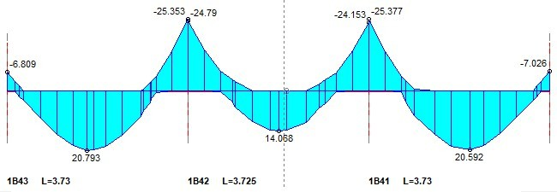

Figure16:BendingMomentDiagram

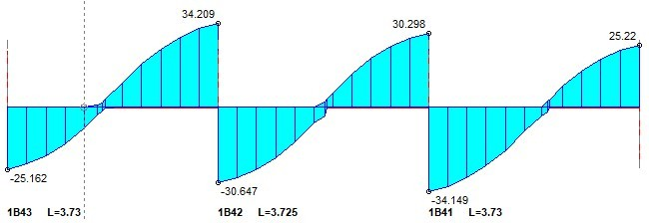
Figure17:ShearForceDiagram

Effective depth ratio, d=heigh to f column−C.
ф COV− 2−
^{ф}, assuming ϕ=16mm
2

d=450−25−8−8=409mm;
b=225mm

M 25.377×10⁶

k=
Fcu
bd²=20×225×409²=0.034,

Since k<0.156,singly reinforcement required.

z=d(0.5+√0.25−
k 0.9
)=d(0.96)

usez=0.95d =0.95×409 =388.55mm

A M 25.377×106
Sreq= =

=178.57mm2

0.95zFy 0.95×388.55×385

Provide2ϕ16mm

A_{s} provided=402mm²
The detailing of Beam No1 is as shown below;
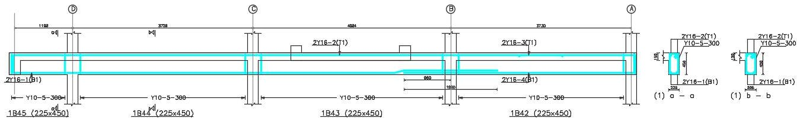

Figure18:Beam Details and Section of Proposed Residential Development for Mr.Timieri

      - Design of Column: Loads from slabs and beams are transferred to the foundations through the columns. In typical cases, columns are usually rectangular or circular in shape. Normally, they are usually classified as short or slender depending on their slenderness ratio, andthis, in turn, influences their mode of failure. Columns are either subjected to axial, uniaxial, or biaxial loads depending on the location and/or loading condition.
The column axial loads have been obtained by summing up the reactions from all the beams supported by the columns, including the self-weight of the column.
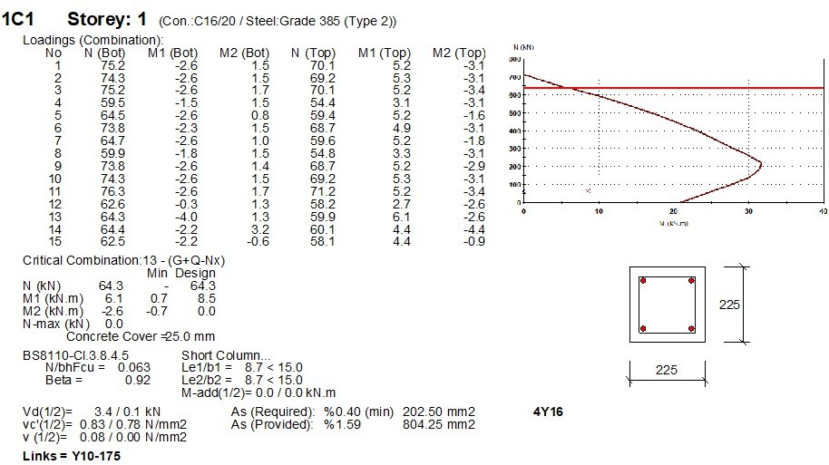

Figure19:Column C1 Details/Design Report for the Proposed Residential Development for Mr.
Timieri
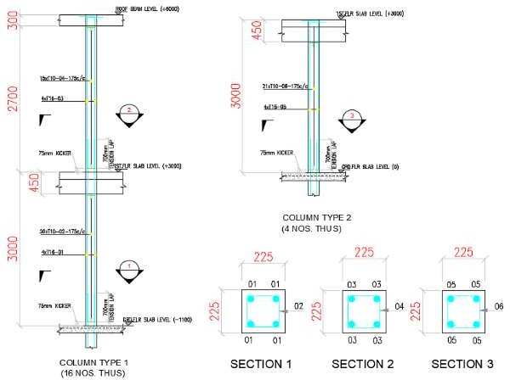
Figure20:Column Reinforcement Details/Sections for the Proposed Residential Development for Mr. Timieri

      - Design of Staircase: Staircase is an important component of a building providing access to different floors and roof of the building. It consists of a flight of steps (stairs) and one or more intermediate landing slabs between the floor levels. Staircase is a structure enclosing a stair. The design of staircase, therefore, is the application of the designs of the different elements of the staircase.
Architectural considerations involving aesthetics, structural feasibility and functional requirements are the major aspects to select a particular type of the staircase.
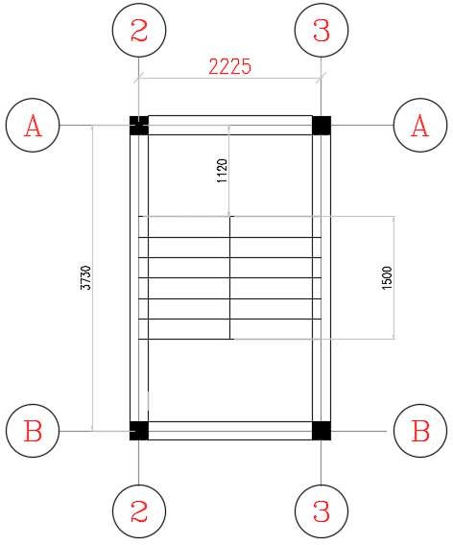
Figure21:Staircase Plan and Dimension for the Proposed Residential Development for Mr.
Timieri

In order to determine the load on the landing and the load on the going, the following details must be edited on the excel file – just as seen in Figure 22:
Effective span=3m
Thickness of waste slab=150mm Riser = 150mm
Tread=250mm
Concrete cover(𝑓_{cu})=20𝐾𝑁/𝑚²
Steel grade(𝑓_{y})=385𝐾𝑁/𝑚²

Number of Tread=6
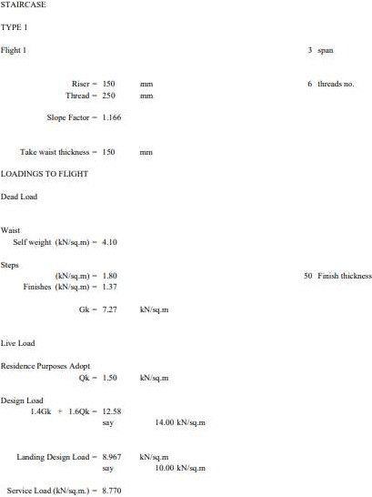

Figure22:StaircaseLoadingCalculationusingExcel

The values of the loadings for the flight and landing will be used to determine the moment from Beamax– just as seen in the below figure:
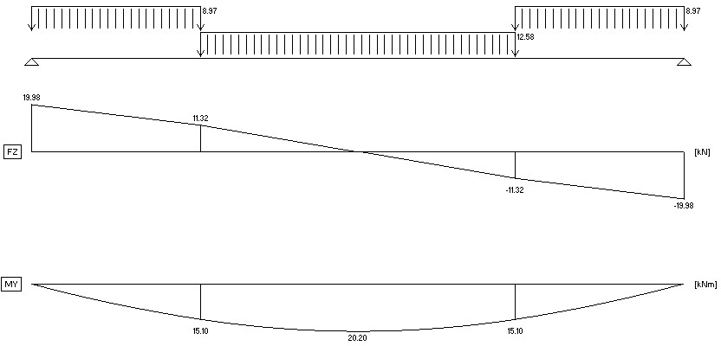

Figure23:Moment and Shear Force Diagram swith Values for the Staircase Plan

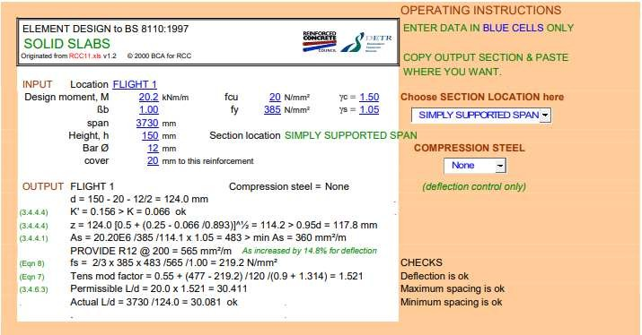

Figure24:Element Design to BS8110Templatet oDeterminetheAreaofReinforcementsforthe Staircase
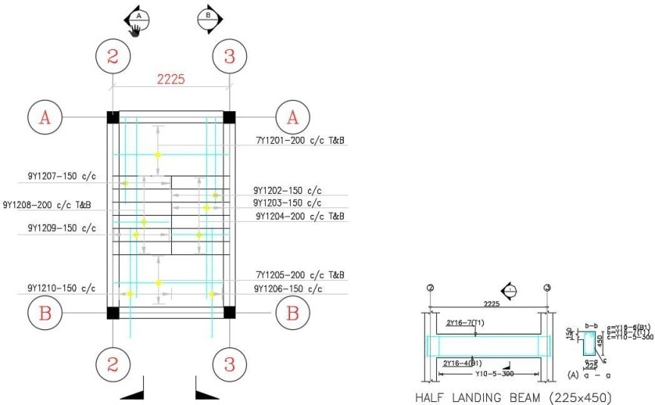
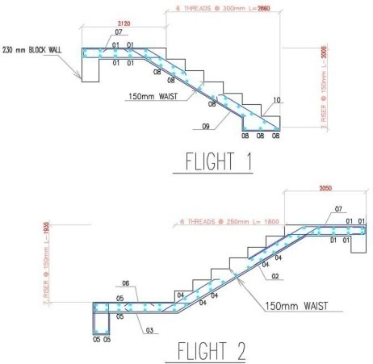

(a) (b)

Figure25aandb:StaircasePlanandStaircaseReinforcementDetails

      - Design of Foundation: All loads from the superstructure of a buildingare transferredto the ground. If the foundation of a building is poorly designed, then all the efforts input in designing the super structure was in vain. It is therefore imperative that adequate care is taken

in the design of foundations. Foundation design starts with a detailed field and soil investigation. It is very important to know the index and geotechnical properties of the soil, including the soil chemistry, so that the performance of the foundation can be guaranteed.
All design parameters are shown in table1, 2 and 3.

Parameter | Notation | Value
Yield strength of steel | 𝑓_{y} | 385MPa
Strength of concrete | 𝑓cu | 20MPa
Young modules of elasticity | E | 5000
Dead load factor | D.L.F | 2
Live load factor | L.L.F | 1.5
Soil Unit weight | γ soil | 18kN/m³
Allow able Bearings tress | 𝑞_{a} | 50kN/m²
Concrete Unit weight | Γ concrete | 24kN/m³
Table1:Parameters used in Raft Foundation Design

Load type | Load case | Loadvalue(kN/m2)
Services | Dead | 2kN/m²
Slab own weight assumed | Dead | 6kN/m²
Flooring | Dead | 1kN/m²
Live loads | Live | 1.5kN/m²
Table2:Raft Loads

Soil type | Loosesand
Effective bearing stress for the soil | 50kN/m²
Sub-grade modules | 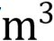5000kN/
Concrete strength of raft | 20MPa
Reinforcement Steel strength | 385 MPa
Table3:Properties taken in Raft Foundation Design
The values of the properties and parameters in the above tables were used in design the top and the bottom reinforcement for the raft. The maximum moments in each direction will be used to design the reinforcement in all raft strips.
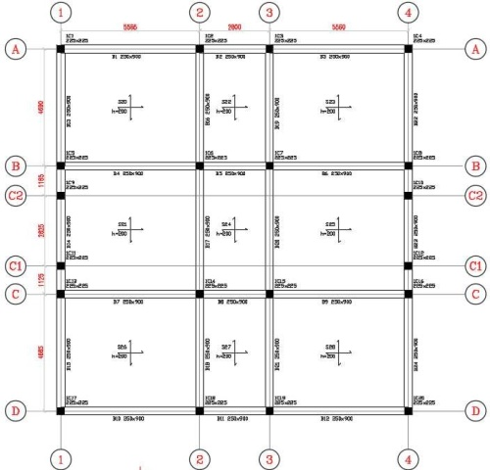
Figure26:Raft Foundation Layout of the Proposed Residential Development for Mr.Timieri
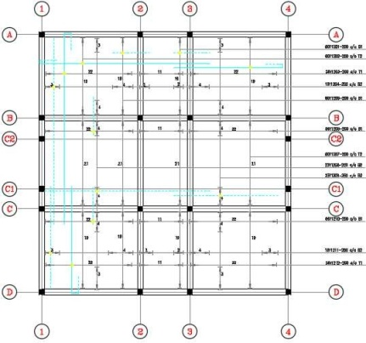
Figure27:RaftSlabReinforcementDetailingoftheProposedResidentialDevelopmentforMr.
Timieri

The structural analysis and design of all members have been fully done, including a step-by-step modeling and design on Orion 18, and how to manually design. See the completed models below:
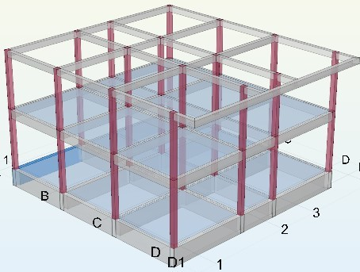

Figure28:The3DViewoftheProposedResidentialDevelopmentforMr.TimieriEvinEllington, Situated Along Harmony Avenue, Behind Jakande Estate, Off Isheri Road, Oshodi/Isolo Local Government Area, Lagos State.

Other Experiences Gained

Virtual Learning on Building andConstructionManagement2.0(Udemy)

During the period of my industrial training at KW-GIS Construction Company, when there wasn’t significant project to work on, I used the opportunity to acquire knowledge from the online educational platform, Udemy on Civil and Construction Management 2.0 course. I gained valuable insights into the key responsibilities, future trends, scope, and processes of Civil and Construction Management.
One of the primary responsibilities of Civil and Construction Managers is effective project management. This includes tasks such as project planning, resource allocation, scheduling, cost

estimation and control, quality control, and risk management. These responsibilities are crucial for ensuring the successful completion of construction projects.
The future of building and construction management is marked by significant trends. Greenconstruction practices are becoming increasingly important, as sustainability and environmental considerations take center stage in the industry. Digitalization is also transforming the field, with the adoption of technologies such as building information modelling (BIM) and artificial intelligence (AI) toenhance efficiency and decision-making processes.


Figure29:TheCertificateofCompletiononFundamentalCourseinCivil&Construction Management 2.0 from Udemy
The scope of building and construction management covers various phases of a construction project. The Pre-Construction phase involves conducting feasibility studies, project planning, site selection, obtaining necessary permits and approvals, and cost estimation. The Construction phase focuses on executing the project according to the established plans and specifications. Lastly, the Post- construction phase involves activities such as financier inspection, final inspection, rectifying defects and deficiencies, and ensuring a proper handover of the completed project.

Furthermore, I was able to understand the steps and processes of building and construction management which entails pre-construction, design and engineering, procurement and resources management, construction execution, quality control and safety, project documentation and reporting and the project hand-over and follow-up.
This knowledge will undoubtedly contribute to my growth and success as a professional in the construction industry.

Preparation of Cost Estimation Using Excel Spreadsheet

Cost estimation involves estimating the costs associated with various elements such as labour, project activities, equipment, and overhead expenses. Cost estimation plays a critical role in the successful execution of construction projects, as it provides an accurate and realistic projection of the financial resources needed to successfully execute a project. By accurately predicting the financial requirements of a project, stakeholders can make informed decisions, allocate resources effectively, and ensure project profitability.
Preparing an accurate cost estimation requires careful consideration of various factors. Here are some essential details to gather before starting the estimation process:
      - Project Scope: A clear understanding of the project scope is crucial. This includes the project's objectives, deliverables, and any specific requirements or constraints.
      - Design and Engineering: Detailed architectural and engineering plans provide critical inputs for cost estimation. These plans should include specifications, drawings, and any relevant technical documentation.
      - Material Costs: Gathering accurate information on material costs is essential. This includes prices, quantities, and any fluctuations in market rates or availability.

      - Labour Costs: Understanding the labor requirements and associated costs, including wages, benefits, and productivity rates, is essential for accurate estimation.
      - Project Location: Considering the project location for each material is very important to determine the buying cost and transportation cost of the materials.
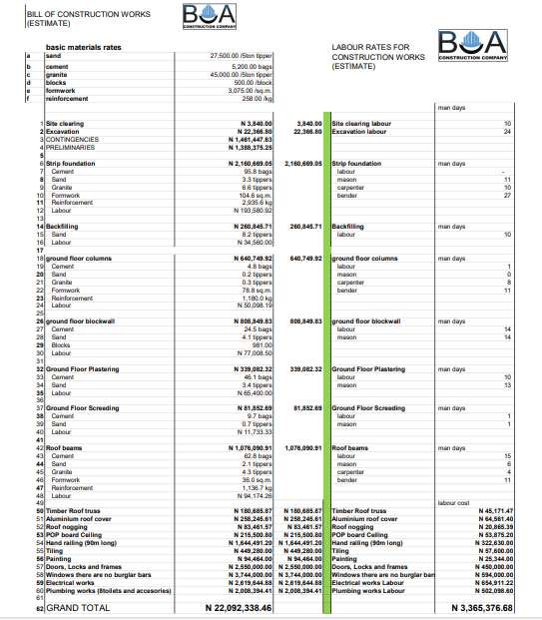
Figure30:TheCostEstimationfora3-bedroomFlatBuildingProject

Cost estimation is a critical aspect of construction project management. By understanding its importance and following a systematic approach, project stakeholders can make informed decisions, effectively allocate resources, and ultimately ensure the success of their construction projects. Utilizing Excel spreadsheets can simplify the estimation process, providing a structured framework to develop accurate and reliable cost estimates.

Preparation of Bar Bending Schedule

Bar bending schedule is a list of reinforcement bars for a given reinforced concrete work item, and is presented in a tabular form for easy visual reference. The bar bending schedule summarizes all the needed particulars of bars - diameter, shape of bending, length of each bent and straight portions, angles of bending, total length of each bar, and number of each type of bar. This information is a great help in the following:
      - preparing an estimate of quantities

      - ensuring that reinforcement cutting, bending, and placement are carried out in the most efficient manner on site
      - guiding against the excessive waste of reinforcement by minimizing the number of useless off cuts
      - fast tracking construction and supervision
      - planning, detecting in consistencies, and save costs in the handling of reinforcements

In preparing the bar bending schedule as in Plate 8a, b, c, d, e, f & g, I began with the appropriate study of the reinforcement detailing drawings and the following checklists guided me:
- Check the concrete cover to each face

- Check the lapping length for tensions and compression bars of each structural elements

- Check the direction of bend of each bar

- Group each structural unit and floor by floor, starting with the footing and proceeding to the other structural elements.
- Bar mark must start from 01 and increasing up ward consecutively

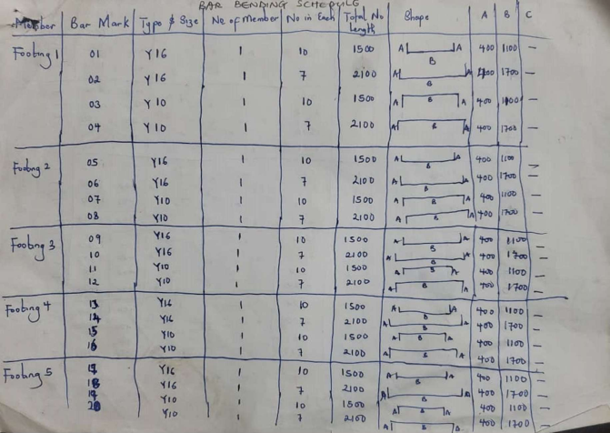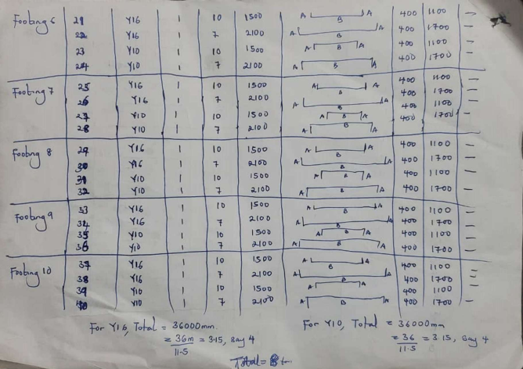
(a) (b)
(e)
(f)
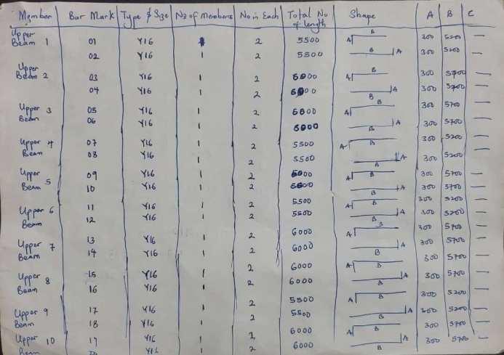
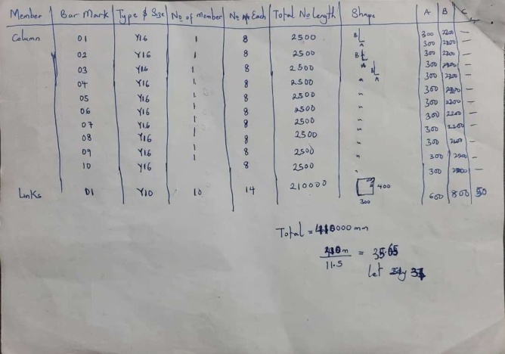
(c) (d)
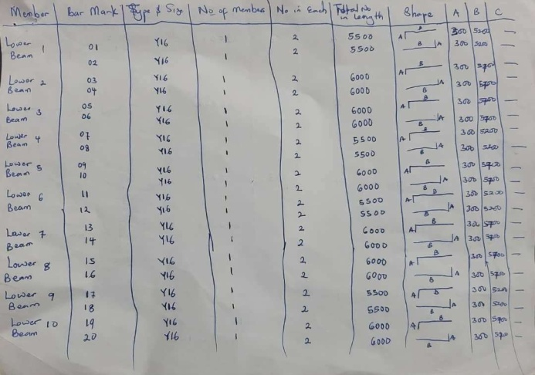
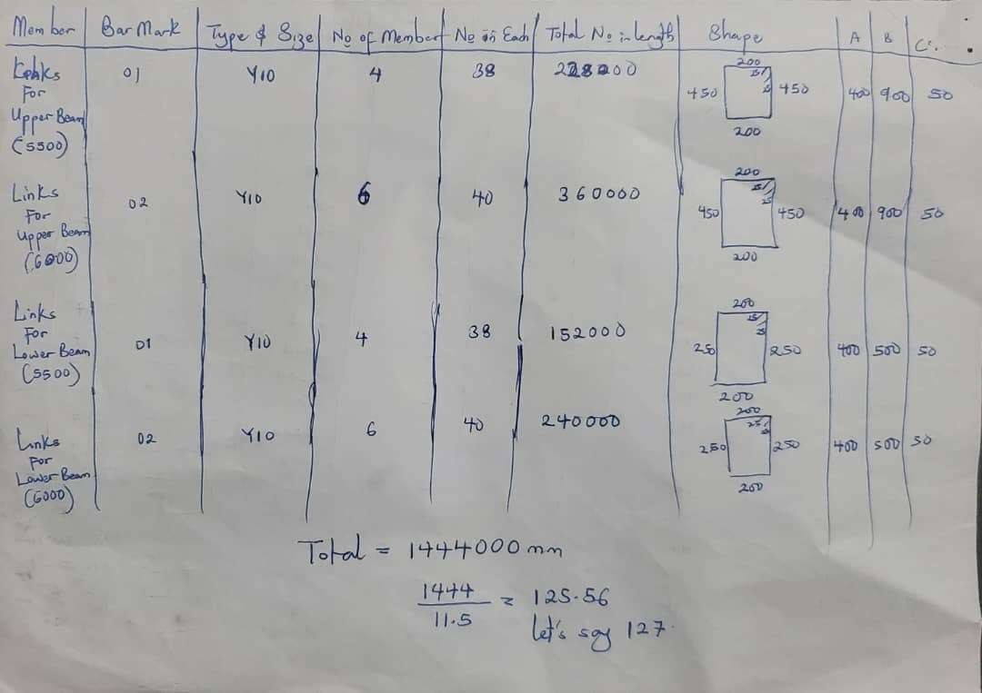
(e)
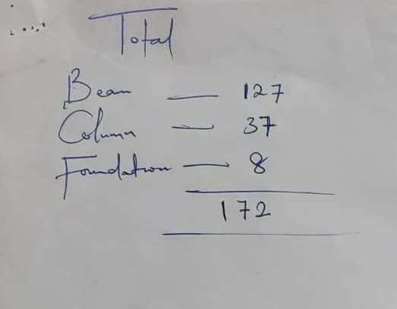
(g)
Plate8a,b,c,d,e,f&g:BarBendingScheduleforaProposedTrainingSchoolatBHNLimited

Preparation of Gantt Chart Using Microsoft Project

A Gantt Chart is a visual representation of a project schedule that shows the tasks, their durations, and the dependencies between them.It can be useful for both small and large construction projects. The chart provides a clear overview of the project timeline, allowing project managers and team members to understand the sequence of tasks and track progress. In the context of a construction project, a Gantt Chart plays a crucial role in project management. It helps in scheduling and coordinating various activities, allocating resources effectively, and ensuring that tasks are completed in a timely manner.
To create an accurate Gantt Chart, you will need the following details:

      - Task list: Identify all the tasks required to complete the construction project. Break down the project into smaller, manageable tasks that are specific and measurable.
      - Task duration: Estimate the time it will take to complete each task. This information will help determine the length of each bar on the Gantt Chart.
      - Task dependencies: Determine the relationships and dependencies between tasks. Sometasks may need to be completed before others can start, while some may be parallel or independent.
      - Resource allocation: Assign resources, such as labor, equipment, and materials, to each task.

This ensures that the necessary resources are available when needed and helps in managing resource constraints.
      - Project start date: Define the project start date from which the Gantt Chart will be created.

This sets the foundation for scheduling the tasks and determining their respective start and finish dates.

Also, before preparing the Gantt Chart as seen in Figure31, I went through a checklist to ensure that I have the necessary information and a clear understanding of the project requirements. Here are some key points considered:
- Define project objectives: Clearly establish the goals and objectives of the construction project.
- Identify stakeholders: Determine the individuals or groups who have a vested interest in the project's success.
- Gather project data: Collect all relevant project information, including task details, timelines, and resource availability.
- Communicate with the team: Engage with the project team members to ensure that everyone is aligned on the objectives, tasks, and timelines.
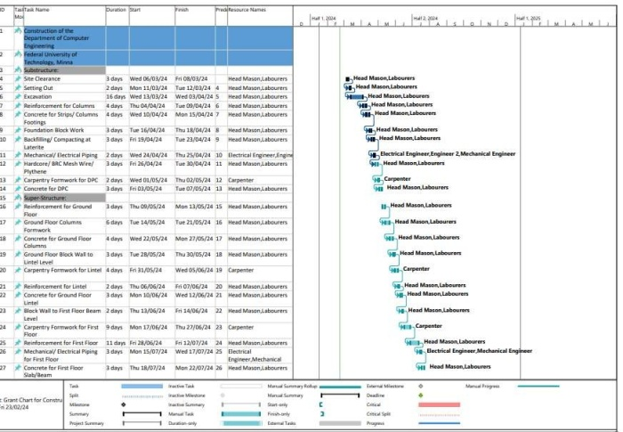
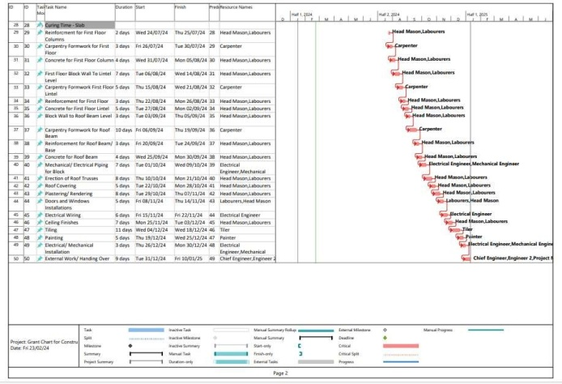
Figure31:The Gantt Chart for the Construction of Computer Engineering Department

CHAPTER FOUR CHALLENGE SAND SOLUTIONS PROFERRED

Challenges Encountered in Course of Work

The following challenges were encountered in the course of my industrial training at KW-GIS Construction Company, either in the engineering design studio or on the site:

In the Engineering Design Studio:

    - Insufficient Information on the Architectural Plan: Before going into designing, modelling and analyzing a particular project, there is an architectural plan of that project that is needed to be checked to know the right dimensions used and to find a strategic point to place the columnsinthatproject.Someofthearchitecturalplanswereceiveddoesnothavedimensions, or the dimensions are not clearly seen and the related elements of the plans cannot be find. This made works very difficult and delay the submission of the structural working design, as it takes more time in the conceptualization process.
    - Cost of Printing: The economic in stability of the nation has really affected the cost of printing working drawings. Likewise, the location of our company acts as a factor affecting the cost. With that, there is higher financial need in getting a full structural working drawing of residential development project printed.

On-Site:

- Tight Scheduling: There was this particular project, the construction of drainage pa that BHL Limited, along Lagos-Ogun State Expressway, that came in around December 12, 2023 and we were expected to finish up by January 6, 2024. Due to the some challenges found in the

site ground, most especially the partially flood area caused by the heavy downpour and the leak age in the pipe used to transfer water for the construction of other projects along the area and alongside with the number of labours available, it seemed difficult to achieve our goal within the stipulated schedule.
- Unavailability of Materials: Using the construction of drainage path at BHN Limited, along Lagos-Ogun State Expressway as case study, the transportation of the materials needed, such as the concrete mixture and reinforcement bars, for the construction were being scheduled and synchronize. We even need to wait until it gets to our turn to have the materials, as a lot of construction and engineering activities were going on and as such, had an impact to the construction schedule.
- Conflicts among the Labourers: While on work, some labourers were found fighting over in activeness, lack of productivity, and poor attribute towards work. This caused a little delay in the project.
- Communication Barrier: Still using the construction of drainage pa that BHN Limited, along Lagos-Ogun State Expressway as a case study-This project was assigned to our company as sub-contractor. While we visited the site for inspection, we got to notice that the main contractor for the project is a Lebanese and other key professional working on other construction activities are from Lebanon; it was not easy for us to comprehend with the way they were delivering with English language using their native intonation.

Solutions Proffered to the Challenges

The solutions proffered to the challenges I encountered during my industrial training at KW-GIS Construction Company are:

In Engineering Design Studio:

    - In order to the insufficient information on the architectural plan, we established a clear communication channel with the architects responsible for providing the architectural plans. We requested comprehensive dimensions and ensured that all relevant elements are clearly visible on the plans.
    - Given the economic instability and the impact of location on printing costs, we explored alternative printing options – by transporting to nearby printing press firm that offers competitive and affordable prices. Afterwards, we fixed our company’s printer in order to be able to print by ourselves with little or no cost.

On-Site:

- When we were faced with a tight schedule, we identified potential challenges and develop contingency plans. We also assessed the site conditions, including potential flooding areas, on the first day of visit in order to know whether the construction methodologies already used can be adjusted and also, to secure additional resources.
- To mitigate the impact of material availability on construction schedules, we established strong relationships with suppliers within the site and engaged in proactive planning. We maintained regular communication with suppliers to monitor material.
There was a proactive intervention, which prevented a potential escalation of the conflicts into something more serious. Then, there was a meeting between us and the labourers in which we address the causes of the conflicts among labourers, created a positive work environment and encouraged open communication channels.

- Overcoming communication barriers with individuals from different linguistic backgrounds requires a proactive approach. The only issue we had is that the spoken English language was not fluent enough. In order to bridge the communication gap and facilitate effective collaboration, we decided to listen carefully and pay attention to details to every statement made

CHAPTER FIVE CONCLUSIONANDRECOMMENDATION

Conclusion

The Students’ Industrial Work Experience Scheme (SIWES) has helped in shedding more light on the theoretical aspect of some of the courses previously taken in school classes. It gave me more experience into the codes and ethics governing civil engineering practices and civil construction works. Through this industrial training, I have gained new insight and more understanding about the real industrial working conditions and practices and have improved my soft and functional technical skills.
The eighteen-week duration of the programme at KW-GIS Construction Company has provided me with valuable hands-on experience and knowledge on structural design and analysis, structural calculation, contract negotiation, cost estimation, project evaluation and management, site coordination, preparation of Gantt charts and bar bending schedule, project presentation and execution, building interpersonal relationships on-site and dealing with clients. These experience gained were not only acquired through the direct involvement in task, but also through other aspects of the training, such as observation and interaction with colleagues and other people related to the field. Because of this programme, my mind has been prepared for who I will become, my importance, and my roles in the society, and I am now confident to build my future career.

Recommendation

After the eighteen-week duration of the programme at KW-GIS Construction Company, I would like to make the following recommendations, which must be done to improve the industrial training and to make it more efficient and challenging in future:
    - Proper Planning: It is crucial that the SIWES programme be well planned by the university and properly fixed into the academic calendar properly so that the required period of the training will not be compromised, and so that the quantity and quality of the experience gained are augmented.
    - Adequate Monitoring: The school officials should monitor the activities of IT students and make more regular visits to ensure that the objectives of the scheme are achieved.
    - Financial Assistance: To ease the financial burden on students especially on transport, ITF should endeavor to pay the allowances stipulated to the students. In addition, the company should encourage students by providing financial support to aid them during their industrial training programme.
    - Accessibility: Establishments should provide the necessary growth tools related to the field and grant access to students to make use of them in order to have a practical understanding on how to use them and to make the programme enjoyable.
    - Foundational Learning: Students should have learnt the basics of some Civil Engineering related software like AutoCAD, Orion 18, and Prota Structure before the industrial training, so that they will be more easy for the Industry-based supervisor to provide further assistance without going back to the basics again.

REFERENCES

(1997). In B. a. Technical Committee B/535, BS 8110-1:1997, Structural Use of Concrete - Part 1: Code of Practice for Design and Construction (pp. 26-81). Bristish Standard.
Ambrose,S.(2021).Students Industrial Work Experience Scheme: SIWES Report. Jite Projekts Ltd.
Association, C.S. (2011). Essential Materials Sustainable Solutions. Retrieved from CSMA: https://ukcsma.co.uk/what-is-ggbs/#:~:text=GGBS%20(Ground%20Granulated%20Blast- furnace,iron%20ore%2C%20coke%20and%20limestone
BOA. (n.d.). Homepage. Retrieved from KW-GIS Construction Company: https://boaconstruction.com.ng/
Mrs, B. Y.-I. (2015, November 1). Influence Of Students' Industrial Work Experience Scheme On Professional Development Of Library And Information Science Students In South-West, Nigeria. Library Philosophy and Practice, 1. Retrieved from https://api.semanticscholar.org/CorpusID:155988869
Uzodimma, U. O. (2017, March). Structural Analysis and Design of Residential Buildings Using Staad Pro, Orion, and Manual Calculations. Retrieved from Structville: https://structville.com/2017/03/structural-analysis-and-design-of-residential-buildings-
using-staad-pro-orion-and-manual-calculations.html
Oyenuga(2011).Simplified Reinforced Concrete Design. 2nd edition. Vasons Concept Engineering Series.

