

TECHNICAL REPORT ON
STUDENT INDUSTRIAL WORK EXPERIENCE SCHEME (SIWES)

Held at

LUTONIAN AUTO-TECHNICIAN COMPANY
ORITA-NAIRA JUNCTION, OGBOMOSO OYO STATE.

By
OKENIYI OLUWATIMILEYIN MICHEAL
ND/23/MEC/PT/0030

DEPARTMENT OF MECHANICAL ENGINEERING, INSTITUTE OF TECHNOLOGY (I.O.T), KWARA STATE POLYTECHNIC, ILORIN.
IN PARTIAL FULFILLMENT OF THE REQUIREMENT FOR THE AWARD OF NATIONAL DIPLOMA (ND) IN MECHANICAL ENGINEERING.

AUGUST – NOVEMBER, 2024.
DEDICATION
This report is dedicated to Almighty God and my parents who really know the value of education.

ACKNOWLEDGMENT
First and foremost, my utmost thanks to Almighty God for his infinite mercy, wisdom and power to carry out this report.
I will like to express my profound gratitude and appreciation to my parent Mr. and Mrs. OKENIYI for their contributions financially, morally and prayerfully you will reap the fruit of your labour.

PREFACE
This technical report put together by my experience during Industrial Attachment in LUTONIAN AUTO-TECHNICIAN COMPANY, Orita-Naira Junction, Ogbomoso, Oyo State. During my industrial training I was being thought how to repair various component of an engine and there maintenance and I hope this report will be valuable to future engineers and any interested groups.

TABLE OF CONTENT
TITLE PAGE
DEDICATION
ACKNOWLEDGMENT
PREFACE
TABLE OF CONTENT
CHAPTER ONE
1.0 INTRODUCTION
1.1 Meaning of SIWES
1.2 Aim and Objectives
CHAPTER TWO
2.0 History of the Company
2.1 Organization Chart
2.2 Operation of the Company
CHAPTER THREE
3.0 STEPS OF CHANGING BRAKE PADS
3.1 CONNECTION OF BATTERIES
3.2 MAINTENANCE OF BATTERY
3.2 CHANGING OF OIL FILTERS
CHAPTER FOUR
4.0 COMPONENT PARTS OF CAR AND THEIR FUNCTION
4.1 CHANGING OF GEAR AND ENGINE
4.2 CHANGING OF CAR ENGINE
CHAPTER FIVE
5.0 CONCLUSION
5.1 PERSONAL IMPRESSION ABOUT THE ORGANIZATION
5.2 SUGGESTION TO THE POLYTECHNIC CONCERNING THE SIWES
PROGRAMME
5.3 RECOMMENDATION

CHAPTER ONE
1.0 INTRODUCTION
1.1 Meaning of SIWES
This can be defined as Student Industrial Work Experience Scheme or a place where student of technology visualized into practice of what they are been taught during the theoretical aspect in school. SIWES is to be undergone in an establishment that is relevant to One’s field of study.
Moreover is run for a period of four months after first year of study.
1.2 Aim and Objectives
SIWES is the application of practical work of the learn theoretical aspect of one’s field of study. Meanwhile the aims of SIWES as the objectives cannot be over emphasized.
Aim
- To enable student to relate classroom theory with respect to the skill gained.
- To increase the knowledge of student
- To enable student to acquire the necessary practical training and experience in their chosen field.
Objective
- It helps the student to be practically oriented
- It helps the student to relate with practical work
- It helps the student to have ability to know the practical aspect and how to perform it.

CHAPTER TWO
2.0 HISTORY OF THE COMPANY
The LUTONIAN AUTO-TECHNICIAN COMPANY was established in the year 1980 and the business name of the organization I mean company was registered on 19th Aug, 2000 with Corporate Affairs Commission (CAC), Orita-Naira Junction, Ogbomoso, Oyo State, Nigeria.
The LUTONIAN AUTO-TECHNICIAN COMPANY located at Orita-Naira Junction, Ogbomoso, Oyo State
This shows the organization chart of “Lutonian Auto-Technician Company” where I undertook my Student Industrial Work Experience Scheme (SIWES).
2.1 Organization Chart
Director
Supervisor
Secretary
Accountant
Technicians
Mate

2.2 Operation of the Company
The company basically undertakes it operations in the following areas, namely:
- Car Maintenance
- Repair of various cars like Honda, Mistibushi, Toyota etc.
- General contractors

CHAPTER THREE
3.0 STEPS OF CHANGING BRAKE PADS
- Remove the Vehicle's Brake Fluid.
- Lift the Vehicle and Remove the Wheel Assembly. ...
- Check the Brake Assembly
- Remove the Brake Pads.
- Inspect the Slide or Locate Plugs.
- Retract the Vehicle Piston.
- Add in the New Brake Pads.

Remove the wheel
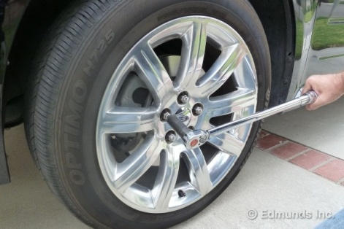
Loosen the lug nuts on the wheel. Then jack up the car and place a jack stand under the car's frame. Lower the floor jack so its weight rests on the jack stand. Fully remove the lug nuts and remove the wheel. You now have access to the brake assembly and can safely reach under the car.

Remove the slider bolt
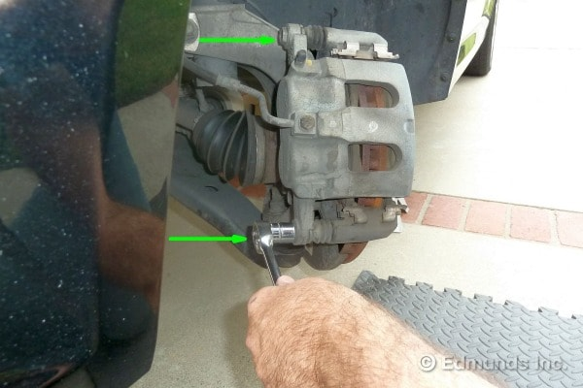
Find the two slider bolts (sometimes called "pins") that hold the caliper in place. The bolts are on the inside. It's generally only necessary to remove the lower bolt. It can be long but once it is fully loosened, it will slide out easily.

Pivot the brake caliper up
The bottom bolt removed, the brake caliper pivots up. The rubber hose, which is the hydraulic line, will flex to allow this so we do not disconnect any hydraulic brake lines and reassemble the brakes.
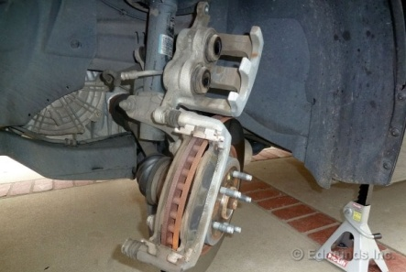
To inspect the thickness of the brake pads to confirm that they need to be changed. Most brake pads have metal wear indicators, which are small metal tabs that squeak when they contact the rotors. Even if these are not yet touching, the pads are worn out if the friction material is one-eighth of an inch thick or less at any point.

Slide out the old brake pads
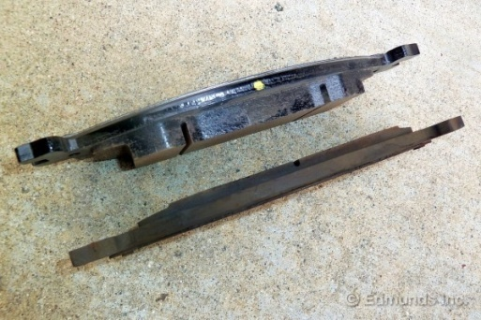
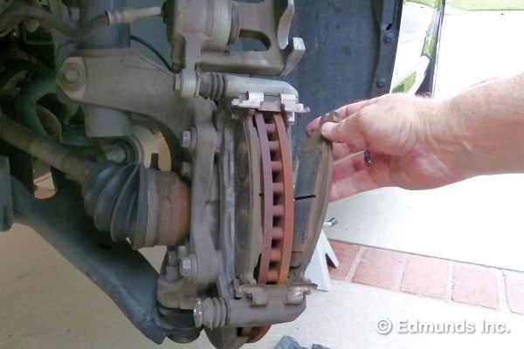
The brake pads are now exposed and the retaining clips hold them loosely in place.

Replace the retaining clips
New pads almost always come with new clips, which allow the pads to slide back and forth easily. Use the new ones and chuck the old ones. There are no retaining screws for the clips. They just snap in place. There are usually left-handed and right-handed clips, so change one at a time, making sure they match up exactly as you go.
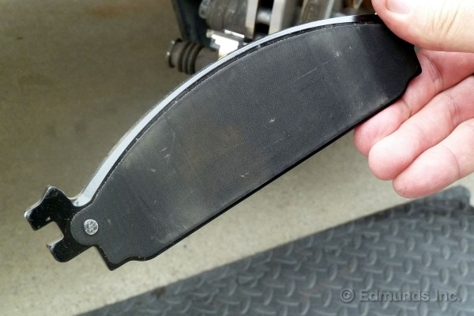
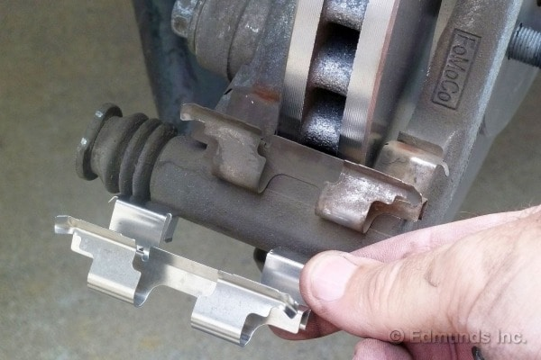

The new brake pad has a riveted-on shim, which is the thin metal plate. Some brake pads might have unattached shims that have to be temporarily held in position until you lock the pads in place. The "ears" are the metal tabs on either end of the brake pad (only the two left ears are visible here). These ears fit into the slots in the clips.

Slide in the new brake pads
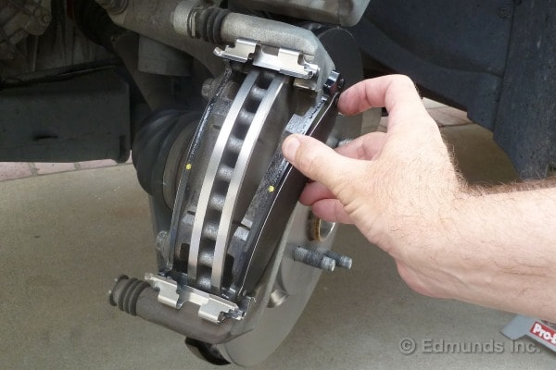
The new pads slide into place as easily as the old ones did when they came out, though sometimes the new clips will be tighter. The ears of the new pads should slot nicely into place on the brake grease you applied.

Monitor the brake fluid level
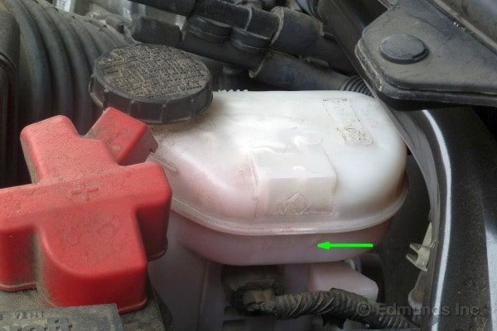
When you push the pistons back, the brake fluid level slowly rises. Open the master cylinder reservoir and check it often. This is more of a concern when you work on the second brake because the combined fluid volume of two calipers could cause the brake fluid to overflow.

3.1 CONNECTION OF BATTERIES
When connecting Batteries to an engine this should be made is series connection not in parallel connection to avoid sparking first set the positive terminal on the laid starter then the Negative terminal which can be treat on the engine body and the remaining positive and Negative terminal will be joined by cross wire they terminal should be firmly high to avoid sparking and it corroded should clean with baking Soda Water Solution & Wire brush
The cable should be fixed appropriately i.e. the Negative Cable should be fixed to the Negative terminal & the positive cable should be fixed to the positive terminal

3.2 MAINTENANCE OF BATTERY
- Constant correct charging
- Proper fixed of Battery terminal end cable clamps
- Avoid placing the battery on the ground as they may run down the battery
- Mashing of corroded battery terminals and cable clamps before fixing
- Avoid collision or Inversion and putting of any metal goods on it Top head.
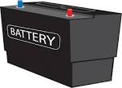
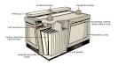

BATTERIES

3.2 CHANGING OF OIL FILTERS
The oil filter is considered a consumable, so it wears down the more you drive the car or the longer it sits. It needs regular maintenance and replacement, just like any other car component. Since you need to drain the oil out to change the oil filter, it's best to replace the oil filter when you do an oil change.

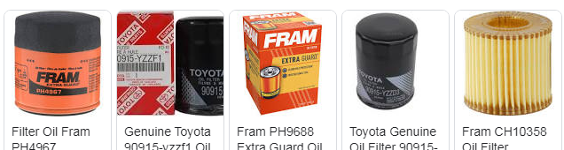

CHRACTERISTICS OF QUALITY ENGINE OIL FOR AN ENGINE
- Viscosity: This is the Thickness of the oil which however changes, with temperature different of the engine
- Energy Conserving: This reflect of frictional quality which to Conserve energy and improve fuel economy.
- The period for the oil to looses it lubricating strength
CHAPTER FOUR
4.0 COMPONENT PARTS OF CAR AND THEIR FUNCTION

1. RADIATOR
The radiator is a heat exchanger used to remove heat from the coolant in the cooling system to prevent your vehicle’s engine from overheating. Hot coolant is routed through the radiator, where the coolant can exchange heat with the passing air. For general maintenance on your radiator, check your coolant levels twice a year.

2. AC COMPRESSOR
The AC Compressor is responsible for pumping coolant throughout your system and starting the process of cooling your car. Without it, the AC system will not work.

3. BATTERY
The battery stores energy in chemical form so it can be released as electricity to run your vehicle’s electrical components. Other terms you may run into when talking about a car battery are:
- Battery Terminal: A means of connecting the battery to the vehicle’s electrical system. The three types of battery terminals are post or top, side, and L.
- Battery Capacity: The energy output of a battery measured in amp/hours.
- Cold Cranking Amps: Abbreviated CCA, this refers to the amount of current that the battery can supply to the vehicle.
- Group Size: The group size is just what it sounds like, the size of the battery. Common group sizes are: 24, 24F, 25, 34, 35, 51, 51R, 52, 58, 58R, 59, 65
- AGM: This stands for absorbent glass mat, a design in which sulfuric acid is absorbed by a fiberglass mat, making the battery spill-proof and better at holding a charge.

4. ALTERNATOR
The alternator is an electricity-generating device that converts mechanical energy to electrical energy in the form of alternating current. It is used to supply power to your vehicle’s electrical system along with the battery. The alternator also recharges the battery using mechanical energy generated by the motion of the vehicle’s parts.

5. AXLE
The front and rear axles are cross members supporting a vehicle where the wheel hubs are attached. Axles are also part of suspension system and are responsible for sending power to the wheels from the engine through the transmission and differential. They link the wheels to the vehicle and support the weight of each.

6. BRAKES
A car’s brake system is used to stop or slow a vehicle or prevent it from moving when stopped or parked. The two most common systems are disc brakes and drum brake systems. Some of the most common disc brake parts include:
- Caliper: Non-rotational components of disc brakes that straddle the disc and contain hydraulic components forcing the brake pads against the rotor to slow or stop the vehicle. Can be found in the front or rear of a vehicle.
- Brake Pad: The pad of friction material that is pressed against the disc by the caliper, to slow or stop a vehicle. It is also a term often used for brake lining.
- Brake Rotor: Disc-shaped component that revolves with hub and wheel. The lining pads are forced against the rotor to provide a friction surface for the brake system, to slow or stop a vehicle.

7. SHOCK ABSORBERS (SHOCKS AND STRUTS)
Shock Absorbers are a hydraulic device used at each wheel of the suspension system to help control the up, down, and rolling motion of a car body by dampening the oscillations or jounce of the springs when the car goes over bumps, thereby contributing to vehicle safety and passenger comfort.
A typical shock absorber has three functions:
- Dampen the effect of spring oscillation in order to control the ride stabilization of a vehicle
- Control body sway
- Reduce the tendency of a tire tread to lift off the road surface (a problem often caused by static unbalance)

8. TRANSMISSION
The transmission is a gearing device of a vehicle that provides variable ratios between the engine output and the differential input. There are two types of transmission:
- Automatic Transmission: A transmission in which gear ratios are changed automatically using automatic transmission fluid (ATF). Shifts are controlled by the engine computer. Some automatic transmissions are continuously variable (CVT), or shiftless transmissions which can change seamlessly through a continuous range of effective gear ratios.
- Manual Transmission: A manually shifted gearing device in the power train that allows variation on the relationship between engine speed and road speed.

9. FUEL TANK
A storage tank for gasoline that powers your vehicle.

4.1 CHANGING OF GEAR AND ENGINE
Gears allow a car to be driven with the minimum strain on the engine. Modern cars usually have five forward and one reverse gear, although some cars now have a sixth forward which gives greater fuel economy when driving at higher speeds over longer distances.
To change gear in a car:
- Release the accelerator pedal and at the same time press the clutch pedal down.
- Remove your left hand from the steering wheel, cup it around the gear knob and move the lever gently but positively from one position to another.
- Return your left hand to the steering wheel.
- Release the clutch pedal slowly and simultaneously apply power by pressing down on the accelerator pedal.
4.2 CHANGING OF CAR ENGINE
Remove the hood: The hood will be held in place by hinges on either side, each with two or three bolts. You and a friend will need to support the weight of the hood as you each remove the bolts connecting the hood to the hinges. Once the bolts have been removed, lift the hood off of the vehicle.
Drain all fluids from the engine: An engine uses a number of different fluids in regular use and all of it will need to be drained prior to removing the engine. Start with the engine oil, which can be drained through the oil drain plug on the oil pan.
- The fluids drained from your vehicle cannot be re-used in the new engine.
- Drain engine oil and coolant into separate containers for later recycling.
- You can bring oil and coolant too many auto parts stores to be recycled for free.
- If not used correctly, starting fluid can cause damage to the engine
Disconnect the intake, exhaust and coolant lines: The intake draws air into your engine and looks like a pipe or tube traveling from the air filter to the throttle body. Disconnect the pipe from the throttle body, then remove all the fasteners holding the intake in place and remove it from the engine bay. The exhaust can be unbolted at the bottom of the exhaust manifold.
- Expect coolant lines to drip or pour coolant as they are disconnected, so place a container beneath each as you disconnect them.
Disconnect the wiring: Depending on the era of your vehicle, there is a wide variety of wiring possibilities that you may need to address when conducting an engine swap. The more modern the vehicle, the more wiring and sensors you'll often have to contend with when disconnecting the engine.
Unbolt the engine from the transmission: Depending on how the engine is mounted in the vehicle's engine bay, the transmission may either be behind or to the side of the engine.
- Be very careful not to strip the bolts that connect the transmission to the engine block, as it will be very difficult to drill and tap out bolts with broken heads.
- Do not remove the bolts one at a time. Instead, loosen each of them a bit at a time until they are all hand loose before removing them.
Disconnect the motor mount bolts: The engine in your vehicle is likely connected by three motor mounts, with the fourth serving as the transmission mount. These motor mounts are usually made up of steel and rubber (to absorb engine vibration) with a single bolt passing through the mount to secure the engine
- If you intend to lower the engine out of the bottom of the vehicle, you will likely need to remove a cross member and place an engine jack beneath the engine.
- With the motor mount bolts removed, the engine will now be supported by the cherry picker or engine jack.
Either raise or lower the engine from the engine bay: Depending on the design of your vehicle, it may be easier to raise the engine out of the engine bay using a cherry picker, or to leave the engine where it is and raise the vehicle itself over it.

CHAPTER FIVE
5.0 CONCLUSION
The experience gained within the four months of the programme remains one of the greatest experiences that had impacted knowledge, skills and attitude in the field of mechanical engineering.
It has enhanced my knowledge about the theoretical and practical aspect of my field of study.
Finally, having passed through the industrial training, I was able to achieve the aims and objectives of the Student Industrial Work Experience Scheme (SIWES).
In fact, it really increased my understanding knowledge and made me to be courageous in the field of automobile engineering.
5.1 PERSONAL IMPRESSION ABOUT THE ORGANIZATION
The organization is well organized with good division of labour and the management setting is also organized.
Another impression about the organization is how the various sections are organized to the extent that any distance at one section affects the other section.
The staff and non-staff are so disciplined that they resume working at normal time and close at the normal time.
5.2 SUGGESTION TO THE POLYTECHNIC CONCERNING THE SIWES PROGRAMME
I suggested that various organizations should be enlightened by polytechnic concerning the SIWES programme.
I suggested that there should be chance to change the address of attachment of student at least a month after the programme as being in case they found out that cannot gain enough from the organization of attachment.
5.3 RECOMMENDATION
I recommended that the student allowance should be paid during the period of stay for the program at various establishments where the students are staying for their programme (SIWES) as to encourage the student the more.

