
A TECHNICAL REPORT
ON
STUDENT INDUSTRIAL WORK EXPERIENCED SCHEME
(SIWES)

HELD AT
DIAMOND FM, 89.3
Plot 2, New Yidi Road, Ilorin Kwara State

PRESENTED BY
SOLIU BASIRAT AJIKE
ND/22/MAC/PT/347

SUBMITED TO:
THE DEPARTMENT OF MASS COMMUNICATION
INSTITUTE OF INFORMATION AND COMMUNICATION TECHNOLOGY
KWARA STATE POLYTECHNIC, ILORIN
IN PARTIAL FULFILMEN OF AWARD ON NATIONAL DIPLOMA.

2023/2024 SESSION
DEDICATION
This technical report is dedicated to the almighty God who gave me the life, strength, ability to acquire the knowledge and practical experience for the period of my attachment of my SIWES on my field of study.

ACKNOWLEGEMENT
I’m indebted to several people who at various stages contributed towards making this industrial training programme a success. My special thanks first and foremost goes to Almighty God for the grace and enablement He gave to me during the period of my attachment and during the period of writing this technical report.
I also wish to appreciate my parent in persons of Mr. and Mrs. Peter who has helped me in all aspect of my life. You will reap the fruit of your labour. Thank you

TABLE OF CONTENT
Title page
Dedication
Acknowledgement
Table of content
CHAPTER ONE
1.0 Introduction to Siwes
1.1 Advent of Siwes
1.2 The objective
1.3 Mission |
1.4 Vision
1.5 Benefit of industrial Training
CHAPTER TWO
2.0 Brief History of Diamond FM
2.1 Mission And Objectives Of Establishment
2.2 Functions And Duties
2.3 Departments
CHAPTER THREE
3.0 Jobs Done / Experience Gained
3.1 Safety Rules and Regulations
3.2 introduction to broadcasting
3.3 The Emergence Of Broadcast Communication
CHAPTER FOUR
4.0 Siwes experience
4.1 Challenges faced during siwes
4.2 Relevance of siwes
CHAPTER FIVE
5.0 Summary
5.1 Conclusion
5.2 Recommendation
CHAPTER ONE
INTRODUCTION OF STUDENT INDUSTRIAL WORK EXPERIENCE SCHEME (SIWES)
1.0 INTRODUCTION
Student Industrial Work Experience Scheme was established by the Industrial training Fund (ITF) in 1973 with the aim of bridging the gap between the skills which the labour market required with that of those acquired by the graduate students.
Since its introduction by the ITF in 1973 the Scheme has gone through series of reforms. its management, for instance, has changed hands from the ITF to the various regulatory AGENCIES SUCH AS National Universities Commission (NUC) National board for Technical Education (NBTE) and National Commission for college of Education (NCCE) and now back to the ITF again. These are the major stakeholders in (SIWES).
Consequently, SIWES Programme was introduced into the curriculum of tertiary institutions in the country as far back as 1974 with 748 students from 11 institutions of higher learning.
However, the scheme has over the years contributed immensely to the personal development and motivation of students to be able to understand the important connection between the taught and learnt content of their academic programmes and what knowledge and skill will be expected of them on professional practice after graduation.
Meanwhile, the need for students to possess adequate information on (SIWES) is further underlined by the fact that (SIWES) is a course of study that attract two, four and six credit units in Colleges of Education, Polytechnics and Universities respectively, depending on the need attached to it by the institutions.
The availability of required information therefore, enhances the capacity of students to work for and earn the credit units allotted for SIWES, rather than wobbling through the training intervention because of lack of pertinent information.

1.2 ADVENT OF SIWES
In recognition of the short courses and weakness in the formation of Set graduates, particularly with respect o acquisition of relevant production skills, the industrial training fund established the students Industrial Work Experience Scheme (SIWES) in 1973.
The Scheme was designed to exposed students to the industrial environment and enable them develop occupational experiences so that they can readily contribute their quota to national economic and technological development after graduation.
Consequently, SIWES is a planned and structured programme based on stated and specific career objectives, which are geared toward developing the occupational competencies of participants.
1.3 OBJEC TIVES OF SIWES
The Industrial training funds policy document no. 1 of 1973, which established SIWES outline the objectives of the scheme.
The objectives are to:
- Provide an avenue for students in institution of higher learning to acquire industrial skills and experience during their course of study.
- Prepare students for industrial work situation that they are likely to meet after graduation.
- Expose students to work methods and techniques in handling equipment and machinery that may not be available in their institutions.
- Make the transition from school to the world of work carrier and enhances students contacts for later job placements.
- Provide students with the opportunities to apply their educational knowledge in real work situations, thereby bridging the gap between theory and practical.

1.4 MISSION
SIWES: Is charged with the responsibility of promoting and encouraging the acquisition of skill, commerce and industry, with the view to generating a pool of trained indigenous manpower sufficient to meet the need of the economy.
SIWES, is aimed at developing the human resources of the nation. It builds the nation’s work force to promote the economy of a nation.
1.5 VISION
The vision of SIWES is to prepare students to contribute to the productivity of their nation.
1.6 BENEFITS OF INDUSTRIAL TRAINING TO STUDENTS
The major benefits accruing to students who participate conscientiously in industrial training are the skills and competencies they acquire. This is because the knowledge and skill acquired through training by students are internalized, and it becomes relevant, during job performances or functions.
Several other benefits include:
- Opportunity for students to blend theoretical knowledge acquired in the classroom with practical hand-on application of knowledge required to perform work in industry.
- Exposes students to the working environment, i.e. to enable them see how their professions are organized in practice.
- Prepares students to contribute to the productivity of their employers and nation’s economy.
- Provision of an enabling environment where students can develop and enhance personal attributes such as critical thinking, creativity, initiative, resourcefulness leadership, time management, presentation of skills and interpersonal skills.
- Prepares students for employment and makes transition from school to the work environment easier after graduation.
- Enables Students Bridge the gap between the acquired skills in the institutions and the relevant production skill required in the work organization.
- Enhances students’ contact with potential employers while on training.

CHAPTER TWO
2.1 BRIEF HISTORY OF DIAMOND FM IN ILORIN
Diamond FM is a Regional Commercial Radio Station under the Radio Broadcasting Division of the Zimpapers Group. The Station was officially launched on the 13th of May 2016.
Diamond FM (88.7 MHZ) is a radio station in Ilorin, Kwara State, Nigeria. The station began operating on 22 December 2020. Bright Broadcasting Ltd. In 2021, the launch of a sister television channel, Diamond TV, was announced.
VISION STATEMENT
“Our vision is to continue earning the trust of our audience, through quality reportage, standard content production, entertaining and informative programmes and the right business attitude that encourages growth and community development”.
MISSION STATEMENT
“To build and sustain a station that promotes stakeholders’ relationships through professionalism and innovative quality programming”.
2.3 OBJECTIVE OF DAIMOND FM
The Diamond FM broadcast station was established for the following objectives:
1. We engage our audience in conversations that add value to their lives and contribute to nation – building.
2. We are relentless in our resolve to maintain professional and ethical standards.
3. To ensure accurate, impartial objective and balanced News.
4. To maintain balance in political, industrial and religious matters.
2.4 VARIOUS DEPARTMENT AND THEIR FUNCTIONS IN DIAMOND FM.
In the broadcast station or media house all department work together in other to achieve a common goal.
- News and current affairs department
- Program department
- Marketing department
- Administration department
- Finance and account department
- Engineering department

2.5 NEWS AND CURRENT AFFAIRS DEPARTMENT: The editor in chief assigns beats for the correspondents and the reporters. Editor edits news, source for news, collate news bulletin by himself and coordinates programs.
2.6 PROGRAMME DEPARTMENT: The head of programme creates plan and produce programmes, dramas jingle etc. he prepare roll star for the present anchors and monitor them while on air.
2.7 MARKETING DEPARTMENT: The head of marketing department make sure that the department generate enough fund for the firm through his hard work and outreach to the people organization.
2.8 ADMINISTRATION AND SUPPLY DEPARTMENT: The head here sees for the welfare and the progress of the organization.
2.9 FINANCE AND ACCOUNT DEPARTMENT: The head of finance and account department with the people under him keep a very good accurate records of the organization.
2.10 ENGINEERING DEPARTMENT: This department make sure that there is smooth operation of engines, medium and tackles the technical problems in the organization.

CHAPTER THREE
3.0 JOBS DONE / EXPERIENCE GAINED
On my first day at the radio station, I was first given a rundown of the studio safety rules and regulations. I took time to peruse through, and understand, this safety rules. I was also introduced to the management and various departments in the company, after which I was shown some transmission and broadcasting machines.
3.1 SAFETY RULES AND REGULATIONS
General Safety Rules When using the studios for broadcast or production.
Health & Safety
• REPORT ANY INJURIES TO THE TEACHER IMMEDIATELY!
• Learn the location of the nearest fire extinguisher
• NEVER MOVE ANYTHING HEAVY BY YOURSELF. Some of the equipment in the station is very large and heavy. Avoid back strain or other bodily harm by working with a partner.
• NEVER MOVE ANYTHING IF YOU HAVE PREVIOUS INJURIES. If you have preexisting back injuries, other physical injuries, or health issues that may be aggravated by moving an object, notify the Radio Operations Manager and/or your teacher, and do not move anything.
• Keep all food and drink out of all studios and the radio office area.
• Keep all exits free of obstruction and keep belongings in designated areas.
• Turn off (or airplane mode) all cell phones and other electronic communication devices before entering any radio broadcast or production studio.
• Never enter a studio above which the “onair” light is illuminated.
This studio is meant to accommodate 3 talent onmic.
The studio doors must always be closed when broadcasting.
3.2 INTRODUCTION ON BROADCASTING
Broadcasting, Radio and Television, primary means by which information and entertainment are delivered to the public in virtually every nation around the world. The term broadcasting refers to the airborne transmission of electromagnetic audio signals (radio) or audiovisual signals (television) that are readily accessible to a wide population via standard receivers.
Broadcasting is a crucial instrument of modern social and political organization. At its peak of influence in the mid-20th century, national leaders often used radio and television broadcasting to address entire countries. Because of its capacity to reach large numbers of people, broadcasting has been regulated since it was recognized as a significant means of communication. (For more information, see the section "The Regulation of Broadcasting.")
Beginning in the early 1980s, new technologies–such as cable television and videocassette players–began eroding the dominance of broadcasting in mass communications, splitting its audiences into smaller, culturally distinct segments. Previously a synonym for radio and television, broadcasting has become one of several delivery systems that feed content to newer media.
3.3 THE EMERGENCE OF BROADCAST COMMUNICATION
Throughout history, long-distance communication had depended entirely upon conventional means of transportation. A message could be moved aboard a ship, on horseback, by pigeon, or in the memory of a human courier, but in all cases it had to be conveyed as a mass through space like any other material commodity.
RADIO
Radio is the radiation (wireless transmission) of electromagnetic energy through space. The biggest use of radio waves is to carry information, such as sound, by systematically changing (modulating) some property of the radiated waves, such as their amplitude, frequency, phase, or pulse width. When radio waves strike an electrical conductor, the oscillating fields induce an alternating current in the conductor. The information in the waves can be extracted and transformed back into its original form. Radio systems need a transmitter to modulate (change) some property of the energy produced to impress a signal on it, for example using amplitude modulation or angle modulation (which can be frequency modulation or phase modulation). Radio systems also need an antenna to convert electric currents into radio waves, and vice versa. An antenna can be used for both transmitting and receiving. The electrical resonance of tuned circuits in radios allows individual stations to be selected. The electromagnetic wave is intercepted by a tuned receiving antenna. A radio receiver receives its input from an antenna and converts it into a form usable for the consumer, such as sound, pictures, digital data, measurement values, navigational positions, etc. Radio frequencies occupy the range from a 3 kHz to 300 GHz, although commercially important uses of radio use only a small part of this spectrum.
A radio communication system sends signals by radio. The radio equipment involved in communication systems includes a transmitter and a receiver, each having an antenna and appropriate terminal equipment such as a microphone at the transmitter and a loudspeaker at the receiver in the case of a voice-communication system.
PROCESSES
Radio communication. Information such as sound is converted by a transducer such as a microphone to an electrical signal, which modulates a radio wave sent from a transmitter. A receiver intercepts the radio wave and extracts the information-bearing electronic signal, which is converted back using another transducer such as a speaker. Radio systems used for communication have the following elements. With more than 100 years of development, each process is implemented by a wide range of methods, specialized for different communications purposes.
ANTENNA.
Rooftop television antennas. Yagi-Uda antennas like these six are widely used at VHF and UHF frequencies.
An antenna (or aerial) is an electrical device which converts electric currents into radio waves, and vice versa. It is usually used with a radio transmitter or radio receiver. In transmission, a radio transmitter supplies an electric current oscillating at radio frequency (i.e. high frequency AC) to the antenna's terminals, and the antenna radiates the energy from the current as electromagnetic waves (radio waves). In reception, an antenna intercepts some of the power of an electromagnetic wave in order to produce a tiny voltage at its terminals, that is applied to a receiver to be amplified. Some antennas can be used for both transmitting and receiving, even simultaneously, depending on the connected equipment.
PROPAGATION
Once generated, electromagnetic waves travel through space either directly, or have their path altered by reflection, refraction or diffraction. The intensity of the waves diminishes due to geometric dispersion (the inverse-square law); some energy may also be absorbed by the intervening medium in some cases. Noise will generally alter the desired signal; this electromagnetic interference comes from natural sources, as well as from artificial sources such as other transmitters and accidental radiators. Noise is also produced at every step due to the inherent properties of the devices used. If the magnitude of the noise is large enough, the desired signal will no longer be discernible; the signal-to-noise ratio is the fundamental limit to the range of radio communications.
NEWS WRITING STYLE
News Writing has universal way of writing it. In other words, there is a global standard of writing news. It means that the style is adopted by the Journalists around the world. The style are; 1. The Inverted Pyramid 2. 5Ws and H The style is peculiar to both print and broadcast. It should be noted that the style of broadcast is different from print. Television style is different from radio style. Every medium now adopts in-house style and Editorial policies e.g the in-house style is different from TV to TV, Radio.to Radio, Print to Print. Similarly, newspaper in-house style is also different from magazine to magazine and journal to journal. Also, Editorial policies of every media also different. 5Ws and H explains what happens, where it happened, why it happened, who it happened to and how it happened. It should be noted that your news item must answer all the 5Ws and H questions. Additionally, Lead should not bear more than one or two of the 5Ws and H. it is an aberration and erroneous for all 5Ws and H to occupy a lead. Interestingly, news Writing is a creative writing, hence it should be learnt through vocation and professionalism, your creativity will appear in your news writing if you have one. In a nutshell to write a very good news item, you have to be brainy, good command of English language which is the official language of the Country and intelligence.
NEWS SOURCES
1. Press Releasels an information materials meant to be broadcast or publish and submitted to broadcast or print media.
TWO TYPES OF PRESS RELEASES
1. Essay format style press release: This is a press release not written in news style. It is written with personalized words e.g we want to use this medium to draw the attention of general public. The words I, We, You, My, Our and others are directly used in writing such a press release. If such a press release. gets to a news room five minutes before broadcast, it cannot be accommodated because the release is not treated and raw, such could be used in subsequent news bulletin. However, such a press release if important to be used when it gets to the news room five minutes before broadcast the best that can done is to flash i.e information reaching us says the General Manager, Kwara State Water Corporation, Engineer Mohammed Abolarin has been relieved of his appointment, details of this in our subsequent bulletins or Breaking news.
Rector, Kwara State Polytechnic, Engineer Abdul Jimoh Mohammed has encouraged Students of tertiary institutions to desist from action capable of impending their future. It is important to note that news is written from general to specific and every word in a news item will be queried by the duty Editor, which means that the news writer/Reporter must be proficient in the spellings of English words, Sentence constructs, punctuation and other necessary grammar agreements.
3.4 EQUIPMENT THAT WAS FOUND IN THE STUDIO
Audio Console
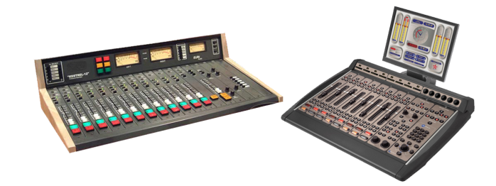
At the heart of any studio is the audio console (sometimes called a radio panel, sound panel, or sound desk). This is the interface the radio announcer (or panel operator) uses to control what’s heard on air. Every channel represents one “input”. The fader (slider) attenuates or amplifies the incoming signal.
Radio Audio Consoles are very different from a regular PA or Live Sound audio console, and are often more expensive than PA audio consoles as they are purpose-built for on-air talent ease of use. When you turn a microphone on or off, a radio console will mute any speakers and illuminate an “on air” light. When you turn a CD Player, Phone or Computer channel on, often it will “trigger” that input so it starts playing immediately.
Microphone

A microphone captures sounds from the studio and turn it into electrical impulses. Broadcast microphones are designed a little differently to PA microphones, as issues such as feedback (the squealing sound that can come through speakers) isn’t an issue in a studio.
Experienced audio announcers will often have a favourite microphone. Common microphones include ElectroVoie RE20, Sennheiser MD421, and Rode Broadcaster.
Microphone Arm
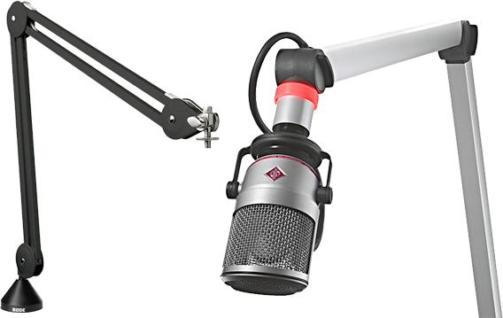
Studio microphones are often mounted on a special arm that keeps the microphone at the correct height. These arms often extend over the audio console, computer monitors, and other equipment – leaving plenty of table space free for equipment and paper.
Playout & Automation Software
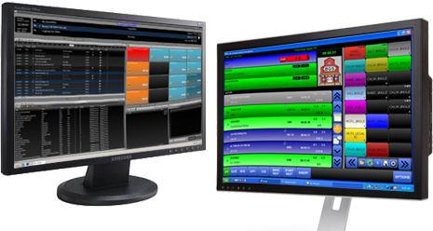
The computer system that plays back music, spots (ads, promos, etc.) and sweepers (the little voice-overs played between songs) is called a Playout System or Automation Software. These are specially designed computer programs that allow for continuous playback of audio, with a lot of granular control for Announcers and Programme Directors.
At the heart of any Automation System is the “log”. This is a sequential list of all audio files and commands that need to be played at certain times. All music played on a commercial radio station will be pre-programmed by the Music Director and loaded into the log. A separate person will often load all advertisements into the same log.
Most automation systems also contain a music database, hot keys (to play ad-hoc audio), an audio editor, segue editor (to change the mix between different elements), interfaces for website and RDS data, and a lot more.
Level Meters
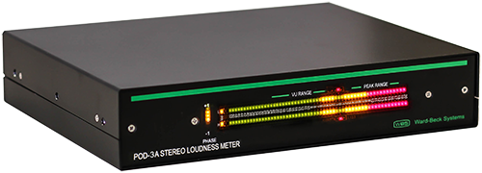
To ensure output of a station is somewhat consistent, radio studios contain different Level Meters. These allow the announcer or panel operator to see if their audio is too loud or too quiet at any given time. Often, you’ll have multiple meters showing the levels at different points in the signal chain.
Some radio stations also provide phase meters along side level meters. This helps you detect mono content, and spot any problems in source material that are likely to cause issues with the stereo image.
Studio Monitor Speakers
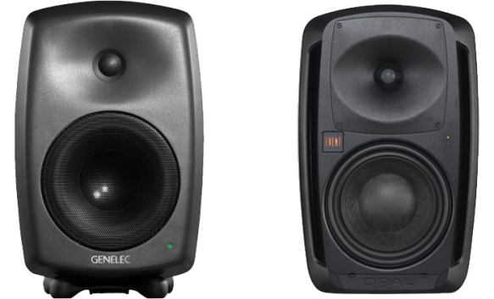
Studio Monitor Speakers provide an easy way to hear what’s going to air without headphones. Often, these are very high quality speakers so any abnormalities in sound quality can be detected.

Cue/Preview Speaker
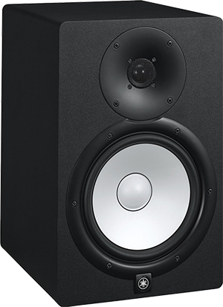
A separate speaker is often provided for the announcer hear all audio that isn’t going to air, such as the preview output from your audio console or the feed from your audio editor. By having a separate speaker for this, announcers can be sure their “preview” audio isn’t going to air.
Headphones

Studio Monitor Speakers are automatically muted whenever a microphone is turned on. As a result, anyone in a studio needs headphones to hear what is going to air. Headphone selection is often a very personal decision based on your preferences in comfort and frequency response.

Talent Panel
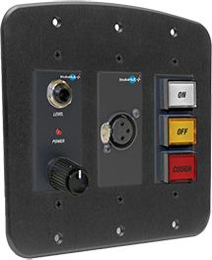
While the main announcer or panel operator can control everything via the audio console, guests often need their own individual control for headphone levels, a cough mute and mic on/off. These panels are generally mounted in front of each guest microphone, usually recessed into the table. Most panels include a headphone jack, and some also contain an XLR connector for the microphone.
On Air Light
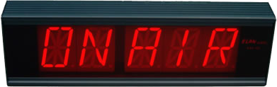
How do you know a mic in the studio is live? There’s a light especially for that! This light is automatically turned on/off by the audio console whenever a microphone channel is turned on. Usually you’d have at least one light inside the studio, and one outside.

Button Panel (GPIO)
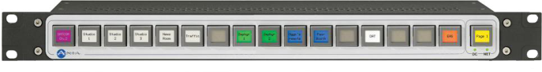
Sometimes you need to control settings not available from the audio console itself. This is why many consoles can have at least one row of configurable buttons. These can be physically wired to other equipment (in analog audio consoles), or configured via software (in digital audio consoles).
These buttons will often control studio delegation (which studio goes to air), phone systems, automation systems, or even remote triggering for networked radio stations.
P.S. GPIO stands for General Purpose Input/Output.
Phone Talkback System
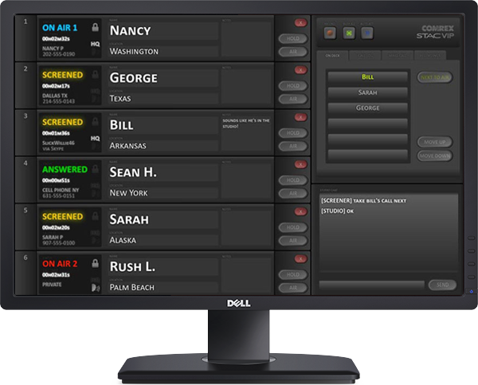
If you want to take a lot of calls on air, you’re going to need a Phone Talkback/Talkshow System. This is a software program or physical controller that shows you every call coming in on each line, and allows you to send this caller to a specific studio or audio channel.
Most systems allow you to track callers (a phone book with history), chat between the studio and producers and “conference” multiple callers together. The talkback system often doesn’t connect directly to a phone system, but instead interfaces to a PABX and/or Phone Hybrid.
Intercom
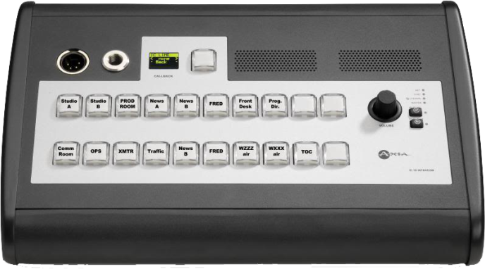
How do you communicate easily between studios? An intercom system. Sometimes an audio console will have a built-in talkback system, and other times it’ll be built into the phone system.
FUNCTION
- Micro phone: it is use in changing physical/natural voice to electronic voice.
- Console mixer: basic units of all equipment to control the each programme.
- Computer system: to keep a file, songs and typing news.
- Aquatic wall: to present sound and hear.
- Que light: it enable the people to known whether there is a live programme going on or not.
- Disk: it is use to record some programme.
- U.p.s: it enable the programme to be continue when the light is off.
- Phone: the serve as a means of which audience get through to the presenter.
- Log book: the is where title of programme is been written and other necessary document to be put down.
- Air condition: it make all the equipment in the studio to be cool.
- Dictionary: it help the newscaster to be able to pronounce words correctly.

SENTENCE BUILDING IN NEWS WRITING FOR BROADCAST MEDIA
Sentence construction is the bed rock of news Writing. Poorly constructed sentence is tantamount to news poorly written.
Lead casting for broadcast requires simple, concise and straight forward sentences devoid of ambiguity.
It should be noted that a lead for a broadcast should not exceed two conjunctions. Also, a news reporter as the first gate keeper must ensure that the lead is not above a sentence or two. A lead should not exceed three to four lines. That is why some professionals in the media practice recommended number of words in a lead, at least 3 0-40words. Your lead could even be a line sentence e.g Today is World food day, Nigerians have been cautioned against corruption, People in positions of Authority have been asked ,to meet the yearnings and aspirations of the people etc. For attribution sentences, there should not be lengthy sentences but simple and straight forward. Similarly, Sentences after attribution must also be positioned in line with the lead and attribution sentences.

PRACTICAL NEWS ENGAGEMENT NEWS STORY ON MISSING
A five year old girl, Johnson has been reported missing. A statement from the family signed by Mr. John Peters said the missing person is tall, light in complexion and speaks Yoruba and English fluently. The statement noted that Johnson was last seen at post office area Ilorin, around half past five in the evening and has not returned Anyone with useful information on how the missing girl could be found or located should call 07044667788 and 07063677410 or contact the nearest police station.
SPECIALIZED REPORTING
Specialized Reporting/Beats: this is a situation where a reporter is assigned to cover a particular sector or special area. A place where reporter is assigned to he/she is our correspondent. Judiciary Reporting; the person is assigned to cover the happening in the court and 'Judiciary as a whole.
Entertainment Beat; anything related to Entertainment. Others includes: Science and technology Beat, Sport Beat, Business, Defense/Security beat. etc
* What made it specialized?? It is specialized because terminologies and register of every beat must be used.

CHAPTER FOUR
4.0 SIWES EXPERIENCE
The major experiences during the period of my (SIWES) were based on journalism field.
I was attached to programme department where I was privilege to work with studio manager where I was able to familiar with series of operating machine, MCR and performance room. I was privilege to monitor live programme that come every day. And I was taught how to associate myself to every other organization and any others persons without the act of discrimination. Siwes program enlighten me to various segment on media unit unlike news department.
I was redeployed to news and current affair department where I taught me how to source for news, write news stories e.g. business watch, environmental sanitation, jumat service, etc. write commentaries/heart of the matter, write lest we forget for news bulletin, cast headline, collation of news bulletin, edit news stories, posting news stories to online, translate news stories into Yoruba stories, translate press release into news stories.
4.1 CHALLENGES FACING DURING SIWES
During my SIWES program, I had the challenges of transportation because the media house is very far from my place of residence. This making the siwes program a little inconvenient whereas some of my colleagues didn’t experience that because their place of residence is near to the media house.
4.2 RELEVANCE OF SIWES
Student industrial work experience scheme (SIWES) help to provide an opportunity to apply theoretical knowledge in real life situation and it expose students to move practical works method and techniques.
Also, it prepares students for the labor market after graduation.

CHAPTER FIVE
5.1 RECOMMENDATION
All students in industrial work experience especially in media organization should be allowed to pass through all departments in the medium to ensure the experience gather is complete, on the other hand student would have the opportunity to discover and choose which department they seem better at.
Private-owned media organization should invest more on the necessary equipment that are needed, this will make press work easier and the atmosphere conducive enough to work, the more the equipment in place the better and faster the works gets.
5.2 CONCLUSION
SIWES plays a significant role in human resource development in Nigeria. ICT development have put more pressure on the SIWES program to help students develop new skill. Student should be aware of what the present society hold for them and adapt accordingly. This can only be facilitated by LIS educator and practitioners, with adequate provision of ICT infrastructure.
The federal government of Nigeria should therefore not relent on their effort in reinforcing the body that controls and monitor the program as it adding more knowledge to student especially those that were not taught in their classrooms. Also, ways to improve the program should be sought, so that the students would be better off at the end of the program.

