

A TECHNICAL REPORT ON
STUDENT INDUSTRIAL WORK EXPERIENCE SCHEME
(SIWES)

HELD AT:
KWARA STATE TELEVISION AUTHORITY
ILORIN KWARA STATE

WRITTEN BY
ADEBAMIRO FOLAKE
ND/23/MAC/PT/0712

SUBMITTED TO
DEPARTMENT OF MASS COMMUNICATION,
INSTITUTE OF INFORMATION AND COMMUNICATION TECHNOLOGY (IICT),
KWARA STATE POLYTECHNIC, ILORIN

IN PARTIAL FULFILLMENT OF THE REQUIREMENTS FOR THE
AWARD OF NATIONAL DIPLOMA (ND) IN MASS COMMUNICATION.

AUGUST –NOVEMBER, 2024
DEDICATION
I dedicate this report, first and foremost, to Almighty God for His favor and grace upon my life, especially throughout my four-month SIWES program.
I also dedicate it to my loving parents and siblings for their unwavering love and support. Additionally, I extend my gratitude to everyone who contributed to making my SIWES training a rewarding and enjoyable experience.

ACKNOWLEDGEMENT
I express my deepest gratitude to Almighty God for the gift of life, the giver and taker of all things. I am also profoundly thankful to my parents for their unwavering support and prayers, which have guided me through every step of my journey. May they live long to reap the rewards of their hard work.
My heartfelt appreciation goes to my parents, Mr. and Mrs. ADEBAMIRO, for their spiritual, moral, and financial support, which contributed immensely to the success of my SIWES program.
I am sincerely grateful to the management and staff of the company, especially my supervisor for their invaluable support, guidance, and knowledge shared during my training. I also extend my gratitude to my lecturers and supervisors for their continuous encouragement and constructive feedback throughout the program.

TABLE OF CONTENTS
Title Page i
Dedication ii
Acknowledgement iii
Table of Contents vi
CHAPTER ONE
1.1 Introduction to Training Programme 1
1.2 Objective of the programme to student 1

1.3 Objectives of the Industrial Training 2
CHAPTER TWO
2.1 Brief History of Kwara TV 3

2.2 Organizational Structure 3

2.3 Core Services and Operations 3
CHAPTER THREE

3.0 TRAINING ACTIVITIES 4

3.1 Departments Covered 4

3.2 Skills Acquired 4

3.3 Challenges Encountered 4

3.4 Solutions and Lessons Learned 4
CHAPTER FOUR
4.0 Television Industry 6
4.1 Introduction 6
4.2 Overview of the Television Industry 6
4.3 Key Trends in the Television Industry 6
4.4 News Production Procedures and Techniques 7
4.5 News Arrangement 8
4.6 Challenges Facing the Television Industry 9
CHAPTER FIVE

5.1 Summary of Experience 10
5.2 Conclusion 10

5.3 Recommendations 10
CHAPTER ONE
1.1 INTRODUCTION TO TRAINING PROGRAMME
The students Industrial Work Experience Scheme (SIWES) was initiated in 1973 by the Industrial Training Fund (ITF). This was to update practical knowledge of students in the Universities, Polytechnics and College of Technology. It was aimed at bridging the gap between the theoretical knowledge acquired in classes and technical knowledge in the industries by providing students with opportunities to apply their educational knowledge in real work situations.
Over the years, SIWES has contributed immensely to building the common pool of technical and allied skills available to the Nigerian economy which are needed for the nation’s industrial development.
Furthermore, the place and relevance of SIWES is underscored by the fact that the scheme contributes to improving the quality of technical skills generally available in the pool from which employers’ source technical manpower.

The Students Industrial Work Experience Scheme (SIWES) is a program designed to bridge the gap between theoretical knowledge and practical application in various industries. It provides students with firsthand experience in their chosen fields, equipping them with relevant skills for the job market.

1.2 Objectives of SIWES
The objectives of the SIWES program include:
- Exposing students to real-world work environments.
- Developing technical and professional skills.
- Encouraging teamwork and problem-solving.
- Providing insight into industry operations and standards.

1.3 Objectives of the Industrial Training
The primary objectives of this industrial training in the television broadcasting industry include:
- Understanding the workflow in a television station.
- Learning about different departments such as production, editing, and broadcasting.
- Acquiring skills in camera operation, video editing, and live broadcasting.
- Gaining knowledge of television programming and audience engagement.

CHAPTER TWO
2.1 Brief History of Kwara TV
Kwara State Television Authority (KWTV), established in 1991, serves as the state-owned broadcasting station in Kwara State, Nigeria. As a public broadcaster, KWTV follows standard procedures and techniques in television news production to ensure the delivery of accurate and engaging content to its audience.
Over the years, it has provided reliable news, entertainment, and educational content to the people of Kwara State and beyond.

2.2 Organizational Structure
The company consists of various departments, including:
- Production Department
- Editing and Post-Production
- News and Journalism
- Engineering and Technical Support
- Marketing and Advertising
- Administration and Human Resources

2.3 Core Services and Operations
Kwara Television provides:
- Live broadcasting of news, sports, and entertainment programs.
- Pre-recorded shows and documentaries.
- Advertisement and commercial production.
- Online streaming services.

CHAPTER THREE

3.0 TRAINING ACTIVITIES

3.1 Departments Covered
During my training, I worked in the following departments:
- Production Department: Learned scriptwriting, directing, and studio management.
- Editing Department: Gained experience in video editing software such as Adobe Premiere Pro and Final Cut Pro.
- Newsroom: Assisted in news reporting, scriptwriting, and live coverage.
- Technical Department: Worked with broadcast equipment, lighting, and camera setups.

3.2 Skills Acquired
- Camera operation and shot composition.
- Video and audio editing techniques.
- News scriptwriting and research.
- Live broadcasting procedures and troubleshooting.

3.3 Challenges Encountered
- Adapting to a fast-paced work environment.
- Learning complex broadcasting equipment.
- Meeting deadlines for news and production tasks.

3.4 Solutions and Lessons Learned
- Improved time management and multitasking skills.
- Gained confidence in handling production responsibilities.
- Learned the importance of teamwork and communication.

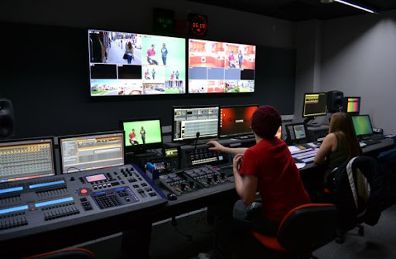

CHAPTER FOUR
4.0 Television Industry
4.1 Introduction
The television industry has undergone significant transformations over the decades, evolving from traditional broadcasting to digital and streaming platforms. This report examines the current state of the television industry, key trends, challenges, and future prospects.
4.2 Overview of the Television Industry
The television industry encompasses various segments, including broadcast television, cable and satellite TV, and streaming services. Major players in the industry include traditional broadcasters like ABC, NBC, and BBC, as well as streaming giants such as Netflix, Amazon Prime, and Disney+.
4.3 Key Trends in the Television Industry
- Streaming Services: The rise of on-demand content has led to a decline in traditional cable subscriptions.
- Content Production: Increased investment in original programming by streaming platforms to attract subscribers.
- Technological Advancements: Adoption of 4K, 8K, and HDR technology to enhance viewing experiences.
- Advertising Shifts: Growth in digital and targeted advertising as opposed to traditional TV commercials.
- Global Expansion: International markets are becoming crucial for content distribution and revenue generation.
4.4 News Production Procedures and Techniques:
- Pre-Production:
  - Idea Generation and Research: Journalists and producers brainstorm potential news stories, conduct thorough research, and verify facts to ensure accuracy.
  - Scripting: Scriptwriters develop scripts that outline the structure of the news segments, including key points, transitions, and timing.
  - Planning: Logistical arrangements, such as scheduling interviews, securing locations, and arranging necessary equipment, are made during this phase.
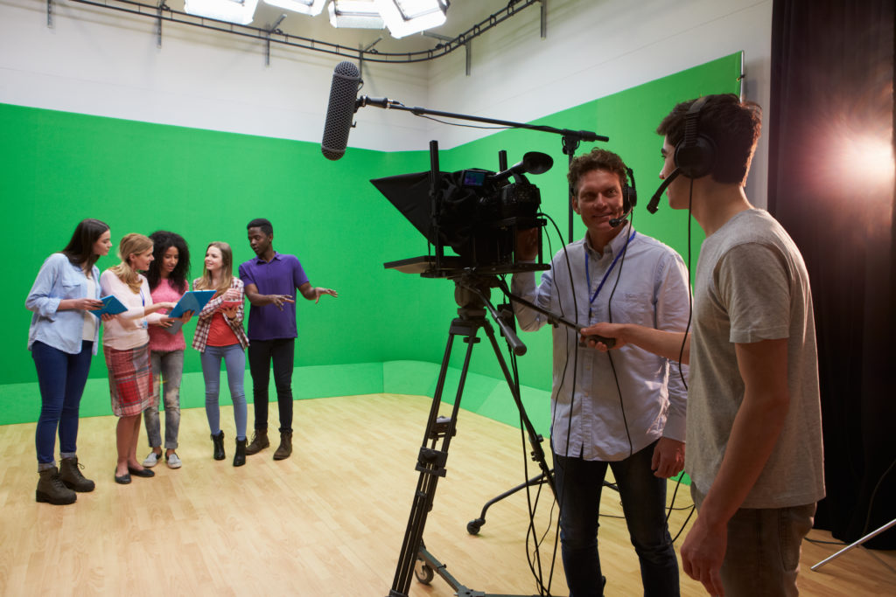

- Production:
  - Field Reporting: Reporters gather news on-site, conducting interviews and capturing relevant footage.
  - Studio Recording: Anchors present news segments from the studio, often using teleprompters to deliver scripts seamlessly.
  - Technical Operations: Camerapersons, sound recordists, and lighting technicians work collaboratively to ensure high-quality audio-visual output.
- Post-Production:
  - Editing: Editors compile and refine footage, integrating visuals, audio, graphics, and effects to create cohesive news segments.
  - Review: Producers and directors review the edited content for accuracy, coherence, and compliance with broadcasting standards before airing.
4.5 News Arrangement:
KWTV structures its news broadcasts to provide a coherent and engaging flow of information:
- Headlines: A summary of the main news stories to be covered, giving viewers an overview of the broadcast.
- Local News: Coverage of events and issues pertinent to Kwara State, reflecting the station's commitment to community-focused journalism.
- National News: Significant developments from across Nigeria that impact or interest the local audience.
- International News: Major global events presented to provide viewers with a broader perspective.
- Sports: Updates on local, national, and international sports events, highlighting achievements and upcoming fixtures.
- Weather: Forecasts and climate-related information relevant to the region.

4.6 Challenges Facing the Television Industry
- Declining Cable Subscriptions: The "cord-cutting" phenomenon continues to reduce traditional TV viewership.
- Content Saturation: Increasing competition makes it harder for content providers to retain audience engagement.
- Piracy Issues: Illegal streaming and content piracy impact revenue streams.
- Regulatory Challenges: Compliance with broadcasting laws and content regulations varies across regions.

CHAPTER FIVE

CONCLUSION AND RECOMMENDATIONS

5.1 Summary of Experience
The SIWES training at Kwara Television provided me with valuable industry exposure and practical skills. I gained hands-on experience in television production, editing, and broadcasting.

5.2 Conclusion
The industrial training was a rewarding experience that enhanced my professional growth. I am now more equipped with the knowledge and skills necessary to pursue a career in television broadcasting.
The television industry is rapidly evolving with digital advancements and changing consumer preferences. Companies must adapt by leveraging technology, investing in original content, and exploring new revenue models to remain competitive in this dynamic landscape.

5.3 Recommendations
- Future SIWES students should receive preliminary training on industry software.
- More structured internship programs should be implemented to maximize learning.
- Institutions should collaborate with media companies to improve the training experience.

