

A TECHNICAL REPORT ON
STUDENT INDUSTRIAL WORK EXPERINCE SCHEME (SIWES)

HELD AT
KWARA STATE ROAD MAINTENANCE AGENCY (KWARMA) AHMADU BELLO WAY, ILORIN
BY
ABDULSALAM MUSLIU
ND/23/BLD/FT/0039

SUBMITTED TO
DEPARTMENT OF BUILDING TECHNOLOGY, INSTITUTE OF ENVIRONMENTAL STUDIES
KWARA STATE POLYTECHNIC, ILORIN

IN PARTIAL FUFILMENT OF THE REQUIREMENT FOR THE AWARD OF NATIONAL DIPLOMA IN BUILDING TECHNOLOGY

MARCH, 2025

CERTIFICATION
This to certify that this SIWES program was done and written by ABDULSALAM MUSLIU of Matric No ND/23/BLD/FT/0039 as a part of the requirement for the award of National Diploma (ND) in Building of Kwara State Polytechnic, Ilorin.

__________________________ _____________
SUPERVISOR SIGNATURE DATE

DEDICATION
This work is dedicated to the Almighty Allah, for his love, mercies, guidance and protection during and even after this work. This work is also dedicated to my lovely and caring parents and wonderful brothers and sisters and friends for their love, support and encouragement.

ACKNOWLEDGEMENT
All praises are due to Almighty Allah, the immoral creator and the provider for all creatures for given the opportunity to complete the training successfully.
I owe my profound gratitude to my HOD and all the lecturers for their immerse advice and fatherly roles.
I express my profound gratitude and special thanks to my lovely and caring parent for their moral, finance and intellectual support. I pray that Almighty Allah will make you reap the fruit of your labour.
I also thank my SIWES coordinator, Engr. Abiodun Adeoye J. for his contribution to my education at my place of attachment
Finally, huge thanks to those who contributed in one way or the other to make my industrial training a success, that God in his infinite goodness guide and grant their heart desires.

TABLE OF CONTENT
Cover page
Certification
Dedication
Acknowledgement
Table of content
Chapter one
1.1 Introduction to SIWES
1.2 Objective of the SIWES
Chapter Two
2.0 Historical Background of Attachment
Chapter Three
3.0 Building Construction
3.1 Excavation
3.2 Setting out
3.3 Buttoming
3.4 Foundation

3.5 Block Laying
3.6 Classification of Concrete Blocks
3.7 Laterite Filling
3.8 Walling

CHAPTER FOUR
4.1 Bonding
4.2 Laying of block to the slab level
4.3 Lintel
4.4 Spacing for lintel on wall
4.5 Plastering and Rendering
CHAPTER FIVE
5.1 Experience Gained
5.2 Conclusion
5.3 Recommendation

CHAPTER ONE
1.0 Introduction to SIWES
The Students Industrial Work Experience Scheme (SIWES), is a skills development programme initiated by the Industrial Training Fund (ITF), in 1973 to bridge the gap between theory and practice among students of Engineering and technology in Institutions of Higher Learning in Nigeria. It provides for on-the-job practical experience for students as they are exposed to work methods and techniques in handling equipment and machinery that may not be available in their Institutions.
SIWES was established by ITF in 1973 to solve the problem of lack of adequate practical skills preparatory for employment in industries by Nigerian graduates of tertiary institutions. The Scheme exposes students to industry based skills necessary for a smooth transition from the classroom to the world of work. It affords students of tertiary institutions the opportunity of being familiarized and exposed to the needed experience in handling machinery and equipment which are usually not available in the educational institutions.
Participation in SIWES has become a necessary pre-condition for the award of Diploma and Degree certificates in specific disciplines in most institutions of higher learning in the country, in accordance with the education policy of government.
1.1 Mission
SIWES is charged with the responsibility of promoting and encouraging the acquisition of skill, commerce and industry with the view of generating a pool of trained indigenous man power sufficient to meet the need of the economy.
SIWES is aimed at developing the human resource of the nation. It build the nation’s work force to promote the economy of the nation
1.2 Vision
The vision of SIWES is to prepare student to contribute to the productivity of their nation and strength the student is practical aspect.
Student industrial work experience scheme promote skill, training and competency building intervention for student of tertiary institution has the potential of increasing the scope and variety of technical skills in the common pool or general stock available for the industrial development of Nigeria.
1.3 Aim and Objective of SIWES
The aim of the study was to evaluate the impact of SIWES on Technical Skills Development in the Nigerian economy. This is to enable Institutions of Higher Learning and other Stakeholders assess the performance of their roles in the Scheme.
OBJECTIVE
- To help curbing the problem of lack of adequate practical skills preparatory for employment in industries by Nigeria graduates of Tertiary institutions.
- To afford students of Tertiary Institution the opportunity of being familiarized and exposed of the needed experience in handling machinery and equipment which are usually not available in the Educational Institution.
- To promote and encourage the acquisition of skills in industry and commence with a view to generate indigenous trained manpower sufficient to meet the need of the economy.
- To expose the student and broaden their knowledge on the practical aspect of the course they are pursuing in their various schools.
- To improve the technology development in the country.
- The scheme exposes student to industry based skills necessary for a smooth transition from the classroom to the world work.
- The Industrial Fund as a human resources development organization has its core mandate to be that of training to improve the performance of the industrial work in the economy by training for skills acquisition and improvement of work process.

CHAPTER TWO
2.1 HISTORICAL BACKGROUND OF SIWES PLACEMENT
The Kwara State Roads Maintenance Agency (KWARMA) is responsible for the maintenance of roads and facilities in Kwara State. The agency also works to improve the skills of its direct labor force.
Functions of KWARMA
- Maintain roads and facilities
- Demolish structures that are a public nuisance on roads
- Take custody of vehicles or obstructions on roads
- Implement direct labor in road construction and maintenance
- Work with ministries, departments, and other sectors to create an effective road maintenance policy
- Use direct labor effectively in road maintenance activities
- Develop the skills of its direct labor force
- Receive funds from the Federal Government for road maintenance

CHAPTER THREE
3.0 Building Construction
3.1 Excavation
This is the process of removing the top soil and when necessary digging out trenches of the sub-soil to 900mm depth hardcore bed which is strong enough to bear the site concrete is reach
Method of Excavation carried out on site
The method of excavation we normally use on site is manual excavation with the use of hand tools. The tools are used for excavating manually are:
- Shovel
- Spade
- Digger
- Builder’s line
- Cutlass
- Axe
3.2 Setting out
In actual practice, setting out in building is generally known as the transfer of architectural drawing to the reality i.e. the feature on paper to the ground or land.
Setting out must be arranged so that the work is checks every pegs placed must be provided to be in its correct position within acceptable limit.
The basic requirement for the setting out
- Builder’s square
- Builder line
- Measuring tape
- Hammer
- Pegs
- Nails
- Profile board
3.3 Buttoming
This is used during excavation of trenches to level or ram the soil in the narrow hole.
Honey Comb: This occur when there is hole on the column mode or reinforcement
Scaffolding: This is used during plastering or painting a story or multi-storey building
Beam: This is the horizontal supporting structure
Column: This is vertical for supporting structure
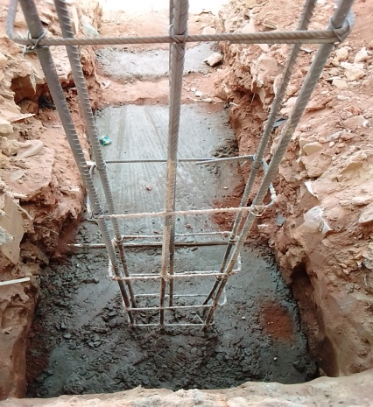

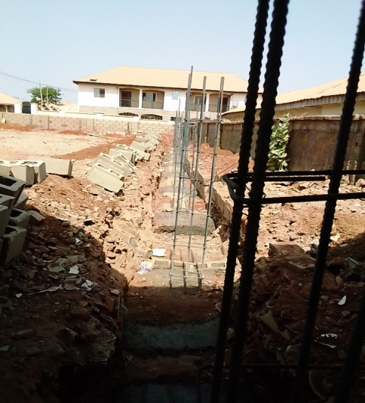
Reinforcement: This is an art using iron rod in a concrete structure such as column.

Coarse Aggregate: Soil that have little sand in it, it may be found under the budge
Fine Aggregate: These are the soft grounded in nature. It is smooth enough for plastering or for other purpose like concrete.
Gravel: These are stone like in nature especially brown in colour
Granite: These are used for road grading, black and white in colour
Basement: This is the construction of two ground floor on a piece of land back the other at the front.
Precast concrete: This is on already made concrete that has been out cast somewhere before bringing it to the place for use Example Bridge or sock away
In-situ concrete: This is pour directly to the form work it’s used in a sock-away or in building.

Mixer: This is used for mixing cement, sand etc. We have two types of mixer: Meavel and Mechanical mixer
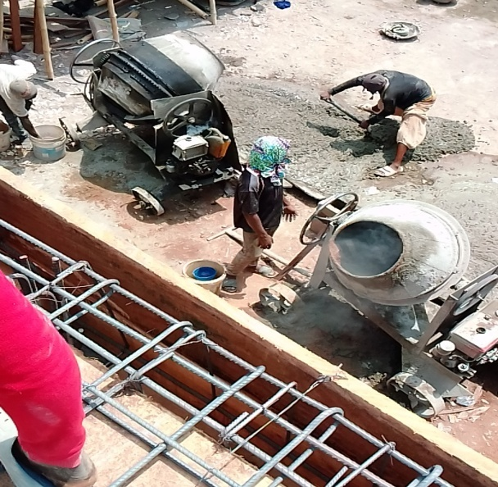

Blinding: This is the mixture of concrete i.e. Fine aggregate, coarse aggregate, cement and water with the mix rate of 1:2:4 then poured into the foundation after excavation.
3.4 Foundation
Foundation is the part of a building component beneath the surface of the earth, and also can be referred as a sub-structure.
Types of foundation carried out on site
The type of foundation we used on site is stepped strip foundation which is the common type of foundation we used to practice in our area.

3.5 Block Laying

The basic laying procedure for block and brick walls is the same for all types of block and brick and is identical to the procedure for block foundation walls
• The top surface of the foundation, or of the previous course, should be covered with a bed of mortar. Apply the mortar only on the edges of hollow bricks. Cover the entire surface of solid blocks.
• Butter each new block or brick on its ends either before or after it is placed. Again, butter only the edges of hollow blocks; butter the entire head of solid blocks.
• Use string to guide the placement of each new block or brick in a straight line. Position the blocks or bricks up to but not touching the string. Press and tape each one firmly into place so that the mortar joint is 11.25cm thick. Do not pound the block in place.
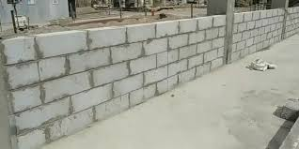
• After every 2-3 blocks or bricks check the course for level and plumb. Remove and re-mortar any blocks that are out of line.

3.6 Classification of Concrete Blocks
Hollow concrete blocks: Open and closed cavity type hollow concrete blocks are classified into three grades:
- Grade A: They possess a minimum density of 15000kg/m and are use for load bearing walls.
- Grade B: They have density below 1500kg/m and used for load bearing walls.
- Grade C: These blocks are use for non-load bearing walls and have density more than 1000kg/m
3.7 Laterite Filling
This is the filling of the foundation, it consist of filling sand, hardcore or broken concrete, after the hardcore have been place on, they will need to sand fill again because of the DPM (Damp Proof Membrane) they will lay on the filling before casting concrete on it.
Concrete
Concrete composed of binding agent (cement) coarse aggregate, fine aggregate and water.
Mixing of concrete
In the method of mixing of concrete they use on site is manually and mechanical method. Hand mixing as manual required the measure qualities as the coarse aggregate to the place on a platform, each measured quality of aggregate are leveled up until the required overall quality of its obtained.
Place the cement of the top of heap of an aggregate and spread it evenly with the mixing shovel. The dry material are mixed together with shovel together turning the mixture from side to side on the platform until heap show on every colour throughout the mix is now ready for the addition of water. Water is then added to a chosen formed in the middle of the heap, while the mechanical method is by the mix of concrete mixer machine for mixing of concrete.
Tools for Concrete Mixing Manually
- Shovel
- Head pan
- Wheelbarrow
3.8 Walling
Wall is the vertical continuous parts of a building which enclosed or protect the building or divided the building into room or compartment. It is made of block concrete stone and metal. This can be defined as systematically arrangement of blocks or bricks with mortal to form a wall.
Type of wall
- Load bearing
- Non- loading bearing
Functional Requirement of Wall
- Durability
- Fire resistance
- Thermal resistance
- It must be weather resistance
- Sound insulation
- Wall must be able to provide security

Opening in the wall
Opening can be simply described as a source of in the building that allow access of ventilation or human into building. They are many categories of opening such as:
- Door
- Window
Door: This is important in the building to access into the building without any difficult. It must accommodate passing of in and out of the building.
Window: This is also important for good ventilation in the building. It must be well located to allow cross ventilation in the building

CHAPTER FOUR
4.1 Bonding
This is the systematic of proper arrangement of brick or block. The units are laid together in other to form a solid mass and gives stable which is calla wall.
Types of bond
- English bond
- Stretcher bond
- Header bond
- Flemish bond
Note: The types of bond used on site are known as stretcher bond.
Types of block used for bonding
- 9 inches which is 225mm is used as load bearing block of foundation block and external wall
- 6 inchers which is 150mm is mainly use for internal partition.
4.2 Laying of block to the slab level
- Laying of block in stretcher bond are measurement of door 900mm
- Laying a block in stretcher bond to the window level, measurement of door 2, 400mm
4.3 Lintel
A lintel is structural horizontal member that span across an opening between vertical supports. It can be load bearing building component or combine ornamental structure item, it’s commonly found over portal, window, door and fire place.
Materials use for lintel
- Fine aggregate
- Coarse aggregate
- Reinforcement bar
- Binding agent (Cement)
- Water
Component of lintel
- Formwork
- Reinforcement bar (12mm)
- Concrete
Construction of formwork of the lintel
Formwork are temporary mould to which some wet concrete are to be poured and compacted so that the concrete will flow and finally set to form shape similar to the inner cross section of the mould itself.
Wood for formwork (Softwood)
Softwood are sold at vapors saw-mill and can be easily swoon to various size and board which are used to form panel for beam and column sizes.
Instrument used for the formwork
- Measuring tape
- Saw
- Hammer
- Metre square
- Nail
Materials used are:
- Softwood
- Reinforcement bar (16mm)
4.4 Spacing for lintel on wall
Spacing is very important in the construction of lintel in the site, this as to do with length of lintel and the space cover on the wall. There must be appropriate and adequate space in which the lintel will be laid on the wall vertically. So that it can bear the load coming on the roof of the opening in other to avoid collapse of the building which can cause damage of the material and in most cases, it damage life and properties. At least it must not less than 450mm and the medium height must be within 225mm or 250mm so it can retain the load coming from the upper structure of the building.
Mixing of concrete for lintel
Instrument used
- Head pan
- Spade
- Shovel
- Wheelbarrow
Material used
- Cement
- Fine aggregate
- Coarse aggregate
- Water
Casting for Lintel Beam
Instrument Used
- Head pan
- Shovel
- Hand trowel
Material Used
- Cement
- Water
- Fine aggregate
- Coarse aggregate
- Reinforcement bar
- Plant
4.5 Plastering and Rendering
Plastering: Refers to substances that become hard. It dries and it used primarily for spreading on wall and ceiling to give a smooth surface. It contain less cement
Rendering: Involve the use of Ore cement because it has to be weather resistance. Both plastering and rendering can be considered wall, coating that rest on top of the block work. The outer coating on the outer surface are called plastering.

CHAPTER FIVE
5.1 Experience Gained
I had more knowledge in almost all aspect of building construction, mostly in time of roofing know the so called wall plate, ceiling joist, tie beam, king post, rafter purlin, laying of block in timer of drainage.
How to construct a room
The way concreting is concreted
A lot about lintel and
How we mix and so on
5.2 Conclusion
From all the practice task I have undertaken the Industrial Training (SIWES) has made me has much understanding of practical. Land has also given me independent stand of physical planning decision within environment. I have come to realization that the programme is really meant to be enlighten one on what one’s course of study demand.
5.3 Recommendation
The sixteen weeks Industrial Training (SIWES) is very good programme which students of every high institution undergo so as to gain practical experience in their various field of study and to let them know more about their course of study.

