

A TECHNICAL REPORT ON
STUDENT INDUSTRIAL WORK EXPERINCE SCHEME (SIWES)

HELD AT
GOD’S FIRST FURNITURE AND CARPENTARY
BY
GANIYU ROSHEED OPEYEMI
ND/23/BLD/PT/0031

SUBMITTED TO
DEPARTMENT OF BUILDING TECHNOLOGY, INSTITUTE OF ENVIRONMENTAL STUDIES
KWARA STATE POLYTECHNIC, ILORIN

IN PARTIAL FUFILMENT OF THE REQUIREMENT FOR THE AWARD OF NATIONAL DIPLOMA IN BUILDING TECHNOLOGY

MARCH, 2025

CERTIFICATION
This to certify that this SIWES program was done and written by GANIYU ROSHEED OPEYEMI of Matric No ND/23/BLD/PT/0031 as a part of the requirement for the award of National Diploma (ND) in Building of Kwara State Polytechnic, Ilorin.

__________________________ _____________
SUPERVISOR SIGNATURE DATE

DEDICATION
This work is dedicated to the Almighty Allah, for his love, mercies, guidance and protection during and even after this work. This work is also dedicated to my lovely and caring parents and wonderful brothers and sisters and friends for their love, support and encouragement.

ACKNOWLEDGEMENT
All praises are due to Almighty Allah, the immoral creator and the provider for all creatures for given the opportunity to complete the training successfully.
I owe my profound gratitude to my HOD and all the lecturers for their immerse advice and fatherly roles.
I express my profound gratitude and special thanks to my lovely and caring parent for their moral, finance and intellectual support. I pray that Almighty Allah will make you reap the fruit of your labour.
I also thank my SIWES coordinator, Mr. Adeoye Rotimi for his contribution to my education at my place of attachment
Finally, huge thanks to those who contributed in one way or the other to make my industrial training a success, that God in his infinite goodness guide and grant their heart desires.

TABLE OF CONTENT
Cover page
Certification
Dedication
Acknowledgement
Table of content
Chapter one
1.1 Introduction to SIWES
1.2 Objective of the SIWES
Chapter Two
2.0 Historical Background of Attachment
Chapter Three
3.0 Work Actually Carried Out
3.1 Door
CHAPTER FOUR
4.1 Roof
4.2 Fascia Board
4.3 Experience Gained
CHAPTER FIVE
5.1 Conclusion
5.2 Recommendation
CHAPTER ONE
1.1 Introduction to SIWES
The student industrial work experience scheme (SIWES) is an approved skill training scheme which forms part of the minimum academic standards in various degree scheme for all Nigerian universities, Polytechnics and Mono-Poly to acquire skills and experience in their various course of study. Student Industrial Work Experience Scheme was established by the Industrial training Fund (ITF) in 1973 with the aim of bridging the gap between the skills which the labour market required with that of those acquired by the graduate students. Since its introduction by the ITF in 1973 the Scheme has gone through series of reforms. Its management, for instance has changed hands from the ITF to the various regulatory AGENCIES SUCH AS National Universities Commission (NUC) National board for Technical Education (NBTE) and National Commission for college of Education (NCCE) and now back to the ITF again. These are the major stakeholders in (SIWES). Consequently, SIWES Programmed was introduced into the curriculum of tertiary institutions in the country as far back as 1974 with 748 students from 11 institutions of higher learning. However, the scheme has over the years contributed immensely to the personal development and motivation of students to be able to understand the important connection between the taught and learnt content of their academic programmed and what knowledge and skill will be expected of them on professional practice after graduation. In recognition of the short courses and weakness in the formation of Set graduates, particularly with respect o acquisition of relevant production skills, the industrial training fund established the students Industrial Work Experience Scheme (SIWES) in 1973. The Scheme was designed to expose students to the industrial environment and enable them develop occupational experiences so that they can readily contribute their quota to national economic and technological development after graduation. Consequently, SIWES is a planned and structured programmed based on stated and specific career objectives, which are geared toward developing the occupational competencies of participants.
1.2 Objective of the SIWES
The Industrial training funds policy document no. 1 of 1973, which established SIWES outline the objectives of the scheme. The objectives are to:
- Provide an avenue for students in institution of higher learning to acquire industrial skills and experience during their course of study.
- Prepare students for industrial work situation that they are likely to meet after graduation.
- Expose students to work methods and techniques in handling equipment and machinery that may not be available in their institutions.
- Make the transition from school to the world of work carrier and enhances students contacts for later job placements.
- Provide students with the opportunities to apply their educational knowledge in real work situations, thereby bridging the gap between theory and practical.
1.3 Benefits of Industrial Training to Students
The industrial attachment seeks to offer students a practical translation of the theory they have been taught. It has also got individual benefit of linking the student to the industries, hence brightening the employment chances of the students in the school. Through this attachment, I have generated a good inter personal relationship through my interaction with my supervisors and colleagues. It has also improved my working skills either under pressure with or without supervision.
CHAPTER TWO
2.1 Historical Background of Attachment
God First Furniture and Carpentry was established in the year 2003 by Mr. Adeoye Rotimi. The company deals with any kind of Interior Furniture and Capentary work. They make use of modern tools. These include roof construction, construction of door, windows, construction of decking, hand rays, noggin, formwork of stairs and lintel etc.
It is located in Kwara State Mayegun Area, Along Specialist Hospital Alagbado Ilorin.

CHAPTER THREE
3.0 Work Actually Carried Out
3.1 Explanation, Types and Uses of Wood
Wood has been used in construction for thousands of years and is still one of the most widely used building materials. Certain properties of wood can be complex in terms of use for construction, but despite this, engineers have successfully harnessed this natural resource to build a variety of structures. From houses to boats and other shelters, as well as furniture and décor, the construction industry has exploited the potential of wood to the fullest.
Wood is favoured as a material because of the wide variety of properties depending on type. It is readily available and economically competitive, as well as being extremely strong in relation to its weight.

Types and uses
Wood is generally classified as hardwood and softwood.
Hardwood: is typically heavier and denser than softwood and is usually utilized for construction of walls, ceilings and floors. The highest possible grade of hardwood contains 83% usable material on one face and is suitable for high-quality furnishings, solid wood mouldings and interior joinery.
Softwoods: are generally used to make more of the inner structures to the frame of hardwoods, such as doors and window frames. It is also used to produce furniture.
The words ‘lumber’ and ‘timber’ are often used to refer to wood used specifically in construction work, however there is debate as to which terms should apply to different scenarios. As a rule of thumb, wood which is smaller than five inches wide by five inches thick is referred to as lumber. These pieces are usually machine-planed and sawn for certain dimensions primarily being used in residential construction.
Pieces of wood over the lumber dimensions, regardless of length are timber, although any timber pieces that are more than eight inches wide and eight inches thick are called beams. As timber is usually larger in dimension it is used for the frames of structures in buildings and bridges, as well as being used in railroad ties, mine shaft support and crossbeams on utility poles.
3.2 Cutting Tools Used in Work Shop

Hacksaws
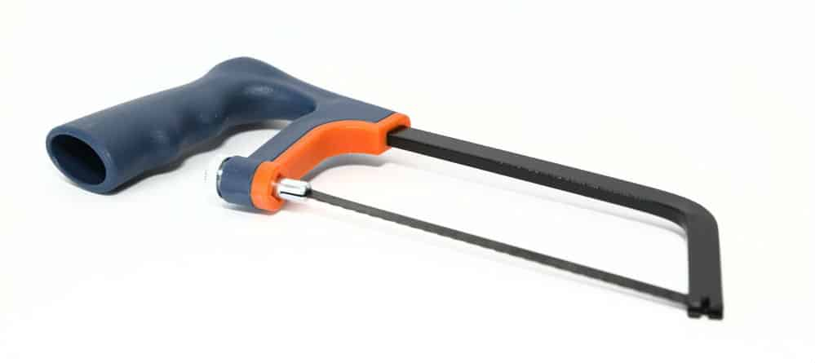
Hacksaws are more commonly used to cut pipes and other things inside of the home in modern times. Regardless, they can be quite handy when you need to saw through a log. A good hacksaw is going to be very affordable, and you’ll be able to find one at just about any hardware store. They’re easy to use and very reliable, making them an essential saw to own. One interesting thing about hacksaws is that you can remove the blade and insert a blade that is meant for the type of material that you are cutting. The tooth count on the blade is going to differ depending on what you are using at the time. If you want to cut through wood, then you will want to get a blade that is meant for this material. Once you have everything that you need, this is going to be a really useful saw to have around for its multi-purpose nature.

Chisels

Chisels are used for the purpose of carving wood by hand. This can make creating works of art and very fine products a lot simpler. You have probably seen a few beautiful wood sculptures at some point in your life. These sculptures were likely created using wood chisels.


Crosscut Saw
A crosscut saw: is any saw designed for cutting wood perpendicular to (across) the wood grain. Crosscut saws may be small or large, with small teeth close together for fine work like woodworking or large for coarse work like log bucking, and can be a hand tool or power tool.
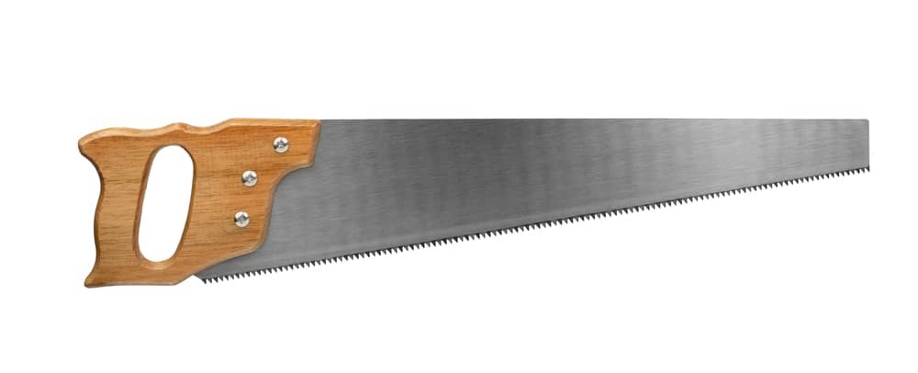

Rip Cut Saw
Sometimes rip cut saws are simply referred to as hand saws. They are the most traditional and typical hand saw that you could possibly think of. Almost everyone who works with wood owns one of these saws. It is great for cutting boards quickly, and it is easy to take with you to different job sites.
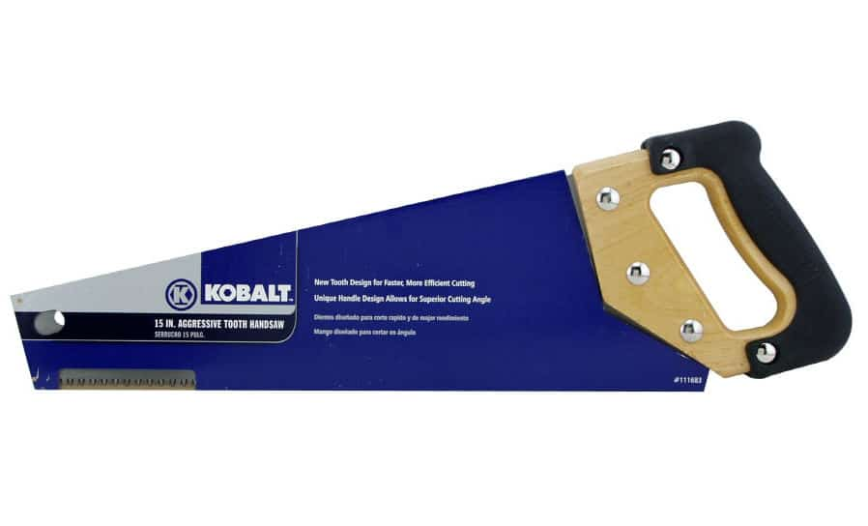

3.3 Door
A door is a hinged or otherwise movable barrier that allows ingress into and egress from an enclosure. The created opening in the wall is a doorway. A door's essential and primary purpose is to provide security by controlling access to the doorway (portal). Conventionally, it is a panel that fits into the portal of a building, room. Doors are generally made of a material suited to the door's task. Doors are commonly attached by hinges, but can move by other means, such as slides or counterbalancing.
The door may be moved in various ways (at angles away from the portal, by sliding on a plane parallel to the frame, by folding in angles on a parallel plane, or by spinning along an axis at the center of the frame) to allow or prevent ingress or egress. In most cases, a door's interior matches its exterior side. But in other cases (e.g., a vehicle door) the two sides are radically different.
Doors may incorporate locking mechanisms to ensure that only some people can open them. Doors may have devices such as knockers or doorbells by which people outside announce their presence. Apart from providing access into and out of a space, doors may have the secondary functions of ensuring privacy by preventing unwanted attention from outsiders, of separating areas with different functions, of allowing light to pass into and out of a space, of controlling ventilation or air drafts so that interiors may be more effectively heated or cooled, of dampening noise, and of blocking the spread of fire.
Doors may have aesthetic, symbolic, ritualistic purposes. Receiving the key to a door can signify a change in status from outsider to insider Doors and doorways frequently appear in literature and the arts with metaphorical or allegorical import as a portent of change.

CHAPTER FOUR
4.1 Roof
The term roof refer to a cover design basically to protect the building and it’s protect from environmental factor such as rain, heat, snow, cold etc. it also play a respective function in determine the character of a building.
The size of the member depends on the style of the roof, type of construction and weight of the covering materials.
Functional requirement of a roof
- Stability
- Weather resistance
- Durability
- Fire resistance
- Sound insulation
Types and choice of a roof
Roof systems are generally divided into:
- Flat roof
- Pitch roof
There is other sub-division under this main heading depending on the angle which the roof make with the horizontal and the overall shape with regard to the span which the roof is expected to make.
- Flat roof: This is a type of roof that an angle that is less than 10⁰ to the horizontal.
- Pitch roof: A pitch roof is the one that make an angle of not less than 10⁰ to horizontal. It is the most commonly use especially for large span structure both in domestic and industrial building.
Single roof
These types of roof has their rafter support at one side only
Lean-to-roof
These types of roof can also be classified as single roof, it is a situation when one wall is carried up higher level than the other and rafter bridges the space between them.
Couple roof
These consist of pairs of couple of rafter against each other at their heads with their feet baring in opposite word
Roof Member/Roof Cover/Trusses
There are some structure brought together that make up the roof, these include:
- Wall plate
- Tie beam
- King post
- Rafter
- Purling
- Ridge
- Roof covering
Wall Plate: These are embedded in or supported on a wall. It supported the common end of the rafter
Tie Beam:
King Post: It is used to support the thrust rafter at the center and it length determined the height of the roof structure. It can be as high as 3.00m. the sectional dimension is usually 50mm by 150mm.
Rafter: It bears the purlins. It is the main inclined member of the thrust. The size of rafter section varies but usually 50mm by 10mm or 500mm by 150mm.
Purlins: This is a timber member of the roof to which the roofing sit is nail and the size is usually 500mm by 75mm to rafter.
Ridge Cap: This is the apex line of the sloping. It is usually cover the roof to prevent rain water entering the roof space. It is the part of the roof that is direct to open or expose to the weather. It protects other member material for covering maybe state, aluminium.
Roof Covering:
Roof Construction procedure
- Take accurate direction from the actual building
- Lay the wall plate
- Place the wooden beam horizontally and nail the same to the wall plate and predetermined center, spanning through roof ensure proper joint to prevent sandring.
- Fixed the kingpost to the beam, height or length of kingpost depending on the given pitch
- Mark out the pattern 10 plates for rafter trimming and halving of rafter in preparation for jointing
- Nailed the rafter to the kingpost and tie beam
- Laid purlins and nailed to the upper side of the rafter provide extra support to the rafter
- Nailed the struct to the rafter, the struct is a post or piece jointed to the rafter and tie beam either vertically or particularly
- Cutting the projected and extended rafter at eve and ridges
- Nailing the roof covering with adequate lap to timber purlin
- Nailing of the timber face board to the time extended end of the rafter placement or ridge cap on the exposed end of the rafter.
4.2 Fascia Board
Fascia is an architectural term for a vertical frieze or band under a roof edge, or which forms the outer surface of a cornice, visible to an observer.
Typically consisting of a wooden board, PVC or non-corrosive sheet metal, many of the non-domestic fascias made of stone form an ornately carved or pieced together cornice, in which case the term fascia is rarely used.
The word fascia derives from Latin fascia meaning "band, bandage, ribbon, swathe". The term is also used, although less commonly, for other such band-like surfaces like a wide, flat trim strip around a doorway, different and separate from the wall surface.
The horizontal "fascia board" which caps the end of rafters outside a building may be used to hold the rain gutter. The finished surface below the fascia and rafters is called the soffit or eave.
In classical architecture, the fascia is the plain, wide band (or bands) that make up the architrave section of the entablature, directly above the columns. The guttae or drip edge was mounted on the fascia in the Doric order, below the triglyph. The term fascia can also refer to the flat strip below the cymatium.
4.3 Experience Gained
This part deals with the knowledge gained by me from the construction sites visited during my SIWES program where I was exposed to various projects. I spent my industrial training with God First Furniture. The company is focused on interior furniture and carpentry work. Mr. Adeoye Rotimi was my site supervisors. From time to time assigned me to different activities like preparing door and window schedules, building materials and he also put me through all diverse ways of things I knew nothing about.

CHAPTER FIVE
5.1 CONCLUSION
In the past 16 weeks of my learning at God First Furniture , I learnt a crucial aspect of Furniture, not only did I learn about building construction, I also learnt about office etiquette and operations. My ability and knowledge on computer aided designs have been explored and thus have being enlightened. The SIWES program has contributed immensely to the acquisition of practical experience and knowledge which are of paramount importance to my field of study. Its relevance therefore can never be overestimated. This training section has broadened my level of knowledge and as well paved way for diverse future opportunities. Consequently, the SIWES program has made me to understand that the profession furniture is multifaceted. In that, it does not solely rely on Site work but also encompasses various forms of administrative duties which make it more captivating.

RECOMMENDATION
This SIWES program has being of immense benefit to me while undergoing the training However, the identified problems are affecting the efficiency of the scheme and reducing the level of its aimed potentiality. Thus to ameliorate the situations sprouting from the identified problems and make SIWES more beneficial, the following recommendations are suggested:

- The Federal Government should make it compulsory for all ministries, public parastatals and companies to offer placement to interested students as stated in the NUC job specification for SIWES.

- The payment of prompt ITF allowance in order to encourage them for efficient carriage of duties.

- Institutions that the students would be attached to should have the potentials of providing relevant information on planning activities, and possess sophisticated machinery so as to help the student to acquire the necessary skills that would be needed in the work. In view of the earlier limitations/ challenges experienced by the firm, I recommend that the Federal Government of Nigeria should further intensify their effort in the area of funding of the SIWES program and enforcing students to participate actively in this program which will result to a future where Nigeria would be a better place.

