

Technical Report
On
STUDENT INDUSTRIAL WORK EXPERIENCE SCHEME (SIWES)

HELD AT
BELAD BLOCK INDUSTRY ILORIN
10, Off Tepatan Street, Feju Area , Ilorin Kwara State
Presented by:
ABUBAKAR SARATU
ND/23/ACC/PT/0016

Submitted to:
DEPARTMENT OF ACCOUNTANCY, INSTITUTE OF FINANCE AND MANAGEMENT STUDIES
KWARA STATE POLYTECHNIC
P.M.B. 1375, ILORIN

IN PARTIAL FULFILLMENT OF THE REQUIREMENT FOR THE AWARD OF NATIONAL DIPLOMA (ND) IN
ACCOUNTANCY, KWARA STATE
POLYTECHNICS, ILORIN

August – December, 2024
PREFACE
This technical report is written to situate the standard of experience gain by student in the industrial as awareness of continuity at the tertiary level of learning. The technical indulgence of training has been expressed formally in these report required by the constitution of the industrial training office of polytechnic.
This report is divided into five different parts which each part explains the meaning of siwes, major organization, work actually carried out and experienced gain. Even challenged faced, conclusion and recommendation are also involved.

DEDICATION
I dedicate this report to the Almighty God, for granting me the privilege to commence this course. Also to my reliable and respectful loving parents, Mr. & Mrs. Abubakar for being there for me. I pray may the Almighty Allah reward you abundantly, Amen.

ACKNOWLEDGEMENT
I wish to express my sincere gratitude to Almighty God for spearing my life throughout my first year in Kwara State Polytechnic, Ilorin and for making my vision to come to reality. I also thank him for his goodness, mercy and joy throughout my life.
My greatest debt is to my indispensible parent Mr. and Mrs. Abubakar for their moral and financial support throughout the duration of my training may Almighty God reward you abundantly.
My special thanks go to the head department and the entire staff of Accountancy department, Kwara State Polytechnic.
My appreciation also goes to the entire staffs of Belad Block Industry
I also acknowledge the effort of my friends and siblings for their financial, moral and spiritual support throughout my academic pursuit. Also to my SIWES supervisor for his great work.

TABLE OF CONTENT
Title Page
Preface
Dedication
Acknowledgement
Table of content
CHAPTER ONE
1.1 Meaning of SIWES
1.2 Brief history of SIWES
1.3 Aims and Objectives of SIWES
CHAPTER TWO
2.1 History of the Organisation
2.2 The organizational Structure
2.3 Department in the organization
2.4 Interpersonal Relation with the organization
CHAPTER THREE
3.1 Work Actually Carried Out
CHAPTER FOUR
4.1 Experienced Gained
4.2 Challenges Faced
CHAPTER FIVE
5.1 Conclusion
5.2 Recommendation

CHAPTER ONE
1.1 MEANING OF SIWES
SIWES is skill development program designed to prepare students of all institutions for transition from the collage environment to work. Also to promote and encourage the acquisition of skills in industry and commerce with a view of generating a poll of indigenous trained manpower sufficient to meet the needs of the Nigeria economy
It is also described as work experience in a education program in while attending school, while the work experience gives student opportunity to be part of an actual work situation outside the classroom.
1.2 BRIEF HISTORY OF SIWES
The government decrees no 47 of 8th October, 1971 as amended in 1990 highlighted the capacity building resource in industry commerce and government through training and re-training of workers in order to effecting provide the much needed high quality goods and services in a dynamic economy as ours (Jemerigbo 2003) the decree led the establishment of Industrial Training Fund (ITF) in 1973/1974.
The growing concern among our industrialist that graduates of our institution lack adequate practical background studies preparatory for employment in industries, led to the information of student industrial work experience scheme (SIWES) by ITF 1993/1994
The student industrial work experience scheme (SIWES) is a skill training program designed to expose and prepare student of agriculture, technology, environmental science, medical science and applied science for the industrial work situation which they are likely to meet after graduating.

1.3 AIMS AND OBJECTIVES OF SIWES
1. The main aim is the exposing of students to work method and technologies in handing equipment and machinery that may not be available in educational institutions.
2. SIWES provide an avenue for students in institutions of higher learning to acquire industrial skills and experience in their course of study especially in engineering.
3. To strengthen employers involvement in the educational process of preparing students for past graduation work situation.
4. To make transition from school to the world of Work easier and to enhance student contact for later job placement.
5. To provide student an opportunity to apply their knowledge in actual practice
6. Provide opportunity for students to apply their knowledge in real work situation thereby bringing the gain between theory and practical.

CHAPTER TWO
About Belad Block Industry
BELAD Block Industry is a renowned company in the production of high-quality concrete blocks, cement products, and other building materials. The company serves both residential and commercial construction projects, providing essential building materials to the growing construction sector.
The Accounts Department at BELAD Block Industry is responsible for managing financial records, ensuring compliance with tax regulations, and supporting the overall financial operations of the company.
VISION AND MISSION
Mission
To empower individuals and businesses through financial services.
Vision
To serve the needs of individuals and businesses within its community.

THE ORGANIZATION STRUCTURE AND CHART
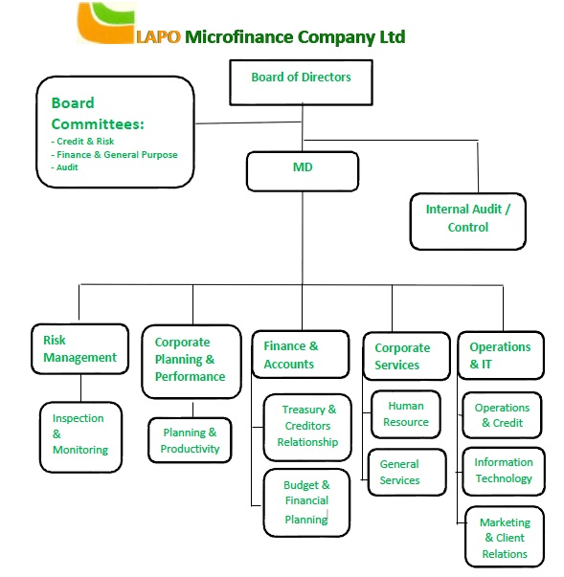
  - DIFFERENT DEPARTMENT IN THE ORGANIZATION
Customer Service Department: Handles inquiries, complaints, and assists customers with various banking services.
Loan Department: Responsible for the assessment, disbursement, and management of loans to individuals and small businesses.
Risk Management Department: Works to identify, assess, and mitigate financial and operational risks to protect the bank's assets and reputation.
Marketing and Business Development: Focuses on promoting the bank’s products and services and expanding its customer base.
Finance and Accounting Department: Manages the financial records, ensures compliance with regulations, and prepares financial reports.
Human Resources (HR) Department: Deals with recruitment, employee welfare, training, and performance management.
Information Technology (IT) Department: Manages the bank’s technological infrastructure, ensuring secure and efficient banking systems and digital services.
Compliance and Legal Department: Ensures that the bank complies with regulatory requirements and handles legal matters.
Treasury Department: Manages the bank’s funds, investments, and liquidity to ensure operational efficiency.
Internal Audit Department: Responsible for examining and evaluating the bank’s operations and financial records to ensure accuracy and compliance with internal policies.

2.4 INTERPERSONAL RELATION WITH THE ORGANIZATION
There was mutual understanding and love among the staff and the student that did their SIWES programme there because they took all the student like their own children, advising and guiding them to do the right thing at the right time.
High level of discipline was displayed among the student, even though the staffs a make sure that every problem encountered by the student are been tackled and solved out by both the student and staff all in the aspect of bringing about unity and peace.

CHAPTER THREE
3.1 WORK ACTUALLY CARRIED OUT
During my time at BELAD Block Industry, I was assigned to various tasks within the Accounts Department, which allowed me to develop a deep understanding of financial operations within a manufacturing business. Some of my key duties included:
- Financial Recordkeeping: I assisted in recording daily transactions in the general ledger, including sales, purchases, and expenses. This involved ensuring all entries were accurate and timely.
- Bookkeeping: I maintained and updated the company's books by tracking payments and receipts. This included monitoring outstanding invoices and following up with clients and suppliers on overdue accounts.
- Bank Reconciliation: I participated in reconciling the company's bank statements with internal records, ensuring there were no discrepancies between the two.
- Accounts Payable and Receivable: I assisted in processing payments to suppliers and vendors, and monitored incoming payments from clients, ensuring that records were up-to-date and accurate.
- Use of Accounting Software: I was introduced to accounting software such as QuickBooks and Tally, and assisted in entering financial data into the system, generating financial statements, and running reports.
- Financial Reporting: I helped prepare monthly financial reports, including income statements and balance sheets, to ensure that the company’s financial performance was accurately represented.
- Inventory Management: As part of the accounting team, I also had the opportunity to work with inventory management systems, tracking the costs of materials and supplies used in production.

CHAPTER FOUR
4.1 EXPERIENCED GAINED
I can actually say I gained a lot from my SIWES Programme by having the opportunity to know my capability on the work I have been taught in school.
Throughout my internship, I developed both technical and soft skills that will be essential for my future career in accounting. Some of the skills I acquired include:
- Practical Accounting Knowledge: I gained a deeper understanding of financial recordkeeping, budgeting, and financial reporting within a business environment.
- Proficiency with Accounting Software: I became proficient in using accounting software like QuickBooks and Tally for financial data entry and report generation.
- Problem-solving and Analytical Skills: By working on financial discrepancies and reconciling accounts, I developed strong analytical and problem-solving skills.
- Communication Skills: I learned how to effectively communicate financial information to both internal stakeholders and clients, improving my ability to present financial data in a clear and concise manner.
- Attention to Detail: Accuracy is essential in accounting, and my experience at BELAD Block Industry taught me the importance of paying attention to small details to avoid errors in financial reporting.
4.2 CHALLENGES FACED
During the course of my internship, I faced a few challenges that tested my skills and adaptability. These included:
- Time Management: Balancing multiple tasks and deadlines at the same time was sometimes overwhelming. However, I learned how to prioritize tasks and effectively manage my time.
- Technical Issues with Accounting Software: Occasionally, I faced technical difficulties with the accounting software, which required troubleshooting and quick adaptation. With the help of my supervisor, I was able to resolve these issues and continue my work without significant delays.

CHAPTER FIVE
CONCLUSION AND RECOMMENDATION

5.1 CONCLUSION
Student Industrial Work Experience Scheme (SIWES) is a good programme for higher institution in the sense that it adds to one’s practical knowledge based on your course of study. As for me SIWES as a course has truly exposed me to face in a growing information world that depend on Business Administration and Management.
5.2 RECOMMENDATION
As a bonafide student of the department of Accountancy of Kwara State Polytechnic and who has undergo industrial training. I hereby make the recommendation that the government should continue funding this programme (SIWES) and pay directly to student after the completion of the programme due to the stress inclined to the programme, in order to serve as encouragement to student that want to increase their practical and technical knowledge.

