A TECHNICAL REPORT ON STUDENT
INDUSTRIAL WORK EXPERIENCE SCHEME
(SIWES)

HELD AT
ANYINKE SALAYE CLINIC
NO 1 SHO- ALLAH OKE OSE ILORIN KWARA STATE

PRESENTED BY:

MUBARAK AYOMIDE
ND/23/SLT/PT/0046

SUBMITTED TO:
THE DEPARTMENT OF SCIENCE LABORATORY TECHNOLOGY
INSTITUTE OF APPLIED SCIENCE (IAS)
KWARA STATE POLYTECHNIC, ILORIN, KWARA STATE
IN PARTIALLY FULFILLMENT OF THE REQUIREMENT

FOR THE AWARD OF
NATIONAL DIPLOMA (ND) IN SCIENCE LABORATORY TECHNOLOGY
FROM AUGUST TO NOVEMBER 2025

TABLE OF CONTENT
CHAPTER ONE
1.1 Background of SIWES
1.2 Objectives of SIWES
CHAPTER TWO
2.1 Precaution taken in the laboratory
2.2 Equipments used in the laboratory
CHAPTER THREE
3.1 Laboratory
3.2 Malaria parasite test
3.3. Packed cell volume
3.4. Urine analysis test
3.5. Hepatitis test
CHAPTER FOUR
4.1. HIV test
4.2. Blood group
4.3. Blood sugar test
CHAPTER FIVE
5.1. Conclusion and recommendation

CHAPTER ONE
1.1. BACKGROUND OF SIWES
The student industrial work experience scheme (SIWES) was introduced in year 1976, during the military regime of Muhammed and General Olusegeun Obansanjo. Although the scheme was introduced by military, it was not full force until 1977. Consequently, the need for student in tertiary institution to acquire practical Knowledge, gave rise to introduction of the scheme by the federal government of tertiary institutions.
The scheme which is to last for at least three months industrial attachments for students into different organization either private or government owned, is designed for students in universities, polytechnics, monotechnics and college of educations.
These programmes serve as a great deal to help students, as it expose them to practical knowledge of the theoretical aspect of what they have been taught through their different institutions.
Furthermore, the scheme help the student to adapt to the challenge which might spring up that now gives them the clear distinction between theoretical lecturing in the lecture rooms and practical experience derived in organization where related practices are on daily basis exhibited. This therefore serves as a first – hand – which student would delve into after graduation from their tertiary institution.
During the period the ITF keeps the student on allowance through their liaison offices set up in different states of the federations; with headquarter in Mango, in Jos, the capital of Plateau State. The allowance is however given by the federal government to student who genuinely completed the scheme.
1.2 OBJECTIVES OF SIWES
The student industrial work experience scheme (SIWES) is of great benefit to students in tertiary institutions. Below are some objectives of the scheme.
Firstly, the scheme serve as first – hand – test of what the students would actually be exposed to after graduation. It proves an avenue for student in Nigeria universities to acquire practical skills, knowledge and experience in their course of study.
Secondly, it exposes students to work methods of techniques in handing equipment and machinery that may not be available in the institutions.
Thirdly, it provides students with an opportunity to apply their theoretical knowledge in real work situation, thereby bridging the gap between institutions work and actual practices.
Lastly, the scheme enlists and strengthens employer’s involvement in the entire educational process of preparing universities graduation for employment in the institutions.

CHAPTER TWO
2.1 PRECUATION TAKEN IN THE LABORATORY
- Wash hand thoroughly after each test
- Wear hand gloves before carrying out any test In the laboratory and discard after use.
- Do not touch exposed eyes, nose or skin gloved hands.
- Wash hand with water and soap or removal of gloves and after the day’s work.
- Always put on laboratory coat.
- Ensure that work surface are kept clean and disinfected before each work
- Do not store food, drink or beverages in the laboratory refrigerator.
- Unnecessary talks are disallowed during work.
- Eating, drinking or application of cosmetics is not allowed in the laboratory.
2.2 EQUIPMENT USED IN THE LABORATORY
There are various equipment used in the laboratory to carry out different tests, among which are briefly discussed below:
- Microscope: used for manifying and focusing image that is not easily seen with the naked eyes.
- Bunsen Burner: source of flame (red hot heat)
- Wire loop: used for inoculating
- Test tube: used to heat, centrifuge and hold sample during test.
- Slides: used for routine works such as microscopy and staining purpose in the laboratory.
- Micro capillary reader: used to measure the percentage of PCV
- Capillary tube: used to spin blood during PCV determination
- Genotype machine: used for genotype determination
- Glucometer machine: used for blood glucose test.
- Laboratory refrigerator: used to keep sample for further use
- Centrifuge machine: used to centrifuge blood or urine.
- Haemocytometer: used for white bloods count
- Wintrobe tube: used for erythrocytes sedimentation rate (ESR).

CHAPTER THREE
3.1 LABORATORY TESTS
BLOOD PREGNANCY TEST
Blood pregnancy test is a method used to demonstrate whether or not a woman is pregnant using blood as a test sample.
MATERIALS/REAGENT: Blood lancet or picking needle, capillary tube, test Kit/Strip E. D. T. A salt.
PROCEDURE
- Collect about 1 ml of blood into the capillary tube
- Add E. D. T. A salt to prevent the blood from coagulation
- Inject into the pregnancy test strip
- Leave it for about 3 minutes
- Do not pass the maximum line (MAX) on the strip when immersing the strip
- Lay the test strip horizontal on clean surface and start the timer
- Read the result after 5 minutes
READING OF RESULT
POSITIVE RESULT
Two red-purple colored lines appear, one line at the control region (C) and another line at the test region (T). it means the person is pregnant.
NEGATIVE RESULT
One red-purple colored line appeared at the control region (C) and no colored lined appears at the region (T). it means the person is not pregnant.

INVALID RESULT
The result is invalid if the control line (C) fails to appear after 5 minutes. Insufficient volume of plasma or incorrect procedure is the most likely reason for an invalid result.
3.2 MALARIA PARASITE TEST (MPT)
Malaria parasite test is any method used to test for the presence of an infection disease due to the presence of parasitic protozoa of the genus plasmodium falciparium malaria, and plasmodium ovale within the red blood cell.
REAGENT/MATERIAL: picking needle, buffer solution, cotton wool, malaria kit and time.
PROCEDURE
Blood is obtained by skin puncture, with a picking needle.
- Add into malaria kit
- Add 2 drop of buffer solution on the kit and leave it for 3 minutes
RESULT
- If one line appear in the kit, this signifies that the patient is negative
- If two line appears, it signifies that the patient is positive
- If no line appear, it signifies that the patient is invalid
3.3 PACKED CELL VOLUME (PCV)
Packed cell volume is a percentage of the known of whole blood occupied by packed blood cells, when the blood is centrifuge at a constant speed and period of time. It is also expressed as the fraction 9 of the volume occupied by the erythrocytes, when a sample of whole blood In a capillary or win robe tube is centrifuged.

MICROHAEMATOCRIT METHOD OF DETERMINING PCV
The micro-hematrocrit or capillary method is the most convenient and has been adopted as a method of choice for the routine estimation of packed cell volume. This because only a little quantity of blood is required.
MATERIALS: cotton wool, sealant (Plasticine), micro-hematocrit tube, Micro-hematocrit centrifuge.
PROCEDURE
- Collect the blood sample by using needle and syringe
- Fill the micro-hematocrit tube with blood by capillary action. The tube should filled to at least ¾ length
- Clean the excess blood on the tube with cotton wool
- Seal the dry end of the tube with the sealant
- Open the lid of the hematocrit centrifuge
- Place the tube in the radial grooves of the hematocrit centrifuge with the open and towards the center
- Cover the lid lightly
- Allow the centrifuge to stop on its own
- Open the lid and remove the tube
- Use the hematocrit reader to read the PCV
READING THE RESULT
Place the capillary tube on reader slide tray
Align the base of red cell in the column with O, and the bottom of the meniscus of the plasma with 100
The volume of the packed cells is taken directly from the capillary read by moving the adjustable of the reader.
Read the result in percentage
3.4 URINALYSIS (URINE DISPSTIC CHEMICAL ANAYSIS)
Urinalysis is the analysis of urine, using practical, chemical and Microcopical test to determine the proportion if its normal constituents which includes bilirubin, urobillinogen, ketones, ascorbic acid, glucose, protein, blood, Ph, specific gravity, nitric, appearance and to detect alcohol, drug, sugar, or the order abdominal constituent.
Urinalysis can reveal disease that have gone unnoticed because they do not produce striking signs or symptoms. Example include diabetes mellitus various forms of glomerulonephrits and chronic urinary tract infections. The first part of urine analysis is direct visual observation. Normal, fresh urine is clear and pale yellow in color due to the presence of a pigment urochrome a compound of urobillin, urobillinogen and a peptide substance, but could be cloudy at times.
Procedure
- Little quantity of the urine sample (5ml) is poured into each of the centrifugal tubes and then it is spanned at 200rev/min for 5mins.
- When 5min elapsed, the test-tube was brought out and the test-tube was inverted in a dish: to discard the supernatant.
- The test-tube was brought back to its upright position and the fluid at the sides of the test-tube was allowed to drain down to bottom of the test-tube.
- The bottom of test-tube was taped to re-suspense the fluid sediment of the urine
- The deposit/sediment obtained is poured into a clean glass slide and covered gently to make a smear with a cover slide.
- The smeared sediment on the slide is examined under the microscope using x10 and x40 objective lens.

Observation
- For the microscopic examination, when the urine is observed turbid, then it suggests that the patient is likely to have urinary tracts infection.
- Finally the presence of blood in the urine of a male patient suggests that the patient is likely to be infected with the parasite called schlist stoma haemotibum.
- The presence of many degenerate White Blood Cells (Plus Cells) indicates that there is an infection.
- The presence of Red Blood Cells (if the patient is not menstruating) indicates some infection or would the urethral tract
- Cast indicates kidney disorder and epithelial cells is normal if formed moderately, but in large quantities indicates inflammation of the urinary tract.
Some motile and non-motile organisms are likely to be seen depending on the health status of the patient. They include pus cells, spermatozoa, red blood cells, yeats cyst, epithelia cells and cast.
3.5 HEPATITIS C VIRUS STRIP (SERUM/PLASMA)
This is rapid test for the qualitative detection of antibodies to Hepatitis C Virus (HCV) in serum or plasma. The HCV one step Hepatitis C Virus Test Strip (Serum/Plasma) is a rapid chromatographic immunoassay for the qualitative detection of antibody to Hepatitis C Virus in serum or plasma.
Antibody to HCV is found is over 80% of patients with well documented non-A, non-B hepatitis. The Hcv ONE Step Hepatitis C Virus Test Strip (Serum/Plasma) is a qualitative, membrane based immunoassay for the detection of antibody to HCV antigen on the test line region of the strip. During testing, the serumor plasma specimen reacts with the protein a coated particles. The mixture migrates upward on the membrane chromatographically by capillary action to react with recombinant HCV antigen on the membrane and generate a colored line. Presence of this colored LINE. Presence of this colored line indicates a positive result, while its absence indicates a negative result. To serve as a procedural control, a colored line will always appear at the control line region indicating that proper volume of specimen has been added and membrane wicking has occurred.
Hepatitis B Surface Antigen (HBSAg) test (Serum/Plasma)
The HBsAgg one step Hepatitis B Surface Antigen Test Strip (Serum/Plasma) is a rapid chromatographic immunoassay for the quality detection of Hepatitis B Surface Antigen in Serum or Plasma.
The HBsAg one step Hepatitis B surface antigen test strip (Serum/Plasma) is a qualitative, lateral flow immunoassay for the detection of HBsAg in Serum and Plasma. The membrane is pre-coated with anti-HBsAg antibodies on the test line region of the strip. During testing, the serum or plasma specimen reacts with the particle coated with anti- HBsAg antibody. The mixture migrates upward on the membrane chromatographically by capillary action to react with anti HBsAg antibodies on the membrane and generate a colored line. The presence of this colored line in the test region indicates a positive result, while its absence indicates negative result. To serve as a procedural control, a colored line will always appear in the control line region indicating that proper volume of specimen has been added and membrane wicking has occur.

CHAPTER FOUR
4.1 DETERMINE HIV-1/2 Test
The determine Hiv-1/2 is an easy-to-use, rapid (15minutes) test for HIV antibodies. It is an in vitro, visually read, qualitative immunoassay for the detection of antibodies to HIV-1 and HIV-2 in human sertum, plasma or whole blood. The test is intended as an acid to detect antibodies to Hiv-1/hiv-2 from the infected individuals.
Determine Hiv-1/2 is an immune chromatographic test for the qualitative detection of antivodIES TO Hiv-1 and HIV-2. Sample is added to the sample pad. As the sample migrate through the conjugate pad, it reconstitute and mix with the selenium colloiad-antigen conjugate. This mixture continues to migrate through the solid phase to the immobilized recombinant antigens and synthetic peptides to the patient window site.
If antibodies to HIV-1 and/or HIV-2 are present in the sample, the antibodies bind to the angite selenium colloid and to the window site. Antibodies to Hiv-1 and/or HIV-2 are absent the antigen-selenium colloid flows past the patient window and on red line are formed at the patient window sit.
4.2 BLOOD GROUPING
There are four blood groups these are blood group A,B, O and AB where blood group O is referred to as the universal purpose of blood grouping is to determine the phenotypic and genotypic properties of an individual. With these properties, one can determine the paternity of a child, help in blood transfusion, and help in forensic study. The principle behind this is that when an antigen is introduced into the body, it triggers the production of antibodies. In this test, the blood sample acts as the antigens while the antiserum (which is the presence of antibodies in the serum) acts as the antibody. There are four anti sera that are used in this test. These are antiserum A, B, and Rhesus d. Antiserum A is tilt with blue color, antiserum B is tilt with yellow color while Rhesus d has no color.
PROCEDURE
- Blood sample is collected into an anticoagulant bottle
- With the use of a micropipette, a drop of the blood is placed on three marks on the test card.
- To the first mark, antiserum A is added, to the second antiserum B, and the third antiserum D.
- It is then mixed together with a stirrer for reaction to occur.
- A resulting clumping of the cells indicates the presence of antigen to the anti sera used. The clumping of the cells is referred to As Hem agglutination.
- If agglutination occurs with anti A only the blood Group Is called A Rh D negative.
- If agglutination occurs with anti A only the blood group is called A Rh D positive
- If agglutination occurs with anti B only the blood group is called A Rh D negative.
- If agglutination occurs with anti sera used the blood group is called AB Rh D positive.
- If agglutination occurs with anti A and D only the blood group is called A Rh D positive
- If agglutination occurs with anti B and D only the blood group is called B Rh d positive

ANTI-SERA  A | ANTI SERA B | ANTI SERA D | RESULT
+ | - | + | A+
+ | - | - | A-
- | + | + | B+
- | + | - | B-
+ | + | + | AB+
- | - | + | O+
- | - | - | O-

BLOOD GROUP RESULTS
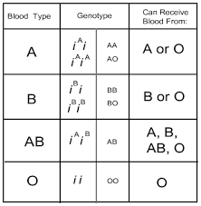
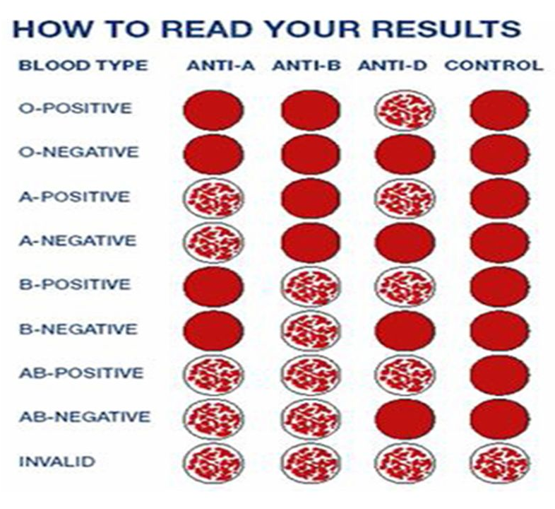
4.3 BLOOD SUGAR TEST
This is a test used to determine the glucose level in the blood sample of a patient. There are two ways of carrying out this test. It could be done while the patient is fasting (Fasting blood sugar or by finding the average result of the patients blood sample before and after Eating (Random blood sugar)
PPROCEDURE
- The blood sample is collected into a fluoride oxalate bottle
- The blood is spanned in a centrifuge to obtain serum/plasma
- 100ml OF GLU-Gap is measured in to two test tubes of which one is labeled test and the other standard.
- 20ml of glu cap is measured into the standard test tube, and 20ml is measured from the serum obtained into the test tube labeled test.
- Both test tube are then incubated for 15min at 37^{O}c,
- After 15min elapses, both bottles are brought out of the incubator, and 1000ml of water are added into each test-tube this is done to stop the reaction.
- Into the spectrometers’ tube, the solution in the test tubes are poured separately and the reading are taking for each (i.e. for test and standard)
- The result: test X 5.1 = xmmol/1x18 = ymg/dl
- Result: if the spectrophotometer reads between 60-115mg/dl (i.e. 3.3-7.2mmol/L), it is considered to be normal. But if the blood sugar level is 116mg/dl and above, it considered to be hyperglycemia and the patient is diabetic. Also, if the blood sugar levels falls below 50mg/dl, it is said to be hypoglycemia.

CHAPTER FIVE
5.0 CONCLUSION AND RECOMMENDATION
5.1 CONCLUSION
Having passed through the SIWES training, have been able to discover and explore different things about the microbial world; therefore, its usefulness cannot be over emphasized. The interesting part of this is that the field of microbiology has gotten answer to most of the infection and disease affecting the world. For the few infections that has not been diagnosed, precautionary measures that can be taken against it has been discovered. The only section left is for people should come out of their ignorance and go for medical check up instead of relying on self medication and visiting unqualified practitioners, if people could visit hospitals or health centers frequently and follow the treatments given to them, mortality rate will drastically be reduced and health status of the nation will be promoted.
More importantly I have been able to see the various prospects available in the field and also the various challenges that call for quick attention. Indeed, the industrial training program has been impactful; it was never a waste of time and energy.

