A TECHNICAL REPORT

ON

STUDENTS INDUSTRIAL WORK EXPERIENCE SCHEME
(SIWES)

UNDERTAKEN
AT

BRAVO INVESTMENT NIGERIA LIMITED, ILORIN, KWARA STATE.

BY
ADEBAYO AZEEZAT
MATRIC NO: ND/23/PSM/FT/0165

SUBMITTED TO

THE DEPARTMENT OF PROCUMENT AND SUPPLY CHAIN MANAGMENT
INSTITUTE OF FINANCE AND MANAGEMENT STUDIES (IFMS)

KWARA STATE POLYTECHNIC, ILORIN

IN PARTIAL FULFILMENT OF THE REQUIREMENTS FOR THE AWARD OF NATIONAL DIPLOMA IN PROCUMENT AND SUPPLY CHAIN MANAGEMENT

AUGUST TO DECEMBER, 2024
DEDICATION
I dedicate this report write up to Almighty Allah who gives me strength and inspiration in the course of this work. Special dedication also goes to my ever supportive parents Mr. and Mrs. ADEBAYO, and other family members for their relentless, financial and moral support towards the success of my four (4) months SIWES programme.

ACKNOWLEDGEMENT
I have taken effort in this Siwes. However, it would not have been possible without the kind support and help of some individuals and this organization. I would like to extend my earnest thanks to all of them.
I would and in Respect like explicitly express my gratitude to the Managing Director of BRAVO INVESTMENT NIGERIA LTD. Mr Ibrahim Aliu, and the staffs for their kind co-operation and their professional guidance and instruction during my Siwes which assisted me in completion of this Siwes.
I would like to express my special gratitude and thanks to industry persons for giving me such attention and time.
My thanks and appreciations also go to my colleagues in developing the Siwes Report and people who have willingly helped me out with their abilities. I am highly indebted to you all.

TABLE OF CONTENTS
TITLE PAGE
DEDICATION 1
ACKNOWLEDGEMENT 2
TABLE OF CONTENTS 3
CHAPTER ONE: INTRODUCTION 5 - 10
  - HISTORY OF SIWES
  - OBJECTIVES OF SIWES
CHAPTER TWO: DESCRIPTION OF THE ESTABLISHMENT OF ATTACHMENT 11-17
2.0 LOCATION AND BRIEF HISTORY OF ESTABLISHMENT
2.1 OBJECTIVES OF ESTABLISHMENT
2.2 ORGANIZATION STRUCTURE
2.3 THE VARIOUS DEPARTMENTS/UNIT IN THE ESTABLISHMENT
CHAPTER THREE 18
3.0 REPORTING ON WORK ACTUALLY CARRIED OUT AND GAINED
CHAPTER FOUR: SUMMARY, CONCLUSTION AND RECOMMENDATION 19
4.0 Summary of attachment activities
4.1 Problems encountered during the program
4.2 Suggestions for the improvement of the scheme

CHAPTER ONE
INTRODUCTION
1.1 HISTORY OF SIWES
SIWES (Student Industrial Working Experience Scheme) was established by ITF in 1973 to solve the problem of lack of adequate practical skills preparatory for employment in industries by Nigerian graduates of tertiary institutions.
The Scheme exposes students to industry based skills necessary for a smooth transition from the classroom to the world of work. It affords students of tertiary institutions the opportunity of being familiarized and exposed to the needed experience in handling machinery and equipment which are usually not available in the educational institutions. Participation in Industrial Training is a well-known educational strategy. Classroom studies are integrated with learning through hands-on work experiences in a field related to the student’s academic major and career goals. It also expose the student to the practical aspect of some course being offer in the school.
Successful internships foster an experiential learning process that not only promotes career preparation but provides opportunities for learners to develop skills necessary to become leaders in their chosen professions.
One of the primary goals of the SIWES is to help students integrate leadership development into the experiential learning process. Students are expected to learn and develop basic non-profit leadership skills through a mentoring relationship with innovative non-profit leaders.
By integrating leadership development activities into the Industrial Training experience, we hope to encourage students to actively engage in non-profit management as a professional career objective. However, the effectiveness of the SIWES experience will have varying outcomes based upon the individual student, the work assignment, and the supervisor/mentor requirements.
It is vital that each internship position description includes specific written, learning objectives to ensure leadership skill development is incorporation.
Participation in SIWES has become a necessary pre-condition for the award of Diploma, Degree and NCE certificates in specific disciplines in most institutions of higher learning in the country, in accordance with the education policy of government.
1.2 OPERATORS OF SIWES
Operators - The ITF, the coordinating agencies (NUC, NCCE, NBTE), employers of labor and the institutions.
Funding - The Federal Government of Nigeria
Beneficiaries - Undergraduate students of the following: Agriculture, Engineering, Technology, Environmental, Science, Education, Medical Science and Pure and Applied Sciences.
Duration - Four months for Colleges of Education and Polytechnics, and Six months for the Universities.
1.3 OBJECTIVES OF SIWES
1. SIWES will provide students the opportunity to test their interest in a particular career before permanent commitments are made.
2. SIWES students will develop skills in the application of theory to practical work situations.
3. SIWES will provide students the opportunity to test their aptitude for a particular career before permanent commitments are made.
4. SIWES students will develop skills and techniques directly applicable to their careers.
5. SIWES will aid students in adjusting from college to full-time employment.
6. SIWES will provide students the opportunity to develop attitudes conducive to effective interpersonal relationships.
7. SIWES will increase a student's sense of responsibility.
8. SIWES students will be prepared to enter into full-time employment in their area of specialization upon graduation.
9. SIWES students will acquire good work habits.
10. SIWES students will develop employment records/references that will enhance employment opportunities.
11. SIWES will provide students the opportunity to understand informal organizational interrelationships.
12. SIWES will reduce student dropouts.
The four (4) months Students Industrial Work Experience Scheme (SIWES) which is a requirement for the completion of my course of study, was undertaken at BRAVO INVESTMENT NIGERIA LTD.
The Industrial Training was based on working with Personal Computers, laptops, installation and maintenance, spreadsheet and word processing.

CHAPTER TWO
DESCRIPTION OF THE ESTABLISHMENT OF ATTACHMEMT
2.1 Location and brief history of BRAVO INVESTMENT NIGERIA LTD.
BRAVO INVESTMENT NIGERIA LTD. is a non-governmental organization (NGO) which was established 9years ago to assists in tackling basic societal problems, promotes education for indigent children and empowering youths through the provisions of various opportunities to be self-reliant.
This Institute is a skill acquisition centre which was established to compliments the state governments’ efforts at finding lasting and sustainable solution to the menace of unemployment through the provision of an enabling environment for youths to function effectively in the society.
The centre is also designed to eradicate unemployment in the society and to ensure that graduates of the institute could be gainfully employed in the state, nationally and internationally through the provision of a recognized qualification.
The venture is also giving efficient services to individual in the following areas as well:-
- Selling of gasoline/petrol
- Selling of diesel and
- Selling of engine oil

2.2 Objectives of Establishment
The company’s core value offers include:-
- As part of its cooperate social responsibility, the company offers the most affordable prices on its service rendered
- It also provides unmatched after sales service to its numerous customers.
- The brand named BRAVO INVESTMENT NIGERIA LTD. is known for providing quality services, prompt service and excellent customer relations.
- Building strong reputation in the community through trust, honesty and transparency
- Continuously improving processes and services to meet evolving customer needs.
2.3 Organization Structures/Departments
BRAVO INVESTMENT NIGERIA LTD. is divided into the following departments:-
- Manager
- Assistance Manager
- Attendant

2.4 The various departments in the establishment and their functions
BRAVO INVESTMENT NIGERIA LTD.
The service rendered by BRAVO INVESTMENT NIGERIA LTD. are selling of gasoline/fule, selling of diesel, selling of engine oil etc.

CHAPTER THREE
SKILLS AND KNOWLEDGE ACQUIRED
2.0 INTRODUCTION
A filling station is a small facility typically located in urban areas or along roadways, where gasoline and other products are stored in underground tanks. These stations can pose a risk to ecological resources if leaking tanks contaminate groundwater that may affect nearby water bodies or wetlands.
A Petrol Station, Filling Station, Gas Station, Fueling Station, or Service Station is a facility which sells fuel and lubricants for motor vehicles, the most common fuel sold is petrol and kerosene. According to Keble (1968), Petrol stations should be located not only where they are in fact accessible but where they can be easily located by strangers and that, in details, they should be placed where they will little danger and congestion as, much possible. According to the central place theory (Christallers, 1966), Service point could be distributed rationally according to the size, spacing or distance and population to be served. This means that, demand for products sold at filling stations would be satisfied by a system of service points at the central places. Consequently, the tangible expression in the landscape of any urban activities should be distributed on of service points at which a variety of demands are satisfied. Losch (1954) has argued, however, that it is possible to have unequal distribution of service centre’s (i.e. central places) around the metropolis producing city rich and city poor sector. An urban planner faces challenges of location of facilities and services that as a result exposed our urban populace to some dangers.

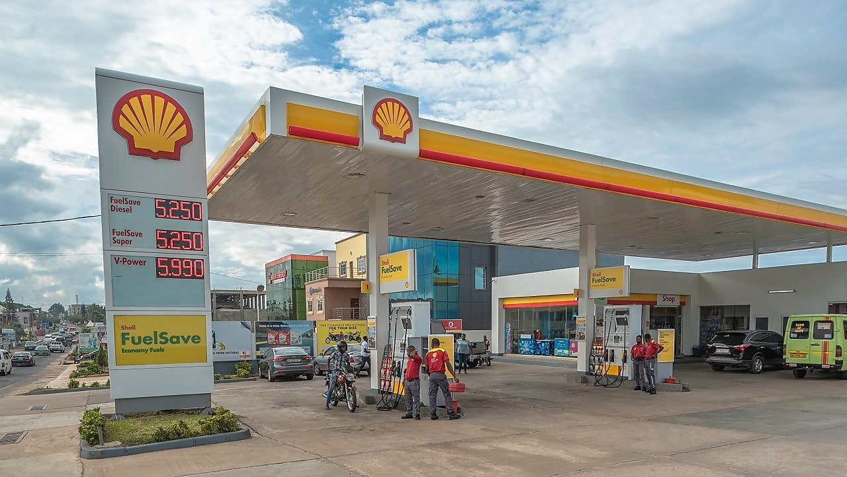

PETROLEUM
Petroleum has diverse uses, serving as fuel for vehicles (gasoline, diesel, kerosene) and jet fuel, and as a base material for various products like plastics, solvents, lubricants, asphalt, and even some pharmaceuticals.


USES OF PETROLEUM

Transportation: Transportation is heavily dependent on petroleum, and as transportation is important for life itself, it could save life or protect life.

Electricity: It serves as a crucial energy source for power plants, helping to produce electricity that powers homes, businesses, and industries around the world.

Pharmaceutical field: In the pharmaceutical field, petroleum-derived products are used as raw materials for producing various medications, including capsules, coatings, and even some active pharmaceutical ingredients. Additionally, petroleum-based products are used in the manufacture of medical devices, such as syringes, IV bags, and various types of equipment.
Also are commonly found in cosmetics and personal care products. These ingredients are used in items like lipsticks, moisturizers, shampoos, and perfumes. They can serve various purposes, such as providing texture, acting as preservatives, or offering moisturizing properties.

Lubricants: Motor oil, grease, and other lubricants are made from refined petroleum products, ensuring machinery functions smoothly.

Asphalt: Bitumen, a component of petroleum, is used in road construction and maintenance.

Waxes and Polishes: Petroleum-based waxes are used in products like candles, shoe polish, and furniture polish.
CRITERIAL FOR ESTABLISHMENT OF A FILLING STATION
- Stations should be located within a growth center or an urban area except in circumstances where it can be shown through appropriate studies that the need exists otherwise.
- Land should be zoned for commercial/industrial use or be designated specifically for the purpose in a subdivision.
- Stations should be located at a minimum of 500 ft. from any public institution such as schools, churches, public libraries, auditoriums, hospitals, public playgrounds, etc.
- Area of land to be developed should be sufficient to allow manufacturing of vehicles within its cartilage but should not be less than 12,000 sq. ft. with a minimum frontage of 300 ft. on the primary street.
- Filling Stations will not be allowed in any area where the traffic situation is such that it will cause obstructions in entering or leaving a station, or on tight curves where visibility is not adequate.
- Wherever possible, stations should be erected on level rather than sloping site to prevent rolling or discarded materials such as cans, drums, etc.
- When sited in shopping centers, stations should be located in an isolated area of the development as long as planning criteria are met, example, set back

A FUEL ATTENDANT
A Fuel Attendant is a professional responsible for providing fuel services to customers. They typically work at gas stations and are responsible for dispensing fuel, collecting payment for fuel, and performing other routine tasks. They also make sure that the gas station and the fuel dispensers are clean and in good working order. Additionally, they may be required to troubleshoot and resolve minor issues that customers encounter when using the fuel dispensers. Fuel attendants need to have good customer service skills and should be able to communicate effectively with customers.

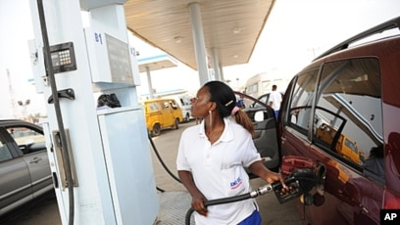

Fuel Attendant Role Purpose
The purpose of a fuel attendant is to provide efficient and effective service to customers when they are purchasing fuel, such as petrol or diesel, at a petrol station. This includes operating the pumps, managing the payment process, and providing advice and assistance to customers. The attendant is also responsible for ensuring that the station is clean and safe for customers, as well as monitoring and stocking fuel supplies.

Fuel Attendant Role
Fuel Attendant is a customer-facing role responsible for serving customers at petrol stations and ensuring that fuel pumps, payment systems and other equipment is kept in working order. Duties include serving customers, handling payments, stocking shelves, carrying out basic maintenance, and providing a safe and clean environment.

Fuel Attendant Duties
- Greet customers in a friendly and courteous manner
- Provide customers with information about fuel products and other services
- Handle all cash and credit transactions accurately
- Refuel vehicles
- Collect payments and issue receipts

SOME OF THE SKILLS AND REQUIREMENT TO BE A SUCCESSFUL FULE ATTENDAT
- Communication and interpersonal skills: Ability to effectively communicate with customers, respond to their inquiries, and provide excellent customer service.
- Problem-solving and conflict resolution: Ability to handle customer complaints, resolve issues, and provide solutions.
- Time management and efficiency: Ability to manage time efficiently, handle multiple customers, and maintain a clean and organized work environment.
- Knowledge of safety procedures and protocols: Understanding of safety procedures, including emergency response plans, fire safety, and first aid.
- Ability to identify and report hazards: Ability to identify potential hazards, report incidents, and take proactive measures to prevent accidents.
- Cash handling and security: Ability to handle cash, operate a point-of-sale system (POS), and maintain a secure work environment.
- Physical stamina and endurance: Ability to stand for long periods, lift heavy objects, and work in a fast-paced environment.
- Mental focus and attention to detail: Ability to maintain focus, attention to detail, and mental clarity in a busy and dynamic work environment.
- Basic math and calculation skills: Ability to perform basic math calculations, handle cash, and operate a point-of-sale system.
- Teamwork and adaptability: Ability to work effectively with colleagues, adapt to changing situations, and maintain a positive attitude.
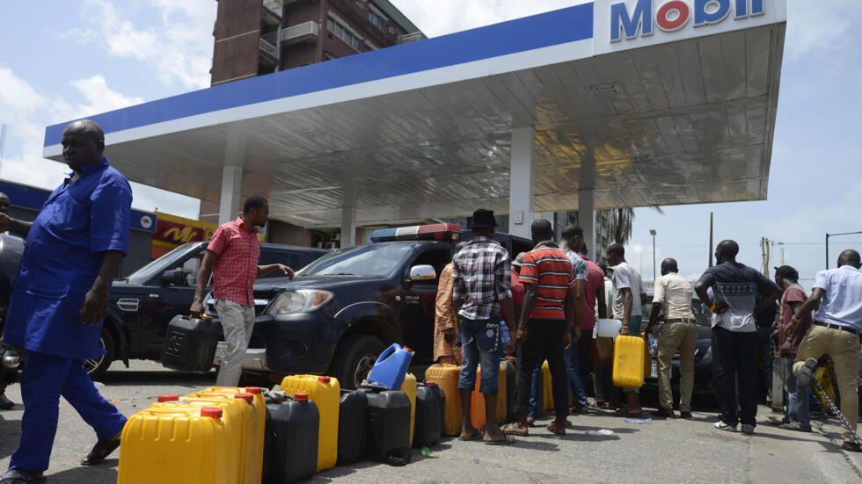

CHALLENGES AND DIFFICULTIES OF ATTENDANCE
- Long hours of standing: Fuel attendants often work long hours on their feet, which can lead to fatigue, back pain, and other musculoskeletal issues.
- Exposure to extreme weather: Fuel attendants may be exposed to extreme temperatures, rain, snow, and other weather conditions, which can be uncomfortable and affect their health.
- Lifting heavy objects: Fuel attendants may need to lift heavy objects, such as fuel hoses or equipment, which can cause injuries if not handled properly.
- Robbery and theft: Fuel attendants may be vulnerable to robbery and theft, particularly during late-night shifts or in high-crime areas.
- Dealing with difficult customers: Fuel attendants may encounter difficult or aggressive customers, which can be stressful and challenging.
- Cash handling and management: Fuel attendants may need to handle cash, operate a point-of-sale system (POS), and manage inventory, which can be challenging and require strong organizational skills.

CHAPTER FOUR
SUMMARY, CONCLUSION AND RECOMMENDATION
4.1 SUMMARY OF ATTACHMENT ACTIVITIES
This report contained and gives the details explanation of all activities carried out at BRAVO INVESTMENT NIGERIA LTD., Ita-merin Area, Ilorin, Kwara State, Nigeria.
The report explains briefly the details of all the activities with each Siwes been involved in outlined under each chapter. Chapter 1 started with the general introduction knowledge and objectives of the SIWES programme, Chapter 2 gives detailed of the skills and knowledge acquired during the programme, contained the activities at Laundry department and gives detailed of the skills and knowledge acquired during the programme, Chapter 3 explained the problems encountered during SIWES programme and Recommendations, Chapter 4 contained the summary of the whole report and the conclusion.

5.2 PROBLEMS ENCOUTERED DURING THE PROGRAM
There are numerous problems I encountered during my SIWES program at BRAVO INVESTMENT NIGERIA LTD..
Some of the major problems are as follow:-
- Problem of searching a place of attachment:- I had so many problems when searching for a place of attachment for my SIWES because most organization rejected my request giving one reason or the other that they do not want SIWES student.
- Cost of transport:- Also encountered challenges in the aspect of transport fair during the course of my training due to the distance of my place of attachment.
- Finance: - The organization do not make any provision to pay SIWES student nor do they draft any allowance package for s so as to less the expenses during the course of the program.
5.3 SUGGESTIONS FOR THE IMPROVEMENT OF THE SCHEME
- The establishment should provide the adequate facilities to make the programme enjoyable for the students.
- Government should motivate partners from the private sector through granting tax relief for companies that accept Students on SIWES.
- The company should be willing to accept and encourage students that are seeking for SIWES placement in their company without requesting for any money.
- Institutions should be encouraged to create financial autonomy for Institution based SIWES Units/Directorates.
- The establishment should provide the adequate facilities to make the programme enjoyable for the SIWES Students.
- SIWES should be properly presented to potential sponsors, such as Banks, multinational companies and other corporate institutions for Support in creating placement opportunities, training, equipment, Facilities, as well as direct funding of SIWES.

