

KWARA STATE POLYTECHNIC
TECHNICAL REPORT
ON
STUDENT INDUSTRIAL WORK EXPERIENCE SCHEME
HELD AT:
OLUWATOLA OGUNRUKU MOTOR MECHANIC WORKS
72, KOFO ABAYOMI STREET, BESIDE MOBILE POST OFFICE ROUNDABOUT, APAPA LAGOS.

PREPARED BY:
BAKARE ABDULBASIT AYOMIDE
MATRICULATION NUMBER: ND/23/MEC/PT/0194
SUBMITTED TO
THE DEPARTMENT OF Mechanical engineering
SCHOOL OF

AUGUST - DECEMBER, 2024.
i
DEDICATION
This report is dedicated to Almighty God for his protection and mercy on me from the conception to completion of my SIWES and to my beloved and lovely parents, Mr. and Mrs. Bakare their moral and financial support during my SIWES period.

ii
ACKNOWLEDGEMENT
I thank God Almighty for His mercy ad grace that kept me all through my SIWES period.
I am greatly indebted to my parents, Mr. and Mrs Bakare for their financial and moral support during the course of the programme. May God strengthen you to reap the fruit of your labour on me (Amen).
Also thank my industrial training supervisor, Engr. Oluwatola for his motherly care and support during the training was a worthwhile and fulfilling one. May God continue to reign in your life sir. (Amen)
I appreciate my all my department lecturers for the knowledge they have impacted in me. Thanks and God bless you all (Amen)
I also want to thank everyone that contributed to my success; my colleagues, co-workers and all my relatives.
I am grateful to you all. May Almighty and merciful God bless you all. (Amen).

iii
TABLES OF CONTENTS
Title page………………………………………………………………………………………….i
Dedication…………………………………………………………………………………………ii
Acknowledgements………………………………………………………………………………..iii
Table of contents…………………………………………………………………………………..iv
CHAPTER ONE:
1.1 BACKGROUND ……………………………………………………………………………….1
1.3. Objectives of Siwes……………………………………………………………………………..1
CHAPTER TWO:
2.1. Location and brief history of establishment ……..……………………………………………2
2.2 Organogram of the Organisation…………………….………………………………………….2
2.3 Various Department and their function ………………………………………………………...3
CHAPTER THREE
3.1. Mechanical Workshop Equipment and Tools…………..………..…………...………....………4
3.2 Maintenance of the tools ……………………………………………………………………….6
3.3 Safety Precautions in the workshop …………………………………………………………….7

3.4 Classification of Motor Vehicle Components and Their Functions ………………………..….7

CHAPTER FOUR
4.1. Relevance of the Experience Gain at Student Field of Study ……………………...……………..9
CHAPTER FIVE
5.1 Summary of attachment activities…………………………………………………………..…..11
5.2 Problems encountered during the program …………………………………………………….. 11
5.3 Suggestions for the improvement of the scheme ………………………………………………. 11

iv
CHAPTER ONE
- INTRODUCTION
Student industrial work experience (SIWES) is a program organized by industrial training found (ITF) purposely to improve practical knowledge of the students in an institution. Also to expose them to a various equipment and their uses in their field of studies. Due to the fact that only theory aspect of their course are covered throughout the semester. Meanwhile, SIWES program is brought to the student in other to expose them to different type of machine and tools as well as their uses in their respective field of studies.
1.1 BACKGROUND
The Student’s Industrial Work Experience Scheme (SIWES), was introduced in 1973 by the Industrial Training Fund (ITF), and the institution established federal government of Nigerian to carry training programmed for students in institution the country.
Student’s Industrial Work Experience Scheme (SIWES) is under the National Board for Technical Education (NBTE). It was established by ITF (Industrial Training Fund) to solve the problem of lack of adequate skills preparatory for employment in industries by Nigerian graduate of tertiary institution.
1.2 AIMS AND OBJECTIVE OF SIWES
The program, Student’s Industrial Work Experience Scheme (SIWES) is designed for student’s most especially technical student to expose them to the industrial technical require in their various field of study’s.
- To facilitate the students towards a full potential.
- To prepare students for future ambition.
- To enable students to be self-employed.
- To make students to practically oriented.
- To enhance qualified education in all tertiary institution.
1
CHAPTER 2
2.0 LOCATION AND BRIEF HISTORY OF ESTABLISHMENT
2.1 LOCATION OF THE ESTABLISHMENT
Located at 72, Kofo Abani Street, Beside Mobile Post Office Roundabout, Apapa Lagos State.
2.2 HISTORY OF THE ESTABLISHMENT
Oluwatola Ogunruku Motor Mechanics Works is a renowned automobile repair and maintenance service based in Apapa Lagos, Nigeria. Established several years ago, the business has earned a reputation for providing high-quality mechanical solutions for various vehicles, ranging from routine maintenance to complex engine repairs.
The workshop is strategically positioned to serve both residents and travelers in and around Lagos State. Oluwatola Ogunruku Motor Mechanics Works prides itself on its skilled workforce, efficient service delivery, and commitment to customer satisfaction, making it a trusted name in the local automotive industry.
2.3 ORGANIZATION STRUCTURE
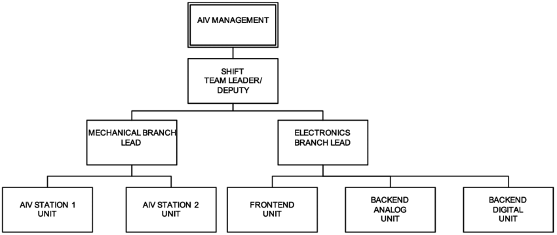

2
2.4 VARIOUS DEPARTMENTS IN THE ORGANIZATION
Oluwatola Ogunruku Motor Mechanics Works is typically structured into several specialized departments to ensure efficiency and expertise in handling diverse automotive needs. These departments may include:
- Engine Repair and Overhaul Department
Focuses on diagnosing and repairing engine-related issues, including engine overhauls, valve adjustments, and replacement of major engine components.
- Electrical and Diagnostics Department
Handles electrical systems such as wiring, alternators, starters, and advanced diagnostics using modern tools to identify and resolve electrical faults.
- Transmission and Gearbox Department
Specializes in the repair and maintenance of manual and automatic transmissions, clutches, and gearboxes.
- Suspension and Alignment Department
Addresses suspension systems, wheel alignment, shock absorbers, and other components related to ride comfort and stability.
- Brake and Hydraulic Systems Department
Ensures the proper functioning of braking systems, including hydraulic systems, disc brakes, and ABS-related components.
- Bodywork and Painting Department
Focuses on vehicle body repairs, dent removal, repainting, and aesthetic restorations.
- Spare Parts and Supply Department
Manages the sourcing, stocking, and distribution of genuine spare parts for repairs and replacements.
3
CHAPTER THREE
3.0 WORKSHOP EQUIPMENT AND TOOLS
During my SIWES placement, I worked in a well-equipped automobile workshop where various tools and equipment were utilized for efficient automobile repairs and maintenance. Below is an overview of the key tools and equipment along with their functions:
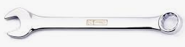
- Spanners: Spanners, including open-end, ring, and combination types, were used for loosening or tightening bolts and nuts of various sizes. They are essential in dismantling and assembling parts during repairs.

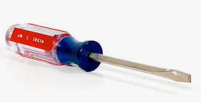
- Screwdrivers: These tools, available in flathead and Phillips types, were used to fasten or loosen screws in different components of the vehicle. They are crucial for tasks involving the vehicle’s interior and electrical systems.

- Pliers: Pliers, such as combination, needle-nose, and cutting pliers, were utilized for gripping, bending, or cutting wires and other small materials. They were especially handy for electrical repairs and wire management.
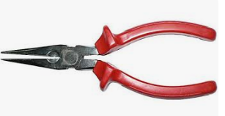
4
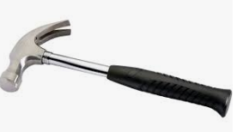
- Hammers: Ball peen hammers and rubber mallets were used for reshaping metal parts, driving nails or chisels, and ensuring proper fitting of components. Rubber mallets were particularly useful to avoid surface damage during assembly.

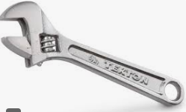
- Wrenches: Adjustable, torque, and pipe wrenches were used for gripping and turning objects such as pipes and fasteners. Torque wrenches ensured that bolts were tightened to the manufacturer’s specifications to avoid over-tightening or under-tightening.

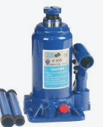
- Hydraulic Jacks: Hydraulic jacks were essential for lifting vehicles to provide access to the undercarriage. This equipment facilitated tasks such as changing tires, inspecting suspension systems, and replacing brake components.

5
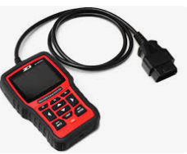
- Diagnostic Scanners: These devices were used to evaluate engine performance and identify faults in the vehicle’s systems. They provided error codes that guided troubleshooting and repair processes efficiently.

The availability of these tools and equipment ensured efficiency and accuracy in diagnosing and fixing automobile faults, contributing to a seamless workflow in the workshop.
3.2 MAINTENANCE OF THE TOOLS.
The maintenance are listed below.
- Regular Cleaning: Tools such as spanners, screwdrivers, and pliers were cleaned after use to remove grease, dirt, and other contaminants. This helped in maintaining their functionality and extending their lifespan.
- Proper Storage: All tools were stored in designated toolboxes or racks to prevent damage and ensure easy access. Proper storage also minimized the risk of misplacing or losing tools.
- Lubrication: Moving parts of tools like pliers, wrenches, and hydraulic jacks were lubricated regularly to prevent rust and ensure smooth operation.
- Inspection for Damage: Tools were inspected periodically for wear, cracks, or defects. Damaged tools were either repaired or replaced promptly to avoid compromising safety.
6
3.3 SAFETY PRECAUTIONS IN THE WORKSHOP:
- Wearing Protective Gear: Safety gear, including gloves, goggles, helmets, and safety boots, was worn at all times to minimize the risk of injuries.
- Maintaining a Clean Workspace: The workshop was kept clean and free of clutter to prevent accidents and ensure a safe working environment.
- Proper Tool Handling: Tools were handled carefully and used as per their specifications to avoid accidents or tool damage.
- Following Safety Protocols: Established safety protocols, such as locking vehicle lifts before working underneath them, were strictly followed.
- Avoiding Loose Clothing: Loose clothing and accessories were avoided to prevent them from getting caught in moving machinery.
3.4 CLASSIFICATION OF MOTOR VEHICLE COMPONENTS AND THEIR FUNCTIONS
- Braking System
- Brake Disc: Part of the braking system; works with brake pads to slow or stop the vehicle.
- Suspension and Drivetrain System
- Shaft Rubber: Protects the driveshaft or CV joint from dirt and debris, and retains lubrication.
- Drive Shaft: Transmits torque from the engine to the wheels.
- The Rod: Likely referring to a suspension or steering rod (e.g., tie rod) that connects components for alignment and stability.
- Filtration System
- Paper Oil Filter: A disposable filter used to clean engine oil of contaminants.
- Iron Oil Filter: A durable, reusable oil filter made of metal, often used in heavy-duty vehicles.
7

- Air Conditioning and Cooling System
- AC Compressor: Compresses and circulates refrigerant in the vehicle’s air conditioning system.
- Cooling Fan: Helps regulate engine temperature by drawing air through the radiator.
- Air Flyer: Likely refers to air blowers or fans in the HVAC system for cabin airflow.
- Exhaust System
- Catalyst: Part of the catalytic converter; reduces harmful emissions by converting them into less harmful substances.
- Exhaust Manifold: Collects exhaust gases from the engine cylinders and channels them to the exhaust system.
- Steering System
- Power Steering Hose: Transfers hydraulic fluid in power steering systems, enabling smoother control of the vehicle.
- Electrical and Charging System
- Alternator: Generates electrical power to recharge the battery and supply electricity to the vehicle's electrical systems.

8
CHAPTER FOUR
4.0 RELEVANCE OF THE EXPERIENCE GAIN AT STUDENT FIELD OF STUDY
During my training, I actively participated in various tasks related to the maintenance and repair of motor vehicles. Below are the details of the key activities performed:
- Changing and Replacing Brake Pads:
  - Inspected the brake system to identify worn-out brake pads.
  - Removed the old brake pads and replaced them with new ones.
  - Tested the braking system to ensure proper functionality.
- Replacing Ball Joints:
  - Diagnosed suspension issues caused by faulty ball joints.
  - Removed worn-out ball joints using a hydraulic press.
  - Installed new ball joints and performed alignment checks.
- Gear Replacement and Repairs:
  - Disassembled the gearbox to identify damaged gears.
  - Replaced faulty gears and ensured proper lubrication.
  - Reassembled the gearbox and tested for smooth operation.
- Oil Change:
  - Drained old engine oil and replaced it with fresh oil.
  - Replaced the oil filter to ensure cleanliness.
  - Verified oil levels and checked for any leaks.
- Wheel Balancing and Alignment:
  - Used wheel balancing machines to ensure even weight distribution.
  - Adjusted wheel alignment to prevent uneven tire wear.
  - Conducted road tests to confirm smooth driving.
9
- Shaft Repairs and Replacement:
  - Inspected drive shafts for wear and tear.
  - Replaced damaged shafts and applied appropriate grease.
  - Ensured proper installation and alignment.
- General Maintenance and Repairs:
  - Repaired damaged suspension components like shocks and struts.
  - Replaced worn-out tires and ensured proper inflation.
  - Performed diagnostic checks to identify additional faults.
Key Achievements:
- Successfully replaced critical components such as brake pads, ball joints, and drive shafts to restore vehicle functionality.
- Gained hands-on experience with tools like hydraulic jacks, diagnostic scanners, and wheel alignment machines.
- Improved my troubleshooting and repair skills through practical exposure.
- Enhanced my ability to work effectively in a team and adhere to safety protocols.

10
CHAPTER FIVE
5.0 CONCLUSION AND RECOMMENDATION
5.1 CONCLUSION
My exposure to and training in the field of electrical and electronic engineering have both benefited from the SIWES program. It has also aided me in applying the new information I have learned in the classroom to real-world professional experience. A critical and practical attitude to problems and their solutions in the electrical area should also be developed.
5.2 PROBLEM ENCOUNTERED DURING THE PROGRAM
• High Transport Costs
• Accommodation Issues
• Time Management
- Health and Safety Concerns
5.3 RECOMMENDATION
All students at the polytechnic should be required to take it, as the curriculum involves both practical and theoretical experience. SIWES program is such a program that exposes student to the practical aspect of what he/she had been taught theoretically at school.

11

