

A TECHNICAL REPORT
STUDENT INDUSTRIAL WORKING EXPERIENCE SCHEME
(SIWES)

HELD AT
KWARA STATE MINISTRY OF AGRICULTURE AND RURAL DEVELOPMENT
Old Jebba Road, P.M.B 1383, Ilorin, Kwara State

Prepared by:
AYODELE OLAJIDE
ND/23/ABE/FT/0033

SUBMITTED TO

DEPARTMENT OF AGRICULTURAL AND BIO-ENVIRONMENTAL ENGINEERING TECHNOLOGY
INSTITUTE OF TECHNOLOGY, KWARA STATE POLYTECHNIC, ILORIN

IN PARTIAL FULFILLMENT OF THE AWARD OF THE REQUIREMENT FOR THE AWARD OF NATIONAL DIPLOMA IN AGRICULTURAL AND BIO-ENVIRONMENTAL ENGINEERING TECHNOLOGY

DEDICATION
This report is dedicated to God Almighty, my family, whose support was unwavering, and to the resilience within me, which has propelled me to successfully complete this Student industrial work experience through my own determination, hard work, and perseverance.

ABSTRACT
This report presents an overview of the Student Industrial Work Experience Scheme (SIWES) conducted at the Ministry of Agricultural and Rural Development Services, located at Old Jebba Road, P.M.B 1383, Ilorin, Kwara State. It provides insights into the history, objectives, and significance of the SIWES program, alongside a detailed description of the organization of attachment, its roles, and functions. The report places emphasis on the technical exposure and hands-on experience acquired, particularly within the engineering department of the establishment. Additionally, it highlights the equipment used, their types, and respective functions. Furthermore, the challenges encountered during the program are discussed, along with recommendations to enhance the effectiveness of future training.

ACKNOWLEDGEMENT

I would like to thank the Almighty God, my strong pillar, my source of inspiration, wisdom, knowledge and understanding. he has been source of my strength, commitment and patience to pass various obstacles throughout this program also, my profound gratitude goes to the Kwara State Polytechnic Management for including the Student Industrial Workshop Experience Scheme (SIWES) to the National Diploma Programme which enable me to learn and gain more experience outside the campus.

Also, I will like to say a big thank you to the management of Ministry Of Agricultural And Rural Development Services, for giving me the opportunity to be trained under an organization of high status.
I would not end this acknowledgment without appreciating my parents for their unwavering support, co-operation, encouragement and understanding throughout the duration of the SIWES programme.

TABLE OF CONTENTS
Title page i
Dedication ii
Acknowledgement iii
Preface iv
Table Of Contents v
CHAPTER ONE
1.1 Introduction 1
1.2 Background of SIWES 1
1.1 Aim and Objective of SIWES 2
CHAPTER TWO
2.1 Description of the Establishment of Attachment 3
2.2 Vision and Mission Statements 3
2.3 Policy Thrusts 3
2.4 Aims/Objectives of the Ministry 4
2.5 Organizational Structure 5
CHAPTER THREE
3.1 Land Survey Using Leveling Compass 6
3.2 Tractor 6
3.3 Disc Plough 7
3.4 Measuring Tape 9
CHAPTER FOUR
4.1 Storage Facilities 10
4.2 General Safety in Agricultural Machinery & Equipment 11
4.3 Types of machine Maintenance 12
CHAPTER FIVE
5.1 Summary 13
5.2 Conclusion 13

CHAPTER ONE
  - INTRODUCTION
In October 1971, the federal government established the Industrial Training Fund (I.T.F). In its policy statement no.1 published in 1973, a clause was inserted dealing with the issue of practical skills among the locally trained professionals in the tertiary institutions especially the Universities of Technology, Monotechnics, Polytechnics, Colleges of Education and Technical Colleges. Section 15 of the policy statement states clearly that “Great emphasis will be placed on assisting certain products of the post-secondary school system to adapt or orientate easily to their possible post-graduation job environments”, subsequently leading to the launch of a scheme known as the Student’s Industrial Work Experience Scheme(SIWES).

1.2 BACKGROUND OF SIWES
The S.I.W.E.S. was launched in 1973 by the Industrial Training Fund (I.T.F) as a programme designed to impart the undergraduate of the nation’s tertiary institutions studying various professional courses with the practical methods of performing professional functions to real life situations on site, in the office or even the factory and how they apply themselves mentally, intellectually and physically in relation to what they have been taught in the classrooms theoretically. It works with the following professional bodies to function effectively across the tertiary institutions nationwide. These are the Nigeria University Commission (N.U.C), National Board for Technical Education (N.B.T.E.) and the National Commission for Colleges of Education (N.C.C.E.). Thus, equipping the students with the necessary skills and technical knowledge to make them highly competitive and professional individuals in the Labour Market.

1.3 AIM AND OBJECTIVES OF SIWES
The aim of SIWES is to bridge the gap between the level of knowledge acquired in tertiary institutions and the practical application of such knowledge in the field of work.

The Objectives of SIWES are as follows:
- To provide an avenue for students in industries of higher learning to acquire industrials skills and experience in their course of study.
- To expose students to work methods and techniques in handling equipment and machinery that may not available in the educational institution.
- To make transition from school to the world of work easier and enhance students contact for later job placements.
- To improve student’s interpersonal relationship with others in their field.
- To prove students an opportunity to apply his/her knowledge in real work situation, thereby bridging the gap between college work and actual practice.

CHAPTER TWO
2.1 DESCRIPTION OF THE ESTABLISHMENT OF ATTACHMENT
2.2 Vision and Mission Statements
To position Kwara as the leading and most efficient food producing State in Nigeria and West Africa by harnessing her enormous agricultural resources, human capital potentials and strategic geographical location in order to ensure food security, create wealth, decent employment for the teeming youths and women, provide raw materials for secondary production sector as well as produce for domestic and international consumption, there by leading to Rural development increased IGR of the State and ultimately improving the standard of living of Kwarans.
2.3 Policy Thrusts
To see agriculture as a sustainable business through the promotion of Commercial Agriculture, provision of enabling environment for peasant and small holder farmers to profitably engage in farming activity beyond subsistence level and put mechanism in place for the promotion of all-season farming through irrigation.

2.4 AIMS/OBJECTIVES OF THE MINISTRY
The aims and objectives of the Kwara State Ministry of Agriculture and Rural development include:
- the achievement of self-sufficiency in basic food supply and the attainment of food security;
- increased production of agricultural raw materials for industries;
- increased production and processing of export crops, using improved production and processing technologies;
- generating gainful employment;
- rational utilization of agricultural resources, improved protection of agricultural land resources from drought, desert encroachment, soil erosion and flood, and the general preservation of the environment for the sustainability of agricultural production;
- promotion of the increased application of modern technology to agricultural production; and,
- improvement in the quality of life of rural dwellers

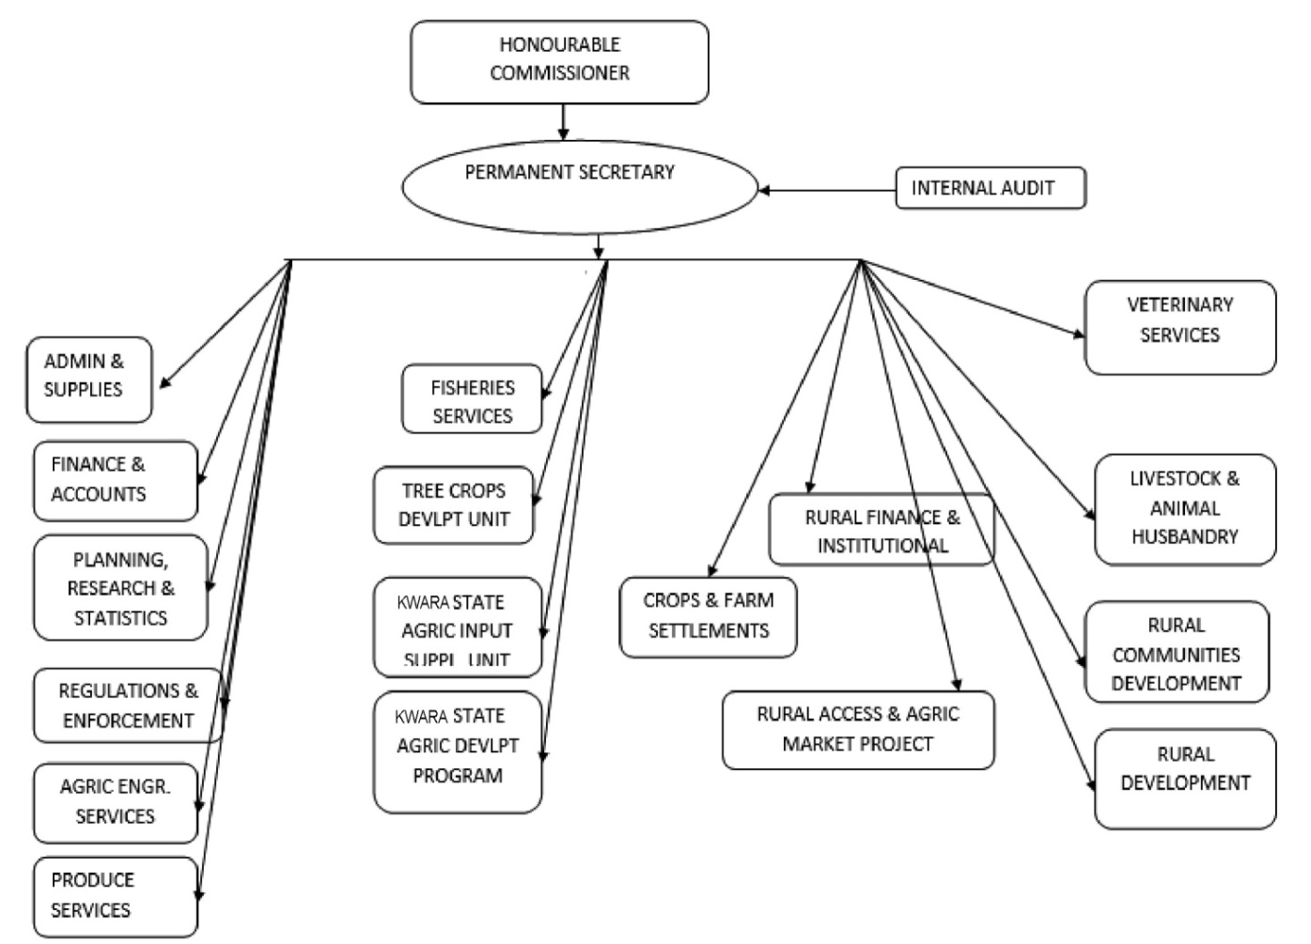
2.5 ORGANIZATION STRUCTURES

CHAPTER THREE
EXPERIENCE GRAINED
3.1 LAND SURVEY USING LEVELING COMPASS
I participated in land surveying using a leveling compass. This activity involved marking contours, identifying high and low areas, and preparing the land for effective irrigation and drainage systems.
TOOLS USED
  - Leveling Compass: Measures angles and gradients.
  - Staff: Marks specific heights for level determination.
  - Measuring Tape: Ensures accuracy in distance measurement.
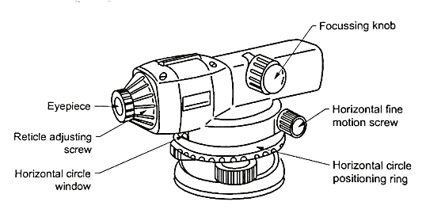

LEVELING COMPASS

3.2 TRACTOR
A tractor is a powerful agricultural machine designed for various farming activities such as plowing, tilling, harrowing, planting, and transporting heavy loads. It is one of the most essential pieces of equipment in modern farming due to its ability to perform multiple tasks efficiently, saving time and labor. Tractors come in different sizes and types, including wheeled tractors and crawler (tracked) tractors, depending on the terrain and farming requirements.
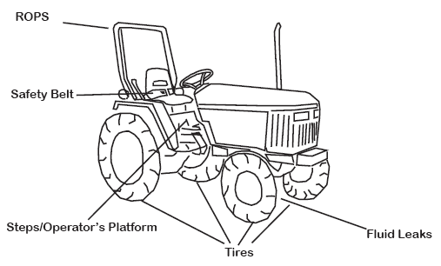

Tractor
Part of tractor
- Engine – The power source of the tractor, usually diesel or petrol-powered, responsible for driving all its mechanical operations.
- Chassis – The main frame that supports all other components of the tractor.
- Wheels and Tires – Tractors have large rear tires for stability and traction, while the front wheels are smaller for maneuverability.
- Fuel Tank – Stores fuel required to run the engine.
3.3 DISC PLOUGH
A disc plough is a primary tillage implement used in land preparation for farming. It consists of concave discs mounted on a frame, which cut, lift, and turn the soil. Unlike moldboard ploughs, the disc plough is particularly effective in hard, dry, and rocky soils where conventional ploughs may struggle. It is commonly used in breaking new ground, turning crop residues into the soil, and improving soil aeration.
Parts of a Disc Plough:
- Discs – Concave metal plates that penetrate and turn the soil.
- Disc Hub and Bearings – Allow the discs to rotate smoothly.
- Frame – Supports all components and provides structural stability.
- Scrapers – Remove soil sticking to the discs for efficient operation.
- Adjustable Brackets – Control the depth and angle of the plough.
- Hitch Point – Connects the plough to a tractor for towing.
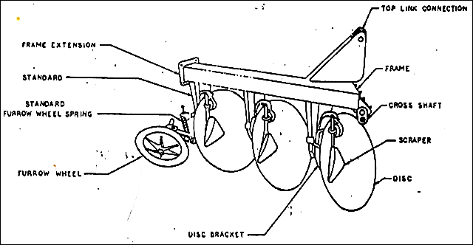

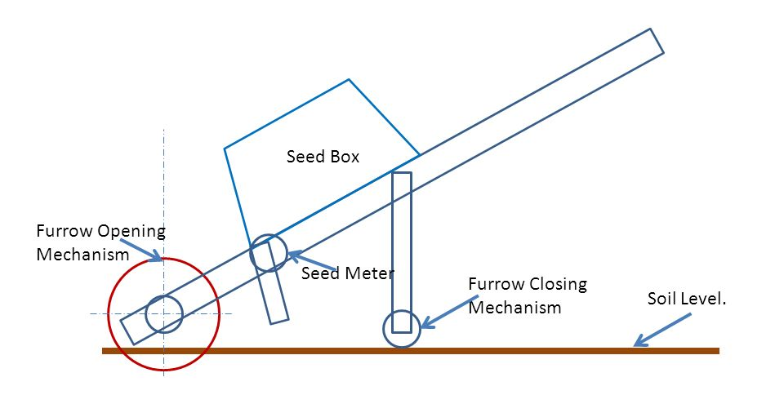
Seed Drill

A seed drill is a farm implement used for sowing seeds at the correct depth and spacing in the soil. It ensures uniform seed distribution, improves germination rates, and enhances crop yield compared to traditional broadcasting methods. The seed drill can be manual, mechanical, or tractor-operated, depending on the scale of farming.

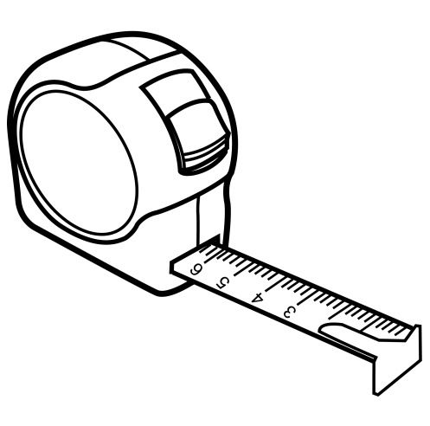
3.4 Measuring Tape

Measurement and Measuring Tape
Measurement refers to the process of determining the size, length, or amount of something using standard units. It is essential in various fields, including construction, engineering, agriculture, and tailoring, ensuring accuracy and precision in tasks such as land surveying, equipment setup, and material estimation.
A measuring tape is a flexible, retractable tool used for measuring distances, lengths, and dimensions. It is commonly made of metal, plastic, or fabric and is marked with metric (centimeters, meters) and imperial (inches, feet) units. Measuring tapes come in different lengths, ranging from a few meters for household use to over 100 meters for professional applications.
Uses of Measuring Tape:
- Land Measurement – Used in surveying and agriculture for measuring farm plots and construction sites.
- Carpentry & Construction – Essential for measuring wood, pipes, and other materials to ensure precision in cutting and assembling.
- Tailoring & Fabric Work – Helps in taking body measurements and fabric dimensions.
- Machine and Equipment Setup – Ensures proper alignment and spacing when setting up farm machinery.

CHAPTER FOUR
4.1 STORAGE FACILITIES
Storage facilities are structures or areas designed to store and preserve agricultural products, machinery, and inputs to maintain their quality and prevent losses. These facilities vary based on the type of goods being stored, environmental conditions, and duration of storage.
Types of Storage Facilities:
- Warehouses – Large buildings used for storing grains, seeds, fertilizers, and equipment in bulk.
- Silage Pits & Bunkers – Used for storing animal feed (silage) to preserve its nutritional value.
- Cold Storage Units – Refrigerated facilities that keep perishable products like fruits, vegetables, dairy, and meat fresh.
- Grain Silos – Tall, cylindrical structures designed to store grains like maize, wheat, and rice, protecting them from pests and moisture.
- Barns & Sheds – Used for storing hay, livestock feed, and farm tools.
- Tanks & Drums – Utilized for storing liquids such as water, pesticides, and fuel.
Importance of Storage Facilities:
- Prevents spoilage and losses due to pests, moisture, and temperature fluctuations.
- Ensures food security by preserving agricultural produce for future use.
- Reduces post-harvest losses, increasing profitability for farmers.
- Facilitates continuous supply of farm products throughout the year.

4.2 GENERAL SAFETY IN AGRICULTURAL MACHINERY & EQUIPMENT
Safety is crucial when handling agricultural machinery and equipment to prevent accidents, injuries, and equipment damage. Proper usage, maintenance, and adherence to safety guidelines ensure efficient operations and protect farm workers.
General Safety Measures:
- Proper Training – Only trained personnel should operate machinery to avoid mishandling.
- Wear Protective Gear – Use safety boots, gloves, helmets, and goggles to prevent injuries.
- Inspect Equipment Before Use – Check for loose parts, leaks, and other potential hazards before operating.
- Follow Manufacturer Guidelines – Operate machinery according to the recommended procedures to avoid malfunction.
- Keep Work Areas Clean – Remove obstacles, debris, and unnecessary tools from the operating area.
- Ensure Proper Machine Maintenance – Regular servicing and lubrication help prevent breakdowns and accidents.
- Turn Off Machines When Not in Use – Always switch off and unplug equipment when performing maintenance or repairs.
- Avoid Loose Clothing – Wear fitted clothing to prevent entanglement in moving parts.
- Keep Hands and Feet Away from Moving Parts – Never reach into running machines to avoid serious injuries.
- Use Guards and Shields – Ensure safety guards are in place to protect against rotating or sharp parts.
- Be Aware of Surroundings – Look out for people, animals, and obstacles before operating machinery.
- Handle Chemicals Safely – When using equipment for spraying pesticides or fertilizers, wear appropriate protective gear and follow handling instructions.
4.3 TYPES OF MACHINE MAINTENANCE
Proper maintenance of agricultural machinery and equipment is essential for ensuring efficiency, longevity, and safety in farm operations. There are several types of machine maintenance, each serving a specific purpose.
- Preventive Maintenance – Regular servicing and inspection of machines to prevent breakdowns. This includes oil changes, lubrication, tightening of bolts, and checking for wear and tear.
- Corrective Maintenance – Repairing faulty or damaged parts after a breakdown has occurred to restore the machine to working condition.
- Predictive Maintenance – Using advanced monitoring tools (such as sensors) to detect early signs of wear and failure before they cause a breakdown.
- Routine Maintenance – Basic daily or weekly checks performed by operators, such as cleaning, checking fluid levels, and inspecting parts for minor issues.
- Breakdown Maintenance – Emergency repairs carried out when a machine unexpectedly stops working. This is often costly and time-consuming.
- Scheduled Maintenance – Maintenance tasks that follow a fixed timetable, such as servicing after a certain number of hours of operation.
- Condition-Based Maintenance – Maintenance performed based on the machine's condition rather than a set schedule. This relies on inspections and monitoring.

CHAPTER FIVE
SUMMARY AND CONCLUSION
5.1 SUMMARY
In summary, the student industrial work experience scheme (SIWES) has been carried out and it can be categorically said that objectives of the scheme has been achieved. It has exposed me to the four major units of a standard institutional Agricultural and Bio-environmental Engineering work experience (Farm Power and Machinery, machine maintenance and Safety and storage facilities, crop processing and farm storage structure).
The safety rules and regulations, operational guideline of some basic equipment in the workshop house were also exposed. In general, practical exposures to base engineering practical have been learnt.
5.2 CONCLUSION
The Industrial Training Programme as its been designed has actually fulfilled its purpose by exposing undergraduate students of Engineering to industrial environment, use of tools, and equipment, practical knowledge and application of safety measure to life and properties.

