

KWARA STATE POLYTECHNIC, ILORIN
TECHNICAL REPORT ON
THE STUDENT INDUSTRIALWORKS EXPERIENCE SCHEME (SIWES)

HELD AT
(GERIN F.M 95.5)

PRESENTED BY
OYENIKE BALIKIS ADETOHUN
ND/23/MAC/PT/0557

SUBMITTED TO:
DEPARTMENT OF MASS COMMUNICATION
INSTITUTE OF INFORMATION AND COMMUNICATION TECHNOLOGY
(I.I.C.T))
KWARA STATE POLYTECHNIC, ILORIN.

IN PARTIAL FULFILLMENT OF THE REQUIREMENT FOR AWARD OF NATIONAL DIPLOMA (ND) CERTIFICATE IN MASS COMMUNICATION

AUGUST TO DECEMBER 2024

DEDICATION
This report is dedicated to AlmightyAllah for His boundless grace, consistent love, immeasurable faithfulness, and for sparing my life throughout the duration of my SIWES program. It is also dedicated to my parents, Mr. and Mrs. OYENIKE, for their unwavering support and immeasurable assistance throughout the entire exercise, as well as to my beloved friends who always trigger me to be strong.

ACKNOWLEDGEMENT
I wish to register to my profound gratitude to God Almighty for the guidance and grace throughout my life.
I'm appreciative to (GERIN F.M)
complete crew for making my industrial training exciting, instructive, and beneficial.
My special gratitude goes to my boss and mentor, Adetunji Adebayo Y., for his effort to see that this work saw the light of day. I appreciate my supervisor, and also my amazing lecturers for their seasoned lectures. To them all, I say thank you.

PREFACE
The student industrial work Experience scheme (SIWES) helps in exposing students to the practical application of their course and to get used to equipment and machine that are utilize in the factory. The SIWES was established to promote student ability and skill in industrial Practice and pre-expose them to working experience in industrial settings.
The SIWES program covered a period of four month from August to November 2024 and it is a partial fulfillment of a two year academic program to obtain an OND certificate in Mass Communcation. The report explains the description of the work here.

TABLE OF CONTENT
TITLE PAGE i
DEDICATION ii
ACKNOWLEDGEMENT iii
PREFACE iv
TABLE OF CONTENT
CHAPTER ONE
  - INTRODUCTION 1
  - BACKGROUND 1
  - OBJECTIVES 2
CHAPTER TWO
2.1 LOCATION AND BRIEF HISTORY OF THE ESTABLISHED 3
2.2 ORGANIZATION STRUCTTURE 4
23 DEPARTMENTS IN RADIO STATION 4
CHAPTER THREE
3.0 RADIO STATION TOOLS AND INSTRUMENT 6
3.1 USES OF THE TOOLS AND INSTRUMENT 6
3.2 MAINTENANCE OF THE TOOLS 10
3.4 work done 10
CHAPTER FOUR
4.0 RELEVANCE OF THE EXPERIENCE GAIN AT STUDENT FIED OF STUDY.
CHAPTER FIVE
5.0 CONCLUSION AND RECOMMENDATION 16
5.1 CONCLUSION 16
5.2 RECOMMENDATION 16

CHAPTER ONE
1.0 INTRODUCTION
1.1 Background
The Industrial Training fund established by decree 43 was introduced in 1971, vis-à-vis the birth of the Students Industrial Work Experience Scheme (SIWES) the same year by the Federal Government of Nigeria (FGN). It is against this background that the industrial training fund (ITF) initiated, designed and introduced SIWES Scheme in 1973 to acquaint students with the skills of handling employers’ equipment and machinery.
The Industrial Training Fund (ITF) solely funded the scheme during its formative years. However, due to financial constraints, the fund withdrew from the scheme in 1978. The Federal Government, noting the significance of the skills training, handed the management of the scheme to both the National Universities Commission (NUC), and the National Board for Technical Education (NBTE) in 1979. The management and implementation of the scheme was however, reverted to the ITF by the Federal Government in November, 1984 and the administration was effectively taken over by the industrial training fund in July 1985, with the funding solely boned by the Federal Government. It is an integral part of the requirements for the award of Certificates, Diplomas and Degrees in institutions of higher learning, e.g. Colleges of Education, Polytechnics, Universities, etc.
Student Industrial Work Experience Scheme (SIWES) exposes students to industry based skills necessary for a smooth transition from the classroom to work environments. It accords students of tertiary institutions the opportunity of being familiarized, exposed, and prepare students of universities, polytechnics, college of technology, college of agricultures and college of education for the industrial work situation they are likely to meet after graduation and to the needed experience in handling machinery and equipment which are not found in such an educational institution.
1.2 Objectives of SIWES
- To provide students with relevant practical experience.
- To satisfy accreditation requirements set by the Nigerian Universities Commission (NUC).
- To familiarize students with typical environments in which they are likely to function professionally after graduation.
- To provide student an opportunity to see the real world of their discipline and consequently bridge the gap between the University work and actual practice.
- To change the orientation of students towards labour market when seeking for job.
- To help students access area of interest and suitability for their chosen profession.
- To enhance students, contact for future employment
- To provide access to equipment and other facilities that would not normally be available in the University workshop.

CHAPTER 2
2.1 LOCATION AND BRIEF HISTORY OF ESTABLISHMENT

Gerin F.M. (Gerin Radio) is a local radio station based in Ilorin, the capital city of Kwara State, Nigeria. The station is known for providing entertainment, news, and community-related programs to the people of Ilorin and the surrounding areas.
Location:
Gerin F.M. is situated in Ilorin, Kwara State, which is located in the western part of Nigeria. The station primarily serves the people of Kwara State but has a wider reach within the radio frequency of the area.

Brief History of Establishment:

Gerin F.M. was established to cater to the broadcasting needs of the people in Ilorin and the broader Kwara State region. It is one of the private radio stations that emerged as part of the liberalization of broadcasting in Nigeria, which allowed for private ownership of radio stations. The station was founded with the aim of providing quality, locally relevant content, including news, cultural programming, and music that reflects the diverse culture of the people of Kwara. Its establishment is part of the larger trend of media diversification in Nigeria, which saw a boom in local and regional radio stations starting in the early 2000s.

2.2 organization structure
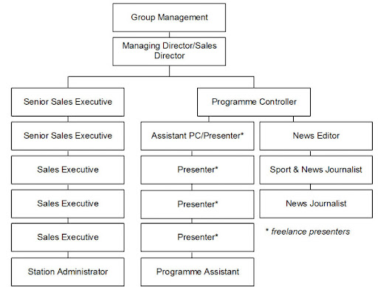

2.3 DEPARTMENTS IN RADIO STATION
- Administrative Department
- Programme Department
- Marketing Department
- Engineering Department
- Finance Department
- News and current affairs
- Audit Department
- Administrative Department: This department is in charge of all staffs matters, ranging from the code of conduct for all staffs, moral behavior, rules and regulation and scheme of services for all staffs. The department caters for personal matters training, training of staffs, and employment of new staffs, discipline and promotion. The department handles record keeping, takes care of matters relating to insurance of man and materials, survey of corporations land matters, dealing with contracts, provides clerical and secretariat duties for all department.
- Programme Department: This department handles the entire programs that are not part of news section details. There are expertise that anchoress programs for the organization. This department is responsible for the initiation of programs, and this idea must serve the purpose of informing, educating, persuading and entertaining. Programs that are being presented in Tungba F.m 100.9FM.
- Marketing Department: This is the department where the financial aspect of the organization is discussed and settled, not only that, this is the department that deal with any jingle or advert to go on air where program is going on.
- Engineering Department: This department is indebted with the task of supervising the equipment procurement, installation and maintenance of such equipment. He must be conversant with the broadcasting technology state.
- Finance Department: The finance department is a service department that deals with the inflow and the outflow of the organization finances. It is in charge of budget preparation and budget control. It offers advice on financial matters to the chief director at all times. This department discharge duties ranging from billings, debt collection and payment of all fees for all channel, account reconciliation.
- Graphic Department: This is the department of work of art, they are in charge of organization designs structure e.g. design of the station logo, captions, backdrops, and systematic arrangement of the studio.
- Editing Department: This is the department where we have experienced computer operator, their ingenuities is being task with the burning of disk, editing of recorded videos, and also keep the record of videos.

CHAPTER THREE
3.0 RADIO STATION TOOLS AND INSTRUMENTS
Radio Station make use it different instrument in performing different operations.
Some of the instruments used are listed below:
- Microphones
- Mixing Consoles
- Consoler
- Speaker
- Computer
- Studio ringlight
- Soundproof Glass
- Speaker
- Laptop
- Headphone

3.1 USES OF ABOVE TOOLS AND INSTRUMENTS

- Microphones: Essential for capturing sound, microphones come in various types such as dynamic, condenser, and ribbon microphones.

- Mixing Consoles: Also known as audio mixers or soundboards, mixing consoles are used to combine and adjust the levels of audio signals from different sources, including microphones, music players, and phone lines.
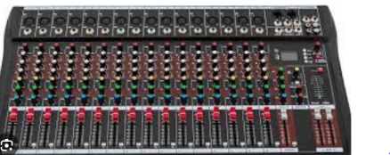

- Consoler: The console serves as the central hub where various audio sources, such as microphones, music players, phone lines, and external audio feeds, are routed, mixed, and processed before being broadcasted.
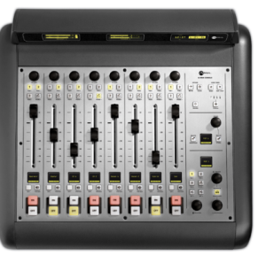

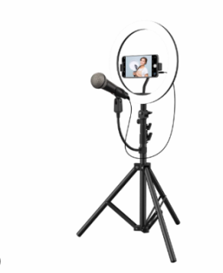
Ringlight: Ring lights are used in broadcasting studios to provide even and flattering lighting for presenters and guests during video recordings or live streams.

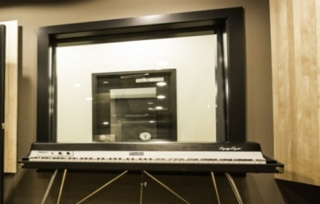
Soundproof Glass: Soundproof glass is used in studio windows to isolate broadcasting rooms from external noise. It helps maintain a quiet and controlled environment for recording high-quality audio.

Speaker: Speakers are used to monitor audio output in broadcasting studios. They allow broadcasters and producers to listen to live broadcasts, pre-recorded segments, and playback audio recordings.
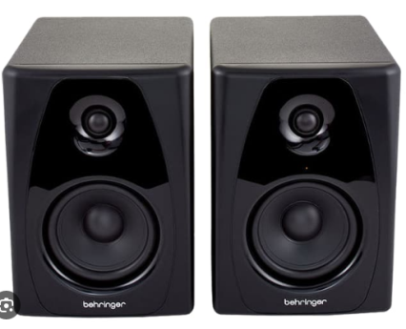

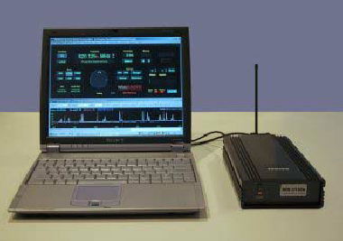
Laptop: Laptops are versatile computing devices used in radio stations for various purposes, including scriptwriting, editing audio, managing playlists, and accessing online resources.


Headphone: Headphones are used by broadcasters, producers, and guests for monitoring audio output during recordings or live broadcasts. They provide a way to hear audio without causing feedback or interference with microphones.

3.2 MAINTENANCE OF THE TOOLS.
The maintenance are listed below.
- Regular Cleaning: Dust and dirt can accumulate on equipment surfaces and connectors, affecting performance. Use appropriate cleaning materials to wipe down equipment regularly.
- Inspect Cables and Connectors: Check cables and connectors for signs of wear, fraying, or corrosion. Replace damaged cables or connectors promptly to prevent signal loss or equipment damage.
- Calibration: Periodically calibrate audio equipment such as mixers, processors, and meters to ensure accurate performance.
- Temperature and Humidity Control: Maintain proper temperature and humidity levels in equipment rooms to prevent damage from moisture, condensation, or excessive heat.
- Power Protection: Use surge protectors, voltage regulators, or uninterruptible power supplies (UPS) to protect equipment from power surges, fluctuations, and outages.
3.3 WORK DONE
News Writing:
News writing is the process of gathering information and presenting it in a clear, concise, and objective manner to inform the audience about current events. It follows a specific structure called the inverted pyramid, where the most important information is presented first, followed by supporting details in descending order of importance.
Sources of News:
Sources of news can include official statements from government agencies, interviews with eyewitnesses or experts, press releases from or…
News Bulletin:
A news bulletin is a concise summary of important news stories presented in a quick and easily digestible format. It typically includes headlines, brief descriptions of each story, and may be accompanied by images or video clips. News bulletins are commonly found on television, radio, websites, and social media platforms, providing audiences with updates on current events throughout the day.
How Bulletin Looks Like:
A news bulletin often appears as a list of headlines followed by short summaries or bullet points. It may be presented on television screens, websites, or in print publications.
News broadcasting:
News broadcasting in a radio station involves the dissemination of timely and relevant news content to listeners through radio broadcasts. This process typically involves several stages, including gathering news, writing and editing news stories, and delivering them to the audience through radio programming.
Editing:
Editing involves reviewing and revising written content for accuracy, clarity, grammar, and style. It ensures that the information presented is coherent and well-structured, adhering to the publication's standards and guidelines.
Interview:
An interview is a formal or informal conversation between a journalist and a source, conducted to gather information, insights, or opinions for a news story. Interviews can be conducted in person, over the phone, or via video conferencing, and they often involve asking questions to elicit specific responses from the interviewee. Interviews are essential in journalism for obtaining firsthand accounts, expert opinions, and additional context to enhance the quality and depth of news reporting.
News Story:
A news story is a journalistic article that reports on a specific event, issue, or topic. It follows the inverted pyramid structure, with the most important information presented at the beginning, followed by supporting details and background information. News.
CHAPTER FOUR

4.0 RELEVANCE OF THE EXPERIENCE GAIN AT STUDENT FIED OF STUDY.
In summary, this program has exposed me to some practical aspect in relation to my course of study (Mass communication) and I benefited greatly in the program. What I learnt at various sites involves the following
- Practical Broadcasting Skills
- Building a Portfolio
- Networking Opportunities
- Leadership and Teamwork Skills
- Creative Expression and Experimentation

CHAPTER FIVE

5.0 CONCLUSION AND RECOMMENDATION
5.1 CONCLUSION
In conclusion, the Student Industrial Work Experience Scheme (SIWES) offers invaluable opportunities for Mass Communication students to gain practical experience and insights into the media industry. Through internships at media organizations, students have the chance to apply theoretical knowledge in real-world settings, develop essential skills, and build professional networks. The SIWES program provides a bridge between academic learning and professional practice, preparing students for future careers in journalism, broadcasting, public relations, advertising, and related fields. The experiences gained during SIWES help students to identify their strengths, interests, and areas for growth, shaping their career aspirations and enhancing their employability in the competitive media landscape. Overall, SIWES plays a vital role in the holistic education of Mass Communication students, contributing to their personal, academic, and professional development.
5.2 RECOMMENDATION
All students at the polytechnic should be required to take it, as the curriculum involves both practical and theoretical experience. SIWES program is such a program that exposes student to the practical aspect of what he/she had been taught theoretically at school.

