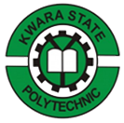

REPORT ON

STUDENTS’ INDUSTRIAL WORK EXPERIENCE SCHEME (SIWES)
Held at:

Kenkid land and contract
107 beside bikin filing station university road tanke ilorin

BY

OKEDAIRO VICTORIA REMILEKUN
ND/23/QTS/PT/0017

IN PARTIAL FULFILLMENT FOR AWARD OF NATIONAL DIPLOMA (ND) IN THE DEPARTMENT OF QUANTITY SURVEYING,
INSTITUTE OF ENVIROMENTAL STUDIES,
KWARA STATE POLYTECHNIC, ILORIN

AUGUST – DECEMBER, 2024
ABSTRACT
I was attached to Collection Developments Construction Ltd which had an on-going project; the construction of a residential building at egbejila village. My duties were to observe and report the weekly construction activities, procedures and work progresses carried out on the site and make a weekly presentation to the office on the various building stages, construction processes and knowledge obtained on the project. This report is therefore an illustration of the nature of works and activities carried out on the construction site and the nature of works done during the course of the industrial programme. It also provides a detailed principle of building construction and some aspects of Health and Safety Environment in reference to building technology and how they are applied practically in the construction of buildings.

TABLE OF CONTENT
Title page
Acknowledgement
Abstract
Table of contents
CHAPTER ONE: INTRODUCTION
1.0 SIWES Background
1.1 Objectives of SIWES
1.2 Bodies involved in the management of SIWES
1.3 Background of Establishment.
CHAPTER TWO:
2.0 Historical Background of the Organization
2.1 Organizational Chart
CHAPTER THREE:
3.0 Work experience during attachment
3.1 Introduction to construction materials, equipments and machinery.
3.2 Control of International workplace hazard
3.3 Construction of the second floor.
3.4 Block-work
3.5 Lintels
3.6 Plastering
3.7 Rendering
3.8 Construction of the Septic tank.
CHAPTER FOUR
4. 1 Problems encountered during attachment
CHAPTER FIVE
5.1 Recommendation
5. 2 Conclusion
References

CHAPTER ONE

INTRODUCTION

STUDENT INDUSTRIAL WORK EXPERIENCE SCHEME (SIWES) BACKGROUND
In the earlier stage of science and technology education in Nigeria, students were graduating from their respective institutions without any technical knowledge or working experience. It was in this view that students undergoing science and technology related courses were mandated for students in different institution in view of widening their horizons so as to enable them have technical knowledge or working experience before graduating from their various institutions.
The Student Industrial Work Experience Scheme (SIWES) was established by the Industrial Training Fund (ITF) in 1973 to enable students of tertiary institution have technical knowledge of industrial work base on their course of study before the completion of their program in their respective institutions. The scheme was designed to expose students to industrial environment and enable them develop occupational competencies so that they can readily contribute their quota to national economic and technological development after graduation. The major background behind the embarkment of students in SIWES was to expose them to the industrial environment and enable them develop occupational competencies so that they can readily contribute their quota to national economic and technological development after graduation. The major benefit accruing to students who participate conscientiously in Students Industrial Work Experience Scheme (SIWES) are the skills and competencies they acquire. The relevant production skills remain a part of the recipients of industrial training as life-long assets which cannot be taken away from them. This is because the knowledge and skills acquired through training are internalized and become relevant when required to perform jobs or functions.

1.1 OBJECTIVES
The Industrial Training Funds policy Document No. 1 of 1973 which established SIWES outlined the objectives of the scheme. The objectives are to:
- Provide an avenue for students in higher institutions of learning to acquire industrial skills and experiences during their course of study.
- Prepare students for industrial work situations that they are likely to meet after graduation.
- Expose students to work methods and techniques in handling equipment and machinery that may not be available in their institutions.
- Make the transition from school to the world of work easier and enhance students’ contacts for later job placements.
- Provide students with the opportunities to apply their educational knowledge in real work situations, thereby bridging the gap between theory and practice.
- Enlist and strengthen employers’ involvement in the entire educational process and prepare students for employment in Industry and Commerce (Information and Guideline for SIWES, 2002).
1.2 BODIES INVOLVED IN THE MANAGEMENT OF SIWES
The bodies involved are:
- The Federal Government.
- Industrial Training Fund (ITF).
Other supervising agents are:
- National University Commission (NUC)
- National Board for Technical Education (NBTE)
- National Council for Colleges of Education (NCE)
1.3 The functions of these Agencies above include;
- Establish SIWES and accredit SIWES unit in the approved institutions.
- Formulate policies and guideline for participating bodies and institutions as well as appointing SIWES coordinators and supporting staff.
- Supervise students at their places of attachment and sign their lob-book and IT forms.
- Ensure payment of allowances for the students and supervisors.
- Ensure adequate funding of the scheme.

CHAPTER TWO
HISTORICAL BACKGROUND OF THE ORGANIZATION
2.1 BACKGROUND OF ESTABLISHMENT
Kenkid land and contract located at 107 beside bikin filing station university road tanke ilorin, was incorporated as a limited liability company in March 2011, the company which was formerly known as Kenkid land and contract started business in April 2006 and with the needs of expansion and bringing in more investors, the company became a limited liability company with the name Kenkid land and contract ltd.
The company was Established by ENGR MOSES JEGEDE because of the realization that Nigerian construction professionals should take the bull by the horn and dictate the pace for the complete development of the construction and real estate sector of the economy. Because of the competitive nature of the terrain of business, the Organization is aware that for indigenous engineering companies to survive, a complete re-orientation of the erstwhile Nigeria approach to business must be embraced.
To this end, the organisation’s subscription to Total Quality Management is unsurpassed consequently therefore matters such as;
- Conducive business environment.
- Competitive pricing.
- Employees and Public safety.
- Commitment to ultimate quality.
- Staff welfare
- Commitment to project on-time delivery.
- Effective management techniques have become second nature to our organization.
MOSCO Engineering ltd should provides and deploys the best in class project management techniques and procedures in executing all projects to the highest standard. Projects undertaken include Construction, Engineering and Architectural Design, Interior Decoration, Procurement and Consultancy to both private and corporate clients in Nigeria.

2.2 ORGANIZATIONAL CHART

Chairman/CEO
Recommending Officer
Field Officer
Software Design
ITF Student

CHAPTER THREE
3.0 WORK EXPERIENCED DURING ATTACHMENT
I was introduced by my site supervisor to the construction site in general, steps and procedure taken before and during the site construction. The following are the steps involved in Building Construction which is as stated as follow:
3.1 Pre-Construction Steps
- To Acquire Land or Plot: It is the most important step in building construction. Search for the location for the building which is best suited for building construction purposes. Be careful while selecting land which has all the desired facilities available nearby and should be free from all land-related issues.
- To Seek Technical Help: After selecting proper land for building, take the help of a professional architect to create building designs and take his/her advice. An architect prepare plan as per building requirement, number of flats, shops based on your requirements and budget.
- Prepare Estimation and Budgets: Building construction involves a huge amount of material and budget. After, planning and structural detailing completed these details are transferred to the building estimator. The building estimator will estimate the material quantity, quantity of different items of work, and prepare an abstract sheet that shows the cost of building construction
Permission from Authorities: This is important work to do after the project is ready to be executed. For that, we have to take permission from the local municipal body before you could go for the construction. Such as follow
a) Land survey: Survey of the land has to be carried out with the help of authorized land surveyor
b) Soil test report of the land.
c) Land documents.
d) Architecture/ elevation/ sectional drawings.
e) Structural report.
f) Architect Certificate of undertaking on Record and Certificate of the undertaking of Civil Engineer on Record

3.2 During Building Construction Steps
During the building construction there are some step and procedure to be carriedout so as to acquire a successful work done and its has been state as follow
- Site Preparation or Levelling work.
The construction site must be cleaned before the work is executed. This work involves the removal of roots of trees, debris and leveling ground area.
- Excavation and PPC
The foundation of building ground is excavated with the help of excavating machines as per the building dimension specified in drawings. In this foundation trench, a layer of PCC (Plain cement concrete) is laid in the dug portion before placing the reinforcements for the foundation.
- Foundation
Foundation is the lowermost part of the building that is in contact with the soil. A building is load transferred from the superstructure to the soil and needs to be extremely strong to handle the load. After the PCC work foundation reinforcement work is started. The foundation bottom level must check before concreting it. The remaining space between the foundation is filled with earth.
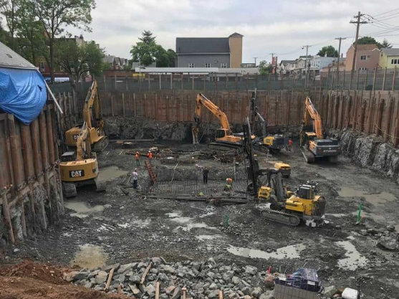
- Plinth Beam or Slab
After the foundation work is done ground beam formwork preparation is started and poured with concrete. Over the plinth beam, masonry work is started. And space between foundation and plinth beam filled with soil.
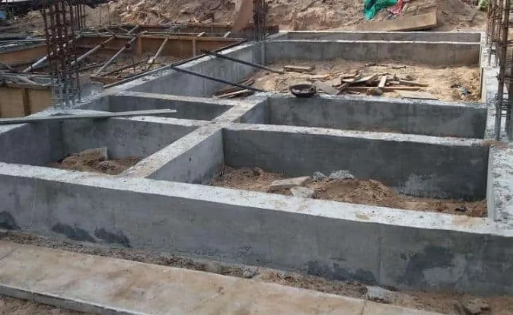
- Superstructure – Column
The superstructure is the portion above the plinth level of the building. The main component of the superstructure is a column and beam. The columns are built up to slab level and the frame for further construction is prepared.
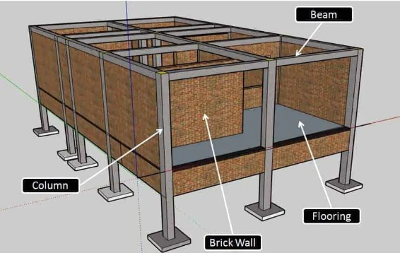
- Brick Masonry Work
As column and beam framework completed masonry work is started with different materials such as bricks, concrete blocks, fly ash bricks, etc. according to building drawing. Masonry work is done using a cement mortar mix. It is a mixture of cement & sand. During this carefully and as per drawing gaps are laid for doors and windows during the masonry work.
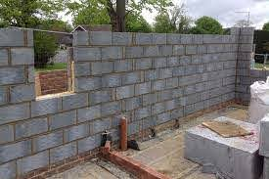
- The Lintel Over Door Window Gaps
The lintel is constructed on the door and window to support the masonry work over it. After this further masonry work is done.
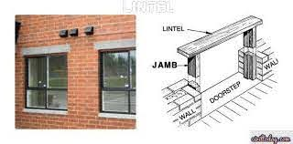
- Floor Slab or Roof Structure.
Then the formwork is started to construct slab resting on the column and beam. Over slab formwork, slab reinforcement is placed as per slab detailed drawing.
- Door Window Framing and Fixations
After that door window frames are fixed at their specified position given in drawing.
- Electrical and Plumbing
Buildings are constructed with a clean finish in which electrical and plumbing work is not visible. They are installed in the walls and slabs such that they are concealed and not visible after the finishing work is done. The point and pipe end left out such that later they can be finished with the electric fitting and plumbing fixtures.
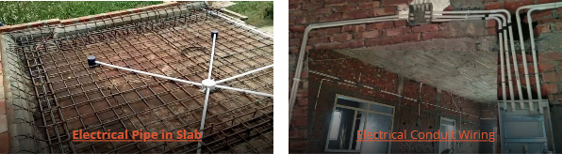

11) Exterior Finishing:
Once this work is completed, external plastering and finishing work is started. Waterproofing is also done to prevent rising dampness in the wall. External cladding can also be done to enhance the elevation of the house.

12) Terrace and Roof Finishing:
On top of the slab, waterproofing is done to prevent any leakage in the slab. Generally, terrazzo tiling is done to prevent the slab from a weathering effect.

13) Internal Finishing:
Internal walls are plaster with smooth finish and flooring is done with tiles. Later on, the walls are painted or textured.

14) Woodwork and Fixture Fittings:
By following the above step, almost construction work is completed and then after furniture work is started. Side by side, electrical fitting, switchboard, and plumbing fittings are complete in the bathrooms and kitchen areas too.
3.3 During Drainage Construction Steps
There some steps to be follow before having a quality and solid drainage construction and the procedure are briefly explained as follow:
- Setting out and marking drainage alignment.
- Site clearing/bush clearing.
- Excavation to level.
- Spreading and compaction.
- Blinding.
- Fixing reinforcement bars.
- Erecting of Formwork.
- Concrete casting.

1.Setting out and marking drainage alignment
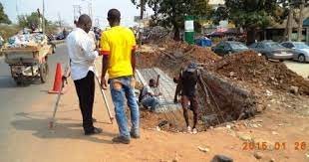
Surveying for setting out road drainage works depends on the nature of the work.
New constructions require the establishment of new alignments while improvement or rehabilitation of existing road drainage may only require minor alignment corrections. The choice of alignment has great implications on the costs and method of construction. The setting out for realignment and new construction shall involve staking of the intended road drainage centerline with pegs (wooden if possible) at 50 meters intervals.

2. Site clearing/bush clearing
Site clearance is the first operation in the construction/upgrading/rehabilitation sequence (after the alignment has been set out) and it is the removal from within the proposed road drainage construction width of all bushes, trees, boulders, and organic matter including topsoil.

3. Excavation to level
Excavation to level is carried out to provide a level terrace, by the designed vertical alignment, on which the drainage and camber can be constructed in an accurate and controlled manner.
This can be done by labour-based technology or machine-intensive application.

4. Spreading and compaction
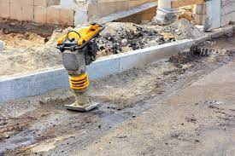
The formation bed of the drainage structure needs to be leveled and compacted properly to the required relative degree of compaction. This can be to 90 -95% Maximum Dry Density as per AASHTO or the selected specification standard in use.

5. Blinding
Upon bed leveling and compaction, concrete blinding is done to remove irregularities and offer a good bed for the placement of concrete while minimizing differential settlement.
The thickness of blinding concrete is usually 50-75mm depth of C-10 0r C-15 concrete and it’s a mass concrete. The mix ratio for concrete blinding can be obtained by performing a concrete mix design.
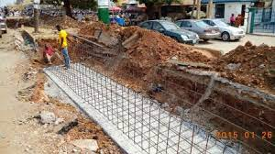

6. Fixing reinforcement bars
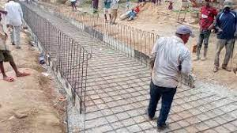
If the drainage structure is precast, installation becomes the next step. But if it’s insitu cast, steel bars are fixed at this stage.
Reinforcement must be fixed in the correct position and care must be taken to keep it in the correct position while concrete is being placed and compacted.

7. Erecting of Formwork
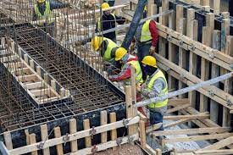
Formwork retains concrete until it has set and produces the desired shapes and sometimes, desired surface finishes. Formwork must be supported on falsework of adequate strength and sufficient rigidity to keep deflections within acceptable limits.
The forms too must be strong and rigid to meet dimensional tolerances. But they also must be tight, or motar will leak out during vibration and cause unsightly sand streaks and rock pockets.

Materials for formwork

1. Timber
Timber and plywood are commonly used materials for formwork because they can easily be cut and assembled on-site. Another advantage of timber formwork is that it is relatively cheap compared to steel formwork. Normally timber formworks are re-used about three times

2. Steel
Steel is mainly used for formwork systems that can be bought or hired ‘off-the-shelf f-the-shelf. These systems provide a simple way of dealing with repetitive work and can be reused easily and quickly. Steel forms are also sometimes specially designed and made for ‘on-off’ jobs or sections of work.

8. Concrete casting
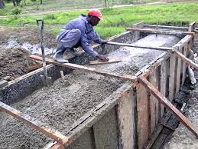
At this stage, the next activity will be the casting of the concrete structure.
The concrete should have good workability so that it’s easy to place and compact with the available equipment. It should also fulfill the requirements for strength and durability.

CHAPTER FOUR
4.0 PROBLEMS ENCOUNTERED DURING ATTACHMENT
- Access Road: The access road to the site is extremely poor due to the lack of drainages and constant passage of heavy vehicles such as trailer and Lorries.
- Land Pollution: The soil and water of the land is polluted as a result of oil spillage from trailers and lorries that where formerly abandoned on the land. The borehole that was sunk by the company was producing water of brownish color.
- Nature of Soil: The area of the site appears to be water logged thereby providing ponds of water in excavated trenches.
- Site Accommodations: The site accommodation is quite poor. The lack of provision of sleeping materials like beds and mosquito treated nets. Laborers sleep on plywood and use only bed covers to protect themselves against mosquitoes and other harmful insects.

CHAPTER FIVE
5.1 RECOMMENDATION AND CONCLUSION
The following Recommendation is referred to the Establishment I undertook my SIWES program, my college, Industrial Training Fund and the Government; in order to improved and enhance the expected results of the Student Industrial Work Experience Scheme;
- The Federal Government should establish and promote laws and agencies that regulate land use to prevent pollution.
- The Federal Government should provide and construct adequate roads in less developed areas.
- The Federal Government should provide industries and organizations with incentives to encourage and solicit for their cooperation and contribution to the programme
- The management of Mosco Engineering ltd should create and organise a special forum for students on attachment, this will help in discovering students’ potentials and to appropriately use them effectively.
- The management of Mosco Engineering ltd should provide adequate social amenities for their workers and enhance the welfare of their workers.
- The management of Mosco Engineering ltd should try to encourage workers initiatives and contributions to projects so at to enhance their esteem and contributions to such projects.

