

TECHNICAL REPORT ON
THE STUDENT INDUSTRIALWORKS EXPERIENCE SCHEME (SIWES)

HELD AT
FAITHERISE GENERATION ENTERPRISES

PRESENTED BY
SALAWUDEEN JAMALDEEN
ND/23/MAC/PT/0979

SUBMITTED TO:
DEPARTMENT OF MASS COMMUNICATION
INSTITUTE OF INFORMATION AND COMMUNICATION TECHNOLOGY [I.I.C.T]
KWARA STATE POLYTECHNIC, ILORIN.

IN PARTIAL FULFILLMENT OF THE REQUIREMENT FOR AWARD OF NATIONAL DIPLOMA (ND) CERTIFICATE IN MASS COMMUNICATION

SEPT - DEC 2024

DEDICATION
This report is dedicated to Almighty ALLAH for His boundless grace, consistent love, immeasurable faithfulness, and for sparing my life throughout the duration of my SIWES program. It is also dedicated to my parents, Mr. and Mrs. Salawudeen, for their unwavering support and immeasurable assistance throughout the entire exercise, as well as to my beloved friends who always trigger me to be strong.

ACKNOWLEDGEMENT
I wish to register to my profound gratitude to God Almighty for the guidance and grace throughout my life.
I'm appreciative to Faitherise Generation Enterprises complete crew for making my industrial training exciting, instructive, and beneficial.
My special gratitude goes to my boss and mentor, Mr. M BADDA, for his effort to see that this work saw the light of day. I appreciate my supervisor, and also my amazing lecturers for their seasoned lectures. To them all, I say thank you.

PREFACE
The student industrial work Experience scheme (SIWES) helps in exposing students to the practical application of their course and to get used to equipment and machine that are utilize in the factory. The SIWES was established to promote student ability and skill in industrial Practice and pre-expose them to working experience in industrial settings.
The SIWES program covered a period of four month from September to December 2024 and it is a partial fulfillment of a two year academic program to obtain an OND certificate in Mass Communcation. The report explains the description of the work here.

TABLE OF CONTENT
TITLE PAGE i
DEDICATION ii
ACKNOWLEDGEMENT iii
PREFACE iv
TABLE OF CONTENT
CHAPTER ONE
  - INTRODUCTION 1
  - BACKGROUND 1
  - AIMS AND OBJECTIVE 1
  - IMPORTANCE OF SIWES 2
CHAPTER TWO
2.0 LOCATION AND BRIEF HISTORY OF THE ESTABLISHED 3
CHAPTER THREE
3.0 RADIO STATION TOOLS AND INSTRUMENT 4
3.1 USES OF THE TOOLS AND INSTRUMENT 5
3.2 MAINTENANCE OF THE TOOLS 6
3.3 SOME SAFEETY PRECAUTION IN RADIO STATION 7
3.4 SOME SAFEETY PRECAUTION OF A PRESENTER 7
3.5 DEPARTMENT IN RADIO STATION 8
CHAPTER FOUR
4.0 RELEVANCE OF THE EXPERIENCE GAIN AT STUDENT FIELD OF STUDY 10
CHAPTER FIVE
5.0 CONCLUSION AND RECOMMENDATION 11
5.1 CONCLUSION 11
5.2 RECOMMENDATION 10

CHAPTER ONE
1.0 INTRODUCTION
1.1 Background
The Industrial Training fund established by decree 43 was introduced in 1971, vis-à-vis the birth of the Students Industrial Work Experience Scheme (SIWES) the same year by the Federal Government of Nigeria (FGN). It is against this background that the industrial training fund (ITF) initiated, designed and introduced SIWES Scheme in 1973 to acquaint students with the skills of handling employers’ equipment and machinery.
The Industrial Training Fund (ITF) solely funded the scheme during its formative years. However, due to financial constraints, the fund withdrew from the scheme in 1978. The Federal Government, noting the significance of the skills training, handed the management of the scheme to both the National Universities Commission (NUC), and the National Board for Technical Education (NBTE) in 1979. The management and implementation of the scheme was however, reverted to the ITF by the Federal Government in November, 1984 and the administration was effectively taken over by the industrial training fund in July 1985, with the funding solely boned by the Federal Government. It is an integral part of the requirements for the award of Certificates, Diplomas and Degrees in institutions of higher learning, e.g. Colleges of Education, Polytechnics, Universities, etc.
Student Industrial Work Experience Scheme (SIWES) exposes students to industry based skills necessary for a smooth transition from the classroom to work environments. It accords students of tertiary institutions the opportunity of being familiarized, exposed, and prepare students of universities, polytechnics, college of technology, college of agricultures and college of education for the industrial work situation they are likely to meet after graduation and to the needed experience in handling machinery and equipment which are not found in such an educational institution.
1.2 Objectives of SIWES
- To provide students with relevant practical experience.
- To satisfy accreditation requirements set by the Nigerian Universities Commission (NUC).
- To familiarize students with typical environments in which they are likely to function professionally after graduation.
- To provide student an opportunity to see the real world of their discipline and consequently bridge the gap between the University work and actual practice.
- To change the orientation of students towards labour market when seeking for job.
- To help students access area of interest and suitability for their chosen profession.
- To enhance students, contact for future employment
- To provide access to equipment and other facilities that would not normally be available in the University workshop.

CHAPTER 2
2.1 LOCATION AND BRIEF HISTORY OF ESTABLISHMENT

Faitherise Generation Enterprises, located in ede osun state, Nigeria, is a prominent station serving the local community. While the detailed history of Faitherise Generation Enterprises may not be extensively documented, I can provide a general overview based on available information.
Faitherise Generation Enterprises likely emerged in response to the growing demand for local radio content in the Ikorodu area, which is a densely populated suburb of Lagos known for its vibrant culture and diverse community. The station likely started as a grassroots initiative, aiming to provide news, entertainment, and educational programming tailored to the needs and interests of the local population.
stations like Faitherise often play a crucial role in promoting community engagement, cultural preservation, and social cohesion. They serve as platforms for local artists, musicians, activists, and community leaders to share their voices and perspectives.
Over the years Faitherise likely expanded its reach and influence, becoming a trusted source of information and entertainment for residents of Ede and its surrounding areas. It likely faced various challenges typical of community radio stations, including funding constraints, regulatory hurdles, and competition from larger media outlets.
Despite these challenges, Faitherise Generation Enterprises likely persevered, driven by its commitment to serving the community and providing a platform for local expression. It likely continues to play a vital role in the social, cultural, and political life of Ede, contributing to the development and empowerment of its residents.

CHAPTER THREE
3.0 RADIO STATION TOOLS AND INSTRUMENTS
Electrical Engineering make use it different instrument in performing different operations.
Some of the instruments used are listed below:
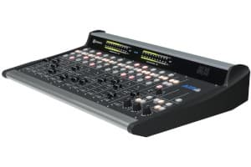
- Microphones
- Mixing Consoles
- Vox pop
- Audio Processing Equipment
- CD Players and Turntables
- Computer Software
- Telephone Hybrids
- Headphones and Monitoring Equipment
- Transmitters and Antennas
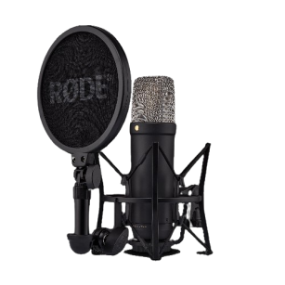
- Receivers
- Telecommunication Devices
- Broadcasting Software
- Studio Furniture and Acoustic Treatment
- Backup Power Systems
- Streaming Equipment
- Remote Broadcasting Equipments and Timers
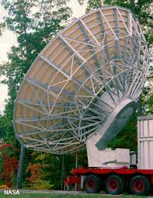
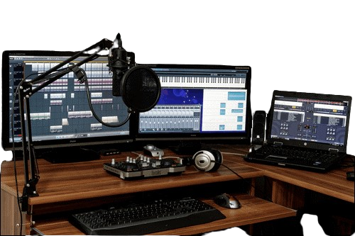

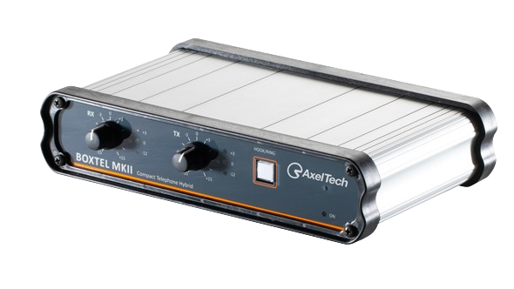

3.1 USES OF ABOVE TOOLS AND INSTRUMENTS
- Microphones: Essential for capturing sound, microphones come in various types such as dynamic, condenser, and ribbon microphones.
- Mixing Consoles: Also known as audio mixers or soundboards, mixing consoles are used to combine and adjust the levels of audio signals from different sources, including microphones, music players, and phone lines.
- Vox pop: is a short interview with members of the public, typically recorded on the streets or in public places. The purpose is to gather opinions, reactions, or brief comments from ordinary people on a specific topic or issue.
- Audio Processing Equipment: This includes tools like equalizers, compressors, and limiters used to enhance and control the audio quality of broadcasts.
- CD Players and Turntables: Used for playing pre-recorded music, sound effects, and other audio content during broadcasts.
- Computer Software: Radio stations often use software for audio editing, playlist management, scheduling, and automation of broadcasts.
- Telephone Hybrids: Devices used to integrate phone calls into radio broadcasts, allowing hosts to take calls from listeners or conduct interviews over the phone.
- Headphones and Monitoring Equipment: Used by broadcasters and technicians to monitor audio quality during broadcasts.
- Transmitters and Antennas: Essential for transmitting radio signals over the airwaves to reach listeners' radios.
- Receivers: Used for monitoring broadcasts, especially for remote broadcasts or monitoring competitors' signals.
- Telecommunication Devices: Including telephones, mobile phones, and VoIP (Voice over Internet Protocol) systems used for communication with listeners, guests, and colleagues.
- Broadcasting Software: Specialized software for managing live broadcasts, scheduling programming, and managing station operations.
- Studio Furniture and Acoustic Treatment: Furniture designed for radio studios and acoustic panels or foam used to improve sound quality and reduce echoes and reverberation.
- Backup Power Systems: Uninterruptible Power Supplies (UPS) or generators used to ensure continuous operation of equipment during power outages.
- Streaming Equipment: Tools and software for streaming radio broadcasts online, reaching listeners over the internet.
- Remote Broadcasting Equipment: Portable recording devices, microphones, and transmission equipment used for live broadcasts from remote locations.
- Clocks and Timers: Used for precise timing of broadcasts, including commercials, news bulletins, and programming segments.
3.2 MAINTENANCE OF THE TOOLS.
The maintenance are listed below.
- Regular Cleaning: Dust and dirt can accumulate on equipment surfaces and connectors, affecting performance. Use appropriate cleaning materials to wipe down equipment regularly.
- Inspect Cables and Connectors: Check cables and connectors for signs of wear, fraying, or corrosion. Replace damaged cables or connectors promptly to prevent signal loss or equipment damage.
- Calibration: Periodically calibrate audio equipment such as mixers, processors, and meters to ensure accurate performance.
- Temperature and Humidity Control: Maintain proper temperature and humidity levels in equipment rooms to prevent damage from moisture, condensation, or excessive heat.
- Power Protection: Use surge protectors, voltage regulators, or uninterruptible power supplies (UPS) to protect equipment from power surges, fluctuations, and outages.

3.3 SOME SAFETY PRECAUTIONS IN RADIO STATION.
- Ensure that electrical equipment is properly grounded and maintained.
- Install and regularly maintain fire detection and suppression systems, including smoke detectors and fire extinguishers.
- Follow manufacturer's instructions for the safe operation and maintenance of equipment.
- Provide ergonomic workstations and seating arrangements to prevent musculoskeletal injuries.
- Provide adequate ventilation and air circulation to maintain indoor air quality.
3.4 SOME SAFEETY PRECAUTION OF A PRESENTER
Safety precautions for radio presenters are essential to ensure their well-being during broadcasts. While the risks associated with presenting in a radio studio might not be as apparent as in other professions, there are still several safety measures presenters should consider:
- Voice Care: Presenters should practice proper vocal hygiene to prevent voice strain or injury. This includes staying hydrated, avoiding excessive shouting or whispering, and taking breaks when needed.
- Ergonomics: Ensure that the studio setup promotes good posture and comfort. Adjust chair height, monitor position, and microphone placement to reduce strain on the neck, back, and wrists during long periods of sitting.
- Electrical Safety: Be aware of electrical hazards in the studio, such as exposed wires, faulty outlets, or overloaded circuits. Avoid handling equipment with wet hands and unplug devices when not in use.
- Noise Protection: Protect your hearing by using noise-canceling headphones or earplugs when monitoring audio at high volumes. Avoid prolonged exposure to loud sounds and use volume-limiting features when available.
- Emotional Well-being: Take care of your mental health by managing stress, practicing self-care, and seeking support when needed. The nature of broadcasting, including public scrutiny and performance pressure, can be emotionally demanding, so prioritize your well-being.
3.5 DEPARTMENTS IN RADIO STATION
- Administrative Department
- Programme Department
- Marketing Department
- Engineering Department
- Finance Department
- News and current affairs
- Audit Department
- Administrative Department: This department is in charge of all staffs matters, ranging from the code of conduct for all staffs, moral behavior, rules and regulation and scheme of services for all staffs. The department caters for personal matters training, training of staffs, and employment of new staffs, discipline and promotion. The department handles record keeping, takes care of matters relating to insurance of man and materials, survey of corporations land matters, dealing with contracts, provides clerical and secretariat duties for all department.
- Programme Department: This department handles the entire programs that are not part of news section details. There are expertise that anchoress programs for the organization. This department is responsible for the initiation of programs, and this idea must serve the purpose of informing, educating, persuading and entertaining. Programs that are being presented in Tungba F.m 100.9FM.
- Marketing Department: This is the department where the financial aspect of the organization is discussed and settled, not only that, this is the department that deal with any jingle or advert to go on air where program is going on.
- Engineering Department: This department is indebted with the task of supervising the equipment procurement, installation and maintenance of such equipment. He must be conversant with the broadcasting technology state.
- Finance Department: The finance department is a service department that deals with the inflow and the outflow of the organization finances. It is in charge of budget preparation and budget control. It offers advice on financial matters to the chief director at all times. This department discharge duties ranging from billings, debt collection and payment of all fees for all channel, account reconciliation.
- Graphic Department: This is the department of work of art, they are in charge of organization designs structure e.g. design of the station logo, captions, backdrops, and systematic arrangement of the studio.
- Editing Department: This is the department where we have experienced computer operator, their ingenuities is being task with the burning of disk, editing of recorded videos, and also keep the record of videos.

CHAPTER FOUR
4.0 RELEVANCE OF THE EXPERIENCE GAIN AT STUDENT FIED OF STUDY.
In summary, this program has exposed me to some practical aspect in relation to my course of study (Mass communication) and I benefited greatly in the program. What I learnt at various sites involves the following
- Practical Broadcasting Skills
- Building a Portfolio
- Networking Opportunities
- Leadership and Teamwork Skills
- Creative Expression and Experimentation

CHAPTER FIVE
5.0 CONCLUSION AND RECOMMENDATION
5.1 CONCLUSION
In conclusion, the Student Industrial Work Experience Scheme (SIWES) offers invaluable opportunities for Mass Communication students to gain practical experience and insights into the media industry. Through internships at media organizations, students have the chance to apply theoretical knowledge in real-world settings, develop essential skills, and build professional networks. The SIWES program provides a bridge between academic learning and professional practice, preparing students for future careers in journalism, broadcasting, public relations, advertising, and related fields. The experiences gained during SIWES help students to identify their strengths, interests, and areas for growth, shaping their career aspirations and enhancing their employability in the competitive media landscape. Overall, SIWES plays a vital role in the holistic education of Mass Communication students, contributing to their personal, academic, and professional development.
5.2 RECOMMENDATION
All students at the polytechnic should be required to take it, as the curriculum involves both practical and theoretical experience. SIWES program is such a program that exposes student to the practical aspect of what he/she had been taught theoretically at school.

