

Technical Report
On
STUDENT INDUSTRIAL WORK EXPERIENCE SCHEME (SIWES)

HELD AT
ILORIN MICROFINANCE BANK LIMITED
Exit Gate Baboko New Market Along Kuntu Street, Ilorin Kwara State
Presented by:
IBRAHIM WASILAT OYINDAMOLA
ND/23/ACC/FT/0060

Submitted to:
DEPARTMENT OF ACCOUNTANCY, INSTITUTE OF FINANCE AND MANAGEMENT STUDIES
KWARA STATE POLYTECHNIC
P.M.B. 1375, ILORIN

IN PARTIAL FULFILLMENT OF THE REQUIREMENT FOR THE AWARD OF NATIONAL DIPLOMA (ND) IN
ACCOUNTANCY, KWARA STATE
POLYTECHNICS, ILORIN

August – December, 2024
PREFACE
This technical report is written to situate the standard of experience gain by student in the industrial as awareness of continuity at the tertiary level of learning. The technical indulgence of training has been expressed formally in these report required by the constitution of the industrial training office of polytechnic.
This report is divided into five different parts which each part explains the meaning of siwes, major organization, work actually carried out and experienced gain. Even challenged faced, conclusion and recommendation are also involved.

DEDICATION
I dedicate this report to the Almighty God, for granting me the privilege to commence this course. Also to my reliable and respectful loving parents, Mr. & Mrs. Ibrahim for being there for me. I pray may the Almighty Allah reward you abundantly, Amen.

ACKNOWLEDGEMENT
I wish to express my sincere gratitude to Almighty God for spearing my life throughout my first year in Kwara State Polytechnic, Ilorin and for making my vision to come to reality. I also thank him for his goodness, mercy and joy throughout my life.
My greatest debt is to my indispensible parent Mr. and Mrs. Ibrahim for their moral and financial support throughout the duration of my training may Almighty God reward you abundantly.
My special thanks go to the head department and the entire staff of Accountancy department, Kwara State Polytechnic.
My appreciation also goes to the entire staffs of Alert Micro-Finance Bank
I also acknowledge the effort of my friends and siblings for their financial, moral and spiritual support throughout my academic pursuit. Also to my SIWES supervisor for his great work.

TABLE OF CONTENT
Title Page
Preface
Dedication
Acknowledgement
Table of content
CHAPTER ONE
1.1 Meaning of SIWES
1.2 Brief history of SIWES
1.3 Aims and Objectives of SIWES
CHAPTER TWO
2.1 History of the Organisation
2.2 The organizational Structure
2.3 Department in the organization
2.4 Interpersonal Relation with the organization
CHAPTER THREE
3.1 Work Actually Carried Out
CHAPTER FOUR
4.1 Experienced Gained
4.2 Challenges Faced
CHAPTER FIVE
5.1 Conclusion
5.2 Recommendation

CHAPTER ONE
1.1 MEANING OF SIWES
SIWES is skill development program designed to prepare students of all institutions for transition from the collage environment to work. Also to promote and encourage the acquisition of skills in industry and commerce with a view of generating a poll of indigenous trained manpower sufficient to meet the needs of the Nigeria economy
It is also described as work experience in a education program in while attending school, while the work experience gives student opportunity to be part of an actual work situation outside the classroom.
1.2 BRIEF HISTORY OF SIWES
The government decrees no 47 of 8th October, 1971 as amended in 1990 highlighted the capacity building resource in industry commerce and government through training and re-training of workers in order to effecting provide the much needed high quality goods and services in a dynamic economy as ours (Jemerigbo 2003) the decree led the establishment of Industrial Training Fund (ITF) in 1973/1974.
The growing concern among our industrialist that graduates of our institution lack adequate practical background studies preparatory for employment in industries, led to the information of student industrial work experience scheme (SIWES) by ITF 1993/1994
The student industrial work experience scheme (SIWES) is a skill training program designed to expose and prepare student of agriculture, technology, environmental science, medical science and applied science for the industrial work situation which they are likely to meet after graduating.

1.3 AIMS AND OBJECTIVES OF SIWES
1. The main aim is the exposing of students to work method and technologies in handing equipment and machinery that may not be available in educational institutions.
2. SIWES provide an avenue for students in institutions of higher learning to acquire industrial skills and experience in their course of study especially in engineering.
3. To strengthen employers involvement in the educational process of preparing students for past graduation work situation.
4. To make transition from school to the world of Work easier and to enhance student contact for later job placement.
5. To provide student an opportunity to apply their knowledge in actual practice
6. Provide opportunity for students to apply their knowledge in real work situation thereby bringing the gain between theory and practical.

CHAPTER TWO
ABOUT ILORIN MICROFINANCE BANK LIMITED
Alert Microfinance Bank (Alert MFB) is a community-driven, state-licensed financial institution founded in 2014, focused on empowering individuals and businesses with innovative financial solutions, including savings accounts, loans, and more.
VISION AND MISSION
Mission
To empower individuals and businesses through financial services.
Vision
To serve the needs of individuals and businesses within its community.

THE ORGANIZATION STRUCTURE AND CHART
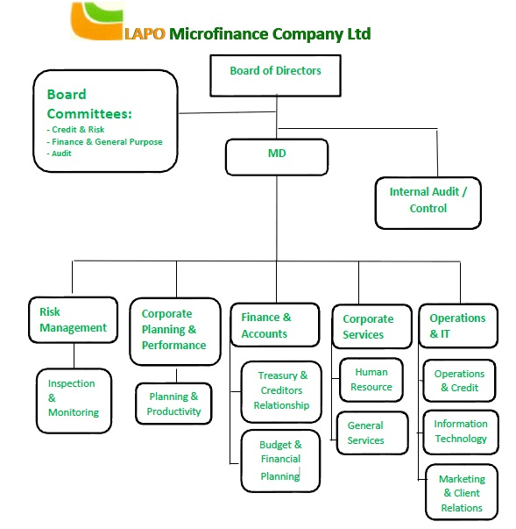
  - DIFFERENT DEPARTMENT IN THE ORGANIZATION
Customer Service Department: Handles inquiries, complaints, and assists customers with various banking services.
Loan Department: Responsible for the assessment, disbursement, and management of loans to individuals and small businesses.
Risk Management Department: Works to identify, assess, and mitigate financial and operational risks to protect the bank's assets and reputation.
Marketing and Business Development: Focuses on promoting the bank’s products and services and expanding its customer base.
Finance and Accounting Department: Manages the financial records, ensures compliance with regulations, and prepares financial reports.
Human Resources (HR) Department: Deals with recruitment, employee welfare, training, and performance management.
Information Technology (IT) Department: Manages the bank’s technological infrastructure, ensuring secure and efficient banking systems and digital services.
Compliance and Legal Department: Ensures that the bank complies with regulatory requirements and handles legal matters.
Treasury Department: Manages the bank’s funds, investments, and liquidity to ensure operational efficiency.
Internal Audit Department: Responsible for examining and evaluating the bank’s operations and financial records to ensure accuracy and compliance with internal policies.

2.4 INTERPERSONAL RELATION WITH THE ORGANIZATION
There was mutual understanding and love among the staff and the student that did their SIWES programme there because they took all the student like their own children, advising and guiding them to do the right thing at the right time.
High level of discipline was displayed among the student, even though the staffs a make sure that every problem encountered by the student are been tackled and solved out by both the student and staff all in the aspect of bringing about unity and peace.

CHAPTER THREE
3.1 WORK ACTUALLY CARRIED OUT
During my SIWES placement at Ilorin Microfinance Bank Limited, I was assigned to various departments where I participated in different activities that enriched my practical knowledge. The activities I was involved in include:
Accounting and Finance Department
- Financial Reporting: I assisted in the preparation of monthly and annual financial statements by collecting data, analyzing transactions, and ensuring compliance with the bank’s accounting policies and regulations.
- Ledger Management: I participated in updating the general ledger, reconciling accounts, and posting journal entries.
- Cash Flow Management: I observed and contributed to monitoring the bank’s cash flow, ensuring that there was enough liquidity to meet short-term obligations.
- Loan Disbursement and Repayment Tracking: I helped track and record the repayment schedules of loans provided to customers and reported on the bank's loan portfolio performance.

Customer Account Management
- Account Opening and Documentation: I assisted in the opening of savings and loan accounts for new customers, ensuring the proper documentation was collected and verified.
- Account Reconciliation: I was involved in reconciling customer account balances, ensuring that there were no discrepancies between the bank’s records and those of the customers.
- Transaction Recording: I helped record daily transactions of customer deposits, withdrawals, and loan disbursements.
Internal Audit Department
- Auditing Processes: I observed the internal audit processes, including the review of financial transactions to detect any irregularities, errors, or fraud.
- Compliance Checks: I participated in ensuring that the bank adhered to regulatory standards and internal policies.
Software Application
- Accounting Software: I was trained on using the bank’s accounting software to input and track transactions, generate financial reports, and conduct data analysis.

CHAPTER FOUR
4.1 EXPERIENCED GAINED
I can actually say I gained a lot from my SIWES Programme by having the opportunity to know my capability on the work I have been taught in school.
During my SIWES placement, I developed several skills and gained practical knowledge, including:
- Practical Accounting Skills: I gained hands-on experience with accounting principles, financial statement preparation, and cash management.
- Understanding of Banking Operations: I learned how microfinance banks operate, including loan processing, customer relations, and regulatory compliance.
- Analytical Skills: I enhanced my ability to analyze financial data and make informed decisions based on financial reports.
- Communication and Interpersonal Skills: Working with different departments and interacting with customers improved my communication and interpersonal skills.
- Familiarity with Banking Software: I became proficient in using accounting software and other tools to track financial transactions and generate reports.
4.2 CHALLENGES FACED
While at Ilorin Microfinance Bank Limited, I encountered a few challenges, including:
Data Accuracy: Ensuring the accuracy of financial data while reconciling customer accounts and handling complex transactions.
Time Management: Balancing the workload between multiple departments required strong time management skills to meet deadlines.
Understanding Banking Software: Getting accustomed to the specific banking software used by the institution initially posed some difficulty, but I quickly adapted through hands-on experience and training.
Despite these challenges, the experience taught me valuable lessons in attention to detail, organization, and adaptability.

CHAPTER FIVE
CONCLUSION AND RECOMMENDATION

5.1 CONCLUSION
Student Industrial Work Experience Scheme (SIWES) is a good programme for higher institution in the sense that it adds to one’s practical knowledge based on your course of study. As for me SIWES as a course has truly exposed me to face in a growing information world that depend on Business Administration and Management.
5.2 RECOMMENDATION
As a bonafide student of the department of Accountancy of Kwara State Polytechnic and who has undergo industrial training. I hereby make the recommendation that the government should continue funding this programme (SIWES) and pay directly to student after the completion of the programme due to the stress inclined to the programme, in order to serve as encouragement to student that want to increase their practical and technical knowledge.

