

A TECHNICAL REPORT ON
STUDENT INDUSTRIAL WORK EXPERIENCE SCHEME (SIWES)

HELD AT
MUTFEM GLOBAL CONSTRUCTIONS
Ejigbo, Osun State

PREPARED BY:
JUNAID FADILULAHI BOLAJI
MATRIC NO:
ND/23/BLD/FT/0023

SUBMITTED TO:
DEPARTMENT OF BUILDING TECHNOLOGY
INSTITUTE OF ENVIRONMENTAL STUDIES
KWARA STATE POLYTECHNIC, ILORIN
IN PARTIAL FULFILLMENT OF THE REQUIREMENT FOR THE AWARD OF NATIONAL DIPLOMA (ND) IN BUILDING TECHNOLOGY, KWARA STATE POLYTECHNIC, ILORIN.

AUGUST TO NOVEMBER, 2024.
i
DEDICATION
This report is dedicated to God Almighty for His boundless grace, consistent love, and immeasurable faithfulness and for sparing my life throughout the duration of my SIWES program. It is also dedicated to my parents, Mr. & Mrs. JUNAID, for their unwavering support and immeasurable assistance throughout the entire exercise, as well as to my beloved friends who always trigger me to be strong.

ii

PREFACE
This student industrial work experience scheme (SIWES) helps in exposing students to the practical application of their course and get used to equipment and machine that are utilize in the factory. The SIWES was established to promote student ability and skill in individual practice and pre – expose them to working experience in industrial settings.
The SIWES program covered period of four month from August to November 2024 and it is a partial fulfillment of a two year academic program to obtain an OND certificate in Building technology. The report explains the description of the work here.

iii
ACKNOWLEDGEMENT
I am thankful to Almighty God for His inspiration, guidance and strength throughout the course of this work.
I am very grateful to my beloved parents Mr. & Mrs. JUNAID.
I am appreciative to MUTFEM GLOBAL CONSTRUCTIONS for making my industrial training exciting instructive and beneficial.
My special gratitude goes to my boss and mentor, MUTFEM, for his effort to see that this work saw the light of day, I appreciate my supervisor and also my amazing lecturers for their seasoned lecturers. To them all I say thank you.

iv
TABLE OF CONTENTS
Title page i
Dedication ii
Preface iii
Acknowledgement iv
Table of contents v
CHAPTER ONE 1 – 2
1.0 Introduction
1.1 Definition of SIWES
1.2 Aims and objectives of SIWES
CHAPTER TWO 3
2.0 Location and brief history of the established
CHAPTER THREE 4 – 7
3.0 Work experienced during Attachment
3.1 Material and equipment
CHAPTER FOUR 8 – 12
4.0 Reporting on work actually carried out
CHAPTER FIVE 13 – 14
5.0 Conclusion
5.1 Recommendation

v
CHAPTER ONE
1.0 INTRODUCTION
In the earlier stage of science and technology education in Nigeria, students were graduating from their respective institutions without any technical knowledge or working experience. It was in this view that students undergoing science and technology related course were mandated for students in different institutions in view of widening their horizons so as to enable them have technical knowledge or working experience before graduating from their various institutions.
The student industrial work experience scheme (SIWES) was established by the industrial training fund (ITF) in 1973 to enable students of tertiary institutions have technical knowledge of industrial work based on their course of study before the completion of their in their respective institutions. The scheme was designed to expose students to the industrial environment and enable them develop occupational competencies so that they readily contribute their quota to national economic and technological development after graduation. The major background behind the embarkment of students in SIWES was to expose them to the industrial environment and enable them develop occupational competencies so that they can readily contribute their quota to national economic and technological development after graduation. The major benefit accruing to students who participate conscientiously in Students Industrial Work Experience scheme (SIWES) are the skills and competencies they acquire. The relevant production skills remain a part of the recipients of industrial training as life – long assets which cannot be taken away from the. This is because the knowledge and skills acquired through training are internalized and become relevant when required to perform jobs or functions.
1.1 DEFINITION OF SIWES
Students Industrial Work Experience Scheme (SIWES) can be defined as the practical experience of student in order to have quality control and satisfactory performance, when in the field. ‘SIWES’ can be interest in a particular subject which is connected with the people and activities
1
involves in producing a particular. Thing (industrial) by involving in a hard physical work rather than office work in order to gain knowledge and skill through the job undergo for a period of time (Experience) under a system of organizing things (scheme).
1.2 AIMS AND OBJECTIVES OF SIWES
AIM OF THE STUDY
The aim of the study was to evaluate the impact of SIWES on technical skills development in the Nigeria economy. This is to enable institution of Higher learning and other stakeholders assess the performance of their roles in the scheme.
OBJECTIVES
The industrial training fund policy document No. 1 of 1973 which established SIWES outlined the objectives of the scheme. The objectives are to:
- Provide an avenue for the student in higher institutions of learning to acquire industrial skill and experiences during their course of study.
- Prepare students for industrial work situations that they are like to meet after graduation
- Expose student to work methods and techniques in handling equipment and machinery that may be available in their institutions.
- Make the transition from school to the world of work easier and enhance student’s contacts for later job replacement.
- Provide students with the opportunities to apply their educational knowledge in real work situations, there by bridging the gap between theory and practice.
- Enlist and strengthen employer’s involvement in the entire educational process and prepare students for employment in industry and commerce (information and guidelines for SIWES, 2002)

2
CHAPTER TWO
2.0 LOCATION AND BRIEF HISTORY OF THE ESTABLISHMENT
MUTFEM GLOBAL CONSTRUCTIONS is a construction firm owned by a private contractor which has been set up and running for 20years now.
A Nigerian firm committed to excellent professional practices MUTFEM GLOBAL CONSTRUCTIONS is noted for the timely and quality job service.
MUTFEM GLOBAL CONSTRUCTIONS has achieved a good measure of success in the constructing and have several projects to credit.

3
CHAPTER THREE
3.0 WORK EXPERIENCED DURING ATTACHMENT
I was introduced to my site supervisor who expose me to proper site work including casting of footing in foundation. We also did excavation, setting out of a building using square method and block wall of a building.
3.1 INTRODUCTION TO MATERIAL AND EQUIPMENT
In the process of my work experience, I was introduced to various material and equipment and machineries used in construction and development of a building.
Materials
Example of material used in building construction is as follow:
Cement: This is a powdered substance that develops strong adhesive properties when mixed with water. It is used in Block work, Plastering, Rendering and Concreting. The establishment of Cement is achieved by burning a mixture of clay and chalk o limestone in a kiln. A proportion of the raw materials in a definite proportion are converted into liquid state by grinding, mixing and watering, termed Slurry. The slurry is then conveyed through a set of pipes to rotary kiln which dry and burn the constituent in a high temperature to form hard lumps. This process changes the slurry to hard lumps called Clinker, which afterwards pass on through a conveyor belt to the grinding mills for grinding to a fine powder in its final process. During the final grinding, small quantity of gypsum of between 2 and 5% of the whole materials is added to retard the setting time. Tests are usually carried out on the finished product occasionally to ensure high quality. This process is mainly on Ordinary Portland Cement (OPC) used for general purposes. There are other types of cement made for special purposes, including Rapid Hardening Portland Cement (RHPC), Sulphate resisting Portland cement and Low Heat Portland Cement.
Reinforcement: Reinforcement is provided in concrete structures to enhance its tensile strength. Therefore in all structural elements, the reinforcement is provided in the region of the element that will be subjected to tension. Standard bar diameters~6, 8, 10, 12, 16, 20, 25, 32 and 40 mm.
4
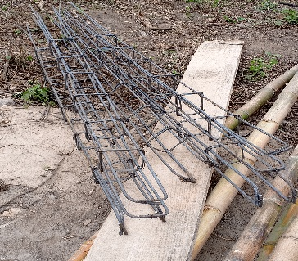

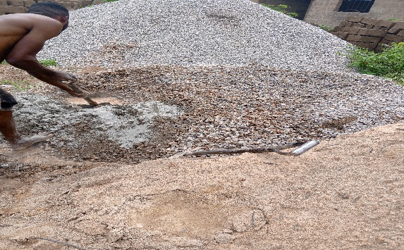
Aggregates: This consists of sand, ground crushed stone, pebbles, broken blocks and similar such materials. Aggregates may either be light or heavy weight and also All-in-Aggregates. Aggregates must be clean, structural sound, well graded, weather resistance and inert in the presence of water. Aggregates are of two types: Fine Aggregate; this should be clean, sharp and passes through the sieve size of 4.5mm. Coarse Aggregate; aggregate which consists largely of particles over 5mm in diameter. This is usually gravel or crushed stones.

Equipment
The following are examples of various tools used in construction;
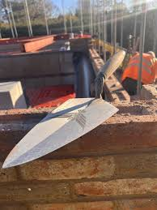
Trowel: This is a flat metal blade fixed to a short handle used for the application, jointing, smoothing and shaping of mortar in masonry. It is also used in the trimming of block/bricks. Trowel sizes ranges from 225-350mm measuring from the blade.

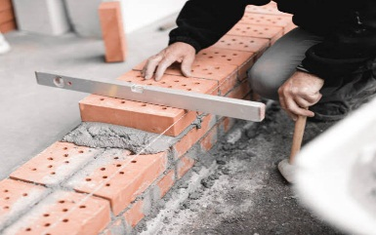
Spirit Level: This is a Hand-tool used for indicating true horizontal and vertical of a work, by means of an air bubble sealed in a marked, liquid-filled glass tube mounted in a frame; the tube is horizontal when the bubble is between two marks. Spirit levels are of various length ranging from about 225mm to 1.2m.

5
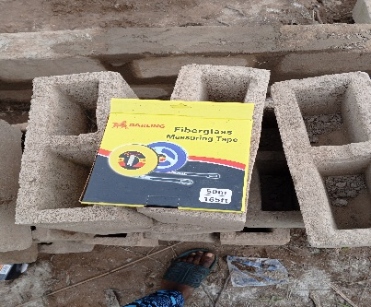
Measuring tape: measuring tape is a long, flexible ruler used to measure length or distance. It usually consists of a ribbon of cloth, plastic, fiber glass, or metal strip with linear measurement markings.

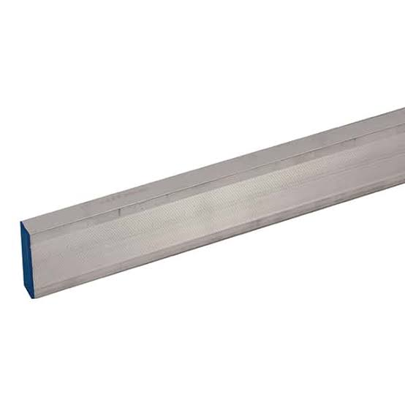
Straight Edge: The kind of straight edge that was used on the construction site is Aluminum frame of about 2m in length. The straight edge is used to check the fairness of newly laid piece of a wall and to ensure that all the blocks are laid to the same level of each course.

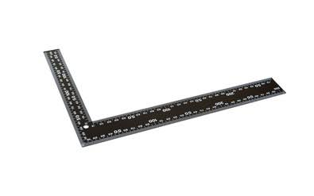
Iron Square: This is a hand tool of angle 90 which measure 600mm by 450mm long. It is used for setting out walls at right angles to check for square nature of a section of work.


Hammer: A hammer is a tool consisting of a weighed head fixed to a long handle that is swung to deliver an impact to a small area of an object


Head pan: This is a round container, like a bowl used in construction works. It is used to transport mortal, concrete, fine or coarse aggregates.

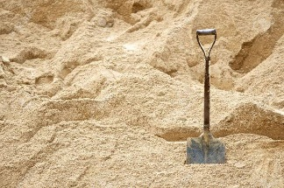
Shovel: A shovel is a tool resembling a spade with a broad blade and typically upturned sides, used for moving earth or other materials. It is sued for digging, lifting, and moving bulk materials such as sand soil or gravel.

6
MACHINERIES
Machinery refers to the various types of heavy equipment and vehicles used to perform tasks related to building, excavation, demolition and other construction activities. These machines are essential for increasing efficiency, safety and precision in construction projects.
I was introduce to this following machineries during four month SIWES.
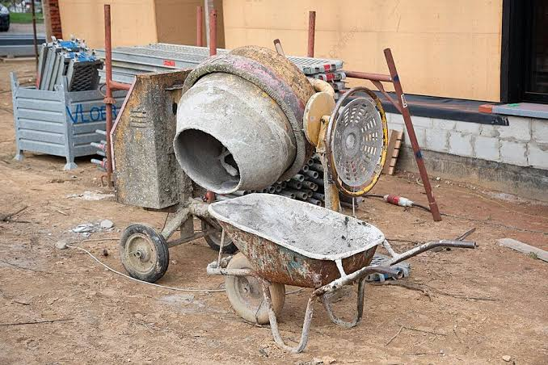
Concrete Mixer: It is used to mix cement, sand, and water to create concrete and is to ensure that all the ingredients are thoroughly combined to create a uniform and consistent mixture, which is essential for the strength and durability of concrete structures.

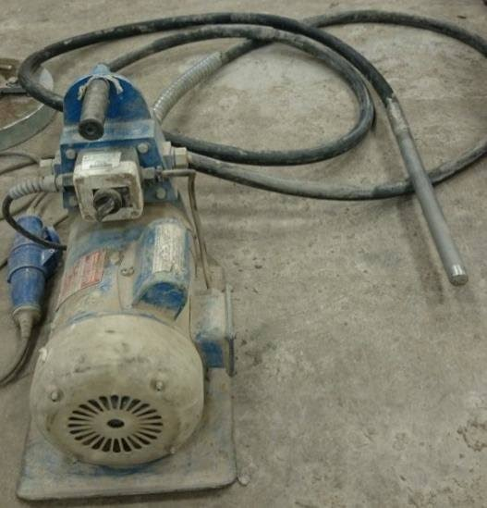
Poker vibrator: It is a construction tool used to compact freshly poured concrete and is to remove air bubbles and ensure that the concrete is evenly distributed within the formwork, resulting in a dense, strong, and durable concrete structure.

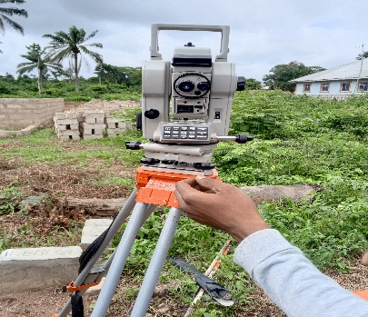
Digital theodolite: It is an optical instrument used in surveying and construction to measure horizontal and vertical angles. Digital theodolite is essential tasks requiring precise angular measurements, such as setting out building foundations, aligning structures, and mapping land

7
CHAPTER FOUR
4.0 REPORTING ON WORK ACTUALLY CARRIED DURING MY SIWES
I was introduce to this following work on site by my supervisor.
Setting Out
Setting is the process of transferring the architectural and structural design from the construction drawings to the ground. It involves marking the exact positions of the building’s foundations, walls, columns, and other structural elements on the site. This step is crucial to ensure that the building is constructed in the correct location, alignment and dimensions as per the design.
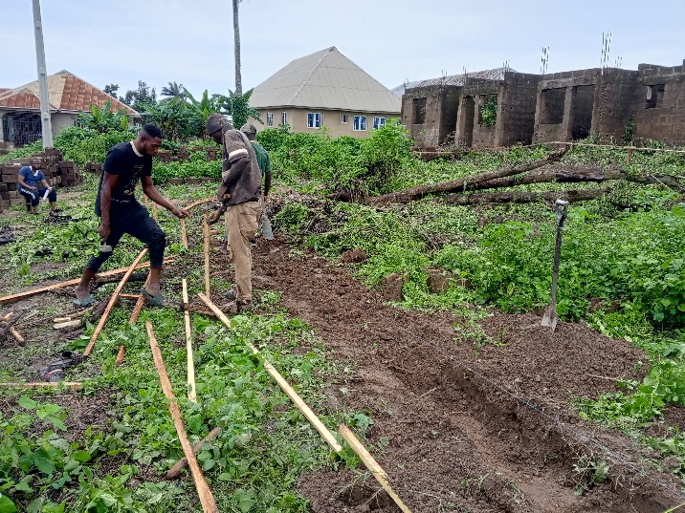

Steps for setting out a Building:
- Preparation
- Establishing a baseline
- Marking the building corners
- Checking for squareness
- Setting out foundation
- Establishing levels
- Marking internal walls and columns
- Verification
Tools and equipment include theodolite or total station, measuring tape, pegs and stakes, strings and lines, spirit level or laser level, marking paint and plumb bob.

8
Foundation
A foundation is the lowest part of a building or construction that transfers the load from the building to the ground. It is a critical component of any construction project, as it provide stability, prevents settlement, and ensures the structure’s longevity.
During my SIWES I was most exposed to Strip foundation which there are some project that we start with during my SIWES at MUTFEM GLOBAL CONSTRUCTIONS.

Strip Foundation
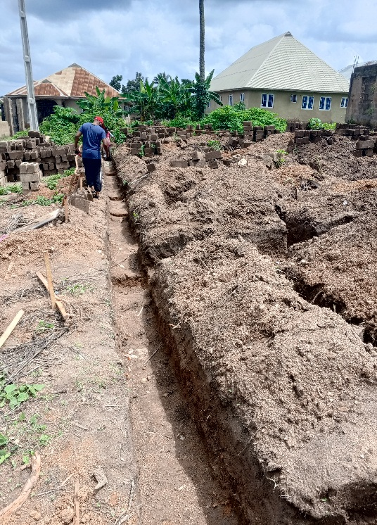
A strip foundation is also a strip footing and is a type of shallow foundation commonly used to support load – bearing walls or closely spaced columns. It consists of a continuous strip of concrete that runs along the length of the wall or column line, distributing the load evenly to the soil below.
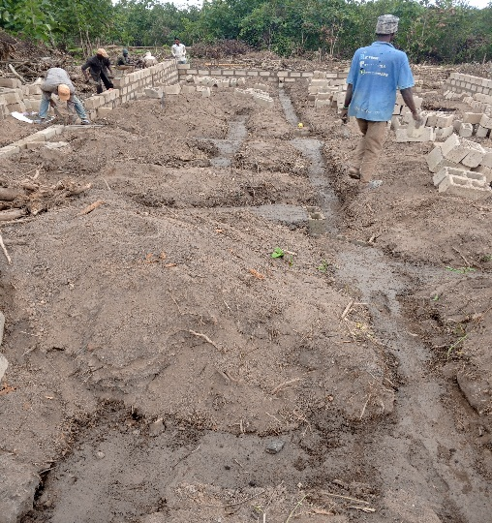

Steps construct a strip foundation:
- Site preparation
- Excavation
- Laying the base
- Formwork
- Reinforcement
- Pouring concrete
- Curing
- Backfilling

9
Block Wall
A block wall is a type of wall constructed using masonry blocks, such as concrete blocks, cinder block, or clay bricks. Block walls are commonly used in construction for their strength, durability and versatility. They can be used for both load – bearing and non – load – bearing walls in buildings, retaining walls, boundary walls, and other structures.
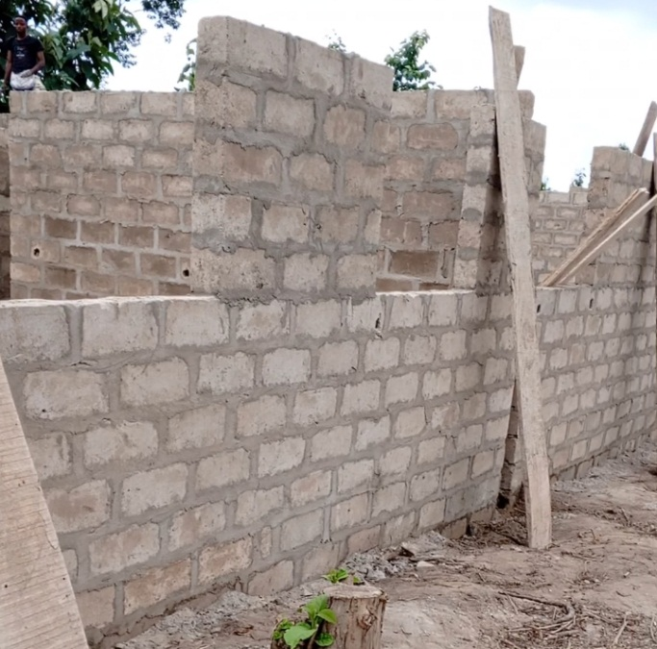

Construction of a Block Wall:
- Planning and preparation
- Foundation
- Laying the first course
- Building the Wall
- Finishing
Techniques for Building Block Walls:
- Running bond
- Stack bond
- Corner construction
- Lintels and opening
- Capping the wall
Tools and equipment for block wall construction are trowel, spirit level plumb bob, string line, masonry saw, mortar mixer and rubber mallet.

10
Lintel
A lintel is a horizontal structure element installed above openings such as doors, windows and arches to support the load from the structure above. It spans the opening and transfers the weight to the surrounding walls or columns, preventing the structure from collapsing. Lintels are essential in both load – bearing and non – load bearing walls to maintain structural integrity and provide stability. There are some type of lintel include concrete lintel, steel lintel, timber lintel, stone lintel and brick lintel
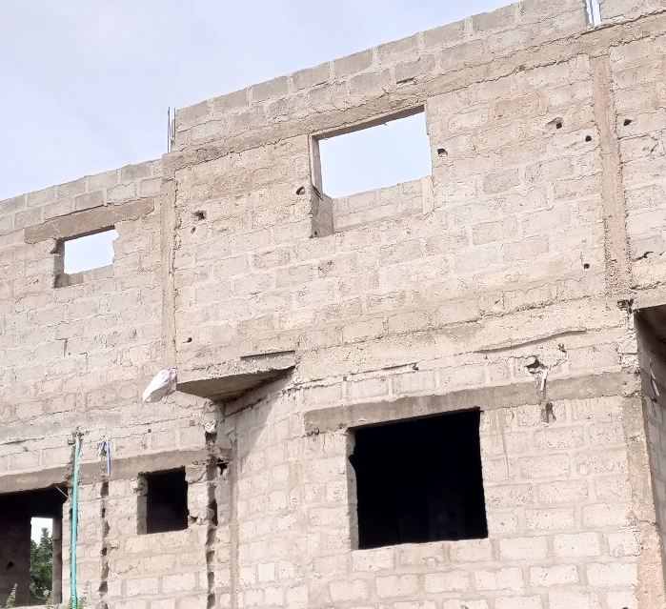

Key consideration for lintel design and installation:
- Load calculation
- Span length
- Reinforcement
- Levelling and alignment
- Damp proofing

Pillar
A pillar is a vertical structural element that provides support to a building or other structure. Unlike columns, which are primarily cylindrical and often decorative, pillar can have various shape (e.g square, rectangle or circular) and are primarily functional, though they can also be designed for aesthetic purpose.

11
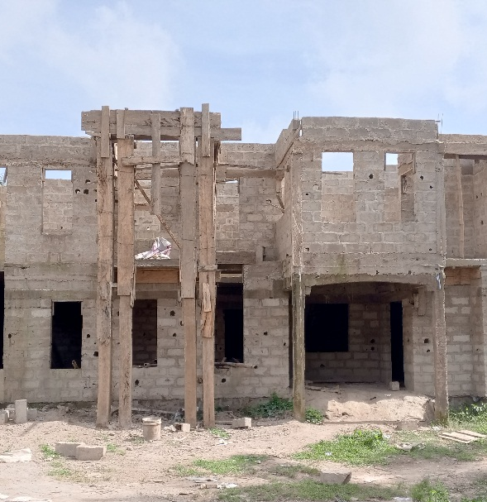

Construction of a pillar:
- Design and planning
- Foundation preparation
- Reinforcement
- Formwork
- Concrete pouring
- Curing
- Removing formwork


During construction of Block Wall

12
CHAPTER FIVE
5.0 CONCLUSION
The four month industrial training I had was very awesome and educating. It availed me the opportunity to appreciate some of the theoretical courses had been taught in school. The experience I gain majorly on construction of a factory of pure water and two of one storey residential building with typical floors and this encompasses the construction of strip foundation, lintel, setting out and block wall and use of survey instrument such digital theodolite. I learned a lot including how to interpret structural drawings and architectural drawings.
I sincerely appreciate all those that incorporated this training into the polytechnic’s course, and MUTFEM GLOBAL CONSTRUCTIONS for offering me this rare privilege. It will a long way in boosting my career.

5.1 RECOMMENDATION
The following recommendation is referred to the Establishment I undertook my SIWES program, my institution, industrial training Fund and the Government; in order to improve and enhance the expected results of the Student Industrial Work Experience Scheme
- The Federal Government school provide industries and organizations with incentives to encourage and solicit for their cooperation and construction to the program.
- The Industrial Training Fund should provide a network in which Establishments and student could communicate better so promote easier means of finding placements.
- Government on their part should make reasonable payment to students on completion of this program. This will help to reduce the financial burden on parents of these students. It will also help to encourage them to fully participate in it.
- The students should prepare to face the realities of work life. There should be adequate orientation to educate them on the need for them to embrace the program and possible challenges the may encounter.
13
- The institution and Industrial Training Fund should help the student to get the place of attachment, so that the program will commence as planned.

14

