

TECHNICAL REPORT ON STUDENTS INDUSTRIAL WORK EXPERIENCE SCHEME (SIWES)
HELD AT

SBS [96.9fm]
BY
KAZEEM HARAFAH ORIYOMI
ND/23/MAC/PT/0741

SUBMITTED TO:
THE DEPARTMENT OF MASS COMMUNICATION, KWARA STATE POLYTECHNIC
INSTITUTE OF INFORMATION AND COMMUNICATION TECHNOLOGY (IICT)
P.M.B. 1375 ILORIN, KWARA STATE.

IN PARTIAL FULFILMENT FOR THE AWARD OF NATIONAL DIPLOMA (ND) IN
MASS COMMUNICATION,
KWARA STATE.

AUGUST- NOVEMBER, 2024

DEDICATION
I dedicate this to God for seeing me through; also to my lovely parent Mr& Mrs KAZEEM for their support both morally and financially, May God reward you abundantly with long life and good health.

ACKNOWLEDGEMENT
Special appreciation goes to my parent Mr& Mrs KAZEEM for their love and care, applaud them for making me fall in love with education. My gratitude is incomplete without acknowledging my maternal family for their support and contribution to my onward progress in life. I also commend my supervisor, Mr Akolawole Ishola. for his intellectual contribution and support during my SIWES A big thanks to my colleagues from different intuitions that formed the group members during my training.

TABLE OF CONTENTS
TITLE PAGE…………………………………………………………………………..i
Dedication……………….………………………………………………………………ii
Acknowledgement………………………………………………………………………iii
Table of Contents………………...…………………………………………………iv-v
CHAPTER ONE
- Introduction………………………………………………………………………….1
  - Background of the SIWES……………………………………………………...…1-2
  - Aims and Objectives of SIWES…………………………………………………......2
CHAPTER TWO
2.0 Location and Brief history of SBS ……………………………………………….3
2.1 Objectives of SBS …………………………….………………………………….3
2.2 Organization of SBS….……..…………………………………………………....4
2.3 SBS organization Chart…………………………………………………………..5
CHAPTER THREE
3.0 Items in the Studio with their functions…………………………………………….6
3.1 Departments in SBS and their functions.…………………….………..……………10
CHAPTER FOUR
- Experience Gained………………………………………………………………12
4.1 Interpersonal Relationship with the organization……………………………........12
4.2 Suggestion for improvement of the program……………………………………..12
CHAPTER FIVE
- Conclusion………………………………………………………………………….13
5.1 Recommendation………………………………………………………………..13

CHAPTER ONE
1.0 INTRODUCTION
1.1 BACKGROUND OF SIWES
The abbreviation “SIWES” stands for student industrial work experience scheme. It was initiated by Industrial Training Fund (ITF) in 1973 so as to complement the theoretical knowledge acquired in higher institutions with practical experience.
The Scheme exposes students to industry based skills necessary for a smooth transition from the classroom to the world of work. It affords students of tertiary institutions the opportunity of being familiarized and exposed to the needed experience in handling machinery and equipment which are usually not available in the educational institutions.
Participation in Industrial Training is a well-known educational strategy. Classroom studies are integrated with learning through hands-on work experiences in a field related to the student’s academic major and career goals. Successful internships foster an experiential learning process that not only promotes career preparation but provides opportunities for learners to develop skills necessary to become leaders in their chosen professions.
One of the primary goals of the SIWES is to help students integrate leadership development into the experiential learning process. Students are expected to learn and develop basic non-profit leadership skills through a mentoring relationship with innovative non-profit leaders. By integrating leadership development activities into the Industrial Training experience, they hope to encourage students to actively engage in non-profit management as a professional career objective.
Participation in SIWES has become a necessary pre-condition for the award of Diploma and Degree certificates in specific disciplines in most institutions of higher learning in the country, in accordance with the education policy of government. Another goal of the SIWES is to promote industrialization in Nigeria, an avenue between the world of teaching, learning, industry and work with reference to the field of study.
  - AIMS AND OBJECTIVES OF SIWES
- Provision of avenue for students in the Nigerian universities to gain industrial skills and experience in their course of study.
- To expose students to work methods and techniques in handling equipment and machinery that may not be available in the universities.
- To make the transitions from the university to the world of world of work easier and thus enhance students’ contacts for later job placement.
- To provide students with the opportunity to apply their theoretical knowledge in real work situation, thereby bridging the gap between university work and actual practice.
- To enlist and strengthen employers involvement in the entire educational process of preparing university graduates for employment.
- To provide students the opportunity to test their interest in a particular career before permanent commitments are made.
- To provide students the opportunity to develop attitudes conducive to effective interpersonal relationships.
- To increase students’ sense of responsibility.
- To prepare students for work situation they are likely to meet after graduation.

CHAPTER TWO
2.0 LOCATION AND BRIEF HISTORY OF SBS
[SBS 96.9 fm] it is a newly and fast media station that is owned by a sole proprietorship under the board of trustees as a body of decision maker. Salman Babatunde Salman is the founder of Sbs fm.
[SBS 96.9 fm] is a commercial license radio station, located at federal housing estate, beside air force base oloje, Ikwah community, Ilorin Kwara State.
The station as an online radio station in the year 2018 and grew into terrestrial station in October 2019 as a community radio station, to God be the glory SBS fm is now fully licensed commercial radio station approved by NBC in the year 2022 till date.
SBS fm is an household name in Ilorin kwara state capital which is the most density city in the state. The location of the station make it only one in the heart of Ilorin and both elites and masses embraced it as their medium.
Our reach on terrestrial broadcasting include entire Kwara State, part of Oyo, Osun, Ekiti, Ondo and Niger state while online streaming make our medium has no boundary throughout the world.
  - OBJECTIVES OF SBS
- To be the channel transforming the world through broadcasting by upholding our heritage using global best practice.
- To raise and sustain a television station that promotes stakeholders mutual relation and agreement through professionalism and innovative quality programming.
- To put information and classic entertainment music at listener’s fingertips
- To enable audience to be aware/involve in certain issue.
- To make a tour to the station’s site in the cyberspace presents a programming promise that is focused on a package of culture that is rich in local content, news, education and youth entertainment.
- To ensure that its main core values are practiced to provide quality service and to enable satisfaction from its audience. The core values of SBS is explained below;
S salman
B babatunde
S salman
2.2 ORGANIZATIONAL STRUCTURE OF SBS
An organizational structure is the typically hierarchical arrangement of lines of authority, communications, rights and duties of an organization. It determines how the roles, power and responsibilities are assigned, controlled, and coordinated, and how information flows between the different levels of management.
It provides for explicit and implicit institutional rules and policies designed to provide a structure where various work roles and responsibilities are delegated, controlled and coordinated. Organizational structure also determines how information flows from level to level within the company. In a centralized structure, decisions flow from the top down. In a decentralized structure, the decisions are made at various different levels.
In most organizations, the organizational structure is often referred to as organogram. The head of SBS is the General Manager. The explanation below is how SBS structure is being arranged.
- GENERAL MANAGER
A general manager or GM is the chief executive officer of a television station. This person manages the budget for the station, set human resources policies, hires and fires staff and also oversees all programming and sales initiatives. This or these individuals create a strategic plan for organization and set benchmarks for achieving goals. They often have a high profile in the community and form strategic partnership with local organization to raise the visibility of the station within the market.
- STATION MANAGER
The station manager is responsible for the overall health of their radio station and help their team achieve the highest standard of content production through creative leadership. It’s their responsibility to make sure the team focused on the network’s goals and strategy with everything.
- PROGRAMM MANAGER
Program manager they coordinate activities between multiple project without direct managing them, instead the manage the main program, giving detailed attention to program strategy, project delegation, and program implementation.
2.3 SBS ORGANIZATION CHART
GENERAL MANAGER

Chief engineer
Operations
Transmitter manager
News director
Business manager
Talents
Reporters
Accounting
Building maintenance
Engineers
Technicians
Traffic manager

Maintenance supervisor

CHAPTER THREE
3.0 ITEMS IN THE STUDIO WITH THEIR FUNCTIONS
The television studio is a treasure trove of equipment, tools, and props that collectively contribute to the seamless execution of broadcast productions. From state-of-the-art cameras to intricate set designs, each item plays a vital role in bringing stories to life on screen. Let's delve into the diverse array of items found within the studio:
Cameras: Cameras are the eyes of the production, capturing visuals that transport audiences into the heart of the action. From traditional studio cameras mounted on pedestals to handheld and robotic cameras, each serves a unique purpose in capturing dynamic shots and angles.
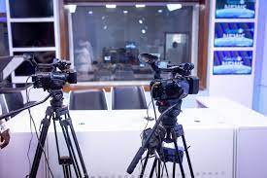

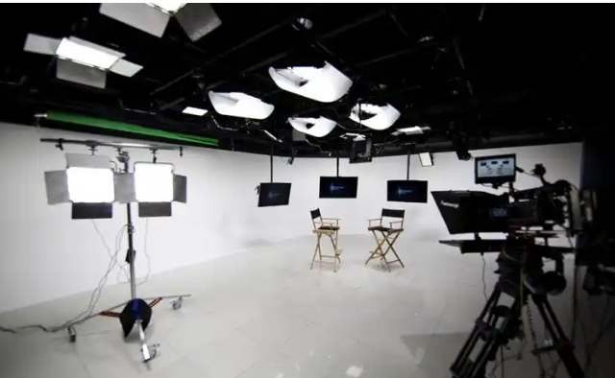
Lighting Equipment: Lighting equipment is essential for setting the mood, atmosphere, and tone of a production. This includes various types of lights such as key lights, fill lights, and backlights, as well as accessories like diffusers, gels, and barn doors to control and manipulate light intensity and direction.

Audio Equipment:
Audio equipment ensures crystal-clear sound quality, immersing viewers in the auditory world of the production. Microphones, mixers, amplifiers, and monitors are among the essential components used to capture, process, and monitor audio signals during recording and broadcasting.

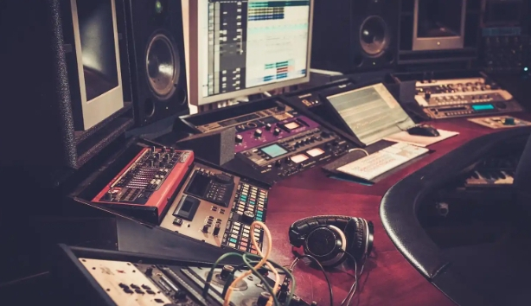

Set Design Elements:
Set design elements encompass a wide range of props, furniture, and scenic elements that transform a soundstage into a vibrant and immersive environment. From furniture and decor to backdrops and set pieces, each element is carefully selected and arranged to enhance the visual storytelling experience.
Teleprompters:
Teleprompters are invaluable tools for presenters and actors, providing them with a script or cue cards displayed on a screen in front of the camera lens. This allows performers to deliver lines and dialogue confidently while maintaining eye contact with the audience.

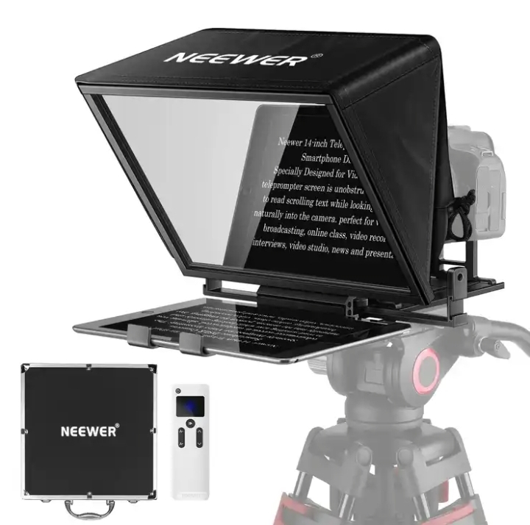

Graphics and Visual Effects:
Graphics and visual effects add depth, context, and visual interest to broadcast productions. This includes on-screen graphics, animations, virtual sets, and augmented reality elements that enhance storytelling and engage viewers in new and exciting ways.
Control Room Equipment:
The control room is the nerve center of the studio, housing equipment such as video switchers, audio mixers, and computer systems that facilitate real-time monitoring, editing, and broadcasting of live and recorded content.

3.1 DEPARTMENTS IN SBS AND THEIR FUNCTIONS
SBS has the following departments:
- Administrative department: This department handles the day to day business of a television station .They see to staff recruitment, training, promotions, etc. This department is also responsible for smooth management of the processes in SBS. Also they consult with other department heads regarding cash flow and expenditures. In SBS the branch manager oversees the activities of other departments and ensures proper working condition for staffs, hiring employees and ensures a safe workplace in all departments.
- News and current affairs department: This department is the local face of any television station. They are responsible for the compilation of news and keeping up to date with trending information, news, events and so on. In this department; there are various beat reporters who are assigned to different locations in Ilorin. Therefore, this department sees to the generation and presentation of news items and current affairs material as well as editing, writing/typing and printing the news in the station’s house-style. The department carries out research everyday as events/occurrences unfold to have their facts and figures as well as having accurate report for their listener. News anchors, reporters, meteorologists and sports anchors usually become recognizable personalities in their communities.
- Programme department: This department is sub-divided into two: programmes and production sections. The programmes department is in charge of programming while the production unit is made up of producers who produce programmes and presenters that do the presentations. In this department, there are the English and Yoruba newscasters as well as the sports broadcaster. The production department consists of the manager and assistant staff, e.g production staff, operations staff and on-air personalities.
- Engineering department: This department handles the technical aspects of broadcasting and on air time. It ensures broadcast signals are transmitted to the audience as well as see to the proper functioning of the studio equipment. Therefore, the department is in charge of all the technological and electronic machines/equipment in the radio station be it the transmitter, monitor, mixer and so on. Some of the engineers in this department record, work on and edit recorded materials in the recording studio before it is being broadcast. Under a chief engineer otherwise known as director of broadcasting operations, there are host of managers like engineers and studio crew members including show directors, cameramen, audio board operators, photographers, videographers, tape room editors and engineering technicians.
- Sales and marketing department: This department generate revenue. They are responsible for generating direct revenue for the broadcast station by selling air time to advertisers. Also they includes staffs like the voice talent, art directors etc
- Finance/account department: this department is in charge of handling all revenues and expenses in the TV station. The primary function is to ensure that dues from advertisers are collected in a timely manner and similarly all payments like utilities, salary and others are done on time.

CHAPTER FOUR

ACTUAL WORKDONE WITH EXPERIENCE GAINED (Cont’d)
4.1 COVERING OF EVENTS
Writing about live events such as meetings, press conferences, and speeches can be tricky even for seasoned reporters. Such events are often unstructured and even a bit chaotic, and the reporter, on deadline, has to make sense of what happened and present it in a story that has structure, order, and meaning. Not always easy. Here are some basic do's and don'ts for good reporting of live events:
FIND YOUR LEAD
The lead of a live event story should center on the most newsworthy and interesting thing that occurs at that event. Sometimes that's obvious: If a congressional leader announces a vote to raise income taxes, chances are that's your lead. But if it's not clear to you what's most important, or even what just happened, after the event interview knowledgeable people who can give you insight and perspective. It may be something you didn't even fully understand or a combination of a few things. Don't be afraid to ask.
AVOID LEADS THAT SAY NOTHING
Whatever the story—even a boring one, and sometimes those happen, find a way to write an interesting lead. "The Centerville City Council met last night to discuss the budget" does not pass muster, nor does, "A visiting expert on dinosaurs gave a talk last night at Centerville College."
Your lead should give readers specific information about something interesting, important, funny, or catchy that happened or was said. For example, "Members of the Centerville town council argued bitterly last night over whether to cut services or raise your taxes." Or, "A giant meteorite was probably responsible for the extinction of dinosaurs 65 million years ago, an expert said last night at Centerville College."
WATCH FOR THE UNEXPECTED
No matter how it was sold, sometimes what you expected would be the most important story of a live event turns out to be dull: a non-event. Perhaps a side story—a protest or something said unexpectedly by someone noteworthy—rises to center stage and becomes the better story. Grasp it.
Keep your ears and eyes tuned and your mind open. Be willing to shift your focus, start over and reorganize.
DON'T COVER EVENTS CHRONOLOGICALLY
When enthusiastic newbie reporters cover their first live events, they often feel an urge to tell their readers everything: Afraid of missing something important, they cover the event as it happens, from beginning to end, starting with the roll call and the approval of the minutes. This is a classic mistake that most reporters quickly learn to avoid.

INCLUDE PLENTY OF DIRECT QUOTES​
Good direct quotes are like a spice in a dish: They take the readers right there on the spot, give them a sense of the person who is speaking, and lend the story flavor, energy, and music. They also lend authoritativeness and credibility to stories involving public officials (whose career a quote can break). So, great quotes are essential to the fabric of a great story.
ADD COLOR AND LEAVE OUT THE BORING STUFF
Remember, you're a reporter, not a stenographer. You're under no obligation to include in your story absolutely everything that happens at an event. If the school board members discuss the weather, it's probably not worth mentioning (though if it's all they discuss, that might be a good story). On the other hand, you are your readers' eyes and ears: Color that gives the reader a sense of the scene can take your story from ordinary to memorable. Report with your senses.
4.2 PHOTO NEWS AND CAPTIONS
Photo captions are often the first elements of a publication to be read. Writing photo captions is an essential part of the news photographer’s job. A photo caption should provide the reader basic information needed to understand a photograph and its relevance to the news. It should be written in a consistent, concise format that allows news organizations to move the photo to publication without delay.
WRITING CAPTIONS
In most photo captions, the first sentence identifies the people and place in the photograph, and the date and location where it was taken. The second (and perhaps third) sentence should provide contextual information to help readers understand what they are looking at.The exact format for captions varies from publication to publication, but a basic photo caption should:
Clearly identify the people and locations that appear in the photo. Professional titles should be included as well as the formal name of the location. SPELL NAMES CORRECTLY (check against the spellings in the article if necessary). For photographs of more than one person, identifications typically go from left to right. In the case of large groups, identifications of only notable people may be required and sometimes no identifications are required at all. Your publication should establish a standard for its photographers.
Include the date and day the photograph was taken. This is essential information for a news publication. The more current a photo is, the better. If an archive photograph or photograph taken prior to the event being illustrated is used, the caption should make it clear that it is a “file photo.”
Provide some context or background to the reader so he or she can understand the news value of the photograph. A sentence or two is usually sufficient.
Be brief. Most captions are one or two short, declarative sentences. Some may extend to a third sentence if complex contextual information is needed to explain the image completely.

CHAPTER FIVE

SUMMARY AND CONCLUSION
5.1 SUMMARY OF ATTACHMENT ACTIVITIES
This is a complete report of an industrial training program carried out during my SIWES (2023/2024) at Sbs Fm Ilorin, Kwara State. Activities including field work such as news writing and report, different types of interview, news editing, photo news and caption and so on.
The experience gained has given me a sound knowledge on media house in general which has helped prepare me for the future journalism work.
5.2 SUGGESTIONS FOR IMPROVEMENT OF THE SCHEME
- Visiting of students during the program should be ensured by the ITF
- Students should be paid their allowance on time to ensure motivation
- Selection of placement should not be left to students. Polytechnics should make a means of allocating students to related companies
- Seminars should be organized for establishments to acquaint them with their roles towards students on training
5.3 CONCLUSION
The period has contributed immensely to my academic experience. Students Industrial Working Experience Scheme (SIWES) is an important program for all students. It helps in tackling the issue of unemployment amongst youth as it teaches us way to be independent. The exercise made me understood part of what is expected as a journalistin the practice. It helped groom my relationship skills especially in areas where team work are required and communicating with the staffs and students alike. It has exposed me to work ethics and routines.
The problems, if not tackled, will make it lose its usefulness and vitality notwithstanding the benefits of it.
Finally, I do hope the program will be improved so as to enhance manpower development and student’s skill in their respective field of study.

