

A TECHNICAL REPORT

ON
STUDENT INDUSTRIAL WORK EXPERIENCE SCHEME (SIWES)

HELD AT

SHUKURALLAHI ELECTRICAL ENGINEERING

WRITTEN BY

ABDULMAJEED ABDULQOYUM AYOMIDE
ND/23/EEE/PT/0181

SUBMITTED TO:

DEPARTMENT OF ELECTRICAL/ELECTRONICS ENGINEERING
INSTITUTE OF TECHNOLOGY (I.O.T.) KWARA STATE POLYTECHNIC, ILORIN

IN PARTIAL FULFILMENT OF THE REQUIREMENT FOR THE AWARD OF NATIONAL DIPLOMA (ND) CERTIFICATE IN ELECTRICAL/ELECTRONIC ENGINEERING TECHNOLOGY

AUGUST - NOVEMBER, 2024
DEDICATION
This report s dedicated to Almighty GOD, the guidance, provider, protector, the creator of one and all. I also appreciate my parents Mr and Mrs ABDULMAJEED and amiable friends for their full support throughout this program.

ACKNOWLEDGEMENT
I hereby express my profound gratitude to Almighty GOD for His absolute control over my life during this program. I also express my gratitude to my parents Mr and Mrs ABDULMAJEED, who have done all within their capacity to ensure that I got better and brighter future. Despite all challenges of life, they still strive to see me through this stage of my life. I pray Almighty GOD in His mercy will grant them good health and make sure they reap the fruit of their labour.
My profound appreciation to all those who have contributed to my success during this training program, my amiable friends won’t be left out. I hereby say a very big thanks to you all. May GOD reward you back abundantly.

TABLE OF CONTENT
Title page i
Dedication ii
Acknowledgement iii
Table of Content iv
CHAPTER ONE
  - Introduction 1
  - Definition of SIWES 1
  - Scope of SIWES 1
  - Aims and Objective of SIWES 2
  - Organization Chart 3
CHAPTER TWO
2.0 Wire or Wiring 4
2.1 Wiring 4
2.2 Type of Wiring 5
CHAPTER THREE
3.0 Circuit Breaker 6
3.1 Type of Circuit Breaker 6
3.2 Advantages of Circuit Breaker 8
CHAPTER FOUR
4.1 Socket 9
4.2 Electrical Switch 9
4.3 Change over Switch 10
CHAPTER FIVE
5.0 Conclusion 1
5.1 Recommendation 11

CHAPTER ONE
1.0 INTRODUCTION
Student Industrial Work Experience Scheme (SIWES) was established under Federal Government of Nigeria through ITF (Industrial Training Fund) in 1973 to solve the problem of inadequate practical skill for employment industrial by Nigeria graduate of tertiary institution.
The program is designed for four months and it is mandatory for all ND I engineering and science applied students in Nigeria Polytechnic. It is also controlled by the school management and ITF (Industrial Training Fund).
SIWES has become an acceptable training program for the award of National Diploma (ND) and degree certification in specific tertiary institutions for engineering and science applied courses. It s also set up for schools of engineering college of education.
1.1 DEFINITION OF SIWES
Student Industrial Work Experience Scheme (SIWES) can be defined as a program meant for student in tertiary institution in which they are exposed to practical training in their respective field of study in order to be able to handle machinery, requiring tools and respond to challenges in labour market.
1.2 SCOPE OF SIWES
SIWES has contributed toward the progress and achievement of the student that undergoes its training, most of the theoretical aspect of the courses, thought in lecture rooms demand practical with SIWES training more practical skilled are learned.

1.3 AIMS AND OBJECTIVES OF SIWES
The aims and objectives of the Industrial Training Fund (ITF) in conjunction with the National Board for Technical Report about introducing the Students Industrial Work Experience Scheme (SIWES) are as follows:
- To give opportunity to student to transform their theoretical knowledge into practical.
- To familiarize student with typical environment in which they are likely to function professionally.
- Prepare student to work method and techniques in handling equipment and machineries that may not be available in institutions.
- To help improve technological development of the country.

ORGANIZATION CHART

MANAGING DIRECTOR

ASSISTANT M.D.

OPERATION OFFICER CHIEF ENGINEER SERVICE

CHAPTER TWO
2.0 WIRE OR WIRING
A wire is a flexible metallic conductor, especially one made of copper, usually insulated, and used to carry electric current in a circuit.
A wire is a flexible, round, bar of metal. Wire is commonly formed by drawing the metal through a hole in a die or draw plate
TYPES OF WIRE
- Live wire (L): The live wire has an insulation that is red in color, it carries high voltage and brings in the current.
- Neutral wire (N): The insulation of the neutral wire is black in color and provides a return path for the current to flow in. It has zero potential.
- Earth wire (E): The insulation of the earth wire is green in color. It has no charge.

2.1 WIRING

WIRING

2.2 TYPES OF WIRING
1. Junction box
2. Clips and nail
3. Pattress
4. Trunking pipe
5. Twins wire

CHAPTER THREE
3.0 CIRCUIT BREAKERS
A circuit breaker is a protective safety device that stops the flow of an electrical current if it becomes too strong or if the circuit experiences a fault. Circuit breakers accomplish their function through mechanisms known as thermal or magnetic breakers, which block the current of electricity between live wires and the circuit's conductor.
Circuit breaker is an electrical safety device, a switch that automatically interrupts the current of an overloaded electric circuit, ground faults, or short circuits.
3.1 TYPES OF CIRCUIT BREAKER
1. Radial Venting MOCB: While in radial venting MOCB, the vents are designed radially along the arc chamber. Therefore, the arc is swept radially through the multiple vents.

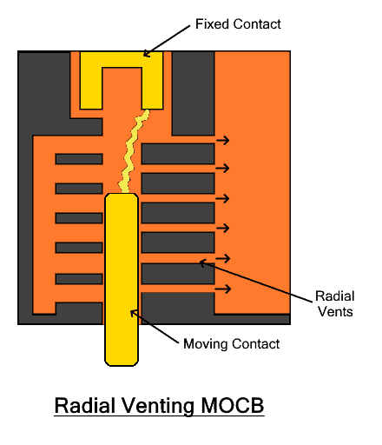
Advantages
- It requires a very less amount of oil.
- It has low weight.
- It has small size and takes up small space
Disadvantages
- Lesser oil is more affected by the amount of carbonization from the contacts.
- The oil quickly losses its dielectric strength.
- It requires more frequent maintenance.
2. Oil circuit breaker (OCB) is a type of circuit breaker that uses insulating oil as a dielectric medium to quench the arc and break the circuit safely. The oil used is insulating oil use d usually transformer oil that has better dielectric strength than air
3. Miniature Circuit Breaker ( MCB), is an electromechanical device enclosed in molded insulating material. Its main function is to automatically open the connected circuit when the flowing current exceeds its set value. It can also be manually operated to switch the connected circuit ON and OFF, similar to a standard switch,

4. Vacuum Circuit Breaker (VCB)
A Vacuum Circuit Breaker or VCB is a type of circuit breaker that uses the vacuum as the arc quenching medium. The vacuum has very high dielectric strength and arc quenching properties far more superior than any other medium. It can quickly recover its dielectric strength.
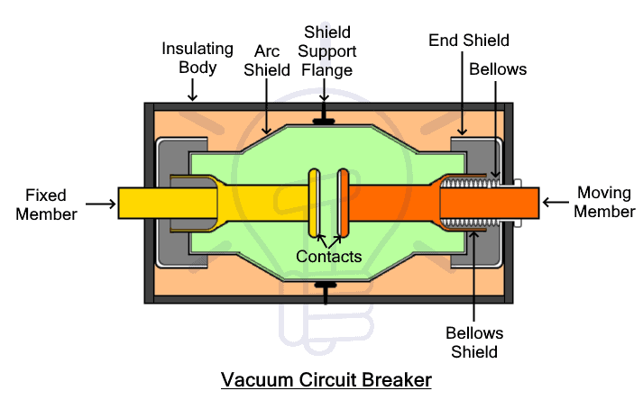
3.2 Advantages of Circuit Breaker:
- Circuit-breakers are a great replacement for mechanically operating fuses.
- Circuit-breakers are highly reliable.
- Circuit-breakers are more functional.
- Circuit-breaker can be fixed once, easy to reset and lasts for a long time.

CHAPTER FOUR
INSTALLATION OF ELECTRICAL ACCESSORIES
4.1 SOCKET: It connect electric equipment to the alternating current power supply in buildings and at other sites.
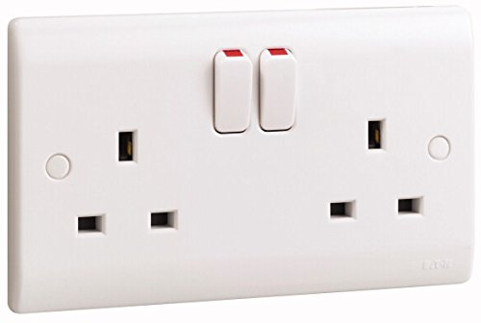

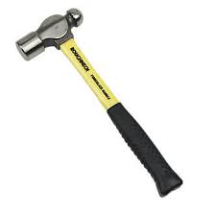
4.2 Hammer:- Hammer head are made of carbon steel. The face are hardened and tempered, while the eye is left, soft to absorb shock. Handles are made from hickory or ash wood. The hammer is used for striking work.

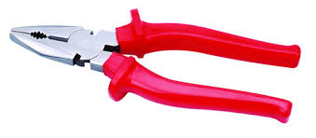
4.3 Pliers:- These are used for gripping, and cutting small flat and round material and depressing of soft objects.

CHAPTER FIVE
5.0 CONCLUSION
The programme had enabled me to put into practice the knowledge gained in the classroom with the actual industrial experience and develop a critical and realistic approach to some problems and their solutions in the electrical field.
5.1 RECOMMENDATIONS
l hereby recommend that this programme should be continued because it help the student to compare their theoretical experience with that of industrial training.
More so, the student industrial training programme is very important programme in which every student should pass through before graduating from their institution as it broaden their knowledge and their skills as well as technical know-how.
The Student Industrial Work Experience Scheme (SIWES) had contributed to my exposure and training in the field of Electrical/Electronic Engineering.

