NAME:
AGBOOLA OLAMIDE PETER

MATRICULATION NUMBER:
ND/23/TPM/FT/0042

LEVEL:
ND II

DEPARTMENT:
TRANSPORTATION PLANNING AND MANAGEMENT

REPORT ON STUDENTS INDUSTRIAL WORK EXPERIENCE SCHEME (SIWES)

AT

MINISTRY OF TRANSPORT, AKURE
SITUATED AT AKURE, ONDO STATE.

SUBMITTED TO THE DEPARTMENT OF TRANSPORTATION PLANNING AND MANAGEMENT

CERTIFICATION
This is to certify that this report is original to the author, AGBOOLA OLAMIDE PETER of the Department of Transportation Planning And Management, Institute of Technology, Kwara State Polytechnic and was supervised accordingly by; MR. MAIYAKI IBRAHIM T.D.

Supervisor’s Name Sign/Date
________________________ _______________________

HOD’s Name Sign/Date
_________________________ ________________________

Internal Supervisor’s Name Sign/Date
_________________________ ________________________

DEDICATION
This is dedicated to Almighty God, the creator of the universe who gave me the opportunity to start and complete my Students’ Industrial Work Experience Scheme.
I also dedicate this to my family and to the Managing Director of Ministry of Transport, Akure, Ondo State for their untimely support financially.

ACKNOWLEDGMENT
All praise and adoration to Almighty God for the inspiration, guidance and strength throughout my SIWES training.

I owe my profound gratitude to my HOD and all my lecturers in my department for their immense support towards my academics. My sincere appreciation goes to MR. OLADELE ODUNAYO PAUL my coordinator and the entire members of Ministry of Transport, Akure for allowing me to do my training in their firm.

Special thanks to family and friends.

PREFACE
This report is about the knowledge acquired during the Industrial Training Program known as SIWES.

The technical report comprises of daily activities undertaken in my place of attachment MINISTRY OF TRANSPORT, AKURE.

TABLE OF CONTENT
Cover Page i
Certification ii
Dedication iii
Acknowledgement iv
Preface v
Table of content vi - vii

Chapter 1: Introduction
1.1: Mission
1.2: Vision
1.3: Aims
1.4: Objectives

Chapter 2: Description of the establishment of attachment
2.1: Location and brief history of establishment
2.2: Responsibilities of the establishment
2.3 The various departments/unit in the establishment and their functions

Chapter 3: Inland water ways department
3.1: About IWW
3.2: Functions of IWW
3.3: Machines used in IWW and their functions
3.4 Safety devices on water
3.5: Common accident on water
3.6: Preventive measures for accidents on water

Chapter 4: Transportation Planning
4.1: Functions of Department of Planning and Engineering (D.P.E)
4.2: Transport operations department
4.3: Functions of free shuttle
4.4: Benefits of free shuttle

Chapter 5: Conclusion
Problems encountered during the program
Recommendations

CHAPTER ONE
- INTRODUCTION TO SIWES:
The Student Industrial Work Experience Scheme (SIWES) was established by the Industrial Training Fund (ITF) in 1973 to enable student of Tertiary Institutions to have technical knowledge of industrial work base on their course of study before the completion of their program in their respective institutions. The major background behind the embankment of students in SIWES was to expose them to the industrial environment and enable them develop occupational competences so that they can readily contribute their quota to national economic and technological development after graduation.

1.1. MISSION:
SIWES is charged with the responsibility of promoting and encouraging the acquisition of skills, commerce and industry with the view of generating a pool of trained indigenous manpower sufficient to meet the need of the economy. It is aimed at developing the human resources of the nation. It builds the nation’s workforce to promote the economy of the nation.

1.2. VISION:
The vision of SIWES is to prepare students to contribute to their nation and strength the students in practical aspect.

1.3. AIMS OF SIWES
The aim of study was to evaluate the impact of SIWES on technical skills development in the Nigeria economy. This is to enable institution of higher learning and other stakeholders access the performance of their roles in the schemes.

1.4. OBJECTIVES
The Industrial Training funds policy document No.1 of 1973, which established SIWES outline the objectives of the schemes. The objectives are to:
- Provide an avenue for the student in institution of higher learning to acquire industrial skills and experience during their course of study.
- Prepare students for industrial work situation that they are likely to meet after graduation.
- Expose students to work methods and techniques in handling equipment and machinery that may not be available in their institutions.
- Make the transition from school to the world of work carrier and enhances students contacts for later job placements.
- Provide students with the opportunity to apply their knowledge in real work situation thereby bridging the gap between the theory and practice.

CHAPTER TWO
DESCRIPTION OF THE ESTABLISHMENT OF ATTACHMENT

2.1: Location and brief history of establishment:
MINISTRY OF TRANSPORT, AKURE is located Akure, Ondo State. The organization was established February 3, 1976, from the Western State and it comprised of 19 local government area. The state has a rich history, with the city of Akure serving as its capital. The Ministry of Transport is likely a key player in the state’s development, overseeing transportation infrastructure and services.

2.2: Responsibilities of the establishment:
- Overseeing the development and maintenance of roads, bridges, and other transportation infrastructure.
- Developing and implementing policies to improve transportation services in the state.
- Ensuring that vehicles operating in the state meet safety and regulatory standards.
- Managing the state’s waterways and ensuring safe and efficient transportation.

2.3: The various departments/unit in the establishment and their functions
- Inland Waterway Department: This department deals with clearing of water hyacinths and weed. The department is ended by a Director who oversees the management of the department, controls and maintenance of the department. The department controls the maritime activities and other related activities.
- Planning and Engineering Department: This department is charged with the responsibilities of planning and development of the ministry.
- Transport Operation Department: They are responsible for managing and coordinating transportation activities.
- Vehicle Inspections Service Department: This department is responsible for the issuer of road worthiness for a vehicle. Ensuring that vehicles operating in the state meet safety and regulatory standards.
CHAPTER THREE
INLAND WATER WAYS (IWW) DEPARTMENT

3.1: INLAND WATER WAYS (IWW)
This department deals with clearing of water hyacinths and weed. It is one of the four (4) departments that were created in 2009 when the Ministry of transport was created in Ondo State. The department is ended by a Director who oversees the management of the department, controls and maintenance of the department. The department controls the maritime activities and other related activities.

Inland water way transport (IWW) also known as inland navigation, refers to the movement of goods and, to a lesser extent, passengers, using navigable inland waterways like rivers, canals, and lakes.

3.2: FUNCTIONS OF INLAND WATER WAYS (IWW)
- Promote cooperation with Nigeria Maritime Administration and Safety Agency (NIMASA) on the training of sea fares.
- Ensuring safety on inland waterways, including removing wrecks and other obstructions, and providing aids to navigation.
- Dredging of shallow rivers and opening up of blocked water ways in the coastal areas.
- Opening up of creeks for navigation purpose in the riverine areas of the state.
- Repair and maintenance of machine equipment such as supper chopper, skimming boat and amphibex 400E.
- Clearance of water hyacinths and weeds from the state inland waterways using manual and machine methods.
- Licensing with the Federal State Government ministries and parastatals on issues and policies affecting maritime sectors e.g National Inland Waterways Authority (NIWA), Nigeria Maritime Administration and Safety Agency (NIMASA).

3.3: MACHINES USED IN INLAND WATER WAYS AND THEIR FUNCTIONS
- Amphibex 400E Machine
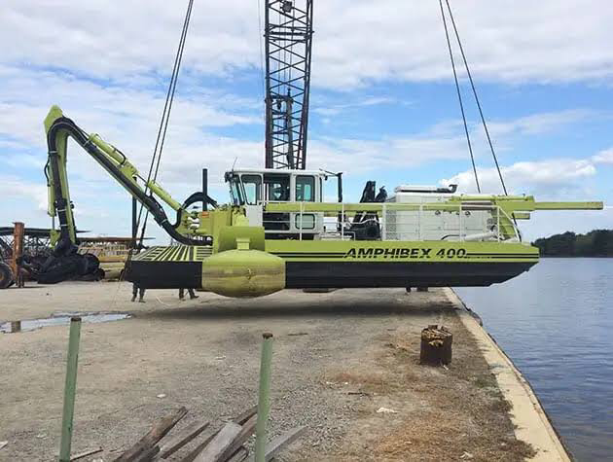

- It is used for clearing water hyacinths and weeds.
- It is used for dredging of shallow water.
- It is used for sand filling of site.

- Supper chopper
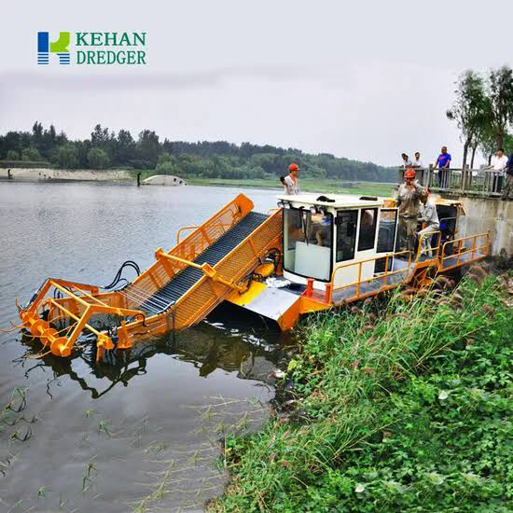

- It is used for the clearing of water hyacinth and weed but it cannot be used to remove the waste like the Amphibex 400E Machine but rely on the skimming boat to help remove the residue.

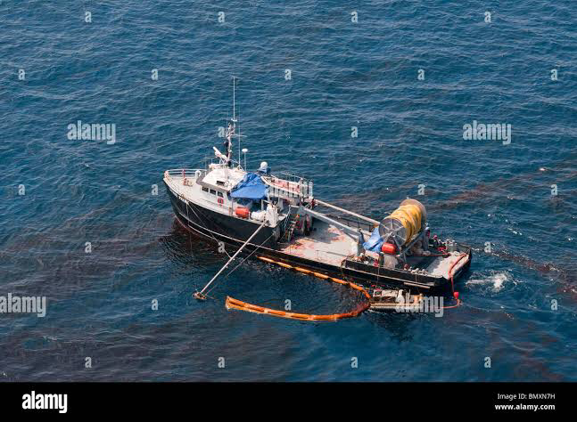
- Skimming Boat

- It is used to remove the residue of water hyacinths and weed being cleared by the supper chopper.

3.4: SAFETY DEVICES ON WATER
- Buoys: They are floating devices that serves special purpose on water. They also separate traffic lanes and indicate traffic directions.
- Life jackets: It is used to prevent drowning incase of emergencies.
- Navigation lights: Prevents collisions and improve visibility.
- Alarm system: Detect and alert of potential hazards such as flooding or leaks.
- Depth sounder: Measure water depth to prevent grounding.

3.5: COMMON ACCIDENTS ON WATER
- Collisions: Vessel to vessel or vessel to object impact and
- Equipment failure: Accidents caused by malfunctioning equipment.

- Grounding: Vessel running aground or striking underwater obstacles and
- Navigation errors: Accident caused by navigational mistakes.

- Capsizing: Vessel completely overturning or flipping and
- Weather related accidents: Accidents caused by extreme weather condition.
- Sinking: Vessel completely or partially submerging and
- Marine life encounters: Attack or encounter with marine animal.

- Fire or explosions: Onboard fires or explosions and
- Stip, tip and fall: Onboard accidents due to wet or uneven surface.

3.6: PREVENTIVE MEASURES FOR ACCIDENTS ON WATER
- Proper training: Ensure operators are experienced and trained.
- Regular maintenance: Schedule regular vessel maintenance.
- Safety inspections: Conduct pre-departure checks.
- Weather monitoring: Check forecast and be prepared.
- Life jackets: Ensure all passengers wear life jackets.
- Safety speed: Operate at a safe speed especially in congested areas.
- Lookout: Maintain a lookout for obstacles and other vessels.
- Communication: Establish clear communication with passengers and other vessels.
- Safety equipment: Ensure adequate safety gear, such as flares and fire extinguishers.
- Emergency preparedness: Develop and practice emergency response plans.

CHAPTER FOUR
TRANSPORTATION PLANNING
The transportation planning department is responsible for developing and implementing transportation plans, policies, and programs that promote safe, efficient, and sustainable transportation systems.

The department of planning and engineering (D.P.E) plays a crucial role in ensuring the safe, efficient, and sustainable movement of people and goods within Ondo state.

4.1: FUNCTIONS OF DEPARTMENT OF PLANNING AND ENGINEERING (D.P.E)
- Construction of buildings, roads, bridges, covet, etc: They are the department charged with different construction of Government properties in the state and ministry.
- Installation of road furnitures: They install road furnitures like zebra crossing, the U-turn signs, no parking sign and the street light and traffic light to control traffic.
- Maintenance and management of parks: They are charged with the maintenance and management of all parks in the state, and the one in charge of issuing tickets to drivers/riders.

4.2: TRANSPORT OPERATIONS DEPARTMENT
The transport operations department is responsible for managing and coordinating transportation activities. There are different units in the transport operations department which includes: vehicle inspection unit, driver licensing unit, transport permit unit, traffic enforcement unit, and emergency response unit. Free shuttle as a case study in Ondo state. They are the department charged with the maintenance and managing the free shuttle. The free shuttle is a mass transit/public transport which aim for the movement of students for free with the state.

4.3: FUNCTIONS OF THE FREE SHUTTLE
- It is used for the transportation of primary and secondary school students only within Ondo state and it only ply on the state road only.
- Conveying students to educational events, such as quizzes, debates, and competitions, within Akure.
- Promoting education by providing a safe and convenient transportation service, allowing students to focus on their studies.
- Enhancing the student experience by providing a comfortable and convenient transportation service.

4.4: BENEFITS OF THE FREE SHUTTLE
- Increased Access to Education: Increases access to education for Ondo State Government students in Akure.
- Improved Attendance: Improves attendance by providing a reliable transportation service.
- Reduced Financial Burden: Reduces the financial burden on parents and guardians by providing free transportation.
- Enhanced Safety: Enhances safety by providing a secure reliable transportation service.
- Promoting Equity: Promotes equity by providing equal access to education for all students, regardless of their socio-economic background.

CHAPTER FIVE
CONCLUSION
During my SIWES program, I faced little challenges. Inadequate infrastructure- the transportation infrastructure in Akure was inadequate, leading to congestion and accidents and there was also lack of enforcement of traffic laws and regulations, leading to reckless driving and accidents.

RECOMMENDATIONS
Based on my experience during the SIWES program, I recommend the following:
- Infrastructure Development: The transportation infrastructure in Akure should be developed to reduce congestion and accidents.
- Enforcement of Traffic Laws: Traffic laws and regulations should be enforced to reduce reckless driving and accidents.

CONCLUSION
Throughout the program, I was exposed to various aspects of transportation management, including transportation planning, traffic management, and safety management. I also had the opportunity to work with experienced professionals in the transportation sector, who provided guidance and mentorship throughout the program. I am confident that the experience and skills I gained during my SIWES program will be valuable assets in my future career.

Finally, I would like to express my gratitude to the Ministry of Transport, Akure, Ondo State, for providing me with the opportunity to participate in the SIWES program. I also appreciate the guidance and support provided by my supervisors and colleagues throughout the program.

