A TECHNICAL REPORT
ON
STUDENT INDUSTRIAL WORKING EXPERIENCE SCHEME (SIWES)

HELD AT
SEAP F.M (89.1)
OKEHO, ISIA AREA, KAJOLA LOCAL GOVERNMENT, OYO STATE

BY
OLAIYA TAWAKALIT TITILAYO
ND/23/MAC/PT/0404

THE DEPARTMENT OF MASS COMMUNICATION
INSTITUTE OF INFORMATION, COMMUNICATION AND TECHNOLOGY (I.I.C.T)

IN PARTIAL FULFILMENT OF THE REQUIREMENT FOR THE AWARD OF NATIONAL DIPLOMA IN MASS COMMUNICATION

SEPTEMBER – DECEMBER 2024
CERTIFICATION
This is to certify that the bearer has successfully completed the Student Industrial Work Experience (SIWES).

Department Coordinator Date

SIWES Director Date

DEDICATION
This report is dedicated to the Almighty God, the giver and sustainer of life, for His unconditional love and mercy granted to me throughout the period of my Industrial Training.
ACKNOWLEDGEMENTS

I thank Almighty God for the glory, honor, adoration and mercy I received during the course of my study and when undergoing my Student Industrial Work Experience Scheme (SIWES)

My appreciation also goes to my supervisor, during my training who accessibility, untiring effort, patience and guidance and suggestions fabulously contributed to the completion of this report. Who do not just teach me but makes me understood all his teaching, may Almighty God continue to guide and protect him and his house hold.

My appreciation also goes to my parent for their support during my training. May Almighty God continue to guide and protect them.

CHAPTER ONE
1.1 INTRODUCTION
The students industrial work experience scheme (SIWES) is a skills training programme designed to expose and prepare students of Universities, Polytechnics/Colleges of Technology/Colleges of Agriculture and Colleges of Education for the industrial work situation they are likely to meet after graduation. The scheme also affords students the opportunity of familiarizing and exposing themselves to the needed experience in handling equipment and machinery that are usually not available in their institutions. It is a cooperative industrial internship program that involves institutions of higher learning, industries, the Federal Government of Nigeria, Industrial Training Fund (ITF), and Nigerian Universities Commission (NUC).
The Objectives of the Scheme are to:
- Provide avenues for students to acquire industrial skills and experience during their course of study.
- Prepare students for industrial work situation they are likely to meet after graduation.
- Expose students to work methods and techniques in handling equipment and machineries that may not be available in the university.
- Provide students with the opportunities to apply their educational knowledge in real work situations, thereby bridging the gap between theory and practice.
- To make the transition from the schooling to world of work easier through enhancing students’ contact for later job placement.
1.2 OBJECTIVES OF SIWES
Specifically, the objectives of the student’s industrial work experience scheme are to:
- Prepare students for the work situation they are likely to meet.
- Provide an avenue for students in the Nigerian Universities to acquire industrial skills and experience in their course of study
- Make the transition from the university to the world of work easier, and thus enhance students contacts for later job placements;
- Enlist and strengthen employers’ involvement in the entire educational process of preparing university graduates for employment in industry.
- Provide students with an opportunity to apply their theoretical knowledge in real work situation, thereby bridging the gap between university work and actual practices; and
- Expose students to work methods and techniques in handling equipment and machinery that may not be available in the universities.
1.3 IMPORTANCE OF SIWES
- It provides students with an opportunity to apply their theoretical knowledge in real life situations.
- It exposes students to more practical work methods and techniques.
- It strengthens links between the employers, universities and industrial training fund (ITF)
- It also prepares the students for the labour market after graduation
1.4 THE ROLE OF FEDERAL GOVERNMENT
- Make it mandatory for all ministries, companies and government parastatals, to offer attachment places to students;
- Make it a policy to include a clause in every major contract lasting over six to nine months being awarded for contractors to take student on attachment
- Make adequate funds available to the federal ministry of industry to fund the Scheme.

1.5 ROLE OF THE CO-ORDNATING AGENCY (NUC)
- In collaboration with ITF, compile lists of employers for institution’s placement lists;
- Establish SIWES coordinating units
- Evolve a minimum national guide programme for supervised industrial training activities for approved SIWES courses:
- Appoint full —time industrial co coordinators to operate the scheme at agency level;
- Vet and approve SIWES master arid placement lists and forward to ITF.
1.6 ROLE OF THE INDUSTRIAL TRAINING FUND (ITF)
- Organize bi-ennial conference and seminars on SIWES
- Provide logistic material needed to administer the scheme;
- Compile lists of employers and available training places for industrial attachment and forward such lists to the co-ordinating agencies (i.e NUC, NBTE, NCCE).
1.7 ROLE OF EMPLOYERS
- Control and discipline students like permanent staff.
- Accept students and assign them to the relevant on—the-job training
- Provide medical care for students within the limits of the employers conditions of service during attachment
- Attach experienced staff to students for effective training and supervision.
- Supervisors should not handle more than ten students at a time;
- Pay students monthly allowance as and when due
1.8 ROLE OF POLYTECHNICS
- Prepare and submit master and placement lists to the respective coordinating agency and IT.
- Place students on attachment w.th employers
- Establish SIWES coordinating units and appoint department, faculty SIWES coordinators within the institutions;
- Organize orientation programmes for students to prepare them for industrial training. ITF representative may be invited to give a talk to the students during the orientation programme
- Appoint full-time industrial coordinators to operate the scheme at industrial level
1.9 ROLE OF STUDENTS
- Comply with the employer’s rules and regulations
- Arrange their own living accommodation during the period of attachment
- Be regular and punctual at respective place of attachment
- Arrange their own living accommodation during the period of attachment

CHAPTER TWO
2.0 HISTORICAL BACKGROUND OF SEAP FM (89.1)
SEAP FM 89.1 is a radio station located in Okeho, a town in the Kajola Local Government Area of Oyo State, Nigeria. Established on February 9, 2024, it stands as the first terrestrial radio station in the area. The station was inaugurated by Dr. Olatunde Oladokun, the Chairman of SEAP Microfinance Bank, with the vision of promoting entrepreneurship and providing a platform for the community to thrive.
The launch event was attended by notable figures, including Prince Dotun Oyelade, who represented Oyo State Governor Seyi Makinde. Prince Oyelade emphasized Oyo State's competitive advantages, highlighting its extensive landmass and dry port facilities as key factors for attracting investors.
In March 2024, seasoned broadcaster Lawrence Olisa was appointed as the General Manager of SEAP FM 89.1. Olisa's appointment aimed to steer the station towards broadcasting excellence and effectively serve the community.
SEAP FM 89.1 distinguishes itself with a primary focus on entrepreneurship, aligning with its tagline "The Entrepreneur Radio." This focus aims to inspire and support individuals in the community, fostering economic growth and development.

2.1 OBJECTIVES OF SPACE FM 90.1
Seap F.M was conceived as a community broadcasting station to serve as a rallying point for the people of the Okeho and environs. Specifically, the Station will provide leadership in articulating the development NEEDS of the people; moderates their WANTS while vigorously promoting the consensus of the community on issues.
It is also to serve the Okeho community in providing timely, national and international news and information that are considered relevant to the community. The station shall identify and transmit local music and other music and entertainment materials in line with the cultural values of the people of the Ilorin residents.
The foregoing are listed below as specific objectives:
- To promote the Yoruba language and culture towards retaining our cultural heritage in the context of contemporary society.
- To disseminate information and analysis of issues and events that is of local, national and international importance.
- To generate revenue, in line with the NBC guidelines on community broadcasting; through the sale of air-time and to promote other commercial activities like product exhibitions, shows, events and joint promotion of products and social activities.
- To install and maintain equipment for gathering, processing and transmission of information on radio
- To mobilize the community for development aspirations and defend their interest as appropriate
- To facilitate the achievement of these objectives through relevant support services
- To facilitate the building of economic community that is line with modern ICT requirement
- To use the facility of the station to promote educational aspiration of the community through educational broadcasting approach.

2.2 MISSION

Our mission is to provide quality programming for cultural education, reliable information and entertainment needs of the Okeho community.
  - VISSION
- To be the leading station for the promotion of cultural awakening and re-orientation
- Programming Policy and Philosophy
Primarily, Seap Fm is established to provide specialized broadcasting for educational purposes. Educational broadcasting is the use of broadcasting, in this case radio, to achieve formal, informal, non- formal and other forms of education as may be defined by experts in the area. Furthermore, educational broadcasting combines the traditional functions of broadcasting of Information (news and current affairs), education (enlightenment and educative programmes), Entertainment (relaxation and amusement) with the traditional educational functions of developing the intellectual, moral and skills capabilities of citizens. Therefore, they shall be guided by this objective in its programming conception, design and transmission.
The station shall maintain a 3:1 programming ratio between educational (formal, non-formal and informal education) and general audience programme. In order words educational programmes shall constitute seventy five percent (75%) as against twenty five percent (25%) for general audience programmes. For the purpose of clarity, the station is neither primarily a commercial nor entertainment station. The station shall work in collaboration with the Department of Mass Communication for the conception and production of programmes in all ramifications

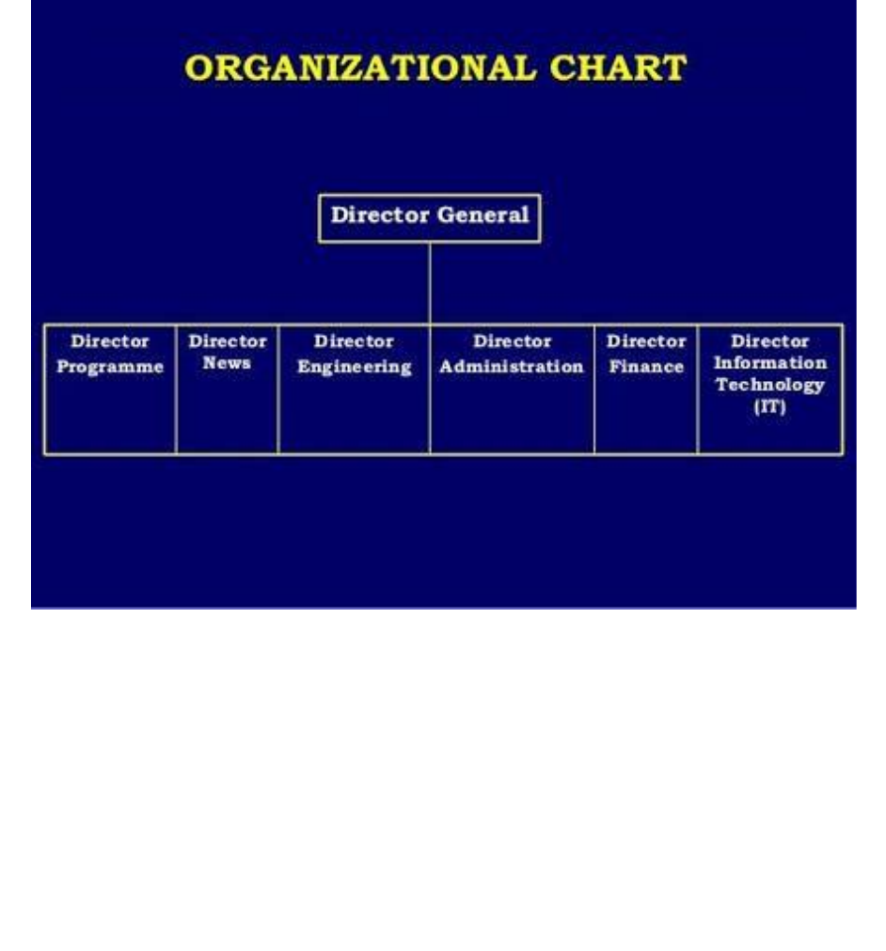
2.4 ORGANIZATIONAL STRUCTURE OF SPACE FM 90.1

CHAPTER THREE
3.0 DEPARTMENTS AND RESPONSIBILITY
There are six different departments in the station, which work hand in hand for the actualisation of the corporate objectives of the station. Among the departments and their functions are the following.
- OFFICER IN CHARGE
This officer is responsible to the Director General the SPLASH, for planning, coordinating and supervision and implementation of Splash policies in the community stations and production Centre
He/she is the Chief Executive Officer of Community Station that works under the supervision of a General Manager or Zonal Director as the case may be. The office ensures staff welfare and staff development as well as facilitating industrial harmony among the Union and management. It is also part of its function to render periodical reports to Headquarters. O IC, as fondly called should be a custodian of discipline by monitoring the staff and provide incentives and appropriate discipline measures. He coordinates the junior and senior staff in his station.
- ADMINISTRATIVE DEPARTMENT
This is the exit and entry point to the station. It is the custodian of the day to day running of the television station that sees to the welfare and career progression of the staff. It participates in policy formulation and implementation for the authority, and it is the chief manager of the authority’s finance, human and material resources.it also helps monitoring and ensuring policy implementation and by extension exercising controls all other departments. i.e ensure orderly running of the station through provision of needed facilities for the station. Administrative department is the custodian of discipline, it makes sure that erring operatives are duly punished while officers with exceptional performance are rewarded.
- PROGRAMMES DEPARTMENT
This is the unit of the station that over sees the content creation for the station. Programmes department takes control over various programmes that feature on the station, be it in-house programme, commercial programme or syndicated ones, either on live mode or recorded format. The department functions in policy formulation for programs production and transmission at the community level; it is the overall manager in designing programmes in accordance with the objectives of the Authority. It equally evolves rules and regulations aimed at upholding broadcasting. Programmes department looks for programmes from other stations and independent producers in and outside the country.
- NEWS DEPARTMENT
This is the live wire of the station, and where I was attached to during the period under review. It coordinates the News and Current Affairs unit of the station. It is the department that ensures that news content is produced on daily basis which must reflects the local content and national outlook. News department is responsible for policy formulation for news production, gathering and broadcasting from all legitimate sources Okeho Community. In line with the directive from the headquarters, News department ensure that local events that have national outlook are promptly covered and sent to the Network Centre. It monitors news from the same network that has significant impact to the inhabitant of the community.
- ENGINEERING DEPARTMENT
Engineering-base medium, this is because the distribution of the content produced by both the News and Programmes departments could only be gotten to the public through the effort of the Engineering department.
Therefore, engineering department oversees corporate engineering policy, information, planning, research and development. It provides technical training and maintenance support for the station. It is also the responsibility of the engineering to ensure compliance with the authority’s technical standards and codes. Acquisition, operation and maintenance of technical assets including plants and equipment are part of the functions of this department.
- MARKETING DEPARTMENT
This department is the main source of revenue to the station, because majority of commercials that generate money for the smooth running of the station comes from this department. Marketing department embarks on aggressive marketing drive that brings money to the station. It looks out for money on daily basis. Another function of this department is engaging most private organisations like hotels in batter, where by their adverts will be aired, and the station can benefit from the services they provide.
- FINANCE DEPARTMENT
This is the department that takes custody of the station’s finances. It coordinates the judicious use of the station’s money. Finance department supervises and monitors every purchase incurred by the station as well as settlement of debts. It equally pays the various bills incurred by the station as well as settlement of government dues.All said and done, one thing that clears to me while working as an intern with the station was that all of them work together for the actualisation of the corporate objectives of the station. It does clear to me that no department is an island of the other, and no one can function effectively without the input of another
3.1 IDENTIFICATION OF EQUIPMENT IN STUDIO
There are basic equipment found in the studio which are used for production, they include:
- Studio light
- Computer system
- Sound mixer
- Camera
- Cromer machine
- Back drop (Cromer cloth)
- Air condition (AC)
- Studio chairs and table


MICROPHONE
A microphone is a device that translates sound vibrations in the air into electronic signals and scribes them to a recording medium or over a loudspeaker.

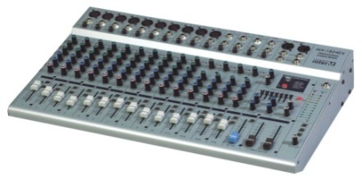

AUDIO MIXER MACHINE
A sound mixer is also known as a mixing console or more commonly an audio mixer. This is an electronic device used for mixing, balancing, and combining different sounds and audio signals, sources like microphones, instruments, and synthesizers, or previously recorded audio.


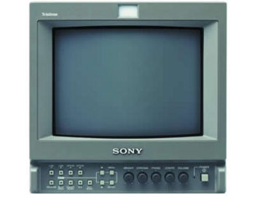

MONITOR
Computer Monitor
A computer monitor is an output device that displays information in pictorial or textual form. A discrete monitor comprises a visual display, support electronics, power supply, housing, electrical connectors, and external user controls.


HEADSET
A headset is a combination of headphone and microphone. Headsets connect over a telephone or to a computer, allowing the user to speak and listen while keeping both hands free.

CHAPTER FOUR
4.0 RELEVANCE OF TRAINING
The relevance of this training cannot be over emphasized; it aided the sharpening of inherent skills and the acquiring of new ones. Also it helped to place high level of relevance on what I have been taught in school. The relevance of this training to me can be divided into two broad groups; the relevance to my academics and the relevance to the labour market.
1. Writing for the Mass Media, News Writing and Reporting & Radio
- One of the things you told me that guides the writing pattern of a reporter is the editorial policy. This I learnt on the job. I learnt how to turn, twist, or slant stories in favor of the editorial policy.
- You also equipped us with a lot of writing skills, styles & techniques e.g KISS (keep it short and simple), proximity, prominence, Use of Registers, etc. These helped my writing skill. For the times I went on assignment, I wrote the intros and narration for the report.
- It was also made known to us the variances in scripts and the writing attitudes to apply in each. During my training I mostly encountered the reportorial script. I also extracted headline international stories from foreign medium for scroll messages.
- We were fore warned of the challenges in news writing and they were encountered. I must say the news room is truly a mad house, whenever I come back from an assignment; you are to sit in that noisy office to write your report. Thinking above the noise wasn’t easy.
Element of Journalistic Style:
- We were also taught the inverted pyramid style of writing which involved the 5w’s and 1h. I put this into major consideration when writing my intro, knowing full well what an intro is and how to write it.
- We were taught about style i.e. organizational style & house style. There was a house style in (Radio Kwara) for script writing. There was a laid down format for writing script and doing a lot of other thing and I appreciated and respected that because of the knowledge I had.

CHAPTER FIVE
5.1 SUMMARY
A) Impression about the organization
Impression about the industrial training base on four months programs (siwes) was the acceptance of my siwes letters in their organization and also for provision of a lecture class to enlighten us more about construction work which all siwes student settle down there every day for their day to day activities before being taken to the studio
B) Personal relationship with the organization
The personal relationship with the company in highly correlating, because company accepts the training of the Siwes students as their personal assignment, by showing us different technique in broadcasting. The welfare and care giving to us in company was highly impressive because the company attached each and every one of the Siwes student to different supervisor in which we are free to ask questions about every unclear aspect during the taking off process and in the studio.
5.2 CONCLUSION
This program has brought improvement to my field of study. The experience gained through this program is majorly based on radio broadcasting; this program has inspired me to have technical knowledge and practical aspect of what I have learnt in school.
I hereby forward my appreciation to the Rector and director of the institute, HOD of my department, professional lecturers in my department including my colleague in training, friends and every member of my family for their support both morals and financial. My prayer to you all is for God to in his infinity mercy bless you and reward every of endeavor abundantly. AMEN
5.3 RECOMMENDATION
As a result of difficulties experience during the Four months SIWES program, I will like to recommend the following changes;
- The Industrial Training Fund should make monthly allowance available for students, so as to put end to financial difficulties that may arise as a result of transportation problems.
- The Institution must confirm that each student partake in the Industrial Training program, by making sure that they pay every student a visit before the end of the program.
- The Institution and Industrial Training Fund should help the student to get the place of attachment, so that the program will commence as planned.
- Students on SIWES program should be posted or deployed to the Organizations, Department or Firms that are relevant to their Course of study, so that the sole aim of SIWES can be achieved.
- Proper modalities should be put in place to monitor students on SIWES to ensure that none of the students boycott the program.

