

A TECHNICAL REPORT ON
STUDENT INDUSTRIAL WORK EXPERIENCE SCHEME
(SIWES)

HELD AT:
OLAJESU GLOBAL SERVICE
ALONG FGGC ROAD OMU-ARAN KWARA STATE

WRITTEN BY
KAREEM OLAWUMI OPEYEMI
ND/23/BAM/PT/0360

SUBMITTED TO
DEPARTMENT OF BUSINESS ADMINISTRATION AND MANAGEMENT,
INSTITUTE OF FINANCE MANAGEMENT STUDIES (IFMS)
KWARA STATE POLYTECHNIC, ILORIN

IN PARTIAL FULFILLMENT OF THE REQUIREMENTS FOR THE
AWARD OF NATIONAL DIPLOMA (ND) IN BUSINESS ADMINISTRATION AND MANAGEMENT
AUGUST –NOVEMBER, 2024

DEDICATION
I dedicate this report, first and foremost, to Almighty God for His favor and grace upon my life, especially throughout my four-month SIWES program.
I also dedicate it to my loving parents and siblings for their unwavering love and support. Additionally, I extend my gratitude to everyone who contributed to making my SIWES training a rewarding and enjoyable experience.

ACKNOWLEDGEMENT
I express my deepest gratitude to Almighty God for the gift of life, the giver and taker of all things. I am also profoundly thankful to my parents for their unwavering support and prayers, which have guided me through every step of my journey. May they live long to reap the rewards of their hard work.
My heartfelt appreciation goes to my parents, Mr. and Mrs. Kareem, for their spiritual, moral, and financial support, which contributed immensely to the success of my SIWES program.
I am sincerely grateful to the management and staff of the company, especially my supervisor for their invaluable support, guidance, and knowledge shared during my training. I also extend my gratitude to my lecturers and supervisors for their continuous encouragement and constructive feedback throughout the program.

TABLE OF CONTENTS
Title Page i
Dedication ii
Acknowledgement iii
Table of Contents vi
CHAPTER ONE
1.1 Background to SIWES
1.2 Importance of Industrial Training in Business Operations
1.3 Objectives of the Internship
CHAPTER TWO
2.1 Overview of the Poultry Feed Industry
2.2 Production Process of Livestock Feed
CHAPTER THREE: TRAINING EXPERIENCE
3.1 Familiarity with Feed Types
3.2 Learning How to Write Stock Records
3.3 Monitoring Import and Export Process
3.4 Implementation of Price Adjustments
3.5 Sales Calculations of Livestock Feeds Sold
3.6 Maintaining High-Quality Egg Delivery & Customer Satisfaction
3.7 Use of Data Analysis for Sales Trends & Pricing Optimization
3.8 Inventory Management and Cost Reduction
3.9 Balancing Accounts of Feeds Sold
CHAPTER FOUR
4.1 Poultry feeds formulation
CHAPTER FIVE

5.0 CHALLENGES, CONCLUSIONS AND RECOMMENDATIONS
5.1 Challenges Encountered
5.2 Conclusion 10

5.3 Recommendations 10

CHAPTER ONE

INTRODUCTION

1.1 Background of SIWES
The Student Industrial Work Experience Scheme (SIWES) was established by the Federal Government of Nigeria in collaboration with the Industrial Training Fund (ITF) to provide students in tertiary institutions with practical experience in their respective fields of study. The program is designed to bridge the gap between theoretical knowledge and practical application in real-world work environments. SIWES enables students to gain hands-on experience, develop essential skills, and understand the professional working environment.
The students Industrial Work Experience Scheme (SIWES) was initiated in 1973 by the Industrial Training Fund (ITF). This was to update practical knowledge of students in the Universities, Polytechnics and College of Technology. It was aimed at bridging the gap between the theoretical knowledge acquired in classes and technical knowledge in the industries by providing students with opportunities to apply their educational knowledge in real work situations.
Over the years, SIWES has contributed immensely to building the common pool of technical and allied skills available to the Nigerian economy which are needed for the nation’s industrial development.
1.2 Importance of Industrial Training in Business Operations
Industrial training is essential for students in business and management-related fields, as it exposes them to the day-to-day operations of businesses. It provides an opportunity to learn about retail operations, inventory management, customer service, and financial transactions. Through this experience, students gain insights into business management practices, problem-solving techniques, and the importance of teamwork in achieving organizational goals.
1.3 Objectives of the Internship
The primary objectives of my SIWES training at the provisions store were:
- To gain practical experience in retail store operations and management.
- To understand customer service principles and their application in a retail setting.
- To learn inventory control techniques, including stocktaking and replenishment.
- To acquire skills in cash handling, sales transactions, and record-keeping.
- To develop communication and interpersonal skills through direct customer interaction.
- To understand the challenges of running a provisions store and identify possible solutions.

CHAPTER TWO

INDUSTRY OVERVIEW
2.1 Overview of the Poultry Feed Industry
The poultry feed industry plays a crucial role in livestock farming by providing balanced nutrition for poultry production. Feed types include starter feed, grower feed, finisher feed, and layer feed, each tailored to specific growth stages.
2.2 Production Process of Livestock Feed
The production of poultry feed involves ingredient selection, grinding, mixing, pelletizing, and packaging. Quality control measures ensure nutritional balance and compliance with regulatory standards.

CHAPTER THREE

TRAINING EXPERIENCE
3.1 Familiarity with Feed Types
During my training, I gained knowledge of various poultry feed types, including:
- Starter Feed: High protein content for chicks.
- Grower Feed: Balanced nutrition for developing birds.
- Finisher Feed: Optimized for broilers before market sale.
- Layer Feed: Enriched with calcium for egg production.
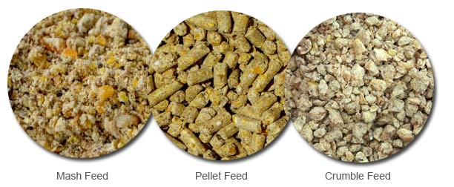
3.2 Learning How to Write Stock Records
Maintaining accurate stock records was crucial for inventory management. I learned how to:
- Record feed production and sales.
- Track stock levels and avoid shortages.
- Manage stock rotation to prevent spoilage.
3.3 Monitoring Import and Export Process
I observed how imported feed ingredients were cleared, stored, and processed. Export procedures involved quality checks, packaging, and logistics coordination.
3.4 Implementation of Price Adjustments
Price adjustments were based on:
- Cost of raw materials.
- Market demand and competition.
- Seasonal fluctuations in livestock feed consumption.
3.5 Sales Calculations of Livestock Feeds Sold
Sales calculations involved:
- Determining total sales revenue.
- Analyzing profit margins.
- Managing discounts and promotional pricing.
3.6 Maintaining High-Quality Egg Delivery & Customer Satisfaction
I participated in ensuring that high-quality feed translated into better egg production. Customer satisfaction was achieved through timely deliveries, effective communication, and addressing customer feedback.
3.7 Use of Data Analysis for Sales Trends & Pricing Optimization
I was introduced to basic data analysis tools to monitor sales trends, predict demand, and optimize pricing strategies to maximize profit.
3.8 Inventory Management and Cost Reduction
Inventory management strategies included:
- Ensuring adequate stock levels.
- Reducing transportation costs by optimizing delivery schedules.
- Identifying opportunities to minimize feed wastage.
3.9 Balancing Accounts of Feeds Sold
I learned how to record financial transactions, reconcile sales records, and ensure proper account balancing to maintain financial accuracy.
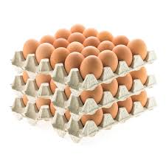

CHAPTER FOUR
4.1 Poultry feeds formulation
Poultry feed production involves several stages, starting with receiving and cleaning raw materials, followed by grinding, mixing, and then either pelleting or leaving as mash, before finally packaging and storing the finished feed.
Here's a more detailed breakdown of the process:
1. Receiving and Cleaning:
- Raw materials, such as grains (corn, wheat), oilseeds (soybeans, sunflower), and protein sources (fish meal, meat and bone meal), are received and cleaned to remove impurities.
- This ensures the quality and safety of the final product.
2. Grinding:
- The cleaned raw materials are then ground into a fine powder or a specific particle size, depending on the desired feed type.
- This process increases the digestibility of the feed.
3. Mixing:
- The ground ingredients are mixed in precise proportions to create a balanced and nutritionally complete feed.
- This includes adding vitamins, minerals, and other additives as needed.
4. Pelleting (Optional):
- After mixing, the feed can be pelleted, where the mash is pressed into small, uniform pellets.
- Pellets are easier to store and transport, and they reduce wastage.
5. Cooling and Drying:
- After pelleting, the feed is cooled and dried to prevent spoilage and maintain quality.
6. Packaging and Storage:
- The finished feed is then packaged and stored in a dry, cool place to maintain its nutritional value and prevent spoilage.
Common Poultry Feed Ingredients:
- Grains: Corn, wheat, sorghum, millet
- Oilseeds: Soybeans, sunflower, rapeseed
- Protein Sources: Fish meal, meat and bone meal, soybean meal
- Additives: Vitamins, minerals, premixes

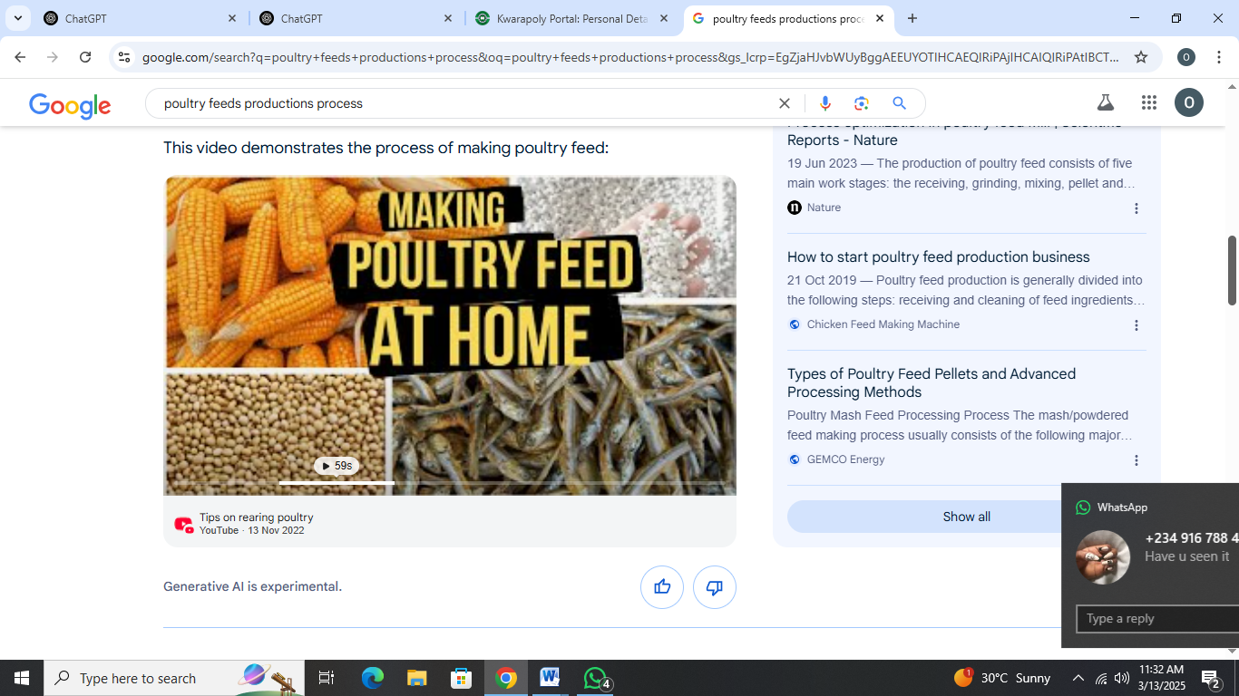

CHAPTER FIVE

5.0 CHALLENGES, CONCLUSIONS AND RECOMMENDATIONS
5.1 Challenges Encountered
- Fluctuations in raw material prices.
- Delays in feed supply chain due to import bottlenecks.
- Managing feed storage to prevent contamination.
- Difficulty in balancing customer demand with inventory levels.

5.2 CONCLUSION
My SIWES experience provided hands-on training in poultry feed management, covering aspects of feed production, inventory control, sales analysis, and customer service. The knowledge gained will be valuable in future roles within the agricultural sector.
5.3 Recommendations
- Improve supply chain efficiency to reduce import delays.
- Invest in local production of key feed ingredients to reduce costs.
- Use digital inventory tracking systems for better stock management.
- Implement customer feedback mechanisms for service improvement.

