

KWARA STATE POLYTECHNIC ILORIN
STUDENTS INDUSTRIAL WORK EXPERIENCE SCHEME (SIWES)
A TECHNICAL REPORT OF TRAINING UNDERTAKEN AT
KWARA STATE LIBRARY BOARD,
ILORIN, KWARA STATE
(AUGUST - NOVEMBER 2024)
BY
ABDULFATAI ZAINAB OMOTAYO
ND/23/LIS/FT/0025
SUBMITTED TO THE DEPARTMENT OF LIBRARY AND INFORMATION SCIENCE
INSTITUE OF INFORMATION AND COMMUNICATION TECHNILOGY
MARCH, 2025
ACKNOWLEDGMENT
I express my heartfelt gratitude to the management of Kwara State Polytechnic Library, Ilorin, for providing an enabling environment to conduct my industrial training. My deepest appreciation goes to my supervisor, for his mentorship, patience, and invaluable insights throughout my training period. I also appreciate all the staff members of the library, especially those in the Technical, Circulation, and Reference, Serial, Acquisition and E-Library Units, for their cooperation and guidance.
I acknowledge my institution, Kwara State Polytechnic, for creating the opportunity for students to gain practical experience through the SIWES program. Lastly, I am grateful to my family and friends for their continuous encouragement and support during this program.

REPORT OVERVIEW
This report provides a detailed account of my Student Industrial Work Experience Scheme (SIWES) at the Kwara State Library Board, Ilorin, Kwara State. The training was an essential part of my Library and Information Science (LIS) program, aimed at bridging the gap between theoretical knowledge and practical application in a real-world library setting.
During the training, I worked in the following sections:
- Catalogue Section - Assisted in cataloguing of library materials for availability for users.
- Classification Section - Helped in assigning class number to the information resources.
- Acquisition Section - Helped in the selection and procurement of new books and library materials.
- Reading Sections – (Humanities, reference, children), monitored library users and maintained an orderly reading environment.
My SIWES experience at the Kwara State Library Board was highly beneficial, equipping me with practical skills in library management, digital resource handling, and user services. This report documents my learning journey, the tasks I performed, and the knowledge gained, reinforcing the importance of industrial training in preparing students for professional careers.

TABLE OF CONTENT
Title page
Acknowledgement
Report Overview
CHAPTER ONE:
Introduction
1.1 Brief history and background to SIWES
1.2 Aims and objectives of SIWES
CHAPTER TWO:
2.1 Description of the establishment of placement
2.2 Location and brief history of the establishment
2.3 Organizational structure of the establishment
2.4 Various departments/sections and their functions
2.5 Specific sections I was posted
CHAPTER THREE:
3.1 Actual work done report
3.2 Experience gathered
CHAPTER FOUR:
4.1 Equipment used, their functions and detailed description of their usage
CHAPTER FIVE:
5.1 Summary
5.2 Conclusion
5.3 Problems encountered
5.4 Recommendations
5.5 References

CHAPTER ONE
INTRODUCTION
1.1 BACKGROUND HISTORY OF SIWES
The Students Industrial Work Experience Scheme (SIWES) is a skill development program established by Industrial Training Fund (ITF) in 1973 which the headquarters is based in Jos Nigeria. It is meant to enable students in tertiary institutions in Nigeria to acquire technical skills and experience for professional development in their course of study as it bridges the gap between theory and practical. The Scheme exposes students to industry-based skills necessary for a smooth transition from the classroom to the world of work. It affords students of tertiary institutions the opportunity of being familiarized and exposed to the needed experience in handling machinery and equipment which are usually not available in the educational institutions.
Before the inception of the Scheme, there was a growing concern among Nigerian industrialists that graduates of institutions of higher learning lacked adequate practical background experience necessary for employment. So, employers were of the opinion that the theoretical education provided by higher institutions did not meet nor satisfy the needs of the economy. It was against this background that the Fund during its formative years, introduced SIWES to provide students with the opportunity of exposure to handle equipment and machinery in Industry to enable them acquire prerequisite practical knowledge and skills (ITF and UNIJOS, 2011). This program (SIWES) is a four (4) credit unit course in some UNIVERSITIES and other tertiary institution which must be met by students before graduation, in order to gather practical knowledge of the theoretical aspect that they have learn during the course of their study in university. This is the reason why it is mandatory for students in the department of Library and Information Science, to go to different library to acquire practical knowledge of librarianship.
1.2 Aims and Objectives of the STUDENT’S INDUSTRIAL WORK EXPERIENCE (SIWES)
The following are the aims and objectives of Scheme as summarized by the federal government in its Gazette of April, 1978 as follows:
1. To provide students the opportunity to test their interest in a particular career before permanent commitments are made.
2. To help students to develop skills in the application of theory to practical work situations.
3. To provide students the opportunity to test their aptitude for a particular career before permanent commitments are made.
4. To help students to develop skills and techniques directly applicable to their careers.
5. To provide students the opportunity to develop attitudes conducive to effective interpersonal relationships.

CHAPTER TWO
2.1 DESCRIPTION OF THE ESTABLISHMENT OF PLACEMENT
The Kwara State Library Board is a government-established institution responsible for providing library and information services to the residents of Kwara State, Nigeria. As a public library, its primary function is to promote literacy, lifelong learning, and access to information resources for students, researchers, and the general public. The Library board operates under the supervision of the Kwara State Ministry of Education and aligns with national policies on library development. It provides a range of services, including book lending, reference services, access to newspapers and periodicals, and educational programs such as reading campaigns and literacy initiatives.
The library houses a diverse collection of materials, including textbooks, journals, government publications, and digital resources. It serves as an essential hub for academic and intellectual engagement, supporting students, educators, and professionals in their research and learning activities.
2.2 BRIEF HISTORY OF THE ESTABLISHMENT
The Kwara State Library was established in 1967, following the creation of Kwara State, to provide qualitative and adequate reading resources for the people of the state, irrespective of age, educational background, status, religion, or gender. Initially housed in an area court building, the library underwent several relocations before the construction of its current facility, commissioned on November 21, 1990, by then Military President Ibrahim Babangida. In 2005, the library was renovated to enhance its infrastructure and services. The headquarters are located in Ilorin, the state capital, with divisional libraries in Jebba and Offa.

2.3 ORGANIZATIONAL STRUCTURE OF THE ESTABLISHMENT OF PLACEMENT
The Kwara State Library Board operates under the supervision of the Kwara State Ministry of Education and follows a hierarchical structure to ensure effective administration and service delivery. The organizational structure is typically as follows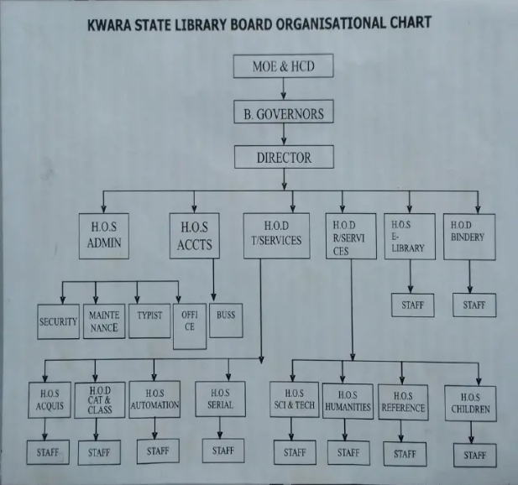
2.4 VARIOUS DEPARTMENTS/UNITS AND THEIR FUNCTIONS
The Kwara State Library Board is structured into various departments and sections to ensure efficient service delivery and proper management of library resources. Throughout the six months I spent at the library, I was assigned to different sections for a specific period in each. Mr. F.A. Adelodun, The SIWES Coordinator allocated me to various departments, where I engaged in hands-on training, participated in practical activities, acquired knowledge, and performed tasks relevant to each section.
- Acquisition Section: Responsible for selecting and procuring new materials, including books, periodicals, and electronic resources, to ensure the library's collection remains current and relevant.
- Children's Section: Dedicated to serving young readers, this section provides age-appropriate books, educational materials, and programs designed to foster early literacy and a love for reading among children.
- Classification Section: Involves organizing library materials based on established classification systems, which the library mske use of the Dewey Decimal Classification, to facilitate easy location and retrieval by users.
- Cataloguing Section: Focuses on creating detailed bibliographic records for each item in the library's collection, ensuring accurate and efficient access through the library's catalog.
- Science and Technology Section: Offers specialized resources, including books, journals, and databases, catering to users seeking information in scientific and technological fields.
- Reference Section: Provides assistance to users in locating information, answering queries, and offering access to reference materials such as encyclopedias, dictionaries, and directories.
- Serials Section: Manages the library's collection of periodicals, including newspapers, magazines, and academic journals, ensuring timely access to current and archival issues.
- Humanities Section: Houses resources related to the arts, literature, history, and social sciences, supporting users with interests in these disciplines.
CHAPTER THREE
3.1 REPORT ON THE ACTUAL WORK DONE
During my SIWES training at Kwara State Library, Ilorin, I was assigned to various departments where I participated in several activities and gained practical experience. Below is a summary of my duties and tasks in the respective departments/Sections:
Acquisition Section
In this section, I was actively involved in various tasks related to the procurement and management of library materials. My responsibilities included:
- Assisting in selecting books based on user demand and curriculum needs.
- Learning how to procure and process book orders.
- Managing donated books and ensuring their proper classification.
- Understanding budgeting and funding for book purchases.
Children Section
In this section, I played an active role in engaging young readers and maintaining an organized learning environment. My responsibilities included:
- Assisting Children with Reading: I helped children read storybooks, guiding them through pronunciation, comprehension, and vocabulary development to enhance their literacy skills.
- Teaching Games and Recreational Activities: I introduced children to educational games such as Monopoly and puzzles, which helped develop their critical thinking, problem-solving, and social skills.
- Reshelving and Organizing Books: I ensured that books were properly arranged on the shelves after use, following the library’s classification system to make them easily accessible to users.
Classification Section
In this section, I gained practical experience in organizing library materials using standardized classification systems. My tasks included:
- Learning to Use the Dewey Decimal Classification (DDC) System: I familiarized myself with the principles and structure of the DDC, which is widely used for organizing library collections.
- Classifying Books Using the DDC: I applied my knowledge of the DDC to classify books, including a title called Ideal Management Concept, ensuring that they were assigned appropriate subject categories.
- Assigning Call Numbers to Library Materials: I assisted in determining and assigning call numbers to books and other materials, facilitating easy retrieval and proper shelving.
Cataloguing Section
In this section, I gained foundational knowledge and practical skills in cataloguing library materials. My responsibilities included:
- Learning Basic Cataloguing Tools and Abbreviations: I familiarized myself with essential cataloguing tools and common abbreviations used in bibliographic records.
- Using the Anglo-American Cataloguing Rules, Second Edition (AACR2): I studied and applied AACR2, a widely used standard for descriptive cataloguing, to ensure consistency in library records.
- Creating Three Types of Catalogue Entries: I prepared the main entry, added entries, and subject entries for the book "The Study of Language by George Yule, following standard cataloguing procedures."
Science and Technology Section
This section houses materials related to mathematics, science, and technology. My tasks in this section included:
- Shelving Newly Arrived Books: I arranged newly acquired books in their appropriate positions, ensuring they were easily accessible to users.
- Recording User Attendance: I documented the number of users accessing the section at two-hour intervals (8–10 AM, 10 AM–12 PM, and 12–2 PM), helping track user engagement and resource utilization.
Reference Section
The Reference Section contains specialized materials, including engineering and medical books, as well as general reference resources like dictionaries and encyclopedias. My responsibilities in this section included:
- Assisting library users in finding reference materials such as dictionaries, encyclopedias, and almanacs.
- Helping researchers with literature reviews and academic citations.
- Understanding how to provide accurate and timely information to patrons.
Serial Section
This section houses periodical publications such as newspapers, government gazettes, journals, and pamphlets. My duties in this section included:
- Arranging and indexing newspapers, magazines, and official gazettes.
- Ensuring proper storage and retrieval of serials for reference purposes.
- Assisting in maintaining government publications and reports for public access.
- Learning how to classify serial materials using ISSN (International Standard Serial Number).
Humanity Section
This section contains materials related to social sciences and humanities. My responsibilities included:
- Registering New Users: I assisted in the registration of new library users, ensuring they had access to the library’s resources and services.
- Stock Taking of Materials: I participated in stock-taking activities to verify the availability and condition of books and other resources in the section.
- Performing Daily Shelf Maintenance: I carried out daily shelf organization tasks, including arranging books properly and ensuring materials were in their correct order for easy access.

CHAPTER FOUR
4.0 TOOLS AND EQUIPMENT USED, THEIR FUNCTIONS AND USAGE DESCRIPTION
The following are the equipment and tools used in all sections visited including their function and usage description:
1.Stamps and Stamp pad
2.Book Trolley
3.Bookend
4.Computer systems
5.Binding machine
STAMP AND STAMP PAD
A Stamp is one of the equipment that is used in all units of the library. there are various stamps in the library and they all have their purposes. These stamps are : The ownership stamp, accession stamp, security stamp, donation stamp, serial stamp, government publications and the reference stamp. The ownership stamp is placed at the title page and at the edge of books to indicate that the books belong to the library. Accession stamp is given to books after they are duly recorded in the accession register then stamp and write accession number on it and the stamp also has a column for the classification number of the book. Donation stamp is another stamp which indicates that certain books are donated and has a column where the name of the individual or organization responsible for the donation is inscribed, and also the Tet fund stamp to indicate that it is from Tet fund.
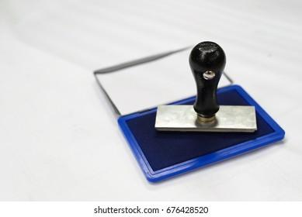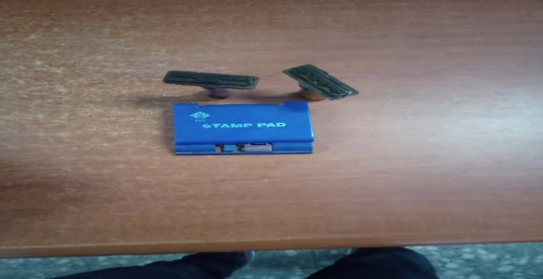
BOOK TROLLEY
This is used at the collection development, circulation, cataloguing and classification as well as serial and documentation units. It is used to carry or transport heavy or large collection of books from one location to another within the library. It has wheels which allow it to move, it is like a moving library shelf.
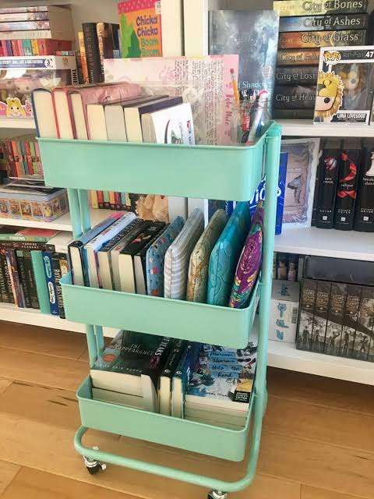
BOOKEND/BOOK GUIDE
The book end is an object which is designed as a book support, they are flat iron metals that are used in holding the books on the shelves from being fallen off. It is an object that is designed to buttress, or support, an upright row of books. It is placed on either end to prevent books from falling over, such as in a half-filled bookshelf.
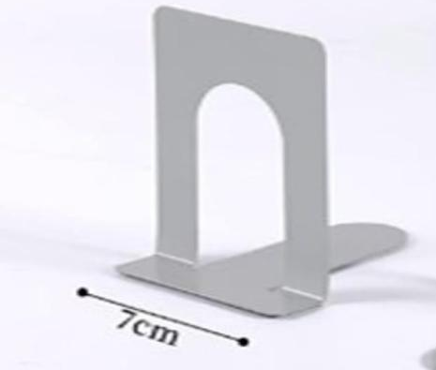
THE COMPUTER SYSTEM
Computer is available at all units of the library except bindery unit. It is used by the user.
The computer is also used by the users to have access online or to the Microsof8t word as well as to access e-journals and library subscribed database at the e-library.
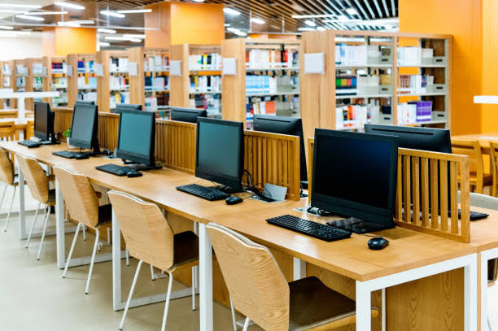

BINDING MACHINE
Binding machines are used in libraries to create durable and professional-looking bound documents. The most common type of binding machine used in libraries is the comb binding machine. This type of machine uses plastic combs that are inserted into punched holes in the pages of a document. The combs are then closed with a clamp, which secures the pages together. This type of binding is often used for library reference materials, handbooks, and other documents that need to be opened flat or turned over easily.
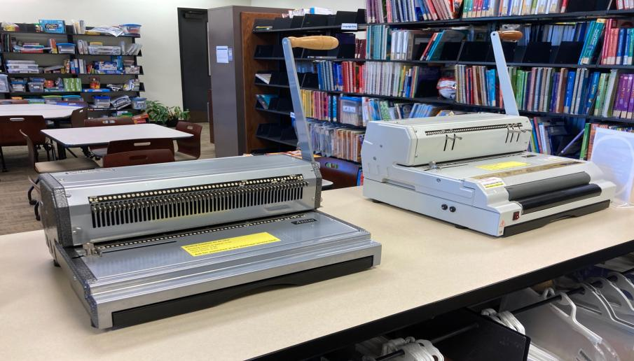

NEWSPAPER RACK
This is used to display daily newspapers.

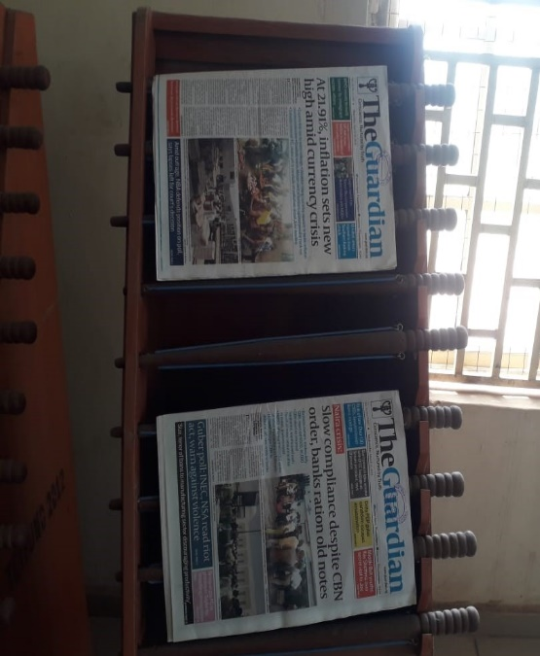

CHAPTER FIVE
5.1​ SUMMARY
A student industrial training is an opportunity for students to gain hands-on experience in their chosen field. It allows them to apply the knowledge they've learned in the classroom to real-world situations. It also allows them to develop important skills like problem-solving, teamwork, and communication. By completing a student industrial training, students can gain a competitive edge when entering the workforce.
During my student industrial work experience scheme (SIWES), I was able to gain valuable insight from the day to day operations of a professional environment. I learned the importance of time management, problem solving and communication. There is no doubt that this training experience has helped me to complete one of the important phases of my education. I have gained valuable skills and insights that will serve me well as I move forward in my studies and my career.
5.2 CHALLENGES ENCOUNTERED
The following are the problem I encountered, during the course of the training, they include:
- Inadequate professional staff in the library, as there are only few professional librarians in the whole of the library.
- Inadequate library cleaners
- Lack of professional skills and Lackadaisical attitude of some staff toward rendering services,
- No cafeteria around the library and this makes library users and staff to break their activities to go in search of refreshments at long distance, which supposed to be available around the library.
- Low patronage of the library users

5.3​ SUGGESTION FOR IMPROVEMENT OF THE LIBRARY
In this section, suggestions are made toward tackling identified challenges faced by users during/course of SIWES. Possible suggestions are presented below:
1.The library should focus on providing excellent customer service and user experience, as this will encourage people to use the library and build a positive reputation.
2.It is important to have a strong collection development strategy that focuses on the needs and interests of the user community.
3.One additional suggestion is to invest in training and professional development for library staff. This will help ensure that the staff has the knowledge and skills to provide excellent service and support the library's mission.
4.Another suggestion is to develop strong partnerships with other organizations in the community, such as schools, businesses, and cultural institutions. This can help the library reach new users and make its resources more accessible.

5.4​CONCLUSION
The SIWES program at Kwara State Library Board, Ilorin, was an enriching experience that bridged the gap between theoretical knowledge and practical application. The training allowed me to develop essential skills in cataloging, user services, and library automation. Despite the challenges, the experience was invaluable, and the knowledge gained will significantly contribute to my professional development in Library and Information Science.
5.5​RECOMMENDATION
The following recommendations are based on the experience at the place of attachment for SIWES:
- Upgrade Library Infrastructure: Providing backup power supply systems would minimize disruptions caused by power outages.
- Invest in Modern Technology: Equipping the library with advanced automation tools and software would enhance efficiency and expose students to industry standards.
- Extend Training Duration: Lengthening the SIWES period would allow for more comprehensive learning and exposure to all library departments.
- User Education Programs: Regular workshops and training sessions for library users on how to navigate library systems and utilize electronic resources effectively.
- Expand Digital Resources: Increasing the availability of online journals, databases, and e-books to cater to the diverse needs of library users.

