

A TECHNICAL REPORT ON
STUDENT INDUSTRIAL WORK EXPIRENCE SCHEME (SIWES)

HELD AT:
SOBI 101.9 FM
SOBI FM, SOBI HILL, OFF SHAO ROAD, SOBI ILORIN

BY
JOHN ELEOJO PRECIOUS
ND/23/MAC/PT/0737

SUBMITTED TO
THE DEPARTMENT OF MASS COMMUNICATION, KWARA STATE POLYTECHNIC, ILORIN, KWARA STATE, NIGERIA

IN PARTIAL FULFILMENT OF THE REQUIREMENT FOR THE AWARD OF NATIONAL DIPLOMA (ND)

AUGUST – NOVEMBER 2024

DEDICATION
I dedicate this report to Almighty God, who has been all in all from the beginning of my attachment to the end of the SIWES program all glory belongs to Him.
I also dedicate the SIWES report to my lovely Parent for their financial support and spiritual advice during the period of attachment.

ACKNOWLEDGEMENT
I thanked God for the glory, honour, mercy and adoration I received during the time of my industrial training and course of study.
I also thanked my parent and friends for all their support especially financially during my SIWS program.
More so, my appreciation also goes to every individuals that contributed to the completion of my industrial training, may the God Almighty bless them all and their households.

TABLE OF CONTENTS
Title Page
Dedication
Acknowledgment
Preface
CHAPTER ONE
1.0 Introduction
1.1 Background
1.2 Objectives of SIWES
CHAPTER TWO
2.1 Brief History of The Organization
2.2 Mission and Objectives of Establishment
2.3. Departments/Units in the Establishment and their Functions
CHAPTER THREE
3.0 Work Experience
3.1 Introduction to News
3.2 News Writing and News reporting
3.3. Some equipment available at the place of attachment.
CHAPTER FOUR
4.0 Relevance of The Experience Gained
CHAPTER FIVE
Recommendation and Conclusion
5.1 Recommendation
5.2 Conclusion

CHAPTER ONE
1.0 Introduction
1.1 Background
The Industrial Training fund established by decree 43 was introduced in 1971, vis-à-vis the birth of the Students Industrial Work Experience Scheme (SIWES) the same year by the Federal Government of Nigeria (FGN). It is against this background that the industrial training fund (ITF) initiated, designed and introduced SIWES Scheme in 1973 to acquaint students with the skills of handling employers’ equipment and machinery.
The Industrial Training Fund (ITF) solely funded the scheme during its formative years. However, due to financial constraints, the fund withdrew from the scheme in 1978. The Federal Government, noting the significance of the skills training, handed the management of the scheme to both the National Universities Commission (NUC), and the National Board for Technical Education (NBTE) in 1979. The management and implementation of the scheme was however, reverted to the ITF by the Federal Government in November, 1984 and the administration was effectively taken over by the industrial training fund in July 1985, with the funding solely boned by the Federal Government. It is an integral part of the requirements for the award of Certificates, Diplomas and Degrees in institutions of higher learning, e.g. Colleges of Education, Polytechnics, Universities, etc.
Student Industrial Work Experience Scheme (SIWES) exposes students to industry based skills necessary for a smooth transition from the classroom to work environments. It accords students of tertiary institutions the opportunity of being familiarized, exposed, and prepare students of universities, polytechnics, college of technology, college of agricultures and college of education for the industrial work situation they are likely to meet after graduation and to the needed experience in handling machinery and equipment which are not found in such an educational institution.
1.2 Objectives of SIWES
- To provide students with relevant practical experience.
- To satisfy accreditation requirements set by the Nigerian Universities Commission (NUC).
- To familiarize students with typical environments in which they are likely to function professionally after graduation.
- To provide student an opportunity to see the real world of their discipline and consequently bridge the gap between the University work and actual practice.
- To change the orientation of students towards labour market when seeking for job.
- To help students access area of interest and suitability for their chosen profession.
- To enhance students, contact for future employment
- To provide access to equipment and other facilities that would not normally be available in the University workshop
- To enlist and enhance industry involvement in university education.
- Summarily the objective of the Student Industrial Work Experience Scheme.
- To solve, the problem of inadequate practical skills, preparatory for employment in industries by Nigerian graduates of tertiary institution.
- To promote and encourage the acquisition of skills in industry and commerce, with a view of generating a pool of indigenous trained manpower sufficient to meet the needs of the economy.

CHAPTER TWO
2.1 BRIEF HISTORY OF THE ORGANIZATION
- Sobi FM (101.9 MHz) is a radio station based in Ilorin, Kwara State, Nigeria.
- The station was established on July 10, 2017.
- It is located on top of the Sobi Hill, off Shao Road, about 390 meters above sea level.

Founder

- The founder of Sobi FM is Lukman Akanbi Olayiwola Mustapha, a Nigerian politician and banker.
Programming
- Sobi FM offers news, sports, entertainment, and culture in both English and indigenous languages like Yoruba, Hausa, Fulfude, Nupe, and Batonu.
- The station aims to promote local content and provide a platform for the community to share their stories and experiences.
2.2. Departments/Units in the Establishment and their Functions
- Program Unit
A programme or project management office is a single, central support structure, designed to aid change and delivery initiatives within an organization. This applies particularly in an organization where there is a lot of ongoing programme and project activity. Without such a PMO, an organization is forced to replicate support arrangements over and over again as programmes and projects come and go.

- Marketing Unit
Promotes business and drives sales of its products or services in the media. It provides the necessary research to identify your target customers and other audiences. Depending on the company's hierarchical organization, a marketing director, manager or vice president of marketing might be at the helm.
- Technical Unit
The technical manager is a versatile position that requires sufficient managerial skills as well as sufficient technical skills. A technical manager should be able to perform all necessary tasks related to company systems including troubleshooting any technical issues.
- Admin Unit
Administration department is backbone of an organization. An effective administrator is an asset to an organization. He or she is the link between an organization's various departments and ensures the smooth flow of information from one part to the other.
- News and Current Affairs Unit
Current affairs are a genre of broadcast journalism. The news departments are responsible for putting down headline about current matters together.

CHAPTER THREE
3.0 ACTUAL WORK DONE
3.1 Introduction to News
Introduction to news refers to the initial segment or presentation of news content within a media outlet, whether it's a newspaper, radio broadcast, or online news platform. It serves as the gateway to informing audiences about current events, developments, and issues of relevance. The introduction typically outlines the major headlines and stories that will be covered, providing a brief overview to grab the audience's attention and set the tone for the news program. It may include key highlights, breaking news updates, and teasers to encourage viewers or listeners to engage further with the news content. The effectiveness of the introduction is crucial in capturing the audience's interest and establishing the credibility of the news source.
Various sources of News
Newspapers: Traditional print publications offering in-depth reporting on local, national, and international news.
Radio: News radio stations deliver updates and reports throughout the day, covering a wide range of topics.
Online News Websites: Digital platforms operated by news organizations provide articles, videos, and multimedia content on breaking news and in-depth reporting.
Social Media: Platforms like Twitter, Facebook, and Instagram serve as sources of news through posts, tweets, and live streams shared by individuals, news outlets, and organizations.
Press Releases: Organizations issue press releases to share announcements, updates, and information with the media and the public.
Academic Research: Studies and reports from universities and research institutions provide data and analysis on various topics covered in the news.
Interviews and Expert Commentary: News outlets interview experts, analysts, and stakeholders to provide context and insight into news stories.
Citizen Journalism: Individuals use digital tools and platforms to report on events and share firsthand accounts, photos, and videos, contributing to news coverage from diverse perspectives.
3.2 News Writing and News reporting
News writing and news reporting are integral components of journalism, each playing a distinct role in the dissemination of information to the public.
News writing involves crafting articles, reports, or stories that convey factual information in a clear, concise, and engaging manner. Journalists who specialize in news writing strive to present the facts objectively, without bias or personal opinion, adhering to the principles of accuracy, fairness, and balance. They carefully research their topics, gather relevant data and quotes from credible sources, and organize their content in a way that is easy for readers to understand and follow. Whether it's breaking news, investigative pieces, or feature stories, news writing serves as the foundation for informing and educating the public about current events, issues, and developments in society.
3.3. Some equipment available at the place of attachment.
Equipment include:
- Reel to reel audio tape recording:
is a form of magnetic tape audio recording in which the recording medium is held on a reel, rather than being securely contained within a cassette. In use, the supply reel or feed reel containing the tape is mounted on a spindle; the end of the tape is manually pulled out of the reel, threaded through mechanical guides and a tape head assembly, and attached by friction to the hub of a second, initially empty take-up reel.
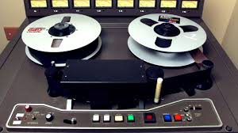

- Long grammar phone (Micro-Phone)
A microphone is a device that translates sound vibrations in the air into electronic signals or scribes them to a recording medium. Microphones enable many types of audio recording devices for purposes including communications of many kinds, as well as music and speech recording.
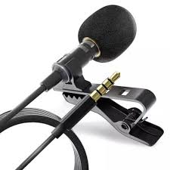

- Sound mixing board
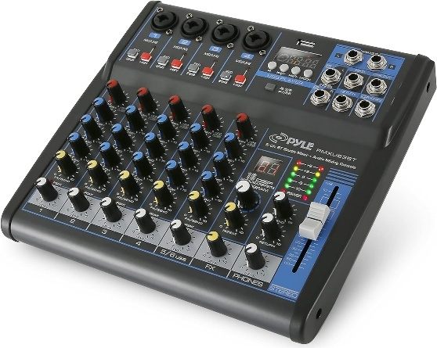
The sound mixing board, also known as an audio mixer, plays a crucial role in a radio station by allowing operators to control and balance various audio inputs. It enables the blending of different sound sources such as microphones, music players, and pre-recorded segments, ensuring smooth transitions between them. Operators can adjust volume levels, apply equalization for clarity, add effects if needed, and monitor audio quality in real-time. Additionally, the mixer facilitates communication between hosts, guests, and technical staff by providing features like talkback systems and headphone monitoring. Overall, the sound mixing board is the central hub for managing audio content and ensuring broadcast quality in a radio station.
- Headphone
In the radio station, headphones are essential tools for various tasks such as monitoring audio quality during live broadcasts, editing recorded segments, conducting interviews, and communicating with other staff members. They enable DJs and producers to cue up music, listen to caller feedback, and ensure smooth transitions between songs. Additionally, headphones facilitate communication between hosts, producers, and technical staff, allowing for seamless coordination during broadcasts. Overall, headphones play a crucial role in maintaining the professionalism and quality of the station's programming.


- Deck to the Cassette
A cassette deck is a type of tape machine for playing and recording audio compact cassettes. Consumer electronics formerly used the term deck to distinguish them from a tape recorder, the "deck" being part of a stereo component system, while a "tape recorder" was more portable and usually had a self-contained power amplifier (and often speakers). Other software’s include the audibling and Nero software
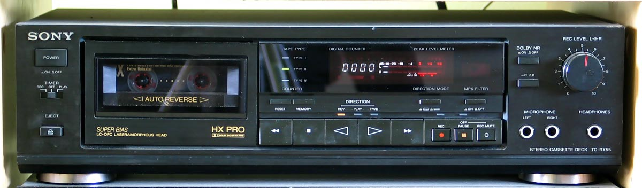

- Studio monitor
Studio monitors are precision speakers used in recording studios for accurate audio reproduction. They provide a flat frequency response, avoiding any bias towards specific frequencies. This neutrality allows engineers to make precise adjustments to recordings and mixes. Studio monitors ensure consistency and quality across different playback systems.
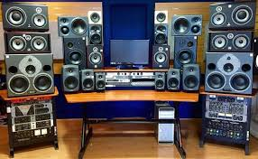
CHAPTER FOUR
4.0 RELEVANCE OF THE EXPERIENCE GAINED
In summary, this program has exposed me to some practical aspect in relation to my course of study (Mass Communication) and I benefitted greatly from the program, involves the following:
- I leant about the two studio every radio station has which is Live studio and recording studio.
- Theoretical aspect about the radio station equipment’s and machineries i.e microphone, audio console, computer system, headphone etc.
- Also leant on how to source for local news and foreign news by using platform such as BBC, Aljazeera and CNN.
- On how to use jingle to promote the radio and the basic radio styles.

CHAPTER FIVE
RECOMMENDATION AND CONCLUSION
5.1 Recommendation
- Tertiary institutions need to comply with the standards set for proper implementations of SIWES to enable students derive the greatest benefits from participation in the scheme.
- Tertiary institutions need to provide adequate logistics (mobility, internet service etc.) and adequate funding to make their SIWES units functional.
- Students should be well prepared through meaningful orientation programmes by institutions before embarking on SIWES. A book, such as the “Guide to successful participation in SIWES” would be useful in achieving the purpose if read before, during and after SIWES by participants.
- Quality assurance of SIWES, through adequate supervision of participants by the relevant stakeholders (institutions, employers and ITF) would ensure that the scheme meets its objectives vis-à-vis the principles of cooperative education or work-integrated learning.
5.2 Conclusion
The Student Industrial Work Experience Scheme (SIWES) plays a significant role in human resource development, it helps students develop new skills and enlightens them of what the present society holds for them after graduation and helps them adapt accordingly. As a result of the programme, I am now more confident to build my future, my four (4) months industrial attachment has been one of the most interesting, productive and instructive experience in my life. Through this training, I have gained new insight and more comprehensive understanding about the real industrial working condition and practice; it has also improved my soft and functional skills. All these valuable experience and knowledge that I have gained were not only acquired through the direct involvement in task but also through other aspect of training such as work observation, interaction with colleges, superior and other people related to the field.

