A TECHNICAL REPORT

ON
STUDENT INDUSTRIAL WORK EXPERIMENCE SCHEME [SIWES]

HELD AT
REAL MERCY MULTIBIZ STORE
SHOP 775 BABOKO MARKET ILORIN

WRITTEN BY:
JOSEPH ISREAL AYOMIDE
(ND/23/PAD/PT/0231)

SUBMITTED TO THE
DEPARTMENT OF PUBLIC ADMINISTRATION
INSTITUTE OF FINANCE AND MANAGEMENT STUDIES
KWARA STATE POLYTECHNIC, ILORIN

IN PARTIAL FULFILLMENT OF THE REQUIREMENTS FOR THE AWARD OF NATIONAL DIPLOMA (ND) IN PUBLIC ADMINISTRATION,

KWARA STATE POLYTECHNIC, ILORIN.

AUGUST-NOVEMBER 2024

DEDICATION
This Technical report is dedicated to Almighty God for sparing my lives throughout this programme. Also to my Parents Mr. & Mrs. JOSEPH.

ACKNOWLEDGEMENT
I give thanks to Almighty God for given me the grace and opportunity to participate in this SIWES programme. May his name be praise forever
I want to specially appreciate the effort of my parent Mr. & Mrs. JOSEPH for their financial support and their moral support, they will live to eat the fruit of their labour.
I also acknowledge my amiable and capable SIWES coordinator, I will be an ingrate if I fail to mention my SIWES Supervisor and my Lecturer in Business Administration Department for their tremendous effort in my life and the knowledge they have impacted to me
My gratitude goes to Industrial base supervisor for the impartation of knowledge given to me.
My profound gratitude goes to my brother and sister for their support during this program.
May Almighty God bless every one of you (AMEN)

TABLE OF CONTENT
Front Page
Dedication
Acknowledgement
Table of Content
CHAPTER ONE
  - Introduction to Siwes
1.2 Definition of Siwes
1.3 Historical Background of Siwes
1.4 Aims and Objectives of Siwes
1.5 Reasons for Training
1.6 The Major Document of ITF
CHAPTER TWO
2.1 A Brief History of the Company
2.2 Organogram of the Company
CHAPTER THREE
3.1 Introduction
3.2 Types of Business Enterprises
3.3 Functions of a Business Enterprise

CHAPTER ONE
  - INTRODUCTION TO SIWES
In the early stages of Public Administration, Nigerian Student were graduating from their respective Institutions without any technical knowledge or working experience. According to Akereloja (2008), acquisition of practical skills is an antidote of meaningful development in any society. In accordance with Akereloja's view, Odiagha (1995) also posits that practical knowledge is learning without which mastery of an area of knowledge may be too difficult to achieve and that practical knowledge involves developing skills through the use of tools or equipment to perform tasks that are related to a field of study.
As a result, the Federal Government of Nigeria introduced the Student Industrial Work Experience Scheme (SIWES) programme in Tertiary Institutions in 1975 to ensure acquisition of field practical knowledge and skills by Students before graduation, and to further expose Students to Industry based skills that are necessary for smooth transition from classroom to the labour world, providing the students with the basic prospects to be part of real work situations outside the lecture room. Thus, it became obligatory for Students in Tertiary Institutions, mostly those studying Business Administration related courses to embark on SIWES programme in order to acquire practical knowledge and working skills prior to graduating from their various institutions of learning.To this end, the Business Administration professionlike other course professions require practical skills. Hence it became imperative for Students of Urban and Regional Planning to embark on theSIWES programme so as to acquire the necessary practical skills required for the profession before graduation
1.2 DEFINITION OF SIWES
The student industrial working experience scheme is a Program that constitutes immensely to building of technical skills available to the Nigeria economy, which are needed for the national industrial development.
1.3 HISTORICAL BACKGROUND OF SIWES
The Student Industrial Work Experience Scheme (SIWES) was established in 1973 by the Industrial Training Fund (ITF). Prior to the establishment of the Scheme, there was a growing concern among our Industrialists that graduants of our institutions of higher learning lacked adequate practical background studies preparatory for employment in industries. It is against this rationale for initiating and designing the scheme was hinged.
Consequently the scheme affords students the opportunity of familiarizing and exposing themselves to the needed experience in handling equipments and machinery that are usually not available in their institutions so as to smoothen their entry into industrial practices on completion of their studies and also reduces period spent in training fresh graduates as new employees.
1.4 AIMS AND OBJECTIVES OF SIWES
SIWES is strategized for skills acquisition, therefore, the key aim is to bridge the gap between theory and practice by exposing students to the industrial environment and enable them to develop occupational competences so that they can readily contribute their quota to national economic development and technological advancement after graduation.
The Specific Objectives of the Scheme as outlined in the Industrial Training Funds Policy document no.1 of 1993 are as follows:
- To provide placements in industries for students of higher institutions of learning approved by relevant authorities (NUC, NBTE, NCCE) to acquire experience and skills relevant to their course of study.
- Prepare Students for the real work situations they will meet after graduation.
Expose Students to work methods and techniques in handling of equipment and machinery that may not be available in school. Makes transition from School to the labour World smooth and enhance Student contact for later job placement.
- Provides Students with the opportunity to apply their knowledge in real life work situation thereby bridging the gap between theory and practice.
1.5 REASONS FOR TRAINING
Reason for the industrial training are as follows:
1. The knowledge acquired in the classrooms are not enough due to lack of practical
2. The program has also helped to distinguish between class and practical work
3. Class room theories cannot be compare with the practical work done on the field.
4. The Siwes program has proved a means of opportunity for students to handle some sophisticated equipment not found in the school
1.6 THE MAJOR DOCUMENT OF ITF
1. PLACEMENT LETTER: This is the formal letter of the placement to be submitted to any employer by each students
2. THE JOB REPORTING FORM: This form is to be completed by students before he/she settle down with the employer. The information on the form will assist the central and department during supervision visits. Failure to return this form is taken as non participant in the program.
3. THE TRAINING LOG BOOK: This has to be completely filled daily and signed weekly by industrial based supervisor, and this logbook carried detailed information about work carried out daily, the logbook must be with you daily.

CHAPTER TWO
2.1 A BRIEF HISTORY OF THE COMPANY
The AbdulazeezOlaitan Business Enterprises is responsible for developing the business sector of the Nigerian business, with a view to growing the business, driving income growth, accelerate money and food security, generating employment and transforming Nigeria into a leading global business market, through the commodity value chain concept of the business development.
The idea is to treat money as a business and not as a development program, concentrate on develop where Nigeria has comparative advantage and develop strategic partnerships to stimulate investment in the country. The Marketing promotes business, encourages business development, supports private sector institutions and broadens stakeholders’ partnership to facilitate buy materials for market based industries, diversify market along commodity value chains and generate foreign exchange earnings for the country.
The AbdulazeezOlaitan Business Enterprises is a business man of the Nigerian government that regulates business research, marketing, develop and veterinary research all over Nigeria. Established in 1999, the abdulazeezOlaitanhas the responsibility of optimizing market and integrating rural development for the transformation of the Nigerian economy, with a view to attaining money, food and security positioning Nigeria as a net money and food exporter for marketing of their business development. Primarily funded by the Federal Government, the AbdulazeezOlaitan Business Enterprisescurrently superintends almost fifty parastatals operating as either key departments or agencies across the country.
The AbdulazeezOlaitan Business Enterpriseshas 2 major departments:
- Technical Departments:business (marketing and banking), Market, Livestock, Land Resources, Fertilizer, Food Reserve & Storage and Rural Development.
- Service Departments: Finance, Human Resources, Procurement, PPAS (Plan, Policy, Analysis & Statistics) and Co-operatives. Share4dev
The AbdulazeezOlaitan Business Enterprisesworkforce is 5,133 staff as at March 2021, comprising of the 1,709 Staff at Headquarters staff and staff 3,424 in the States. In all, establishment has 396 Staff at Directorate level consisting of 25 Directors, 119 Deputy Directors and 252 Assistant Directors.

2.2 ORGANOGRAM OF THE COMPANY

State Director
Livestock
H.O.D MARKETING
H.O.D OF BUSINESS
Booking Unit
H.O.D OF ACCOUNT
Scale of chemical
H.O.D OF ADMINISTRATION
Blacksmith
H.O.D AUDITING
Mechanical Unit

CHAPTER THREE
3.1 INTRODUCTION
The establishment of new industries and businesses is important for people looking to invest and become part of the growth of a company or an industry. Think how many early investors in Facebook or Amazon, or Apple benefited from investing in these business enterprises.
Furthermore, the profit earned by the investors as a result of the company's successful operation contributes to the accumulation of a greater quantity of savings, which may be used to fund future businesses. As a result, business is crucial in creating investment possibilities.
To sum up, business enterprises produce goods and services in exchange for commercial benefits. As drivers of innovation and investment, problem solvers, creators of jobs, and stimulants to the overall economy, these enterprises serve a vital function in our society.
Business enterprise meaning
To understand the meaning of the term business enterprise, you first have to understand the difference between a social enterprise and a business enterprise.
An enterprise can be defined as undertaking an activity that requires a lot of effort to develop.
A social enterprise involves helping others without receiving a commercial benefit in return. On the other hand, a business enterprise consists of producing goods or services in exchange for commercial and financial benefits.
Examples of business enterprises include all the companies you pay to receive a good or service from. These may include your local shop or your Netflix subscription, both of which are business enterprises.
A business provides goods and services to what we call customers. Goods refer to physical goods that usually go through a production process. This may involve bicycles, chocolate, or whatever item you pay to receive.
Other businesses provide services instead of physical goods; this involves intangible products, such as a private lesson from a math teacher or personal trainer.
All these goods and services are delivered to customers. A customer refers to anyone who purchases these products. Consumers use the product or service but do not necessarily buy them.
For instance, if your parents pay for your Netflix subscription, you are the consumer and your parents are the customer. If they also watch Netflix with you, they become consumers and customers simultaneously.
The business enterprise depends on customers, goods, and services for its very existence. These three components are intrinsically linked to the meaning of business.
3.2 TYPES OF BUSINESS ENTERPRISES
There are many types of business enterprises providing a wide variety of services or products. Business enterprises can be classified into three main categories, according to the production stage:
Business Enterprise: Primary sector
The primary sector involves businesses that are at the beginning of the production processes. These businesses make sure that the raw materials are created and produced to be used later by other companies.
Primary companies are mostly made of business-to-business (B2B) models, where you have one business supplying to the other. For example, oil exploration companies produce oil that retail companies sell, or other businesses use for production processes. Restaurants use agricultural goods produced by this sector to provide meals to their customers.
Advertisement
Thanks to this ad, Study Smarter remains free. Sign up for a free account to access a better learning experience.
Business Enterprise: Secondary sector
The secondary sector consists of business enterprises at the second step of the production process. These businesses use raw materials produced from the primary sector to develop into new goods and services. For example, car manufacturers use raw materials to build new cars, which they later supply to customers.
Examples of companies in the tertiary sector include banks that help individuals get loans or airline companies that enable one to fly around the world.
3.3 FUNCTIONS OF A BUSINESS ENTERPRISE
The four basic functions of a business enterprise are Finance, Operations, Human Resources, and Marketing.
Business Enterprise: Finance
One of the essential functions of a business is raising and managing money. A business enterprise may use internal or external sources of finance to raise the funds needed to get the business going. Internal sources of finance involve the money that business owners invest in their own business.
In contrast, external sources of finance involve cash from outside sources, such as money from family, banks loans, and investors. After the money starts moving around the business, the business managers should manage it cautiously so they don’t have too many costs, thereby failing to make any sales.
Business Enterprise: Human Resources
Another important function of a business enterprise is that of human resources. A business needs to get the right human capital to provide goods or services. This entails hiring people with the necessary expertise and skill set that the production process requires.
Stay organized and focused
Collect and manage all your study materials in one place in the StudySmarter app.
Functions of a business enterprise include Finance, Operations, Human Resources, and Marketing.
Reasons why business enterprises are important: economic development, solving problems, creating jobs, and investment opportunities.
Types of Business/ Enterprise
From the perspective of ownership and management, business enterprises can be broadly classified under three categories.
1) Private Sector Enterprises: Enterprises owned, controlled and managed by private individuals fall under this category with the main objective of earning. Contains:
A) Sole proprietorship
B) Participation
C) Joint Hindu Family Business
D) Cooperative
E) Company
2) Public Sector Enterprises: Business enterprises owned, controlled and operated by public enterprises, with the primary goal as secondary goal and welfare as profit, fall under this category.
Either whole or most of the investment in these ventures is done by the government such as:
A) Departmental undertaking
B) Public corporation
C) Government companies
3) Joint Sector Enterprises: As the name suggests, the joint sector is a form of partnership between the private sector and the government where management is generally in the hands of the private sector, and adequate representation by the government on the board of directors. is. Resources in such enterprises are mostly generated equally.
Thus, one of the first decisions an entrepreneur must make for his new venture is how the business should be structured.
From the entrepreneur's point of view, the most commonly chosen forms for starting a new venture are:
* Sole proprietorship
* Partnerships
* Company

CHAPTER FOUR
4.1 TO START A CLOTHING BUSINESS

Find Your Niche
The fashion industry is massive, consisting of a myriad of different brands–all with very different styles and niches. It’s important to identify your niche and stick to it. This will help you to create a product line that resonates with your target market and build a solid brand. Remember that as appealing as it may be to try to be everything to everyone, the best brands have a very defined niche and they stay in said niche.
Here are a few examples of highly successful clothing brands that operate in different niches:
- Wrangler (casual)
- Adidas (athletic)
- H&M (trendy)
- Ralph Lauren (classic)
Picking a niche means playing to your strengths. If you’re a strong seamster, you’ll spend most of your time designing and constructing pieces. If you’re a visual artist, you might create art that can be printed on T-shirts or other clothing items.

Know Your Audience
Early on, it’s important to figure out your ideal customer. When you’re working towards establishing your business, fashion makes things both easier and harder at the same time. You can easily imagine who would wear your clothes, but you also have to find where they congregate (in brick-and-mortar stores and online) and how to reach them.
Here are a few questions to consider when determining your audience:
- Who are they?
- What are their favorite clothing brands?
- Do they identify with certain brands?
- Where do they shop?
- How often do they shop?
- Do they care about trends?
- What is their price point?
- What influences their buying decisions?
By answering these questions, you will get a better understanding of your target audience. This enables you to more strategically build your brand, develop products they’ll want, and distribute products so they’re easily discoverable by the people who will buy them.

Create a Marketing Plan
After defining your niche and identifying your audience, the next step is to put together a marketing plan. While it sounds like a lot of work–it doesn’t have to be very comprehensive. But you do need to detail which channels you plan to use to sell your products, such as direct, Amazon, Etsy, boutiques and big box stores, as well as how you plan to market your businesses so that you get sales.
Here’s are the must-haves when creating a new business marketing plan:
- Market and competition
- Distribution channels
- Marketing strategy
- Marketing and advertising channels, such as social media and pay-per-click ads
- Marketing budget
A marketing plan essentially establishes how you will market your clothing line, and with that, can greatly guide how you go about product distribution and advertising strategies, which will impact your sales. Learn more about how to write a marketing plan.

Name Your Brand and Create Brand Assets
If you don’t already have a business name in mind, it’s time to choose one. Clothing business names can vary wildly. For example, Under Armor, ASOS, Banana Republic, L.L. Bean, American Apparel, TopShop, Brooks Brothers, Dickies, Deus Ex Machina, Vardagen, Life is Good, or Salt Life. In short, your clothing business can be named just about anything you want it to be.
Here are a few tips to keep in mind when naming your clothing business:
- Make sure that it is easy to pronounce and spell
- Choose a catchy or memorable name
- Consider how it translates into other languages
- Check if it is available as a domain name, such as yourbusinessname.com
Once you have a business name, choose a slogan (optional), a brand color scheme, and create your logo. If you’re looking for an easy and affordable way to create your own logo, try using Canva, which is a free drag-and-drop design tool that has dozens of prebuilt logos you can customize. Alternatively, you can get a logo professionally designed for as little as $5 on Fiverr.

Register Your Business
After choosing a brand name and putting together your brand assets, the next step is to register your business with your state. It’s not a fun step, but it is a necessary step–even for brand new clothing businesses as you will need an Employer Identification Number (EIN) to accept payments for your products. And to get an EIN, you need to register as a business. Additionally, it also enables you to get wholesale pricing and work with retailers.
The process of registering your business will vary depending on your state, but you will register it with your state’s Secretary of State. Small businesses typically opt to register as a Limited Liability Corporation (LLC) which costs around $100 on average but can be as little as $40 and over $250. If you’re not sure which is right for you, learn more about what an LLC is and how to set up an LLC.

Design and Source Your Products
Chances are you already know how you’re going to design and source your products. However, if you’re on the fence or open to ideas, there are three main ways:
- Buy products from wholesalers
- Design your own and have them manufactured
- Design and sew your own in-house
Of course, which you choose will depend on how you plan to sell your products. For example, if you’re planning to curate collections of clothing to sell online, say directly via your website or on Amazon, you could opt to purchase products from wholesalers or drop shippers. This is a great way to keep upfront costs low–especially if you are dropshipping products. However, it also means your products are not as unique and therefore might require more marketing.

Price Your Products
Pricing products in fashion is largely determined by two key variables. First, the cost of goods sold (COGS), such as labor expenses and cost of materials, and second, by the niche you’ve chosen to target. For example, the average clothing line uses what is called the keystone markup strategy, where the price is calculated by taking the cost of production and doubling it. However, it may be increased as much as 5X, depending on your niche, such as high-end clothing brands.
Here are a few key costs to include when pricing your products:
- Cost of materials
- Time
- Marketing and advertising
- Packaging
- Shipping
If you’re stepping into the luxury brand space, your products should be priced accordingly. Items that require a lot of attention, care and time in their creation should have premium prices.
On the other hand, a clothing company focused on high volume can have items with lower price points. Encouraging consumers to buy more means adding deals and flash sales to further incentivize purchases.

Distribute Your Products
Clothing businesses have a number of distribution options available, from selling directly via their own website and selling on third-party sites such as Amazon and Etsy, to selling in-store, through local retailers, or national big box retailers. To maximize your exposure and increase your sales, it’s generally best to plan to distribute and sell your products via multiple channels.
Even if you do not plan to sell products directly or online, you still need to have a website. This helps build your brand and if you’re planning to approach retailers, it gives them a way to check your product catalogs and lookbooks. Learn more about how to make a website or check out the best e-commerce platforms that enable you to easily create an online store where you can sell your products directly to customers.
No matter how you plan to sell the bulk of your products, you should have your own website.
If you’re not ready to sell from your own website, you can look into Etsy or other highly ranked e-commerce platforms to lessen your workload. The less time you have to spend troubleshooting a website, the more time you have to work on designing clothing.

Market Your Clothing Brand
Last but not least, you need to market your clothing brand so that it can be discovered by your target market. There are a number of ways to market a clothing business, but ultimately you want to choose marketing channels that reach your particular target market. In other words, be where your target customers are.
Here are some of the most popular marketing channels and strategies for clothing brands:
- Organic social media marketing, such as Pinterest and Instagram
- Paid social media advertising, such as Facebook Ads and YouTube Ads
- Paid search advertising, such as Google Ads
- Forums, such as Reddit
- Content marketing
- Influencer marketing
- Paid placements
- Banner ads, such as Google AdSense
- E-commerce ads, such as Amazon Ads and Etsy Ads
- Search engine optimization (SEO)
- Email marketing
- Sponsorships
- Local events
- Local news
When choosing the right marketing strategies and channels for your clothing business, remember to always keep your brand in mind. Consider if it stays on brand and if it’s likely to be a good use of your marketing budget. As with choosing distribution channels, you will also want to use multiple marketing channels for maximum exposure.

To Start Shoe Business
Becoming part of the most successful shoe stores will require planning, research, hard work, and the right partners. We summarized the process in ten steps, focusing on eCommerce and Print on Demand.

Research the Industry
Start with market research. You need a good idea of what other brands are doing in the shoe industry.
Study the competition and be aware of their strengths and weaknesses. What do they sell?
Research fashion trends, best-selling products, target market, location, and prices.
Look for shoe stores on marketplaces like Amazon, eBay, Etsy, and Walmart and type queries as “popular shoes” or “trending footwear.” Try out queries related to your target audience – for example, “trending athletic shoes for women.”
Read the product reviews and note what attracts customers and disappoints them.
Get inspiration from other shoe stores, but add your input and plan unique designs that add value to your target customers.
Repeat the queries from the marketplaces, pick the name of preferred products, and look for the terms in free tools like Google Trends.
Survey the related queries, demographics, and trends. Observe trends related to the products you’re planning to sell – do people look for them all year round, is there seasonality, are the queries increasing over time?

Find the Right Niche
A niche is a specific, targetable segment of a larger audience. It’s a group of like-minded people with particular interests and needs. The narrower the niche, the better.
Defining a niche is essential to reach the right customers and offer custom shoes to answer their demands.
Use Google Trends and type keywords representing your unique selling proposition (for example, “artsy footwear for men”).
Look into the related queries, demographics, and locations. Understand who is looking for products similar to your shoe brand, and target them.
Learn more about niches and tools with our video:

Choose Your Business Model
The most crucial decision to make when starting a shoe company – what will your structure be?
Choose one of these three models for a shoe store:
- Ownership of production – you design and manufacture the shoes and control a good part of the supply chain, assuring quality control and customization. It requires detailed planning, funding, installations, technical capacity, and human resources.
- Wholesale – the shoe store buys products in bulk from a manufacturer, keeps them in a warehouse, and sells the footwear gradually. It demands costs with facilities, managing inventory, and business insurance.
- Dropshipping and Print on Demand – the way to start a shoe business without worrying about the shoe store’s startup costs. The shoe store is the intermediary between the final customer and the manufacturer. Focus on design, marketing, and communication while the print provider takes care of applying the designs, fulfillment, and managing inventory. The shoes are produced only when an order is placed in the online store
Start selling

Develop Your Business Plan

Come Up With Your Business Name and Brand
Your shoe store’s name and brand should reflect the products it sells. Whether the line focuses on luxury boots, artsy sneakers, or athletic shoes, the theme should reflect in the brand name.
A brand name must harmonize with its story. Why the shoe line is named as such, and what story is behind the brand and enterprise? Memorable stories will make a brand unique.
Besides that, ideally, a business name should be short, easy to remember, and not difficult to spell or type.
Online name generators assist in finding the perfect name for your brand. You can type keywords like “luxury shoes” or “minimalist,” and the generator suggests related business names.
Using the same name on your internet domain is a good SEO and marketing practice. So, after deciding on the brand name, check if there’s an available domain name using tools like DomainWheel or GoDaddy.
Finally, don’t forget about copyright and registering a trademark.

Step 6: Find a Place for Your Shoe Store and Facilities
You have three possibilities to place your shoe brand – using a physical location, going fully online, or adopting a mixed approach:
- A regular retail shoe store requires physical locations with the accompanying requirements, such as renting, bills, operating costs, and business insurance.
- An online store is less expensive than a physical shop. It has a broader reach, and you can manage it anywhere.
- A business can maintain an online storefront while manufacturing the goods or keeping inventory. The store will have operational costs with a few physical locations in this case.
Ownership over quality control is the main advantage of owning the production and holding inventory. On the other hand, this is the more expensive way of starting a shoe business.
The best way to eliminate extra expenditure with facilities and go fully online is to opt for print on demand. Print providers will deal with the material costs, while the shoe store focuses on design and marketing.
The downside of POD is quality control. Be sure to find the right partner to guarantee consistent quality.
With Printify, you can create a new business online and sell shoes with builders like Shopify, BigCommerce, PrestaShop, WooCommerce, Wix, or Squarespace. You can also sell your shoe brand in marketplaces such as Etsy, eBay, Walmart, or Amazon.
Each one of these Commerce platforms has costs with subscriptions, plugins, hosting, or fees. Still, they are more affordable than renting and keeping facilities and human resources.

Step 7: Register Your Footwear Business
Registering a shoe brand differs depending on the country and state. If you’re not partnering with legal entities, you only have to register as an individual entrepreneur.
Usually, there are two main processes to solve in the US:
- Deciding the business type. The most common are:
- Sole proprietorship
- Partnership
- LLC – limited liability company
- Corporation
- Registering for taxes. There are two different types of registration required:
- Federal taxes – an Employer Identification Number (EIN) is necessary for accepting payments and filing taxes.
- State taxes – check your state website, as each state will have different procedures to be followed.
Registering an LCC and setting taxes can be easily done with the assistance of third parties, such as ZenBusiness.
If you create your shoe line with Printify and POD, our Help Center provides extensive FAQs about taxes for the US, EU, and Canada. Find information on registering and collecting sales taxes or lists and links to reputable companies that may assist when you file taxes.

Create a Business Bank Account and More
Create separate business accounts for everything connected to your legal entity.
Use a different bank account unrelated to your personal assets for your shoe store business. The same applies to a business credit card.
For creating a business bank account in the US, you’ll need:
- EIN or a Social Security number (in the case of sole proprietorship)
- Business license and other business registration documents
- Any ownership agreements (for partnerships and similar)
Acquiring business insurance is recommended to operate safely if you keep a physical inventory and mandatory if you have employees. Consult your bank on options provided by the institution, or get quotes from reputable insurance companies, like State farm, Hiscox, or Liberty Mutual.
Depending on the business model and state, you may need additional licenses and permits. Start looking on the city council if any essential document is missing according to city, county, or state requirements.
Create separate accounts for your shoe store when promoting on social media platforms. Most website builders will connect to social platforms.
Decide What Shoes to Sell, Design, and Produce Them

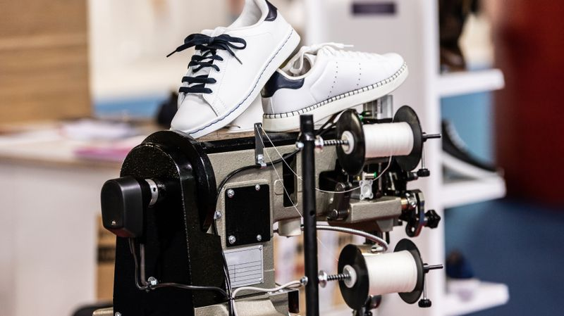

There are two distinct approaches to designing a shoe line:
- Manufacture the footwear from scratch. That will require designing the whole shoe, sourcing materials, manufacturing, and keeping an initial inventory.
- Focus on the design and outsource the production. Print on demand will allow you to create your shoe line in no time, with no upfront costs. Focus on designing and creating while print providers will produce and print the footwear.
Partnering with Printify will make that possible, as we have the largest network of print providers and a catalog with over 750 products. Here’s how to start a custom shoe business using Printify with no money:

Create a Printify Account
Go to the Printify homepage, click Start selling, and create an account. Use a Google account or an email address. Sign in to Printify for free with unlimited products and up to five stores per account.
Small businesses can escalate with the Premium plan ($24.99 monthly billed annually), which offers up to ten stores per account and up to a 20% discount on all products.
The Enterprise plan, for merchants with more than 10,000 orders a day, offers unlimited stores, a 20% discount on all products, and custom pricing.

Integrate a Sales Channel
Choose the sale channel where you have an online shoe store. Printify integrates with Shopify, Etsy, eBay, PrestaShop, BigCommerce, Wix, WooCommerce, Squarespace, or a custom API.
Depending on the channel, you may be required to create a standalone website and pay for subscriptions. Shoe selling on marketplaces like Etsy and eBay will demand no such costs, although each listing on Etsy will cost $0.20 to be published.

Choose and Design Your Custom Footwear
Pick a shoe in our catalog and select the closest print provider.

Sneakers
Get more customers with our classic, low-top, high-top, or sports custom sneaker options.
- Classic Sneakers (polyester canvas, low top) – for women and men

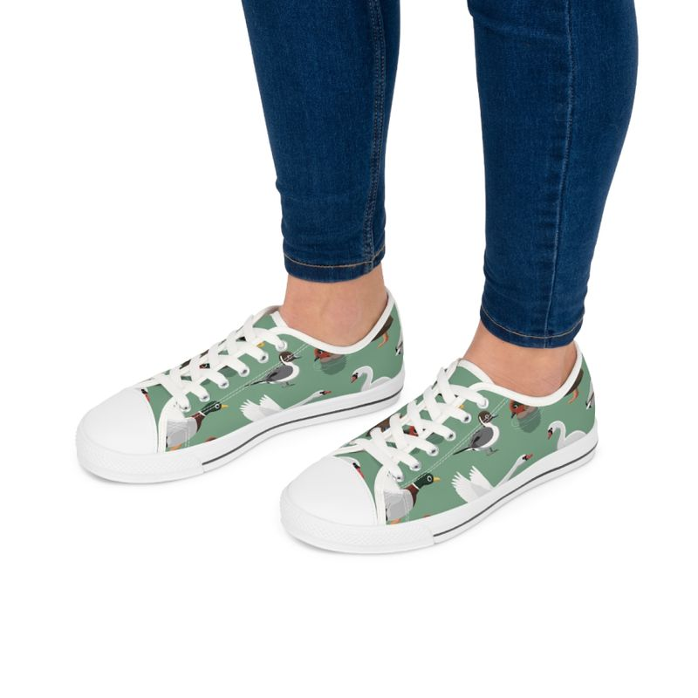

Fully customizable, order these classic sneakers with white or black laces and soles, while it’s possible to print different images on the left side, right side, and tongue.
The rubber outsole pairs with an EVA shock-absorbing layer and a hi-poly deodorant memory foam insole.
Men’s sneakers run bigger than usual – it’s suggested to size down.
- From $27.61
- Classic Sneakers (polyester canvas, 5” calf height) – for women and men
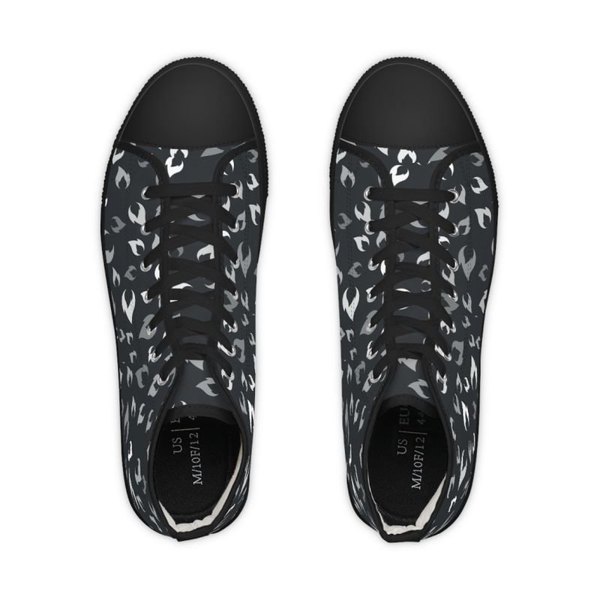

These classic high-top sneakers are fully customizable, can be ordered with white or black laces and soles, and can be printed differently on the left, right, and tongue.
They come with a rubber outsole, an EVA shock-absorbing layer, and a hi-poly deodorant memory foam insole.
- From $29.85
- Sneakers (nylon canvas, low top) – for women and men
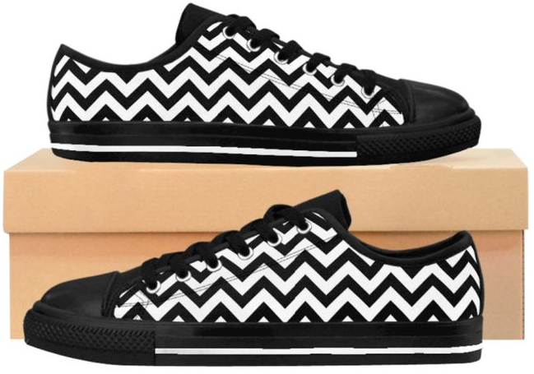

These 25.71 oz. nylon canvas sneakers are lightweight and comfortable. They come with a rubber outsole and a black interior. This canvas material is not suitable for small and detailed prints.
- For women – from $37.31
- For men – runs smaller than usual, suggested to size up. From $38.81.
- Classic Sneakers (nylon canvas, 5” calf height) – for women and men

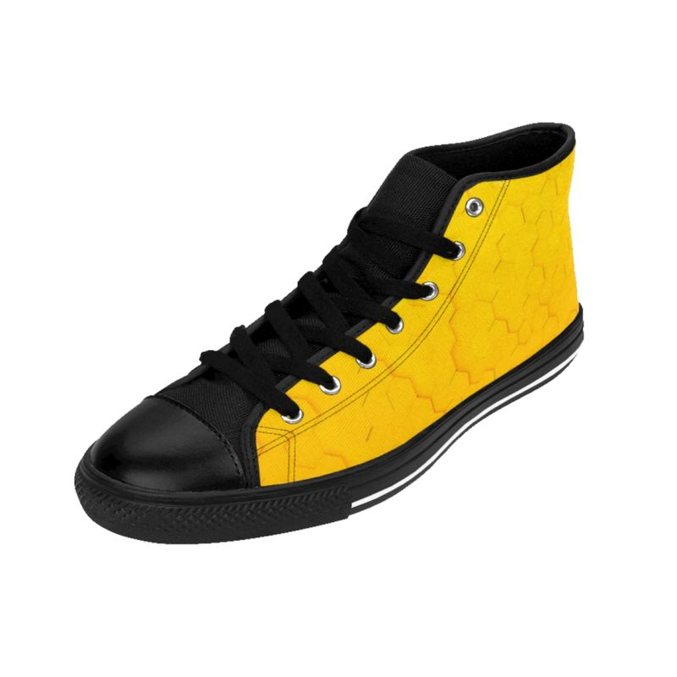

Slightly sturdier than the low tops, these sneakers retain comfort and style with a 27.87 oz. nylon canvas. The black inside interior accompanies a rubber outsole. The nylon canvas isn’t suitable for small prints.
For men, the sneakers run smaller than usual – we suggest sizing up.
- From $38.81

- Men’s Mesh Sports Sneakers
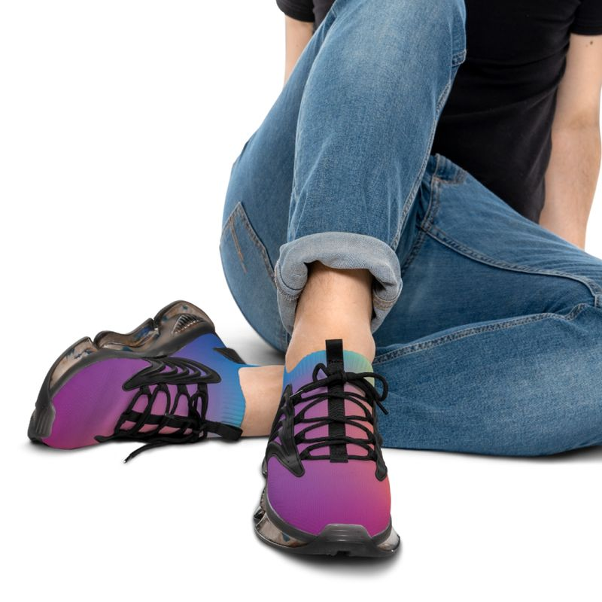

These sports shoes are fabricated with the industry standard material for sports footwear – a breathable mesh polyester and a layered sole from TPU and EVA for extended durability and shock absorption. The insoles are breathable deodorant memory foam.
- From $34.33

Boots
- Martin Canvas Boots

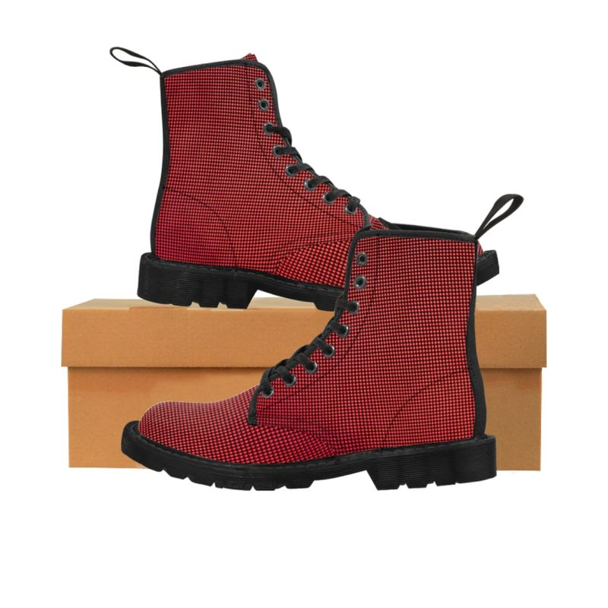

Classic and stylish, their surface is made from a mesh nylon fabric and foamed lining for softness and comfort. The men’s boots fabric is slightly heavier to increase durability.
The outsoles are rubber – translucent brown rubber or black gum rubber, while the foamed insoles are anti-heat, anti-moisture, and anti-corrosion.
The boots have rear pull-loops, black (with the black soles) or yellow (with the brown soles).
- Women – 30.69 oz. nylon canvas. From $61.19
- Men – 37.74 oz. nylon canvas. From $64.18

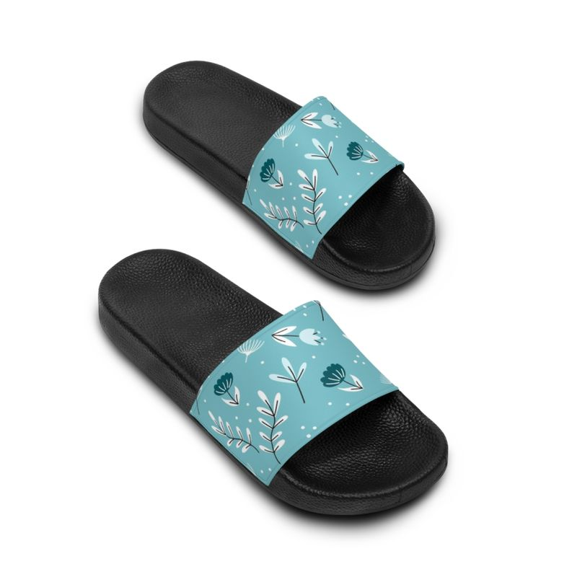
Sandals
Slide Sandals

With outsoles made of durable PVC foam and quick-drying printable straps, these slide sandals are comfortable, durable, and customizable.
For wide feet, we recommend sizing up.
- Women – from $28.51
- Men – from $34.33
Want to go further? Check our options for custom slippers and flip-flops.

Publish and Start Selling
Use the Product Creator to customize the chosen footwear and apply designs by clicking Start Designing.
After applying your design and picking the colors, click Save product.
Now it's time to edit the descriptions and define the profit margin. Use appropriate keywords when possible.
Finally, choose the main shoe’s mockup picture and color.
Once you’ve completed the designing and product creation, click Publish. The product will be displayed automatically in the integrated online shoe store.

Develop an Online Marketing Strategy for Your Shoe Company
Digital marketing will be fundamental in promoting your eCommerce business and getting new customers. Explore the marketing resources offered by your eCommerce platform, especially the following:
- Social media is free. Create integrated business accounts for your shoe brand on several platforms to reach potential customers. Post consistently according to the platform’s audience, alternating between promotional posts and educational content explaining features of your brand.

Instagram reaches audiences younger than Facebook. Pinterest is an excellent place for online marketing, especially if you own an online store on Etsy. Consider TikTok, aiming to reach your niche.

Use social media to gather email addresses in exchange for promotional codes, coupons, or free ebooks, but be sure to ask permission before sending emails.
- Use tools like Mailchimp to create email marketing campaigns. Mailchimp’s free plan gives a subdomain for free website building in a Mailchimp subdomain, analytics, campaigns, or automations.

Besides social media, get email addresses on your webpage, always trading them for something of value. Make it easier for the customers to subscribe with widgets on websites and buttons in Facebook shops.
Send promotional and informative emails. Informative emails let the customers know about order status and shipping and are usually automated by any eCommerce platform. Promotional emails can promote seasonal offers, inform of new products, or bring back lost customers.
- Last but not least, optimizing SEO and content generates organic traffic. Research for keywords related to your target audience with Google Trends (see Step 2), and apply the keywords in every piece of content, from descriptions of products to alt texts and blog posts.
Different platforms will provide specific marketing possibilities. Stay in the loop with updated articles for:
- Creating ads for Facebook, Instagram
- Improving Shopify’s SEO
- Boosting WooCommerce SEO
- Marketing strategies for Etsy
Multichannel and Omnichannel marketing strategies

